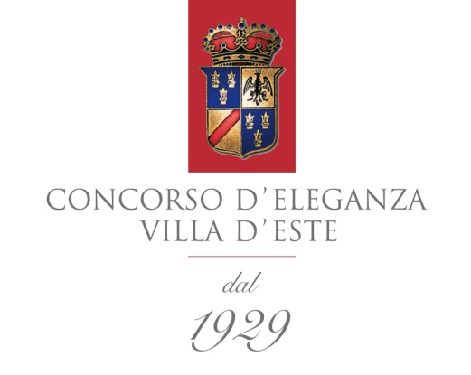

Press release 5 March 2013

Concorso d’Eleganza Villa d’Este 2013: Classic Weekend on Lake Como.

Extensive programme at the Villa d’Este and Villa Erba +++ Third motorcycle Concorso +++ Special “90 years of BMW Motorrad” and “60 years of Corvette” exhibitions +++ Auction held by RM Auctions.

Munich/Geneva. On the weekend of 24 – 26 May 2013, the spectacular grounds of the Grand Hotel Villa d’Este and Villa Erba in Cernobbio on Lake Como will once again be transformed into a unique stage for the most beautiful automobiles and motorcycles from the past and the most extravagant concept cars of the present day. First held at the same location in 1929, the Concorso d’Eleganza Villa d’Este today ranks as the most traditional show of its kind in the world. It lays on an extensive programme throughout the weekend, maintaining an exclusive ambience for those involved but at the same time offering the wider public a chance to experience the “Classic Weekend” on Lake Como in the company of classic car and motorcycle enthusiasts. As well as the automobile Concorso for invited guests in the grounds of the Grand Hotel Villa d’Este on the Saturday, the adjacent parkland of Villa Erba will open its gates to all car and motorcycle aficionados on the Friday evening for an open-air cinema, and on the Saturday and Sunday for the Public Days.

A multisensory experience: the Concorso di Motociclette
The Concorso di Motociclette, a successful addition to the automobile Concorso since 2011, will take place once again in 2013 in the grounds of Villa Erba, not far from the Cornt hotel in Cernobbio. The participants begin proceedings on Saturday with a parade from the Cornt hotel via Piazza Cavour in Cernobbio to the exhibition venue at Villa Erba. The local police escort and motorcycles piloted by riders in historic dress ensure this will be a memorable experience for the participants and crowds of spectators alike. The motorcycle Concorso itself will be conducted on the Sunday afternoon – with the lively participation of the assembled public – on the central stage in the gardens of Villa Erba. The 30 or so entrants are divided into five different categories (according to era and design), from which the three class winners from the various categories are introduced to the public galleries and presented with their prizes. The overall winner (Best of Show) is chosen from the class winners by an international jury.

“90 years of BMW Motorrad”: special exhibition at Villa Erba
An exhibition presenting milestones from the 90-year history of BMW Motorrad will be held at Villa Erba to commemorate this anniversary. Starting with the BMW R 32 – the first ever BMW motorcycle – and continuing all the way to the futuristic BMW K 1, the key motorcycles in BMW history highlight to the assembled audience what BMW motorcycles have always been: premium machines with character and a unique blend of innovation, sporting capability and stand-out aesthetics. The line-up is rounded off by another special exhibition in the grounds of Villa Erba marking “60 years of Corvette” and by the historic Klemm KL 25 sports aircraft.

Automotive dreams change hands: under the hammer with RM Auctions
The renowned auction house RM Auctions will once again be a guest at the Concorso d’Eleganza Villa d’Este in 2013. Some 45 top-class cars will go under the hammer on Saturday evening at Villa Erba. This spectacular auction will begin at 8.00 p.m. and again feature some very special models, such as a Bugatti Type 57 Ventoux (1937) and a Pininfarina Ferrari 330 GTC (1966).

The heart of the Concorso
The heart of the Concorso d’Eleganza remains at the Grand Hotel Villa d’Este where – every year since 1929 – beautiful and rare examples of the automotive art seek the favour of the invited guests and the jury. In 2013 some 52 select cars will be entered in competition. Speaking at the Geneva Motor Show, Dr Ralf Rodepeter, Director of the BMW Museum and member of the Concorso d’Eleganza Villa d’Este Selecting Committee, gave his audience a taste of what we can expect.

Aston Martin DB4GT Zagato (1961)
Aston Martin created another monument to itself with the 1960 DB4GT Zagato. Just 19 examples of this extraordinary sports car were fitted with their hand-built Zagato bodies in Newport Pagnell. A rigorous focus on lightweight construction methods, the use of plexiglass and a stripped-out interior penned the car’s kerb weight at 1,225 kg. Four of these exclusive lightweight models were purpose-built in 1961 for use on the race track. Following an eventful career in competition, including outings with Jim Clark and other elite drivers behind the wheel, the DB4GT Zagato with registration 2 VEV was sent for restoration in 1993. After two years of loving attention, during which its restorers demonstrated an impressive eye for detail, Aston Martin brought the car back to its original condition in 1963. It was acquired by its current owner in 1971.

Lamborghini 350 GTV (1963)
Ferruccio Lamborghini had a dream, which he pursued with fierce determination: to build – alongside his successful tractors – genuine sports cars that would give his Italian rivals from Maranello something to think about. The first step to fulfilling this dream came in the form of the 350 GTV prototype, which left a lasting impression on the automotive world at the 1963 Turin Motor Show. This Franco Scaglione-designed precursor to the first Lamborghini series-produced sports car (the 350 GT) was the main attraction in Turin – not least, of course, on account of the V12 engine conjured by Giotto Bizzarrini, which occupied its own pride of place alongside the car at the show. Today, the Lamborghini 350 GTV features green metallic paintwork and is in fully ready-to-drive condition.

Bugatti Type 57SC Atlantic (1938)
The Bugatti T 57SC – affectionately known as the “Atlantic” – is not only one of the world’s rarest and most valuable cars, but also one of the most visually beguiling. Only four examples of this nigh-on flawless automobile were built between 1937 and 1938 at the legendary factory in the Alsace. The “masterpiece” of Jean Bugatti, son of company founder Ettore Bugatti, is blessed with both breathtaking design and extraordinary engineering. The Atlantic set to go on show at the Concorso d’Eleganza Villa d’Este dates from 1938 and is number four in the production run. It is in impressively original condition and can already look back on an extremely successful career in automotive beauty pageants around the world.

Media representatives can find further information at www.concorsodeleganzavilladeste.com and www.press.bmwgroup.com. Please use the search term “Concorso”.
For accreditation follow the “Press” link at www.concorsodeleganzavilladeste.com.

For any further queries please contact:
Stefan Behr, BMW Group Corporate Communications, Spokesperson BMW Group Classic and BMW Group Driving Experience; Telephone: +49-(0)89-382-51376, Fax: +49-(0)89-382-28567
Internet: www.press.bmwgroup.com, Email: Stefan.Behr@bmw.de

