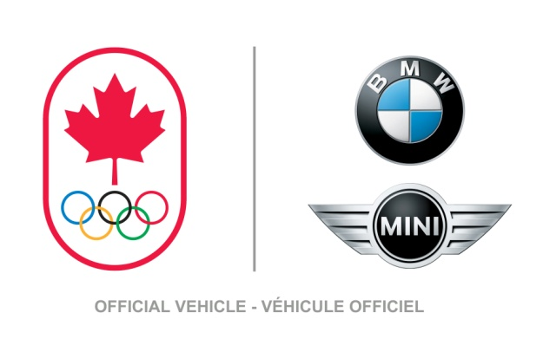
Release
January 18, 2012
For immediate release

BMW GROUP CANADA DRIVES SUPPORT FOR CANADIAN OLYMPIC ATHLETES
Canadian Olympic Team proudly welcomes new performance partner at Toronto Event

Toronto – Today, high performance vehicles and high performance sport formalized a new relationship to support Canadian athletes as luxury automobile manufacture BMW Group Canada and the Canadian Olympic Team revealed a four-year sponsorship deal for the coming quadrennial.

Announced through high-octane events in Montreal and Toronto, and which included Winter and Summer athletes, the deal signals yet another fuel-injection for Canadian high performance athletes and coaches, and will continue through the next two Olympic Games: Sochi 2014 and Rio 2016.

“Much like our Canadian Olympic heroes, BMW is an innovative performance brand with a legacy of excellence,” said Marcel Aubut, President of the Canadian Olympic Committee. “We are delighted to welcome this amazing corporation as an official National Partner of the Canadian Olympic Team and look forward to driving together toward an even more exciting future for our Canadian athletes.”

In addition to this partnership, BMW Group Canada will continue its high-performance support by sponsoring two National Sport Federations to bolster Canada’s world-class development in the sport community.

“The BMW Group, a company focused on performance and innovation, is the perfect partner for the Canadian Olympic Team, whose athletes strive for peak performance in every competition,” said Eduardo Villaverde, president and CEO, BMW Group Canada. “Our two organizations share many of the same beliefs and values, and we believe working together will bring tremendous benefits to both of our teams. Over the next four years, we look forward to creating innovative programs that provide substantial financial support to Canadian athletes. Our retailers look forward to this as well; they will be a major force in our overall contributions and programming. At the same time, we know that our associates and customers will be mightily engaged in this partnership, as well.”

“For the Canadian Olympic Team to be sponsored by BMW pretty much gives new meaning to the term ‘performance partners,” said Rosie MacLennan, London 2012 Gold Medallist in Trampoline. “It’s another huge vote of confidence for all of us to have such an amazing partner, and it’s a great feeling for us all as we get working towards Rio over the next four years.”

“Sochi’s just more than a year away and it’s a great boost to our confidence to get this kind of support right now,” said Heather Moyse, Vancouver 2010 Gold Medallist in Bobsleigh. “It’s great to welcome BMW to the Canadian Olympic Family and I know it’s going to be a great relationship for all of us.”

"Canada's rich Olympic tradition is a source of national pride and inspiration. As the single largest contributor to sport in Canada, our government understands that in order to train and compete at an elite level our athletes must rely on a diverse network of funding including, public and private. On behalf of the Harper Government, I want to congratulate the Canadian Olympic Committee and BMW Group on this new partnership and the resulting benefits for our present and future Olympians,” stated Hon. Peter Kent on behalf of Minister of State (Sport) Gosal.

- 30 -

Canadian Olympic Committee Media Office:

Jane Almeida, Manager, Media Relations
Tel: 416-324-4120 / Cell: 416-540-1788
Email: jalmeida@olympic.ca
Dimitri Soudas, Executive Director, Communications
Tel: 416-324-4136 / Cell: 289-388-6419
Email: dsoudas@olympic.ca
BMW Group Canada media contact:

Barb Pitblado
Director, Corporate Communications
Mobile: 416-627-0436
Email: Barb.Pitblado@bmwgroup.ca

