Rolls-Royce

Media Information

THE HOUSE OF ROLLS-ROYCE PREMIERES
THE FIRST IN A SERIES OF FASCINATING FILMS –
‘THE SPIRIT OF ECSTASY’

12 December 2016, Goodwood

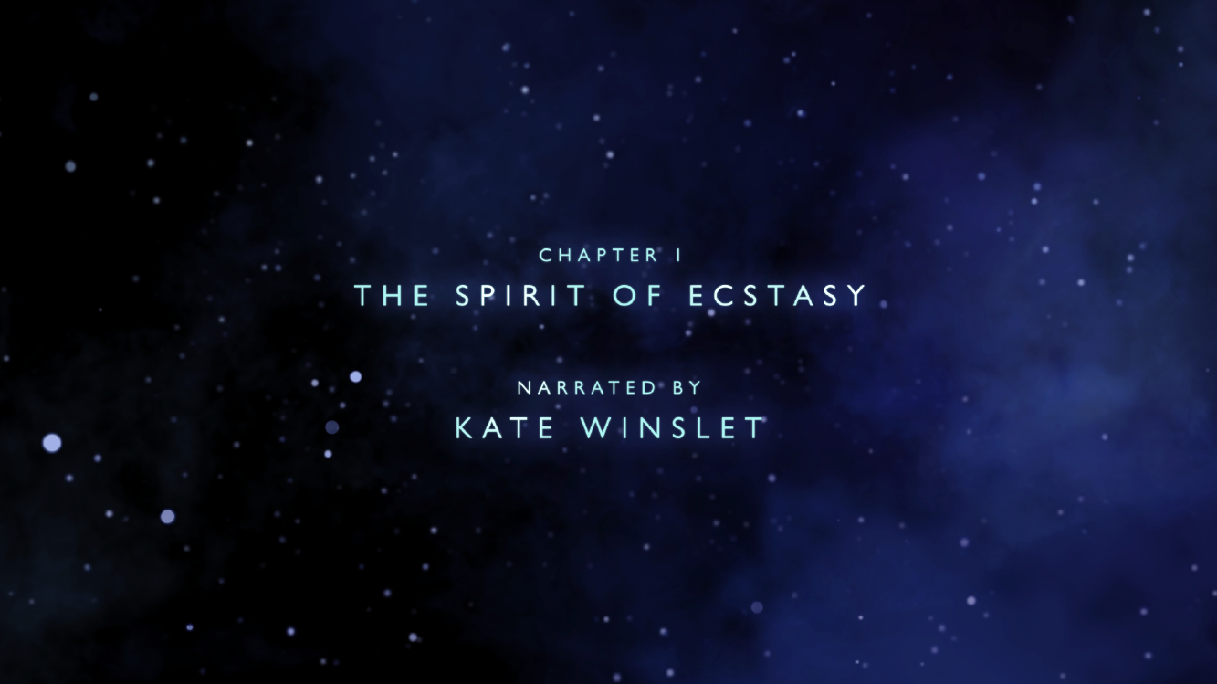

The House of Rolls-Royce premieres the first in a series of fascinating short films today, telling how it became the world’s leading and most respected luxury house. ‘The Spirit of Ecstasy’ film will premiere at www.rolls-roycemotorcars.com.

Kate Winslet, the Academy Award winning actress, will give voice to the Spirit of Ecstasy in this first film for the House of Rolls-Royce as she retells luxury’s most fascinating and enduring story. The British actress will recount the story of the muse that guides the world’s most celebrated luxury house.

The premiere signals the beginning of a year of celebrations for the House of Rolls-Royce as it prepares, once again, to reset the standard by which all other luxury goods are judged with the arrival of the New Rolls-Royce Phantom later in the year. This landmark moment will also herald the beginning of the second chapter of the remarkable story of Rolls-Royce since its renaissance began in 2003 at the marque’s centre of luxury excellence in Goodwood, West Sussex.

“The Spirit of Ecstasy has stood on the prow of every Rolls-Royce since 1911, representing ‘the best’ of everything, whilst silently guiding through life those exceptional people who have made our world turn. This is a story that inspires greatness and needs to be told,” said Torsten Müller-Ötvös, Chief Executive Officer, Rolls-Royce Motor Cars. “Our world-wide search for the perfect voice of the Spirit of Ecstasy led us back to West Sussex, England, where both Kate Winslet and Rolls-Royce, two British icons reside. Kate Winslet brings her great talent to this role.”

The Premiere: Episode 1 – ‘The Spirit of Ecstasy’
The first episode of The House of Rolls-Royce series, ‘The Spirit of Ecstasy’, retells the story of the muse that has guided and inspired the world’s most celebrated luxury house for the past 105 years.

Since her creation in 1911, the Spirit of Ecstasy, modelled by sculptor and artist Charles Sykes, has silently guided every Rolls-Royce and its prestigious owner through momentous events in their lives and the lives of others. She has stood as an elegant presence and witness at some of history’s most notable events.

This first episode uses cutting edge motion capture and 3D scanning techniques to bring back to life one of the most fascinating legends in the mythology of Rolls-Royce – how and why the Spirit of Ecstasy, which is the most recognised luxury icon in the world, came to be.

Our story begins in the milieu of Belle Époque London, where artists and inventors, scientists and engineers, aristocrats and bohemians collaborate and compete in the white heat of early 20th Century creativity. Fittingly, this time very much echoes the path of today’s Rolls-Royce patrons, visionary men and women who take risks and boldly innovate to achieve their success.

The film opens when Rolls-Royce has been in business since 1904 and has spent several years ‘taking the best that exists and making it better’ for its wealthy and discerning clientele.
Relentless in their quest to create ‘the Best Car in the World’, driven by an ethereal muse, Rolls and Royce go out into the world to test, to perfect and to secure the fundamentals of this great brand that endure to this day: an unparalleled combination of pace, elegance, engineering, comfort and handcraftsmanship.

Only when this perfection is secured does the resulting Rolls-Royce Silver Ghost merit the muse’s approval; an approval that comes in the shape of the iconic ‘Spirit of Ecstasy’. This ecstatic status of perfection finally allows it to carry the ‘Flying Lady’ on its prow, a fact that has endured for every Rolls-Royce since, and will do into the future. A muse that leads the dreamers, visionaries, innovators and those leaders who make our world turn.

The House of Rolls-Royce
The legend of the House of Rolls-Royce will unfold over the year and beyond through further short films as the marque prepares for another landmark moment in automotive and luxury history: the arrival of the benchmark for luxury goods worldwide, the New Rolls-Royce Phantom.

This series of films will serve as a new platform in the ethereal, virtual sphere where followers and devotees of Rolls-Royce can engage further with the marque.

In addition to exclusive early views of the next episodes of the story of the House of Rolls-Royce, those advocates and followers of the marque will be offered the opportunity to attend exclusive Rolls-Royce gatherings around the world. Further news on such events will come next year.

- Ends -

Notes to editors:

You can find all our press releases and press kits, as well as a wide selection of high resolution, downloadable photographs and video footage at our media website, PressClub. You can also find the communications team at Rolls-Royce Motor Cars on Twitter and Instagram (RollsRoyceMedia).

Press contacts:
Goodwood
- Director of Global Communications
Richard Carter +44 (0) 1243 384060 richard.carter@rolls-roycemotorcars.com
- Global Corporate Communications
Andrew Ball +44 (0) 1243 384064 andrew.ball@rolls-roycemotorcars.com
- Global Product Communications
Andrew Boyle +44 (0) 1243 384062 andrew.boyle@rolls-roycemotorcars.com
- Global Lifestyle Communications
Emma Rickett +44 (0) 1243 384061 emma.rickett@rolls-roycemotorcars.com

Regional
- Asia Pacific - North
Rosemary Mitchell +81 (0) 3 6259 8888 rosemary.mitchell@rolls-roycemotorcars.com
- Asia Pacific - South
Hal Serudin +65 6838 9675 hal.serudin@rolls-roycemotorcars.com
- China
Anna Xu + 86 1084558037 anna.xu@rolls-roycemotorcars.com
- Eastern Europe
Frank Tiemann +49 (0) 89 382 29581 frank.tiemann@rolls-roycemotorcars.com

- Northern Europe and Scandinavia
Ruth Hucklenbroich +49 (0) 89 382 60064 ruth.hucklenbroich@rolls-roycemotorcars.com

- Middle East, Africa and India
Jamal Al Mawed +971 561717883 jamal.almawed@rolls-roycemotorcars.com

- The Americas
Gerry Spahn +1 201 930 8308 gerry.spahn@rolls-roycemotorcarsna.com

- UK and Western Europe
James Warren +44 (0)1243 384578 james.i.warren@rolls-roycemotorcars.com

