MINI
Corporate Communications

Media Information
2 March 2010

MINI brings Hollywood to Geneva for the world premiere of the new MINI Countryman.
MINI surprises with huge guerrilla projection at 80th Geneva Motor Show.

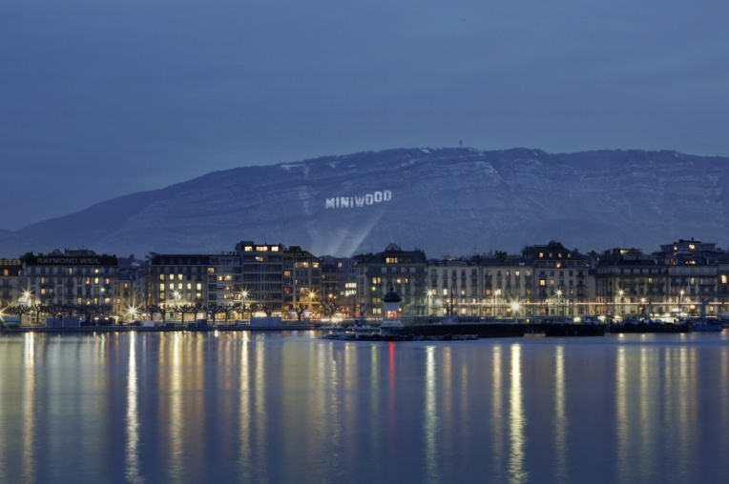
Geneva. MINI brings Hollywood to Geneva. The launch of the new star of the MINI family – the MINI Countryman – at the 80th Salon International de l’Auto provides reason enough for an unconventional marketing campaign: The city built on Lake Geneva is being renamed “MINIWOOD” by way of a huge projected image, creating a rival to the Hollywood dream factory in Los Angeles. The gigantic projection of the “MINIWOOD” sign onto Mont Salève on French soil is one of the largest projections of its kind.
The projected image is 30 metres high and 192 metres wide. In the evening light it is visible for miles around to Geneva residents as well as the many visitors to the Motor Show.
This unconventional campaign involves powerful technology: High-performance projectors with 348,000 Ansi lumen illuminate an area of over 5,760 square metres with an output of more than 28,000 watt.

The projection will be complemented by a short video in typical MINI style. This “viral” will show how the projection is realised and will be widely distributed in the Internet.

Film posters entitled “MINI Countryman – GETAWAY” will publicise the guerrilla action and hence the world debut of the fourth member of the MINI family, raising public awareness and highlighting the MINI presence in Geneva. The “Making of” video will also be posted on MINI’s official YouTube channel at: http://www.youtube.com/MINI, and MINI Countryman’s Facebook page, http://www.facebook.com/MINI.Countryman.


MINIWOOD would not be complete without the celebrated “Walk of Fame”. So, as Motor Show visitors walk from the airport to the Palexpo, for example, they are guided by “MINIWOOD stars”. Walkways through busy areas of downtown Geneva have also been adorned with stars to strengthen MINI’s presence in the city centre.

MINIWOOD is brought to life through “red carpet parking”: In true Hollywood style, a MINI Countryman is parked and displayed on a red carpet on the streets of Geneva. A sign right next to the newest MINI star bears the slogan “I BECAME FAMOUS IN MINIWOOD – MINI COUNTRYMAN. GETAWAY.”

Thanks to a wide variety of communications activities in connection with the 80th International Motor Show in Geneva, the MINI Countryman is set to be the toast of the town. The MINIWOOD concept is the brand’s latest guerrilla action and confirms once again that MINI makes an unconventional statement.
“Guerrilla marketing plays an especially important part in MINI communications. That is why the launch of the new MINI Countryman will also be accompanied by characteristically unconventional and eye-catching marketing campaigns that are deliberately designed to appeal to the brand’s modern target groups,” explains Andreas-Christoph Hofmann, head of MINI Brand Communication.

Company
Bayerische
Motoren Werke
Aktiengesellschaft

Address
BMW AG
80788 München

Telephone
089-382-0

Internet
www.bmw.com

If you have any questions, please contact:

Corporate Communications

Susanne Spatz, Product Communications MINI
Telephone: +49 89 382-20961, Fax: +49 89 382-28017

Alexander Bilgeri, Business and Finance Communications
Telephone: +49 89 382-24544, Fax: +49 89 382-24418

Markus Sagemann, Business and Finance Communications
Telephone: +49 89 382-68796, Fax: +49 89 382-24418

Media website: www.press.bmwgroup.de
E-mail: presse@bmw.de

The BMW Group
The BMW Group is one of the most successful manufacturers of automobiles and motorcycles in the world with its BMW, MINI and Rolls-Royce brands. As a global company, the BMW Group operates 24 production facilities in 13 countries and has a global sales network in more than 140 countries.
The BMW Group achieved a global sales volume of approximately 1.29 million automobiles and over 87,000 motorcycles for the 2009 financial year. Revenues for 2009 totalled euro 50.68 billion. At 31 December 2009, the company employed a global workforce of approximately 96,000 associates.
The success of the BMW Group has always been built on long-term thinking and responsible action. The company has therefore established ecological and social sustainability throughout the value chain, comprehensive product responsibility and a clear commitment to conserving resources as an integral part of its strategy. As a result of its efforts, the BMW Group has been ranked industry leader in the Dow Jones Sustainability Indexes for the last five years.

