1. Fun has no limits.
The MINI Countryman. 2

The MINI Countryman*.
Contents.
2. Description in brief. 5
3. MINI on a growth path.
The concept. 10
4. The first of its kind in the premium segment –
and unmistakably a MINI.
The design. 12
5. Lively and economical thanks to a dose of MINIMALISM.
The engines. 17
6. New routes to unbeatable agility.
Power transfer and chassis. 23
7. Inspiringly versatile, imposingly safe.
Body and occupant protection. 27
8. New customisation options for individualists.
Equipment and accessories. 30
9. Specifications. 36
10. Output and torque diagrams. 50
11. Exterior and interior dimensions. 55

*The name of the vehicle may vary in some markets.

The MINI Countryman takes the hallmark driving fun of the brand into a new dimension. This is the first MINI to come with four doors and a large tailgate
as well as a versatile interior offering space for up to five people. The
MINI Countryman is the first member of the MINI family with a body measuring more than four metres (157") in length and which can be ordered as an option with all-wheel drive. With these features, in addition to the Countryman’s raised seating position and optimised ride comfort, the world’s only premium vehicle of its kind crosses the boundaries of urban mobility to take the trademark
MINI feeling into new dimensions and win over additional target groups.

1. Fun has no limits.
The MINI Countryman.
The latest generation of petrol and diesel engines.
Three petrol and two diesel engines will be available at launch. The selection
of petrol variants ranges from the MINI One Countryman developing 72 kW/98 hp and MINI Cooper Countryman (90 kW/122 hp) to the 135 kW/184 hp MINI Cooper S Countryman, whose 1.6-litre four-cylinder engine is the most efficient unit in its displacement class. The petrol models are joined in the line-up by the diesel-powered MINI One D Countryman (66 kW/90 hp) and MINI Cooper D Countryman (82 kW/112 hp). All variants
of the MINI Countryman meet the EU5 exhaust gas standard in Europe and
the ULEV II standard in the USA.
MINI ALL4: Breaking new ground in driving fun.
Optional MINI ALL4 all-wheel drive allows the driving fun you expect from the brand to be experienced off the beaten track as well. The permanent all-wheel-drive system’s quick and precise responses to changing conditions provide
a new, traction-led expression of the handling talents for which MINI is famed. An electromagnetic centre differential positioned directly on the final drive varies the distribution of power seamlessly between the front and rear axles. The ALL4 system is available for the MINI Cooper S Countryman and
MINI Cooper D Countryman.

Newly developed suspension combines quintessential MINI
agility with outstanding ride comfort.
With its precise handling and captivating agility, the MINI Countryman transplants the driving characteristics associated with the brand into a new vehicle concept. These attributes are complemented by outstanding ride comfort, equipping the Countryman perfectly for a wider range of usage. Underpinning this is sophisticated new suspension technology, which includes a front axle with MacPherson spring struts and forged track control arms,
multi-link rear suspension and the electromechanical power steering system EPS. The MINI Countryman comes as standard with the Dynamic Stability Control (DSC) system.
Design: Undeniably an individualist, unmistakably a MINI.
The MINI Countryman exudes an air of originality, robustness and versatility. Four doors and a large tailgate, a striking roof shape and an upright front end reinforce its status as an individualist within the MINI ranks. Other distinctive features are its MINI proportions and design cues. Short overhangs, a high window line, the wrap-around look of the windows and the car’s powerful
over-the-wheel stance create a familiar appearance transplanted onto larger exterior dimensions. Elsewhere, the Countryman provides a fresh interpretation of characteristic MINI features, such as the hexagonal radiator grille, large headlights set into the bonnet, side indicator surrounds, voluminous wheel arches and vertical rear light clusters.
Versatility and innovative details deliver cutting-edge functionality.
The rear of the MINI Countryman can be specified with two individual seats
or – as a no-cost option – a seat bench for three passengers. The rear
seats slide fore-and-aft individually or in a 60 : 40 split (three-seat bench),
the angle of the backrests can be adjusted, and the backrests can be
folded down either individually or in a 40 : 20 : 40 split (three-seat bench) –
all of which allows luggage capacity to be increased from 350 litres to a maximum 1,170 litres (12.4 to 41.3 cu ft). The MINI Countryman is also fitted as standard with the innovative Centre Rail storage and fastening system.
Top-class standard equipment, premiere for MINI Connected.
The list of standard equipment for the MINI Countryman includes air conditioning and a CD audio system. A wide range of customisation options are also available, such as exterior paint finishes and interior colours designed exclusively for the Countryman, a host of upholstery variants, trim elements and model-specific equipment items, and high-quality audio and navigation systems. A further in-car entertainment highlight is the unique MINI Connected system, which includes the web radio and Mission Control functions.

• With the addition of the MINI Countryman as the fourth variant in its model family, MINI is taking the inimitable MINI feeling into a new dimension.
The MINI Countryman crossover bridges the gap between the classic MINI concept and a contemporary Sports Activity Vehicle. Its broader range of abilities in both urban use and beyond paves the way for larger and evolving target groups with a greater need for space and flexibility
to experience the driving fun that comes with a MINI. The brand’s first model to feature four doors and a wide-opening tailgate, the Countryman offers more space – which can be used in a wide variety of ways – to go with its raised seating position and optimised ride comfort. Plus, the
“go-kart” feeling for which MINI is a byword has been preserved and takes on a new dimension with the optional MINI ALL4 all-wheel-drive system.
The MINI Countryman expresses the defining virtues of the brand in terms of design, premium quality, handling, efficiency and the scope for customisation – and does so in an absorbingly individual way.

2. Description in brief.
• The MINI Countryman manifests an effective and assured development
of the brand’s design language. The new model combines larger body dimensions, increased ground clearance and four side doors with the hallmark features of MINI design. Short overhangs, a high window line,
a commanding over-the-wheel stance and the wrap-around look of the windows – extending all the way around the vehicle – create typical
MINI proportions. The Countryman provides a fresh interpretation of classic MINI features, such as the roof line, hexagonal radiator grille, large headlights set into the bonnet, side indicator surrounds, capacious wheel arches and vertical rear light clusters.
• Using the MINI design language as a starting point, the stand-out features of the MINI Countryman are showcased in fitting style. The upright front end exudes presence and helps to optimise pedestrian protection. The increase in interior space is emphasised by large glass surfaces, the
four-door layout by the distinctive contours of the roof. The extra-wide border around the lower part of the body and powerfully bolstered wheel arches are a nod to the robustness of the vehicle and its all-wheel drive. The precise transposition of the MINI style into a new vehicle segment ensures that the MINI Countryman comes across as a totally new type
of vehicle and yet is instantly recognisable as a MINI.
• The interior of the MINI Countryman is very much in keeping with the brand’s familiar style but boasts a selection of new design and functional elements. The slightly raised seating position allows easy entry, optimises the driver’s view over the road and reinforces the powerful character of
the new model. The Centre Speedo and air vents are bordered by coloured rings. The unique MINI Centre Rail, meanwhile, runs lengthwise through the middle of the interior in place of a conventional centre console and opens up new ways of integrating storage boxes, cup holders, external audio devices, mobile phones and other comfort-enhancing elements just as you want them. Clip-in fixtures have a flexible range of positioning that allows the storage area to be divided up as desired and items to be kept close at hand at all times. Added to which, the Centre Rail creates an unconventional visual and functional connection between the front and rear compartments.
• The MINI Countryman comes as standard with four seats, while a three-seat bench is available as a no-cost option. Its interior enhances comfort over long journeys with generous legroom, headroom and shoulder room. The rear seats can be moved forwards and backwards individually or in
a 60 : 40 split (three-seat bench), the angle of the backrests can be adjusted and the backrests can be folded down either individually or in a 40 : 20 : 40 split (three-seat bench), all of which allows luggage capacity to be increased from 350 litres to a maximum 1,170 litres (12.4 to 41.3 cu ft).
• The MINI Countryman will be available with three petrol and two diesel engines at launch. All the drive units are sourced from a new generation
of engines optimised using the BMW Group’s development expertise.
And they all meet the EU5 and ULEV II exhaust emission standards. Output ranges from 66 kW/90 hp in the MINI One D Countryman to 135 kW/184 hp in the MINI Cooper S Countryman. With its twin-scroll turbocharger and direct injection now complemented by fully variable
valve management, the 1.6-litre four-cylinder petrol engine in the range-topping model offers by far the best balance between output and fuel consumption in its displacement class. Furthermore, the MINIMALISM concept sees wide-ranging technology designed to reduce fuel consumption and emissions – such as Brake Energy Regeneration, the Auto Start/Stop function, Shift Point Display and the need-based operation of ancillary components – fitted as standard and in model-specific combinations. For the petrol engine variants a six-speed automatic transmission with Steptronic is available as an alternative to the standard six-speed manual.
• The MINI Cooper S Countryman and MINI Cooper D Countryman can be ordered as an option with MINI ALL4 permanent all-wheel drive.
Here, an electromagnetic centre differential positioned directly on the final drive varies the distribution of power seamlessly between the front and rear axles. In normal driving conditions up to 50 per cent of the drive is sent to the rear wheels, in extreme situations as much as 100 per cent. The result is a new, traction-led expression of the agile handling for which
MINI is famed. This ability is underpinned by sophisticated new suspension technology, which includes a front axle with MacPherson spring struts and forged track control arms, multi-link rear suspension and the electromechanical power steering system EPS. The MINI Countryman comes as standard with the Dynamic Stability Control (DSC) system. Available as an option are Dynamic Traction Control (DTC, standard on
the MINI Cooper S Countryman – both with front-wheel drive and ALL4 all-wheel drive – and MINI Cooper D Countryman with ALL4) and an electronic locking function for the front axle differential.
• A crash-optimised body structure with precisely defined load paths and deformation zones ensures exceptional passive safety. Standard safety features include front and side airbags, plus side curtain airbags for the front and rear seats, three-point inertia-reel seat belts on all seats, belt tensioners and belt force limiters at the front and ISOFIX child seat attachments in the rear. A Tyre Defect Indicator also comes as standard, while runflat tyres (standard on the MINI Cooper S Countryman with ALL4) are available as an option.
• New model-specific equipment features have been added to the usual extensive selection of exterior and interior customisation options available for the MINI. A newly configured range of interior colours, trim elements and upholstery materials allows for particularly harmonious combinations. Air conditioning, the MINI Centre Rail and an audio system with CD player are all fitted as standard, while the model-specific array of optional equipment items and accessories available for the MINI Countryman includes high-quality audio and navigation systems as well as mobile phone interfaces with full integration capability for the Apple iPhone or other smartphones. MINI Connected, meanwhile, delivers a unique form
of in-car entertainment with the addition of web radio and Mission Control functions, among others. Customers can also specify a large panoramic sunroof, Adaptive Headlights with xenon light, a heated windscreen,
a trailer coupling, 16- to 19-inch light-alloy wheels, sports suspension (with the vehicle height lowered by 10 mm / almost 0.4") and
John Cooper Works performance components.
• Engine variants:
MINI Cooper S Countryman: Four-cylinder petrol engine with
twin-scroll turbocharger, direct injection and fully variable valve management based on the BMW Group’s VALVETRONIC technology.
Displacement: 1,598 cc,
output: 135 kW/184 hp at 5,500 rpm,
max. torque: 240 Nm/177 lb-ft at 1,600 – 5,000 rpm
(260 Nm/192 lb-ft with Overboost).
Acceleration 0–100 km/h (62 mph): 7.6 seconds,
top speed: 215 km/h (133 mph).
Average fuel consumption according to EU standard:
6.1 litres/100 km (46.3 mpg imp),
CO₂ emissions: 143 g/km.
MINI Cooper Countryman: Four-cylinder petrol engine with fully variable valve management based on the BMW Group’s
VALVETRONIC technology.
Displacement: 1,598 cc,
output: 90 kW/122 hp at 6,000 rpm,
max. torque: 160 Nm/118 lb-ft at 4,250 rpm.
Acceleration 0–100 km/h (62 mph): 10.5 seconds,
top speed: 190 km/h (118 mph).
Average fuel consumption according to EU standard:
6.0 litres/100 km (47.0 mpg imp),
CO₂ emissions: 140 g/km.
MINI One Countryman: Four-cylinder petrol engine with fully
variable valve management based on the BMW Group’s
VALVETRONIC technology.
Displacement: 1,598 cc,
output: 72 kW/98 hp at 6,000 rpm,
max. torque: 153 Nm/133 lb-ft at 3,000 rpm.
Acceleration 0–100 km/h (62 mph): 11.9 seconds,
top speed: 173 km/h (107 mph).
Average fuel consumption according to EU standard:
6.0 litres/100 km (47.0 mpg imp),
CO₂ emissions: 139 g/km.
MINI Cooper D Countryman: Four-cylinder turbodiesel with aluminium crankcase, common-rail injection and variable turbine geometry.
Displacement: 1,598 cc,
output: 82 kW/112 hp at 4,000 rpm,
max. torque: 270 Nm/199 lb-ft at 1,750 – 2,250 rpm.
Acceleration 0–100 km/h (62 mph): 10.9 seconds,
top speed: 185 km/h (115 mph).
Average fuel consumption according to EU standard:
4.4 litres/100 km (64.2 mpg imp),
CO₂ emissions: 115 g/km.
MINI One D Countryman: Four-cylinder turbodiesel with aluminium crankcase, common-rail injection and variable turbine geometry.
Displacement: 1,598 cc,
output: 66 kW/90 hp at 4,000 rpm,
max. torque: 215 Nm/158 lb-ft at 1,750 – 2,500 rpm.
Acceleration 0–100 km/h (62 mph): 12.9 seconds,
top speed: 170 km/h (105 mph).
Average fuel consumption according to EU standard:
4.4 litres/100 km (64.2 mpg imp),
CO₂ emissions: 115 g/km.
• Exterior dimensions:
Length: 4,097 millimetres (161.3") (MINI Cooper S Countryman: 4,110 millimetres/161.8")
Width: 1,789 millimetres (70.4")
Height: 1,561 millimetres (61.5")
Wheelbase: 2,595 millimetres (102.2")

The distinctive appearance of a MINI and the driving fun inextricably linked with the brand are now packaged in a totally new and extremely versatile vehicle displaying a multifaceted spread of excellence. The MINI Countryman crossover represents a whole new combination of the absorbing handling characteristics of a MINI with the versatile interior of a four-door car and the optimised traction of a Sports Activity Vehicle (in the shape of the optional
all-wheel-drive system). At the same time, it provides a fresh and distinctive interpretation of established MINI features as far as design, premium quality, efficiency and customisation are concerned. The brand’s fourth model – joining the classic two-door, MINI Clubman and MINI Convertible in the range – meets the challenges of urban mobility with impressive flexibility, captures the imagination beyond traditional MINI territory with its broader range of abilities, and paves the way for an expanding band of prospective customers with varying mobility-based requirements to experience the trademark driving fun of a MINI.

3. MINI on a growth path.
The concept.
With the long-distance comfort of four individual seats or space for up
to five people on board, plus a raised seating position, versatile interior,
new generation of powerful and efficient engines and optional
MINI ALL4 all-wheel-drive system, the Countryman adds another sprinkling
of attractive features to the emotional driving experience of a MINI. Its body and interior concept invite you to share the MINI feeling with friends and in a variety of different situations. This propels the Countryman onto the radar of broader target groups, whose family or leisure pursuits have created an increased need for space and flexibility and who are therefore keen to blend the distinctive style of the brand with innovative functionality and a higher
level of interior versatility.
Classic principle, innovative concept, hallmark MINI style.
The unmistakable MINI design language showcases the innovative vehicle concept of the Countryman in fitting style. The first MINI to measure more than four metres (157") in length also follows the principle established for
the classic Mini of creating maximum interior space and functionality on
a compact footprint. In addition to the classic MINI proportions, characteristic design features at the front, side and rear of the car help to ensure that
the MINI Countryman is immediately recognisable as a member of the brand family.
The choice of name for the fourth model in the brand's range also reflects the historic roots and British origins of the MINI. Like the MINI Clubman, the
MINI Countryman also builds on the heritage of a forefather based on the brilliant small car concept devised by Alec Issigonis. Indeed, a particularly versatile variant of the classic Mini bearing the Countryman name came onto the market as early as 1960. The Austin Seven Countryman and its technically identical Morris Mini Traveller sister model provided an extra dose of variability, their larger interior offering flexible usage potential. Available for purchase up to 1969, this variant of the Mini – not least the "woody" version with its wooden frame trim on the body flanks and rear doors – achieved a cult status unrivalled to this day.
The MINI Countryman will be built at the BMW Group’s Austrian partner
firm Magna Steyr Fahrzeugtechnik in Graz. Production will take place on a separate assembly line set up and operated according to the exacting standards of the BMW Group. As with all the brand's models, the petrol engines for the MINI Countryman will be sourced from the Hams Hall engine plant, one corner of the MINI Production Triangle in England. The newly developed diesel power units, meanwhile, will be produced at the
BMW Group’s largest engine plant in the Austrian town of Steyr.
MINI Countryman: The first premium model of its kind brings
fresh variety to the MINI model family.
As the brand’s fourth model and the first premium car of its kind, the
MINI Countryman is a pioneer in many respects. The new model is defined by classic MINI features, including its evocative design embodying the unmistakable style of the brand, the agile handling – a.k.a. “go-kart” feeling – which makes a MINI such fun to drive, and its premium quality, in keeping with the high standards of the BMW Group. The MINI Countryman paves the way for new target groups to experience these traits and talents.
The characteristics mentioned above also open up new perspectives for the MINI brand itself. Expanding its model family allows the premium small car manufacturer to bring an unmatched variety to this segment of the market.
In so doing, the MINI brand has demonstrated its ability once again – and more forcefully than ever – to grow with the demands of its fan base and yet remain true to its own identity. The MINI Countryman adds new and intriguing facets to the brand, and presents them in an innovative new body concept.
The concept of the MINI Countryman puts clear water between the new model and the brand’s existing line-up. This new direction is expressed in
its confident body design. Measuring 4,097 millimetres (161.3") in length (MINI Cooper S Countryman: 4,110 mm/161.8"), 1,789 (70.4") in width and 1,561 millimetres (61.5") in height, the four-door body combines the customary brand proportions with increased ground clearance and a raised seating position. The MINI Countryman therefore bridges the gap between the classic MINI concept and a state-of-the-art Sports Activity Vehicle.
- The first of its kind in the premium segment –
and unmistakably a MINI.
The design.
Like the wider spectrum of possibilities opened up by the innovative body concept of the MINI Countryman, its design embodies the further development of the MINI brand’s distinctive design language. The new model showcases fresh interpretations of fundamental MINI design elements.
These include the striking three-level split of body, greenhouse and roof, the front end look (sculpted by large headlights, the hexagonal radiator grille and upright windscreen), the vertically stacked rear lights and the “cascading” contours of the rear, which broaden as they head from roof to wheel. Characteristic MINI design details like the headlights and rear lights integrated like “islands” into the body, the side scuttle between the front wing and door, and the greenhouse tapering back towards the rear of the car also clearly betray the identity of the Countryman as a MINI family member. At the same time their game-altering design gives them a special appeal.
These ingredients combine to highlight both the distinctive character of the new model and its family roots to unmistakable effect. The design of the
MINI Countryman exudes originality, performance, a dependable robustness and versatility. And yet the customary MINI charm and individual allure
remain resoundingly intact.
Front end with characteristic look and mature presence.
The clear structure of its front end gives the MINI Countryman a mature and stylishly imposing appearance. The upright radiator grille, strikingly contoured bonnet and large headlight units are all characteristic features of the front end. Rising up high, it meets the stipulations of current pedestrian protection legislation and lends the crossover model a powerful stance. The powerdome tapering forward to the front of the bonnet betrays the performance of the engine lurking below. Together with the main headlights, which occupy
the traditional MINI position on the outer edges of the bonnet, the powerdome gives the surface of the car an unmistakable look. The newly designed headlights have chrome surrounds and extend conspicuously far into the shoulders of the car, lending extra emphasis to its width. The shape of
the headlights is a marked departure from the classic circular form of the other MINI models in the range. The upper edge slants to the outside, adding further presence to the wheel arches.
On the inner edge, meanwhile, they appear to be shrinking away from the broad-spread radiator grille.
The modified form of the radiator grille complements the stand-alone styling of the MINI Countryman: the enclosed hexagonal unit stands more upright than the grilles on the brand’s existing models. The three horizontal
grille slats of the MINI Cooper Countryman, MINI One Countryman,
MINI Cooper D Countryman and MINI One D Countryman reach a long way back, creating a free-floating impression. The slats on the
MINI One Countryman and MINI One D Countryman grilles are in high-gloss black, while those on the other model versions are painted matt silver. The front end of the MINI Cooper S Countryman has its very own hexagonal grille design in black and can also be identified by an additional air intake integrated into the grille and ventilation inlets for the brakes.
Larger stature and raised ground clearance define the side view.
From the side the impeccable harmony of the metal body and greenhouse is particularly clear. The familiar MINI three-level split of body, greenhouse and roof is also striking on the Countryman. Despite its height and greater ground clearance, the keynote MINI proportions remain intact. The short front and rear overhangs highlight the brand’s trusted philosophy of creating maximum interior space within a compact footprint.
The distinctive contours of the MINI Countryman’s roof underline the
four-door layout of the body and make the car easily recognisable. Functional roof rails are integrated into the roof as standard, lending extra visual effect to a silhouette reminiscent of a helmet. The greenhouse wraps itself like a glass ribbon around the car and exudes an inviting allure with its powerful transparency. The rising shoulder line of the body lends the greenhouse
a “V” shape, which in turn gives the car the appearance of surging forward dynamically – even when at a standstill.
A precise character line, which arcs between the wheels along the lower third of the car’s flank, lowers its visual centre of gravity and stretches out the side view. This stylistic bridge between the front and rear axle also serves as
a reference to the optional all-wheel drive. The imposing wheel arches grow powerfully out of the body of the car and symbolise its solid roadholding.
The black border around the lower part of the body is more clearly defined
on the MINI Countryman than on the brand’s other models and underlines
the raised ground clearance and clear emphasis on the wheels. The
extra-long suspension travel of the wheels is also noticeable and hints at
the car’s broader range of possible uses. The fresh design of the side scuttle at the transition from front wing to door also helps to set the MINI Countryman apart within the brand family. This element – another new interpretation
of the welding seams in a similar position on the classic Mini – houses both the side direction indicators and an air outlet on the MINI Countryman.
The side scuttle has a broad, extremely sturdy-looking design and leads
the eye from the A-pillar down towards the front wheel. Like the path of the
C-pillar heading towards the rear axle, this line also heightens the impression of the body’s powerful over-the-wheels stance.
Rear view: Attractive contrasts created by horizontal lines and
upright rear light clusters.
The proportions and horizontal structuring of the rear of the car underline
the sporting capability of the MINI Countryman and create a strong sense
of purpose. The body spreads out in stages from roof to wheels and accentuates the car’s solid stance, while the muscular shoulder line reinforces its masculine character. The roof, with its integrated, aerodynamically efficient spoiler lip, appears to be “planted” on top of the greenhouse. Another horizontal line is provided by the narrow chrome strip which wraps around
the car as a border between the greenhouse and body.
As with all MINI models, the rear lights on the MINI Countryman are arranged in upright clusters, contrasting with the otherwise horizontal lines of the rear. These clusters have chrome surrounds and protrude from the body in
three-dimensional form. Positioned on the outer edges of the rear end,
they emphasise the width of the car and, in so doing, offer a clear indication
of the generously sized interior. All the light functions are arranged within these “islands”. The inner structure of the lights is defined – in customary MINI style – by full and “sawn-off” circles, which give the rear of the car its distinctive appearance during night driving.
For the first time, the MINI logo at the rear of the car is also assigned
a function. Pressing the inner circle of the brand emblem releases the upward-opening tailgate. The licence plate recess echoes the form of the
air intake in the front bumper, forging a stylistic link between the front and
rear of the car.
The rear apron of the MINI Cooper S Countryman takes the form of
a diffuser, which channels the airflow under the rear of the car to optimise its aerodynamic properties. The most powerful variant in the Countryman range can also be identified by its model-specific roof spoiler, the twin-tailpipe exhaust system and the eye-catching cut-outs in the outer edges of the
rear bumper.
A selection of 11 body colours are available for the MINI Countryman –
five non-metallic and six metallic paint finishes. The roof on the
MINI One Countryman and MINI One D Countryman is painted in the
body colour. Customers choosing a MINI Cooper S Countryman,
MINI Cooper Countryman or MINI Cooper D Countryman, meanwhile, can customise their car by specifying the paint shades Black or Light White for
the roof as an alternative to the body colour.
Standard-fitted 16-inch wheels (17-inch on the MINI Cooper S Countryman) also contribute to the visual impact of the MINI Countryman. In addition, optionally available light-alloy wheels – some designed exclusively for the
MINI Countryman – emphasise both the sporting and robust character of
the new model. They are available in various designs and in sizes between
16 and 18 inches.
The optional Chrome Line Exterior, meanwhile, lends the outward appearance of the MINI Countryman a particularly exclusive edge. This package adds
a model-specific sparkle to elements including the front bumper and side indicator surrounds. On the MINI Cooper S Countryman the front brake ventilation ducts also get a chrome surround and the rear bumper features a chrome strip. The radiator grille slats and rear licence plate surround of all other variants likewise benefit from a touch of chrome.
Interior: High-quality materials and a wide variety of design options.
The interior of the MINI Countryman shows some similarities with the established MINI design language, but adds a refreshing new identity of its own. All the interior surfaces have a new and eye-catching
grain, which merges perfectly with the powerful styling. Thus the interior,
too, reflects the innovative overall concept of the MINI Countryman
and its distinctive character.
The dashboard of the MINI Countryman is striking with its pronounced, concave forms and a sporty yet functional feel. Particularly large side air vents underline an interior character defined by cutting-edge functionality. Like the central vents, Centre Speedo and gearshift lever, they are ringed in a broad surround sporting a contrasting colour. The side edging of the centre console adds another dash of colour and has the visual effect of supporting the dashboard. The centre console exudes an extremely high-quality feel with
its matt black finish and chrome ring encircling the controls for the
standard-fitted air conditioning.
Newly designed interior door trim highlights the distinctive body shape and extra space of the MINI Countryman. The trademark MINI elliptical door ring around the armrests and door pulls is centrally positioned for the first time
in the new model. This design element also takes in the B-pillars and emphasises the length of the interior with its extended contours.
The MINI Countryman is fitted with model-specific seats.
The MINI Cooper S Countryman, for example, has sports seats as standard. All model variants can be specified as an option with sports seats in a choice of two cloth/leather combinations or two full leather options. Another highlight
of the seat range is the Lounge variant, whose exceptionally high-quality hide is reminiscent of the piped leather seats of a classic British car.
The optional Colour Line offers a selection of additional customisation options which add colour emphasis to the door centre panel inside the elliptical door ring, the lower section of the B-pillar trim and the Centre Rail insert.
The selection of colours comprises Carbon Black, Polar Beige, Pure Red, Dark Tobacco and – exclusively for the MINI Cooper S Countryman – the powerful Surf Blue. Meanwhile, customers can tailor the interior even more closely to their personal style with trim elements for the cockpit and Chrome Line Interior, which imbues the air vents, Centre Speedo, rev counter and gearshift lever surround with a subtle lustre.
The latest generation of petrol and diesel engines have been recruited to power the MINI Countryman. Their sporting power development and optimised smoothness help to ensure that the Countryman displays both trademark MINI agility and excellent long-distance comfort. Plus, the remarkable ability of all the units to extract maximum benefit from the energy they consume enables the brand’s fourth model to boast a stand-out level of efficiency over its direct competitors. Extensive MINIMALISM measures play
a key role in further reducing fuel consumption and emissions.

5. Lively and economical thanks
to a dose of MINIMALISM.
The engines.
The MINI Countryman will be available from launch with a choice of three petrol and two diesel engines, whose technology is rooted in the superlative level of development know-how available within the BMW Group. The output of the drive units ranges from 66 kW/90 hp in the MINI One D Countryman up to 135 kW/184 hp in the MINI Cooper S Countryman. All the engine variants available for the Countryman meet the EU5 emissions standard in Europe
and the ULEV II standard in the USA.
New generation of petrol and turbodiesel engines.
The five engines which can be ordered for the MINI Countryman boast both high output and exceptional efficiency. The petrol and turbodiesel variants
all belong to a new generation of drive units designed for MINI models.
The technology they use is the product of the BMW Group’s impressive expertise in engine development. Instantaneous power delivery, free-revving characteristics, a high level of refinement and extraordinary efficiency are
the central features which set the new MINI engines apart from the crowd.
In addition, the particularly extensive selection of MINIMALISM measures
on board play a key role in the reduction of fuel consumption and CO₂ emissions. Technology such as Brake Energy Regeneration, the Auto Start/Stop function, Shift Point Display and the need-based operation
of ancillary components are all included in model-specific combinations.
All the petrol engines available for the MINI Countryman enjoy the benefit
of fully variable valve management. This throttle-free load control technology – based on the VALVETRONIC system used in BMW engines and unique in
the new MINI model’s segment – optimises the engine’s responses and
at the same time makes for a significant reduction in fuel consumption and emissions. Within fractions of a second, this valve management adjusts
the stroke and opening period of the intake valves to the amount of output required, the camshaft acting on the valves through an additional intermediate arm, and not directly through the cam follower. The pivot point of this additional intermediate arm is infinitely adjustable by an eccentric shaft controlled by an electric motor.
The petrol engines in the new MINI Countryman do have a throttle butterfly, but it is not used – as in conventional engines – to control load. Instead, under normal circumstances it remains fully open at all times to minimise the flow losses in the intake manifold; it is fitted solely as an emergency backup and
for diagnostic purposes. This is true of both the naturally aspirated and the turbocharged variants of the four-cylinder petrol engine, which differ from each other principally in their mixture preparation.
MINI Cooper S Countryman:
Bringing together variable valve management with
turbocharging and direct injection for the first time.
The MINI Cooper S Countryman is the brand’s first model in which fully variable valve management has been combined with turbocharging and
petrol direct injection. This impressive blend of technology helps the 1.6-litre four-cylinder unit with twin-scroll turbocharger to achieve a balance between output and fuel consumption that is unsurpassed in this displacement class. The fuel economy of this new engine in the EU test cycle is around 9 per cent better than its predecessor’s.
In a twin-scroll turbocharger the ducts of two cylinders are combined with
one another in the exhaust manifold. This design enables the turbine to reach its maximum speed of 210,000 rpm at low engine revs. The full charge effect (approx. 0.8 bar overpressure) is on tap from as low down the engine speed range as 1,600 rpm. Instead of the familiar “turbo lag” delay in response characteristic of engines with conventional turbocharging, with this technology the driver can enjoy instantaneous power delivery. The compressed air is brought down to a low temperature in an intercooler before entering the combustion chamber. Increasing the specific oxygen content in this way optimises power output.
Petrol is fed into the turbocharged engine by a direct injection system.
A mechanically driven two-piston high-pressure pump delivers fuel to the injection valves via a stainless-steel distributor rail. The high-pressure valves then spray the fuel directly into the combustion chambers from the side at
a maximum 120 bar of pressure, producing a homogeneous fuel/air mixture. The engine in the MINI Cooper S Countryman is not reliant on sulphur-free fuel and so can be used around the world.
The four-cylinder engine of the MINI Cooper S Countryman develops its maximum output of 135 kW/184 hp at an engine speed of 5,500 rpm.
Peak torque of 240 Nm/177 lb-ft is available between 1,600 and 5,500 rpm
and can be raised to 260 Nm/192 lb-ft for a short time using the turbocharger’s Overboost function (approx. 1.0 bar overpressure).
This serves up additional pulling power in the 1,700 to 4,500 rpm range when particularly dynamic acceleration is required. The MINI Cooper S Countryman sprints from 0 to 100 km/h (62 mph) in just 7.6 seconds (automatic: 7.9 seconds) on the way to a top speed of 215 km/h / 133 mph (automatic: 210 km/h / 130 mph). Average fuel consumption in the EU test cycle comes to 6.1 litres (7.1 litres) per 100 kilometres or 46.3 (39.8) mpg imp and CO₂ emissions are 143 grams (166 grams) per km.
The MINI Cooper S Countryman with ALL4 accelerates to 100 km/h (62 mph) in 7.9 seconds (automatic: 8.3 seconds) and has a top speed of
210 km/h / 130 mph (205 km/h / 127 mph). The average fuel consumption
of the all-wheel-drive MINI Cooper S Countryman stands at 6.7 litres (automatic: 7.7 litres) per 100 km or 42.2 (36.7) mpg imp, its CO₂
emissions at 157 grams (180 grams) per km.
MINI Cooper Countryman and MINI One Countryman:
Sporting character and exceptional efficiency.
The 1.6-litre naturally aspirated engines in the MINI Cooper Countryman and MINI One Countryman also use fully variable valve management to support sporty power delivery and efficient fuel consumption. Both power units are
fed by a multi-point fuel injection system. Controlled individually by the engine electronics, single-spark ignition coils supply each spark plug with the optimum ignition voltage. In addition to fully variable valve management, other measures such as the map-controlled oil pump, thermostat-controlled water pump and a reduction in friction losses in the base engine also help these four-cylinder units to achieve an extremely effective balance between output and fuel consumption. The new units can claim an improvement of up to
9 per cent in fuel economy in the EU test cycle over their respective predecessor engines.
The engine under the bonnet of the MINI Cooper Countryman generates
its peak output of 90 kW/122 hp at 6,000 rpm. Maximum torque of 160 Nm/118 lb-ft comes on stream at 4,250 rpm.
The MINI Cooper Countryman dashes from 0 to 100 km/h (62 mph) in
10.5 seconds (automatic: 11.6 seconds) and is capable of a maximum 190 km/h / 118 mph (automatic: 182 km/h / 113 mph). Its fuel consumption
in the EU test cycle is 6.0 litres (7.2 litres) per 100 km (47.0/39.2 mpg imp),
its CO₂ emissions 140 grams (168 grams) per kilometre.
The role of the lively entry-level variant is performed by the 1.6-litre engine
of the MINI One Countryman. It develops its peak output of 72 kW/98 hp
at 6,000 rpm and maximum torque of 153 Nm/113 lb-ft from 3,000 rpm.
The MINI One Countryman takes 11.9 seconds (automatic: 13.9 seconds)
to accelerate from 0 to 100 km/h (62 mph) on its way to a top speed of 173 km/h / 107 mph (168 km/h / 104 mph). Average fuel consumption in
the EU test cycle stands at 6.0 litres per 100 km or 47.0 mpg imp
(automatic: 7.2 litres or 39.2 mpg imp) and CO₂ emissions are 139 grams (168 grams) per kilometre.
MINI Cooper D Countryman and MINI One D Countryman
with new turbodiesel engines.
Instantaneous pulling power, outstanding refinement and exceptional fuel economy mark out the new generation of turbodiesel engines available for
the MINI Countryman. Like their petrol siblings, the 1.6-litre four-cylinder diesels are a fine advertisement for the BMW Group’s remarkable development expertise.
The two diesel engines are supplied with fuel by a common-rail direct injection system, whose solenoid-valve injectors operate with maximum pressure of 1,600 bar. The turbocharger has variable turbine geometry,
which ensures that the required power is generated at all engine speeds.
The MINI Cooper D Countryman and MINI One D Countryman are both fitted as standard with a diesel particulate filter and an oxidation catalytic converter. No extra injections of fuel are required to clean the particulate filter.
The extremely lightweight aluminium construction of the engines also allows them to set new standards for the segment in terms of engine acoustics.
The new turbodiesel engine really comes into its own in the
MINI Cooper D Countryman. Maximum output of 82 kW/112 hp at 4,000 rpm and peak torque of 270 Nm/199 lb-ft between 1,750 and 2,250 rpm generate instantaneous responses and authoritative power delivery. 10.9 seconds is
all the time it requires to accelerate from 0 to 100 km/h (62 mph) on its way
to a top speed of 185 km/h (115 mph). The average fuel consumption of the MINI Cooper D Countryman in the EU test cycle – 4.4 litres per 100 km
(64.2 mpg imp) – is equally as impressive as its CO₂ figure of 115 grams
per kilometre.
The MINI Cooper D Countryman with ALL4 all-wheel drive takes 11.6 seconds to sprint from a standstill to 100 km/h (62 mph) and has a top speed of 180 km/h (112 mph). Its average fuel consumption in the EU test cycle is 4.9 litres per 100 km (57.6 mpg imp), while its CO₂ emissions stand
at 129 grams per kilometre.
The most economical variant of the new MINI model is the
MINI One D Countryman. Its turbodiesel powerplant develops 66 kW/90 hp
at 4,000 rpm and maximum torque of 215 Nm/158 lb-ft between just 1,750 and 2,500 rpm. The MINI One D Countryman accelerates from 0 to 100 km/h (62 mph) in 12.9 seconds and has a top speed of 170 km/h (106 mph).
Its average fuel consumption in the EU test cycle of 4.4 litres per 100 km (64.2 mpg imp) and CO₂ emissions of 115 grams per kilometre set the benchmark in its segment.
Six-speed manual gearbox fitted as standard,
six-speed automatic optional for petrol engine variants.
All model variants of the MINI Countryman are fitted as standard with
a six-speed manual gearbox matched perfectly to the engine’s performance characteristics. With its precise action and short shift travel it ticks all the right boxes for a premium vehicle in this segment. The MINI One Countryman, MINI Cooper Countryman and MINI Cooper S Countryman can all be ordered as an option with a six-speed automatic transmission with Steptronic and steering wheel shift paddles.
MINIMALISM in the MINI Countryman:
Brake Energy Regeneration, the Auto Start/Stop function
and Shift Point Display optimise efficiency.
The rigorous application of the MINIMALISM concept has given the
MINI Countryman a host of other efficiency-enhancing measures to go
with its efficiency-optimised engines. Systems such as Brake Energy Regeneration, which is a standard feature of all the model variants, help
to maximise economy and keep a lid on emissions. Here, intelligent energy management ensures that the engine’s power is channelled primarily to
the driven wheels and used as little as possible to generate electricity for
the on-board power supply. As long as the engine is running under power –
i.e. the driver is accelerating – the alternator is automatically disconnected. Power generation is concentrated in phases when the MINI Countryman is coasting or under braking. Brake Energy Regeneration allows fuel consumption and emissions to be reduced regardless of driving style.
A greater proportion of the energy contained in the fuel is therefore
converted into agility on the road. Energy which is lost through the brakes
of conventional vehicles in the form of heat is used to generate power in
the MINI Countryman.
At the same time, the intelligent energy management system constantly monitors the battery charge. Carefully calculated regeneration phases,
a predefined minimum storage capacity and the use of new AGM (Absorbent Glass Mat) battery technology guarantee a maximum service life for
the storage battery.
In all the model variants of the new MINI Countryman with manual gearbox
the Auto Start/Stop function ensures that the engine switches itself off automatically whenever the car comes to a standstill, e.g. at a junction or traffic lights. As soon as the driver moves the gearshift lever into neutral and takes his foot off the clutch, the ignition and fuel supply are cut and the engine consequently switches off. When the driver presses down on the clutch pedal again, the engine fires up automatically and without delay. Every time the engine is started up the Auto Start/Stop function is put on standby and becomes active as soon as the engine oil has reached operating temperature. However, should reasons of safety or comfort require the engine to remain active at all times, the system’s electronics do not intervene. The Auto Start/Stop function can be deactivated at any time at the touch of a button.
The standard-fitted Shift Point Display helps the driver of a MINI Countryman with manual gearbox to perfect his driving style to maximise fuel economy. The engine electronics keep a constant eye on engine speed, driving conditions and the position of the accelerator, and use the data collection
to calculate the best gear for economical driving. Once the time is right for
a change of gear, an arrow symbol to this effect appears in the cockpit display below the rev counter dial. Next to it the ideal gear is displayed as a figure.
The Shift Point Display can be activated or deactivated via the on-board computer. In addition, the system also takes into account the driving style
at any particular time. For example, if rapid acceleration is required, the
Shift Point Display shuts down temporarily.
While the state-of-the-art engines deliver the power, it is the newly developed chassis and the optional all-wheel-drive system designed and set up specifically for the MINI Countryman that ensure this power is harnessed
into a new and therefore memorable driving experience. The fourth model in the brand’s line-up follows its stablemates in delivering a captivating level of agility unmatched by any of its direct rivals, immediately underscoring its identity as a chip off the MINI block. The sophisticated chassis technology enables this “go-kart” feeling – a distinguishing feature of every MINI – to
be combined with ride comfort which meets the demands of both everyday driving and long-distance touring.

6. New routes
to unbeatable agility.
Power transfer and chassis.
Customers looking for an increased level of traction can specify the all-wheel-drive system MINI ALL4 for the MINI Cooper S Countryman and
MINI Cooper D Countryman models. Marking the debut of all-wheel drive in a MINI, ALL4 distributes power variably between the font and rear wheels. In so doing it paves the way for superlative traction on loose ground and an extra dose of driving fun when the driver decides to explore the sporting tendencies of the MINI Countryman.
The advanced chassis technology of the MINI Countryman comprises a front axle with MacPherson spring struts and forged track control arms, multi-link rear suspension and the electromechanical power steering system EPS with speed-sensitive power assistance. In the interests of optimising active safety all models are equipped as standard with the DSC (Dynamic Stability Control) system. Available as an option are Dynamic Traction Control (DTC, standard on the MINI Cooper S Countryman and MINI Cooper D Countryman with ALL4) and an electronic locking function for the front axle differential.
MINI ALL4: More driving fun on or off the beaten track.
The MINI Cooper S Countryman and MINI Cooper D Countryman can be specified as an option with the permanent all-wheel-drive system MINI ALL4. Based on an electromagnetic centre differential, this system distributes drive seamlessly between the front and rear axle. The result is a traction-led expression of the handling attributes for which MINI is famed, allowing the driver to experience the driving fun associated with the brand on rough surfaces as well as asphalt. Added to which, MINI ALL4 significantly enhances the car’s dynamic potential and imbues it with even more assured handling particularly in critical situations.
In normal situations, up to 50 per cent of the engine’s power is sent to
the rear wheels; in extreme situations such as one ice or snow, this can be
as much as 100 per cent. This need-based distribution of drive between
the front and rear axle optimises the efficiency of the MINI crossover. Integrating MINI ALL4 control electronics directly into the DSC control unit for the first time achieves reaction times of under a tenth of a second. This means the MINI Countryman can react to changing dynamic requirements with the right distribution of drive for the situation at hand. This gives the car unbeatable agility combined with supremely safe driving characteristics, as one has come to expect of MINI. The proactive intervention of the MINI ALL4 system to distribute drive as required by the situation at hand allows it to prevent spinning wheels. All of which means the driver enjoys both the dynamic benefits of the system and considerably enhanced comfort.
In addition, both the models equipped with ALL4 have a very specific chassis set-up. Together with the sophisticated final drive and drive shaft mounting, which includes an inner vibration damper, this set-up gives the all-wheel-drive variants of the MINI Countryman the same high standard of acoustic and dynamic comfort as the models with front-wheel drive.
Newly developed chassis gives the MINI Countryman
the best handling characteristics in its segment.
The unique position held by the MINI Countryman in its segment is based, among other things, on the “go-kart” handling with which the brand is synonymous. The MINI chassis technology, which has been further developed for the new crossover model, comfortably harnesses the potential of the impressively powerful engines and converts it with great authority into captivating agility. Precise, emphatically sporty handling and excellent ride comfort lift the MINI Countryman head and shoulders above its competitors with comparable vehicle concepts.
The front axle of the Countryman has MacPherson spring struts and forged track control arms. This construction provides excellent wheel guidance and ensures that drive forces cannot be felt through the steering wheel, even under rapid acceleration or when cornering at high speed. In addition, the difference in length between the drive shafts to the left and right front wheels – the result of the transverse engine layout – is evened out by an intermediate shaft. This design element, normally only found on front and all-wheel-drive vehicles in higher segments, prevents contortion under acceleration and deceleration.
The multi-link rear axle of the MINI Countryman, which benefited from the BMW Group’s chassis expertise in its development, is designed to fit into either a front-wheel-drive or an all-wheel-drive construction. Anti-roll bars
on the front and rear axle minimise body sway, further boosting the car’s safe
and agile handling. The suspension of the MINI Cooper S Countryman has
an even sportier set-up than the other model variants. In addition, sports suspension, which also lowers the vehicle’s ride height by 10 millimetres (almost 0.4"), can be specified as an option for all variants of the
MINI Countryman.
The powerful brakes of the MINI Countryman allow precise inputs and maintain their performance even under heavy loads. The front brakes
have inner-vented discs with a diameter of 294 mm or 11.6"
(MINI Cooper S Countryman: 307 mm or 12.1"), the rear items are
fitted with solid 280 mm or 11" discs.
Electromechanical power steering:
Trademark MINI handling with unbeatable efficiency.
A large slice of the credit for the trademark MINI agility of the Countryman goes to EPS (Electric Power Steering), offered as standard in all model variants. The precise set-up of the system delivers remarkable accuracy at
all speeds, as well as the clear feedback which has become a MINI hallmark.
The power assistance provided by EPS is graded according to the speed of the car. Parking and manoeuvring at low speeds demand very little effort on behalf of the driver, but the degree of assistance is reduced at higher speeds to aid steering precision. Added to which, EPS also smoothes out jolts and other unwanted vibrations from the steering to impressive effect.
The agile handling of the Countryman – a characteristic feature of all
MINI cars – is achieved with remarkable efficiency. In contrast to conventional mechanical/hydraulic systems, the steering’s power assistance is generated by an electric motor. This motor is only activated when power assistance
is required or desired by the driver. Which means that on straight sections
of road, or when driving around corners with a constant steering angle,
no energy is used. EPS is therefore another element in the package of MINIMALISM measures designed to reduce fuel consumption and emissions.
Also on the list of standard equipment for the MINI Countryman is the DSC (Dynamic Stability Control) system. DSC comprises ABS anti-lock brakes, Electronic Brake Force Distribution (EBD), Cornering Brake Control (CBC), Brake Assist and Hill Assist. DTC mode allows controlled slip through the driven wheels to ease moving off on loose sand or deep snow. DTC is included as a standard feature on the two variants with ALL4 all-wheel-drive and the front-wheel-drive version of the MINI Cooper S Countryman, and is available as an option for all other models. When the stability system is deactivated (in DSC Off mode) an electronic locking function for the front axle differential comes into play. In tight corners it brakes a spinning wheel as required to enhance handling. Known as Electronic Differential Lock Control (EDLC), this system enhances the car’s traction without adversely affecting
its steering properties.
The MINI Cooper S Countryman has 17-inch light-alloy wheels fitted as standard. The MINI Cooper Countryman and MINI Cooper D Countryman, meanwhile, come with standard 16-inch light-alloy rims, available in
a choice of two exclusive designs. The MINI One Countryman and
MINI One D Countryman are fitted with 16-inch steel wheels. 18-inch rims
are available as an option for all model variants and 19-inch wheels can
be ordered from the accessories range to lend the Countryman an even
sportier appearance.

Although the design of the MINI Countryman interior displays clear similarities with the familiar MINI design language, its larger dimensions alone give it a refreshingly original look. Indeed, the Countryman wheelbase measures 2,595 millimetres (102.2") and the car stands 1,561 millimetres (61.5") tall, allowing the interior to offer a degree of space and functionality that outstrips any model the brand has built before.

7. Inspiringly versatile,
imposingly safe.
Body and occupant protection.
The safety concept of the MINI Countryman is likewise based on the principles developed for the brand’s cars and has been carried over in detail
to the new vehicle concept. The body structure, member structures and the dimensions and arrangement of deformation zones are all designed to keep the forces generated in a collision away from the passenger compartment
to the greatest possible degree. The restraint systems inside the
MINI Countryman provide maximum protection in the widest possible range
of accident scenarios.
Characteristic features of the MINI Countryman include a raised seating position, more space and sliding rear seats.
One defining feature of the MINI Countryman is its raised seating position. This enables comfortable entry into the car, optimises the driver’s overview
of the road and provides a more intense driving experience along the lines
of a Sports Activity Vehicle.
The standard individual seats in the rear can slide back or forwards separately through 130 millimetres (5"). The rear seat bench with three seats – available as a no-cost option – also shares this functionality, the bench sliding fore-and-aft in a 60 : 40 split. A pram, for example, can be accommodated in the luggage area of the MINI Countryman without moving the seats from their standard position.
The rear seat backrests can be moved into a cargo position should extra transportation capacity be required, increasing the size of the luggage area from 350 to 450 litres (12.4 to 15.8 cu ft). Plus, the rear seat backrests
can be folded down in part or in full to aid the flexible use of space in the rear. To this end, the backrests of the three-seat rear bench allow a 40 : 20 : 40 split, increasing the potential capacity of the luggage area to a
maximum 1,170 litres (41.3 cu ft). That creates enough space for two mountain bikes with detachable front wheels. Available as an option to supplement the standard roof rails is a rear carrier system, which can be prepared for fitting at the factory.
MINI Centre Rail: Unique storage concept with wide range
of customisation options.
In place of a conventional centre console between the seats, the
MINI Countryman is fitted with an innovative rail system. The unique
MINI Centre Rail allows personal items to be kept within easy reach at all times. Added to which, it creates a visual and functional link between the front and rear compartments. If the MINI Countryman is fitted with individual seats in the rear, the U-profile Centre Rail runs through the middle of the passenger compartment back as far as the rear seat backrests. If the three-seat rear bench is specified, however, the MINI Centre Rail stops at the front seat backrests.
A specially developed and user-friendly clip-in attachment system
allows the MINI Centre Rail to be divided up as desired and fitted with various storage elements. Everything from brackets for entertainment and telecommunications devices to cup holders, from a glasses case in
MINI design to centre armrests, can be fitted to the rail safely and easily.
The storage elements and holders can also slide backwards or
forwards continuously along the Centre Rail.
Comprehensive safety concept – including measures to optimise pedestrian protection.
The high level of passive safety achieved by the MINI Countryman is
reflected in its solid and robust appearance. Rising up high, the front end not only lends the crossover model a particularly powerful stance, it meets the stipulations of current pedestrian protection legislation. Large deformation zones are designed to reduce the risk of injury in the event of a collision with
a pedestrian or cyclist.
Inside the MINI Countryman the driver and passengers are protected by
highly effective restraint systems. What’s more, its body structure is also designed to ensure maximum occupant protection in the event of a crash. Highly durable member structures, precisely defined deformation zones and an extremely strong passenger cell help to keep impact energy away from those inside the car. The external forces generated in a collision are diverted away from the passenger compartment to good effect via member structures in the floorpan and side frame, on the firewall and in the front and rear end of the car. This ensures that the impact energy is distributed between several different body components and transferred to the deformation zones.
All the restraint systems are controlled by central safety electronics to ensure they are activated as required in different types of collision. The standard equipment on board the MINI Countryman includes front and side airbags,
as well as side curtain airbags for the front and rear seats. All seats are fitted with three-point inertia-reel seat belts, while the front seats have belt tensioners and belt force limiters, and ISOFIX child seat attachments are provided in the rear.
The MINI Cooper S Countryman with the ALL4 drive system comes as standard with 205/50 R17 tyres featuring runflat technology. These tyres
are available as an option for all other models. The optional 18-inch wheels are also delivered with runflat tyres. All MINI Countryman variants are fitted with the Tyre Defect Indicator as standard. This system monitors the tyres and alerts the driver to damage with a visible signal in the on-board
computer display.

The MINI Countryman underlines its premium character with a high-quality array of standard equipment and a large number of options previously only available in higher vehicle classes. In addition, the Countryman can be ordered with a range of communications and entertainment systems which are unique and therefore break new ground. The range has been carefully tailored to
a target group of customers who frequently use communications devices and maintain an interest in advanced entertainment technology. Here again,
the MINI Countryman is a country mile ahead of its competitors. MINI is
the world’s first car manufacturer to offer, as part of its MINI Connected concept, a newly developed USB interface which uses its unparalleled range of functionality to maximise the integration of the Apple iPhone into the car’s audio and infotainment system. This technology is exclusive to MINI and opens up a whole new level of integration in the use of smartphone functions.

8. New customisation options
for individualists.
Equipment and accessories.
The range of standard equipment fitted in the MINI Countryman includes air conditioning, the MINI Centre Rail and a high-spec radio system with MP3-compatible CD player, AUX IN connection and five loudspeakers. Added to this, customers can choose from a model-specific selection of optional extras and accessories to help them configure the new model in detail – and in
true MINI style – to their personal requirements.
Optimum visibility with Adaptive Headlights, foglamps and a rain sensor.
Customers can order their MINI Countryman with Adaptive Headlights in conjunction with the optional xenon units. This technology adjusts the beam angle of the headlights to the path of each corner by tracking the steering angle of the car. In addition, it offers variable light distribution, which adapts the beam of light to the speed of the car. The MINI Countryman can also be fitted with foglamps, while the rain sensor – likewise optional – adjusts the frequency of the windscreen wipers to the intensity of the rainfall. The heated windscreen also helps to make adverse weather conditions less problematic. This option has long proved its value in MINI cars and is also available for the brand’s new model.
The MINI Countryman can be specified with a panoramic sunroof to ensure the perfect view skywards. The two-piece glass roof has a pop-up function at both the front and the rear, and comes with a sliding roof liner. The the rear-view mirror and exterior mirrors all have an automatic dimming function, while the optional three-spoke leather steering wheel and sports leather steering wheel form part of a package with a leather-covered gearshift lever or selector lever. All the steering wheel variants available for the MINI Countryman can
be equipped with multifunction buttons to operate the telephone and audio functions, and activate and deactivate the cruise control system.
The ambient lighting system (part of the optional light package) adds a special allure to the interior of the MINI Countryman. This system uses indirect illumination to give a colour accent to the door centre panel during night driving, lending the interior a unique ambience. The colour of the light can
be varied – using a toggle switch – between a warm orange and a sporty blue, just as the mood takes you. Optical fibres also bathe the top surface of the MINI Centre Rail in the desired colour tone along its full length.
Comfort, functionality and sportiness, as desired.
Other features available to enhance the levels of on-board comfort include automatic climate control, heated seats, an armrest for the driver and front passenger, and a height-adjustable front passenger seat. The optional Comfort Access system allows the driver’s door to be opened and the engine started without taking the car key out of your pocket. The MINI Countryman can also be ordered with Park Distance Control, which makes reversing manoeuvres that much easier. The optional Storage Package includes features such as a retaining net in the passenger-side footwell, a 12-volt power socket in the luggage area, a high-quality glasses case, bag holders and a universal adapter for mobile devices – plus, if individual seats are specified for the rear, a further 12-volt power socket and two additional cup holders. A luggage compartment net is also available to complement the Storage Package. For even larger transportation jobs, the MINI Countryman can be fitted with a tow bar. This optional extra is available for the
MINI Cooper S Countryman, MINI Cooper D Countryman and – if an automatic gearbox is specified – for the MINI Cooper Countryman.
It comes with a removable ball head.
Customers can also select from an array of other equipment options which help to lend a particularly sporty touch to both the appearance of the
MINI Countryman and the driving experience behind the wheel. For example, the rear spoiler fitted as standard on the MINI Cooper S Countryman is also available for the other model variants as an option, and a Sport Button can
be added to the centre console of any variant of the new model. A press of this button gives the accelerator and steering particularly direct responses.
In model variants fitted with an automatic gearbox, pressing the Sport Button also shortens gearchange times. The likewise optional sports suspension
set-up also drops the car’s ride height by 10 millimetres (almost 0.4").
Radio and navigation systems with new functions.
The radio systems available for the MINI Countryman offer a wide variety of options to allow customers to tailor the on-board entertainment and innovative communications functions to their personal preferences. The standard-fitted Radio MINI CD includes an MP3-compatible CD player and an AUX IN connection to hook up external music sources with the car’s own audio system. The optional Radio MINI Boost CD, meanwhile, also includes an
on-board computer and a two-line display in the Centre Speedo.
The MINI Visual Boost radio and MINI navigation system come with a 6.5-inch high-resolution display in the Centre Speedo and a Bluetooth hands-free facility with USB audio interface. The maps for the MINI navigation systems are stored on an on-board Flash memory device and can be updated via a USB interface. The map display can be viewed in a day and night mode.
Also, when the car is stationary, video files stored on a compatible Apple iPod can be viewed on the on-board monitor. And to optimise the audio experience, the options list also includes a Harman Kardon hi-fi loudspeaker system. With ten loudspeakers and a 480-watt amplifier, this system treats passengers to high-quality and dynamic music playback.
In conjunction with the Bluetooth mobile phone preparation with USB audio interface, which also includes a snap-in adapter in the centre console with charging function and a roof aerial, both the MINI Visual Boost radio and
MINI navigation system allow the use of add-on functions supported by a connected mobile device. These include audio streaming via Bluetooth, album cover artwork display on the on-board monitor and innovative office functions. For example, caller lists stored on a mobile phone and business cards from contacts can be viewed on the on-board monitor. In addition,
the optional voice output function allows calendar entries recorded in a smartphone to be read out.
Innovative and ground-breaking: MINI Connected.
Both the MINI Visual Boost radio and MINI navigation system allow owners
of an Apple iPhone access to MINI Connected. This development opens the door to a globally unique form of in-car entertainment, using new technology specially developed for the MINI to integrate the telecommunications, entertainment and online functions of the Apple iPhone into the car. MINI-specific functions can be integrated using an application for the Apple iPhone and operated using the joystick, steering wheel buttons and on-board monitor. Using the familiar MINI display and operating logic, MINI Connected allows all functions to be used comfortably, simply, safely and intuitively with minimal distraction from the road ahead. The mobile phone is hooked up to the car either via a cable supplied with MINI Connected for the USB socket
or via a snap-in adapter.
Exclusive MINI technology for the integration of an Apple iPhone forms the basis for extensive update and add-on options. The functional repertoire of MINI Connected can be easily extended by dipping into the Apple App Store. This will allow MINI Connected customers to continue to benefit from technical advances and creative developments in the field of in-car entertainment into the future.
The application for MINI Connected, a full version of which will be available from the fourth quarter of 2010, includes a web radio function to allow users to pick up their preferred radio stations irrespective of their location. The station database available through the application contains thousands of radio stations whose programmes can be accessed online. The other functions of MINI Connected – such as access to the Google local search and Google Send to Car functions and reception of user-definable RSS news feeds,
the content of which is displayed on the on-board monitor and can be read out using the optional voice output function – are also unique in the small
car segment.
In addition, this application gives MINI owners the platform to receive Facebook and Twitter posts in their car, view them on the on-board monitor and use MINI Connected voice output to have them read out. Standardised text messages can also be sent out directly from the car via both services. This function enables MINI drivers to warn each other about traffic congestion or other problems on the road, for example.
Another special and typically MINI feature is the Mission Control function.
This system analyses a host of vehicle information, driving situations and vehicle environment-related signals to supply the driver with relevant information and advice – all generated in dialogue form. The system’s extensive pool of comments ensures impressively sustained variety in
the dialogue between the MINI and its driver, even when situations on
the road recur on a daily basis. MINI Connected also offers a wide range of expansion and individualisation options for the Mission Control function.
A further exclusive MINI innovation is the Dynamic Music function included
in the Apple iPhone application. This comprises a selection of exclusively composed music which can be played on the audio system of the MINI and whose rhythm and dynamics change according to the driving style. This function allows MINI drivers to use their accelerator and steering wheel to create their own personal soundtrack to that trademark “go-kart” feeling.
The range of accessories: Functional, sporty and typically MINI.
The multi-faceted character of the MINI Countryman is also reflected in the selection of accessories available for the fourth model in the brand’s line-up. The range contains a host of high-quality products designed to allow even more thorough exploration of the new car’s broader range of abilities. What’s more, model-specific exterior components can be specified which open the door to even greater individualisation of the MINI Countryman. In addition,
the sporting potential of the new model can be accentuated to impressive effect with John Cooper Works components.
The robust appearance of the MINI Countryman is given extra emphasis by underguard protection-style design elements for the front and rear ends.
The silver-coloured plastic attachments can be fixed to the standard bumpers. For the interior, meanwhile, customers can order hard-wearing all-weather floor mats, and a luggage area mat in matching design is also available. Additional storage potential is provided by items such as a survival kit and a universal box, which can be fixed to the MINI Centre Rail.
The youngest of MINI fans can look forward to safe and comfortable journeys thanks to the new generation of MINI child seats. These seats, boasting a typically MINI design and orange/black colour scheme, can be secured safely in the rear of the car using the ISOFIX attachments provided. In addition, customers can order the Tablet DVD system as part of a customised entertainment package for the rear passengers.
The accessories range also offers a variety of options which create additional transportation capacity beyond the boundaries of the flexible-usage interior. For example, a roof carrier system can be mounted to the standard-fitted roof rails of the MINI Countryman. Additional attachments can then allow the Countryman driver to transport large items of sports equipment or extra luggage. Among the accessories available are a bicycle rack, ski or snowboard holder, surfboard mount, universal carrier, and a roof box. A rear carrier for up to two bicycles can also be purchased for the MINI Countryman. This system can be mounted quickly and easily to the rear of the car with the help of the rear carrier preparation available as an option.
The exterior design accessories available for the MINI Countryman also lend
it an unmistakable identity. The wide variety of items which customers can specify to achieve a detailed level of personalisation include mirror caps in Union Jack and Checkered Flag design, the bonnet Sport Stripes also available for other MINI models, and the Union Jack roof flag.
The sporting character of the MINI Countryman is given an extra edge by the John Cooper Works performance components. The aerodynamics package available for the MINI Cooper S Countryman includes flaps for the front bumper, eye-catching side skirts (painted in the body colour and featuring an additional air intake), a diffuser for the rear apron, which generates extra downforce, and extra-large embellishers for the exhaust tailpipes. 19-inch double-spoke light-alloy wheels are also available exclusively from the range of John Cooper Works accessories. These can be ordered in matt black or in gloss black with a machined surface. For the interior, customers may be tempted by a three-spoke sports steering wheel with Alcantara cover and carbon clasp and a gearshift lever in the same material combination.

9. Specifications.
MINI Cooper S Countryman,
MINI Cooper S Countryman Automatic.
Body |  | MINI Cooper S Countryman |  | MINI Cooper S Countryman  Automatic
No of doors/seats |  | 5 / 4 (5) |  | 5 / 4 (5)
Length/width/height (unladen) | mm | 4110 / 1789 / 1561 |  | 4110 / 1789 / 1561
Wheelbase | mm | 2595 |  | 2595
Track, front/rear | mm | 1525 / 1551 |  | 1525 / 1551
Turning circle | m | 11.6 |  | 11.6
Tank capacity | ca. l | 47 |  | 47
Cooling system incl. heater | l | 5.5 |  | 6.0
Engine oil | l | 4.2 |  | 4.2
Transmission oil incl. drive train | l | lifetime |  | lifetime
Weight, unladen to EU (DIN)¹ | kg | 1310 / 1385 |  | 1335 / 1410
Max load to DIN | kg | 470 |  | 470
Max permissible load | kg | 1780 |  | 1805
Max axle load, front/rear | kg | 960 / 855 |  | 980 / 855
Max trailer load²  braked (12%) / unbraked | kg | 750 / 500 |  | 1000 / 500
Max roofload/max download | kg | 75 / 75 |  | 75 / 75
Luggage comp | l | 350 / 4501170 |  | 350 / 4501170
Air drag c_{x} / A / c_{x} x A | / m² / m² | 0.36 / 2.35 / 0.85 |  | 0.36 / 2.35 / 0.85
Engine
Config/No of cyls/valves |  | Inline / 4 / 4 |  | Inline / 4 / 4
Engine management |  | MEVD 17.2.2 |  | MEVD 17.2.2
Capacity | cm³ | 1598 |  | 1598
Bore/stroke | mm | 77.0 / 85.8 |  | 77.0 / 85.8
Compression ratio | :1 | 10.5 |  | 10.5
Fuel grade | ROZ | 91-98 |  | 91-98
Max output | kW / PS | 135 / 184 |  | 135 / 184
at | min^{–1} | 5500 |  | 5500
Max torque (with overboost) | Nm | 240 (260) |  | 240 (260)
at | min^{–1} | 1600 – 5000 (1700 – 4500) |  | 1600 – 5000 (1700 – 4500)
Electrical System
Battery/installation | Ah / – | 60 / Engine compartment |  | 55 / Engine compartment
Alternator | A | 150 |  | 120
Chassis
Suspension, front |  | Single-joint MacPherson spring strut axle with anti-dive control
Suspension, rear |  | Multi-link axle with trailing arms with aluminium lightweight construction
Front brakes |  | Disc vented |  | Disc vented
Diameter | mm | 307 x 24 |  | 307 x 24
Rear brakes |  | Disc |  | Disc
Diameter | mm | 280 x 10 |  | 280 x 10
Driving stability systems | Hydraulic 2-circuit brake system with Antilock Brake System (ABS),  electronic brake force distribution (EBD) and Cornering Brake Control (CBC), Dynamic Stability Control (DSC) with Brake Assist and Hill Assist,  Dynamic Traction Control (DTC) and Electronic Differential Lock Control (EDLC). Parking brake acts mechanically on rear wheels
Steering | Electric power steering (EPS); 2.4 rotations in total
Steering transmission, overall | :1 | 14.1 |  | 14.1
Tires |  | 205/55 R17 91V RSC |  | 205/55 R17 91V RSC
Wheels |  | 7J x 17 LM |  | 7J x 17 LM
Transmission
Type of gearbox |  | Six-speed manual transmission |  | Six-speed automatic
Gear ratios I | :1 | 3.308 |  | 4.044
II | :1 | 2.130 |  | 2.371
III | :1 | 1.483 |  | 1.556
IV | :1 | 1.139 |  | 1.159
V | :1 | 0.949 |  | 0.852
VI | :1 | 0.816 |  | 0.672
Reverse gear | :1 | 3.231 |  | 3.193
Final drive ratio | :1 | 3.706 |  | 3.683

Performance
Power-to-weight ratio to DIN | kg / kW | 9.7 | 9.9
Output per litre | kW / l | 84.5 | 84.5
Acceleration 0–100 km/h | s | 7.6 | 7.9
0–1000 m | s | 28.2 | 28.5
In 4th/5th gear 80–120 km/h | s | 7.1 / 8.6 | – / –
Top speed | km / h | 215 | 210
Fuel Consumption in EU Cycle
Urban | l / 100 km | 7.5 | 9.5
Extra-urban | l / 100 km | 5.4 | 5.7
Composite | l / 100 km | 6.1 | 7.1
CO₂ | g / km | 143 | 166
Miscellaneous
Emission rating |  | EU5 | EU5
Ground clearance (empty) | mm | 149 | 149

¹ Weight of the car in road trim (DIN) plus 75 kg for driver and luggage.
² Deviations are possible under certain circumstances.

Specifications.
MINI Cooper S Countryman ALL4,
MINI Cooper S Countryman ALL4 Automatic.
Body |  |  |  | MINI Cooper S  Countryman ALL4 |  | MINI Cooper S  Countryman  ALL4 Automatic
No of doors/seats |  |  |  | 5 / 4 (5) |  | 5 / 4 (5)
Length/width/height (unladen) |  | mm |  | 4110 / 1789 / 1561 |  | 4110 / 1789 / 1561
Wheelbase |  | mm |  | 2595 |  | 2595
Track, front/rear |  | mm |  | 1525 / 1551 |  | 1525 / 1551
Turning circle |  | m |  | 11.6 |  | 11.6
Tank capacity |  | ca. l |  | 47 |  | 47
Cooling system incl. heater |  | l |  | 5.5 |  | 6.0
Engine oil |  | l |  | 4.2 |  | 4.2
Transmission oil incl. drive train |  | l |  | lifetime |  | lifetime
Weight, unladen to EU (DIN)¹ |  | kg |  | 1380 / 1455 |  | 1405 / 1480
Max load as peDIN |  | kg |  | 460 |  | 460
Max permissible load |  | kg |  | 1840 |  | 1865
Max axle load, front/rear |  | kg |  | 980 / 895 |  | 1000 / 895
Max trailer load²  braked (12%) / unbraked |  | kg |  | 750 / 500 |  | 1000 / 500
Max roofload/max download |  | kg |  | 75 / 75 |  | 75 / 75
Luggage comp |  | l |  | 350 / 450 / 1170 |  | 350 / 450 / 1170
Air drag c_{x} / A / c_{x} x A |  | - / m² / m² m² |  | 0.36 / 2.36 / 0.85 |  | 0.36 / 2.36 / 0.85
Engine
Config/No of cyls/valves |  |  |  | Inline / 4 / 4 |  | Inline / 4 / 4
Engine management |  |  |  | MEVD 17.2.2 |  | MEVD 17.2.2
Capacity |  | cm³ |  | 1598 |  | 1598
Bore/stroke |  | mm |  | 77.0 / 85.8 |  | 77.0 / 85.8
Compression ratio |  | :1 |  | 10.5 |  | 10.5
Fuel grade |  | ROZ |  | 91-98 |  | 91-98
Max output |  | kW / PS |  | 135 / 184 |  | 135 / 184
at |  | min^{–1} |  | 5500 |  | 5500
Max torque (with overboost) |  | Nm |  | 240 (260) |  | 240 (260)
at |  | min^{–1} |  | 1600 – 5000 (1700 – 4500) |  | 1600 – 5000 (1700 – 4500)
Electrical System
Battery/installation |  | Ah / – |  | 70 / Engine compartment |  | 55 / Engine compartment
Alternator |  | A |  | 150 |  | 120
Chassis
Suspension, front |  |  |  | Single-joint MacPherson spring strut axle with anti-dive control
Suspension, rear |  |  |  | Multi-link axle with trailing arms with aluminium lightweight construction
Front brakes |  |  |  | Disc vented |  | Disc vented
Diameter |  | mm |  | 307 x 24 |  | 307 x 24
Rear brakes |  |  |  | Disc |  | Disc
Diameter |  | mm |  | 280 x 10 |  | 280 x 10
Driving stability systems |  | Hydraulic 2-circuit brake system with Antilock Brake System (ABS),  electronic brake force distribution (EBD) and Cornering Brake Control (CBC), Dynamic Stability Control (DSC) with Brake Assist and Hill Assist,  Dynamic Traction Control (DTC) and Electronic Differential Lock Control (EDLC). Parking brake acts mechanically on rear wheels
Steering |  | Electric power steering (EPS); 2.4 rotations in total
Steering transmission, overall |  | :1 |  | 14.1 |  | 14.1
Tires |  |  |  | 205/55 R17 91V RSC |  | 205/55 R17 91V RSC
Wheels |  |  |  | 7J x 17 LM |  | 7J x 17 LM
Transmission
Type of gearbox |  |  |  | Six-speed manual transmission |  | Six-speed automatic
Gear ratios I |  |  | :1 | 3.308 |  | 4.044
II |  |  | :1 | 2.130 |  | 2.371
III |  |  | :1 | 1.483 |  | 1.556
IV |  |  | :1 | 1.139 |  | 1.159
V |  |  | :1 | 0.949 |  | 0.852
VI |  |  | :1 | 0.816 |  | 0.672
Reverse gear |  |  | :1 | 3.231 |  | 3.193
Final drive ratio |  |  | :1 | 3.706 |  | 3.683

Performance
Power-to-weight ratio to DIN | kg / kW | 10.2 | 10.3
Output per litre | kW / l | 84.5 | 84.5
Acceleration 0–100 km/h | s | 7.9 | 8.3
0–1000 m | s | 28.4 | 29.0
In 4th/5th gear 80–120 km/h | s | 7.2 / 9.4 | – / –
Top speed | km / h | 210 | 205
Fuel Consumption in EU Cycle
Urban | l / 100 km | 8.2 | 10.3
Extra-urban | l / 100 km | 5.8 | 6.2
Composite | l / 100 km | 6.7 | 7.7
CO₂ | g / km | 157 | 180
Miscellaneous
Emission rating |  | EU5 | EU5
Ground clearance (empty) | mm | 149 | 149

¹ Weight of the car in road trim (DIN) plus 75 kg for driver and luggage.
² Deviations are possible under certain circumstances.

Specifications.
MINI Cooper Countryman,
MINI Cooper Countryman Automatic.
Body |  |  | MINI Cooper Countryman |  | MINI Cooper Countryman  Automatic
No of doors/seats |  |  | 5 / 4 (5) |  | 5 / 4 (5)
Length/width/height (unladen) | mm |  | 4097 / 1789 / 1561 |  | 4097 / 1789 / 1561
Wheelbase | mm |  | 2595 |  | 2595
Track, front/rear | mm |  | 1534 / 1559 |  | 1534 / 1559
Turning circle | m |  | 11.6 |  | 11.6
Tank capacity | ca. l |  | 47 |  | 47
Cooling system incl. heater | l |  | 5.5 |  | 6.0
Engine oil | l |  | 4.2 |  | 4.2
Transmission oil incl. drive train | l |  | lifetime |  | lifetime
Weight, unladen to EU (DIN)¹ | kg |  | 1265 / 1340 |  | 1295 / 1370
Max load to DIN | kg |  | 470 |  | 470
Max permissible load | kg |  | 1735 |  | 1765
Max axle load, front/rear | kg |  | 930 / 855 |  | 960 / 855
Max trailer load²  braked (12%) / unbraked | kg |  | - /- |  | 1000/ 500
Max roofload/max download | kg |  | 75 / - |  | 75 / 75
Luggage comp | l |  | 350 / 450 / 1170 |  | 350 / 450 / 1170
Air drag c_{x} / A / c_{x} x A | - / m² / m² |  | 0.35/ 2.36 / 0.83 |  | 0.35/ 2.36 / 0.83
Engine
Config/No of cyls/valves |  |  | Inline / 4 / 4 |  | Inline / 4 / 4
Engine management |  |  | MEV 17.2.2 |  | MEV 17.2.2
Capacity | cm³ |  | 1598 |  | 1598
Bore/stroke | mm |  | 77/ 85.8 |  | 77/ 85.8
Compression ratio | :1 |  | 11.0 |  | 11.0
Fuel grade | ROZ |  | 91-98 |  | 91-98
Max output | kW / PS |  | 90 / 122 |  | 90 / 122
at | min^{–1} |  | 6000 |  | 6000
Max torque (with overboost) | Nm |  | 160 |  | 160
at | min^{–1} |  | 4250 |  | 4250
Electrical System
Battery/installation | Ah / – |  | 60 / Engine compartment |  | 55 / Engine compartment
Alternator | A |  | 150 |  | 120
Chassis
Suspension, front |  |  | Single-joint MacPherson spring strut axle with anti-dive control
Suspension, rear |  |  | Multi-link axle with trailing arms with aluminium lightweight construction
Front brakes |  |  | Disc vented |  | Disc vented
Diameter | mm |  | 294 x 22 |  | 294 x 22
Rear brakes |  |  | Disc |  | Disc
Diameter | mm |  | 280 x 10 |  | 280 x 10
Driving stability systems | Hydraulic 2-circuit brake system with Antilock Brake System (ABS),  electronic brake force distribution (EBD) and Cornering Brake Control (CBC), Dynamic Stability Control (DSC) with Brake Assist and Hill Assist,  optional: Dynamic Traction Control (DTC) and Electronic Differential Lock Control (EDLC). Parking brake acts mechanically on rear wheels
Steering | Electric power steering (EPS); 2.4 rotations in total
Steering transmission, overall | :1 |  | 14.1 |  | 14.1
Tires |  |  | 205/60 R16 92H |  | 205/60 R16 92H
Wheels |  |  | 6,5J x 16 LM |  | 6,5J x 16 LM
Transmission
Type of gearbox |  |  | Six-speed manual transmission |  | Six-speed automatic
Gear ratios I |  | :1 | 3.214 |  | 4.148
II |  | :1 | 1.792 |  | 2.370
III |  | :1 | 1.194 |  | 1.556
IV |  | :1 | 0.914 |  | 1.155
V |  | :1 | 0.784 |  | 0.859
VI |  | :1 | 0.683 |  | 0.686
Reverse gear |  | :1 | 3.143 |  | 3.394
Final drive ratio |  | :1 | 4.722 |  | 4.643

Performance
Power-to-weight ratio to DIN | kg / kW | 14.1 | 14.4
Output per litre | kW / l | 56.3 | 56.3
Acceleration 0–100 km/h | s | 10.5 | 11.6
0–1000 m | s | 32.2 | 33.3
In 4th/5th gear 80–120 km/h | s | 11.6 / 14.9 | – / –
Top speed | km / h | 190 | 182
Fuel Consumption in EU Cycle
Urban | l / 100 km | 7.4 | 9.3
Extra-urban | l / 100 km | 5.2 | 6.0
Composite | l / 100 km | 6.0 | 7.2
CO₂ | g / km | 140 | 168
Miscellaneous
Emission rating |  | EU5 | EU5
Ground clearance (empty) | mm | 149 | 149

¹ Weight of the car in road trim (DIN) plus 75 kg for driver and luggage.
² Deviations are possible under certain circumstances.

Specifications.
MINI One Countryman,
MINI One Countryman Automatic.
Body |  |  | MINI One Countryman |  | MINI One Countryman  Automatic
No of doors/seats |  |  | 5 / 4 (5) |  | 5 / 4 (5)
Length/width/height (unladen) | mm |  | 4097 / 1789 / 1561 |  | 4097 / 1789 / 1561
Wheelbase | mm |  | 2595 |  | 2595
Track, front/rear | mm |  | 1534 / 1559 |  | 1534 / 1559
Turning circle | m |  | 11.6 |  | 11.6
Tank capacity | ca. l |  | 47 |  | 47
Cooling system incl. heater | l |  | 5.5 |  | 6.0
Engine oil | l |  | 4.2 |  | 4.2
Transmission oil incl. drive train | l |  | lifetime |  | lifetime
Weight, unladen to EU (DIN)¹ | kg |  | 1265 / 1340 |  | 1295 / 1370
Max load to DIN | kg |  | 470 |  | 470
Max permissible load | kg |  | 1735 |  | 1765
Max axle load, front/rear | kg |  | 935 / 855 |  | 965 / 855
Max trailer load²  braked (12%) / unbraked | kg |  | - / - |  | - / -
Max roofload/max download | kg |  | 75 / - |  | 75 / -
Luggage comp | l |  | 350 / 450 / 1170 |  | 350 / 450 / 1170
Air drag c_{x} / A / c_{x} x A | - / m² / m² |  | 0.36 / 2.36 / 0.85 |  | 0.36 / 2.36 / 0.85
Engine
Config/No of cyls/valves |  |  | Inline / 4 / 4 |  | Inline / 4 / 4
Engine management |  |  | MEV 17.2.2 |  | MEV 17.2.2
Capacity | cm³ |  | 1598 |  | 1598
Bore/stroke | mm |  | 77 / 85.8 |  | 77 / 85.8
Compression ratio | :1 |  | 11.0 |  | 11.0
Fuel grade | ROZ |  | 91-98 |  | 91-98
Max output | kW / PS |  | 72 / 98 |  | 72 / 98
at | min^{–1} |  | 6000 |  | 6000
Max torque (with overboost) | Nm |  | 153 |  | 153
at | min^{–1} |  | 3000 |  | 3000
Electrical System
Battery/installation | Ah / – |  | 60 / Engine compartment |  | 55 / Engine compartment
Alternator | A |  | 150 |  | 120
Chassis
Suspension, front |  |  | Single-joint MacPherson spring strut axle with anti-dive control
Suspension, rear |  |  | Multi-link axle with trailing arms with aluminium lightweight construction
Front brakes |  |  | Disc vented |  | Disc vented
Diameter | mm |  | 294 x 22 |  | 294 x 22
Rear brakes |  |  | Disc |  | Disc
Diameter | mm |  | 280 x 10 |  | 280 x 10
Driving stability systems | Hydraulic 2-circuit brake system with Antilock Brake System (ABS),  electronic brake force distribution (EBD) and Cornering Brake Control (CBC), Dynamic Stability Control (DSC) with Brake Assist and Hill Assist,  optional: Dynamic Traction Control (DTC) and Electronic Differential Lock Control (EDLC). Parking brake acts mechanically on rear wheels
Steering | Electric power steering (EPS); 2.4 rotations in total
Steering transmission, overall | :1 |  | 14.1 |  | 14.1
Tires |  |  | 205/60 R16 92H |  | 205/60 R16 92H
Wheels |  |  | 6,5J x 16 St. |  | 6,5J x 16 St.
Transmission
Type of gearbox |  |  | Six-speed manual transmission |  | Six-speed automatic
Gear ratios I |  | :1 | 3.214 |  | 4.148
II |  | :1 | 1.792 |  | 2.370
III |  | :1 | 1.194 |  | 1.556
IV |  | :1 | 0.914 |  | 1.155
V |  | :1 | 0.784 |  | 0.859
VI |  | :1 | 0.683 |  | 0.686
Reverse gear |  | :1 | 3.143 |  | 3.394
Final drive ratio |  | :1 | 4.353 |  | 4.643

Performance
Power-to-weight ratio to DIN | kg / kW | 17.6 | 18.0
Output per litre | kW / l | 45.1 | 45.1
Acceleration 0–100 km/h | s | 11.9 | 13.9
0–1000 m | s | 33.7 | 36.1
In 4th/5th gear 80–120 km/h | s | 13.9 / 17.9 | – / –
Top speed | km / h | 173 | 168
Fuel Consumption in EU Cycle
Urban | l / 100 km | 7.4 | 9.3
Extra-urban | l / 100 km | 5.2 | 6.0
Composite | l / 100 km | 6.0 | 7.2
CO₂ | g / km | 139 | 168
Miscellaneous
Emission rating |  | EU5 | EU5
Ground clearance (empty) | mm | 149 | 149

¹ Weight of the car in road trim (DIN) plus 75 kg for driver and luggage.
² Deviations are possible under certain circumstances.

Specifications.
MINI Cooper D Countryman.
Body |  |  |  |  | MINI Cooper D Countryman
No of doors/seats |  |  |  |  | 5 / 4 (5)
Length/width/height (unladen) | mm |  |  |  | 4097 / 1789 / 1561
Wheelbase | mm |  |  |  | 2595
Track, front/rear | mm |  |  |  | 1534 / 1559
Turning circle | m |  |  |  | 11.6
Tank capacity | ca. l |  |  |  | 47
Cooling system incl. heater | l |  |  |  | 5.4
Engine oil | l |  |  |  | 5.2
Transmission oil incl. drive train | l |  |  |  | lifetime
Weight, unladen to EU (DIN)¹ | kg |  |  |  | 1310 / 1385
Max load to DIN | kg |  |  |  | 470
Max permissible load | kg |  |  |  | 1780
Max axle load, front/rear | kg |  |  |  | 985 / 850
Max trailer load²  braked (12%) / unbraked | kg |  |  |  | 750 / 500
Max roofload/max download | kg |  |  |  | 75 / 75
Luggage comp | l |  |  |  | 350 / 450 / 1170
Air drag c_{x} / A / c_{x} x A | - / m² / m² |  |  |  | 0.35/ 2.36 / 0.83
Engine
Config/No of cyls/valves |  |  |  |  | Inline / 4 / 4
Engine management |  |  |  |  | DDE 7.0
Capacity | cm³ |  |  |  | 1598
Bore/stroke | mm |  |  |  | 78/ 83.6
Compression ratio | :1 |  |  |  | 16.5
Fuel grade | ROZ |  |  |  | Diesel
Max output | kW / PS |  |  |  | 82 / 112
at | min^{–1} |  |  |  | 4000
Max torque (with overboost) | Nm |  |  |  | 270
at | min^{–1} |  |  |  | 1750-2250
Electrical System
Battery/installation | Ah / – |  |  |  | 70 / Engine compartment
Alternator | A |  |  |  | 150
Chassis
Suspension, front |  |  |  | Single-joint MacPherson spring strut axle with anti-dive control
Suspension, rear |  |  |  | Multi-link axle with trailing arms with aluminium lightweight construction
Front brakes |  |  |  |  | Disc vented
Diameter |  | mm |  |  | 294 x 22
Rear brakes |  |  |  |  | Disc
Diameter |  | mm |  |  | 280 x 10
Driving stability systems |  | Hydraulic 2-circuit brake system with Antilock Brake System (ABS), electronic brake force distribution (EBD) and Cornering Brake Control (CBC), Dynamic Stability Control (DSC) with Brake Assist and Hill Assist, optional: Dynamic Traction Control (DTC) and Electronic Differential Lock Control (EDLC). Parking brake acts mechanically on rear wheels
Steering |  | Electric power steering (EPS); 2.4 rotations in total
Steering transmission, overall |  | :1 |  |  | 14.1
Tires |  |  |  |  | 205/60 R16 92H
Wheels |  |  |  |  | 6,5J x 16 LM
Transmission
Type of gearbox |  |  |  |  | Six-speed manual transmission
Gear ratios I |  | :1 |  |  | 3.308
II |  | :1 |  |  | 1.870
III |  | :1 |  |  | 1.194
IV |  | :1 |  |  | 0.872
V |  | :1 |  |  | 0.721
VI |  | :1 |  |  | 0.596
Reverse gear |  | :1 |  |  | 3.231
Final drive ratio |  | :1 |  |  | 3.706

Performance
Power-to-weight ratio to DIN | kg / kW |  | 16.0
Output per litre | kW / l |  | 51.3
Acceleration 0–100 km/h | s |  | 10.9
0–1000 m | s |  | 32.6
In 4th/5th gear 80–120 km/h | s |  | 9.7 / 11.9
Top speed | km / h |  | 185
Fuel Consumption in EU Cycle
Urban | l / 100 km |  | 4.7
Extra-urban | l / 100 km |  | 4.2
Composite | l / 100 km |  | 4.4
CO₂ | g / km |  | 115
Miscellaneous
Emission rating |  |  | EU5
Ground clearance (empty) | mm |  | 149

¹ Weight of the car in road trim (DIN) plus 75 kg for driver and luggage.
² Deviations are possible under certain circumstances.

Specifications.
MINI Cooper D Countryman ALL4.
Body |  |  |  | MINI Cooper D Countryman ALL4
No of doors/seats |  |  |  | 5 / 4 (5)
Length/width/height (unladen) | mm |  |  | 4097 / 1789 / 1561
Wheelbase | mm |  |  | 2595
Track, front/rear | mm |  |  | 1534 / 1559
Turning circle | m |  |  | 11.6
Tank capacity | ca. l |  |  | 47
Cooling system incl. heater | l |  |  | 5.4
Engine oil | l |  |  | 5.2
Transmission oil incl. drive train | l |  |  | lifetime
Weight, unladen to EU (DIN)¹ | kg |  |  | 1380 / 1455
Max load to DIN | kg |  |  | 470
Max permissible load | kg |  |  | 1850
Max axle load, front/rear | kg |  |  | 1010 / 890
Max trailer load²  braked (12%) / unbraked | kg |  |  | 750 / 500
Max roofload/max download | kg |  |  | 75 / 75
Luggage comp | l |  |  | 350 / 450 / 1170
Air drag c_{x} / A / c_{x} x A | - / m² / m² |  |  | 0.35 / 2.36 / 0.83
Engine
Config/No of cyls/valves |  |  |  | Inline / 4 / 4
Engine management |  |  |  | DDE 7.0
Capacity | cm³ |  |  | 1598
Bore/stroke | mm |  |  | 78 / 83.6
Compression ratio | :1 |  |  | 16.5
Fuel grade | ROZ |  |  | Diesel
Max output | kW / PS |  |  | 82 / 112
at | min^{–1} |  |  | 4000
Max torque (with overboost) | Nm |  |  | 270
at | min^{–1} |  |  | 1750-2250
Electrical System
Battery/installation | Ah / – |  |  | 70 / Engine compartment
Alternator | A |  |  | 150
Chassis
Suspension, front |  |  | Single-joint MacPherson spring strut axle with anti-dive control
Suspension, rear |  |  | Multi-link axle with trailing arms with aluminium lightweight construction
Front brakes |  |  |  | Disc vented
Diameter | mm |  |  | 294 x 22
Rear brakes |  |  |  | Disc
Diameter | mm |  |  | 280 x 10
Driving stability systems | Hydraulic 2-circuit brake system with Antilock Brake System (ABS),  electronic brake force distribution (EBD) and Cornering Brake Control (CBC),  Dynamic Stability Control (DSC) with Brake Assist and Hill Assist,  Dynamic Traction Control (DTC) and Electronic Differential Lock Control (EDLC). Parking brake acts mechanically on rear wheels
Steering |  | Electric power steering (EPS); 2.4 rotations in total
Steering transmission, overall |  | :1 |  | 14.1
Tires |  |  |  | 205/60 R16 92H
Wheels |  |  |  | 6,5J x 16 LM
Transmission
Type of gearbox |  |  |  | Six-speed manual transmission
Gear ratios I |  | :1 |  | 3.308
II |  | :1 |  | 1.870
III |  | :1 |  | 1.194
IV |  | :1 |  | 0.872
V |  | :1 |  | 0.721
VI |  | :1 |  | 0.596
Reverse gear |  | :1 |  | 3.231
Final drive ratio |  | :1 |  | 3.706

Performance
Power-to-weight ratio to DIN | kg / kW |  | 16.8
Output per litre | kW / l |  | 51.3
Acceleration 0–100 km/h | s |  | 11.6
0–1000 m | s |  | 33.1
In 4th/5th gear 80–120 km/h | s |  | 10.6 / 12.9
Top speed | km / h |  | 180
Fuel Consumption in EU Cycle
Urban | l / 100 km |  | 5.3
Extra-urban | l / 100 km |  | 4.7
Composite | l / 100 km |  | 4.9
CO₂ | g / km |  | 129
Miscellaneous
Emission rating |  |  | EU5
Ground clearance (empty) | mm |  | 149

¹ Weight of the car in road trim (DIN) plus 75 kg for driver and luggage.
² Deviations are possible under certain circumstances.

Specifications.
MINI One D Countryman.
Body |  |  |  |  | MINI One D Countryman
No of doors/seats |  |  |  |  | 5 / 4 (5)
Length/width/height (unladen) | mm |  |  |  | 4097 / 1789 / 1561
Wheelbase | mm |  |  |  | 2595
Track, front/rear | mm |  |  |  | 1534 / 1559
Turning circle | m |  |  |  | 11.6
Tank capacity | ca. l |  |  |  | 47
Cooling system incl. heater | l |  |  |  | 5.4
Engine oil | l |  |  |  | 5.2
Transmission oil incl. drive train | l |  |  |  | lifetime
Weight, unladen to EU (DIN)¹ | kg |  |  |  | 1310 / 1385
Max load to DIN | kg |  |  |  | 470
Max permissible load | kg |  |  |  | 1780
Max axle load, front/rear | kg |  |  |  | 995 / 850
Max trailer load²  braked (12%) / unbraked | kg |  |  |  | - / -
Max roofload/max download | kg |  |  |  | 75 / -
Luggage comp | l |  |  |  | 350 / 450 / 1170
Air drag c_{x} / A / c_{x} x A | - / m² / m² |  |  |  | 0.35 / 2.36 / 0.83
Engine
Config/No of cyls/valves |  |  |  |  | Inline / 4 / 4
Engine management |  |  |  |  | DDE 7.0
Capacity | cm³ |  |  |  | 1598
Bore/stroke | mm |  |  |  | 78 / 83.6
Compression ratio | :1 |  |  |  | 16.5
Fuel grade | ROZ |  |  |  | Diesel
Max output | kW / PS |  |  |  | 66 / 90
at | min^{–1} |  |  |  | 4000
Max torque (with overboost) | Nm |  |  |  | 215
at | min^{–1} |  |  |  | 1750-2500
Electrical System
Battery/installation | Ah / – |  |  |  | 70 / Engine compartment
Alternator | A |  |  |  | 150
Chassis
Suspension, front |  |  |  | Single-joint MacPherson spring strut axle with anti-dive control
Suspension, rear |  |  |  | Multi-link axle with trailing arms with aluminium lightweight construction
Front brakes |  |  |  |  | Disc vented
Diameter |  | mm |  |  | 294 x 22
Rear brakes |  |  |  |  | Disc
Diameter |  | mm |  |  | 280 x 10
Driving stability systems |  | Hydraulic 2-circuit brake system with Antilock Brake System (ABS), electronic brake force distribution (EBD) and Cornering Brake Control (CBC), Dynamic Stability Control (DSC) with Brake Assist and Hill Assist, optional: Dynamic Traction Control (DTC) and Electronic Differential Lock Control (EDLC). Parking brake acts mechanically on rear wheels
Steering |  | Electric power steering (EPS); 2.4 rotations in total
Steering transmission, overall |  | :1 |  |  | 14.1
Tires |  |  |  |  | 205/60 R16 92H
Wheels |  |  |  |  | 6,5J x 16 St.
Transmission
Type of gearbox |  |  |  |  | Six-speed manual transmission
Gear ratios I |  | :1 |  |  | 3.308
II |  | :1 |  |  | 1.870
III |  | :1 |  |  | 1.194
IV |  | :1 |  |  | 0.872
V |  | :1 |  |  | 0.721
VI |  | :1 |  |  | 0.596
Reverse gear |  | :1 |  |  | 3.231
Final drive ratio |  | :1 |  |  | 3.706

Performance
Power-to-weight ratio to DIN | kg / kW |  | 19.8
Output per litre | kW / l |  | 41.3
Acceleration 0–100 km/h | s |  | 12.9
0–1000 m | s |  | 34.8
In 4th/5th gear 80–120 km/h | s |  | 12.5 / 15.9
Top speed | km / h |  | 170
Fuel Consumption in EU Cycle
Urban | l / 100 km |  | 4.7
Extra-urban | l / 100 km |  | 4.2
Composite | l / 100 km |  | 4.4
CO₂ | g / km |  | 115
Miscellaneous
Emission rating |  |  | EU5
Ground clearance (empty) | mm |  | 149

¹ Weight of the car in road trim (DIN) plus 75 kg for driver and luggage.
² Deviations are possible under certain circumstances.

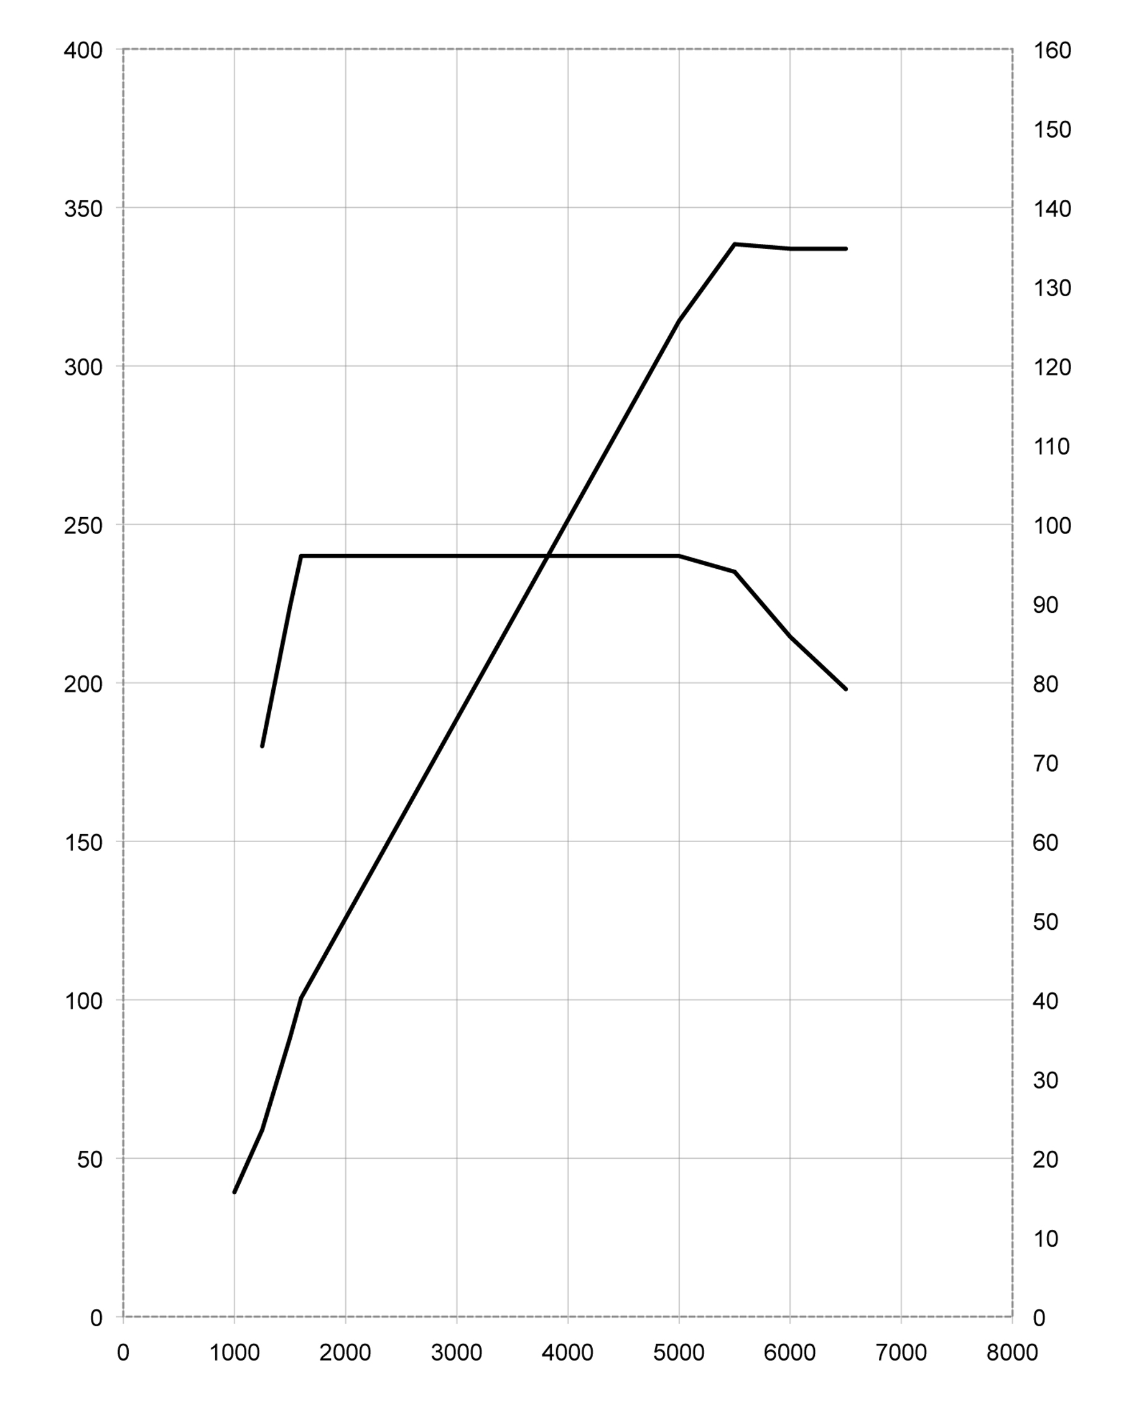
MINI Cooper S Countryman.

10. Output and torque
diagrams.

Output [kW]

Torque [Nm]
Engine speed [min⁻¹]
135 kW @ 5500 min⁻¹
240 Nm @ 1600-5000 min⁻¹

MINI Cooper Countryman.
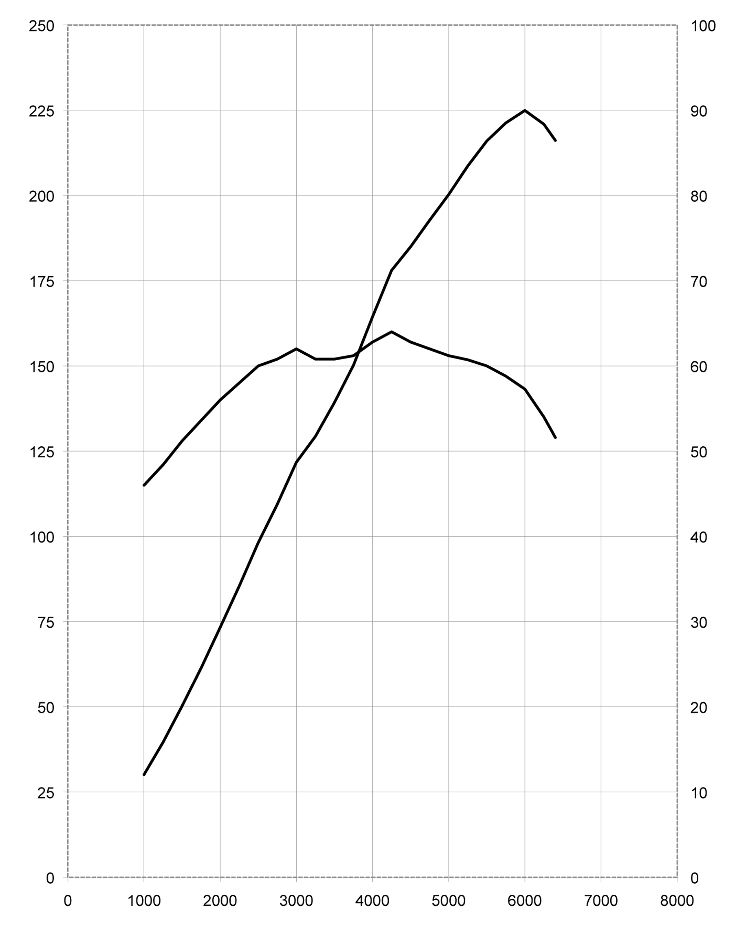
Output [kW]

Torque [Nm]
90 kW @ 6000 min⁻¹
160 Nm @ 4250 min⁻¹
Engine speed [min⁻¹]
MINI One Countryman.
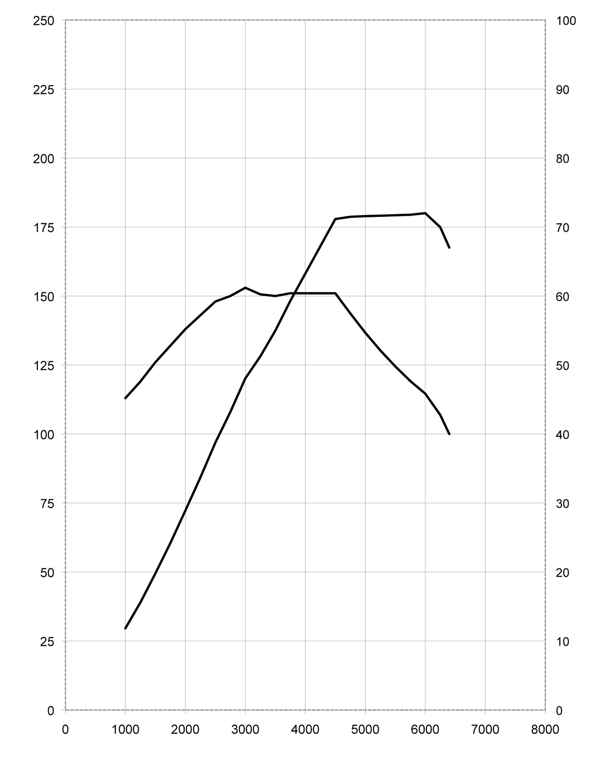
Output [kW]

Torque [Nm]
72 kW @ 6000 min⁻¹
153 Nm @ 3000 min⁻¹
Engine speed [min⁻¹]
MINI Cooper D Countryman.
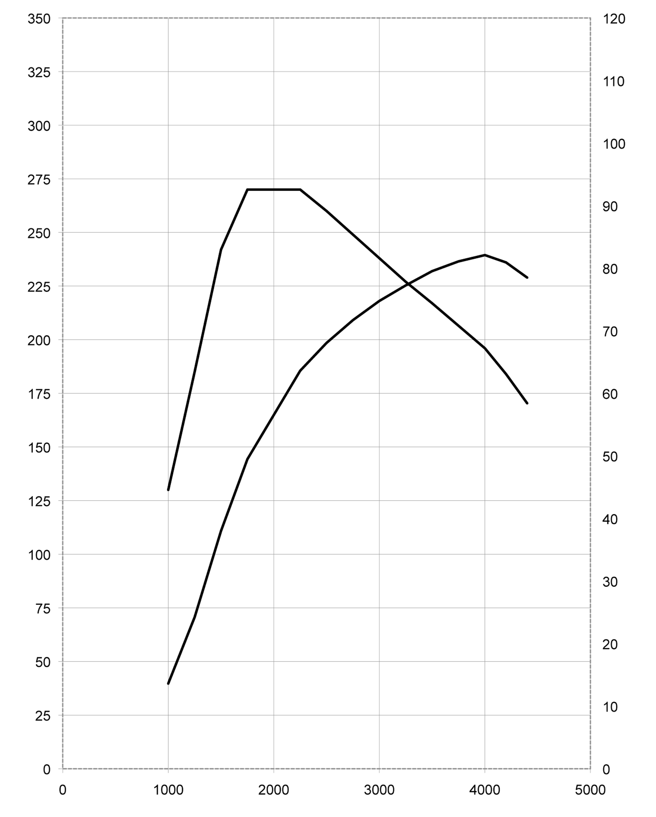
Output [kW]

Torque [Nm]
Engine speed [min⁻¹]
82 kW @ 4000 min⁻¹
270 Nm @ 1750-2250 min⁻¹
MINI One D Countryman.
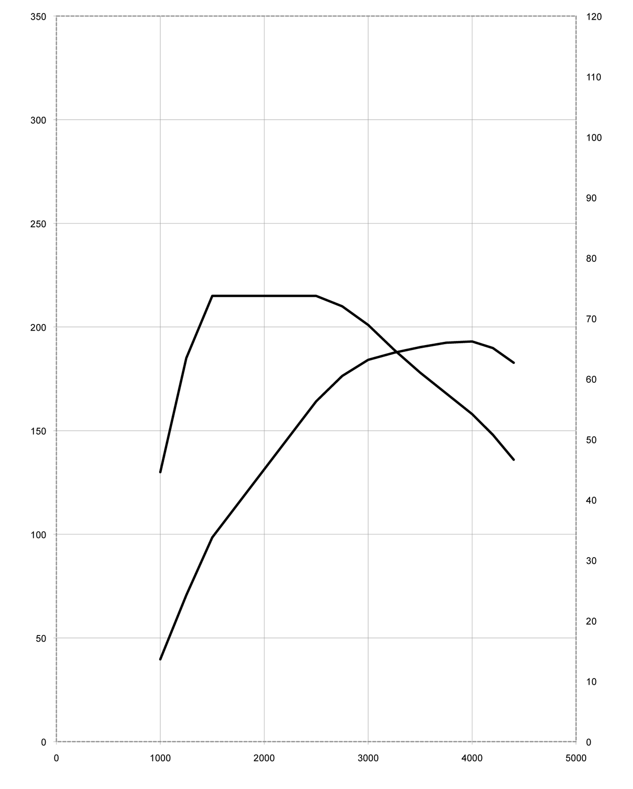
Output [kW]

Torque [Nm]
Engine speed [min⁻¹]
66 kW @ 4000 min⁻¹
215 Nm @ 1750-2500 min⁻¹
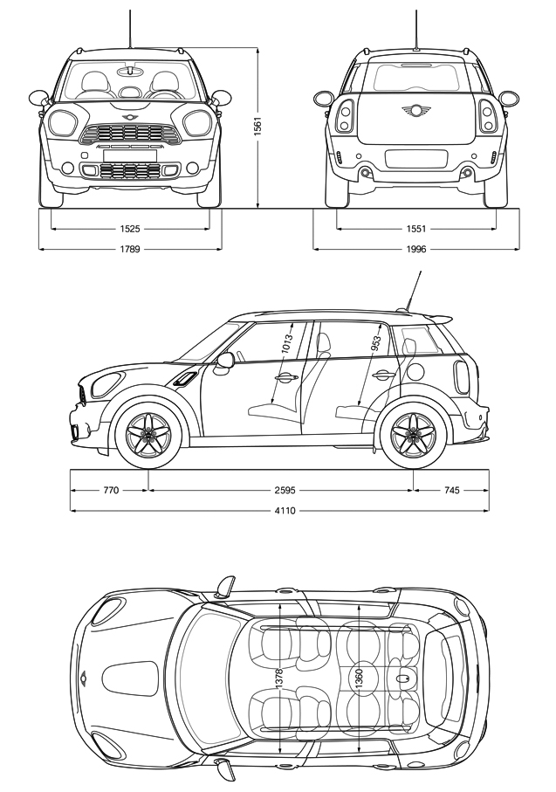
MINI Cooper S Countryman.

11. Exterior and
interior dimensions.

MINI Cooper Countryman.

