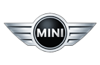The new MINI family.  
Contents.

**1. The new MINI family.**At a glance. 2

**2. Premium quality and individual style in unparalleled variety.**MINI, MINI Clubman, MINI Convertible. 5

**3. Sporty, stylish, unmistakable.**The design. 9

**4. More driving fun, less CO2.**The engines. 11

**5. Innovations for individualists.**Interior and equipment. 15

**6. A link to the future.**MINI Connected. 18

**7. Specifications.** 20

**8. Output and torque diagrams.**  40

**9. Exterior and interior dimensions.** 43

1. The new MINI family.  
At a glance.

* The MINI model family is sharpening up its act in terms of design, driving fun, efficiency and individuality. With the MINI, MINI Clubman and MINI Convertible, the only maker of independently developed premium small cars will continue to boast both the most varied and most appealing model range in the segment. Nine years after its relaunch, the inimitable essence of MINI can be seen both in the new MINI family and in the imminent arrival of the next model designed exclusively for the brand: the MINI Countryman. The new MINI family, the MINI Countryman and the further additions to the range scheduled to arrive in the near future will see MINI strengthen its position as the original premium small car maker.
* Eye-catching design modifications, additional engine variants, an all-new selection of diesel engines and innovative new equipment features give the MINI family fresh impetus to continue its history of success in the small car segment. The changes introduced for the MINI, MINI Clubman and MINI Convertible underpin both the unique premium character of the brand and the leading position in the marketplace of each individual model in terms of driving fun and efficiency. The range of typically MINI customisation options available for the cars – which are each built precisely according to customer specifications – is more appealing and extensive than ever.
* At the global market launch of the new MINI family on 18 September 2010 the range of engines for the MINI, MINI Clubman and MINI Convertible will include a brace of all-new diesel units in addition to the extensively upgraded petrol variants already available. The four-cylinder units stand out with their greater pulling power, efficiency and smoothness – qualities developed on the back of the BMW Group’s outstanding expertise in the field of engine development. Added to which, far-reaching MINIMALISM technology helps to reduce fuel consumption and emissions. The new MINI One D (66 kW/90 hp) and new MINI Cooper D (82 kW/112 hp) set a new benchmark in efficiency with average fuel consumption of 3.8 litres per 100 kilometres (74.3 mpg imp) in the EU5 test cycle and CO2 emissions of 99 g/km. The variety within the model range is broadened further by the new MINI One D Clubman and the new MINI Cooper D Convertible, the first ever open-top MINI with a diesel engine.
* The modified design of the MINI, MINI Clubman and MINI Convertible accurately showcases the increased sporting potential of the three models through a number of details. At the same time, a selection of clever touches, together with new wheel variants, paint finishes and optional extras, accentuate both the elegance and premium character of the MINI family. The new geometry of the front bumper on each model allows them to meet increasingly stringent pedestrian protection requirements even more effectively. All models come with LEDs for the rear lights, as well as the dynamic brake light function.
* Inside the cars, the newly designed controls for the audio and air conditioning systems ensure optimised functionality and ergonomics. The cutting-edge exclusivity of the interior is further underlined by extremely harmonious colours and high-quality materials. The model-specific selection of seat upholstery, trim elements and Colour Lines has also been extensively updated.
* An array of new exterior paint finishes and wheel designs is available for the MINI, MINI Clubman and MINI Convertible to complement their refreshed styling. Chili Red is now available – exclusively for the MINI John Cooper Works and MINI John Cooper Works Clubman – as a contrast colour for the roof and exterior mirror caps. Meanwhile, three “design worlds” – Rally, Classic and Scene – have been introduced to underpin configurations tailored to the customer’s personal style. Each comprises a carefully coordinated combination of body paint finish, roof colour, wheel design, upholstery, trim elements, Colour Line and other visual features. The design worlds represent a recommendation from the MINI design team and lend the car an extremely coherent character. Additional – and almost limitless – customisation can be achieved by varying the individual components of each design world and by adding further equipment items and accessories to the mix.
* All models come with innovative equipment features aimed at enhancing comfort, safety and the trademark MINI personality. For example, the optional xenon headlights can be ordered with black headlight reflectors or the Adaptive Headlights function, while an automatic dimming function is available for both the rear-view and exterior mirrors, and the optional ambient lighting uses a trio of LEDs to provide a broad spectrum of colour. The MINI Clubman is now fitted with a new retractable roller-type luggage compartment cover.
* The new audio and navigation systems and the integration devices for external music players and mobile phones both offer top-class entertainment and communications capability. All the radio systems come with an MP3-compatible CD player and an AUX IN connection, while the MINI Visual Boost radio and MINI navigation system team up with a high-resolution colour display in the Centre Speedo and a Bluetooth hands-free system complete with USB audio interface. If the customer has ordered their car with the Bluetooth mobile phone preparation including USB interface, both systems can be hooked up with compatible mobile devices to allow functions such as audio streaming via Bluetooth, album cover artwork display and innovative office functions. Plus, the MINI Visual Boost radio and MINI navigation system also give owners access to MINI Connected. The application available for this globally unique form of in-car entertainment includes a web radio function, the use of Google local search and Google Send to Car services, and reception of RSS news feeds. Moreover, it also enables Facebook and Twitter posts to be displayed on the on-board monitor and allows the user to send standardised text messages.

2. Premium quality   
 and individual style   
 in unparalleled variety.  
 MINI, MINI Clubman, MINI Convertible.

Striking design modifications, an updated range of engines and a selection of additional innovative equipment items give the MINI family new impetus as it sets about writing a dynamic new chapter in its history of success. The MINI, MINI Clubman and MINI Convertible all enjoy the benefits of a host of new features which emphasise even more powerfully their characteristic personality, high level of quality, unmistakable driving fun and exceptional efficiency. And this, in turn, further enhances the appeal of this unparalleled range of premium models in the small car segment.

The new MINI family showcases the brand’s hallmark charisma across an even greater variety of model variants. The MINI will be available powered by petrol engines with four different outputs or a pair of diesel units, the MINI Clubman range comprises three petrol engines and now also two diesel variants, and the MINI Convertible can be specified with one of three petrol units or the new diesel option. In addition, customers may also be tempted by the extremely sporty MINI John Cooper Works, MINI John Cooper Works Clubman and MINI John Cooper Works Convertible models. Launched under the John Cooper Works badge denoting outstanding performance, these elite sporting machines ensure that the MINI model range is without parallel worldwide, both in its breadth and in terms of ultimate ability.

Whichever body variant and engine the customer chooses, all MINI models share distinctive characteristics born out of the origins and tradition of the brand, a concept geared towards delivering maximum driving fun, an appreciation of individual style and a commitment to premium quality. Expressive design incorporating the contemporary interpretation of historical features, agility commonly described as a “go-kart” feeling, an unmatched variety of customisation options and an exceptional level of technology and workmanship lift the MINI, MINI Clubman and MINI Convertible head and shoulders above the competition.

The original: stand-out concept is the key to giving MINI its unmistakable identity.

The compelling aura of the MINI, however, is rooted in a truly original concept. Although it is part of the BMW Group, the MINI brand benefits from a considerable degree of autonomy, which is expressed as much through its design as in its drive concept, variety of equipment options and the target groups identified in the development of additional models and variants. Every model built by the brand is conceived and produced exclusively as a MINI. This is a recipe for cars defined by a distinctive and credible, not to mention exclusive, character. Every model is therefore very much an original – displaying a wealth of attributes only a MINI can offer.

As the world’s first maker of premium small cars, MINI broke new ground when the brand was relaunched in 2001. The strategy of combining advanced drive and chassis technology, uncompromising quality and an individual style in cars in this segment immediately earned MINI its own niche in the world’s car markets. With its innovative profile, MINI won over a trend-conscious target group of customers who also shared an appreciation of quality. Over 1.7 million MINI models have been sold since 2001, highlighting the dynamic growth in this newly established market segment.

Character with a history – unique for more than 50 years.

In addition to the variety of models and the product quality of the MINI, the car’s historical roots also play a significant role in its popularity. The new MINI family builds on a tradition which now stretches back more than 50 years, and the history of the brand exudes an extraordinarily powerful allure.

Few other vehicles have had such a sustained impact on automotive development as the classic Mini presented in 1959. A rigorous commitment to the efficient use of space and the innovative arrangement of the drive components spawned a small car concept that was revolutionary at the time and is still considered pioneering today. As well as the practical and economic virtues of the compact four-seater, its agile handling also helped the classic Mini to attain legendary status not only in its native Britain, but around the world.

Fast-forward to the 21st century and MINI remains a maker of classless and globally successful cars. Indeed, the brand’s current crop of models also retain significant links with their forebears in terms of design. The principle adhered to in the development of the classic Mini – of creating maximum interior space and functionality within exceptionally small exterior dimensions – also underpins the brand’s present line-up.

Front-wheel drive, engines mounted transversely at the front, short body overhangs and a low centre of gravity helped to give the classic Mini its distinctive character. And, along with the distinctive design features reflected in both the proportions of the cars and a number of details, these elements of the original car’s construction remain – in a reinterpreted, updated form – today. This allows the MINI, similarly to the classic Mini in its day, to raise the bar in terms of advanced drive and chassis technology, combined with state-of-the-art active and passive safety elements. MINI therefore remains faithful to both the traditional values of the brand and the requirements of a modern car in terms of space, performance and safety.

Customisation on a premium level: MINI as an expression of personality.

MINI sets the benchmark in the small car segment and beyond with the unsurpassed variety of customisation options available for its models. Driving a MINI is not only about enjoying the journey but also expressing your own personal style. The MINI enables far-reaching scope for customisation, giving customers enviable freedom to express their personal preferences. MINI offers its customers a more extensive and detailed range of options than any other manufacturer when it comes to kitting out their car in their own image. The unusually large selection of exterior paint finishes, roof/soft-top colours, interior colours, seat covers and trim variants form the basis for each custom-made design.

A host of attractive and high-quality options available ex-factory for the MINI, MINI Clubman and MINI Convertible help to further enhance both driving fun and comfort. The range of Original MINI Accessories, meanwhile, includes everything from classic racing technology – in the form of John Cooper Works components, roof carrier systems and auxiliary headlights – to handy features for everyday needs and rather more off-the-wall elements, such as extravagant roof trim, mirror caps, door handles and side indicator surrounds.

Global popularity, sustained growth: a new chapter in the MINI success story.

Another ingredient in the identity of the brand is its British origins. All the members of the new MINI family are built at the MINI plant in Oxford. Multiple expansion programmes have allowed production capacity to keep pace with growing demand. Today, MINI cars are exported from Oxford to more than 80 countries. The USA has become the biggest single market for premium small cars, with Great Britain and Germany following in second and third places in the sales figures. And, more recently the brand has seen an extremely dynamic growth in demand in China, in particular.

Credit for the steady increase in sales figures must also go to the brand’s rigorously pursued model strategy. In 2004 the classic two-door model was joined by the MINI Convertible in the range. Then, in 2007, the MINI Clubman arrived on the scene with its longer wheelbase and an all-new space concept. The hallmark MINI driving fun had now been combined with additional day-to-day practicality.

The three body variants of the current MINI family already give the brand a broader-based model line-up than any of its competitors. Yet the growth potential of MINI is far from exhausted. Indeed, in autumn 2010 the MINI Countryman will see a five-door MINI measuring more than four metres in length set out onto the world’s roads – and, thanks to the optional all-wheel- drive system, off them as well – for the first time. The Countryman paves the way for the brand’s trademark driving fun to be experienced beyond the boundaries of urban mobility as well, and is therefore geared to the requirements of a larger and evolving target group. Added to which, the MINI Concept Coupé and MINI Roadster Concept studies presented at the 2009 International Motor Show in Frankfurt have offered a preview of further variants, the first of which will be ready for series production as early as 2011.

3. Sporty, stylish, unmistakable.  
The design.

The precision-modified design of the MINI, MINI Clubman and MINI Convertible accurately showcases the three models’ enhanced sporting potential. A new geometry for the front bumper allows them to meet increasingly stringent pedestrian protection requirements even more effectively. The new details merge in subtly with the overall appearance of the new models. The designers went to great lengths with the three-dimensional sculpting of the newly designed body elements to ensure that the customary MINI proportions, including its short overhangs, were kept intact.

Eye-catching air intakes underline the car’s sporting character.

The modifications in the lower section of the front apron are considerably more prominent. Here, the borders of the positioning light units and foglamps now have more pronounced three-dimensional contours. The lower air intake on all the model variants is also given greater visual emphasis. On the MINI One and MINI Cooper, a black cross-piece accentuates the width of the car, while outer air intakes (optionally with chrome frames) on the MINI Cooper S guide cool air to the brake discs and add an extra edge to the sporting appearance of this model variant.

The hallmark MINI circular headlights are halogen units as standard but can be ordered with xenon light – and the Adaptive Headlights function – as an option. Black headlight reflectors, which were first featured in the MINI 50 Camden anniversary model, are available as an option for all models, with the exception of the MINI John Cooper Works.

Looking at the car from the side, the new design of the familiar MINI side indicator surrounds between the front side panel and the door provides an extra, finely-judged touch of elegance. The glass cover of the indicators now has a striking structure formed from concentric circles. On the MINI One and MINI Cooper, the combination of shiny and matt black surfaces gives the surround an extremely high-quality appearance.

Rear lights with LED technology, dynamic brake lights.

LEDs optimise both the signalling efficiency and contemporary appearance of the rear lights on all members of the new MINI family. Standard-fitted dynamic brake lights flash to warn vehicles following behind if the MINI is braking particularly hard and prompts them to follow suit. This advanced light technology also lends the MINI models a very distinctive look during the hours of darkness. Other new features include the reversing lights and rear foglamps, now located in the lower section of the rear bumper. On the MINI One and MINI Cooper these are housed in a centrally positioned and harmoniously styled red strip of lights. An additional light-breaking edge in the bumper emphasises the horizontal arrangement – and thus the broadness – of the rear of both models. In the rear bumper of the MINI Cooper S is an outlet opening whose width and contours take their lead from the design of the front air intake. The reversing lights and rear foglamps are integrated into the outer areas of the rear of the car, reflecting the positioning of the brake air ducts at the front.

The powerful lines of the rear end of the MINI One Clubman and MINI Cooper Clubman are emphasised by the broader impact elements on either side of the licence plate recess. The rear bumper of the MINI Cooper S Clubman has a wide opening between the two exhaust tailpipes which replicates the form of an air outlet.

Attractive new additions to the range of exterior paint finishes and standard and optional wheel variants offer customers additional scope for personalising their new car. The new metallic paint finishes British Racing Green II, Spice Orange and – for the MINI Cooper S – Eclipse Grey can be specified from launch. Ice Blue will be available at a later stage.

Extreme sports performance, exclusive design:   
MINI John Cooper Works.

Chili Red can now be specified exclusively for the MINI John Cooper Works and MINI John Cooper Works Clubman as a contrast colour for the roof and exterior mirror caps, and can be combined with the Pepper White, Pure Silver, Midnight Black, British Racing Green and Eclipse Grey paint finishes for the body. And to complement the effect, the standard-fitted 17-inch light-alloy wheels in Cross Spoke Challenge design can also be specified in black as an option.

4. More driving fun, less CO2.  
The engines.

99 grams per kilometre – that is how little CO2 is emitted by both the new MINI One D and new MINI Cooper D, as the impact of MINIMALISM reaches a whole new level. This eye-catching emissions figure is accompanied by average fuel consumption for the two models of 3.8 litres per 100 km (74.3 mpg imp) in the EU test cycle. Never has a MINI achieved such impressive economy.

This latest reduction in fuel consumption is one benefit of the new generation of four-cylinder diesel engines and extensive application of MINIMALISM technology. The other is a further increase in driving fun. In the new MINI Cooper D the optimised economy and emissions figures combine with output boosted to 82 kW/112 hp, and the new MINI One D (66 kW/90 hp) also offers a noticeable increase in torque.

The new diesel engines will also be available in two other model variants from the market launch of the new MINI family. The new MINI Cooper D Convertible now allows the torque and efficiency of a diesel engine to be enjoyed with the roof down as well, while the MINI One D Clubman is the new entry-level diesel variant of this extremely versatile model variant.

The new four-cylinder diesel engines join the extensively further developed petrol engines already in the line-up. The spread of outputs covered by the MINI family ranges from 55 kW/75 hp in the MINI One to 135 kW/184 hp in the MINI Cooper S.

New diesel engines: increased pulling power, CO2 emissions cut to 99 g/km.

A new generation of turbo-diesel engines enables the members of the MINI family to build further on their already outstanding position as far as efficiency is concerned. The 1.6-litre four-cylinder units embody the superlative level of development expertise within the BMW Group. Their combustion chambers have the same optimum ratio between bore and stroke as the 2.0-litre engines fitted in BMW cars, with a specially designed engine housing and likewise made-to-measure cylinder head making the transversely mounted units the perfect fit for the MINI models. The engines boast common-rail direct injection and a turbocharger with variable turbine geometry, which provides precisely-judged power development throughout the rev range. The new units benefit from a programme of substantial optimisation over the engines they replace – improving both responsiveness and efficiency. Their aluminium construction makes them extremely lightweight, and they also break new ground in the small car segment in terms of engine acoustics.

Both the MINI Cooper D and MINI One D are fitted with a diesel particulate filter and oxidation catalytic converter. These are accommodated within the same housing, are maintenance-free, go about their business so unobtrusively that the driver would not know they were there, and do not require any additional assistance to do their jobs. Like all MINI models, the new turbo-diesel variants also meet the EU5 emissions standard.

The potential of the new turbo-diesel concept in the MINI Cooper D is particularly impressive. Maximum output of 82 kW/112 hp at 4,000 rpm and peak torque of 270 Nm (199 lb-ft) between 1,750 and 2,250 rpm are a recipe for instantaneous responses and impressive power development. The dash from 0 to 100 km/h (62 mph) takes a mere 9.7 seconds on the way to a top speed of 197 km/h (122 mph). The new MINI Cooper D boasts average fuel consumption in the EU5 test cycle of 3.8 litres per 100 km (74.3 mpg imp) and achieves a new best CO2 emissions mark of 99 g per km.

MINI Clubman and MINI Convertible also set new benchmarks in efficiency.

The more powerful of the two turbo-diesel engines in the new MINI Cooper D Clubman generates acceleration of 0 to 100 km/h (62 mph) in 10.2 seconds and a top speed of 197 km/h (122 mph). The average fuel consumption of this model in the EU test cycle has been reduced to 3.9 litres per 100 km (72.4 mpg imp), combined with CO2 emissions of 103 g per km.

The launch of the new MINI family also sees the debut of diesel technology in the brand’s open-top variant. The MINI Cooper D Convertible blends the outstanding efficiency of the new turbo-diesel with a still unmatched level of top-down driving pleasure in the small car segment. The MINI Cooper D Convertible accelerates from a standstill to 100 km/h (62 mph) in 10.3 seconds and is capable of a 194 km/h (121 mph) top speed. The sporting credentials of the new model variant are complemented by average fuel consumption of 4.0 litres per 100 km (70.6 mpg imp) in the EU test cycle and CO2 emissions of 105 g per km.

MINI One D: a new engine and now two model variants.

Impressive torque available low down the rev range and exceptionally high fuel economy are also defining characteristics of the entry-level diesel model in the MINI family. The turbo-diesel unit powering the MINI One D develops 66 kW/90 hp at 4,000 rpm and places maximum torque of 215 Nm (159 lb-ft) on tap from between just 1,750 and 2,500 rpm. The MINI One D completes the sprint from 0 to 100 km/h (62 mph) in 11.4 seconds on the way to a top speed of 184 km/h (114 mph). This model brings together improved performance figures over its predecessor with likewise optimised efficiency. Its average fuel consumption in the EU test cycle also comes in at just 3.8 litres per 100 km (74.3 mpg imp), and CO2 emissions are pinned to the new low of 99 g per km.

The new entry-level diesel engine is also available for the MINI Clubman. This model variant accelerates from 0 to 100 km/h (62 mph) in 11.8 seconds and reaches a top speed of 182 km/h (mph). The average fuel consumption of the MINI One D Clubman in the EU test cycle is 3.9 litres per 100 km (72.4 mpg imp), with CO2 emissions recorded at 103 g per km.

Building on the impressive efficiency of the new diesel engines, MINIMALISM measures also make their contribution to further reducing fuel consumption and emissions. For example, the engineers’ focus on aerodynamic optimisation has seen the front aprons of both models redesigned to reduce drag. MINIMALISM technology is grouped into model-specific combinations, and includes systems such as Brake Energy Regeneration, the Auto Start/Stop function, Shift Point Display, electromechanical power steering (EPS) and the need-based operation of ancillary components. A standard six-speed manual gearbox channels the engine power to the wheels. Both models come with a new, self-adjusting clutch. Automatic readjustment ensures that the pedal feel you expect from a MINI is there to be enjoyed over the car’s full service life. Plus, the synchronisation of the gears is further optimised by a carbon coating for the clutch linings.

Sporting capability, efficiency and variety: the range of petrol engines for the new MINI family.

Cutting-edge drive system technology boasting exceptional variety headlines the range of petrol engines for the new MINI family. The 1.6-litre four-cylinder units also boast a host of technical features whose development is rooted in the outstanding wealth of engine expertise within the BMW Group. The output spread of the new generation of engines – introduced in spring 2010 – ranges from 55 kW/75 hp or 72 kW/98 hp in the MINI One to the 90 kW/122 hp of the MINI Cooper and the 135 kW/184 hp under the bonnet of the MINI Cooper S.

All the petrol engines are equipped with fully variable valve management, which is based on the VALVETRONIC system used in BMW engines. This technology optimises the engine’s responses and at the same time significantly reduces fuel consumption and emissions levels. In the MINI Cooper S, MINI Cooper S Clubman and MINI Cooper S Convertible it joins forces with petrol direct injection and a twin-scroll turbocharger, making the engine the most efficient in its displacement class. In the MINI Cooper S it delivers acceleration of 0 to 100 km/h (62 mph) in 7.0 seconds yet gives average fuel consumption in the EU test cycle of just 5.8 litres per 100 km (48.7 mpg imp) and limits CO2 emissions to 136 g per km.

The MINI One MINIMALIST, available in two variants, has the lowest fuel consumption and emissions of all the petrol-engine models. It can be ordered with output of either 55 kW/75 hp or 72 kW/98 hp, both options claiming average fuel consumption of 5.1 litres per 100 km (55.4 mpg imp) and CO2 emissions of 119 g per km.

Alongside the MINIMALISM technology, all the models in the new MINI family now also boast thermal encapsulation of the entire drivetrain. This addition optimises heat storage between one journey and the next in order to minimise the friction losses in the drive unit which occur as the engine temperature falls. Moreover, fuel consumption from cold starts is reduced by a significant shortening of the warm-up period. The thermal encapsulation measures comprise insulation elements around the bonnet, firewall and side sections, and an all-round rubber seal. They also promote aerodynamic optimisation, which in turn also helps to enhance efficiency. The improved use of heat has benefits for passenger comfort as well; in colder outside temperatures the stored heat can be used effectively to quickly warm up the interior of the car.

5. Innovations for individualists.   
 Interior and equipment.

Every MINI represents an expression of personal style. The key here are a variety of options for customising the MINI, MINI Clubman and MINI Convertible unmatched by the brand’s competitors. The launch of the new MINI family will add further to the scope for personalised configuration. The selection of seat upholstery variants, trim elements and Colour Lines has been updated and expanded. And the range of exterior paint finishes and wheel designs also sets new trends. The Rally, Classic and Scene “design worlds” serve as pointers to help customers put together an appealingly harmonious combination of these features.

All members of the new MINI family boast a further increase in build quality and a refined interior style. High-quality materials and neatly coordinated colours define the contemporary yet exclusive feel inside all the models. The newly designed controls for the audio system and air conditioning ensure optimised functionality and ergonomics, while the innovative character of the premium small car is underlined by a host of optional extras unrivalled in its segment. MINI also takes the lead when it comes to the standard and optional radio and navigation systems available and the possibilities for integrating mobile phones and music players into the car’s control system.

Design worlds help to achieve detailed customisation.

The range of seat upholstery, interior colours, trim elements and Colour Lines for all other models of the new MINI family has also been extensively revised. Among the newly introduced options are the Cross Check cloth/leather combination, the interior colour Polar Beige, trim elements in Striped Alloy, Black Checkered and Pepper White, and the Satellite Grey and Toffy Colour Lines. Depending on the model, the Gravity Leather and Lounge Leather seat variants can now also be specified in colours including Polar Beige, Satellite Grey and Classic Green.

The selection of available colours and materials is set out on a model-specific basis. What’s more, the Rally, Classic and Scene “design worlds” have been introduced for the first time as a basis for creating a configuration of the MINI, MINI Clubman and MINI Convertible which fits the owner’s personal style. Each of these design worlds comprises a carefully coordinated combination of body paint finish, roof colour, wheel design, interior colour, upholstery, trim elements, Colour Line and other visual details. They represent a recommendation by the MINI design team and lend each car an extremely coherent character. In customary MINI style, additional – and almost limitless – customisation can be achieved by varying the individual components of each design world and adding further items from the extensive range of equipment and accessories.

All the models in the new MINI family come as standard with a wealth of interior features which underline their high level of quality even more strikingly than before, as well as ensuring optimised functionality. The distinctive design of the cockpit, all the controls and the door and side trim exudes cutting-edge exclusivity, a virtue now accentuated further by an extremely harmonious colour scheme and high-quality materials. All of the buttons and switches (and their surrounds) on the centre console below the Centre Speedo are now black, as are the controls and framing of the audio system display. The air conditioning controls are bordered by a chrome ring, and another chrome highlight can be found in the steering wheel. The keypads of the optional multifunction steering wheel are also in black.

MINI John Cooper Works: new interior variants with eye-catching colour combinations.

The interior of the MINI John Cooper Works, MINI John Cooper Works Clubman and MINI John Cooper Works Convertible extreme sports models, which are powered by a 155 kW/211 hp four-cylinder engine, are kitted out with black sports seats featuring contrasting red stitching and trim elements in Chili Red. The steering wheel rim, the gearshift lever and handbrake lever gaiters also have contrasting red stitching. Another exclusive option available for the MINI John Cooper Works, MINI John Cooper Works Clubman and MINI John Cooper Works Convertible are Lounge Leather seats with red piping. The instruments of these three model variants are fitted as standard with anthracite-coloured dials. These three elite sports models now also feature the MINI Boost radio and front foglamps as standard.

MINI premiere: Adaptive Headlights.

All models can be ordered with a selection of innovative equipment features to enhance comfort, safety and the familiar MINI personality. Adaptive Headlights are available for the first time for a MINI in conjunction with the optional xenon lights. This technology allows the headlights to follow the line of upcoming corners to ensure illumination of the road surface. The steering angle, yaw rate and speed of the car are all taken into account in determining the beam angle of the headlights. In addition, customers can now specify an automatic dimming function not only for the rear-view mirror but for the exterior mirrors as well.

The optional ambient lighting uses three LEDs to provide an extremely broad spectrum of colour covering a total of 756 possible shades. This allows the lighting in the interior to be adjusted even more widely. The MINI Clubman is fitted with a new retractable roller-type luggage compartment cover. Added to which, the belt guide for the right-side front seat has been optimised to make it easier for rear passengers to get in and out through the rear-hinged Clubdoor.

First-class entertainment and communications.

The new audio and navigation systems and optional integration platforms for external music players and mobile phones all offer top-class entertainment and communications capability. All the radio systems include an MP3-compatible CD player and AUX IN connection to hook up external music players with the on-board audio system. Even the standard-fitted MINI CD radio comes with six loudspeakers. The optional MINI Boost CD radio boasts newly designed controls, and the radio’s volume control and station selector are now positioned at the same level.

The MINI Visual Boost radio and MINI navigation system come with a 6.5-inch high-resolution display in the Centre Speedo and a Bluetooth hands-free facility with USB audio interface. The maps for the MINI navigation systems are stored on an on-board Flash memory device and can be updated via a USB interface. The map display can be viewed in a day mode and a night mode.

In conjunction with the Bluetooth mobile phone preparation with USB audio interface, which also includes a snap-in adapter in the centre console with charging function and a roof aerial, both the MINI Visual Boost radio and MINI navigation system allow the use of add-on functions supported by a connected mobile device. These include audio streaming via Bluetooth, album cover artwork display on the on-board monitor and innovative office functions. For example, caller lists stored on a mobile phone and business cards from contacts can be viewed on the on-board monitor. In addition, the optional voice output function allows calendar entries recorded in a smartphone to be read out.

6. A link to the future.  
 MINI Connected.

The new selection of standard and optional radio systems in the MINI, MINI Clubman and MINI Convertible give customers everything they need to enjoy music just the way they want it. Both the standard MINI CD radio and optional MINI Boost CD radio allow external music sources to be hooked up to the car’s own audio system via an AUX IN connection. A USB audio interface is supplied with the optional MINI Visual Boost radio and MINI navigation system. These systems also come with the Bluetooth hands-free facility for making telephone calls safely while on the move.

Both systems enable even more extensive integration of mobile devices in conjunction with the Bluetooth mobile phone preparation, which also includes a USB audio interface, a snap-in adapter for the centre console and a roof aerial. The phone and music player functions are operated in customary MINI style using a joystick on the centre console and the colour display in the Centre Speedo. The same goes for audio streaming via Bluetooth, displaying album cover artwork on the on-board monitor and using innovative office functions, provided these are supported by the connected device.

Both the MINI Visual Boost radio and MINI navigation system allow access to MINI Connected. This development opens the door to a globally unique form of in-car entertainment, using new technology specially developed for the MINI to integrate the telecommunications, entertainment and online functions of smartphones into the car. MINI-specific functions can be integrated using a MINI Connected software application and operated using the joystick, steering wheel buttons and on-board monitor. Using the familiar MINI display and operating logic, MINI Connected allows all functions to be used comfortably, simply, safely and intuitively with minimal distraction from the road ahead. The mobile phone is hooked up to the car either via a cable supplied with MINI Connected for the USB socket or via a snap-in adapter.

Added future-proofing with MINI-specific apps.

Exclusive MINI technology for the integration of smartphones forms the basis for extensive update and add-on options. The functional repertoire of MINI Connected can be extended easily by dipping into a selection of applications. This will allow MINI Connected customers to continue to benefit from technical advances and creative developments in the field of in-car entertainment into the future.

The application for MINI Connected, a full version of which will be available from the fourth quarter of 2010, includes a web radio function to allow users to pick up their preferred radio stations regardless of their location. The station database available through the application contains thousands of radio stations whose programmes can be accessed online. The other functions of MINI Connected – such as access to the Google local search and Google Send to Car functions and reception of user-definable RSS news feeds, the content of which is displayed on the on-board monitor and can be read out using the optional voice output function – are also unique in the small car segment.

Always in touch: send and receive Facebook and Twitter posts inside the car.

In addition, this application gives MINI owners the platform to receive Facebook and Twitter posts in their car, view them on the on-board monitor and use MINI Connected voice output to have them read out. Plus, standardised text messages can be sent out directly from the car via both services. This function enables MINI drivers to warn each other about traffic congestion or other problems on the road, for example.

Another exclusive MINI innovation is the Dynamic Music function included in the MINI Connected application. This comprises a selection of exclusively composed music which can be played on the audio system of the MINI and whose rhythm and dynamics change according to the driving style. This function allows MINI drivers to use their accelerator and steering wheel to create their own personal soundtrack to that trademark “go-kart” feeling.

7. Specifications.   
MINI One (55 kW) MINIMALIST.

|  |  |  |  |  |  |  |  |
| --- | --- | --- | --- | --- | --- | --- | --- |
| **Body** | |  | **MINI One (55 kW) MINIMALIST** | | |  | |
| No of doors/seats | |  | 3 / 4 | | |  | |
| Length/width/height (unladen) | | mm | 3723 / 1683 / 1407 | | |  | |
| Wheelbase | | mm | 2467 | | |  | |
| Track, front/rear | | mm | 1459 / 1467 | | |  | |
| Turning circle | | m | 10.7 | | |  | |
| Tank capacity | | ca. l | 40 | | |  | |
| Cooling system incl. heater | | l | 5.2 | | |  | |
| Engine oil | | l | 4.2 | | |  | |
| Transmission oil incl. drive train | | l | Lifetime | | |  | |
| Weight, unladen to DIN/EU1 | | kg | 1070 / 1145 | | |  | |
| Max load to DIN | | kg | 450 | | |  | |
| Max permissible load to DIN | | kg | 1520 | | |  | |
| Max axle load, front/rear | | kg | 815 / 730 | | |  | |
| Max trailer load2 | |  |  | | |  | |
| braked (12 %) / unbraked | | kg | – / – | | |  | |
| Max roofload/max download | | kg | 75 / – | | |  | |
| Luggage comp to DIN | | l | 160–680 | | |  | |
| Air drag cx / A / cx × A | | – / m2 / m2 | 0.32 / 1.99 / 0.64 | | |  | |
| **Engine** | |  |  | | |  | |
| Config/No of cyls/valves | |  | Inline/ 4/ 4 | | |  | |
| Engine management | |  | MEV 17.2.2 | | |  | |
| Capacity | | cm³ | 1598 | | |  | |
| Bore/stroke | | mm | 77 / 85.8 | | |  | |
| Compression ratio | | :1 | 11:1 | | |  | |
| Fuel grade | | ROZ | 91–98 | | |  | |
| Max output | | kW/PS | 55 / 75 | | |  | |
| at | | min–1 | 6000 | | |  | |
| Max torque | | Nm | 140 | | |  | |
| at | | min–1 | 2250 | | |  | |
| **Electrical System** | |  |  | | |  | |
| Battery/installation | | Ah / – | 55 / Engine compartment | | |  | |
| Alternator | | A | 120 | | |  | |
| **Chassis** | |  |  | | |  | |
| Suspension, front | | Single-joint MacPherson spring strut axle with anti-dive control | | | | | |
| Suspension, rear | | Multi-link axle with aluminium longitudinal struts and centrally-pivoted control arms | | | | | |
| Front brakes | |  | Vented disc | | |  | |
| Diameter | | mm | 280 × 22 | | |  | |
| Rear brakes | |  | Disc | | |  | |
| Diameter | | mm | 259 × 10 | | |  | |
| Driving stability systems | | Hydraulic two-circuit brake system with anti-lock brakes (ABS), Electronic Brake Force Distribution (EBD) and Cornering Brake Control (CBC), ASC+T traction control, Dynamic Stability Control (DSC) with Brake Assist and Hill Start Assistant, optional: Dynamic Traction Control (DTC) and Electronic Differential Lock Control (EDLC). Parking brake acts mechanically on rear wheels | | | | | |
| Steering | | Electric power steering (EPS); 2.4 rotations in total | | | | | |
| Steering transmission, overall | | :1 | 14.1 | | |  | |
| Tyres | |  | 175 / 65 R15 84H | | |  | |
| Wheels | |  | 5.5J × 15 St | | |  | |
| **Transmission** |  | | |  |  | |  |
| Type of gearbox | |  | 6-gear manual transmission | | |  | |
| Gear ratios I | | :1 | 3.214 | | |  | |
| II | | :1 | 1.792 | | |  | |
| III | | :1 | 1.194 | | |  | |
| IV | | :1 | 0.914 | | |  | |
| V | | :1 | 0.784 | | |  | |
| VI | | :1 | 0.683 | | |  | |
| Reverse gear | | :1 | 3.143 | | |  | |
| Final drive ratio | | :1 | 3.706 | | |  | |
| **Performance** | |  |  | | |  | |
| Power-to-weight ratio to DIN | | kg/kW | 19.5 | | |  | |
| Output per litre | | kW/l | 34.4 | | |  | |
| Acceleration 0–100 km/h | | s | 13.2 | | |  | |
| 0–1000 m | | s | 35.0 | | |  | |
| In 4th/5th gear 80–120 km/h | | s | 13.5 / 16.7 | | |  | |
| Top speed | | km/h | 175 | | |  | |
| **Fuel Consumption in EU Cycle** | |  |  | | |  | |
| Urban | | l/100 km | 6.5 | | |  | |
| Extra-urban | | l/100 km | 4.3 | | |  | |
| Composite | | l/100 km | 5.1 | | |  | |
| CO2 | | g/km | 119 | | |  | |
| **Miscellaneous** | |  |  | | |  | |
| Emission rating | |  | EU5 | | |  | |
| Insurance ratings Germany | | HPF/VK/TK | 14 / 16 / 19 | | |  | |
| Ground clearance | | mm | 139 | | |  | |

1 Weight of the car in road trim (DIN) plus 75 kg for driver and luggage.  
2 Deviations are possible under certain circumstances.

Specifications.  
MINI One 55 kW.

|  |  |  |  |  |  |  |  |
| --- | --- | --- | --- | --- | --- | --- | --- |
| **Body** | |  | **MINI One (55 kW)** | | |  | |
| No of doors/seats | |  | 3 / 4 | | |  | |
| Length/width/height (unladen) | | mm | 3723 / 1683 / 1407 | | |  | |
| Wheelbase | | mm | 2467 | | |  | |
| Track, front/rear | | mm | 1459 / 1467 | | |  | |
| Turning circle | | m | 10.7 | | |  | |
| Tank capacity | | ca. l | 40 | | |  | |
| Cooling system incl. heater | | l | 5.2 | | |  | |
| Engine oil | | l | 4.2 | | |  | |
| Transmission oil incl. drive train | | l | Lifetime | | |  | |
| Weight, unladen to DIN/EU1 | | kg | 1070 / 1145 | | |  | |
| Max load to DIN | | kg | 450 | | |  | |
| Max permissible load to DIN | | kg | 1520 | | |  | |
| Max axle load, front/rear | | kg | 815 / 730 | | |  | |
| Max trailer load2 | |  |  | | |  | |
| braked (12 %) / unbraked | | kg | – / – | | |  | |
| Max roofload/max download | | kg | 75 / – | | |  | |
| Luggage comp to DIN | | l | 160–680 | | |  | |
| Air drag cx / A / cx × A | | – / m2 / m2 | 0.32 / 1.99 / 0.64 | | |  | |
| **Engine** | |  |  | | |  | |
| Config/No of cyls/valves | |  | Inline/ 4/ 4 | | |  | |
| Engine management | |  | MEV 17.2.2 | | |  | |
| Capacity | | cm³ | 1598 | | |  | |
| Bore/stroke | | mm | 77 / 85.8 | | |  | |
| Compression ratio | | :1 | 11:1 | | |  | |
| Fuel grade | | ROZ | 91–98 | | |  | |
| Max output | | kW/PS | 55 / 75 | | |  | |
| at | | min–1 | 6000 | | |  | |
| Max torque | | Nm | 140 | | |  | |
| at | | min–1 | 2250 | | |  | |
| **Electrical System** | |  |  | | |  | |
| Battery/installation | | Ah / – | 55 / Engine compartment | | |  | |
| Alternator | | A | 120 | | |  | |
| **Chassis** | |  |  | | |  | |
| Suspension, front | | Single-joint MacPherson spring strut axle with anti-dive control | | | | | |
| Suspension, rear | | Multi-link axle with aluminium longitudinal struts and centrally-pivoted control arms | | | | | |
| Front brakes | |  | Vented disc | | |  | |
| Diameter | | mm | 280 × 22 | | |  | |
| Rear brakes | |  | Disc | | |  | |
| Diameter | | mm | 259 × 10 | | |  | |
| Driving stability systems | | Hydraulic two-circuit brake system with anti-lock brakes (ABS), Electronic Brake Force Distribution (EBD) and Cornering Brake Control (CBC), ASC+T traction control, Dynamic Stability Control (DSC) with Brake Assist and Hill Start Assistant, optional: Dynamic Traction Control (DTC) and Electronic Differential Lock Control (EDLC). Parking brake acts mechanically on rear wheels | | | | | |
| Steering | | Electric power steering (EPS); 2.4 rotations in total | | | | | |
| Steering transmission, overall | | :1 | 14.1 | | |  | |
| Tyres | |  | 175 / 65 R15 84H | | |  | |
| Wheels | |  | 5.5J × 15 St | | |  | |
| **Transmission** |  | | |  |  | |  |
| Type of gearbox | |  | 6-gear manual transmission | | |  | |
| Gear ratios I | |  | 3.214 | | |  | |
| II | |  | 1.792 | | |  | |
| III | |  | 1.194 | | |  | |
| IV | |  | 0.914 | | |  | |
| V | |  | 0.784 | | |  | |
| VI | |  | 0.683 | | |  | |
| Reverse gear | |  | 3.143 | | |  | |
| Final drive ratio | |  | 3.706 | | |  | |
| **Performance** | |  |  | | |  | |
| Power-to-weight ratio to DIN | |  | 19.5 | | |  | |
| Output per litre | |  | 34.4 | | |  | |
| Acceleration 0–100 km/h | |  | 13.2 | | |  | |
| 0–1000 m | |  | 35.0 | | |  | |
| In 4th/5th gear 80–120 km/h | |  | 13.5 / 16.7 | | |  | |
| Top speed | |  | 175 | | |  | |
| **Fuel Consumption in EU Cycle** | |  |  | | |  | |
| Urban | |  | 7.2 | | |  | |
| Extra-urban | |  | 4.4 | | |  | |
| Composite | |  | 5.4 | | |  | |
| CO2 | |  | 127 | | |  | |
| **Miscellaneous** | |  |  | | |  | |
| Emission rating | |  | EU5 | | |  | |
| Insurance ratings Germany | |  | 14 / 16 / 19 | | |  | |
| Ground clearance | |  | 139 | | |  | |

1 Weight of the car in road trim (DIN) plus 75 kg for driver and luggage.  
2 Deviations are possible under certain circumstances.

Specifications.  
MINI One 72 kW MINIMALIST.

|  |  |  |  |  |  |  |  |
| --- | --- | --- | --- | --- | --- | --- | --- |
| **Body** | |  | **MINI One (72 kW) MINIMALIST** | | |  | |
| No of doors/seats | |  | 3 / 4 | | |  | |
| Length/width/height (unladen) | | mm | 3723 / 1683 / 1407 | | |  | |
| Wheelbase | | mm | 2467 | | |  | |
| Track, front/rear | | mm | 1459 / 1467 | | |  | |
| Turning circle | | m | 10.7 | | |  | |
| Tank capacity | | ca. l | 40 | | |  | |
| Cooling system incl. heater | | l | 5.2 | | |  | |
| Engine oil | | l | 4.2 | | |  | |
| Transmission oil incl. drive train | | l | Lifetime | | |  | |
| Weight, unladen to DIN/EU1 | | kg | 1070 / 1145 | | |  | |
| Max load to DIN | | kg | 450 | | |  | |
| Max permissible load to DIN | | kg | 1520 | | |  | |
| Max axle load, front/rear | | kg | 815 / 730 | | |  | |
| Max trailer load2 | |  |  | | |  | |
| braked (12 %) / unbraked | | kg | – / – | | |  | |
| Max roofload/max download | | kg | 75 / – | | |  | |
| Luggage comp to DIN | | l | 160–680 | | |  | |
| Air drag cx / A / cx × A | | – / m2 / m2 | 0.32 / 1.99 / 0.64 | | |  | |
| **Engine** | |  |  | | |  | |
| Config/No of cyls/valves | |  | Inline/ 4/ 4 | | |  | |
| Engine management | |  | MEV 17.2.2 | | |  | |
| Capacity | | cm³ | 1598 | | |  | |
| Bore/stroke | | mm | 77 / 85.8 | | |  | |
| Compression ratio | | :1 | 11:1 | | |  | |
| Fuel grade | | ROZ | 91–98 | | |  | |
| Max output | | kW/PS | 72 / 98 | | |  | |
| at | | min–1 | 6000 | | |  | |
| Max torque | | Nm | 153 | | |  | |
| at | | min–1 | 3000 | | |  | |
| **Electrical System** | |  |  | | |  | |
| Battery/installation | | Ah / – | 55 / Engine compartment | | |  | |
| Alternator | | A | 120 | | |  | |
| **Chassis** | |  |  | | |  | |
| Suspension, front | | Single-joint MacPherson spring strut axle with anti-dive control | | | | | |
| Suspension, rear | | Multi-link axle with aluminium longitudinal struts and centrally-pivoted control arms | | | | | |
| Front brakes | |  | Vented disc | | |  | |
| Diameter | | mm | 280 × 22 | | |  | |
| Rear brakes | |  | Disc | | |  | |
| Diameter | | mm | 259 × 10 | | |  | |
| Driving stability systems | | Hydraulic two-circuit brake system with anti-lock brakes (ABS), Electronic Brake Force Distribution (EBD) and Cornering Brake Control (CBC), ASC+T traction control, Dynamic Stability Control (DSC) with Brake Assist and Hill Start Assistant, optional: Dynamic Traction Control (DTC) and Electronic Differential Lock Control (EDLC). Parking brake acts mechanically on rear wheels | | | | | |
| Steering | | Electric power steering (EPS); 2.4 rotations in total | | | | | |
| Steering transmission, overall | | :1 | 14.1 | | |  | |
| Tyres | |  | 175 / 65 R15 84H | | |  | |
| Wheels | |  | 5.5J × 15 St | | |  | |
| **Transmission** |  | | |  |  | |  |
| Type of gearbox | |  | 6-gear manual transmission | | |  | |
| Gear ratios I | | :1 | 3.214 | | |  | |
| II | | :1 | 1.792 | | |  | |
| III | | :1 | 1.194 | | |  | |
| IV | | :1 | 0.914 | | |  | |
| V | | :1 | 0.784 | | |  | |
| VI | | :1 | 0.683 | | |  | |
| Reverse gear | | :1 | 3.143 | | |  | |
| Final drive ratio | | :1 | 3.706 | | |  | |
| **Performance** | |  |  | | |  | |
| Power-to-weight ratio to DIN | | kg/kW | 14.9 | | |  | |
| Output per litre | | kW/l | 45.1 | | |  | |
| Acceleration 0–100 km/h | | s | 10.5 | | |  | |
| 0–1000 m | | s | 31.7 | | |  | |
| In 4th/5th gear 80–120 km/h | | s | 12.1 / 15.3 | | |  | |
| Top speed | | km/h | 186 | | |  | |
| **Fuel Consumption in EU Cycle** | |  |  | | |  | |
| Urban | | l/100 km | *6.5* | | |  | |
| Extra-urban | | l/100 km | *4.3* | | |  | |
| Composite | | l/100 km | *5.1* | | |  | |
| CO2 | | g/km | *119* | | |  | |
| **Miscellaneous** | |  |  | | |  | |
| Emission rating | |  | EU5 | | |  | |
| Insurance ratings Germany | | HPF/VK/TK | 14 / 16 / 19 | | |  | |
| Ground clearance | | mm | 139 | | |  | |

1 Weight of the car in road trim (DIN) plus 75 kg for driver and luggage.  
2 Deviations are possible under certain circumstances.

Specifications.  
MINI One 72 kW.

|  |  |  |  |  |  |  |  |
| --- | --- | --- | --- | --- | --- | --- | --- |
| **Body** | |  | **MINI One (72 kW)** | | | **MINI One (72 kW) Automatic** | |
| No of doors/seats | |  | 3 / 4 | | | 3 / 4 | |
| Length/width/height (unladen) | | mm | 3723 / 1683 / 1407 | | | 3723 / 1683 / 1407 | |
| Wheelbase | | mm | 2467 | | | 2467 | |
| Track, front/rear | | mm | 1459 / 1467 | | | 1459 / 1467 | |
| Turning circle | | m | 10.7 | | | 10.7 | |
| Tank capacity | | ca. l | 40 | | | 40 | |
| Cooling system incl. heater | | l | 5.2 | | | 5.2 | |
| Engine oil | | l | 4.2 | | | 4.2 | |
| Transmission oil incl. drive train | | l | Lifetime | | | Lifetime | |
| Weight, unladen to DIN/EU1 | | kg | 1070 / 1145 | | | 1110 / 1185 | |
| Max load to DIN | | kg | 450 | | | 450 | |
| Max permissible load to DIN | | kg | 1520 | | | 1560 | |
| Max axle load, front/rear | | kg | 815 / 730 | | | 855 / 730 | |
| Max trailer load2 | |  |  | | |  | |
| braked (12 %) / unbraked | | kg | – / – | | | – / – | |
| Max roofload/max download | | kg | 75 / – | | | 75 / – | |
| Luggage comp to DIN | | l | 160–680 | | | 160–680 | |
| Air drag cx / A / cx × A | | – / m2 / m2 | 0.32 / 1.99 / 0.64 | | | 0.32 / 1.99 / 0.64 | |
| **Engine** | |  |  | | |  | |
| Config/No of cyls/valves | |  | Inline/ 4/ 4 | | | Inline/ 4/ 4 | |
| Engine management | |  | MEV 17.2.2 | | | MEV 17.2.2 | |
| Capacity | | cm³ | 1598 | | | 1598 | |
| Bore/stroke | | mm | 77 / 85.8 | | | 77 / 85.8 | |
| Compression ratio | | :1 | 11:1 | | | 11:1 | |
| Fuel grade | | ROZ | 91–98 | | | 91–98 | |
| Max output | | kW/PS | 72 / 98 | | | 72 / 98 | |
| at | | min–1 | 6000 | | | 6000 | |
| Max torque | | Nm | 153 | | | 153 | |
| at | | min–1 | 3000 | | | 3000 | |
| **Electrical System** | |  |  | | |  | |
| Battery/installation | | Ah / – | 55 / Engine compartment | | | 55 / Engine compartment | |
| Alternator | | A | 120 | | | 120 | |
| **Chassis** | |  |  | | |  | |
| Suspension, front | | Single-joint MacPherson spring strut axle with anti-dive control | | | | | |
| Suspension, rear | | Multi-link axle with aluminium longitudinal struts and centrally-pivoted control arms | | | | | |
| Front brakes | |  | Vented disc | | | Vented disc | |
| Diameter | | mm | 280 × 22 | | | 280 × 22 | |
| Rear brakes | |  | Disc | | | Disc | |
| Diameter | | mm | 259 × 10 | | | 259 × 10 | |
| Driving stability systems | | Hydraulic two-circuit brake system with anti-lock brakes (ABS), Electronic Brake Force Distribution (EBD) and Cornering Brake Control (CBC), ASC+T traction control, Dynamic Stability Control (DSC) with Brake Assist and Hill Start Assistant, optional: Dynamic Traction Control (DTC) and Electronic Differential Lock Control (EDLC). Parking brake acts mechanically on rear wheels | | | | | |
| Steering | | Electric power steering (EPS); 2.4 rotations in total | | | | | |
| Steering transmission, overall | | :1 | 14.1 | | | 14.1 | |
| Tyres | |  | 175 / 65 R15 84H | | | 175 / 65 R15 84H | |
| Wheels | |  | 5.5J × 15 St | | | 5.5J × 15 St | |
| **Transmission** |  | | |  |  | |  |
| Type of gearbox | |  | 6-gear manual transmission | | | 6-gear manual transmission | |
| Gear ratios I | | :1 | 3.214 | | | 4.148 | |
| II | | :1 | 1.792 | | | 2.370 | |
| III | | :1 | 1.194 | | | 1.556 | |
| IV | | :1 | 0.914 | | | 1.155 | |
| V | | :1 | 0.784 | | | 0.859 | |
| VI | | :1 | 0.683 | | | 0.686 | |
| Reverse gear | | :1 | 3.143 | | | 3.394 | |
| Final drive ratio | | :1 | 3.706 | | | 4.103 | |
| **Performance** | |  |  | | |  | |
| Power-to-weight ratio to DIN | | kg/kW | 14.9 | | | 15.4 | |
| Output per litre | | kW/l | 45.1 | | | 45.1 | |
| Acceleration 0–100 km/h | | s | 10.5 | | | 12.3 | |
| 0–1000 m | | s | 31.7 | | | 34.0 | |
| In 4th/5th gear 80–120 km/h | | s | 12.1 / 15.3 | | | – / – | |
| Top speed | | km/h | 186 | | | 181 | |
| **Fuel Consumption in EU Cycle** | |  |  | | |  | |
| Urban | | l/100 km | 7.2 | | | 8.7 | |
| Extra-urban | | l/100 km | 4.4 | | | 5.1 | |
| Composite | | l/100 km | 5.4 | | | 6.4 | |
| CO2 | | g/km | 127 | | | 150 | |
| **Miscellaneous** | |  |  | | |  | |
| Emission rating | |  | EU5 | | | EU5 | |
| Insurance ratings Germany | | HPF/VK/TK | 14 / 16 / 19 | | | 14 / 16 / 19 | |
| Ground clearance | | mm | 139 | | | 139 | |

1 Weight of the car in road trim (DIN) plus 75 kg for driver and luggage.  
2 Deviations are possible under certain circumstances.

Specifications.  
MINI Cooper.

|  |  |  |  |  |  |  |  |  |  |  |  |  |
| --- | --- | --- | --- | --- | --- | --- | --- | --- | --- | --- | --- | --- |
| **Body** |  | | **MINI Cooper** | | | | | **MINI Cooper Automatic** | | | |  |
| No of doors/seats |  | | | 3 / 4 | | | | 3 / 4 | | | | |
| Length/width/height (unladen) | mm | | | 3723 / 1683 / 1407 | | | | 3723 / 1683 / 1407 | | | | |
| Wheelbase | mm | | | 2467 | | | | 2467 | | | | |
| Track, front/rear | mm | | | 1459 / 1467 | | | | 1459 / 1467 | | | | |
| Turning circle | m | | | 10.7 | | | | 10.7 | | | | |
| Tank capacity | ca. l | | | 40 | | | | 40 | | | | |
| Cooling system incl. heater | l | | | 5.2 | | | 5.2 | | | | | |
| Engine oil | l | | | 4.2 | | | 4.2 | | | | | |
| Transmission oil incl. drive train | l | | | Lifetime | | | | Lifetime | | | | |
| Weight, unladen to DIN/EU1 | kg | | | 1075 / 1150 | | | | 1115 / 1190 | | | | |
| Max load to DIN | kg | | | 450 | | | | 450 | | | | |
| Max permissible load to DIN | kg | | | 1525 | | | | 1565 | | | | |
| Max axle load, front/rear | kg | | | 820 / 730 | | | | 860 / 730 | | | | |
| Max trailer load2  braked (12 %) / unbraked | kg | | | – / – | | | | – / – | | | | |
| Max roofload/max download | kg | | | 75 / – | | | | 75 / – | | | | |
| Luggage comp to DIN | l | | | 160–680 | | | | 160–680 | | | | |
| Air drag cx / A / cx × A | – / m2 / m2 | | | 0.32 / 1.99 / 0.64 | | | | 0.32 / 1.99 / 0.64 | | | | |
| **Engine** |  | | |  | | | | | | | | | |
| Config/No of cyls/valves |  | | | MEV 17.2.2 | | | | MEV 17.2.2 | | | | |  |
| Engine management | cm³ | | | 1598 | | | | 1598 | | | | |  |
| Capacity | mm | | | 77/ 85.8 | | | | 77/ 85.8 | | | | |  |
| Bore/stroke | :1 | | | 11:1 | | | | 11:1 | | | | |  |
| Compression ratio | ROZ | | | 91–98 | | | | 91–98 | | | | |  |
| Fuel grade | kW / PS | | | 90 / 122 | | | | 90 / 122 | | | | |  |
| Max output | min–1 | | | 6000 | | | | 6000 | | | | |  |
| at | Nm | | | 160 | | | | 160 | | | | |  |
| Max torque | min–1 | | | 4250 | | | | 4250 | | | | |  |
| at | min–1 | | | 4250 | | | | 4250 | | | | |  |
| **Electrical system** |  | | |  | | | | | | | | | |
| Battery/installation | Ah / – | | | 55 / Engine compartment | | | | 55 / Engine compartment | | | | |  |
| Alternator | A | | | 120 | | | | 120 | | | | |  |
| **Chassis** |  | | |  | | | | | | | | | |
| Suspension, front |  | | | Single-joint MacPherson spring strut axle with anti-dive control | | | | | | | | | |
| Suspension, rear |  | | | Multi-link axle with aluminium longitudinal struts and centrally-pivoted control arms | | | | | | | | | |
| Front brakes |  | | | Vented disc | | | | Vented disc | | | | | |
| Diameter | mm | | | 280 × 22 | | | | 280 × 22 | | | | |
| Rear brakes |  | | | Disc | | | | Disc | | | | |  |
| Diameter | mm | | | 259 × 10 | | | | 259 × 10 | | | |  | |
| Driving stability systems | Hydraulic two-circuit brake system with anti-lock brakes (ABS), Electronic Brake Force Distribution (EBD) and Cornering Brake Control (CBC), ASC+T traction control, Dynamic Stability Control (DSC) with Brake Assist and Hill Start Assistant, optional: Dynamic Traction Control (DTC) and Electronic Differential Lock Control (EDLC). Parking brake acts mechanically on rear wheels | | | | | | | | | | |  | |
| Steering | Electric power steering (EPS); 2.4 rotations in total | | | | | | | | | | |  | |
| Steering transmission, overall | :1 | 14,1 | | | | 14,1 | | | | | |  | |
| Tyres |  | 175 / 65 R15 84H | | | | 175 / 65 R15 84H | | | | | |  |
| Wheels |  | 5.5J × 15 LM | | | | 5.5J × 15 LM | | | | | |  |
| **Transmission** |  | | | |  | | | | |  |  | |
| Type of gearbox |  | 6-gear manual transmission | | | | | | | 6-speed automatic transmission | | |  |
| Gear ratios I | :1 | 3.214 | | | | | | 4.148 | | | |  |
| II | :1 | 1.792 | | | | | | 2.370 | | | |  |
| III | :1 | 1.194 | | | | | | 1.556 | | | |  |
| IV | :1 | 0.914 | | | | | | 1.155 | | | |  |
| V | :1 | 0.784 | | | | | | 0.859 | | | |  |
| VI | :1 | 0.683 | | | | | | 0.686 | | | |  |
| Reverse gear | :1 | 3.143 | | | | | | 3.394 | | | |  |
| Final drive ratio | :1 | 4.353 | | | | | | 4.103 | | | |  |
| **Performance** |  |  | | | | | | | | | |  |
| Power-to-weight ratio to DIN | kg/kW | 11.9 | | | | | | 12.4 | | | |  | |
| Output per litre | kW/l | 56.3 | | | | | | 56.3 | | | |  | |
| Acceleration 0–100 km/h | s | 9.1 | | | | | | 10.4 | | | |  | |
| 0–1000 m | s | 30.3 | | | | | | 31.4 | | | |  | |
| In 4th/5th gear 80–120 km/h | s | 9.6 / 12.1 | | | | | | – / – | | | |  | |
| Top speed | km/h | 203 | | | | | | 197 | | | |  | |
| **Fuel Consumption in EU Cycle** |  |  | | | | | |  | | | |  | |
| Urban | l/100 km | 6.9 | | | | | | 8.7 | | | |  | |
| Extra-urban | l/100 km | 4.6 | | | | | | 5.1 | | | |  | |
| Composite | l/100 km | 5.4 | | | | | | 6.4 | | | |  | |
| CO2 | g/km | 127 | | | | | | 150 | | | |  | |
| **Miscellaneous** |  |  | | | | | |  | | | |  | |
| Emission rating |  | EU5 | | | | | | EU5 | | | |  | |
| Insurance ratings Germany | HPF/VK/TK | 13 / 17 / 19 | | | | | | 13 / 17 / 19 | | | |  | |
| Ground clearance | mm | 139 | | | | | | 139 | | | |  | |

1 Weight of the car in road trim (DIN) plus 75 kg for driver and luggage.  
2 Deviations are possible under certain circumstances.

Specifications.  
MINI Cooper S.

|  |  |  |  |  |
| --- | --- | --- | --- | --- |
| **Body** |  | **MINI Cooper S** | **MINI Cooper S Automatic** | |
| No of doors/seats |  | 3 / 4 | 3 / 4 | |
| Length/width/height (unladen) | mm | 3729 / 1683 / 1407 | 3729 / 1683 / 1407 | |
| Wheelbase | mm | 2467 | 2467 | |
| Track, front/rear | mm | 1453 / 1461 | 1453 / 1461 | |
| Turning circle | m | 10.7 | 10.7 | |
| Tank capacity | ca. l | 50 | 50 | |
| Cooling system incl. heater | l | 5.2 | 5.2 | |
| Engine oil | l | 4.2 | 4.2 | |
| Transmission oil incl. drive train | l | Lifetime | Lifetime | |
| Weight, unladen to DIN/EU1 | kg | 1140 / 1215 | 1165 / 1240 | |
| Max load to DIN | kg | 450 | 450 | |
| Max permissible load to DIN | kg | 1590 | 1615 | |
| Max axle load, front/rear | kg | 865 / 745 | 890 / 745 | |
| Max trailer load2  braked (12 %) / unbraked | kg | – / – | – / – | |
| Max roofload/max download | kg | 75 / – | 75 / – | |
| Luggage comp to DIN | l | 160–680 | 160–680 | |
| Air drag cx / A / cx × A | – / m2 / m2 | 0.36 / 1.99 / 0.72 | 0.36 / 1.99 / 0.72 | |
| **Engine** |  |  |  | |
| Config/No of cyls/valves |  | Inline / 4 / 4 | Inline / 4 / 4 | |
| Engine management |  | MEVD 17.2.2 | MEVD 17.2.2 | |
| Capacity | cm³ | 1598 | 1598 | |
| Bore/stroke | mm | 77.0 / 85.8 | 77.0 / 85.8 | |
| Compression ratio | :1 | 10.5 | 10.5 | |
| Fuel grade | ROZ | 91–98 | 91–98 | |
| Max output | kW / PS | 135 / 184 | 135 / 184 | |
| at | min–1 | 5500 | 5500 | |
| Max torque | Nm | 240 (260) | 240 (260) | |
| at | min–1 | 1600 – 5000 (1700 – 4500) | 1600 – 5000 (1700 – 4500) | |
| **Electrical system** |  |  |  |  |
| Battery/installation | Ah / – | 55 / Engine compartment | 55 / Engine compartment | |
| Alternator | A | 120 | 120 | |
| **Chassis** |  |  |  |  |
| Suspension, front |  | Single-joint MacPherson spring strut axle with anti-dive control | | |
| Suspension, rear |  | Multi-link axle with aluminium longitudinal struts and centrally-pivoted control arms | | |
| Front brakes |  | Vented disc |  | |
| Diameter | mm | 294 × 22 |
| Rear brakes |  | Disc |  | |
| Diameter | mm | 259 × 10 |
| Driving stability systems | Hydraulic two-circuit brake system with anti-lock brakes (ABS), Electronic Brake Force Distribution (EBD) and Cornering Brake Control (CBC), ASC+T traction control, Dynamic Stability Control (DSC) with Brake Assist and Hill Start Assistant, optional: Dynamic Traction Control (DTC) and Electronic Differential Lock Control (EDLC). Parking brake acts mechanically on rear wheels | | | |
| Steering | Electric power steering (EPS); 2.4 rotations in total | | | |
| Steering transmission, overall | :1 | 14.1 | 14.1 | |
| Tyres |  | 195/55 R16 87V | 195/55 R16 87V | |
| Wheels |  | 6.5J × 16 LM | 6.5J × 16 LM | |
| **Transmission** |  |  |  | |
| Type of gearbox |  | 6-gear manual transmission | 6-speed automatic transmission | |
| Gear ratios I | :1 | 3.308 | 4.044 | |
| II | :1 | 2.130 | 2.371 | |
| III | :1 | 1.483 | 1.556 | |
| IV | :1 | 1.139 | 1.159 | |
| V | :1 | 0.949 | 0.852 | |
| VI | :1 | 0.816 | 0.672 | |
| Reverse gear | :1 | 3.231 | 3.193 | |
| Final drive ratio | :1 | 3.706 | 3.683 | |
| **Performance** |  |  |  | |
| Power-to-weight ratio to DIN | kg/kW | 8.4 | 8.6 | |
| Output per litre | kW/l | 84.5 | 84.5 | |
| Acceleration 0–100 km/h | s | 7.0 | 7.2 | |
| 0–1000 m | s | 27.3 | 27.5 | |
| In 4th/5th gear 80–120 km/h | s | 5.6 / 7.0 | – / – | |
| Top speed | km/h | 228 | 223 | |
| **Fuel Consumption in EU Cycle** |  |  |  | |
| Urban | l/100 km | 7.3 | 8.9 | |
| Extra-urban | l/100 km | 5.0 | 5.0 | |
| Composite | l/100 km | 5.8 | 6.4 | |
| CO2 | g/km | 136 | 149 | |
| **Miscellaneous** |  |  |  | |
| Emission rating |  | EU5 | EU5 | |
| Insurance ratings Germany | HPF/VK/TK | 14 / 20 / 23 | 14 / 20 / 23 | |
| Ground clearance | mm | 130 | 130 | |

1 Weight of the car in road trim (DIN) plus 75 kg for driver and luggage.  
2 Deviations are possible under certain circumstances.

1 Weight of the car in road trim (DIN) plus 75 kg for driver and luggage.

2 Erhöhungen sind unter bestimmten Voraussetzungen möglich.

Specifications.  
MINI John Cooper Works.

|  |  |  |  |  |
| --- | --- | --- | --- | --- |
| **Body** |  | **MINI John Cooper Works** |  | |
| No of doors/seats |  | 3 / 4 |  | |
| Length/width/height (unladen) | mm | 3729 / 1683 / 1407 |  | |
| Wheelbase | mm | 2467 |  | |
| Track, front/rear | mm | 1453 / 1461 |  | |
| Turning circle | m | 10.7 |  | |
| Tank capacity | ca. l | 50 |  | |
| Cooling system incl. heater | l | 5.2 |  | |
| Engine oil | l | 4.2 |  | |
| Transmission oil incl. drive train | l | Lifetime |  | |
| Weight, unladen to DIN/EU1 | kg | 1140 / 1215 |  | |
| Max load to DIN | kg | 450 |  | |
| Max permissible load to DIN | kg | 1590 |  | |
| Max axle load, front/rear | kg | 860 / 750 |  | |
| Max trailer load2  braked (12 %) / unbraked | kg | – / – | – / – | |
| Max roofload/max download | kg | 75 / – | 75 / – | |
| Luggage comp to DIN | l | 160–680 | 160–680 | |
| Air drag cx / A / cx × A | – / m2 / m2 | 0.36 / 1.99 / 0.72 |  | |
| **Engine** |  |  |  | |
| Config/No of cyls/valves |  | Inline / 4 / 4 |  | |
| Engine management |  | MED 17.2 |  | |
| Capacity | cm³ | 1598 |  | |
| Bore/stroke | mm | 77.0 / 85.8 |  | |
| Compression ratio | :1 | 10.0 |  | |
| Fuel grade | ROZ | 91–98 |  | |
| Max output | kW / PS | 155 / 211 |  | |
| at | min–1 | 6000 |  | |
| Max torque | Nm | 260 (280) |  | |
| at | min–1 | 1850 – 5600 (2000 – 5100) |  | |
| **Electrical system** |  |  |  |
| Battery/installation | Ah / – | 46 / Engine compartment |  | |
| Alternator | A | 120 |
| **Chassis** |  |  |  | |
| Suspension, front |  | Single-joint MacPherson spring strut axle with anti-dive control | | |
| Suspension, rear |  | Multi-link axle with aluminium longitudinal struts and centrally-pivoted control arms | | |
| Front brakes |  | Vented disc |  | |
| Diameter | mm | 316 × 22 |  | |
| Rear brakes |  | Disc |  | |
| Diameter | mm | 280 × 10 |  | |
| Driving stability systems | Hydraulic two-circuit brake system with anti-lock brakes (ABS), Electronic Brake Force Distribution (EBD) and Cornering Brake Control (CBC), ASC+T traction control, Dynamic Stability Control (DSC) with Brake Assist and Hill Start Assistant, optional: Dynamic Traction Control (DTC) and Electronic Differential Lock Control (EDLC). Parking brake acts mechanically on rear wheels | | | |
| Steering | Electric power steering (EPS); 2.4 rotations in total | | | |
| Steering transmission, overall | :1 | 14.1 |  | |
| Tyres |  | 205/45 R17 84W |  | |
| Wheels |  | 7J × 17 LM |  | |
| **Transmission** |  |  |  | |
| Type of gearbox |  | 6-gear manual transmission |  | |
| Gear ratios I | :1 | 3.308 |  | |
| II | :1 | 2.130 |  | |
| III | :1 | 1.483 |  | |
| IV | :1 | 1.139 |  | |
| V | :1 | 0.949 |  | |
| VI | :1 | 0.816 |  | |
| Reverse gear | :1 | 3.231 |  | |
| Final drive ratio | :1 | 3.647 |  | |
| **Performance** |  |  |  | |
| Power-to-weight ratio to DIN | kg/kW | 7.4 |  | |
| Output per litre | kW/l | 97.0 |  | |
| Acceleration 0–100 km/h | s | 6.5 |  | |
| 0–1000 m | s | 26.3 |  | |
| In 4th/5th gear 80–120 km/h | s | 5.2 / 6.2 |  | |
| Top speed | km/h | 238 |  | |
| **Fuel Consumption in EU Cycle** |  |  |  | |
| Urban | l/100 km | 9.4 |  | |
| Extra-urban | l/100 km | 5.8 |  | |
| Composite | l/100 km | 7.1 |  | |
| CO2 | g/km | 165 |  | |
| **Miscellaneous** |  |  |  | |
| Emission rating |  | EU5 |  | |
| Insurance ratings Germany | HPF/VK/TK | 17 / 24 / 25 |  | |
| Ground clearance | mm | 130 |  | |

1 Weight of the car in road trim (DIN) plus 75 kg for driver and luggage.  
2 Deviations are possible under certain circumstances.

Specifications.  
MINI One D.

|  |  |  |  |  |  |  |  |  |  |  |  |
| --- | --- | --- | --- | --- | --- | --- | --- | --- | --- | --- | --- |
| **Body** |  | | **MINI One D** | | | | |  | | |  |
| No of doors/seats |  | | | 3 / 4 | | | |  | | | |  |
| Length/width/height (unladen) | mm | | | 3723 / 1683 / 1407 | | | |  | | | |  |
| Wheelbase | mm | | | 2467 | | | |  | | | |  |
| Track, front/rear | mm | | | 1459 / 1467 | | | |  | | | |  |
| Turning circle | m | | | 10.7 | | | |  | | | |  |
| Tank capacity | ca. l | | | 40 | | | |  | | | |  |
| Cooling system incl. heater | l | | | 5.4 | | |  | | | | |
| Engine oil | l | | | 5.2 | | |  | | | | |
| Transmission oil incl. drive train | l | | | Lifetime | | | |  | | | |  |
| Weight, unladen to DIN/EU1 | kg | | | 1090 / 1165 | | | |  | | | |  |
| Max load to DIN | kg | | | 450 | | | |  | | | |  |
| Max permissible load to DIN | kg | | | 1540 | | | |  | | | |  |
| Max axle load, front/rear | kg | | | 860 / 715 | | | |  | | | |  |
| Max trailer load2  braked (12 %) / unbraked | kg | | | – / – | | | |  | | | |  |
| Max roofload/max download | kg | | | 75 / – | | | |  | | | |  |
| Luggage comp to DIN | l | | | 160–680 | | | |  | | | |  |
| Air drag cx / A / cx × A | – / m2 / m2 | | | 0.32 / 2.00 / 0.64 | | | |  | | | |  |
| **Engine** |  | | |  | | | | | | | | |
| Config/No of cyls/valves |  | | | Inline / 4 / 4 | | | |  | | | |  |
| Engine management |  | | | DDE 7.01 | | | |  | | | |  |
| Capacity | cm³ | | | 1598 | | | |  | | | |  |
| Bore/stroke | mm | | | 78/ 83.6 | | | |  | | | |  |
| Compression ratio | :1 | | | 16.5 | | | |  | | | |  |
| Fuel grade | ROZ | | | Diesel | | | |  | | | |  |
| Max output | kW / PS | | | 66 / 90 | | | |  | | | |  |
| at | min–1 | | | 4000 | | | |  | | | |  |
| Max torque | Nm | | | 215 | | | |  | | | |  |
| at | min–1 | | | 1750–2500 | | | |  | | | |  |
| **Electrical system** |  | | |  | | | | | | | | |
| Battery/installation | Ah / – | | | 70 / Engine compartment | | | |  | | | |  |
| Alternator | A | | | 150 | | | |  | | | |  |
| **Chassis** |  | | |  | | | | | | | | |
| Suspension, front |  | | | Single-joint MacPherson spring strut axle with anti-dive control | | | | | | | | |
| Suspension, rear |  | | | Multi-link axle with aluminium longitudinal struts and centrally-pivoted control arms | | | | | | | | |
| Front brakes |  | | | Vented disc | | | |  | | | | |
| Diameter | mm | | | 280 × 22 | | | |  | | |  |
| Rear brakes |  | | | Disc | | | |  | | | |  |
| Diameter | mm | | | 259 × 10 | | | |  | | |  | |
| Driving stability systems | Hydraulic two-circuit brake system with anti-lock brakes (ABS), Electronic Brake Force Distribution (EBD) and Cornering Brake Control (CBC), ASC+T traction control, Dynamic Stability Control (DSC) with Brake Assist and Hill Start Assistant, optional: Dynamic Traction Control (DTC) and Electronic Differential Lock Control (EDLC). Parking brake acts mechanically on rear wheels | | | | | | | | | |  | |
| Steering | Electric power steering (EPS); 2.4 rotations in total | | | | | | | | | |  | |
| Steering transmission, overall | :1 | 14.1 | | | |  | | | | |  | |
| Tyres |  | 175 / 65 R15 84H | | | |  | | | | |  |
| Wheels |  | 5.5J × 15 St | | | |  | | | | |  |
| **Transmission** |  | | | |  | | | |  |  | |
| Type of gearbox |  | 6-gear manual transmission | | | | | |  | | |  |
| Gear ratios I | :1 | 3.308 | | | | | |  | | |  |
| II | :1 | 1.870 | | | | | |  | | |  |
| III | :1 | 1.194 | | | | | |  | | |  |
| IV | :1 | 0.872 | | | | | |  | | |  |
| V | :1 | 0.721 | | | | | |  | | |  |
| VI | :1 | 0.596 | | | | | |  | | |  |
| Reverse gear | :1 | 3.231 | | | | | |  | | |  |
| Final drive ratio | :1 | 3.474 | | | | | |  | | |  |
| **Performance** |  |  | | | | | | | | |  |
| Power-to-weight ratio to DIN | kg/kW | 16.5 | | | | | |  | | |  | |
| Output per litre | kW/l | 41.3 | | | | | |  | | |  | |
| Acceleration 0–100 km/h | s | 11.4 | | | | | |  | | |  | |
| 0–1000 m | s | 32.6 | | | | | |  | | |  | |
| In 4th/5th gear 80–120 km/h | s | 9.5 / 11.8 | | | | | |  | | |  | |
| Top speed | km/h | 184 | | | | | |  | | |  | |
| **Fuel Consumption in EU Cycle** |  |  | | | | | |  | | |  | |
| Urban | l/100 km | 4.2 | | | | | |  | | |  | |
| Extra-urban | l/100 km | 3.5 | | | | | |  | | |  | |
| Composite | l/100 km | 3.8 | | | | | |  | | |  | |
| CO2 | g/km | 99 | | | | | |  | | |  | |
| **Miscellaneous** |  |  | | | | | |  | | | | |
| Emission rating |  | EU5 | | | | | |  | | |  | |
| Insurance ratings Germany | HPF/VK/TK | 13 / 17 / 19 | | | | | |  | | |  | |
| Ground clearance | mm | 139 | | | | | |  | | |  | |

1 Weight of the car in road trim (DIN) plus 75 kg for driver and luggage.  
2 Deviations are possible under certain circumstances.

Specifications.  
MINI Cooper D.

|  |  |  |  |  |  |  |  |  |  |  |  |
| --- | --- | --- | --- | --- | --- | --- | --- | --- | --- | --- | --- |
| **Body** |  | | **MINI Cooper D** | | | | |  | | |  |
| No of doors/seats |  | | | 3 / 4 | | | |  | | | |  |
| Length/width/height (unladen) | mm | | | 3723 / 1683 / 1407 | | | |  | | | |  |
| Wheelbase | mm | | | 2467 | | | |  | | | |  |
| Track, front/rear | mm | | | 1459 / 1467 | | | |  | | | |  |
| Turning circle | m | | | 10.7 | | | |  | | | |  |
| Tank capacity | ca. l | | | 40 | | | |  | | | |  |
| Cooling system incl. heater | l | | | 5.4 | | |  | | | | |
| Engine oil | l | | | 5.2 | | |  | | | | |
| Transmission oil incl. drive train | l | | | Lifetime | | | |  | | | |  |
| Weight, unladen to DIN/EU1 | kg | | | 1090 / 1165 | | | |  | | | |  |
| Max load to DIN | kg | | | 450 | | | |  | | | |  |
| Max permissible load to DIN | kg | | | 1540 | | | |  | | | |  |
| Max axle load, front/rear | kg | | | 860 / 715 | | | |  | | | |  |
| Max trailer load2  braked (12 %) / unbraked | kg | | | – / – | | | |  | | | |  |
| Max roofload/max download | kg | | | 75 / – | | | |  | | | |  |
| Luggage comp to DIN | l | | | 160–680 | | | |  | | | |  |
| Air drag cx / A / cx × A | – / m2 / m2 | | | 0.32 / 2.00 / 0.64 | | | |  | | | |  |
| **Engine** |  | | |  | | | | | | | | |  |
| Config/No of cyls/valves |  | | | Inline / 4 / 4 | | | |  | | | |  |
| Engine management |  | | | DDE 7.01 | | | |  | | | |  |
| Capacity | cm³ | | | 1598 | | | |  | | | |  |
| Bore/stroke | mm | | | 78/ 83.6 | | | |  | | | |  |
| Compression ratio | :1 | | | 16.5 | | | |  | | | |  |
| Fuel grade | ROZ | | | Diesel | | | |  | | | |  |
| Max output | kW / PS | | | 82 / 112 | | | |  | | | |  |
| at | min–1 | | | 4000 | | | |  | | | |  |
| Max torque | Nm | | | 270 | | | |  | | | |  |
| at | min–1 | | | 1750–2250 | | | |  | | | |  |
| **Electrical system** |  | | |  | | | | | | | | |
| Battery/installation | Ah / – | | | 70 / Engine compartment | | | |  | | | |  |
| Alternator | A | | | 150 | | | |  | | | |  |
| **Chassis** |  | | |  | | | | | | | | |
| Suspension, front |  | | | Single-joint MacPherson spring strut axle with anti-dive control | | | | | | | | |
| Suspension, rear |  | | | Multi-link axle with aluminium longitudinal struts and centrally-pivoted control arms | | | | | | | | |
| Front brakes |  | | | Vented disc | | | |  | | | | |
| Diameter | mm | | | 280 × 22 | | | |  | | |  |
| Rear brakes |  | | | Disc | | | |  | | | |  |
| Diameter | mm | | | 259 × 10 | | | |  | | |  | |
| Driving stability systems | Hydraulic two-circuit brake system with anti-lock brakes (ABS), Electronic Brake Force Distribution (EBD) and Cornering Brake Control (CBC), ASC+T traction control, Dynamic Stability Control (DSC) with Brake Assist and Hill Start Assistant, optional: Dynamic Traction Control (DTC) and Electronic Differential Lock Control (EDLC). Parking brake acts mechanically on rear wheels | | | | | | | | | | | |
| Steering | Electric power steering (EPS); 2.4 rotations in total | | | | | | | | | | | |
| Steering transmission, overall | :1 | 14.1 | | | |  | | | | |  | |
| Tyres |  | 175 / 65 R15 84H | | | |  | | | | |  |
| Wheels |  | 5.5J × 15 LM | | | |  | | | | |  |
| **Transmission** |  | | | |  | | | |  |  | |
| Type of gearbox |  | 6-gear manual transmission | | | | | |  | | |  |  |
| Gear ratios I | :1 | 3.308 | | | | | |  | | |  |
| II | :1 | 1.870 | | | | | |  | | |  |
| III | :1 | 1.194 | | | | | |  | | |  |
| IV | :1 | 0.872 | | | | | |  | | |  |
| V | :1 | 0.721 | | | | | |  | | |  |
| VI | :1 | 0.596 | | | | | |  | | |  |
| Reverse gear | :1 | 3.231 | | | | | |  | | |  |
| Final drive ratio | :1 | 3.474 | | | | | |  | | |  |
| **Performance** |  |  | | | | | | | | |  |
| Power-to-weight ratio to DIN | kg/kW | 13.3 | | | | | |  | | |  | |
| Output per litre | kW/l | 51.3 | | | | | |  | | |
| Acceleration 0–100 km/h | s | 9.7 | | | | | |  | | |
| 0–1000 m | s | 31.7 | | | | | |  | | |
| In 4th/5th gear 80–120 km/h | s | 7.4 / 9.2 | | | | | |  | | |
| Top speed | km/h | 197 | | | | | |  | | |
| **Fuel Consumption in EU Cycle** |  |  | | | | | |  | | |
| Urban | l/100 km | 4.2 | | | | | |  | | |
| Extra-urban | l/100 km | 3.5 | | | | | |  | | |
| Composite | l/100 km | 3.8 | | | | | |  | | |
| CO2 | g/km | 99 | | | | | |  | | |
| **Miscellaneous** |  |  | | | | | |  | | |
| Emission rating |  | EU5 | | | | | |  | | |
| Insurance ratings Germany | HPF/VK/TK | 17 / 18 / 22 | | | | | |  | | |
| Ground clearance | mm | 139 | | | | | |  | | |

1 Weight of the car in road trim (DIN) plus 75 kg for driver and luggage.  
2 Deviations are possible under certain circumstances.

Specifications.  
MINI One Clubman.

|  |  |  |  |  |  |  |  |
| --- | --- | --- | --- | --- | --- | --- | --- |
| **Body** | |  | **MINI One Clubman** | | | **MINI One Clubman Automatic** | |
| No of doors/seats | |  | 5 / 5 | | | 5 / 5 | |
| Length/width/height (unladen) | | mm | 3961 / 1683 / 1426 | | | 3961 / 1683 / 1426 | |
| Wheelbase | | mm | 2547 | | | 2547 | |
| Track, front/rear | | mm | 1459 / 1467 | | | 1459 / 1467 | |
| Turning circle | | m | 11.0 | | | 11.0 | |
| Tank capacity | | ca. l | 40 | | | 40 | |
| Cooling system incl. heater | | l | 5.2 | | | 5.2 | |
| Engine oil | | l | 4.2 | | | 4.2 | |
| Transmission oil incl. drive train | | l | Lifetime | | | Lifetime | |
| Weight, unladen to DIN/EU1 | | kg | 1140 / 1215 | | | 1170 / 1245 | |
| Max load to DIN | | kg | 500 | | | 500 | |
| Max permissible load to DIN | | kg | 1640 | | | 1670 | |
| Max axle load, front/rear | | kg | 835 / 840 | | | 870 / 845 | |
| Max trailer load2 | |  |  | | |  | |
| braked (12 %) / unbraked | | kg | – / – | | | – / – | |
| Max roofload/max download | | kg | 75 / – | | | 75 / – | |
| Luggage comp to DIN | | l | 260–930 | | | 260–930 | |
| Air drag cx / A / cx × A | | – / m2 / m2 | 0.32 / 2.01 / 0.64 | | | 0.32 / 2.01 / 0.64 | |
| **Engine** | |  |  | | |  | |
| Config/No of cyls/valves | |  | Inline/ 4/ 4 | | | Inline/ 4/ 4 | |
| Engine management | |  | MEV 17.2.2 | | | MEV 17.2.2 | |
| Capacity | | cm³ | 1598 | | | 1598 | |
| Bore/stroke | | mm | 77 / 85.8 | | | 77 / 85.8 | |
| Compression ratio | | :1 | 11 | | | 11 | |
| Fuel grade | | ROZ | 91–98 | | | 91–98 | |
| Max output | | kW/PS | 72 / 98 | | | 72 / 98 | |
| at | | min–1 | 6000 | | | 6000 | |
| Max torque | | Nm | 153 | | | 153 | |
| at | | min–1 | 3000 | | | 3000 | |
| **Electrical System** | |  |  | | |  | |
| Battery/installation | | Ah / – | 55 / Engine compartment | | | 55 / Engine compartment | |
| Alternator | | A | 120 | | | 120 | |
| **Chassis** | |  |  | | |  | |
| Suspension, front | | Single-joint MacPherson spring strut axle with anti-dive control | | | | | |
| Suspension, rear | | Multi-link axle with aluminium longitudinal struts and centrally-pivoted control arms | | | | | |
| Front brakes | |  | Vented disc | | | Vented disc | |
| Diameter | | mm | 280 × 22 | | | 280 × 22 | |
| Rear brakes | |  | Disc | | | Disc | |
| Diameter | | mm | 259 × 10 | | | 259 × 10 | |
| Driving stability systems | | Hydraulic two-circuit brake system with anti-lock brakes (ABS), Electronic Brake Force Distribution (EBD) and Cornering Brake Control (CBC), ASC+T traction control, Dynamic Stability Control (DSC) with Brake Assist and Hill Start Assistant, optional: Dynamic Traction Control (DTC) and Electronic Differential Lock Control (EDLC). Parking brake acts mechanically on rear wheels | | | | | |
| Steering | | Electric power steering (EPS); 2.4 rotations in total | | | | | |
| Steering transmission, overall | | :1 | 14.1 | | | 14.1 | |
| Tyres | |  | 175 / 65 R15 84H | | | 175 / 65 R15 84H | |
| Wheels | |  | 5.5J × 15 St | | | 5.5J × 15 St | |
| **Transmission** |  | | |  |  | |  |
| Type of gearbox | |  | 6-gear manual transmission | | | 6-speed automatic transmission | |
| Gear ratios I | | :1 | 3.214 | | | 4.044 | |
| II | | :1 | 1.792 | | | 2.371 | |
| III | | :1 | 1.194 | | | 1.556 | |
| IV | | :1 | 0.914 | | | 1.159 | |
| V | | :1 | 0.784 | | | 0.852 | |
| VI | | :1 | 0.683 | | | 0.672 | |
| Reverse gear | | :1 | 3.143 | | | 3.193 | |
| Final drive ratio | | :1 | 3.706 | | | 4.103 | |
| **Performance** | |  |  | | |  | |
| Power-to-weight ratio to DIN | | kg/kW | 15.8 | | | 16.3 | |
| Output per litre | | kW/l | 45.1 | | | 45.1 | |
| Acceleration 0–100 km/h | | s | 11.1 | | | 12.8 | |
| 0–1000 m | | s | 32.3 | | | 34.5 | |
| In 4th/5th gear 80–120 km/h | | s | 12.9 / 16.4 | | | – / – | |
| Top speed | | km/h | 185 | | | 179 | |
| **Fuel Consumption in EU Cycle** | |  |  | | |  | |
| Urban | | l/100 km | 7.3 | | | 8.8 | |
| Extra-urban | | l/100 km | 4.5 | | | 5.2 | |
| Composite | | l/100 km | 5.5 | | | 6.5 | |
| CO2 | | g/km | 129 | | | 152 | |
| **Miscellaneous** | |  |  | | |  | |
| Emission rating | |  | EU5 | | | EU5 | |
| Insurance ratings Germany | | HPF/VK/TK | 13 / 17 / 19 | | | 13 / 17 / 19 | |
| Ground clearance | | mm | 138 | | | 138 | |

1 Weight of the car in road trim (DIN) plus 75 kg for driver and luggage  
 2 Deviations are possible under certain circumstances.

Specifications.  
MINI Cooper Clubman.

|  |  |  |  |  |  |  |  |
| --- | --- | --- | --- | --- | --- | --- | --- |
| **Body** | |  | **MINI Cooper Clubman** | | | **MINI Cooper Clubman Automatic** | |
| No of doors/seats | |  | 5 / 5 | | | 5 / 5 | |
| Length/width/height (unladen) | | mm | 3961 / 1683 / 1426 | | | 3961 / 1683 / 1426 | |
| Wheelbase | | mm | 2547 | | | 2547 | |
| Track, front/rear | | mm | 1459 / 1467 | | | 1459 / 1467 | |
| Turning circle | | m | 11.0 | | | 11.0 | |
| Tank capacity | | ca. l | 40 | | | 40 | |
| Cooling system incl. heater | | l | 5.2 | | | 5.2 | |
| Engine oil | | l | 4.2 | | | 4.2 | |
| Transmission oil incl. drive train | | l | Lifetime | | | Lifetime | |
| Weight, unladen to DIN/EU1 | | kg | 1145 / 1220 | | | 1175 / 1250 | |
| Max load to DIN | | kg | 500 | | | 500 | |
| Max permissible load to DIN | | kg | 1645 | | | 1675 | |
| Max axle load, front/rear | | kg | 840 / 840 | | | 870 / 850 | |
| Max trailer load2 | |  |  | | |  | |
| braked (12 %) / unbraked | | kg | 750 / 500 | | | 750 / 500 | |
| Max roofload/max download | | kg | 75 / 50 | | | 75 / 50 | |
| Luggage comp to DIN | | l | 260–930 | | | 260–930 | |
| Air drag cx / A / cx × A | | – / m2 / m2 | 0.32 / 2.01 / 0.64 | | | 0.32 / 2.01 / 0.64 | |
| **Engine** | |  |  | | |  | |
| Config/No of cyls/valves | |  | Inline/ 4/ 4 | | | Inline/ 4/ 4 | |
| Engine management | |  | MEV 17.2.2 | | | MEV 17.2.2 | |
| Capacity | | cm³ | 1598 | | | 1598 | |
| Bore/stroke | | mm | 77 / 85.8 | | | 77 / 85.8 | |
| Compression ratio | | :1 | 11 | | | 11 | |
| Fuel grade | | ROZ | 91–98 | | | 91–98 | |
| Max output | | kW/PS | 90 / 122 | | | 90 / 122 | |
| at | | min–1 | 6000 | | | 6000 | |
| Max torque | | Nm | 160 | | | 160 | |
| at | | min–1 | 4250 | | | 4250 | |
| **Electrical System** | |  |  | | |  | |
| Battery/installation | | Ah / – | 55 / Engine compartment | | | 55 / Engine compartment | |
| Alternator | | A | 120 | | | 120 | |
| **Chassis** | |  |  | | |  | |
| Suspension, front | | Single-joint MacPherson spring strut axle with anti-dive control | | | | | |
| Suspension, rear | | Multi-link axle with aluminium longitudinal struts and centrally-pivoted control arms | | | | | |
| Front brakes | |  | Vented disc | | | Vented disc | |
| Diameter | | mm | 280 × 22 | | | 280 × 22 | |
| Rear brakes | |  | Disc | | | Disc | |
| Diameter | | mm | 259 × 10 | | | 259 × 10 | |
| Driving stability systems | | Hydraulic two-circuit brake system with anti-lock brakes (ABS), Electronic Brake Force Distribution (EBD) and Cornering Brake Control (CBC), ASC+T traction control, Dynamic Stability Control (DSC) with Brake Assist and Hill Start Assistant, optional: Dynamic Traction Control (DTC) and Electronic Differential Lock Control (EDLC). Parking brake acts mechanically on rear wheels | | | | | |
| Steering | | Electric power steering (EPS); 2.4 rotations in total | | | | | |
| Steering transmission, overall | | :1 | 14.1 | | | 14.1 | |
| Tyres | |  | 175 / 65 R15 84H | | | 175 / 65 R15 84H | |
| Wheels | |  | 5.5J × 15 LM | | | 5.5J × 15 LM | |
| **Transmission** |  | | |  |  | |  |
| Type of gearbox | |  | 6-gear manual transmission | | | 6-speed automatic transmission | |
| Gear ratios I | | :1 | 3.214 | | | 4.044 | |
| II | | :1 | 1.792 | | | 2.371 | |
| III | | :1 | 1.194 | | | 1.556 | |
| IV | | :1 | 0.914 | | | 1.159 | |
| V | | :1 | 0.784 | | | 0.852 | |
| VI | | :1 | 0.683 | | | 0.672 | |
| Reverse gear | | :1 | 3.143 | | | 3.193 | |
| Final drive ratio | | :1 | 4.353 | | | 4.103 | |
| **Performance** | |  |  | | |  | |
| Power-to-weight ratio to DIN | | kg/kW | 12.7 | | | 13.1 | |
| Output per litre | | kW/l | 56.3 | | | 56.3 | |
| Acceleration 0–100 km/h | | s | 9.8 | | | 10.9 | |
| 0–1000 m | | s | 30.9 | | | 32.0 | |
| In 4th/5th gear 80–120 km/h | | s | 10.2 / 12.7 | | | – / – | |
| Top speed | | km/h | 201 | | | 195 | |
| **Fuel Consumption in EU Cycle** | |  |  | | |  | |
| Urban | | l/100 km | 7.0 | | | 8.8 | |
| Extra-urban | | l/100 km | 4.7 | | | 5.2 | |
| Composite | | l/100 km | 5.5 | | | 6.5 | |
| CO2 | | g/km | 129 | | | 152 | |
| **Miscellaneous** | |  |  | | |  | |
| Emission rating | |  | EU5 | | | EU5 | |
| Insurance ratings Germany | | HPF/VK/TK | 13 / 17 / 19 | | | 13 / 17 / 19 | |
| Ground clearance | | mm | 138 | | | 138 | |

1 Weight of the car in road trim (DIN) plus 75 kg for driver and luggage  
 2 Deviations are possible under certain circumstances.

Specifications.  
MINI Cooper S Clubman.

|  |  |  |  |  |  |  |  |
| --- | --- | --- | --- | --- | --- | --- | --- |
| **Body** | |  | **MINI Cooper S Clubman** | | | **MINI Cooper S Clubman Automatic** | |
| No of doors/seats | |  | 5 / 5 | | | 5 / 5 | |
| Length/width/height (unladen) | | mm | 3961 / 1683 / 1432 | | | 3961 / 1683 / 1432 | |
| Wheelbase | | mm | 2547 | | | 2547 | |
| Track, front/rear | | mm | 1453 / 1461 | | | 1453 / 1461 | |
| Turning circle | | m | 11.0 | | | 11.0 | |
| Tank capacity | | ca. l | 50 | | | 50 | |
| Cooling system incl. heater | | l | 5.2 | | | 5.2 | |
| Engine oil | | l | 4.2 | | | 4.2 | |
| Transmission oil incl. drive train | | l | Lifetime | | | Lifetime | |
| Weight, unladen to DIN/EU1 | | kg | 1205 / 1280 | | | 1230 / 1305 | |
| Max load to DIN | | kg | 485 | | | 485 | |
| Max permissible load to DIN | | kg | 1690 | | | 1715 | |
| Max axle load, front/rear | | kg | 875 / 850 | | | 900 / 850 | |
| Max trailer load2 | |  |  | | |  | |
| braked (12 %) / unbraked | | kg | – / – | | | – / – | |
| Max roofload/max download | | kg | 75 / – | | | 75 / – | |
| Luggage comp to DIN | | l | 260–930 | | | 260–930 | |
| Air drag cx / A / cx × A | | – / m2 / m2 | 0.34 / 2.02 / 0.69 | | | 0.34 / 2.02 / 0.69 | |
| **Engine** | |  |  | | |  | |
| Config/No of cyls/valves | |  | Inline/ 4/ 4 | | | Inline/ 4/ 4 | |
| Engine management | |  | MEV 17.2.2 | | | MEV 17.2.2 | |
| Capacity | | cm³ | 1598 | | | 1598 | |
| Bore/stroke | | mm | 77 / 85.8 | | | 77 / 85.8 | |
| Compression ratio | | :1 | 10.5 | | | 10.5 | |
| Fuel grade | | ROZ | 91–98 | | | 91–98 | |
| Max output | | kW/PS | 135 / 184 | | | 135 / 184 | |
| at | | min–1 | 5500 | | | 5500 | |
| Max torque | | Nm | 240 (260) | | | 240 (260) | |
| at | | min–1 | 1600 – 5000 (1700 – 4500) | | | 1600 – 5000 (1700 – 4500) | |
| **Electrical System** | |  |  | | |  | |
| Battery/installation | | Ah / – | 55 / Engine compartment | | | 55 / Engine compartment | |
| Alternator | | A | 120 | | | 120 | |
| **Chassis** | |  |  | | |  | |
| Suspension, front | | Single-joint MacPherson spring strut axle with anti-dive control | | | | | |
| Suspension, rear | | Multi-link axle with aluminium longitudinal struts and centrally-pivoted control arms | | | | | |
| Front brakes | |  | Vented disc | | | Vented disc | |
| Diameter | | mm | 294 × 22 | | | 294 × 22 | |
| Rear brakes | |  | Disc | | | Disc | |
| Diameter | | mm | 259 × 10 | | | 259 × 10 | |
| Driving stability systems | | Hydraulic two-circuit brake system with anti-lock brakes (ABS), Electronic Brake Force Distribution (EBD) and Cornering Brake Control (CBC), ASC+T traction control, Dynamic Stability Control (DSC) with Brake Assist and Hill Start Assistant, optional: Dynamic Traction Control (DTC) and Electronic Differential Lock Control (EDLC). Parking brake acts mechanically on rear wheels | | | | | |
| Steering | | Electric power steering (EPS); 2.4 rotations in total | | | | | |
| Steering transmission, overall | | :1 | 14.1 | | | 14.1 | |
| Tyres | |  | 195/55 R16 87V | | | 195/55 R16 87V | |
| Wheels | |  | 6.5J × 16 LM | | | 6.5J × 16 LM | |
| **Transmission** |  | | |  |  | |  |
| Type of gearbox | |  | 6-gear manual transmission | | | 6-gear manual transmission | |
| Gear ratios I | | :1 | 3.308 | | | 4.044 | |
| II | | :1 | 2.130 | | | 2.371 | |
| III | | :1 | 1.483 | | | 1.556 | |
| IV | | :1 | 1.139 | | | 1.159 | |
| V | | :1 | 0.949 | | | 0.852 | |
| VI | | :1 | 0.816 | | | 0.672 | |
| Reverse gear | | :1 | 3.231 | | | 3.193 | |
| Final drive ratio | | :1 | 3.706 | | | 3.683 | |
| **Performance** | |  |  | | |  | |
| Power-to-weight ratio to DIN | | kg/kW | 8.9 | | | 9.1 | |
| Output per litre | | kW/l | 84.5 | | | 84.5 | |
| Acceleration 0–100 km/h | | s | 7.5 | | | 7.7 | |
| 0–1000 m | | s | 28.0 | | | 27.8 | |
| In 4th/5th gear 80–120 km/h | | s | 5.9 / 7.6 | | | – / – | |
| Top speed | | km/h | 227 | | | 222 | |
| **Fuel Consumption in EU Cycle** | |  |  | | |  | |
| Urban | | l/100 km | 7.4 | | | 8.9 | |
| Extra-urban | | l/100 km | 5.0 | | | 5.0 | |
| Composite | | l/100 km | 5.9 | | | 6.4 | |
| CO2 | | g/km | 137 | | | 150 | |
| **Miscellaneous** | |  |  | | |  | |
| Emission rating | |  | EU5 | | | EU5 | |
| Insurance ratings Germany | | HPF/VK/TK | 14 / 20 / 23 | | | 14 / 20 / 23 | |
| Ground clearance | | mm | 135 | | | 135 | |

1 Weight of the car in road trim (DIN) plus 75 kg for driver and luggage.  
2 Deviations are possible under certain circumstances.

Specifications.  
MINI John Cooper Works Clubman.

|  |  |  |  |  |  |
| --- | --- | --- | --- | --- | --- |
| **Body** |  | **MINI John Cooper Works Clubman** |  |  |  |
| No of doors/seats |  | 5 / 5 |  |  |  |
| Length/width/height (unladen) | mm | 3961 / 1683 / 1432 |  |  |  |
| Wheelbase | mm | 2547 |  |  |  |
| Track, front/rear | mm | 1453 / 1461 |  |  |  |
| Turning circle | m | 11.0 |  |  |  |
| Tank capacity | ca. l | 50 |  |  |  |
| Cooling system incl. heater | l | 5.2 |  |  |  |
| Engine oil | l | 4.2 |  |  |  |
| Transmission oil incl. drive train | l | Lifetime |  |  |  |
| Weight, unladen to DIN/EU1 | kg | 1205 / 1280 |  |  |  |
| Max load to DIN | kg | 485 |  |  |  |
| Max permissible load to DIN | kg | 1690 |  |  |  |
| Max axle load, front/rear | kg | 865 / 855 |  |  |  |
| Max trailer load2 | kg | – / – |  | |  |
| braked (12 %) / unbraked | kg | 75 / – |  | |  |
| Max roofload/max download | l | 260–930 |  | |  |
| Luggage comp to DIN | – / m2 / m2 | 0.34 / 2.02 / 0.69 |  |  |  |
| Air drag cx / A / cx × A |  |  |  |  | |
| **Engine** |  | Inline / 4 / 4 |  |  |  |
| Config/No of cyls/valves |  | MED 17.2 |  |  |  |
| Engine management | cm³ | 1598 |  |  |  |
| Capacity | mm | 77.0 / 85.8 |  |  |  |
| Bore/stroke | :1 | 10.0 |  |  |  |
| Compression ratio | ROZ | 91–98 |  |  |  |
| Fuel grade | kW / PS | 155 / 211 |  |  |  |
| Max output | min–1 | 6000 |  |  |  |
| at | Nm | 260 (280) |  |  |  |
| Max torque | min–1 | 1850 – 5600 (2000 – 5100) |  |  |  |
| at |  |  |  |  | |
| **Electrical System** | Ah / – | 55 / Engine compartment |  |  |  |
| Battery/installation | A | 120 |  |  |  |
| Alternator |  |  |  |  | |
| **Chassis** |  | Single-joint MacPherson spring strut axle with anti-dive control | | | |
| Suspension, front |  | Multi-link axle with aluminium longitudinal struts and centrally-pivoted control arms | | | |
| Suspension, rear |  | Vented disc |  |  |  |
| Front brakes | mm | 316 × 22 |  |  |  |
| Diameter |  | Disc |  |  |  |
| Rear brakes | mm | 280 × 10 |  |  |  |
| Diameter | Hydraulic two-circuit brake system with anti-lock brakes (ABS), Electronic Brake Force Distribution (EBD) and Cornering Brake Control (CBC), ASC+T traction control, Dynamic Stability Control (DSC) with Brake Assist and Hill Start Assistant, optional: Dynamic Traction Control (DTC) and Electronic Differential Lock Control (EDLC). Parking brake acts mechanically on rear wheels | | | | |
| Driving stability systems | Electric power steering (EPS); 2.4 rotations in total | | | | |
| Steering | :1 | 14.1 |  |  |  |
| Steering transmission, overall |  | 205/45 R17 84W |  |  |  |
| Tyres |  | 7J × 17 LM |  |  |  |
| **Transmission** |  |  |  |  | |
| Type of gearbox |  | 6-gear manual transmission |  |  |  |
| Gear ratios I | :1 | 3.308 |  |  |  |
| II | :1 | 2.130 |  |  |  |
| III | :1 | 1.483 |  |  |  |
| IV | :1 | 1.139 |  |  |  |
| V | :1 | 0.949 |  |  |  |
| VI | :1 | 0.816 |  |  |  |
| Reverse gear | :1 | 3.231 |  |  |  |
| Final drive ratio | :1 | 3.647 |  |  |  |
| **Performance** |  |  |  |  | |
| Power-to-weight ratio to DIN | kg/kW | 7.8 |  |  |  |
| Output per litre | kW/l | 97.0 |  |  |  |
| Acceleration 0–100 km/h | s | 6.8 |  |  |  |
| 0–1000 m | s | 26.7 |  |  |  |
| In 4th/5th gear 80–120 km/h | s | 5.4 / 6.6 |  |  |  |
| Top speed | km/h | 238 |  |  |  |
| **Fuel Consumption in EU Cycle** |  |  |  |  |  |
| Urban | l/100 km | 9.5 |  |  |  |
| Extra-urban | l/100 km | 5.8 |  |  |  |
| Composite | l/100 km | 7.2 |  |  |  |
| CO2 | g/km | 167 |  |  |  |
| **Miscellaneous** |  |  |  |  |  |
| Emission rating |  | EU5 |  |  |  |
| Insurance ratings Germany | HPF/VK/TK |  |  |  |  |
| Ground clearance | mm | 135 |  |  |  |

1 Weight of the car in road trim (DIN) plus 75 kg for driver and luggage.  
2 Deviations are possible under certain circumstances.

Specifications.  
MINI One D Clubman.

|  |  |  |  |  |  |  |  |  |  |  |  |
| --- | --- | --- | --- | --- | --- | --- | --- | --- | --- | --- | --- |
| **Body** |  | | **MINI One D Clubman** | | | | |  | | |  |
| No of doors/seats |  | | | 5 / 5 | | | |  | | | |
| Length/width/height (unladen) | mm | | | 3961 / 1683 / 1426 | | | |  | | | |
| Wheelbase | mm | | | 2547 | | | |  | | | |
| Track, front/rear | mm | | | 1459 / 1467 | | | |  | | | |
| Turning circle | m | | | 11.0 | | | |  | | | |
| Tank capacity | ca. l | | | 40 | | | |  | | | |
| Cooling system incl. heater | l | | | 5.4 | | |  | | | | |
| Engine oil | l | | | 5.2 | | |  | | | | |
| Transmission oil incl. drive train | l | | | Lifetime | | | |  | | | |
| Weight, unladen to DIN/EU1 | kg | | | 1185 / 1260 | | | |  | | | |
| Max load to DIN | kg | | | 500 | | | |  | | | |
| Max permissible load to DIN | kg | | | 1685 | | | |  | | | |
| Max axle load, front/rear | kg | | | 890 / 825 | | | |  | | | |
| Max trailer load2 | kg | | | – / – | | | |  | | | |
| braked (12 %) / unbraked | kg | | | 75 / – | | | |  | | | |
| Max roofload/max download | l | | | 260–930 | | | |  | | | |
| Luggage comp to DIN | – / m2 / m2 | | | 0.32 / 2.02 / 0.65 | | | |  | | | |
| Air drag cx / A / cx × A |  | | |  | | | | | | | |
| **Engine** |  | | | Inline / 4 / 4 | | | |  | | | |
| Config/No of cyls/valves |  | | | DDE 7.01 | | | |  | | | |
| Engine management | cm³ | | | 1598 | | | |  | | | |
| Capacity | mm | | | 78/ 83.6 | | | |  | | | |
| Bore/stroke | :1 | | | 16.5 | | | |  | | | |
| Compression ratio | ROZ | | | Diesel | | | |  | | | |
| Fuel grade | kW / PS | | | 66 / 90 | | | |  | | | |
| Max output | min–1 | | | 4000 | | | |  | | | |
| at | Nm | | | 215 | | | |  | | | |
| Max torque | min–1 | | | 1750–2500 | | | |  | | | |
| at |  | | |  | | | | | | | |
| **Electrical System** | Ah / – | | | 70 / Engine compartment | | | |  | | | |
| Battery/installation | A | | | 150 | | | |  | | | |
| Alternator |  | | |  | | | | | | | |
| **Chassis** |  | | | Single-joint MacPherson spring strut axle with anti-dive control | | | | | | | |
| Suspension, front |  | | | Multi-link axle with aluminium longitudinal struts and centrally-pivoted control arms | | | | | | | |
| Suspension, rear |  | | | Vented disc | | | |  | | | |
| Front brakes | mm | | | 280 × 22 | | | |  | | |  |
| Diameter |  | | | Disc | | | |  | | | |
| Rear brakes | mm | | | 259 × 10 | | | |  | | |  |
| Diameter | Hydraulic two-circuit brake system with anti-lock brakes (ABS), Electronic Brake Force Distribution (EBD) and Cornering Brake Control (CBC), ASC+T traction control, Dynamic Stability Control (DSC) with Brake Assist and Hill Start Assistant, optional: Dynamic Traction Control (DTC) and Electronic Differential Lock Control (EDLC). Parking brake acts mechanically on rear wheels | | | | | | | | | | |
| Driving stability systems | Electric power steering (EPS); 2.4 rotations in total | | | | | | | | | | |
| Steering | :1 | 14.1 | | | |  | | | | |  |
| Steering transmission, overall |  | 175 / 65 R15 84H | | | |  | | | | |  |
| Tyres |  | 5.5J × 15 St | | | |  | | | | |  |
| **Transmission** |  | | | |  | | | |  |  | |
| Type of gearbox |  | 6-gear manual transmission | | | | | |  | | |  |
| Gear ratios I | :1 | 3.308 | | | | | |  | | |  |
| II | :1 | 1.870 | | | | | |  | | |  |
| III | :1 | 1.194 | | | | | |  | | |  |
| IV | :1 | 0.872 | | | | | |  | | |  |
| V | :1 | 0.721 | | | | | |  | | |  |
| VI | :1 | 0.596 | | | | | |  | | |  |
| Reverse gear | :1 | 3.231 | | | | | |  | | |  |
| Final drive ratio | :1 | 3.474 | | | | | |  | | |  |
| **Performance** |  |  | | | | | | | | |  |
| Power-to-weight ratio to DIN | kg/kW | 18.0 | | | | | |  | | |  |
| Output per litre | kW/l | 41.3 | | | | | |  | | |  |
| Acceleration 0–100 km/h | s | 11.8 | | | | | |  | | |  |
| 0–1000 m | s | 33.2 | | | | | |  | | |  |
| In 4th/5th gear 80–120 km/h | s | 10.4 / 12.6 | | | | | |  | | |  |
| Top speed | km/h | 182 | | | | | |  | | |  |
| **Fuel Consumption in EU Cycle** |  |  | | | | | |  | | |  |
| Urban | l/100 km | 4.4 | | | | | |  | | |  |
| Extra-urban | l/100 km | 3.6 | | | | | |  | | |  |
| Composite | l/100 km | 3.9 | | | | | |  | | |  |
| CO2 | g/km | 103 | | | | | |  | | |  |
| **Miscellaneous** |  |  | | | | | |  | | |  |
| Emission rating |  | EU5 | | | | | |  | | |  |
| Insurance ratings Germany | HPF/VK/TK |  | | | | | |  | | |  |
| Ground clearance | mm | 138 | | | | | |  | | |  |

1 Weight of the car in road trim (DIN) plus 75 kg for driver and luggage.  
2 Deviations are possible under certain circumstances.

Specifications.  
MINI Cooper D Clubman.

|  |  |  |  |  |  |  |  |  |  |  |  |
| --- | --- | --- | --- | --- | --- | --- | --- | --- | --- | --- | --- |
| **Body** |  | | **MINI Cooper D Clubman** | | | | |  | | |  |
| No of doors/seats |  | | | 5 / 5 | | | |  | | | |  |
| Length/width/height (unladen) | mm | | | 3961 / 1683 / 1426 | | | |  | | | |  |
| Wheelbase | mm | | | 2547 | | | |  | | | |  |
| Track, front/rear | mm | | | 1459 / 1467 | | | |  | | | |  |
| Turning circle | m | | | 11.0 | | | |  | | | |  |
| Tank capacity | ca. l | | | 40 | | | |  | | | |  |
| Cooling system incl. heater | l | | | 5.4 | | |  | | | | |
| Engine oil | l | | | 5.2 | | |  | | | | |
| Transmission oil incl. drive train | l | | | Lifetime | | | |  | | | |  |
| Weight, unladen to DIN/EU1 | kg | | | 1185 / 1260 | | | |  | | | |  |
| Max load to DIN | kg | | | 500 | | | |  | | | |  |
| Max permissible load to DIN | kg | | | 1685 | | | |  | | | |  |
| Max axle load, front/rear | kg | | | 890 / 825 | | | |  | | | |  |
| Max trailer load2 | kg | | | 750 / 500 | | | |  | | | |  |
| braked (12 %) / unbraked | kg | | | 75 / 50 | | | |  | | | |  |
| Max roofload/max download | l | | | 260–930 | | | |  | | | |  |
| Luggage comp to DIN | – / m2 / m2 | | | 0.32 / 2.02 / 0.65 | | | |  | | | |  |
| Air drag cx / A / cx × A |  | | |  | | | | | | | | |
| **Engine** |  | | | Inline / 4 / 4 | | | |  | | | |  |
| Config/No of cyls/valves |  | | | DDE 7.01 | | | |  | | | |  |
| Engine management | cm³ | | | 1598 | | | |  | | | |  |
| Capacity | mm | | | 78/ 83.6 | | | |  | | | |  |
| Bore/stroke | :1 | | | 16.5 | | | |  | | | |  |
| Compression ratio | ROZ | | | Diesel | | | |  | | | |  |
| Fuel grade | kW / PS | | | 82 / 112 | | | |  | | | |  |
| Max output | min–1 | | | 4000 | | | |  | | | |  |
| at | Nm | | | 270 | | | |  | | | |  |
| Max torque | min–1 | | | 1750–2250 | | | |  | | | |  |
| at |  | | |  | | | | | | | | |
| **Electrical System** | Ah / – | | | 70 / Engine compartment | | | |  | | | |  |
| Battery/installation | A | | | 150 | | | |  | | | |  |
| Alternator |  | | |  | | | | | | | | |
| **Chassis** |  | | | Single-joint MacPherson spring strut axle with anti-dive control | | | | | | | | |
| Suspension, front |  | | | Multi-link axle with aluminium longitudinal struts and centrally-pivoted control arms | | | | | | | | |
| Suspension, rear |  | | | Vented disc | | | |  | | | | |
| Front brakes | mm | | | 280 × 22 | | | |  | | |  |
| Diameter |  | | | Disc | | | |  | | | |
| Rear brakes | mm | | | 259 × 10 | | | |  | | |  |
| Diameter | Hydraulic two-circuit brake system with anti-lock brakes (ABS), Electronic Brake Force Distribution (EBD) and Cornering Brake Control (CBC), ASC+T traction control, Dynamic Stability Control (DSC) with Brake Assist and Hill Start Assistant, optional: Dynamic Traction Control (DTC) and Electronic Differential Lock Control (EDLC). Parking brake acts mechanically on rear wheels | | | | | | | | | | |
| Driving stability systems | Electric power steering (EPS); 2.4 rotations in total | | | | | | | | | | |
| Steering | :1 | 14.1 | | | |  | | | | |  |
| Steering transmission, overall |  | 175 / 65 R15 84H | | | |  | | | | |  |
| Tyres |  | 5.5J × 15 LM | | | |  | | | | |  |
| **Transmission** |  | | | |  | | | |  |  | |
| Type of gearbox |  | 6-gear manual transmission | | | | | |  | | |  |
| Gear ratios I | :1 | 3.308 | | | | | |  | | |  |
| II | :1 | 1.870 | | | | | |  | | |  |
| III | :1 | 1.194 | | | | | |  | | |  |
| IV | :1 | 0.872 | | | | | |  | | |  |
| V | :1 | 0.721 | | | | | |  | | |  |
| VI | :1 | 0.596 | | | | | |  | | |  |
| Reverse gear | :1 | 3.231 | | | | | |  | | |  |
| Final drive ratio | :1 | 3.474 | | | | | |  | | |  |
| **Performance** |  |  | | | | | | | | |  |
| Power-to-weight ratio to DIN | kg/kW | 14.5 | | | | | |  | | |  |
| Output per litre | kW/l | 51.3 | | | | | |  | | |  |
| Acceleration 0–100 km/h | s | 10.2 | | | | | |  | | |  |
| 0–1000 m | s | 32.2 | | | | | |  | | |  |
| In 4th/5th gear 80–120 km/h | s | 7.9 / 9.7 | | | | | |  | | |  |
| Top speed | km/h | 197 | | | | | |  | | |  |
| **Fuel Consumption in EU Cycle** |  |  | | | | | |  | | |  |
| Urban | l/100 km | 4.4 | | | | | |  | | |  |
| Extra-urban | l/100 km | 3.6 | | | | | |  | | |  |
| Composite | l/100 km | 3.9 | | | | | |  | | |  |
| CO2 | g/km | 103 | | | | | |  | | |  |
| **Miscellaneous** |  |  | | | | | |  | | | |
| Emission rating |  | EU5 | | | | | |  | | |  |
| Insurance ratings Germany | HPF/VK/TK | 17 / 18 / 22 | | | | | |  | | |  |
| Ground clearance | mm | 138 | | | | | |  | | |  |

1 Weight of the car in road trim (DIN) plus 75 kg for driver and luggage.  
 2 Deviations are possible under certain circumstances.

Specifications.  
MINI One Convertible.

|  |  |  |  |  |  |  |  |
| --- | --- | --- | --- | --- | --- | --- | --- |
| **Body** | |  | **MINI One Convertible** | | | **MINI One Convertible Automatic** | |
| No of doors/seats | |  | 2 / 4 | | | 2 / 4 | |
| Length/width/height (unladen) | | mm | 3723 / 1683 / 1414 | | | 3723 / 1683 / 1414 | |
| Wheelbase | | mm | 2467 | | | 2467 | |
| Track, front/rear | | mm | 1459 / 1467 | | | 1459 / 1467 | |
| Turning circle | | m | 10.7 | | | 10.7 | |
| Tank capacity | | ca. l | 40 | | | 40 | |
| Cooling system incl. heater | | l | 5.2 | | | 5.2 | |
| Engine oil | | l | 4.2 | | | 4.2 | |
| Transmission oil incl. drive train | | l | Lifetime | | | Lifetime | |
| Weight, unladen to DIN/EU1 | | kg | 1160 / 1235 | | | 1200 / 1275 | |
| Max load to DIN | | kg | 430 | | | 430 | |
| Max permissible load to DIN | | kg | 1590 | | | 1630 | |
| Max axle load, front/rear | | kg | 840 / 775 | | | 880 / 775 | |
| Max trailer load2 | |  |  | | |  | |
| braked (12 %) / unbraked | | kg | – / – | | | – / – | |
| Max roofload/max download | | kg | – / – | | | – / – | |
| Luggage comp to DIN | | l | 125 / 170 / 660 | | | 125 / 170 / 660 | |
| Air drag cx / A / cx × A | | – / m2 / m2 | 0.35 / 2.00 / 0.70 | | | 0.35 / 2.00 / 0.70 | |
| **Engine** | |  |  | | |  | |
| Config/No of cyls/valves | |  | Inline/ 4/ 4 | | | Inline/ 4/ 4 | |
| Engine management | |  | MEV 17.2.2 | | | MEV 17.2.2 | |
| Capacity | | cm³ | 1598 | | | 1598 | |
| Bore/stroke | | mm | 77 / 85.8 | | | 77 / 85.8 | |
| Compression ratio | | :1 | 11 | | | 11 | |
| Fuel grade | | ROZ | 91–98 | | | 91–98 | |
| Max output | | kW/PS | 72 / 98 | | | 72 / 98 | |
| at | | min–1 | 6000 | | | 6000 | |
| Max torque | | Nm | 153 | | | 153 | |
| at | | min–1 | 3000 | | | 3000 | |
| **Electrical System** | |  |  | | |  | |
| Battery/installation | | Ah / – | 55 / Engine compartment | | | 55 / Engine compartment | |
| Alternator | | A | 120 | | | 120 | |
| **Chassis** | |  |  | | |  | |
| Suspension, front | | Single-joint MacPherson spring strut axle with anti-dive control | | | | | |
| Suspension, rear | | Multi-link axle with aluminium longitudinal struts and centrally-pivoted control arms | | | | | |
| Front brakes | |  | Vented disc | | | Vented disc | |
| Diameter | | mm | 280 × 22 | | | 280 × 22 | |
| Rear brakes | |  | Disc | | | Disc | |
| Diameter | | mm | 259 × 10 | | | 259 × 10 | |
| Driving stability systems | | Hydraulic two-circuit brake system with anti-lock brakes (ABS), Electronic Brake Force Distribution (EBD) and Cornering Brake Control (CBC), ASC+T traction control, Dynamic Stability Control (DSC) with Brake Assist and Hill Start Assistant, optional: Dynamic Traction Control (DTC) and Electronic Differential Lock Control (EDLC). Parking brake acts mechanically on rear wheels | | | | | |
| Steering | | Electric power steering (EPS); 2.4 rotations in total | | | | | |
| Steering transmission, overall | | :1 | 14.1 | | | 14.1 | |
| Tyres | |  | 175 / 65 R15 84H | | | 175 / 65 R15 84H | |
| Wheels | |  | 5.5J × 15 St | | | 5.5J × 15 St | |
| **Transmission** |  | | |  |  | |  |
| Type of gearbox | |  | 6-gear manual transmission | | | 6-speed automatic transmission | |
| Gear ratios I | | :1 | 3.214 | | | 4.148 | |
| II | | :1 | 1.792 | | | 2.370 | |
| III | | :1 | 1.194 | | | 1.556 | |
| IV | | :1 | 0.914 | | | 1.155 | |
| V | | :1 | 0.784 | | | 0.859 | |
| VI | | :1 | 0.683 | | | 0.686 | |
| Reverse gear | | :1 | 3.143 | | | 3.394 | |
| Final drive ratio | | :1 | 3.706 | | | 4.103 | |
| **Performance** | |  |  | | |  | |
| Power-to-weight ratio to DIN | | kg/kW | 16.1 | | | 16.7 | |
| Output per litre | | kW/l | 45.1 | | | 45.1 | |
| Acceleration 0–100 km/h | | s | 11.3 | | | 13.1 | |
| 0–1000 m | | s | 32.6 | | | 34.8 | |
| In 4th/5th gear 80–120 km/h | | s | 13.4 / 17.1 | | | – / – | |
| Top speed | | km/h | 181 | | | 174 | |
| **Fuel Consumption in EU Cycle** | |  |  | | |  | |
| Urban | | l/100 km | 7.6 | | | 8.9 | |
| Extra-urban | | l/100 km | 4.6 | | | 5.3 | |
| Composite | | l/100 km | 5.7 | | | 6.6 | |
| CO2 | | g/km | 133 | | | 154 | |
| **Miscellaneous** | |  |  | | |  | |
| Emission rating | |  | EU5 | | | EU5 | |
| Insurance ratings Germany | | HPF/VK/TK |  | | |  | |
| Ground clearance | | mm | 139 | | | 139 | |

1 Weight of the car in road trim (DIN) plus 75 kg for driver and luggage.  
2 Deviations are possible under certain circumstances.

Specifications.  
MINI Cooper Convertible.

|  |  |  |  |  |  |  |  |  |  |  |  |  |  |
| --- | --- | --- | --- | --- | --- | --- | --- | --- | --- | --- | --- | --- | --- |
| **Body** |  | | **MINI Cooper Convertible** | | | | | **MINI Cooper Convertible Automatic** | | | |  | |
| No of doors/seats |  | | | 2 / 4 | | | | 2 / 4 | | | | | |
| Length/width/height (unladen) | mm | | | 3723 / 1683 / 1414 | | | | 3723 / 1683 / 1414 | | | | | |
| Wheelbase | mm | | | 2467 | | | | 2467 | | | | | |
| Track, front/rear | mm | | | 1459 / 1467 | | | | 1459 / 1467 | | | | | |
| Turning circle | m | | | 10.7 | | | | 10.7 | | | | | |
| Tank capacity | ca. l | | | 40 | | | | 40 | | | | | |
| Cooling system incl. heater | l | | | 5.2 | | | 5.2 | | | | | | |
| Engine oil | l | | | 4.2 | | | 4.2 | | | | | | |
| Transmission oil incl. drive train | l | | | Lifetime | | | | Lifetime | | | | | |
| Weight, unladen to DIN/EU1 | kg | | | 1165 / 1240 | | | | 1205 / 1280 | | | | | |
| Max load to DIN | kg | | | 430 | | | | 430 | | | | | |
| Max permissible load to DIN | kg | | | 1595 | | | | 1635 | | | | | |
| Max axle load, front/rear | kg | | | 845 / 775 | | | | 880 / 780 | | | | | |
| Max trailer load2 | kg | | | – / – | | | | – / – | | | | | |
| braked (12 %) / unbraked | kg | | | – / – | | | | – / – | | | | | |
| Max roofload/max download | l | | | 125 / 175 / 660 | | | | 125 / 175 / 660 | | | | | |
| Luggage comp to DIN | – / m2 / m2 | | | 0.35 / 2.00 / 0.70 | | | | 0.35 / 2.00 / 0.70 | | | | | |
| Air drag cx / A / cx × A |  | | |  | | | | | | | | | | | |
| **Engine** |  | | | Inline / 4 / 4 | | | | Inline / 4 / 4 | | | | | |  | |
| Config/No of cyls/valves |  | | | MEV 17.2.2 | | | | MEV 17.2.2 | | | | | |  | |
| Engine management | cm³ | | | 1598 | | | | 1598 | | | | | |  | |
| Capacity | mm | | | 77/ 85.8 | | | | 77/ 85.8 | | | | | |  | |
| Bore/stroke | :1 | | | 11 | | | | 11 | | | | | |  | |
| Compression ratio | ROZ | | | 91–98 | | | | 91–98 | | | | | |  | |
| Fuel grade | kW / PS | | | 90 / 122 | | | | 90 / 122 | | | | | |  | |
| Max output | min–1 | | | 6000 | | | | 6000 | | | | | |  | |
| at | Nm | | | 160 | | | | 160 | | | | | |  | |
| Max torque | min–1 | | | 4250 | | | | 4250 | | | | | |  | |
| at |  | | |  | | | | | | | | | | | |
| **Electrical System** | Ah / – | | | 55 / Engine compartment | | | | 55 / Engine compartment | | | | | |  | |
| Battery/installation | A | | | 120 | | | | 120 | | | | | |  | |
| Alternator |  | | |  | | | | | | | | | | | |
| **Chassis** |  | | | Single-joint MacPherson spring strut axle with anti-dive control | | | | | | | | | | | |
| Suspension, front |  | | | Multi-link axle with aluminium longitudinal struts and centrally-pivoted control arms | | | | | | | | | | | |
| Suspension, rear |  | | | Vented disc | | | | Vented disc | | | | | | | |
| Front brakes | mm | | | 280 × 22 | | | | 280 × 22 | | | | | |
| Diameter |  | | | Disc | | | | Disc | | | | | |  | |
| Rear brakes | mm | | | 259 × 10 | | | | 259 × 10 | | | | |  | | |
| Diameter | Hydraulic two-circuit brake system with anti-lock brakes (ABS), Electronic Brake Force Distribution (EBD) and Cornering Brake Control (CBC), ASC+T traction control, Dynamic Stability Control (DSC) with Brake Assist and Hill Start Assistant, optional: Dynamic Traction Control (DTC) and Electronic Differential Lock Control (EDLC). Parking brake acts mechanically on rear wheels | | | | | | | | | | | |  | | |
| Driving stability systems | Electric power steering (EPS); 2.4 rotations in total | | | | | | | | | | | |  | | |
| Steering | :1 | 14.1 | | | | 14.1 | | | | | | |  | | |
| Steering transmission, overall |  | 175 / 65 R15 84H | | | | 175 / 65 R15 84H | | | | | | |  | |
| Tyres |  | 5.5J × 15 LM | | | | 5.5J × 15 LM | | | | | | |  | |
| **Transmission** |  | | | |  | | | | |  |  | | |
| Type of gearbox |  | 6-gear manual transmission | | | | | | | 6-speed automatic transmission | | |  | |
| Gear ratios I | :1 | 3.214 | | | | | | 4.148 | | | |  | |
| II | :1 | 1.792 | | | | | | 2.370 | | | |  | |
| III | :1 | 1.194 | | | | | | 1.556 | | | |  | |
| IV | :1 | 0.914 | | | | | | 1.155 | | | |  | |
| V | :1 | 0.784 | | | | | | 0.859 | | | |  | |
| VI | :1 | 0.683 | | | | | | 0.686 | | | |  | |
| Reverse gear | :1 | 3.143 | | | | | | 3.394 | | | |  | |
| Final drive ratio | :1 | 4.353 | | | | | | 4.103 | | | |  | |
| **Performance** |  |  | | | | | | | | | |  | |
| Power-to-weight ratio to DIN | kg/kW | 12.9 | | | | | | 13.4 | | | |  | | | |
| Output per litre | kW/l | 56.3 | | | | | | 56.3 | | | |  | | | |
| Acceleration 0–100 km/h | s | 9.8 | | | | | | 11.1 | | | |  | | | |
| 0–1000 m | s | 31.0 | | | | | | 32.1 | | | |  | | | |
| In 4th/5th gear 80–120 km/h | s | 10.5 / 13.3 | | | | | | – / – | | | |  | | | |
| Top speed | km/h | 198 | | | | | | 191 | | | |  | | | |
| **Fuel Consumption in EU Cycle** |  |  | | | | | |  | | | |  | | | |
| Urban | l/100 km | 7.2 | | | | | | 8.9 | | | |  | | | |
| Extra-urban | l/100 km | 4.9 | | | | | | 5.3 | | | |  | | | |
| Composite | l/100 km | 5.7 | | | | | | 6.6 | | | |  | | | |
| CO2 | g/km | 133 | | | | | | 154 | | | |  | | | |
| **Miscellaneous** |  |  | | | | | |  | | | | | | | |
| Emission rating |  | EU5 | | | | | | EU5 | | | |  | | | |
| Insurance ratings Germany | HPF/VK/TK |  | | | | | |  | | | |  | | | |
| Ground clearance | mm | 139 | | | | | | 139 | | | |  | | | |

1 Weight of the car in road trim (DIN) plus 75 kg for driver and luggage.  
2 Deviations are possible under certain circumstances.

Specifications.  
MINI Cooper S Convertible.

|  |  |  |  |  |  |
| --- | --- | --- | --- | --- | --- |
| **Body** |  | **MINI Cooper S Convertible** |  |  | **MINI Cooper S Convertible Automatic** |
| No of doors/seats |  | 2 / 4 |  |  | 2 / 4 |
| Length/width/height (unladen) | mm | 3729 / 1683 / 1414 |  |  | 3729 / 1683 / 1414 |
| Wheelbase | mm | 2467 |  |  | 2467 |
| Track, front/rear | mm | 1453 / 1461 |  |  | 1453 / 1461 |
| Turning circle | m | 10.7 |  |  | 10.7 |
| Tank capacity | ca. l | 50 |  |  | 50 |
| Cooling system incl. heater | l | 5.2 |  |  | 5.2 |
| Engine oil | l | 4.2 |  |  | 4.2 |
| Transmission oil incl. drive train | l | Lifetime |  |  | Lifetime |
| Weight, unladen to DIN/EU1 | kg | 1230 / 1305 |  |  | 1255 / 1330 |
| Max load to DIN | kg | 430 |  |  | 430 |
| Max permissible load to DIN | kg | 1660 |  |  | 1685 |
| Max axle load, front/rear | kg | 885 / 795 |  |  | 905 / 795 |
| Max trailer load2 | kg | – / – |  | | – / – |
| braked (12 %) / unbraked | kg | – / – |  | | – / – |
| Max roofload/max download | l | 125 / 170 / 660 |  | | 125 / 170 / 660 |
| Luggage comp to DIN | – / m2 / m2 | 0.37 / 2.00 / 0.74 |  |  | 0.37 / 2.00 / 0.74 |
| Air drag cx / A / cx × A |  |  |  |  | |
| **Engine** |  | Inline / 4 / 4 |  |  | Inline / 4 / 4 |
| Config/No of cyls/valves |  | MEVD 17.2.2 |  |  | MEVD 17.2.2 |
| Engine management | cm³ | 1598 |  |  | 1598 |
| Capacity | mm | 77.0 / 85.8 |  |  | 77.0 / 85.8 |
| Bore/stroke | :1 | 10.5 |  |  | 10.5 |
| Compression ratio | ROZ | 91–98 |  |  | 91–98 |
| Fuel grade | kW / PS | 135 / 184 |  |  | 135 / 184 |
| Max output | min–1 | 5500 |  |  | 5500 |
| at | Nm | 240 (260) |  |  | 240 (260) |
| Max torque | min–1 | 1600 – 5000 (1700 – 4500) |  |  | 1600 – 5000 (1700 – 4500) |
| at |  |  |  |  | |
| **Electrical System** | Ah / – | 55 / Engine compartment |  |  | 55 / Engine compartment |
| Battery/installation | A | 120 |  |  | 120 |
| Alternator |  |  |  |  | |
| **Chassis** |  | Single-joint MacPherson spring strut axle with anti-dive control | | | |
| Suspension, front |  | Multi-link axle with aluminium longitudinal struts and centrally-pivoted control arms | | | |
| Suspension, rear |  | Vented disc |  |  | Vented disc |
| Front brakes | mm | 294 × 22 |  |  | 294 × 22 |
| Diameter |  | Disc |  |  | Disc |
| Rear brakes | mm | 259 × 10 |  |  | 259 × 10 |
| Diameter | Hydraulic two-circuit brake system with anti-lock brakes (ABS), Electronic Brake Force Distribution (EBD) and Cornering Brake Control (CBC), ASC+T traction control, Dynamic Stability Control (DSC) with Brake Assist and Hill Start Assistant, optional: Dynamic Traction Control (DTC) and Electronic Differential Lock Control (EDLC). Parking brake acts mechanically on rear wheels | | | | |
| Driving stability systems | Electric power steering (EPS); 2.4 rotations in total | | | | |
| Steering | :1 | 14.1 |  |  | 14.1 |
| Steering transmission, overall |  | 195/55 R16 87V |  |  | 195/55 R16 87V |
| Tyres |  | 6.5J × 16 LM |  |  | 6.5J × 16 LM |
| **Transmission** |  |  |  |  | |
| Type of gearbox |  | 6-gear manual transmission |  |  | 6-speed automatic transmission |
| Gear ratios I | :1 | 3.308 |  |  | 4.044 |
| II | :1 | 2.130 |  |  | 2.371 |
| III | :1 | 1.483 |  |  | 1.556 |
| IV | :1 | 1.139 |  |  | 1.159 |
| V | :1 | 0.949 |  |  | 0.852 |
| VI | :1 | 0.816 |  |  | 0.672 |
| Reverse gear | :1 | 3.231 |  |  | 3.193 |
| Final drive ratio | :1 | 3.706 |  |  | 3.683 |
| **Performance** |  |  |  |  | |
| Power-to-weight ratio to DIN | kg/kW | 9.1 |  |  | 9.3 |
| Output per litre | kW/l | 84.5 |  |  | 84.5 |
| Acceleration 0–100 km/h | s | 7.3 |  |  | 7.6 |
| 0–1000 m | s | 27.7 |  |  | 28.0 |
| In 4th/5th gear 80–120 km/h | s | 6.2 / 7.5 |  |  | – / – |
| Top speed | km/h | 225 |  |  | 220 |
| **Fuel Consumption in EU Cycle** |  |  |  |  |  |
| Urban | l/100 km | 7.5 |  |  | 9.1 |
| Extra-urban | l/100 km | 5.1 |  |  | 5.1 |
| Composite | l/100 km | 6.0 |  |  | 6.6 |
| CO2 | g/km | 139 |  |  | 153 |
| **Miscellaneous** |  |  |  |  |  |
| Emission rating |  | EU5 |  |  | EU5 |
| Insurance ratings Germany | HPF/VK/TK |  |  |  |  |
| Ground clearance | mm | 130 |  |  | 130 |

1 Weight of the car in road trim (DIN) plus 75 kg for driver and luggage.  
2 Deviations are possible under certain circumstances.

Specifications.  
MINI John Cooper Works Convertible.

|  |  |  |  |  |  |
| --- | --- | --- | --- | --- | --- |
| **Body** |  | **MINI John Cooper Works Convertible** |  |  |  |
| No of doors/seats |  | 2 / 4 |  |  |  |
| Length/width/height (unladen) | mm | 3729 / 1683 / 1414 |  |  |  |
| Wheelbase | mm | 2467 |  |  |  |
| Track, front/rear | mm | 1453 / 1461 |  |  |  |
| Turning circle | m | 10.7 |  |  |  |
| Tank capacity | ca. l | 50 |  |  |  |
| Cooling system incl. heater | l | 5.2 |  |  |  |
| Engine oil | l | 4.2 |  |  |  |
| Transmission oil incl. drive train | l | Lifetime |  |  |  |
| Weight, unladen to DIN/EU1 | kg | 1230 / 1305 |  |  |  |
| Max load to DIN | kg | 430 |  |  |  |
| Max permissible load to DIN | kg | 1660 |  |  |  |
| Max axle load, front/rear | kg | 875 / 800 |  |  |  |
| Max trailer load2 | kg | – / – |  | |  |
| braked (12 %) / unbraked | kg | – / – |  | |  |
| Max roofload/max download | l | 125 / 170 / 660 |  | |  |
| Luggage comp to DIN | – / m2 / m2 | 0.37 / 2.00 / 0.74 |  |  |  |
| Air drag cx / A / cx × A |  |  |  |  | |
| **Engine** |  | Inline / 4 / 4 |  |  |  |
| Config/No of cyls/valves |  | MED 17.2 |  |  |  |
| Engine management | cm³ | 1598 |  |  |  |
| Capacity | mm | 77.0 / 85.8 |  |  |  |
| Bore/stroke | :1 | 10.0 |  |  |  |
| Compression ratio | ROZ | 91–98 |  |  |  |
| Fuel grade | kW / PS | 155 / 211 |  |  |  |
| Max output | min–1 | 6000 |  |  |  |
| at | Nm | 260 (280) |  |  |  |
| Max torque | min–1 | 1850 – 5600 (2000 – 5100) |  |  |  |
| at |  |  |  |  | |
| **Electrical System** | Ah / – | 55 / Engine compartment |  |  |  |
| Battery/installation | A | 120 |  |  |  |
| Alternator |  |  |  |  | |
| **Chassis** |  | Single-joint MacPherson spring strut axle with anti-dive control | | | |
| Suspension, front |  | Multi-link axle with aluminium longitudinal struts and centrally-pivoted control arms | | | |
| Suspension, rear |  | Vented disc |  |  |  |
| Front brakes | mm | 316 × 22 |  |  |  |
| Diameter |  | Disc |  |  |  |
| Rear brakes | mm | 280 × 10 |  |  |  |
| Diameter | Hydraulic two-circuit brake system with anti-lock brakes (ABS), Electronic Brake Force Distribution (EBD) and Cornering Brake Control (CBC), ASC+T traction control, Dynamic Stability Control (DSC) with Brake Assist and Hill Start Assistant, optional: Dynamic Traction Control (DTC) and Electronic Differential Lock Control (EDLC). Parking brake acts mechanically on rear wheels | | | | |
| Driving stability systems | Electric power steering (EPS); 2.4 rotations in total | | | | |
| Steering | :1 | 14.1 |  |  |  |
| Steering transmission, overall |  | 205/45 R17 84W |  |  |  |
| Tyres |  | 7J × 17 LM |  |  |  |
| **Transmission** |  |  |  |  | |
| Type of gearbox |  | 6-gear manual transmission |  |  |  |
| Gear ratios I | :1 | 3.308 |  |  |  |
| II | :1 | 2.130 |  |  |  |
| III | :1 | 1.483 |  |  |  |
| IV | :1 | 1.139 |  |  |  |
| V | :1 | 0.949 |  |  |  |
| VI | :1 | 0.816 |  |  |  |
| Reverse gear | :1 | 3.231 |  |  |  |
| Final drive ratio | :1 | 3.647 |  |  |  |
| **Performance** |  |  |  |  | |
| Power-to-weight ratio to DIN | kg/kW | 7.9 |  |  |  |
| Output per litre | kW/l | 97.0 |  |  |  |
| Acceleration 0–100 km/h | s | 6.9 |  |  |  |
| 0–1000 m | s | 26.8 |  |  |  |
| In 4th/5th gear 80–120 km/h | s | 5.7 / 6.8 |  |  |  |
| Top speed | km/h | 235 |  |  |  |
| **Fuel Consumption in EU Cycle** |  |  |  |  |  |
| Urban | l/100 km | 9.6 |  |  |  |
| Extra-urban | l/100 km | 5.9 |  |  |  |
| Composite | l/100 km | 7.3 |  |  |  |
| CO2 | g/km | 169 |  |  |  |
| **Miscellaneous** |  |  |  |  |  |
| Emission rating |  | EU5 |  |  |  |
| Insurance ratings Germany | HPF/VK/TK |  |  |  |  |
| Ground clearance | mm | 130 |  |  |  |

1 Weight of the car in road trim (DIN) plus 75 kg for driver and luggage.  
2 Deviations are possible under certain circumstances.

Specifications.  
MINI Cooper D Convertible.

|  |  |  |  |  |  |  |  |  |  |  |  |
| --- | --- | --- | --- | --- | --- | --- | --- | --- | --- | --- | --- |
| **Body** |  | | **MINI Cooper D Convertible** | | | | |  | | |  |
| No of doors/seats |  | | | 2 / 4 | | | |  | | | |  |
| Length/width/height (unladen) | mm | | | 3723 / 1683 / 1414 | | | |  | | | |  |
| Wheelbase | mm | | | 2467 | | | |  | | | |  |
| Track, front/rear | mm | | | 1459 / 1467 | | | |  | | | |  |
| Turning circle | m | | | 10.7 | | | |  | | | |  |
| Tank capacity | ca. l | | | 40 | | | |  | | | |  |
| Cooling system incl. heater | l | | | 5.2 | | |  | | | | |
| Engine oil | l | | | 5.2 | | |  | | | | |
| Transmission oil incl. drive train | l | | | Lifetime | | | |  | | | |  |
| Weight, unladen to DIN/EU1 | kg | | | 1200 / 1275 | | | |  | | | |  |
| Max load to DIN | kg | | | 430 | | | |  | | | |  |
| Max permissible load to DIN | kg | | | 1630 | | | |  | | | |  |
| Max axle load, front/rear | kg | | | 875 / 775 | | | |  | | | |  |
| Max trailer load2 | kg | | | – / – | | | |  | | | |  |
| braked (12 %) / unbraked | kg | | | – / – | | | |  | | | |  |
| Max roofload/max download | l | | | 125 / 170 / 660 | | | |  | | | |  |
| Luggage comp to DIN | – / m2 / m2 | | | 0.35 / 2.00 / 0.70 | | | |  | | | |  |
| Air drag cx / A / cx × A |  | | |  | | | | | | | | |
| **Engine** |  | | | Inline / 4 / 4 | | | |  | | | |  |
| Config/No of cyls/valves |  | | | DDE 7.01 | | | |  | | | |  |
| Engine management | cm³ | | | 1598 | | | |  | | | |  |
| Capacity | mm | | | 78/ 83.6 | | | |  | | | |  |
| Bore/stroke | :1 | | | 16.5 | | | |  | | | |  |
| Compression ratio | ROZ | | | Diesel | | | |  | | | |  |
| Fuel grade | kW / PS | | | 82 / 112 | | | |  | | | |  |
| Max output | min–1 | | | 4000 | | | |  | | | |  |
| at | Nm | | | 270 | | | |  | | | |  |
| Max torque | min–1 | | | 1750–2250 | | | |  | | | |  |
| at |  | | |  | | | | | | | | |
| **Electrical System** | Ah / – | | | 70 / Engine compartment | | | |  | | | |  |
| Battery/installation | A | | | 150 | | | |  | | | |  |
| Alternator |  | | |  | | | | | | | | |
| **Chassis** |  | | | Single-joint MacPherson spring strut axle with anti-dive control | | | | | | | | |
| Suspension, front |  | | | Multi-link axle with aluminium longitudinal struts and centrally-pivoted control arms | | | | | | | | |
| Suspension, rear |  | | | Vented disc | | | |  | | | | |
| Front brakes | mm | | | 280 × 22 | | | |  | | |  |
| Diameter |  | | | Disc | | | |  | | | |  |
| Rear brakes | mm | | | 259 × 10 | | | |  | | |  | |
| Diameter | Hydraulic two-circuit brake system with anti-lock brakes (ABS), Electronic Brake Force Distribution (EBD) and Cornering Brake Control (CBC), ASC+T traction control, Dynamic Stability Control (DSC) with Brake Assist and Hill Start Assistant, optional: Dynamic Traction Control (DTC) and Electronic Differential Lock Control (EDLC). Parking brake acts mechanically on rear wheels | | | | | | | | | | | |
| Driving stability systems | Electric power steering (EPS); 2.4 rotations in total | | | | | | | | | | | |
| Steering | :1 | 14.1 | | | |  | | | | |  | |
| Steering transmission, overall |  | 175 / 65 R15 84H | | | |  | | | | |  |
| Tyres |  | 5.5J × 15 LM | | | |  | | | | |  |
| **Transmission** |  | | | |  | | | |  |  | |
| Type of gearbox |  | 6-gear manual transmission | | | | | |  | | |  |
| Gear ratios I | :1 | 3.308 | | | | | |  | | |  |
| II | :1 | 1.870 | | | | | |  | | |  |
| III | :1 | 1.194 | | | | | |  | | |  |
| IV | :1 | 0.872 | | | | | |  | | |  |
| V | :1 | 0.721 | | | | | |  | | |  |
| VI | :1 | 0.596 | | | | | |  | | |  |
| Reverse gear | :1 | 3.231 | | | | | |  | | |  |
| Final drive ratio | :1 | 3.474 | | | | | |  | | |  |
| **Performance** |  |  | | | | | | | | |  |
| Power-to-weight ratio to DIN | kg/kW | 14.6 | | | | | |  | | |  | |
| Output per litre | kW/l | 51.3 | | | | | |  | | |  | |
| Acceleration 0–100 km/h | s | 10.3 | | | | | |  | | |  | |
| 0–1000 m | s | 32.4 | | | | | |  | | |  | |
| In 4th/5th gear 80–120 km/h | s | 8.1 / 9.9 | | | | | |  | | |  | |
| Top speed | km/h | 194 | | | | | |  | | |  | |
| **Fuel Consumption in EU Cycle** |  |  | | | | | |  | | |  | |
| Urban | l/100 km | 4.5 | | | | | |  | | |  | |
| Extra-urban | l/100 km | 3.7 | | | | | |  | | |  | |
| Composite | l/100 km | 4.0 | | | | | |  | | |  | |
| CO2 | g/km | 105 | | | | | |  | | |  | |
| **Miscellaneous** |  |  | | | | | |  | | |  | |
| Emission rating |  | EU5 | | | | | |  | | |  | |
| Insurance ratings Germany | HPF/VK/TK |  | | | | | |  | | |  | |
| Ground clearance | mm | 139 | | | | | |  | | |  | |

1 Weight of the car in road trim (DIN) plus 75 kg for driver and luggage.  
2 Deviations are possible under certain circumstances.

8. Output and torque diagrams

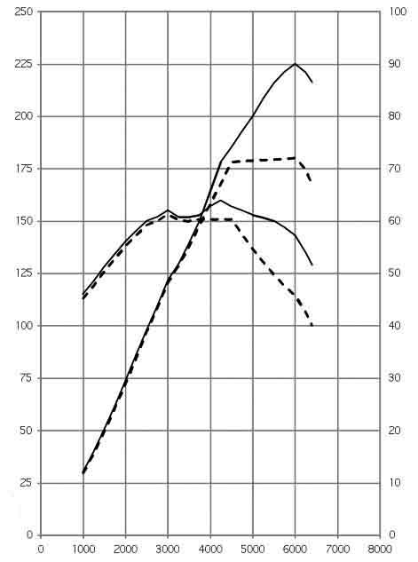MINI One.  
MINI Cooper.   
MINI Cooper S

**153 Nm @ 3000 min-1**

**160 Nm @ 4250 min-1**

**72 kW @ 6000 min-1**

**90 kW @ 6000 min-1**

Torque [Nm]

Output [kW]

Engine speed [min-1]

**MINI One D,  
MINI Cooper D**

Torque [Nm]

**240 Nm @ 1600 - 5000 min-1**

**260 Nm @ 1700 - 45000 min-1**

**135 kW @ 5500 min-1**

Output [kW]

Engine speed [min-1]



Output [kW]

Torque [Nm]

Engine speed [min-1]

**66 kW @ 4000 min-1**

**82 kW @ 4000 min-1**

**270 Nm @ 1750 -2250 min-1**

**215 Nm @ 1750 – 2500 min-1**

**270kW @ 1750 - 2250 min-1**

9. Exterior and interior dimensions.

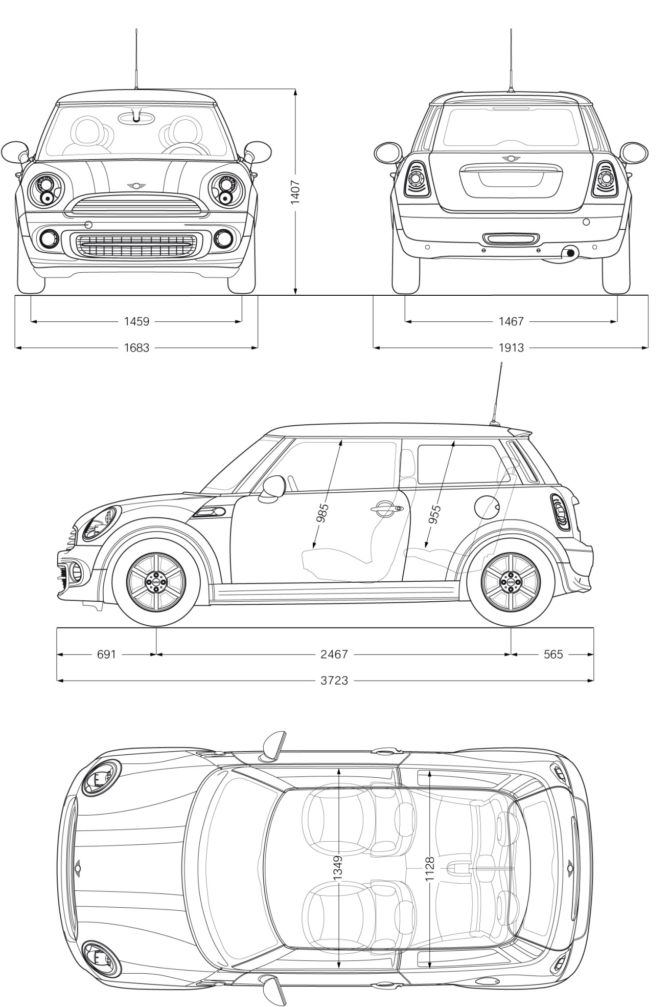**MINI One**

**MINI Cooper**

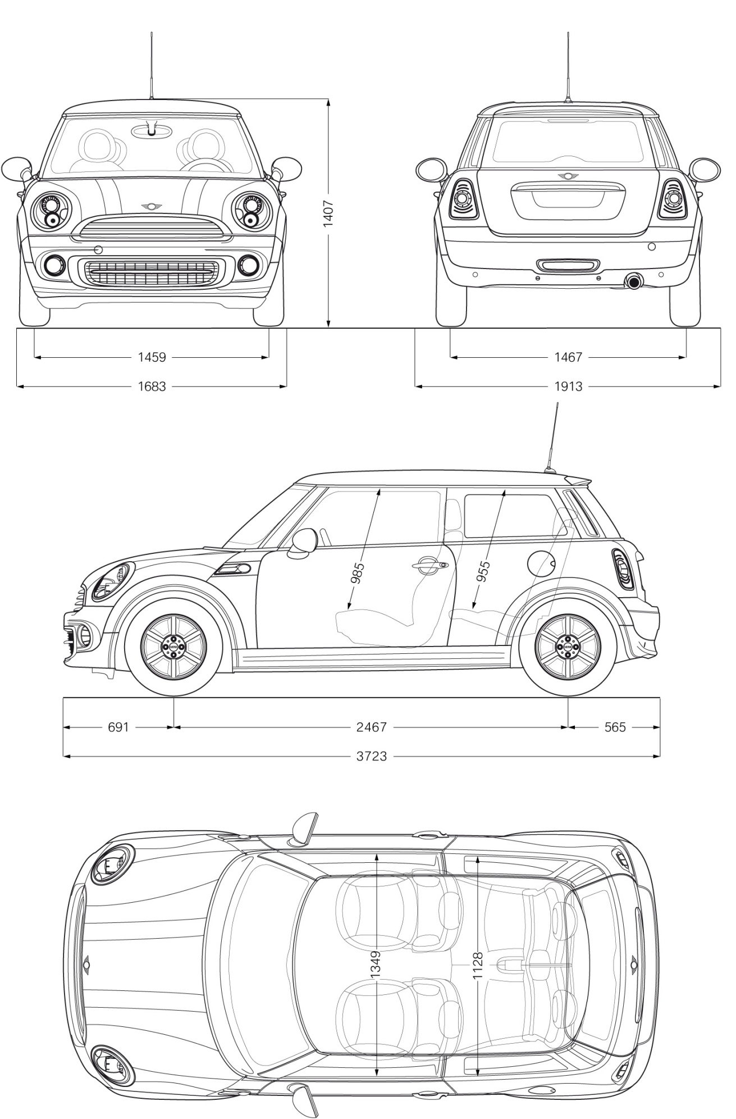

**MINI Cooper S**

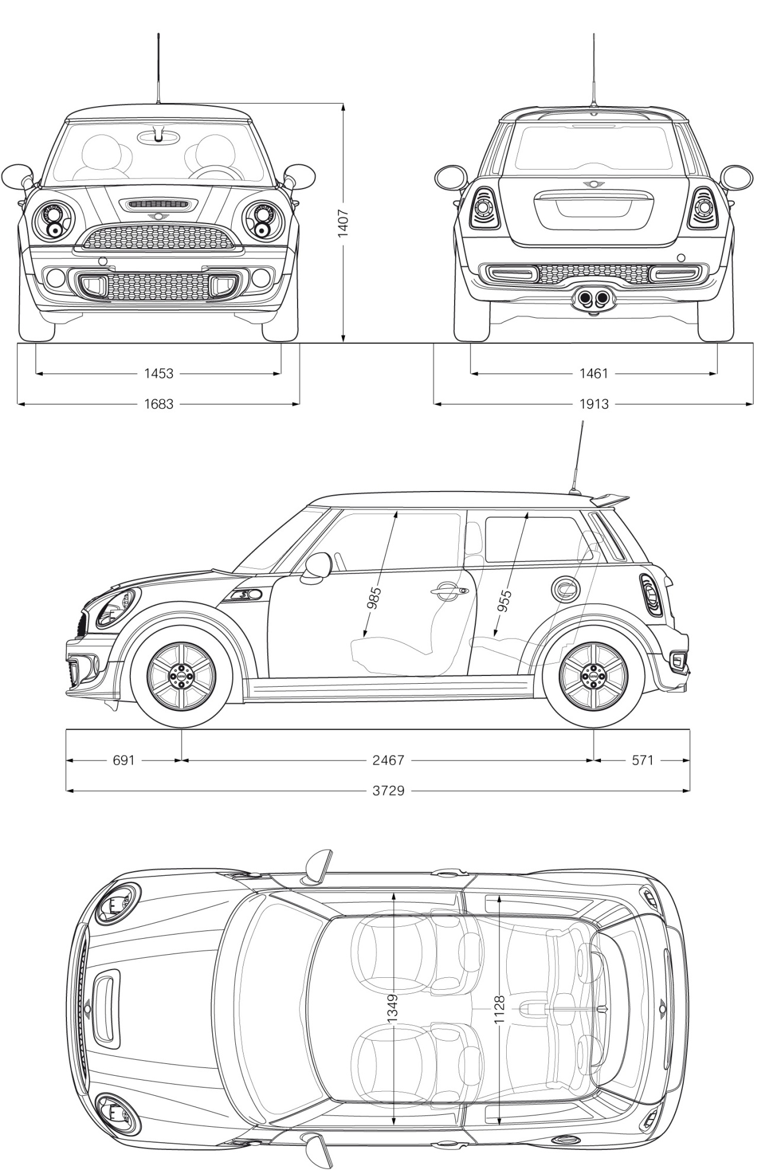

**MINI One Clubman**

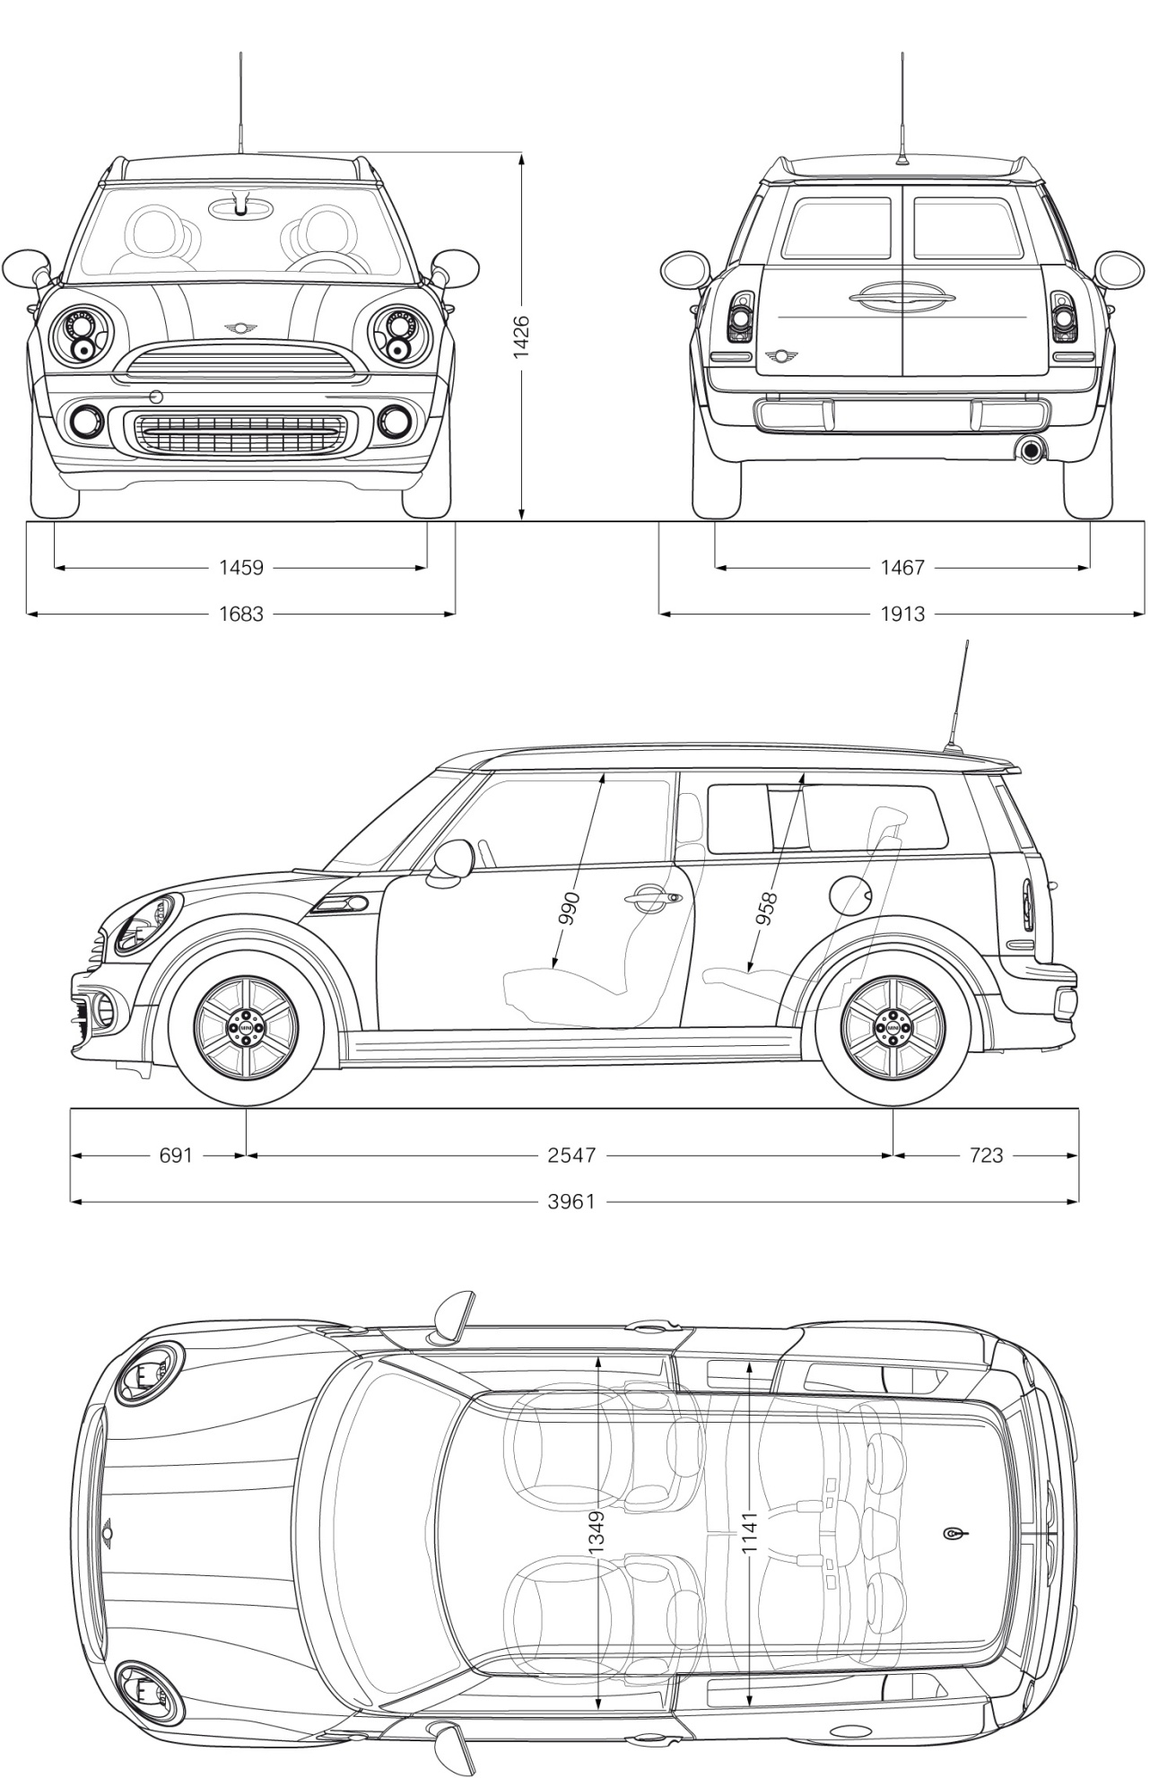

**MINI Cooper Clubman**

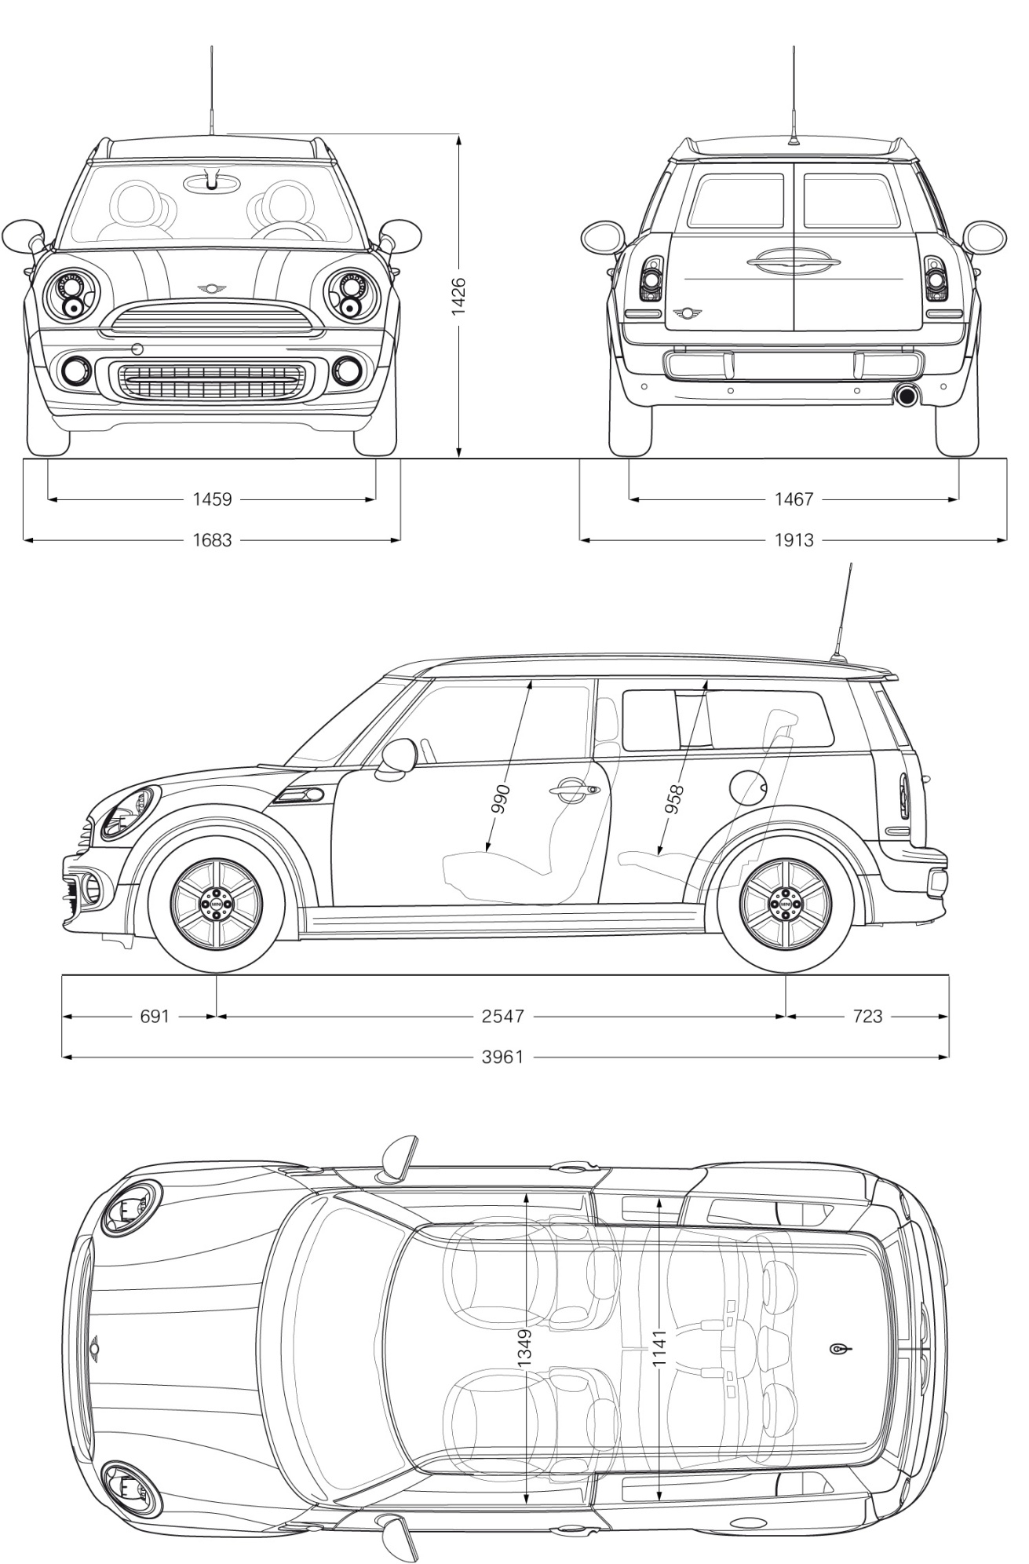

**MINI Cooper S Clubman**

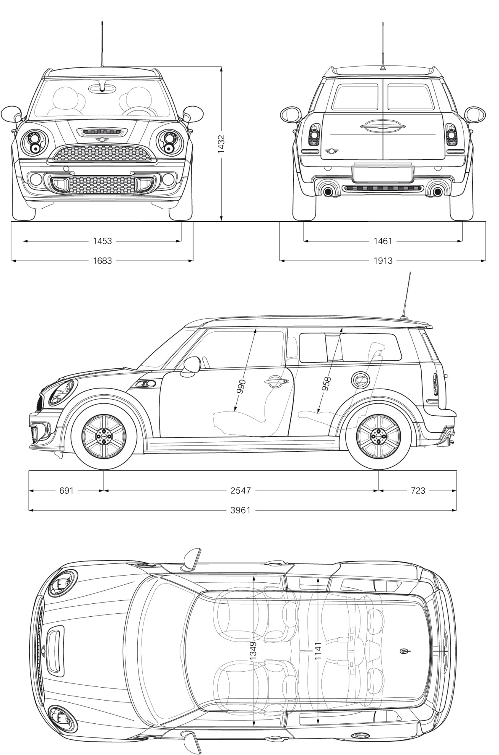

**MINI One Convertible**

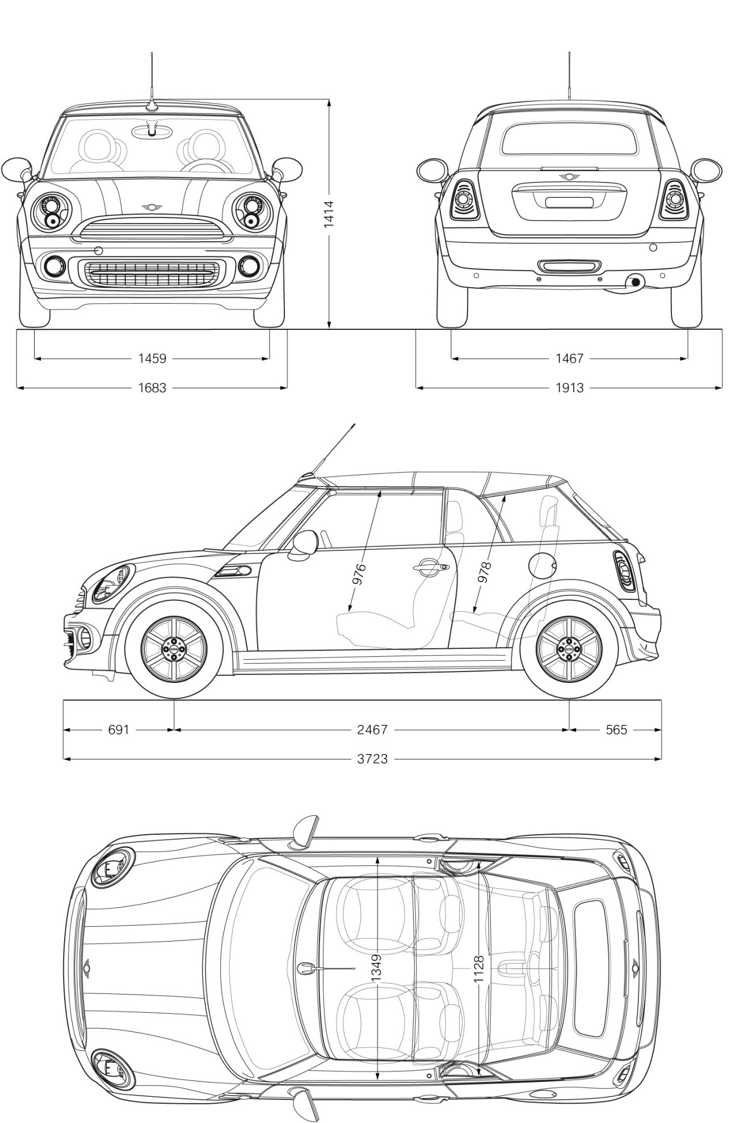

**MINI Cooper Convertible**

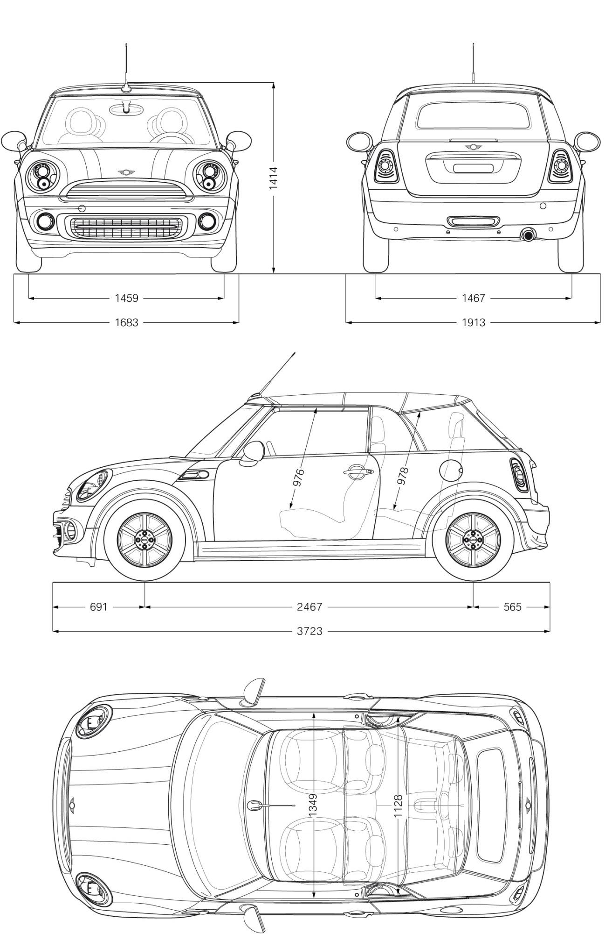

**MINI Cooper S Convertible**

