
The BMW Concept CS.
Contents.
Description in Brief. 2
Entering a New Dimension:
The BMW Concept CS. 6
Exterior and Interior Dimensions. 23

The BMW Concept CS.
Description in Brief.
Character:
• Concept study of a four-door Gran Turismo for the luxury segment.
• Modern, sophisticated surface design bearing testimony to a supreme standard of craftsmanship and experience in moulding convex-concave surfaces.
• The very essence of brand values so typical of BMW in a new segment ensuring a perfect combination of superior dynamics and stylish exclusivity.
• Modern interpretation of the premium concept ensured by extreme precision in every design detail, choice of the most refined materials, and perfect craftsmanship.
• Previously unseen combination of vehicle dimensions and weight ensured by consistent implementation of lightweight strategies.

• European-style aesthetics, clear emphasis on the car’s stretched look, low-slung roof-line, low centre of gravity, extremely long wheelbase (see “Exterior and Interior Dimensions”).
• Innovative interior design with layered surfaces, clearly defined joints serving a functional purpose.
• Clearly defined, sporting seat position for four occupants.

Exterior design:
• Sporting, sleek and low-slung all-round look as an expression of
a four-door Gran Turismo.
• Highly expressive, dynamic front-end design with the striking
BMW kidney grille as the central highlight.
• Prominently positioned BMW kidney grille to ensure a good supply
of cooling air to the engine.
• Re-interpretation of BMW’s classic contour line at the side, door handlers fitted flush in position as a consistent testimony to the car’s attractive sculpture.
• Powerfully flared wheel arches, 21-inch light-alloy wheels,
body width increasing towards the rear and thus emphasising
the sporting, wide track of the car.
• Flowing roof area with aerodynamically optimised contours.
• Innovative headlights with LED reverse projection technology
and extremely slender rear lights behind clear glass. Night design with homogeneous light bodies.

Interior design:
• Uncompromising, highly aesthetic interior design with layered surfaces (layer design concept) and clearly defined functional joints.
• Driver-oriented cockpit with clear ergonomic structuring of functions relevant to the driver and oriented towards superior comfort in the controls and displays.
• Layer design concept also applied to the design of the double circular dials to provide clearly structured information on several visual levels.
• Focus on the joints and seams around the body panels serving to consciously use air venting and ambient interior illumination options.
• Supreme exclusivity and perfect craftsmanship in the finish of the interior highlighted by contrasting colours and surfaces in different kinds of leather.
• Introduction of particularly sophisticated, powerful-looking ceramics as the material for the controls and instruments.
• Innovative sports seats with a fold-up collar element.
Entering a New Dimension:
The BMW Concept CS.
Introducing the BMW Concept CS, Germany’s leading manufacturer
of premium automobiles is presenting the vision of a unique four-door car which combines the exclusivity of a genuine luxury Gran Turismo with the fascinating thrill of a high-performance sports car. This unique combination never seen before offers the perspective to enjoy sheer driving pleasure in a dimension quite unprecedented in the world of motoring. Indeed, the BMW Concept CS is a new definition of design culture. Concentrating on powerful, expressive design, materials of
the highest quality, and quality of finish in perfection, this unique new
model offers a completely new understanding of premium quality.
And within its interior, the BMW Concept CS combines stylish luxury with the most uncompromising ambience full of class and value.
Through its design alone, the BMW Concept CS underlines the supreme skill and competence of the BMW brand in developing the most sporting and dynamic cars offering ample space for more than
two occupants. The most spectacular rendition of this heritage at
BMW is the BMW M5, which established a brand-new segment in the world of motoring more than two decades ago and is acknowledged
to this day as the benchmark in high-performance saloon motoring.

Now the know-how BMW has acquired over the years and decades comes together with the worldwide fame of the company as a manufacturer of premium automobiles, the BMW Concept CS thus offering the best of both worlds.
BMW is using the skills and competence established over such
a long time to combine the most fascinating highlights of sporting performance and sophisticated luxury in an unprecedented new concept. Hence, the BMW Concept CS impressively proves how the successful strategy of the sporting four-door may be carried over consistently into the luxury performance segment.
Exterior design: where qualities typical of BMW all come together.
More than any other saloon in the past, the BMW Concept CS bears out all the highlights of optimum performance through the design of
its body alone. The low-slung, dynamically stretched silhouette, the long engine compartment lid and stylish lines and contours accentuating rear-wheel drive technology simply perfect for sports motoring, all set clear standards for supreme dynamics in a new dimension of out-standing vehicles. Through its supreme presence, stylish elegance,
and challenging dynamism, the BMW Concept CS, in a nutshell, offers truly unique design language with highly individual aesthetic features never seen before.

Precisely this explains why all the elementary values of the
BMW brand are concentrated in the BMW Concept CS, superior dynamics and sophisticated elegance all being borne out together through the authentic style and design of the car. Clearly, therefore,
the BMW Concept CS is the pacemaker leading into a new category
of values typical and characteristic of the BMW brand.
Design culture and dynamics of the highest standard.
Offering a synthesis of features unique to the BMW brand, the
BMW Concept CS introduces new, tempting highlights in a particularly demanding segment of the market. This unique model combines
the qualities of a luxury saloon and a high-performance sports car in one, raising this superiority to a new, unprecedented level. As a result,
the BMW Concept CS adds an unparalleled touch of sporting dynamism to the conventional culture of a saloon, offering the driver and passengers the complete dynamic potential of such unique
power on four full-sized single seats.
While the conventional saloon focuses primarily on driving comfort, the BMW Concept CS sends out a clear message of active, dynamic motoring. A message which reaches all the car’s occupants, with the generous feeling of space in this four-door being supplemented by
a sporting and low seating position enjoyed not only by the driver and front passenger, but also by the passengers at the rear on their
own single seats. For this reason alone, the BMW Concept CS is, not least, the vision of a sports car for the ambitious driver offering
the passengers the same experience of sporting performance and luxurious pleasure.

Individual style meets exclusive class.
The innovative, unique driving experience offered by the
BMW Concept CS is appropriately reflected by all the car’s interior features, the design of the interior and the various technical innovations interacting perfectly with one another. The ambience of the interior is indeed just as unique as the character and body design of this one-off sporting four-seater, offering all the occupants a brand-new experience of aesthetic style and design. And it almost goes without saying that within the car the occupants enjoy such unique exclusivity in particular style on four single seats.
The innovative design and finish of both the surfaces and controls is further accentuated by the use of top-quality materials and quality
of finish enhanced to perfection. Unnecessary opulence is replaced by highly focused luxury, together with an exemplary standard of detail
and elegance. The precision that has gone into the development
and production of all components is obvious at very first sight, clearly expressing BMW’s dedication to supreme performance in every respect.
Style and unique aesthetics of BMW.
Measuring 5.10 metres or 200.8 inches in length, the BMW Concept CS is dominated by dynamically flowing lines. From the BMW kidney
grille standing out powerfully to the front, the eyes of the beholder
move back along the low-slung and sleek engine compartment lid, subsequently meandering along the side-line and roof-line all the way
to the deliberately short rear-end with its clear-cut air flow spoiler.

The dynamically stretched silhouette of the car proudly boasts a wide range of features typical of the character of a particularly sporting, avantgarde automobile. All of these features clearly bear testimony to excellent aerodynamics as well as a low centre of gravity helping to promote superior agility on the road. And at the same time the carefully modelled transitions between the body sections are a clear symbol of the car’s nimble character and performance, despite its size.
Four doors with a unique, sporting and low body line.
The sporting, low-slung silhouette of the car is further accentuated by body height of just 1.36 metres or 53.5 inches. A further important feature is the gentle taper of the roof-line at the rear serving again to smoothly stretch the proportions of the entire car.
The re-interpreted contour line, as seen from the side, serves to emphasise the technical concept of rear-wheel drive so crucial
to dynamic performance on the road. Subdividing the silhouette of the car into various sections, the contour line stretches from the beginning of the A-pillar in a gentle, rising movement all the way up above the front door, gradually petering out beneath the rear side window. Then the contour line starts again in the lower section of the rear door,
first running parallel to the wheel cut-out in a powerful arch. From there the rear contour line is continued as a straight line also rising slightly
up to the rear end of the car.

The roof-line likewise tapering out gently to the rear also provides a brand-new effect when looking at the car from the side, adding a touch never seen before on a saloon. The striking contour of the C-pillar,
in turn, provides an additional visual highlight of attractive clarity, the transition of the C-pillar into the rear section of the car tapering out
at a lower angle than the steeper rear window rising up from its base point. This creates a unique expression of classic notchback design highly individualised and varying according to your angle of vision.
At the bottom, the C-pillar offers a new, enhanced interpretation of
the reverse line sweeping to the front known by tradition as the
“Hofmeister kick”. And last but not least, a gentle and extremely
attractive light-edge stands out above the side window precisely
where the C-pillar merges into the roof-line.
Characteristic front-end design consistently enhanced.
The front-end design of the BMW Concept CS is a particularly striking example of the consistent enhancement of BMW’s design language. Here the BMW kidney grille stands out as a powerful element typical of the BMW brand and naturally a famous icon of body design, giving
the car its unique look and emphasising the flow of air into the engine. Indeed, the kidney grille is not only the central, but also the dominating element in the design of the entire front end.
Through its dimensions alone, as well as its position slightly inclined
to the front, the kidney grille establishes a clear link to classic
BMW sports cars. All further elements at the front end of the car are

angled in the direction of travel and designed as a genuine sculpture around the kidney grille, with all directly adjacent surfaces being modelled in concave design.
Significant functional features add further meaning to this special look
of the car, with the BMW kidney grille serving as the primary supply
of air to the engine. The two recesses in the front side panels, in turn, help to cool the brakes on the car. And since a power unit befitting
the dynamic character of such a sports saloon most probably requires an ample flow of cooling air, the need for an extra-large kidney grille
is obvious at first sight.
Applying the philosophy that “form follows function”, the contours
on the engine compartment typical of a BMW have developed
into a genuine sign of distinction born out of technical needs and requirements. On the BMW Concept CS, the powerdome as a
further highlight in design extends over the power unit as a particularly large, almost awe-inspiring design feature.
The engine compartment lid is supported at either side by headlight units merging flush into the design of the car and resting flat on the side panels, extending far back into the front wings. The slender space
thus left over above the extra-large wheel arches underlies the agility and, accordingly, the athletic performance of the car.

Innovative headlight technology.
Within the dynamic, low-slung headlight units featured in the
BMW Concept CS, particularly innovative technology serves to generate a powerful and consistent light beam: Innovative LED reverse-projection lights bundle their light on a reflection area from where the beam is conveyed smoothly, consistently and with utmost precision to the road ahead. This provides a particularly homogenous area of illumination without the slightest dazzling effect, since the oncoming motorist does not look directly at the projectors.
The short front overhang of the body creates yet another sign
confirming the sporting concept of the car, showing the connoisseur clearly that the engine may be placed behind the front wheel suspension. Obviously, such arrangement of the engine serves once again to make the car particularly agile and dynamic on the road.
The extra-large wheel arches offer space for big 21-inch wheels –
again exceptional proportions alluding clearly to an extremely high standard of steering precision and tracking stability. And the rear wheel arches are powerfully chiselled to perfection even more than the
wheel arches at the front, with the car growing wider towards the
rear end, again accentuating the transmission of power to the rear wheels so typical of BMW.
Dynamic roof-line guiding your eyes – and the air flowing by.
The sculptural design language so characteristic of the
BMW Concept CS in its body design allows unique interplay of

concave and convex surfaces, reflecting and guiding the light on and around the car in exactly the right way. One example in this context
is the exterior mirrors on this unique car blending harmoniously with the side-view, the mirrors through their design alone repeating the overall look and lines of the car. The door handlers are integrated into the flanks of the BMW Concept CS even more discreetly: Housed within a chrome-bar running to the rear at the height of the contour line, the door handlers controlled by sensors move out only when really needed.
Yet another innovation in the design of this saloon is the centrepiece along the roof line of the BMW Concept CS slightly drawn in at
the rear. This exceptional contour design visible only from behind but nevertheless unusually powerful in its look optimises the flow of air
in and around the roof area. The aerodynamic touch established in this way underlines the overall sporting impression of the car and serves
at the same time as yet another feature of sculptural design and perfection.
Sculptural design for truly unique style.
Given all these features, the BMW Concept CS is a modern counterpart to the conventional notchback design of a “regular” four-door. Indeed, never before on a saloon have the individual body sections merged so smoothly into one another, creating a low-slung and stretched appearance. And this impression of all-round perfection with supreme harmony of looks from every angle is further enhanced when admiring the transitions modelled with extreme care and diligence, providing additional light effects, for example, around the C-pillar. Features of

this standard alone clearly confirm BMW’s philosophy to express supreme design culture through perfect precision and style in every respect.
The much lower flow of the C-pillars compared with the position of the rear window again serves to emphasis the flowing transitions from
one body section to the next. Seen from the side, the entire car has the lightness of a coupé – but then all you have to do is change your perspective only slightly in order to perceive and appreciate all the
style of a classic four-door. Given the short body overhang at the rear, the size of the separate luggage compartment is hard to appreciate to begin with. Instead, the rear end is dominated by other design features emphasising both the wide track and the aerodynamically optimised rear look of the car.
Moving up at the rear, we see that the two tailpipe rings are integrated in the rear air dam. In its night design, in turn, the BMW Concept CS is characterised by slender rear lights emitting a homogeneous, low-slung and therefore strikingly harmonious lighting effect.
With its design language absolutely authentic and convincing to the
last detail, the BMW Concept CS offers all the fascinating thrill of new design culture. The particular impact of this sporting four-door, in turn, results not only from individual highlights, but also from the overall look

of the car accentuating its complete character so convincingly. The car’s dynamic potential is indeed expressed both by its proportions
and lines symbolising both power and a dynamic, forward-moving urge. And last but certainly not least, the BMW Concept CS boasts particularly sophisticated elegance through the great care and diligence applied in turning innovative design culture into reality.
The interior: an outstanding driving experience on all four seats.
The interior of the BMW Concept CS also offers dynamism of a completely new standard borne out by the combination of exclusive elegance and sophisticated refinement. In designing the interior, the innovative technique of layering the individual surfaces and components provides an unprecedented combination of function and stylish reduction to the essential. The appropriate use of joints and seams, together with layered surfaces, creates new options in the arrangement of functional elements for both ventilation and illumination. And at
the same time the layering concept offers new possibilities to clearly express the class and value of the materials used as well as the
precise design of the car’s interior through contrasting colours and
the structure of different materials.
Featuring height-adjustable collar elements directly integrated in the seats, the four full-sized sports seats meet all the needs of personalised entertainment and communication, thus raising the experience of
quality within the interior to an unprecedented standard. More than ever before, this highlights the sheer value of the materials used, the love
for all details, and quality of finish now enhanced to perfection.

Interaction of innovative design and exclusive materials, together
with the use of a highly expressive colour scheme, gives the interior of the BMW Concept CS a unique touch of luxury based not on simple opulence, but rather on perfect quality.
The design of the interior clearly reveals the truly outstanding driving experience in a unique ambience. A brand-new concept for subdividing the cockpit into various sections, as well as unparalleled standards
in the choice of materials and in the quality of finish, create an unprece-
dented flair of exclusivity and individual style. And added to this there
is a clear pledge to sportiness expressed both by the arrangement
and finish of the four single sports seats and the design of the controls and instruments.
An invitation to active motoring.
The driver-oriented cockpit immediately shows the motorist that he
or she is in control of everything happening at the wheel. Just like the arrangement of all controls and instruments, the design and layout
of the cockpit is an invitation to active motoring. A very clear example
of this straightforward philosophy is the short distance between the steering wheel and the shift lever, while in their design the sports seats combine a touch of lightness with the sporting elegance of the finest leather. The low-slung seating position and the clear structure of
the instruments likewise evoke the wish to really experience and savour the dynamic potential of this unique car.

Lots of space, lots of support: sports seats also at the rear.
The BMW Concept CS presents the vision of an automobile proudly offering all its qualities to the driver. The unique thrill of driving the car is obviously borne out most by taking your position at the wheel, while
the sheer driving pleasure offered in the process is shared out among all the occupants: Just like the front-seat passenger, the passengers on the single seats at the rear will also appreciate and cherish the sporting and active driving experience offered by the BMW Concept CS. Precisely this is ensured by the contours of the rear seats with their perfect side support tailored to the contours and design of the front sports seats. And thanks to the single seat concept, elbow freedom on the rear seats is just as good as on the front passenger’s seat.
The centre console flows back smoothly all the way to the rear, serving as a comfortable armrest and at the same time offering additional storage space. In all, therefore, the passengers sitting at the rear enjoy a brand-new, truly innovative ambience standing out clearly from the conventional style of a “regular” four-door model.
Cultivating the flow of joints and seams:
layering the interior design.
The combination of features previously regarded as incompatible
within the BMW Concept CS represents a complete departure from conventional standards. Indeed, the BMW Concept CS opens up a
new era in many areas, the unique combination of sporting performance and stylish elegance also coming out clearly in the design of the interior.

The BMW Concept CS is therefore no more and no less than a new milestone in refined interior design, applying an innovative layering technique developed by BMW to provide unprecedented interplay of the various interior elements. Instead of large surfaces and connec-
tions with their transitions nearly always characterised by a change in materials and colours, the layering technique stratifies the various surfaces flowing into one another, with clearly defined seams taking
on a functional role, for example in the arrangement of light sources
and venting nozzles. The result is a very refined effect of light and shade making a significant contribution to the exclusive overall look and impression of the interior.
Contrary to the design of the body incorporating flowing lines, generous surfaces and harmonious interplay of concave and convex elements in order to capitalise above all on light effects, the layering concept applied within the interior mainly uses shade effects and changes in structure. Wherever individual surfaces in the structure of the cockpit do not meet on the same level, we find separate zones kept away from the direct flow of light – and precisely these zones provide the right space for the inconspicuous arrangement of various functions. The recesses and superimposed surfaces provided in this way offer appropriate space for ambient illumination as well as the arrangement of air vents. Dazzle-
free interior lighting and discreet shade effects upgrade the entire flair
of the interior and create a kind of light, hovering effect.

This layering philosophy is continued in the design of the instruments themselves, the displays in the instrument cluster presenting various functions and items of information on different optical levels. This again creates the impression of superimposed surfaces serving, first, to clearly structure the information offered and, second, to generate an impression of three-dimensionality.
Colour design rich in contrasts, high-quality materials.
BMW’s designers have also created unmistakable highlights through the choice of materials and colours: Powerful colour contrasts generate
a dynamic ambience full of vitality appropriately reflecting the dynamic driving experience on the four seats of the BMW Concept CS. High-quality, refined leather in sophisticated brown forms a powerful contrast to surfaces in elegant off-white. Finished in matt tan, this brown
leather is indeed to be admired not only on the seats, but also on the instrument panel, the upper doorsills, and the outer edges of the roof lining. Around the armrests and in the door panels themselves, this change in colours accentuates the dynamic lines of the interior created by the particular design and shape of individual elements. And finally, the leather trim on the dashboard continues in a slender band extending harmoniously into the door linings.
As a further innovative highlight, the roof lining in the BMW Concept CS is accentuated not only through a contrasting colour scheme, but
also by finishing the outer flanks of the roof lining likewise in leather. Ambient light bands stretching out along the entire length between the windscreen and rear window, finally, add yet a further touch of luxury inside the car.

Reflecting the particular style of the exterior, the flowing structure of the interior surfaces shows special care and diligence in the transitions from one section to another. As an example, the leather trim on the centre console and the door entry area extends far down into the footwells.
The dashboard also uses a newly developed metal structure literally “embracing” the various surface elements. This material particularly attractive in its structure as well as its cool colour and feeling surrounds the circular instruments in the cockpit, together with the other features and elements.
Yet another supreme innovation is the use of high-tech ceramics for
the controls and instruments. And as a symbol of solidity and value, the BMW iDrive Controller is also made of a special ceramic material.
Unparalleled and typical of BMW: the BMW Concept CS.
The unique flair pampering both the driver and his passengers within the BMW Concept CS is an equally clear expression of both a new culture in body design. Both outside and inside, the BMW Concept CS therefore conveys the same message, telling the world that the experience of driving a saloon now comes in an entirely new rendition. So in presenting this new Concept Car, BMW is not only entering a brand-new segment of the market never occupied before, but is also setting the milestone with a brand-new type of car: The four-door
luxury Gran Turismo enters a new dimension of motoring in new style and with new features.

A new experience of dynamics and the ambience around us, exemplary quality in design and finish, extreme precision in the dimensions of the car, and concentrated luxury within the interior – these are the features that characterise the BMW Concept CS. And at the same time all
this bears clear testimony to the superior know-how and competence
of BMW’s engineers and designers in creating such truly emotional automobiles.
The sum total of such qualities in the BMW Concept CS can be created only on a sound foundation of firmly defined values: innovative power, sporting performance, aesthetic design, an open frame of mind, and
full awareness of quality. Precisely these are the values BMW has been applying consistently for decades in the development of particularly outstanding saloons and fascinating, truly dynamic sports cars. And
now these values are concentrated even more than before in an unprecedented manner in the BMW Concept CS.

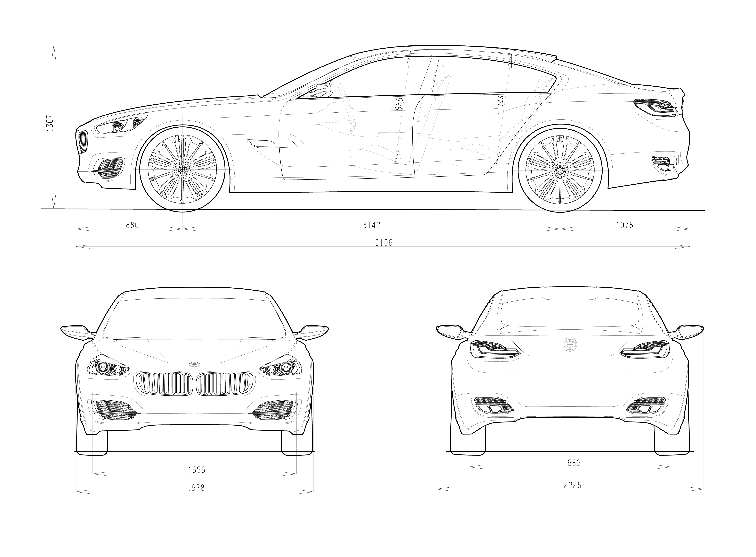
The BMW Concept CS.
Exterior and Interior Dimensions.

