The MINI Countryman*.
Contents.

1. Fun has no Limits.
The MINI Countryman. 2

2. Description in Brief. 4

3. New Routes to Agility and Efficiency.
Drivetrain and Driving Experience. . 8

4. The First of its Kind in the Premium Segment –
and Unmistakably a MINI.
Concept and Design. 19

5. New Customisation Options for Individualists.
Interior Fittings and Equipment. 24

6. Specifications. 28

7. Output and Torque Diagram. 42

8. Exterior and Interior Dimensions. 47

*The name of the vehicle may vary in some markets.
Note: All performance, fuel consumption and emissions figures stated in this press kit are provisional.

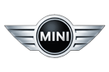1. Fun has no Limits.
The MINI Countryman.
The MINI Countryman takes the hallmark driving fun of the brand into a new dimension. This is the first MINI to come with four doors and a large tailgate
as well as a versatile interior offering space for up to five people. The
MINI Countryman is the first member of the MINI family with a body measuring more than four metres (157") in length and which can be ordered as an option with all-wheel drive. With these features, in addition to the Countryman’s raised seating position and optimised ride comfort, the world’s only premium vehicle of its kind crosses the boundaries of urban mobility to take the trademark
MINI feeling into new dimensions and win over additional target groups.
The latest generation of petrol and diesel engines.
Three petrol and two diesel engines will be available at launch. The selection
of petrol variants ranges from the MINI One Countryman developing 72 kW/98 hp and MINI Cooper Countryman (90 kW/122 hp) to the 135 kW/184 hp MINI Cooper S Countryman, whose 1.6-litre four-cylinder engine is the most efficient unit in its displacement class. The petrol models are joined in the line-up by the diesel-powered MINI One D Countryman (66 kW/90 hp) and MINI Cooper D Countryman (82 kW/112 hp). All variants
of the MINI Countryman meet the EU5 exhaust gas standard in Europe and
the ULEV II standard in the USA.
MINI ALL4: Breaking new ground in driving fun.
Optional MINI ALL4 all-wheel drive allows the driving fun you expect from the brand to be experienced off the beaten track as well. The permanent all-wheel-drive system’s quick and precise responses to changing conditions provide
a new, traction-led expression of the handling talents for which MINI is famed. An electromagnetic centre differential positioned directly on the final drive varies the distribution of power seamlessly between the front and rear axles. The ALL4 system is available for the MINI Cooper S Countryman and
MINI Cooper D Countryman.
Newly developed suspension combines quintessential MINI
agility with outstanding ride comfort.
With its precise handling and captivating agility, the MINI Countryman transplants the driving characteristics associated with the brand into a new vehicle concept. These attributes are complemented by outstanding ride comfort, equipping the Countryman perfectly for a wider range of usage. Underpinning this is sophisticated new suspension technology, which includes a front axle with MacPherson spring struts and forged track control arms,
multi-link rear suspension and the electromechanical power steering system EPS. The MINI Countryman comes as standard with the Dynamic Stability Control (DSC) system.
Design: Undeniably an individualist, unmistakably a MINI.
The MINI Countryman exudes an air of originality, robustness and versatility. Four doors and a large tailgate, a striking roof shape and an upright front end reinforce its status as an individualist within the MINI ranks. Other distinctive features are its MINI proportions and design cues. Short overhangs, a high window line, the wrap-around look of the windows and the car’s powerful
over-the-wheel stance create a familiar appearance transplanted onto larger exterior dimensions. Elsewhere, the Countryman provides a fresh interpretation of characteristic MINI features, such as the hexagonal radiator grille, large headlights set into the bonnet, side indicator surrounds, voluminous wheel arches and vertical rear light clusters.
Versatility and innovative details deliver cutting-edge functionality.
The rear of the MINI Countryman can be specified with two individual seats
or – as a no-cost option – a seat bench for three passengers. The rear
seats slide fore-and-aft individually or in a 60 : 40 split (three-seat bench),
the angle of the backrests can be adjusted, and the backrests can be
folded down either individually or in a 40 : 20 : 40 split (three-seat bench) –
all of which allows luggage capacity to be increased from 350 litres to a maximum 1,170 litres (12.4 to 41.3 cu ft). The MINI Countryman is also fitted as standard with the innovative Centre Rail storage and fastening system.
Top-class standard equipment, premiere for MINI Connected.
The list of standard equipment for the MINI Countryman includes air conditioning and a CD audio system. A wide range of customisation options are also available, such as exterior paint finishes and interior colours designed exclusively for the Countryman, a host of upholstery variants, trim elements and model-specific equipment items, and high-quality audio and navigation systems. A further in-car entertainment highlight is the unique MINI Connected system, which includes the web radio and Mission Control functions.

2. Description in Brief.

• With the addition of the MINI Countryman as the fourth variant in its model family, MINI is taking the inimitable MINI feeling into a new dimension.
The MINI Countryman crossover bridges the gap between the classic MINI concept and a contemporary Sports Activity Vehicle. Its broader range of abilities in both urban use and beyond paves the way for larger and evolving target groups with a greater need for space and flexibility
to experience the driving fun that comes with a MINI. The brand’s first model to feature four doors and a wide-opening tailgate, the Countryman offers more space – which can be used in a wide variety of ways – to go with its raised seating position and optimised ride comfort. Plus, the
“go-kart” feeling for which MINI is a byword has been preserved and takes on a new dimension with the optional MINI ALL4 all-wheel-drive system.
The MINI Countryman expresses the defining virtues of the brand in terms of design, premium quality, handling, efficiency and the scope for customisation – and does so in an absorbingly individual way.

• The MINI Countryman manifests an effective and assured development
of the brand’s design language. The new model combines larger body dimensions, increased ground clearance and four side doors with the hallmark features of MINI design. Short overhangs, a high window line,
a commanding over-the-wheel stance and the wrap-around look of the windows – extending all the way around the vehicle – create typical
MINI proportions. The Countryman provides a fresh interpretation of classic MINI features, such as the roof line, hexagonal radiator grille, large headlights set into the bonnet, side indicator surrounds, capacious wheel arches and vertical rear light clusters.

• Using the MINI design language as a starting point, the stand-out features of the MINI Countryman are showcased in fitting style. The upright front end exudes presence and helps to optimise pedestrian protection. The increase in interior space is emphasised by large glass surfaces, the
four-door layout by the distinctive contours of the roof. The extra-wide border around the lower part of the body and powerfully bolstered wheel arches are a nod to the robustness of the vehicle and its all-wheel drive. The precise transposition of the MINI style into a new vehicle segment ensures that the MINI Countryman comes across as a totally new type
of vehicle and yet is instantly recognisable as a MINI.

• The interior of the MINI Countryman is very much in keeping with the brand’s familiar style but boasts a selection of new design and functional elements. The slightly raised seating position allows easy entry, optimises the driver’s view over the road and reinforces the powerful character of the new model. The Centre Speedo and air vents are bordered by coloured rings. The unique MINI Centre Rail, meanwhile, runs lengthwise through the middle of the interior in place of a conventional centre console and opens up new ways of integrating storage boxes, cup holders, external audio devices, mobile phones and other comfort-enhancing elements just as you want them. Clip-in fixtures have a flexible range of positioning that allows the storage area to be divided up as desired and items to be kept close at hand at all times. Added to which, the Centre Rail creates an unconventional visual and functional connection between the front and rear compartments.

• The MINI Countryman comes as standard with four seats, while a three-seat bench is available as a no-cost option. Its interior enhances comfort over long journeys with generous legroom, headroom and shoulder room. The rear seats can be moved forwards and backwards individually or in
a 60 : 40 split (three-seat bench), the angle of the backrests can be adjusted and the backrests can be folded down either individually or in a 40 : 20 : 40 split (three-seat bench), all of which allows luggage capacity to be increased from 350 litres to a maximum 1,170 litres (12.4 to 41.3 cu ft).

• The MINI Countryman will be available with three petrol and two diesel engines at launch. All the drive units are sourced from a new generation
of engines optimised using the BMW Group’s development expertise.
And they all meet the EU5 and ULEV II exhaust emission standards. Output ranges from 66 kW/90 hp in the MINI One D Countryman to 135 kW/184 hp in the MINI Cooper S Countryman. With its twin-scroll turbocharger and direct injection now complemented by fully variable
valve management, the 1.6-litre four-cylinder petrol engine in the range-topping model offers by far the best balance between output and fuel consumption in its displacement class. Furthermore, the MINIMALISM concept sees wide-ranging technology designed to reduce fuel consumption and emissions – such as Brake Energy Regeneration, the Auto Start/Stop function, Shift Point Display and the need-based operation of ancillary components – fitted as standard and in model-specific combinations. For the petrol engine variants a six-speed automatic transmission with Steptronic is available as an alternative to the standard six-speed manual.

• The MINI Cooper S Countryman and MINI Cooper D Countryman can be ordered as an option with MINI ALL4 permanent all-wheel drive. Here,
an electromagnetic centre differential positioned directly on the final drive varies the distribution of power seamlessly between the front and rear axles. In normal driving conditions up to 50 per cent of the drive is sent
to the rear wheels, in extreme situations as much as 100 per cent. The result is a new, traction-led expression of the agile handling for which
MINI is famed. This ability is underpinned by sophisticated new suspension technology, which includes a front axle with MacPherson spring struts and forged track control arms, multi-link rear suspension and the electromechanical power steering system EPS. The MINI Countryman comes as standard with the Dynamic Stability Control (DSC) system. Available as an option are Dynamic Traction Control (DTC, standard on
the MINI Cooper S Countryman – both with front-wheel drive and ALL4 all-wheel drive – and MINI Cooper D Countryman with ALL4) and an electronic locking function for the front axle differential.

• A crash-optimised body structure with precisely defined load paths and deformation zones ensures exceptional passive safety. Standard safety features include front and side airbags, plus side curtain airbags for the front and rear seats, three-point inertia-reel seat belts on all seats, belt tensioners and belt force limiters at the front and ISOFIX child seat attachments in the rear. A Tyre Defect Indicator also comes as standard, while runflat tyres (standard on the MINI Cooper S Countryman with ALL4) are available as an option.

• New model-specific equipment features have been added to the usual extensive selection of exterior and interior customisation options available for the MINI. A newly configured range of interior colours, trim elements and upholstery materials allows for particularly harmonious combinations. Air conditioning, the MINI Centre Rail and an audio system with CD player are all fitted as standard, while the model-specific array of optional equipment items and accessories available for the MINI Countryman includes high-quality audio and navigation systems as well as mobile phone interfaces with full integration capability for the Apple iPhone or other smartphones. MINI Connected, meanwhile, delivers a unique form
of in-car entertainment with the addition of web radio and Mission Control functions, among others. Customers can also specify a large panoramic sunroof, Adaptive Headlights with xenon light, a heated windscreen,
a trailer coupling, 16- to 19-inch light-alloy wheels, sports suspension (with the vehicle height lowered by 10 mm / almost 0.4") and
John Cooper Works performance components.

• Engine variants:
MINI Cooper S Countryman: Four-cylinder petrol engine with
twin-scroll turbocharger, direct injection and fully variable valve management based on the BMW Group’s VALVETRONIC technology.
Displacement: 1,598 cc,
output: 135 kW/184 hp at 5,500 rpm,
max. torque: 240 Nm/177 lb-ft at 1,600 rpm
(260 Nm/192 lb-ft with Overboost).
Acceleration 0–100 km/h (62 mph): 7.6 seconds,
top speed: 215 km/h (133 mph).
Average fuel consumption according to EU standard:
6.1 litres/100 km (46.3 mpg imp),
CO₂ emissions: 143 g/km.
MINI Cooper Countryman: Four-cylinder petrol engine with fully variable valve management based on the BMW Group’s VALVETRONIC technology.
Displacement: 1,598 cc,
output: 90 kW/122 hp at 6,000 rpm,
max. torque: 160 Nm/118 lb-ft at 4,250 rpm.
Acceleration 0–100 km/h (62 mph): 10.5 seconds,
top speed: 190 km/h (118 mph).
Average fuel consumption according to EU standard:
6.1 litres/100 km (46.3 mpg imp),
CO₂ emissions: 142 g/km.
MINI One Countryman: Four-cylinder petrol engine with fully
variable valve management based on the BMW Group’s VALVETRONIC technology.
Displacement: 1,598 cc,
output: 72 kW/98 hp at 6,000 rpm,
max. torque: 153 Nm/133 lb-ft at 3,000 rpm.
Acceleration 0–100 km/h (62 mph): 11.9 seconds,
top speed: 173 km/h (107 mph).
Average fuel consumption according to EU standard:
5.9 litres/100 km (47.9 mpg imp),
CO₂ emissions: 137 g/km.

MINI Cooper D Countryman: Four-cylinder turbodiesel with aluminium crankcase, common-rail injection and variable turbine geometry.
Displacement: 1,598 cc,
output: 82 kW/112 hp at 4,000 rpm,
max. torque: 270 Nm/199 lb-ft at 1,750 – 2,250 rpm.
Acceleration 0–100 km/h (62 mph): 10.9 seconds,
top speed: 185 km/h (115 mph).
Average fuel consumption according to EU standard:
4.4 litres/100 km (64.2 mpg imp),
CO₂ emissions: 116 g/km.
MINI One D Countryman: Four-cylinder turbodiesel with aluminium crankcase, common-rail injection and variable turbine geometry.
Displacement: 1,598 cc,
output: 66 kW/90 hp at 4,000 rpm,
max. torque: 215 Nm/158 lb-ft at 1,750 – 2,500 rpm.
Acceleration 0–100 km/h (62 mph): 12.9 seconds,
top speed: 170 km/h (105 mph).
Average fuel consumption according to EU standard:
4.3 litres/100 km (65.7 mpg imp),
CO₂ emissions: 113 g/km.

• Exterior dimensions:
Length: 4,097 millimetres (161.3") (MINI Cooper S Countryman: 4,110 millimetres/161.8")
Width: 1,789 millimetres (70.4")
Height: 1,561 millimetres (61.5")
Wheelbase: 2,595 millimetres (102.2")

3. New Routes to Agility
and Efficiency.
Drivetrain and Driving Experience.

The latest generation of petrol and diesel engines, newly designed suspension and an optional all-wheel-drive system developed and tuned specifically for the MINI Countryman form the basis for a new and unmistakable driving experience. The brand’s fourth model also makes
a compelling case for itself with a level of agility unmatched by its direct competitors. The sophisticated chassis technology allows this stand-out feature of every MINI to be combined with excellent ride comfort, which meets the demands of both everyday driving and long-distance journeys. Customers looking for higher levels of traction, meanwhile, can select MINI ALL4 from
the options list. This all-wheel-drive system, which MINI is making available
to customers for the first time, provides variable distribution of drive between the front and rear wheels. It paves the way for supreme traction on unsurfaced terrain and an extra dose of driving fun when the Countryman driver decides to indulge his sporty side.

At launch the MINI Countryman will be offered with a choice of three petrol and two diesel engines, whose technology is rooted in the outstanding development expertise of the BMW Group. The output of the powerplants ranges from 66 kW/90 hp in the MINI One D Countryman to 135 kW/184 hp in the MINI Cooper S Countryman. The engines stand out with their exceptional efficiency and are complemented by cutting-edge MINIMALISM technology aimed at reducing fuel consumption and CO₂ emissions. All the MINI Countryman model variants meet the EU5 exhaust emission standard
in Europe and the ULEV II standard in the USA.

Like the range-topping MINI Cooper S Countryman, the
MINI Cooper D Countryman can also be fitted with MINI ALL4. This
all-wheel-drive system allows the renowned MINI agility to be experienced on rough terrain as well as asphalt. As an alternative to the standard six-speed manual gearbox, the three petrol engines can also be linked up to a six-speed automatic transmission.

The advanced suspension technology of the MINI Countryman consists of
a front axle with MacPherson spring struts and forged track control arms, multi-link rear suspension and electromechanical power steering (EPS)
with speed-sensitive power assistance. To maximise active safety in the Countryman, all models come as standard with the DSC (Dynamic Stability Control) system. DTC (Dynamic Traction Control, standard on the
MINI Cooper S Countryman and on the MINI Cooper D Countryman in conjunction with ALL4) and an electronic locking function for the front
axle differential are available as an option.
New generation of petrol and turbodiesel engines.

The five engines which can be ordered for the MINI Countryman boast both high output and exceptional efficiency. The petrol and turbodiesel variants
all belong to a new generation of drive units designed for MINI models.
The technology they use is the product of the BMW Group’s impressive expertise in engine development. Instantaneous power delivery, free-revving characteristics, a high level of refinement and extraordinary efficiency are
the central features which set the new MINI engines apart from the crowd.

In addition, the particularly extensive selection of MINIMALISM measures
on board play a key role in the reduction of fuel consumption and CO₂ emissions. Technology such as Brake Energy Regeneration, the Auto Start/Stop function, Shift Point Display and the need-based operation of ancillary components are all included in model-specific combinations.

All the petrol engines available for the MINI Countryman enjoy the benefit of fully variable valve management. This throttle-free load control technology – based on the VALVETRONIC system used in BMW engines and unique in
the new MINI model’s segment – optimises the engine’s responses and
at the same time makes for a significant reduction in fuel consumption and emissions. Within fractions of a second, this valve management adjusts the stroke and opening period of the intake valves to the amount of output required, the camshaft acting on the valves through an additional intermediate arm, and not directly through the cam follower. The pivot point of this additional intermediate arm is infinitely adjustable by an eccentric shaft controlled by an electric motor.

The petrol engines in the new MINI Countryman do have a throttle butterfly, but it is not used – as in conventional engines – to control load. Instead, under normal circumstances it remains fully open at all times to minimise the flow losses in the intake manifold; it is fitted solely as an emergency backup and for diagnostic purposes. This is true of both the naturally aspirated and the turbocharged variants of the four-cylinder petrol engine, which differ from each other principally in their mixture preparation.
MINI Cooper S Countryman:
Bringing together variable valve management with
turbocharging and direct injection for the first time.

The MINI Cooper S Countryman is the brand’s first model in which fully variable valve management has been combined with turbocharging and
petrol direct injection. This impressive blend of technology helps the 1.6-litre four-cylinder unit with twin-scroll turbocharger to achieve a balance between output and fuel consumption that is unsurpassed in this displacement class. The fuel economy of this new engine in the EU test cycle is around 9 per cent better than its predecessor’s.

In a twin-scroll turbocharger the ducts of two cylinders are combined with
one another in the exhaust manifold. This design enables the turbine to reach its maximum speed of 210,000 rpm at low engine revs. The full charge effect (approx. 0.8 bar overpressure) is on tap from as low down the engine speed range as 1,600 rpm. Instead of the familiar “turbo lag” delay in response characteristic of engines with conventional turbocharging, with this technology the driver can enjoy instantaneous power delivery. The compressed air is brought down to a low temperature in an intercooler before entering the combustion chamber. Increasing the specific oxygen content in this way optimises power output.

Petrol is fed into the turbocharged engine by a direct injection system.
A mechanically driven two-piston high-pressure pump delivers fuel to the injection valves via a stainless-steel distributor rail. The high-pressure valves then spray the fuel directly into the combustion chambers from the side at
a maximum 120 bar of pressure, producing a homogeneous fuel/air mixture. The engine in the MINI Cooper S Countryman is not reliant on sulphur-free fuel and so can be used around the world.

The four-cylinder engine of the MINI Cooper S Countryman develops its maximum output of 135 kW/184 hp at an engine speed of 5,500 rpm.
Peak torque of 240 Nm/177 lb-ft is available as low down as 1,600 rpm
and can be raised to 260 Nm/192 lb-ft for a short time using the turbocharger’s Overboost function (approx. 1.0 bar overpressure). This
serves up additional pulling power when particularly dynamic acceleration
is required. The MINI Cooper S Countryman sprints from 0 to 100 km/h
(62 mph) in just 7.6 seconds (automatic: 7.9 seconds) on the way to a top speed of 215 km/h / 133 mph (automatic: 210 km/h / 130 mph). Average
fuel consumption in the EU test cycle comes to 6.1 litres (7.1 litres) per 100 kilometres or 46.3 (39.8) mpg imp and CO₂ emissions are 143 grams (166 grams) per km.

The MINI Cooper S Countryman with ALL4 accelerates to 100 km/h (62 mph) in 7.9 seconds (automatic: 8.3 seconds) and has a top speed of
210 km/h / 130 mph (205 km/h / 127 mph). The average fuel consumption
of the all-wheel-drive MINI Cooper S Countryman stands at 6.7 litres (automatic: 7.7 litres) per 100 km or 42.2 (36.7) mpg imp, its CO₂
emissions at 157 grams (180 grams) per km.
MINI Cooper Countryman and MINI One Countryman:
Sporting character and exceptional efficiency.

The 1.6-litre naturally aspirated engines in the MINI Cooper Countryman and MINI One Countryman also use fully variable valve management to support sporty power delivery and efficient fuel consumption. Both power units are
fed by a multi-point fuel injection system. Controlled individually by the engine electronics, single-spark ignition coils supply each spark plug with the optimum ignition voltage. In addition to fully variable valve management, other measures such as the map-controlled oil pump, thermostat-controlled water pump and a reduction in friction losses in the base engine also help these four-cylinder units to achieve an extremely effective balance between output and fuel consumption. The new units can claim an improvement of up to
9 per cent in fuel economy in the EU test cycle over their respective predecessor engines.

The engine under the bonnet of the MINI Cooper Countryman generates
its peak output of 90 kW/122 hp at 6,000 rpm. Maximum torque of 160 Nm/118 lb-ft comes on stream at 4,250 rpm.
The MINI Cooper Countryman dashes from 0 to 100 km/h (62 mph) in
10.5 seconds (automatic: 11.6 seconds) and is capable of a maximum 190 km/h / 118 mph (automatic: 182 km/h / 113 mph). Its fuel consumption
in the EU test cycle is 6.1 litres (7.1 litres) per 100 km (46.3/39.8 mpg imp),
its CO₂ emissions 142 grams (167 grams) per kilometre.

The role of the lively entry-level variant is performed by the 1.6-litre engine
of the MINI One Countryman. It develops its peak output of 72 kW/98 hp
at 6,000 rpm and maximum torque of 153 Nm/113 lb-ft from 3,000 rpm.
The MINI One Countryman takes 11.9 seconds (automatic: 13.9 seconds)
to accelerate from 0 to 100 km/h (62 mph) on its way to a top speed of 173 km/h / 107 mph (168 km/h / 104 mph). Average fuel consumption in
the EU test cycle stands at 5.9 litres per 100 km or 47.9 mpg imp
(automatic: 7.2 litres or 39.2 mpg imp) and CO₂ emissions are 137 grams (167 grams) per kilometre.
MINI Cooper D Countryman and MINI One D Countryman
with new turbodiesel engines.

Instantaneous pulling power, outstanding refinement and exceptional fuel economy mark out the new generation of turbodiesel engines available for
the MINI Countryman. Like their petrol siblings, the 1.6-litre four-cylinder diesels are a fine advertisement for the BMW Group’s remarkable development expertise.

The two diesel engines are supplied with fuel by a common-rail direct injection system, whose solenoid-valve injectors operate with maximum pressure of 1,600 bar. The turbocharger has variable turbine geometry,
which ensures that the required power is generated at all engine speeds.
The MINI Cooper D Countryman and MINI One D Countryman are both fitted as standard with a diesel particulate filter and an oxidation catalytic converter. No extra injections of fuel are required to clean the particulate filter. The extremely lightweight aluminium construction of the engines also allows them to set new standards for the segment in terms of engine acoustics.

The new turbodiesel engine really comes into its own in the
MINI Cooper D Countryman. Maximum output of 82 kW/112 hp at 4,000 rpm and peak torque of 270 Nm/199 lb-ft between 1,750 and 2,250 rpm generate instantaneous responses and authoritative power delivery. 10.9 seconds is
all the time it requires to accelerate from 0 to 100 km/h (62 mph) on its way
to a top speed of 185 km/h (115 mph). The average fuel consumption of the MINI Cooper D Countryman in the EU test cycle – 4.4 litres per 100 km
(64.2 mpg imp) – is equally as impressive as its CO₂ figure of 116 grams
per kilometre.

The MINI Cooper D Countryman with ALL4 all-wheel drive takes 11.6 seconds to sprint from a standstill to 100 km/h (62 mph) and has a top speed of 180 km/h (112 mph). Its average fuel consumption in the EU test cycle is 4.6 litres per 100 km (61.4 mpg), while its CO₂ emissions stand
at 121 grams per kilometre.

The most economical variant of the new MINI model is the
MINI One D Countryman. Its turbodiesel powerplant develops 66 kW/90 hp
at 4,000 rpm and maximum torque of 215 Nm/158 lb-ft between just 1,750 and 2,500 rpm. The MINI One D Countryman accelerates from 0 to 100 km/h (62 mph) in 12.9 seconds and has a top speed of 170 km/h (106 mph).
Its average fuel consumption in the EU test cycle of 4.3 litres per 100 km (65.7 mpg imp) and CO₂ emissions of 113 grams per kilometre set the benchmark in its segment.
Six-speed manual gearbox fitted as standard,
six-speed automatic optional for petrol engine variants.

All model variants of the MINI Countryman are fitted as standard with
a six-speed manual gearbox matched perfectly to the engine’s performance characteristics. With its precise action and short shift travel it ticks all the right boxes for a premium vehicle in this segment. The MINI One Countryman, MINI Cooper Countryman and MINI Cooper S Countryman can all be ordered as an option with a six-speed automatic transmission with Steptronic and steering wheel shift paddles.
MINIMALISM in the MINI Countryman:
Brake Energy Regeneration, the Auto Start/Stop function
and Shift Point Display optimise efficiency.

The rigorous application of the MINIMALISM concept has given the
MINI Countryman a host of other efficiency-enhancing measures to go
with its efficiency-optimised engines. Systems such as Brake Energy Regeneration, which is a standard feature of all the model variants, help to maximise economy and keep a lid on emissions. Here, intelligent energy management ensures that the engine’s power is channelled primarily to the driven wheels and used as little as possible to generate electricity for the
on-board power supply. As long as the engine is running under power –
i.e. the driver is accelerating – the alternator is automatically disconnected. Power generation is concentrated in phases when the MINI Countryman is coasting or under braking. Brake Energy Regeneration allows fuel consumption and emissions to be reduced regardless of driving style.
A greater proportion of the energy contained in the fuel is therefore
converted into agility on the road. Energy which is lost through the brakes
of conventional vehicles in the form of heat is used to generate power in
the MINI Countryman.

At the same time, the intelligent energy management system constantly monitors the battery charge. Carefully calculated regeneration phases,
a predefined minimum storage capacity and the use of new AGM (Absorbent Glass Mat) battery technology guarantee a maximum service life for the storage battery.

In all the model variants of the new MINI Countryman with manual gearbox
the Auto Start/Stop function ensures that the engine switches itself off automatically whenever the car comes to a standstill, e.g. at a junction or traffic lights. As soon as the driver moves the gearshift lever into neutral and takes his foot off the clutch, the ignition and fuel supply are cut and the engine consequently switches off. When the driver presses down on the clutch pedal again, the engine fires up automatically and without delay. Every time the engine is started up the Auto Start/Stop function is put on standby and becomes active as soon as the engine oil has reached operating temperature. However, should reasons of safety or comfort require the engine to remain active at all times, the system’s electronics do not intervene. The Auto Start/Stop function can be deactivated at any time at the touch of a button.

The standard-fitted Shift Point Display helps the driver of a MINI Countryman with manual gearbox to perfect his driving style to maximise fuel economy. The engine electronics keep a constant eye on engine speed, driving conditions and the position of the accelerator, and use the data collection
to calculate the best gear for economical driving. Once the time is right for
a change of gear, an arrow symbol to this effect appears in the cockpit display below the rev counter dial. Next to it the ideal gear is displayed as a figure.

The Shift Point Display can be activated or deactivated via the on-board computer. In addition, the system also takes into account the driving style at any particular time. For example, if rapid acceleration is required, the Shift Point Display shuts down temporarily.
MINI ALL4: More driving fun on or off the beaten track.

The MINI Cooper S Countryman and MINI Cooper D Countryman can be specified as an option with the permanent all-wheel-drive system MINI ALL4. Based on an electromagnetic centre differential, this system distributes drive seamlessly between the front and rear axle. The result is a traction-led expression of the handling attributes for which MINI is famed, allowing the driver to experience the driving fun associated with the brand on rough surfaces as well as asphalt. Added to which, MINI ALL4 significantly enhances the car’s dynamic potential and imbues it with even more assured handling particularly in critical situations.

In normal situations, up to 50 per cent of the engine’s power is sent to the rear wheels; in extreme situations such as one ice or snow, this can be as much as 100 per cent. This need-based distribution of drive between the front and rear axle optimises the efficiency of the MINI crossover. Integrating MINI ALL4 control electronics directly into the DSC control unit for the first time achieves reaction times of under a tenth of a second. This means the MINI Countryman can react to changing dynamic requirements with the right distribution of drive for the situation at hand. This gives the car unbeatable agility combined with supremely safe driving characteristics, as one has come to expect of MINI. The proactive intervention of the MINI ALL4 system to distribute drive as required by the situation at hand allows it to prevent spinning wheels. All of which means the driver enjoys both the dynamic benefits of the system and considerably enhanced comfort.

In addition, both the models equipped with ALL4 have a very specific chassis set-up. Together with the sophisticated final drive and drive shaft mounting, which includes an inner vibration damper, this set-up gives the all-wheel-drive variants of the MINI Countryman the same high standard of acoustic and dynamic comfort as the models with front-wheel drive.

The MINI Cooper S Countryman with ALL4 is fitted as standard with 205/50 R17 tyres featuring runflat technology, and these are available as an option for the other Countryman variants. All the 18-inch wheels on the options list also come with runflat tyres. All MINI Countryman variants are fitted with the Tyre Defect Indicator as standard. This system monitors the tyres and alerts the driver to damage with a visible signal in the on-board computer display.
Newly developed chassis gives the MINI Countryman
the best handling characteristics in its segment.

The unique position held by the MINI Countryman in its segment is based, among other things, on the “go-kart” handling with which the brand is synonymous. The MINI chassis technology, which has been further developed for the new crossover model, comfortably harnesses the potential of the impressively powerful engines and converts it with great authority into captivating agility. Precise, emphatically sporty handling and excellent ride comfort lift the MINI Countryman head and shoulders above its competitors with comparable vehicle concepts.

The front axle of the Countryman has MacPherson spring struts and forged track control arms. This construction provides excellent wheel guidance and ensures that drive forces cannot be felt through the steering wheel, even under rapid acceleration or when cornering at high speed. In addition, the difference in length between the drive shafts to the left and right front wheels – the result of the transverse engine layout – is evened out by an intermediate shaft. This design element, normally only found on front and all-wheel-drive vehicles in higher segments, prevents contortion under acceleration
and deceleration.

The multi-link rear axle of the MINI Countryman, which benefited from the BMW Group’s chassis expertise in its development, is designed to fit into either a front-wheel-drive or an all-wheel-drive construction. Anti-roll bars on the front and rear axle minimise body sway, further boosting the car’s safe
and agile handling. The suspension of the MINI Cooper S Countryman has
an even sportier set-up than the other model variants. In addition, sports suspension, which also lowers the vehicle’s ride height by 10 millimetres (almost 0.4"), can be specified as an option for all variants of the
MINI Countryman.

The powerful brakes of the MINI Countryman allow precise inputs and maintain their performance even under heavy loads. The rear brakes
have inner-vented discs with a diameter of 294 mm or 11.6"
(MINI Cooper S Countryman: 307 mm or 12.1"), the rear items are
fitted with solid 280 mm or 11" discs.
Electromechanical power steering:
Trademark MINI handling with unbeatable efficiency.

A large slice of the credit for the trademark MINI agility of the Countryman goes to EPS (Electric Power Steering), offered as standard in all model variants. The precise set-up of the system delivers remarkable accuracy at all speeds, as well as the clear feedback which has become a MINI hallmark.
The power assistance provided by EPS is graded according to the speed of the car. Parking and manoeuvring at low speeds demand very little effort on behalf of the driver, but the degree of assistance is reduced at higher speeds to aid steering precision. Added to which, EPS also smoothes out jolts and other unwanted vibrations from the steering to impressive effect.

The agile handling of the Countryman – a characteristic feature of all
MINI cars – is achieved with remarkable efficiency. In contrast to conventional mechanical/hydraulic systems, the steering’s power assistance is generated by an electric motor. This motor is only activated when power assistance is required or desired by the driver. Which means that on straight sections
of road, or when driving around corners with a constant steering angle,
no energy is used. EPS is therefore another element in the package of MINIMALISM measures designed to reduce fuel consumption and emissions.

Also on the list of standard equipment for the MINI Countryman is the DSC (Dynamic Stability Control) system. DSC comprises ABS anti-lock brakes, Electronic Brake Force Distribution (EBD), Cornering Brake Control (CBC), Brake Assist and Hill Assist. DTC mode allows controlled slip through the driven wheels to ease moving off on loose sand or deep snow. DTC is included as a standard feature on the two variants with ALL4 all-wheel-drive and the front-wheel-drive version of the MINI Cooper S Countryman, and is available as an option for all other models. When the stability system is deactivated (in DSC Off mode) an electronic locking function for the front axle differential comes into play. In tight corners it brakes a spinning wheel as required to enhance handling. Known as Electronic Differential Lock Control (EDLC), this system enhances the car’s traction without adversely affecting
its steering properties.

The MINI Cooper S Countryman has 17-inch light-alloy wheels fitted as standard. The MINI Cooper Countryman and MINI Cooper D Countryman, meanwhile, come with standard 16-inch light-alloy rims, available in
a choice of two exclusive designs. The MINI One Countryman and
MINI One D Countryman are fitted with 16-inch steel wheels. 18-inch rims
are available as an option for all model variants and 19-inch wheels can be ordered from the accessories range to lend the Countryman an even
sportier appearance.

4. The First of its Kind
in the Premium Segment –
and Unmistakably a MINI.
Concept and Design.

The distinctive appearance of a MINI and the driving fun inextricably linked with the brand are now packaged in a totally new and extremely versatile vehicle displaying a multifaceted spread of excellence. The MINI Countryman crossover represents a whole new combination of the absorbing handling characteristics of a MINI with the versatile interior of a four-door car and the optimised traction of a Sports Activity Vehicle (in the shape of the optional
all-wheel-drive system). At the same time, it provides a fresh and distinctive interpretation of established MINI features as far as design, premium quality, efficiency and customisation are concerned. The brand’s fourth model – joining the classic two-door, MINI Clubman and MINI Convertible in the range – meets the challenges of urban mobility with impressive flexibility, captures the imagination beyond traditional MINI territory with its broader range of abilities, and paves the way for an expanding band of prospective customers with varying mobility-based requirements to experience the trademark driving fun of a MINI.

With the long-distance comfort of four individual seats or space for up
to five people on board, plus a raised seating position, versatile interior,
new generation of powerful and efficient engines and optional MINI ALL4
all-wheel-drive system, the Countryman adds another sprinkling of attractive features to the emotional driving experience of a MINI. Its body and interior concept invite you to share the MINI feeling with friends and in a variety of different situations. This propels the Countryman onto the radar of broader target groups, whose family or leisure pursuits have created an increased need for space and flexibility and who are therefore keen to blend the distinctive style of the brand with innovative functionality and a higher level
of interior versatility.

The unmistakable MINI design language showcases the innovative vehicle concept of the Countryman in fitting style. The first MINI to measure more than four metres (157") in length also follows the principle established for
the classic Mini of creating maximum interior space and functionality on
a compact footprint. In addition to the classic MINI proportions, characteristic design features at the front, side and rear of the car help to ensure that the MINI Countryman is immediately recognisable as a member of the brand family.
MINI family traits with a high degree of individuality.

The concept of the MINI Countryman puts clear water between the new model and the brand’s existing line-up. This new direction is expressed in
its confident body design. Measuring 4,097 millimetres (161.3") in length (MINI Cooper S Countryman: 4,110 mm/161.8"), 1,789 (70.4") in width and 1,561 millimetres (61.5") in height, the four-door body combines the customary brand proportions with increased ground clearance and a raised seating position. The MINI Countryman therefore bridges the gap between the classic MINI concept and a state-of-the-art Sports Activity Vehicle. Its design exudes originality, performance, redoubtable strength and versatility. The clear structure of the front end, in particular, gives the MINI Countryman
a well-resolved and stylishly imposing appearance. And yet the trademark MINI charm and distinctive charisma are still undeniably intact.

The upright radiator grille, strikingly contoured bonnet and large headlight units are all characteristic features of the front end. Rising up high, it meets the stipulations of current pedestrian protection legislation and lends the crossover model a powerful stance. The powerdome tapering forward to the front of the bonnet betrays the performance of the engine lurking below. Together with the main headlights, which occupy the traditional MINI position on the outer edges of the bonnet, the powerdome gives the surface of the car an unmistakable look. The newly designed headlights have chrome surrounds and extend conspicuously far into the shoulders of the car, lending extra emphasis to its width. The shape of the headlights is a marked departure from the classic circular form of the other MINI models in the range. The upper edge slants to the outside, adding further presence to the wheel arches.
On the inner edge, meanwhile, they appear to be shrinking away from the broad-spread radiator grille.

The modified form of the radiator grille complements the stand-alone styling of the MINI Countryman: the enclosed hexagonal unit stands more upright than the grilles on the brand’s existing models. The three horizontal
grille slats of the MINI Cooper Countryman, MINI One Countryman,
MINI Cooper D Countryman and MINI One D Countryman reach a long way back, creating a free-floating impression. The slats on the MINI One Countryman and MINI One D Countryman grilles are in high-gloss black, while those on the other model versions are painted matt silver. The front end of the MINI Cooper S Countryman has its very own hexagonal grille design in black and can also be identified by an additional air intake integrated into the grille and ventilation inlets for the brakes.
Larger stature and raised ground clearance define the side view.

From the side the impeccable harmony of the metal body and greenhouse is particularly clear. The familiar MINI three-level split of body, greenhouse and roof is also striking on the Countryman. Despite its height and greater ground clearance, the keynote MINI proportions remain intact. The short front and rear overhangs highlight the brand’s trusted philosophy of creating maximum interior space within a compact footprint.

The distinctive contours of the MINI Countryman’s roof underline the
four-door layout of the body and make the car easily recognisable. Functional roof rails are integrated into the roof as standard, lending extra visual effect to a silhouette reminiscent of a helmet. The greenhouse wraps itself like a glass ribbon around the car and exudes an inviting allure with its powerful transparency. The rising shoulder line of the body lends the greenhouse
a “V” shape, which in turn gives the car the appearance of surging forward dynamically – even when at a standstill.

A precise character line, which arcs between the wheels along the lower third of the car’s flank, lowers its visual centre of gravity and stretches out the side view. This stylistic bridge between the front and rear axle also serves as
a reference to the optional all-wheel drive. The imposing wheel arches grow powerfully out of the body of the car and symbolise its solid roadholding.

The black border around the lower part of the body is more clearly defined
on the MINI Countryman than on the brand’s other models and underlines
the raised ground clearance and clear emphasis on the wheels. The
extra-long suspension travel of the wheels is also noticeable and hints at the car’s broader range of possible uses. The fresh design of the side scuttle at the transition from front wing to door also helps to set the MINI Countryman apart within the brand family. This element – another new interpretation
of the welding seams in a similar position on the classic Mini – houses both the side direction indicators and an air outlet on the MINI Countryman.
The side scuttle has a broad, extremely sturdy-looking design and leads the eye from the A-pillar down towards the front wheel. Like the path of the
C-pillar heading towards the rear axle, this line also heightens the impression of the body’s powerful over-the-wheels stance.
Rear view: Attractive contrasts created by horizontal lines and
upright rear light clusters.

The proportions and horizontal structuring of the rear of the car underline
the sporting capability of the MINI Countryman and create a strong sense
of purpose. The body spreads out in stages from roof to wheels and accentuates the car’s solid stance, while the muscular shoulder line reinforces its masculine character. The roof, with its integrated, aerodynamically efficient spoiler lip, appears to be “planted” on top of the greenhouse. Another horizontal line is provided by the narrow chrome strip which wraps around
the car as a border between the greenhouse and body.

As with all MINI models, the rear lights on the MINI Countryman are arranged in upright clusters, contrasting with the otherwise horizontal lines of the rear. These clusters have chrome surrounds and protrude from the body in
three-dimensional form. Positioned on the outer edges of the rear end,
they emphasise the width of the car and, in so doing, offer a clear indication
of the generously sized interior. All the light functions are arranged within these “islands”. The inner structure of the lights is defined – in customary MINI style – by full and “sawn-off” circles, which give the rear of the car its distinctive appearance during night driving.

For the first time, the MINI logo at the rear of the car is also assigned
a function. Pressing the inner circle of the brand emblem releases the upward-opening tailgate. The licence plate recess echoes the form of the
air intake in the front bumper, forging a stylistic link between the front and
rear of the car.

The rear apron of the MINI Cooper S Countryman takes the form of
a diffuser, which channels the airflow under the rear of the car to optimise its aerodynamic properties. The most powerful variant in the Countryman range can also be identified by its model-specific roof spoiler, the twin-tailpipe exhaust system and the eye-catching cut-outs in the outer edges of the
rear bumper.

A selection of 11 body colours are available for the MINI Countryman –
five non-metallic and six metallic paint finishes. The roof on the
MINI One Countryman and MINI One D Countryman is painted in the body colour. Customers choosing a MINI Cooper S Countryman, MINI Cooper Countryman or MINI Cooper D Countryman, meanwhile, can customise
their car by specifying the paint shades Black or Light White for the roof
as an alternative to the body colour.
The MINI Countryman:
New vehicle concept, new usage possibilities, familiar MINI feeling.

With a stand-alone design, broader functionality, cutting-edge chassis technology and newly developed engines, the MINI Countryman combines the emotional edge hard-wired into MINI cars with a generous dose of rational thinking. The new MINI Countryman breaks new ground by blending the classic features of the brand with qualities more suggestive of a modern Sports Activity Vehicle. Added to which, the accustomed MINI agility is backed up by improved ride comfort to provide an unparalleled driving experience across a far wider spread of environments.

As the brand’s fourth model and first premium car of its kind, the
MINI Countryman is performing a pioneering role on many different levels. First and foremost, it is opening up the time-honoured MINI feeling to both new and evolving target groups. In so doing it is introducing individual design and intoxicating driving fun into a vehicle segment defined by an elevated demand for interior space, versatility and ride comfort. This move into new territory has opened up fresh perspectives for the MINI brand as well. With
the expansion of its model range, the brand is demonstrating once again –
and more strongly than ever – its ability to match the requirements of its fan base and yet remain true to its own identity. The MINI Countryman adds
new and intriguing facets to the brand, and wraps them up in an innovative body concept.

5. New Customisation Options
for Individualists.
Interior Fittings and Equipment.

The interior of the MINI Countryman shows some similarities with the established MINI design language, but adds a refreshing new identity of its own. A longer, 2,595-millimetre (102.2") wheelbase and higher body allows the interior to reach a level of space and functionality unmatched by any
other MINI model.

The solid, robust and reliable character embodied by the exterior appearance of the MINI Countryman reflects the high level of passive safety the new model has achieved. Its body structure is designed to provide maximum occupant protection in the event of a crash. High-strength member structures, precisely defined deformation zones and an extremely durable passenger cell help to keep impact energy away from the passengers.
The interior is fitted with highly effective restraint systems which are controlled by central safety electronics. The standard equipment of the
MINI Countryman includes front and side airbags as well as side curtain airbags for the front and rear, and all seats have three-point inertia-reel seat belts. Belt tensioners and belt force limiters are fitted to the front seats,
while ISOFIX child seat attachments are provided in the rear.
Central features of the MINI Countryman:
Raised seating position, more interior space, extended functionality.

One characteristic feature of the MINI Countryman is its raised seating position. This enables comfortable access to the interior, optimises the driver’s view over the road and lends the driving experience a stronger
SAV-type flavour. All the interior surfaces have a new and eye-catching
grain, which merges perfectly with the powerful styling. Thus the interior,
too, reflects the innovative overall concept of the MINI Countryman
and its distinctive character.

The dashboard of the MINI Countryman is striking with its pronounced, concave forms and a sporty yet functional feel. Particularly large side air vents underline an interior character defined by cutting-edge functionality. Like the central vents, Centre Speedo and gearshift lever, they are ringed in a broad surround sporting a contrasting colour. The side edging of the centre console adds another dash of colour and has the visual effect of supporting the dashboard. The centre console exudes an extremely high-quality feel with
its matt black finish and chrome ring encircling the controls for the
standard-fitted air conditioning. In addition to the air conditioning controls
and CD player, the centre console also houses the classic MINI toggle switches operating various vehicle functions.

Newly designed interior door trim highlights the distinctive body shape and extra space of the MINI Countryman. The trademark MINI elliptical door ring around the armrests and door pulls is centrally positioned for the first time
in the new model. This design element also takes in the B-pillars and emphasises the length of the interior with its extended contours.
Versatile interior space thanks to sliding individual seats in the rear.

The MINI Countryman is fitted with model-specific seats. The
MINI Cooper S Countryman, for example, has sports seats as standard. All model variants can be specified as an option with sports seats in a choice of two cloth/leather combinations or two full leather options. Another highlight
of the seat range is the Lounge variant, whose exceptionally high-quality hide is reminiscent of the piped leather seats of a classic British car.

The standard individual seats in the rear can slide back or forwards separately through 130 millimetres (5"). The rear seat bench with three seats –
available as a no-cost option – also shares this functionality, the bench sliding fore-and-aft in a 60 : 40 split. A pram, for example, can be accommodated
in the luggage area of the MINI Countryman without moving the seats from their standard position.

The rear seat backrests can be moved into a cargo position should extra transportation capacity be required, increasing the size of the luggage area from 350 to 442 litres (12.4 to 15.6 cu ft). Plus, the rear seat backrests can
be folded down in part or in full to aid the flexible use of space in the rear.
To this end, the backrests of the three-seat rear bench allow a 40 : 20 : 40 split, increasing the potential capacity of the luggage area to a maximum
1,170 litres (41.3 cu ft). That creates enough space for two mountain bikes with detachable front wheels. Available as an option to supplement the standard roof rails is a rear carrier system, which can be prepared for fitting
at the factory.
MINI Centre Rail:
Unique storage concept with wide range of customisation options.

In place of a conventional centre console between the seats, the
MINI Countryman is fitted with an innovative rail system. The unique
MINI Centre Rail allows personal items to be kept within easy reach at all times. Added to which, it creates a visual and functional link between the front and rear compartments. If the MINI Countryman is fitted with individual
seats in the rear, the U-profile Centre Rail runs through the middle of the passenger compartment back as far as the rear seat backrests. If the
three-seat rear bench is specified, however, the MINI Centre Rail stops
at the front seat backrests.

A specially developed and user-friendly clip-in attachment system allows
the MINI Centre Rail to be divided up as desired and fitted with various storage elements. Everything from brackets for entertainment and telecommunications devices to cup holders, from a glasses case in
MINI design to centre armrests, can be fitted to the rail safely and easily.
The storage elements and holders can also slide backwards or forwards continuously along the Centre Rail.
Ambient lighting and Colour Line raise the tone.

The ambient lighting system (part of the optional light package) adds a special allure to the interior of the MINI Countryman. This system uses indirect illumination to give a colour accent to the door centre panel during night driving, lending the interior a unique ambience. The colour of the light can
be varied – using a toggle switch – between a warm orange and a sporty blue, just as the mood takes you. Optical fibres also bathe the top surface of the MINI Centre Rail in the desired colour tone along its full length.

The optional Colour Line offers a selection of additional customisation options which add colour emphasis to the door centre panel inside the elliptical door ring, the lower section of the B-pillar trim and the Centre Rail insert. The selection of colours comprises Carbon Black, Polar Beige, Pure Red, Dark Tobacco and – exclusively for the MINI Cooper S Countryman – the powerful Surf Blue. Meanwhile, customers can tailor the interior even more closely to their personal style with trim elements for the cockpit and a chrome package of high-quality inserts which imbue the air vents, Centre Speedo, rev counter and gearshift lever surround with a subtle lustre.
Extensive standard equipment and a wide variety
of customisation options.

The standard equipment of the MINI Countryman includes an air conditioning system, the MINI Centre Rail and a high-quality hi-fi system with CD player from car audio experts harman/kardon. Meanwhile, customers can configure the new model to their personal requirements in true MINI style by selecting items from the model-specific range of optional equipment and accessories.

Adaptive Headlights can be ordered in conjunction with xenon units.
This technology adjusts the beam angle of the headlights to the path of the road ahead by tracking the steering angle of the car. It also offers variable
light distribution, whereby the beam of light is adapted to the speed
of the car. Also available are a large panoramic sunroof, heated windscreen, trailer coupling, sports suspension – which also lowers the vehicle’s ride height by 10 millimetres (almost 0.4") – and John Cooper Works
performance components.
Premiere for MINI Connected.

The list of options includes high-quality audio and navigation systems,
as well as mobile phone interfaces with full integration capability for the
Apple iPhone and other smartphones. The range has been carefully tailored
to a target group of customers who frequently use communications devices and maintain an interest in advanced entertainment technology. Here again, the MINI Countryman is a country mile ahead of its competitors. MINI is the world’s first car manufacturer to offer, as part of its MINI Connected concept, a newly developed USB interface which uses its unparalleled range of functionality to maximise the integration of the Apple iPhone into the car’s audio and infotainment system. This technology is exclusive to MINI and opens up a whole new level of integration in the use of smartphone functions.

One key example of the extra options available through MINI Connected
is the web radio function. Drivers of MINI cars hooked up to the outside world through MINI Connected can receive a signal from their favourite radio station anywhere around the world, provided the station is available in the extensive station database. Another element of MINI Connected is the Mission Control function. This system analyses a host of vehicle information, driving situations and vehicle environment-related signals to supply the driver with relevant instructions and commentary in accustomed MINI style.

To use the full range of MINI Connected functions, the MINI Visual Boost radio – another new development – or the new MINI navigation system must also be specified. The high-resolution colour display in the Centre Speedo and the MINI joystick mounted on the centre console ensure both are comfortable, easy and intuitive to operate.

6. Specifications.
MINI Cooper S Countryman,
MINI Cooper S Countryman Automatic.
(status: May 2010)

Body |  | MINI Cooper S Countryman |  | MINI Cooper S Countryman  Automatic
No of doors/seats |  | 5 / 4 (5) |  | 5 / 4 (5)
Length/width/height (unladen) | mm | 4110 / 1789 / 1561 |  | 4110 / 1789 / 1561
Wheelbase | mm | 2595 |  | 2595
Track, front/rear | mm | 1525 / 1551 |  | 1525 / 1551
Turning circle | m | 11.6 |  | 11.6
Tank capacity | ca. l | 47 |  | 47
Cooling system incl. heater | l
Engine oil | l
Transmission oil incl. drive train | l | lifetime |  | lifetime
Weight, unladen to EU (DIN) | kg | 1310 / 1385 |  | 1335 / 1410
Max load toDIN | kg | 470 |  | 470
Max permissible load | kg | 1780 |  | 1805
Max axle load, front/rear | kg | 960 / 855 |  | 980 / 855
Max trailer load  braked (12%) | kg | 750 / 500 |  | 1000 / 500
Max roofload/max download | kg | 75 / 75 |  | 75 / 75
Luggage comp | l | 350 / 442 / 1170 |  | 350 / 442 / 1170
Air drag c_{x} / A / c_{x} x A | / m² / m² | 0.36 / 2.35 / 0.85 |  | 0.36 / 2.35 / 0.85

Engine
Config/No of cyls/valves |  | Inline / 4 / 4 |  | Inline / 4 / 4
Engine management |  | MEVD 17.2.2 |  | MEVD 17.2.2
Capacity | cm³ | 1598 |  | 1598
Bore/stroke | mm | 77.0 / 85.8 |  | 77.0 / 85.8
Compression ratio | :1 | 10.5 |  | 10.5
Fuel grade | ROZ | 91-98 |  | 91-98
Max output | kW / PS | 135 / 184 |  | 135 / 184
at | min^{–1} | 5500 |  | 5500
Max torque (with overboost) | Nm | 240 (260) |  | 240 (260)
at | min^{–1} | 1600 |  | 1600

Electrical System
Battery/installation | Ah / – | 60 / Engine compartment |  | 55 / Engine compartment
Alternator | A | 150 |  | 120

Chassis
Suspension, front |  | Single-joint MacPherson spring strut axle with anti-dive control
Suspension, rear |  | Multi-link axle with trailing arms with aluminium lightweight construction
Front brakes |  | Disc vented |  | Disc vented
Diameter | mm | 307 x 24 |  | 307 x 24
Rear brakes |  | Disc |  | Disc
Diameter | mm | 280 x 10 |  | 280 x 10
Driving stability systems | Hydraulic 2-circuit brake system with Antilock Brake System (ABS),  electronic brake force distribution (EBD) and Cornering Brake Control (CBC), Dynamic Stability Control (DSC) with Brake Assist and Hill Assist,  Dynamic Traction Control (DTC) and Electronic Differential Lock Control (EDLC). Parking brake acts mechanically on rear wheels
Steering | Electric power steering (EPS); 2.4 rotations in total
Steering transmission, overall | :1 | 14.1 |  | 14.1
Tires |  | 205/55 R17 91V RSC |  | 205/55 R17 91V RSC
Wheels |  | 7J x 17 LM |  | 7J x 17 LM

Transmission
Type of gearbox |  | Six-speed manual transmission |  | Six-speed automatic
Gear ratios I | :1 | 3.308 |  | 4.044
II | :1 | 2.130 |  | 2.371
III | :1 | 1.483 |  | 1.556
IV | :1 | 1.139 |  | 1.159
V | :1 | 0.949 |  | 0.852
VI | :1 | 0.816 |  | 0.672
Reverse gear | :1 | 3.231 |  | 3.193
Final drive ratio | :1 | 3.706 |  | 3.683

Performance
Power-to-weight ratio to DIN | kg / kW | 9.7 | 9.9
Output per litre | kW / l | 84.5 | 84.5
Acceleration 0–100 km/h | s | 7.6 | 7.9
0–1000 m | s | 28.2 | 28.5
In 4th/5th gear 80–120 km/h | s | 7.1 / 8.6 | – / –
Top speed | km / h | 215 | 210

Fuel Consumption in EU Cycle
Urban | l / 100 km
Extra-urban | l / 100 km
Composite | l / 100 km | 6.1 | 7.1
CO₂ | g / km | 143 | 166

Miscellaneous
Emission rating |  | EU5 | EU5
Ground clearance (empty) | mm | 149 | 149

Specifications.
MINI Cooper S Countryman ALL4,
MINI Cooper S Countryman ALL4 Automatic.
(status: May 2010)
Body |  |  |  | MINI Cooper S  Countryman ALL4 |  | MINI Cooper S  Countryman  ALL4 Automatic
No of doors/seats |  |  |  | 5 / 4 (5) |  | 5 / 4 (5)
Length/width/height (unladen) |  | mm |  | 4110 / 1789 / 1561 |  | 4110 / 1789 / 1561
Wheelbase |  | mm |  | 2595 |  | 2595
Track, front/rear |  | mm |  | 1525 / 1551 |  | 1525 / 1551
Turning circle |  | m |  | 11.6 |  | 11.6
Tank capacity |  | ca. l |  | 47 |  | 47
Cooling system incl. heater |  | l
Engine oil |  | l
Transmission oil incl. drive train |  | l |  | lifetime |  | lifetime
Weight, unladen to EU (DIN) |  | kg |  | 1380 / 1455 |  | 1405 / 1480
Max load as peDIN |  | kg |  | 460 |  | 460
Max permissible load |  | kg |  | 1840 |  | 1865
Max axle load, front/rear |  | kg |  | 980 / 895 |  | 1000 / 895
Max trailer load  braked (12%) |  | kg |  | 750 / 500 |  | 1000 / 500
Max roofload/max download |  | kg |  | 75 / 75 |  | 75 / 75
Luggage comp |  | l |  | 350 / 442 / 1170 |  | 350 / 442 / 1170
Air drag c_{x} / A / c_{x} x A |  | - / m² / m² m² |  | 0.37 / 2.35 / 0.87 |  | 0.37 / 2.35 / 0.87

Engine
Config/No of cyls/valves |  |  |  | Inline / 4 / 4 |  | Inline / 4 / 4
Engine management |  |  |  | MEVD 17.2.2 |  | MEVD 17.2.2
Capacity |  | cm³ |  | 1598 |  | 1598
Bore/stroke |  | mm |  | 77.0 / 85.8 |  | 77.0 / 85.8
Compression ratio |  | :1 |  | 10.5 |  | 10.5
Fuel grade |  | ROZ |  | 91-98 |  | 91-98
Max output |  | kW / PS |  | 135 / 184 |  | 135 / 184
at |  | min^{–1} |  | 5500 |  | 5500
Max torque (with overboost) |  | Nm |  | 240 (260) |  | 240 (260)
at |  | min^{–1} |  | 1600 |  | 1600

Electrical System
Battery/installation |  | Ah / – |  | 70 / Engine compartment |  | 55 / Engine compartment
Alternator |  | A |  | 150 |  | 120

Chassis
Suspension, front |  |  |  | Single-joint MacPherson spring strut axle with anti-dive control
Suspension, rear |  |  |  | Multi-link axle with trailing arms with aluminium lightweight construction
Front brakes |  |  |  | Disc vented |  | Disc vented
Diameter |  | mm |  | 307 x 24 |  | 307 x 24
Rear brakes |  |  |  | Disc |  | Disc
Diameter |  | mm |  | 280 x 10 |  | 280 x 10
Driving stability systems |  | Hydraulic 2-circuit brake system with Antilock Brake System (ABS),  electronic brake force distribution (EBD) and Cornering Brake Control (CBC), Dynamic Stability Control (DSC) with Brake Assist and Hill Assist,  Dynamic Traction Control (DTC) and Electronic Differential Lock Control (EDLC). Parking brake acts mechanically on rear wheels
Steering |  | Electric power steering (EPS); 2.4 rotations in total
Steering transmission, overall |  | :1 |  | 14.1 |  | 14.1
Tires |  |  |  | 205/55 R17 91V RSC |  | 205/55 R17 91V RSC
Wheels |  |  |  | 7J x 17 LM |  | 7J x 17 LM
 | Transmission
Type of gearbox |  |  |  | Six-speed manual transmission |  | Six-speed automatic
Gear ratios I |  |  | :1 | 3.308 |  | 4.044
II |  |  | :1 | 2.130 |  | 2.371
III |  |  | :1 | 1.483 |  | 1.556
IV |  |  | :1 | 1.139 |  | 1.159
V |  |  | :1 | 0.949 |  | 0.852
VI |  |  | :1 | 0.816 |  | 0.672
Reverse gear |  |  | :1 | 3.231 |  | 3.193
Final drive ratio |  |  | :1 | 3.706 |  | 3.683

Performance
Power-to-weight ratio to DIN | kg / kW | 10.2 | 10.3
Output per litre | kW / l | 84.5 | 84.5
Acceleration 0–100 km/h | s | 7.9 | 8.3
0–1000 m | s | 28.4 | 29.0
In 4th/5th gear 80–120 km/h | s | 7.2 / 9.4 | – / –
Top speed | km / h | 210 | 205

Fuel Consumption in EU Cycle
Urban | l / 100 km
Extra-urban | l / 100 km
Composite | l / 100 km | 6.7 | 7.7
CO₂ | g / km | 157 | 180

Miscellaneous
Emission rating |  | EU5 | EU5
Ground clearance (empty) | mm | 149 | 149

Specifications.
MINI Cooper Countryman,
MINI Cooper Countryman Automatic.
(status: May 2010)

Body |  |  | MINI Cooper Countryman |  | MINI Cooper Countryman  Automatic
No of doors/seats |  |  | 5 / 4 (5) |  | 5 / 4 (5)
Length/width/height (unladen) | mm |  | 4097 / 1789 / 1561 |  | 4097 / 1789 / 1561
Wheelbase | mm |  | 2595 |  | 2595
Track, front/rear | mm |  | 1534 / 1559 |  | 1534 / 1559
Turning circle | m |  | 11.6 |  | 11.6
Tank capacity | ca. l |  | 47 |  | 47
Cooling system incl. heater | l
Engine oil | l
Transmission oil incl. drive train | l |  | lifetime |  | lifetime
Weight, unladen to EU (DIN) | kg |  | 1265 / 1340 |  | 1295 / 1370
Max load to DIN | kg |  | 470 |  | 470
Max permissible load | kg |  | 1735 |  | 1765
Max axle load, front/rear | kg |  | 930 / 855 |  | 960 / 855
Max trailer load  braked (12%) | kg |  | - /- |  | 1000/ 500
Max roofload/max download | kg |  | 75 / - |  | 75 / 75
Luggage comp | l |  | 350 / 442 / 1170 |  | 350 / 442 / 1170
Air drag c_{x} / A / c_{x} x A | - / m² / m² |  | 0.36/ 2.35 / 0.85 |  | 0.36/ 2.35 / 0.85

Engine
Config/No of cyls/valves |  |  | Inline / 4 / 4 |  | Inline / 4 / 4
Engine management |  |  | MEV 17.2.2 |  | MEV 17.2.2
Capacity | cm³ |  | 1598 |  | 1598
Bore/stroke | mm |  | 77/ 85.8 |  | 77/ 85.8
Compression ratio | :1 |  | 11.0 |  | 11.0
Fuel grade | ROZ |  | 91-98 |  | 91-98
Max output | kW / PS |  | 90 / 122 |  | 90 / 122
at | min^{–1} |  | 6000 |  | 6000
Max torque (with overboost) | Nm |  | 160 |  | 160
at | min^{–1} |  | 4250 |  | 4250

Electrical System
Battery/installation | Ah / – |  | 60 / Engine compartment |  | 55 / Engine compartment
Alternator | A |  | 150 |  | 120

Chassis
Suspension, front |  |  | Single-joint MacPherson spring strut axle with anti-dive control
Suspension, rear |  |  | Multi-link axle with trailing arms with aluminium lightweight construction
Front brakes |  |  | Disc vented |  | Disc vented
Diameter | mm |  | 294 x 22 |  | 294 x 22
Rear brakes |  |  | Disc |  | Disc
Diameter | mm |  | 280 x 10 |  | 280 x 10
Driving stability systems | Hydraulic 2-circuit brake system with Antilock Brake System (ABS),  electronic brake force distribution (EBD) and Cornering Brake Control (CBC), Dynamic Stability Control (DSC) with Brake Assist and Hill Assist,  optional: Dynamic Traction Control (DTC) and Electronic Differential Lock Control (EDLC). Parking brake acts mechanically on rear wheels
Steering | Electric power steering (EPS); 2.4 rotations in total
Steering transmission, overall | :1 |  | 14.1 |  | 14.1
Tires |  |  | 205/60 R16 92H |  | 205/60 R16 92H
Wheels |  |  | 6,5J x 16 LM |  | 6,5J x 16 LM

Transmission
Type of gearbox |  |  | Six-speed manual transmission |  | Six-speed automatic
Gear ratios I |  | :1 | 3.214 |  | 4.148
II |  | :1 | 1.792 |  | 2.370
III |  | :1 | 1.194 |  | 1.556
IV |  | :1 | 0.914 |  | 1.155
V |  | :1 | 0.784 |  | 0.859
VI |  | :1 | 0.683 |  | 0.686
Reverse gear |  | :1 | 3.143 |  | 3.394
Final drive ratio |  | :1 | 4.722 |  | 4.643

Performance
Power-to-weight ratio to DIN | kg / kW | 14.0 | 14.3
Output per litre | kW / l | 56.3 | 56.3
Acceleration 0–100 km/h | s | 10.5 | 11.6
0–1000 m | s | 32.2 | 33.3
In 4th/5th gear 80–120 km/h | s | 11.6 / 14.9 | – / –
Top speed | km / h | 190 | 182

Fuel Consumption in EU Cycle
Urban | l / 100 km
Extra-urban | l / 100 km
Composite | l / 100 km | 6.1 | 7.1
CO₂ | g / km | 142 | 167

Miscellaneous
Emission rating |  | EU5 | EU5
Ground clearance (empty) | mm | 149 | 149

Specifications.
MINI One Countryman,
MINI One Countryman Automatic.
(status: May 2010)

Body |  |  | MINI One Countryman |  | MINI One Countryman  Automatic
No of doors/seats |  |  | 5 / 4 (5) |  | 5 / 4 (5)
Length/width/height (unladen) | mm |  | 4097 / 1789 / 1561 |  | 4097 / 1789 / 1561
Wheelbase | mm |  | 2595 |  | 2595
Track, front/rear | mm |  | 1534 / 1559 |  | 1534 / 1559
Turning circle | m |  | 11.6 |  | 11.6
Tank capacity | ca. l |  | 47 |  | 47
Cooling system incl. heater | l
Engine oil | l
Transmission oil incl. drive train | l |  | lifetime |  | lifetime
Weight, unladen to EU (DIN) | kg |  | 1265 / 1340 |  | 1295 / 1370
Max load to DIN | kg |  | 470 |  | 470
Max permissible load | kg |  | 1735 |  | 1765
Max axle load, front/rear | kg |  | 935 / 855 |  | 965 / 855
Max trailer load  braked (12%) | kg |  | - / - |  | - / -
Max roofload/max download | kg |  | 75 / - |  | 75 / -
Luggage comp | l |  | 350 / 442 / 1170 |  | 350 / 442 / 1170
Air drag c_{x} / A / c_{x} x A | - / m² / m² |  | 0.37 / 2.35 / 0.87 |  | 0.37 / 2.35 / 0.87

Engine
Config/No of cyls/valves |  |  | Inline / 4 / 4 |  | Inline / 4 / 4
Engine management |  |  | MEV 17.2.2 |  | MEV 17.2.2
Capacity | cm³ |  | 1598 |  | 1598
Bore/stroke | mm |  | 77 / 85.8 |  | 77 / 85.8
Compression ratio | :1 |  | 11.0 |  | 11.0
Fuel grade | ROZ |  | 91-98 |  | 91-98
Max output | kW / PS |  | 72 / 98 |  | 72 / 98
at | min^{–1} |  | 6000 |  | 6000
Max torque (with overboost) | Nm |  | 153 |  | 153
at | min^{–1} |  | 3000 |  | 3000

Electrical System
Battery/installation | Ah / – |  | 60 / Engine compartment |  | 55 / Engine compartment
Alternator | A |  | 150 |  | 120

Chassis
Suspension, front |  |  | Single-joint MacPherson spring strut axle with anti-dive control
Suspension, rear |  |  | Multi-link axle with trailing arms with aluminium lightweight construction
Front brakes |  |  | Disc vented |  | Disc vented
Diameter | mm |  | 294 x 22 |  | 294 x 22
Rear brakes |  |  | Disc |  | Disc
Diameter | mm |  | 280 x 10 |  | 280 x 10
Driving stability systems | Hydraulic 2-circuit brake system with Antilock Brake System (ABS),  electronic brake force distribution (EBD) and Cornering Brake Control (CBC), Dynamic Stability Control (DSC) with Brake Assist and Hill Assist,  optional: Dynamic Traction Control (DTC) and Electronic Differential Lock Control (EDLC). Parking brake acts mechanically on rear wheels
Steering | Electric power steering (EPS); 2.4 rotations in total
Steering transmission, overall | :1 |  | 14.1 |  | 14.1
Tires |  |  | 205/60 R16 92H |  | 205/60 R16 92H
Wheels |  |  | 6,5J x 16 St. |  | 6,5J x 16 St.

Transmission
Type of gearbox |  |  | Six-speed manual transmission |  | Six-speed automatic
Gear ratios I |  | :1 | 3.214 |  | 4.148
II |  | :1 | 1.792 |  | 2.370
III |  | :1 | 1.194 |  | 1.556
IV |  | :1 | 0.914 |  | 1.155
V |  | :1 | 0.784 |  | 0.859
VI |  | :1 | 0.683 |  | 0.686
Reverse gear |  | :1 | 3.143 |  | 3.394
Final drive ratio |  | :1 | 4.353 |  | 4.643

Performance
Power-to-weight ratio to DIN | kg / kW | 17.5 | 17.9
Output per litre | kW / l | 45.1 | 45.1
Acceleration 0–100 km/h | s | 11.9 | 13.9
0–1000 m | s | 33.7 | 36.1
In 4th/5th gear 80–120 km/h | s | 13.9 / 17.9 | – / –
Top speed | km / h | 173 | 168

Fuel Consumption in EU Cycle
Urban | l / 100 km
Extra-urban | l / 100 km
Composite | l / 100 km | 5.9 | 7.2
CO₂ | g / km | 137 | 167

Miscellaneous
Emission rating |  | EU5 | EU5
Ground clearance (empty) | mm | 149 | 149

Specifications.
MINI Cooper D Countryman.
(status: May 2010)

Body |  |  |  |  | MINI Cooper D Countryman
No of doors/seats |  |  |  |  | 5 / 4 (5)
Length/width/height (unladen) | mm |  |  |  | 4097 / 1789 / 1561
Wheelbase | mm |  |  |  | 2595
Track, front/rear | mm |  |  |  | 1534 / 1559
Turning circle | m |  |  |  | 11.6
Tank capacity | ca. l |  |  |  | 47
Cooling system incl. heater | l
Engine oil | l
Transmission oil incl. drive train | l |  |  |  | lifetime
Weight, unladen to EU (DIN) | kg |  |  |  | 1310 / 1385
Max load to DIN | kg |  |  |  | 470
Max permissible load | kg |  |  |  | 1780
Max axle load, front/rear | kg |  |  |  | 985 / 850
Max trailer load  braked (12%) | kg |  |  |  | 750 / 500
Max roofload/max download | kg |  |  |  | 75 / 75
Luggage comp | l |  |  |  | 350 / 442 / 1170
Air drag c_{x} / A / c_{x} x A | - / m² / m² |  |  |  | 0.36/ 2.35 / 0.85

Engine
Config/No of cyls/valves |  |  |  |  | Inline / 4 / 4
Engine management |  |  |  |  | DDE 7.0
Capacity | cm³ |  |  |  | 1598
Bore/stroke | mm |  |  |  | 78/ 83.6
Compression ratio | :1 |  |  |  | 16.5
Fuel grade | ROZ |  |  |  | Diesel
Max output | kW / PS |  |  |  | 82 / 112
at | min^{–1} |  |  |  | 4000
Max torque (with overboost) | Nm |  |  |  | 270
at | min^{–1} |  |  |  | 1750-2250

Electrical System
Battery/installation | Ah / – |  |  |  | 70 / Engine compartment
Alternator | A |  |  |  | 150

Chassis
Suspension, front |  |  |  | Single-joint MacPherson spring strut axle with anti-dive control
Suspension, rear |  |  |  | Multi-link axle with trailing arms with aluminium lightweight construction
Front brakes |  |  |  |  | Disc vented
Diameter |  | mm |  |  | 294 x 22
Rear brakes |  |  |  |  | Disc
Diameter |  | mm |  |  | 280 x 10
Driving stability systems |  | Hydraulic 2-circuit brake system with Antilock Brake System (ABS), electronic brake force distribution (EBD) and Cornering Brake Control (CBC), Dynamic Stability Control (DSC) with Brake Assist and Hill Assist, optional: Dynamic Traction Control (DTC) and Electronic Differential Lock Control (EDLC). Parking brake acts mechanically on rear wheels
Steering |  | Electric power steering (EPS); 2.4 rotations in total
Steering transmission, overall |  | :1 |  |  | 14.1
Tires |  |  |  |  | 205/60 R16 92H
Wheels |  |  |  |  | 6,5J x 16 LM

Transmission
Type of gearbox |  |  |  |  | Six-speed manual transmission
Gear ratios I |  | :1 |  |  | 3.308
II |  | :1 |  |  | 1.870
III |  | :1 |  |  | 1.194
IV |  | :1 |  |  | 0.872
V |  | :1 |  |  | 0.721
VI |  | :1 |  |  | 0.596
Reverse gear |  | :1 |  |  | 3.231
Final drive ratio |  | :1 |  |  | 3.706

Performance
Power-to-weight ratio to DIN | kg / kW |  | 16.0
Output per litre | kW / l |  | 51.3
Acceleration 0–100 km/h | s |  | 10.9
0–1000 m | s |  | 32.6
In 4th/5th gear 80–120 km/h | s |  | 9.7 / 11.9
Top speed | km / h |  | 185

Fuel Consumption in EU Cycle
Urban | l / 100 km
Extra-urban | l / 100 km
Composite | l / 100 km |  | 4.4
CO₂ | g / km |  | 116

Miscellaneous
Emission rating |  |  | EU5
Ground clearance (empty) | mm |  | 149

Specifications.
MINI Cooper D Countryman ALL4.
(status: May 2010.)

Body |  |  |  | MINI Cooper D Countryman ALL4
No of doors/seats |  |  |  | 5 / 4 (5)
Length/width/height (unladen) | mm |  |  | 4097 / 1789 / 1561
Wheelbase | mm |  |  | 2595
Track, front/rear | mm |  |  | 1534 / 1559
Turning circle | m |  |  | 11.6
Tank capacity | ca. l |  |  | 47
Cooling system incl. heater | l
Engine oil | l
Transmission oil incl. drive train | l |  |  | lifetime
Weight, unladen to EU (DIN) | kg |  |  | 1380 / 1455
Max load to DIN | kg |  |  | 470
Max permissible load | kg |  |  | 1850
Max axle load, front/rear | kg |  |  | 1010 / 890
Max trailer load  braked (12%) | kg |  |  | 750 / 500
Max roofload/max download | kg |  |  | 75 / 75
Luggage comp | l |  |  | 350 / 442 / 1170
Air drag c_{x} / A / c_{x} x A | - / m² / m² |  |  | 0.36 / 2.35 / 0.85

Engine
Config/No of cyls/valves |  |  |  | Inline / 4 / 4
Engine management |  |  |  | DDE 7.0
Capacity | cm³ |  |  | 1598
Bore/stroke | mm |  |  | 78 / 83.6
Compression ratio | :1 |  |  | 16.5
Fuel grade | ROZ |  |  | Diesel
Max output | kW / PS |  |  | 82 / 112
at | min^{–1} |  |  | 4000
Max torque (with overboost) | Nm |  |  | 270
at | min^{–1} |  |  | 1750-2250

Electrical System
Battery/installation | Ah / – |  |  | 70 / Engine compartment
Alternator | A |  |  | 150

Chassis
Suspension, front |  |  | Single-joint MacPherson spring strut axle with anti-dive control
Suspension, rear |  |  | Multi-link axle with trailing arms with aluminium lightweight construction
Front brakes |  |  |  | Disc vented
Diameter | mm |  |  | 294 x 22
Rear brakes |  |  |  | Disc
Diameter | mm |  |  | 280 x 10
Driving stability systems | Hydraulic 2-circuit brake system with Antilock Brake System (ABS),  electronic brake force distribution (EBD) and Cornering Brake Control (CBC),  Dynamic Stability Control (DSC) with Brake Assist and Hill Assist,  Dynamic Traction Control (DTC) and Electronic Differential Lock Control (EDLC). Parking brake acts mechanically on rear wheels
Steering |  | Electric power steering (EPS); 2.4 rotations in total
Steering transmission, overall |  | :1 |  | 14.1
Tires |  |  |  | 205/60 R16 92H
Wheels |  |  |  | 6,5J x 16 LM

Transmission
Type of gearbox |  |  |  | Six-speed manual transmission
Gear ratios I |  | :1 |  | 3.308
II |  | :1 |  | 1.870
III |  | :1 |  | 1.194
IV |  | :1 |  | 0.872
V |  | :1 |  | 0.721
VI |  | :1 |  | 0.596
Reverse gear |  | :1 |  | 3.231
Final drive ratio |  | :1 |  | 3.706

Performance
Power-to-weight ratio to DIN | kg / kW |  | 16.8
Output per litre | kW / l |  | 51.3
Acceleration 0–100 km/h | s |  | 11.6
0–1000 m | s |  | 33.1
In 4th/5th gear 80–120 km/h | s |  | 10.6 / 12.9
Top speed | km / h |  | 180

Fuel Consumption in EU Cycle
Urban | l / 100 km
Extra-urban | l / 100 km
Composite | l / 100 km |  | 4.6
CO₂ | g / km |  | 121

Miscellaneous
Emission rating |  |  | EU5
Ground clearance (empty) | mm |  | 149

Specifications.
MINI One D Countryman.
(status: May 2010.)

Body |  |  |  |  | MINI One D Countryman
No of doors/seats |  |  |  |  | 5 / 4 (5)
Length/width/height (unladen) | mm |  |  |  | 4097 / 1789 / 1561
Wheelbase | mm |  |  |  | 2595
Track, front/rear | mm |  |  |  | 1534 / 1559
Turning circle | m |  |  |  | 11.6
Tank capacity | ca. l |  |  |  | 47
Cooling system incl. heater | l
Engine oil | l
Transmission oil incl. drive train | l |  |  |  | lifetime
Weight, unladen to EU (DIN) | kg |  |  |  | 1310 / 1385
Max load to DIN | kg |  |  |  | 470
Max permissible load | kg |  |  |  | 1780
Max axle load, front/rear | kg |  |  |  | 995 / 850
Max trailer load  braked (12%) | kg |  |  |  | - / -
Max roofload/max download | kg |  |  |  | 75 / -
Luggage comp | l |  |  |  | 350 / 442 / 1170
Air drag c_{x} / A / c_{x} x A | - / m² / m² |  |  |  | 0.36 / 2.35 / 0.85

Engine
Config/No of cyls/valves |  |  |  |  | Inline / 4 / 4
Engine management |  |  |  |  | DDE 7.0
Capacity | cm³ |  |  |  | 1598
Bore/stroke | mm |  |  |  | 78 / 83.6
Compression ratio | :1 |  |  |  | 16.5
Fuel grade | ROZ |  |  |  | Diesel
Max output | kW / PS |  |  |  | 66 / 90
at | min^{–1} |  |  |  | 4000
Max torque (with overboost) | Nm |  |  |  | 215
at | min^{–1} |  |  |  | 1750-2500

Electrical System
Battery/installation | Ah / – |  |  |  | 70 / Engine compartment
Alternator | A |  |  |  | 150

Chassis
Suspension, front |  |  |  | Single-joint MacPherson spring strut axle with anti-dive control
Suspension, rear |  |  |  | Multi-link axle with trailing arms with aluminium lightweight construction
Front brakes |  |  |  |  | Disc vented
Diameter |  | mm |  |  | 294 x 22
Rear brakes |  |  |  |  | Disc
Diameter |  | mm |  |  | 280 x 10
Driving stability systems |  | Hydraulic 2-circuit brake system with Antilock Brake System (ABS), electronic brake force distribution (EBD) and Cornering Brake Control (CBC), Dynamic Stability Control (DSC) with Brake Assist and Hill Assist, optional: Dynamic Traction Control (DTC) and Electronic Differential Lock Control (EDLC). Parking brake acts mechanically on rear wheels
Steering |  | Electric power steering (EPS); 2.4 rotations in total
Steering transmission, overall |  | :1 |  |  | 14.1
Tires |  |  |  |  | 205/60 R16 92H
Wheels |  |  |  |  | 6,5J x 16 St.

Transmission
Type of gearbox |  |  |  |  | Six-speed manual transmission
Gear ratios I |  | :1 |  |  | 3.308
II |  | :1 |  |  | 1.870
III |  | :1 |  |  | 1.194
IV |  | :1 |  |  | 0.872
V |  | :1 |  |  | 0.721
VI |  | :1 |  |  | 0.596
Reverse gear |  | :1 |  |  | 3.231
Final drive ratio |  | :1 |  |  | 3.706

Performance
Power-to-weight ratio to DIN | kg / kW |  | 19.8
Output per litre | kW / l |  | 41.3
Acceleration 0–100 km/h | s |  | 12.9
0–1000 m | s |  | 34.8
In 4th/5th gear 80–120 km/h | s |  | 12.5 / 15.9
Top speed | km / h |  | 170

Fuel Consumption in EU Cycle
Urban | l / 100 km
Extra-urban | l / 100 km
Composite | l / 100 km |  | 4.3
CO₂ | g / km |  | 113

Miscellaneous
Emission rating |  |  | EU5
Ground clearance (empty) | mm |  | 149

7. Output and
Torque Diagram.
MINI Cooper S Countryman.

135 kW @ 5500 min⁻¹

240 Nm @ 1600-5000 min⁻¹

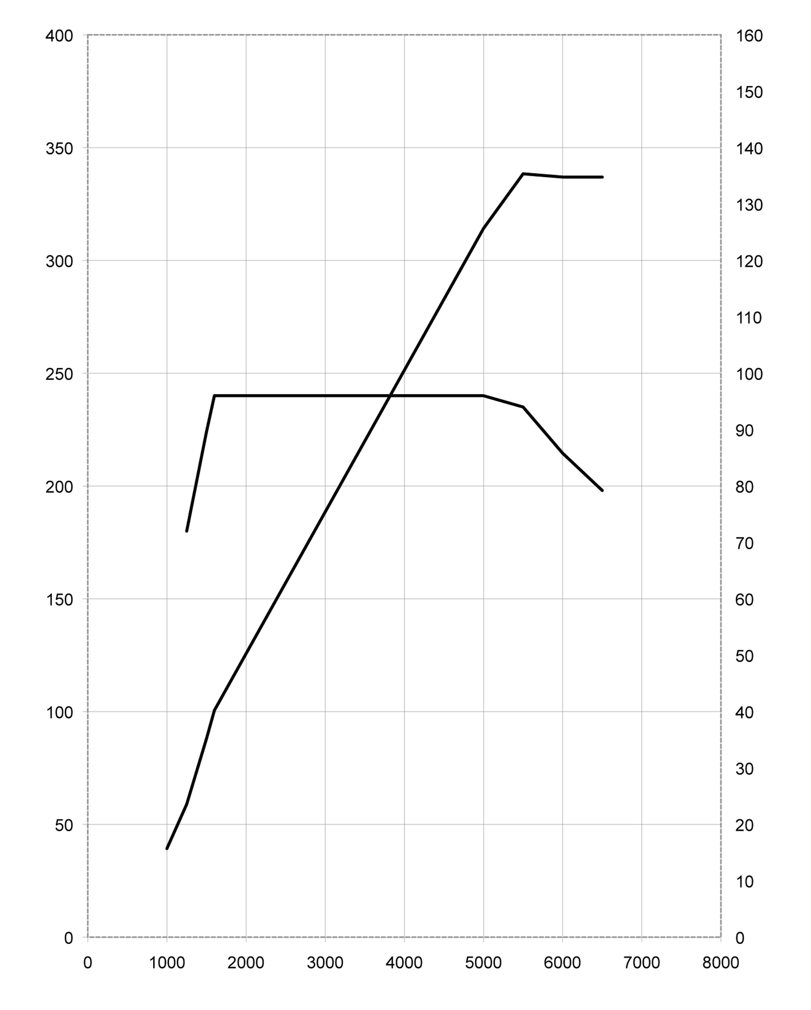
Engine speed [min⁻¹]
Torque [Nm]
Output [kW]

MINI Cooper Countryman.
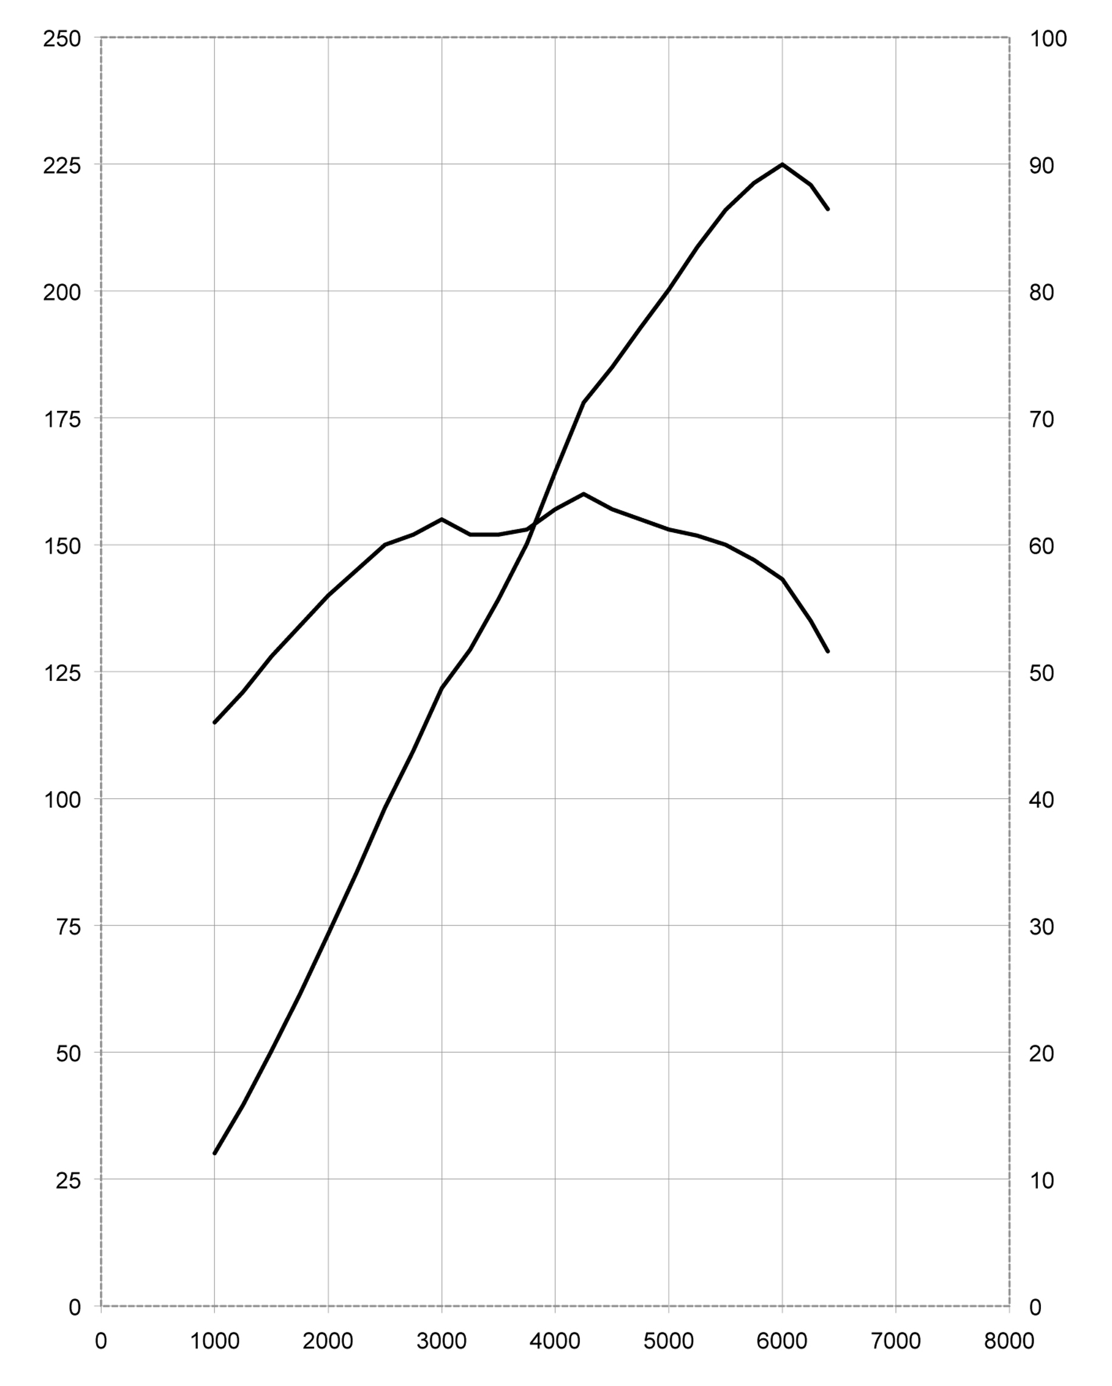

90 kW @ 6000 min⁻¹

160 Nm @ 4250 min⁻¹

Output [kW]

Engine speed [min⁻¹]
Torque [Nm]

MINI One Countryman.
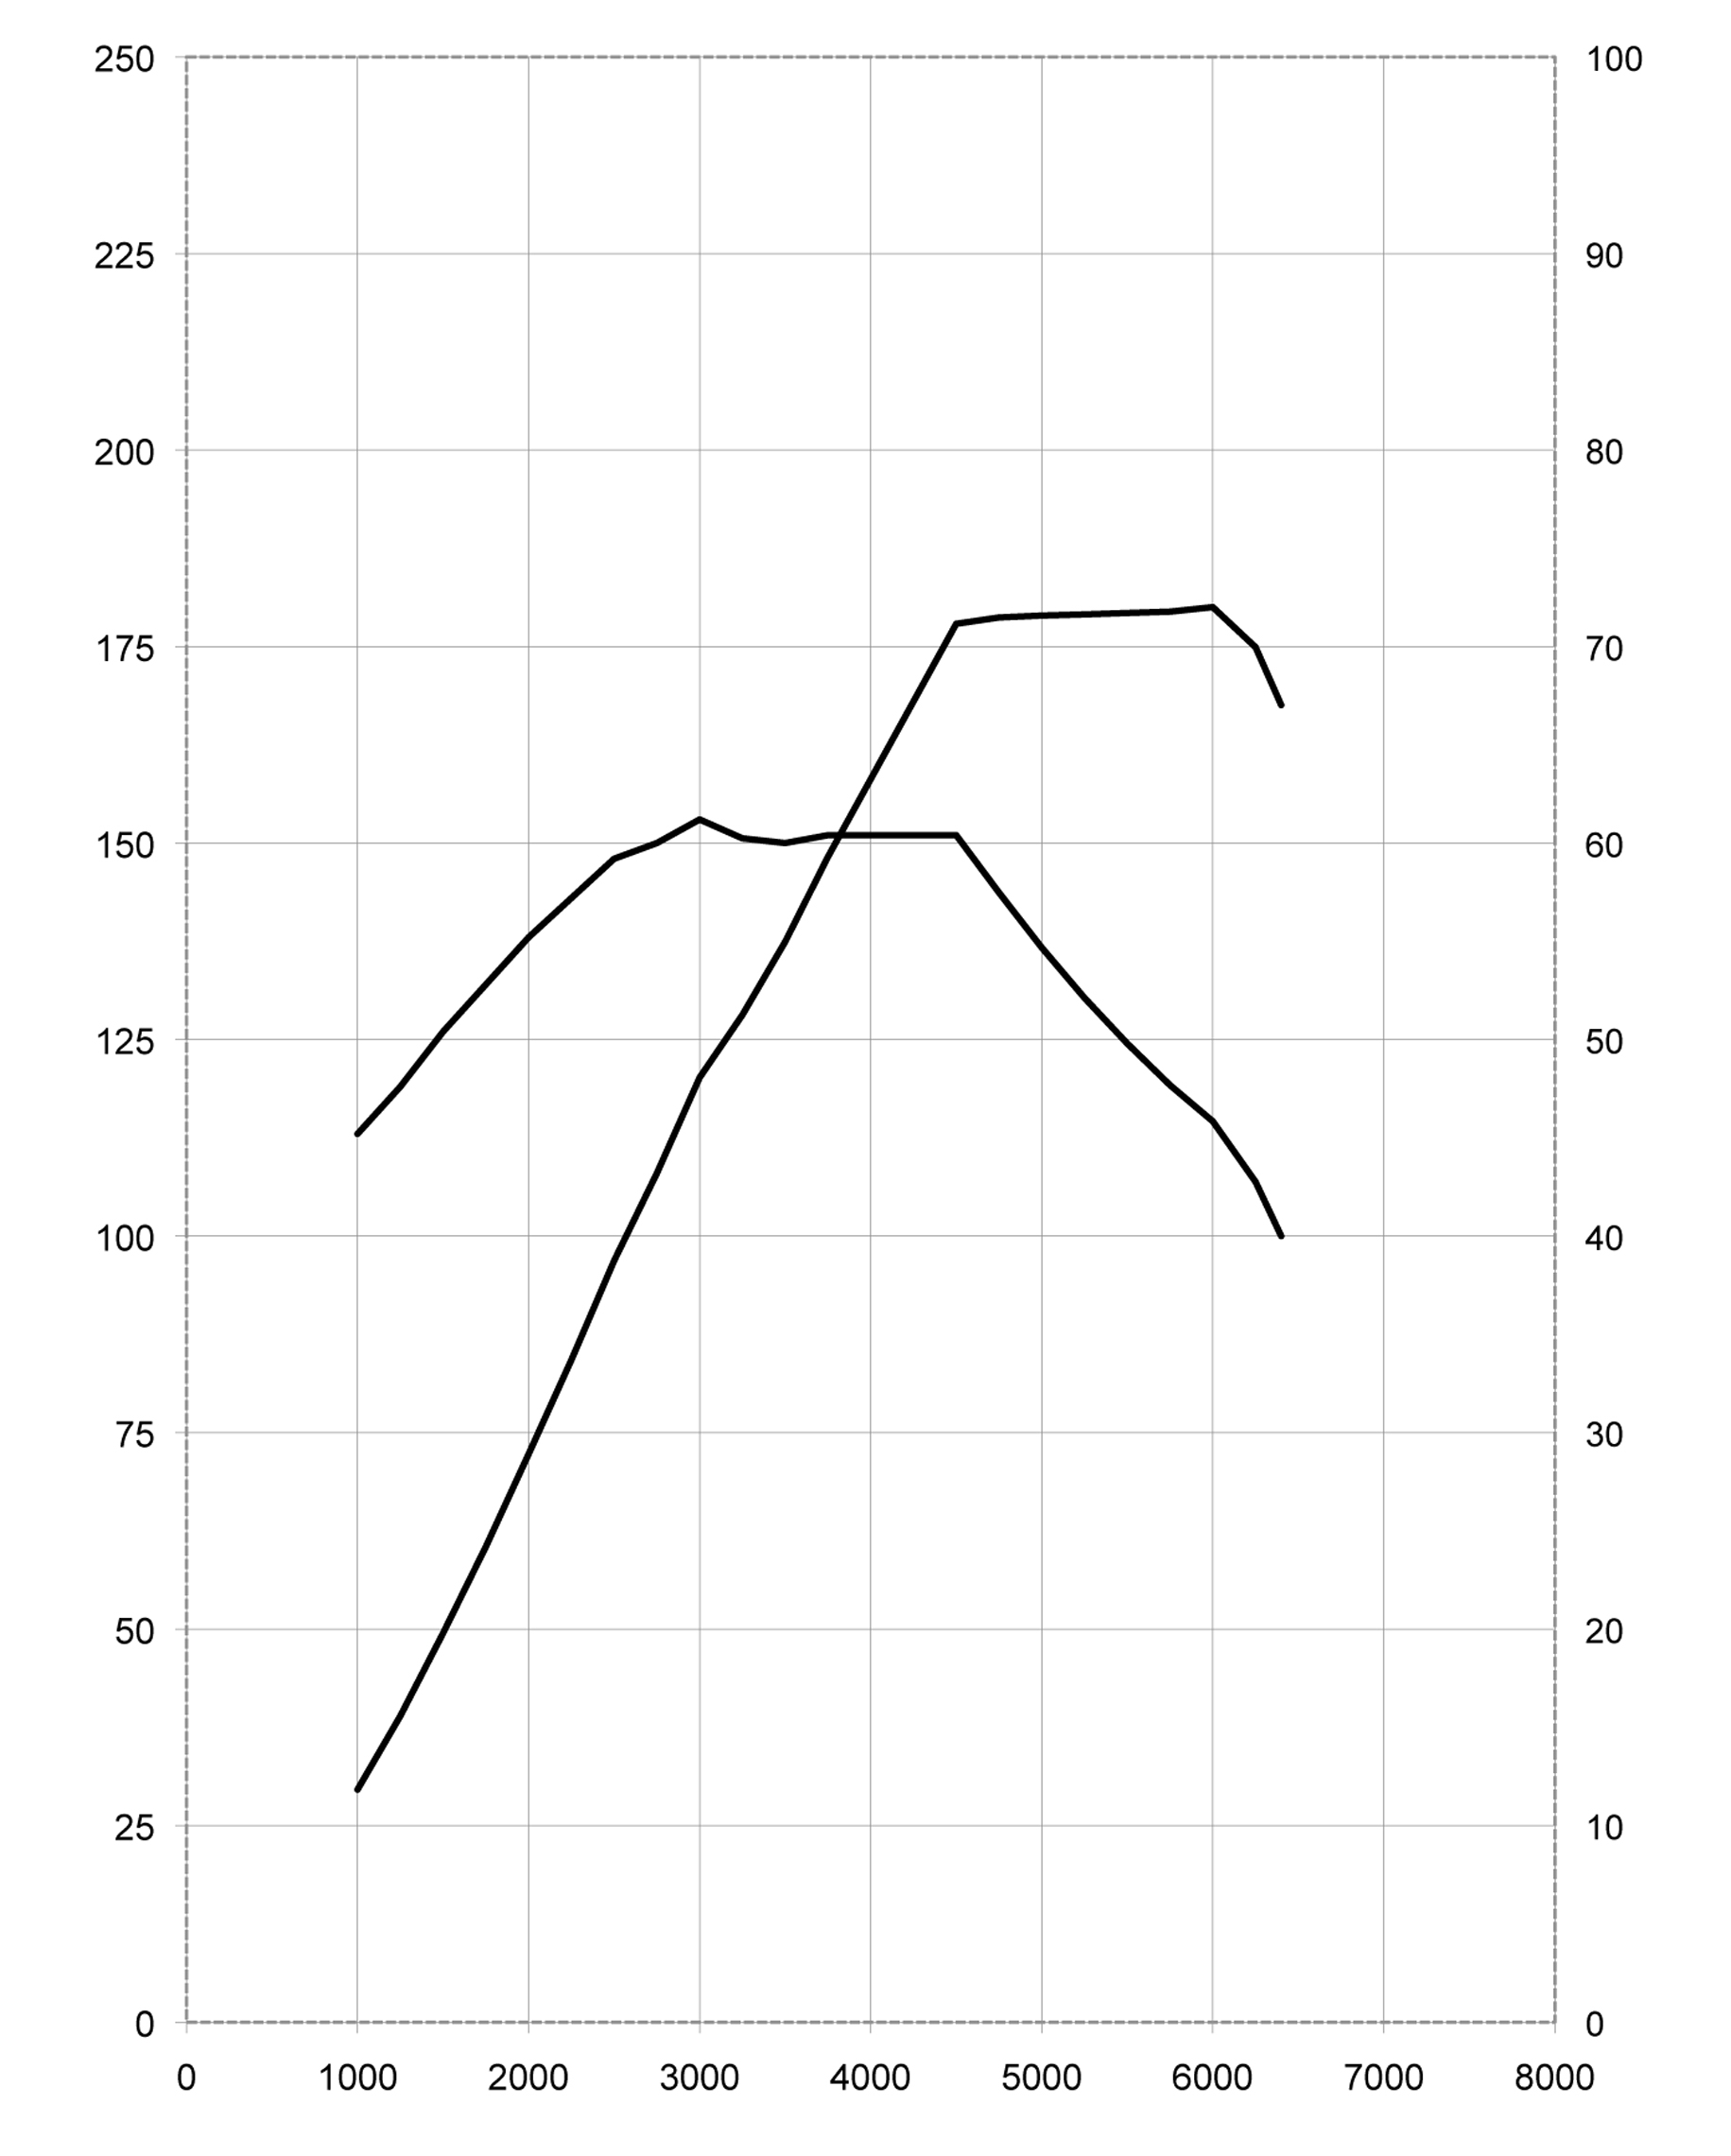

72 kW @ 6000 min⁻¹
153 Nm @ 3000 min⁻¹

Torque [Nm]
Output [kW]

Engine speed [min⁻¹]

MINI Cooper D Countryman.
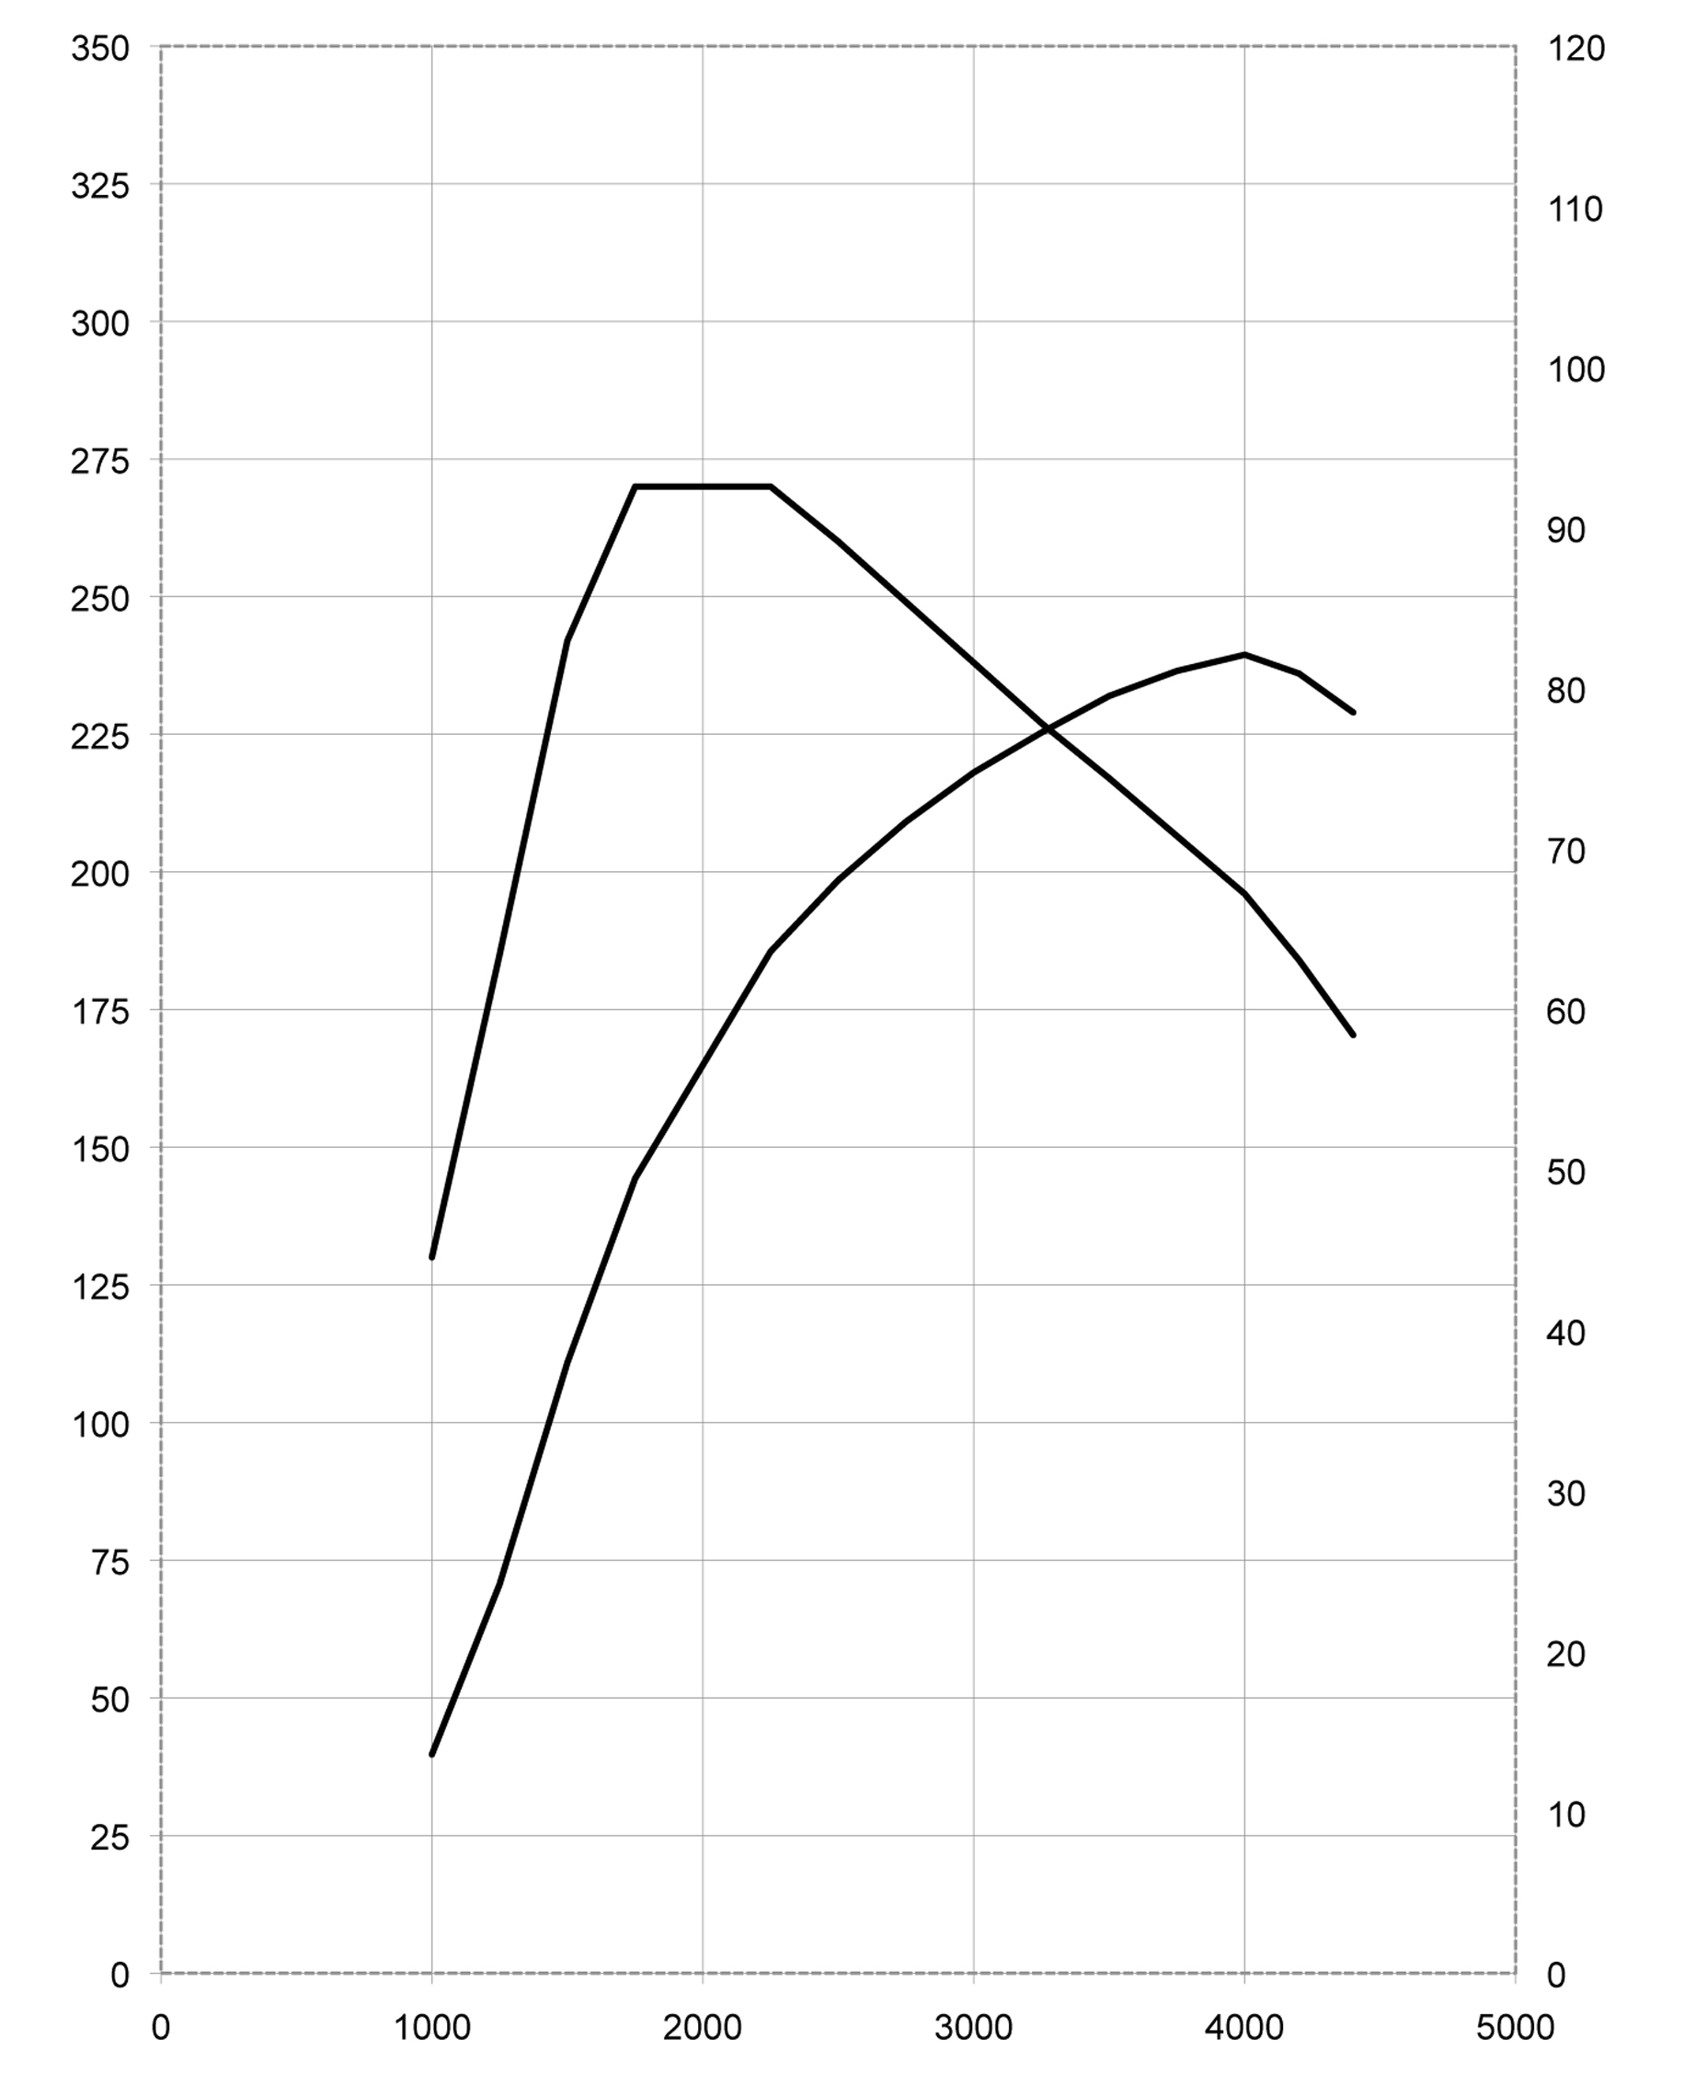

Output [kW]

Torque [Nm]
270 Nm @ 1750-2250 min⁻¹
82 kW @ 4000 min⁻¹

Engine speed [min⁻¹]

MINI One D Countryman.
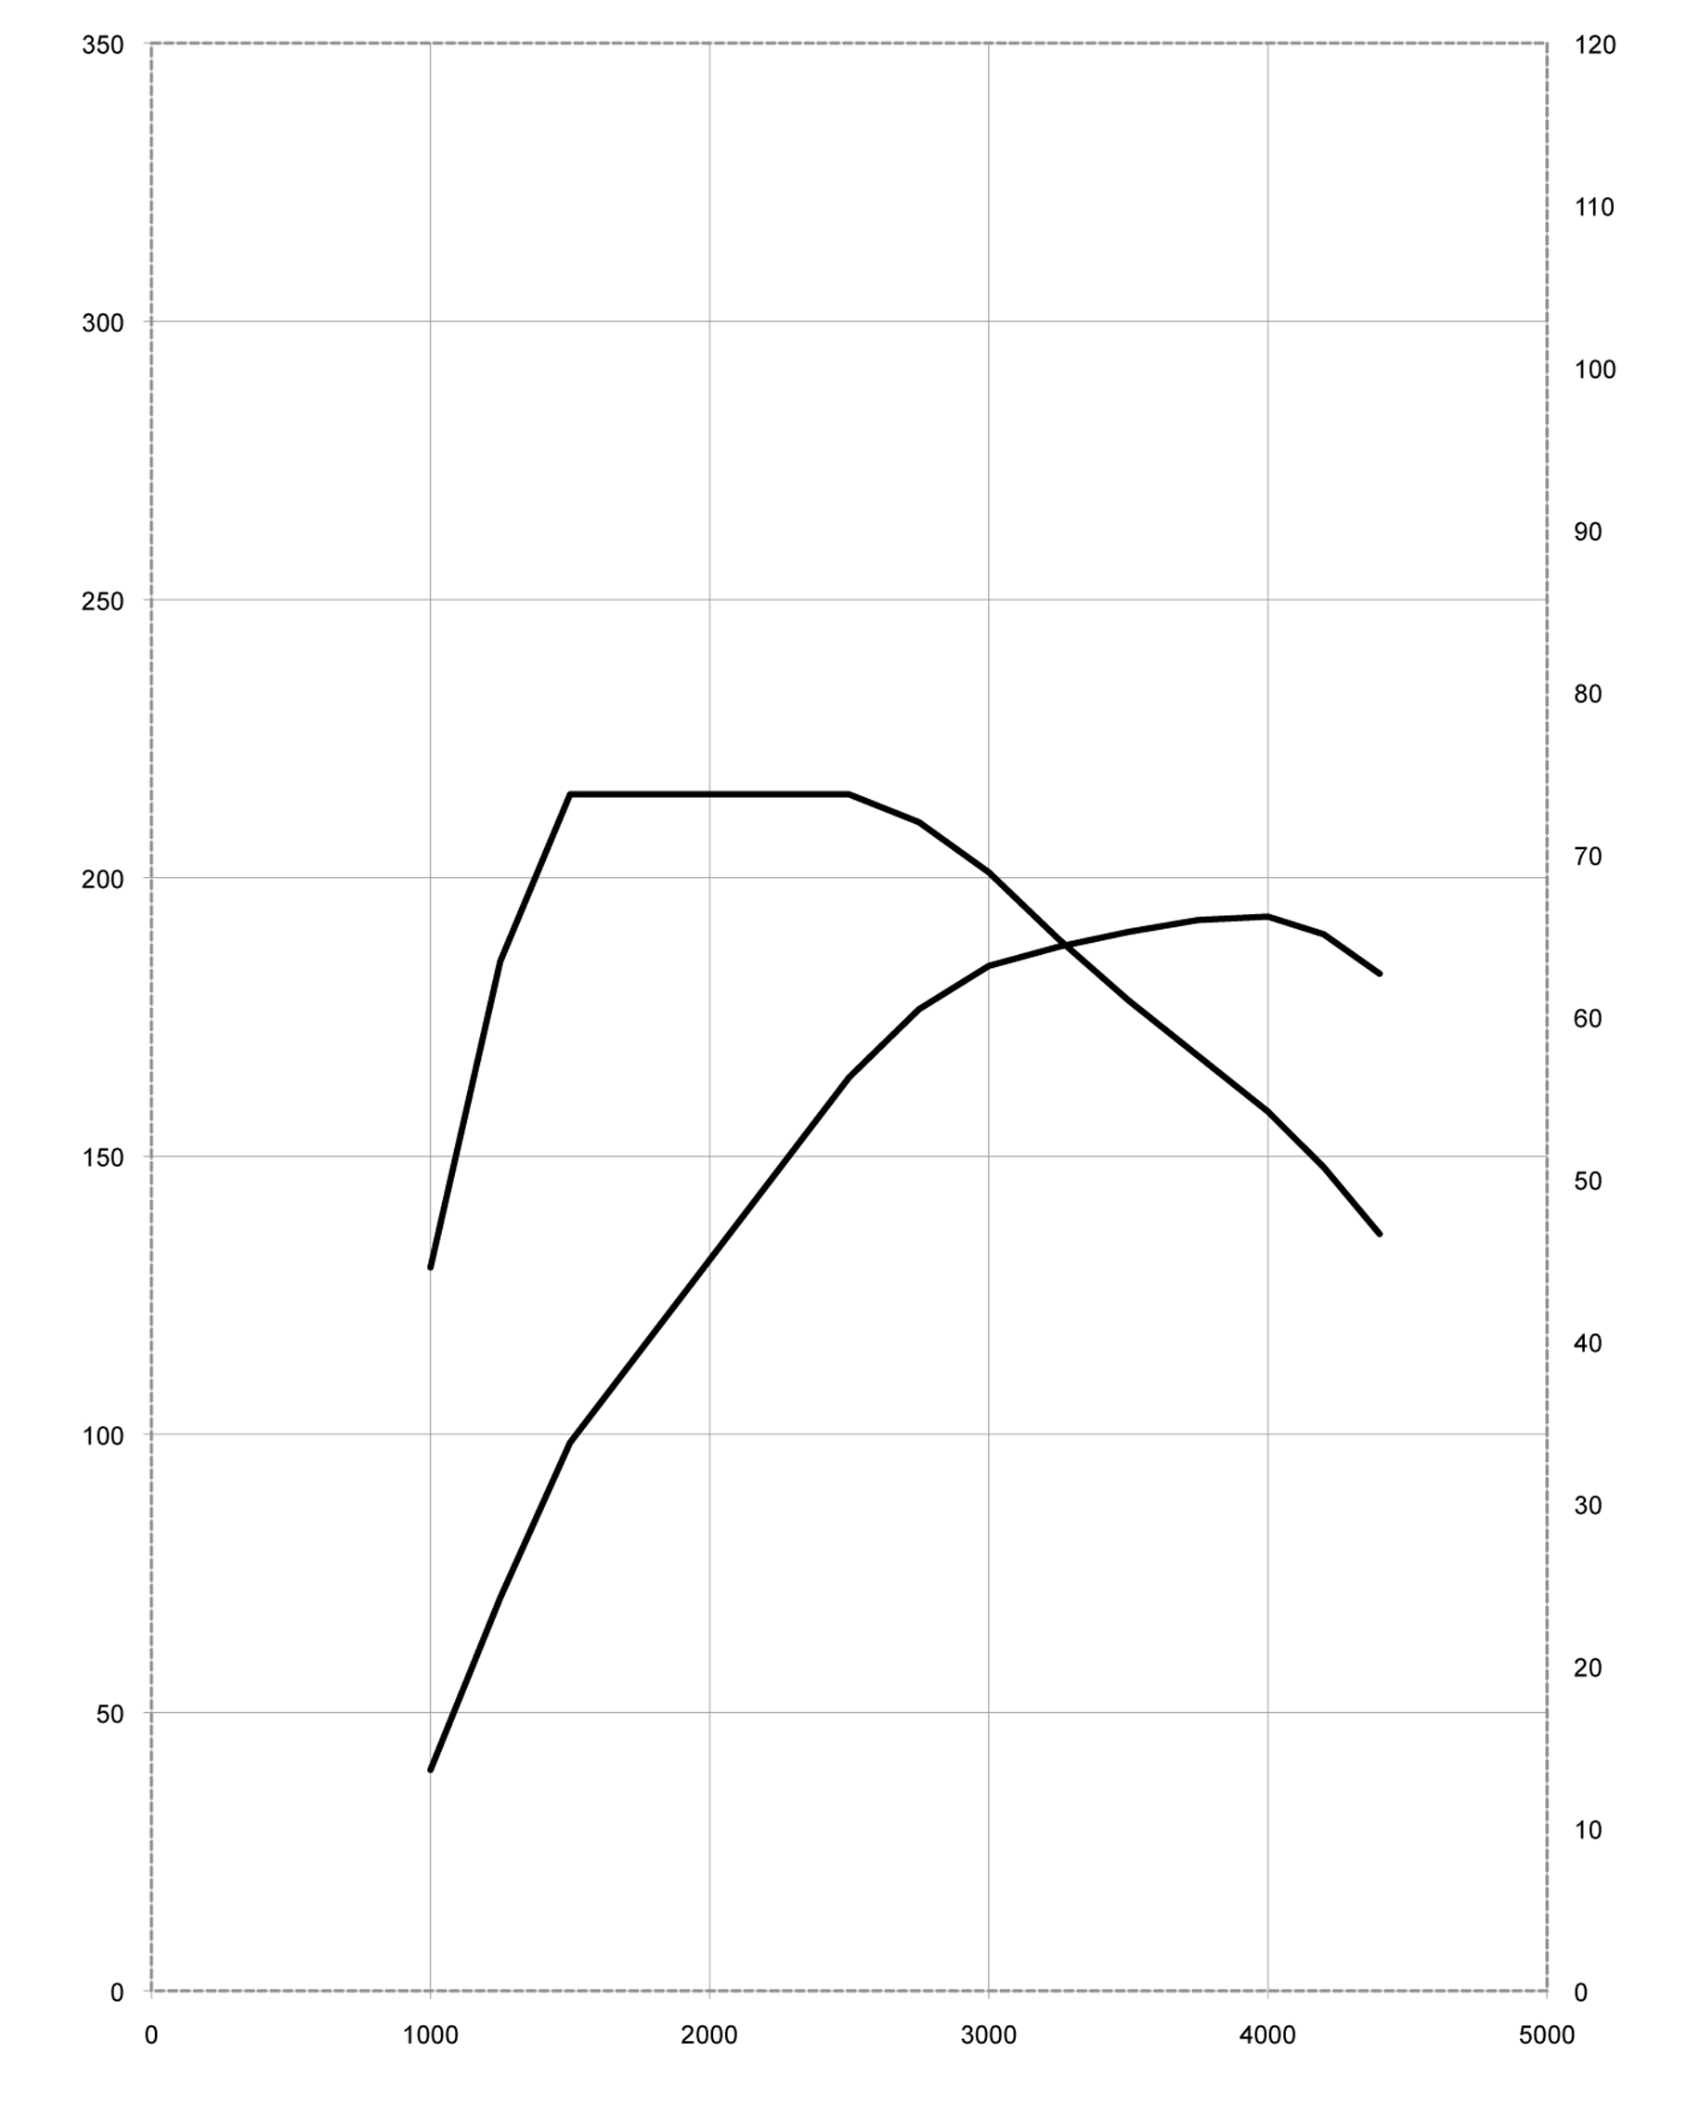

215 Nm @ 1750-2500 min⁻¹
66 kW @ 4000 min⁻¹

Output [kW]

Torque [Nm]

Engine speed [min⁻¹]

8. Exterior and
Interior Dimensions.

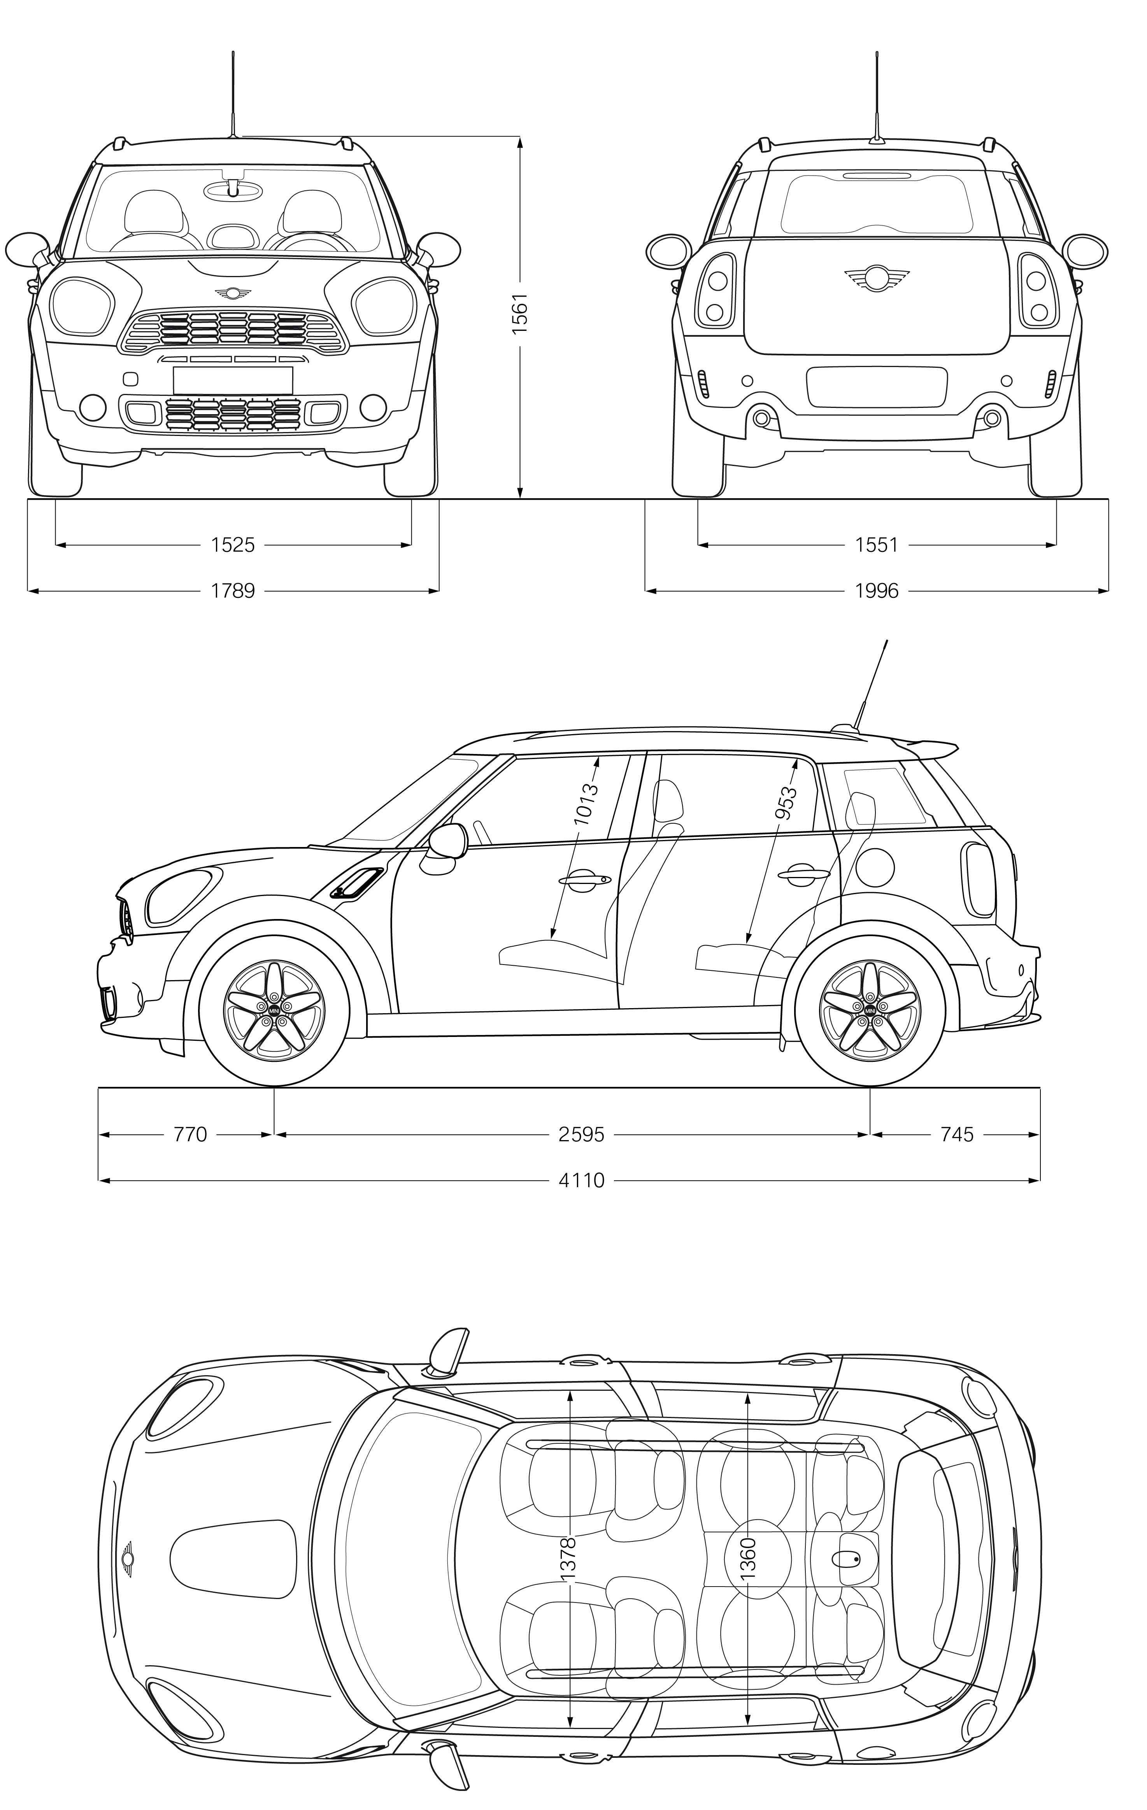MINI Cooper S Countryman.

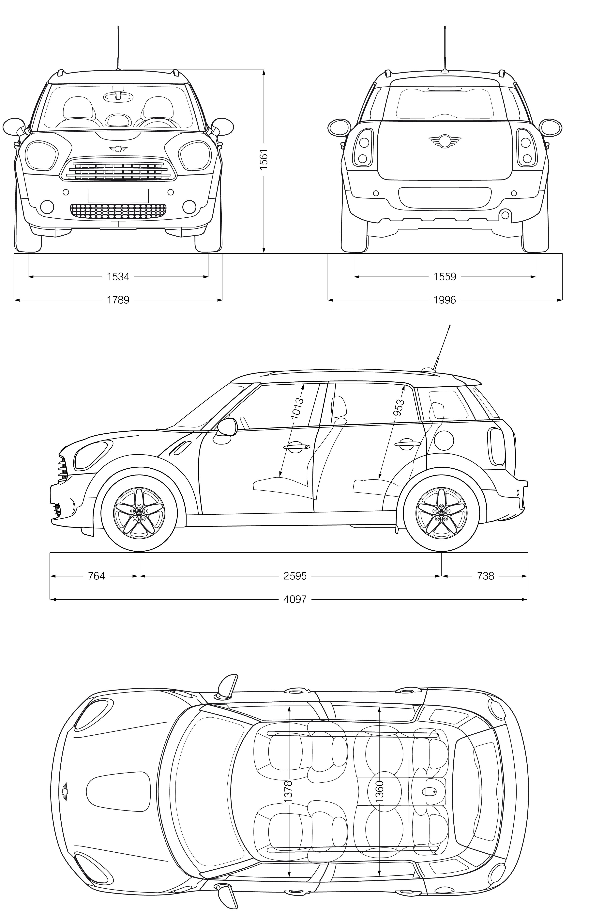MINI Cooper Countryman.

