MINI
Corporate Communications

Media Information
22 June 2010

Company
Bayerische
Motoren Werke
Aktiengesellschaft

Postal Address
BMW AG
80788 München

Telephone
+49 89 382-149808

Internet
www.bmwgroup.com
Waka waka Makarapa!

MINI mingles with the fans of the world championship in South Africa.

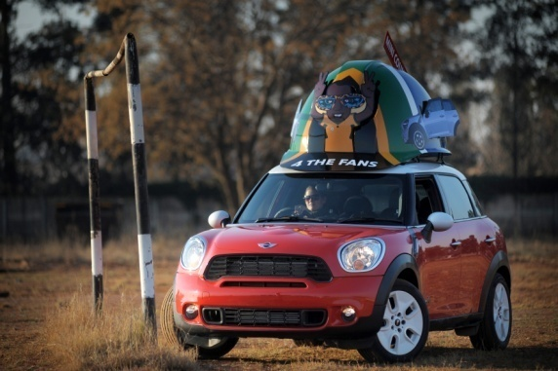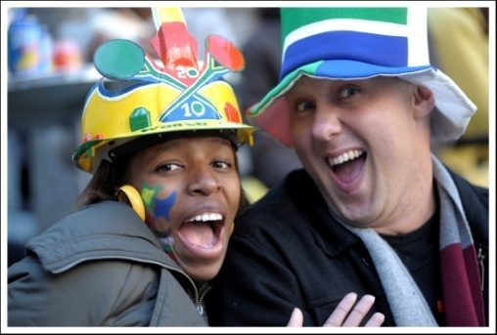

Munich/South Africa.The MINI Countryman in its typical way of being wears the popular and individually created hardhat and mixes up with the soccer fans in South Africa. If you believed the Vuvuzela had been the craziest South African fan article, you were wrong! Next to the famous plastic-trumpet, the Makarapa is the top-football-item in South Africa.

For those not familiar with this design innovation, a Makarapa is a workman’s safety helmet that has been completely remodelled and customised according to the individual tastes of the football supporter wearing it. Each handcrafted, colourfully painted headdress is worn with pride and becomes an artwork in its own right.
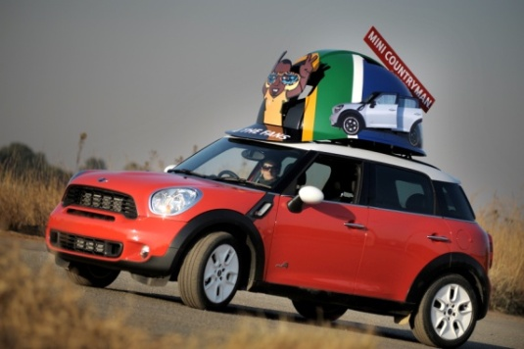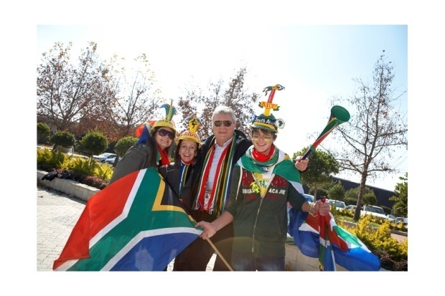

Makarapa literally translated means ‘Migrant Worker’ and gains its origin from the safety helmets worn by the migrant labourers working in the gold mines of Johannesburg.

In short, the story goes that in 1979 – the year MINI turned 20 – Alfred Boloyi was in the stands watching a football match when a friend was hit on the head by a flying bottle. For protection, Alfred wore a workman’s helmet to the next game, which he painted in the colours of his team. The headgear was an instant hit.

From humble beginnings – just like MINI – the Makarapa has grown into a style institution: unique, quirky and an extension of its owner’s individual personality. The “true” combination of a crazy South African football style does not only consist of the much sought Vuvuzelas, indeed the exotically created Makarapas can be added. So it is obvious that MINI follows this style and creates its own Makarapa-design in South Africa.

“Waka waka” – This time for Africa!

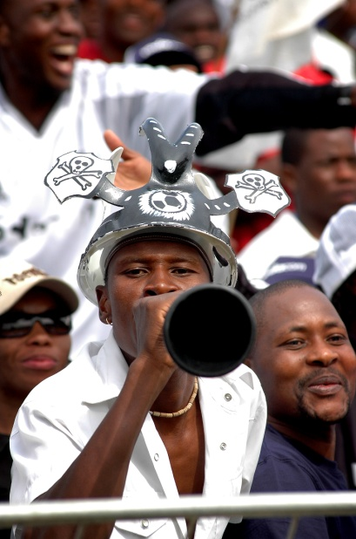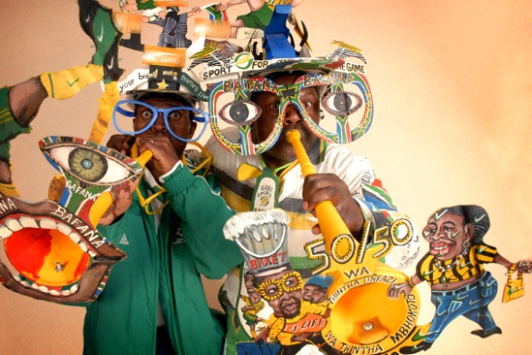

For more information log onto:

www.mini.co.za/6colourstostandby/
www.makarapa.com.

For questions please contact:

Corporate and Governmental Affairs

Martina Daschinger, Business and Finance Communications, Marketing
phone: +49 89 382-14908, fax: +49 89 382-24418
Markus Sagemann, Business and Finance Communications, Sales
phone: +49 89 382-68796, fax: +49 89 382-24418

Internet: www.press.bmwgroup.com
e-mail: presse@bmw.de

The BMW Group
The BMW Group is one of the most successful manufacturers of automobiles and motorcycles in the world with its BMW, MINI and Rolls-Royce brands. As a global company, the BMW Group operates 24 production facilities in 13 countries and has a global sales network in more than 140 countries.
The BMW Group achieved a global sales volume of approximately 1.29 million automobiles and over 87,000 motorcycles for the 2009 financial year. The pre-tax profit for 2009 was euro 413 million, revenues totalled euro 50.68 billion. At 31 December 2009, the company employed a global workforce of approximately 96,000 associates.
The success of the BMW Group has always been built on long-term thinking and responsible action. The company has therefore established ecological and social sustainability throughout the value chain, comprehensive product responsibility and a clear commitment to conserving resources as an integral part of its strategy. As a result of its efforts, the BMW Group has been ranked industry leader in the Dow Jones Sustainability Indexes for the last five years.

