1. Description in Brief. 2

The new MINI Convertible.
Contents.
2. Consistently Open: The new MINI Convertible.
(Short Version) 5
3. Typically MINI – and More Expressive than Ever.
Design. 20
4. Fresh Power for Efficient Driving Pleasure.
Engines and Transmissions. 26
5. Supreme Handling, Supreme Safety.
Chassis and Suspension. 32
6. Innovative Solutions for Enhanced Variability and Occupant Safety.
Body and Safety. 35
7. Individual Style All the Way.
Equipment and Accessories. 40
8. Flexible, Efficient and Quality-Minded.
Production. 44
9. Specifications. 49
10. Exterior and Interior Dimensions. 51
11. Output and Torque Diagrams. 53


- New edition of the highly successful open four-seater accounting for worldwide sales of some 164,000 units, continuation of the third body version within the MINI model family. The new MINI Convertible symbolises the thrill of motoring in the open air and bears out the unmistakable style of the MINI brand. Moving up to an even higher standard than on the former model, the unique features of the MINI Convertible in its segment in terms of design, premium quality, handling, performance, efficiency, and functionality have been appropriately enhanced and improved to perfection.
- Description in Brief.
- Evolutionary enhancement of the car’s design: The body with two doors and a soft roof including a separate sliding roof function ensures unique, unmatched proportions, sleek, horizontal lines, and truly individual style. Design language typical of the brand, design features and proportions clearly making the new model a genuine, fully-fledged member of the MINI product family.
- Refined, sophisticated overall appearance highlighting the stretched silhouette and ensuring enhanced presence from both front and rear. Sophisticated, beautifully modelled body surfaces, roadster-like flair ensured by the low roofline, rollover safety bar hidden away out of sight. Front and rear light design as on the current MINI models. Inner-mounted four-pivot joints for the luggage compartment lid ensure a harmonious and smooth look with even greater emphasis on the wide rear end.
- Electrohydraulic operation of the roof including sliding roof function featured as standard. Option to open and close the soft top while driving at a speed of up to 30 km/h or 20 mph. Optional Always-Open Timer as a special feature determining the time spent travelling with the roof down. Even wider range of paintwork colours, roof colours, wheel rims, upholstery and interior trim providing even greater freedom in customising the car. Model-specific range of optional extras and special equipment.
- Newly developed, electromechanically operated rollover bar behind the rear seats, activated by the car’s central safety electronics in the event of a possible rollover. The innovative, absolutely unique principle of a single-piece safety bar allows optimum visibility to the rear and facilitates visibility to the side. A further advantage is the option to integrate an exceptionally large through-loading storage option between the luggage and passenger compartments.
- Outstanding functionality ensured by the flexible storage concept. Easy-load system providing an even larger opening into the luggage compartment, rear seat backrests folding down individually and lockable in position, luggage compartment cover fastening in two positions, as required. Luggage compartment capacity increased to 125 litres (+5) (4.38 cu ft) with the roof open, 170 litres (+5) (5.95 cu ft) with the roof closed, and 660 litres (+55) (23.10 cu ft) with the rear-seat backrest folded down.
- New generation of four-cylinder petrol engines with twin-scroll turbochargers or, respectively, fully variable valve management. Engine capacity 1,598 cc, max output 88 kW/120 hp (MINI Cooper Convertible) and 128 kW/175 hp (MINI Cooper S Convertible). Both engine variants with a wide range of technical features serving to optimise both fuel economy and emissions: Auto Start Stop, Brake Energy Regeneration, gearshift point indicator.
- Front-wheel drive, go-kart feeling typical of the brand with refined suspension technology tailored specifically to the MINI Convertible. Electric Power Steering (EPS). Brake system with anti-lock brakes (ABS), Electronic Brake Force Distribution (EBD), Cornering Brake Control (CBC), and Brake Assistant as well as Dynamic Stability Control (DSC) including Start-Off Assistant all featured as standard. Dynamic Traction Control (DTC) including electronically controlled limited-slip differential function on the drive wheels available as an option.
- Crash-optimised body structure with newly conceived floorpan and A-pillars and side-sills appropriately reinforced for a convertible. Body stiffness further improved over the former model, with a reduction in vehicle weight by 10 kg or 22 lb. Three-point inertia-reel seat belts on all seats, with belt latch tensioners and belt force limiters at the front, frontal airbags, head/thorax airbags at the side integrated in the seat backrest, rollover sensor masterminding the rollover safety system, airbags and belt letch tensioners optimised in their function. Runflat tyres and Tyre Defect Indicator.
- Engine variants:
MINI Cooper S Convertible:
Four-cylinder petrol engine with twin-scroll turbocharger and
direct fuel injection.
Capacity: 1,598 cc
Max output: 128 kW/175 hp at 5,500 rpm
Max torque: 240 Nm/177 lb-ft from 1,600–5,000 rpm
(260 Nm/192 lb-ft with Overboost)
Acceleration 0–100 km/h: 7.4 sec
Top speed: 222 km/h (138 mph)
Average fuel consumption to EU standard: 6.4 litres/100 km
(equal to 44.1 mpg imp), CO2 rating: 153 g/km
- MINI Cooper Convertible:
Four-cylinder petrol engine with fully variable valve management based on the BMW Group’s VALVETRONIC technology.
Capacity: 1,598 cc
Max output: 88 kW/120 hp at 6,000 rpm.
Max torque: 160 Nm/118 lb-ft at 4,250 rpm.
Acceleration (0–100 km/h): 9.8 sec
Top speed: 198 km/h (123 mph)
Average fuel consumption to EU standard: 5.7 litres/100 km
(equal to 49.6 mpg imp), CO2 rating: 137 g/km
The driving pleasure and individual style so typical of the MINI are now being combined once again with all the flair and refreshment of driving in the open air, the new MINI Convertible offering this unique rendition of motoring freedom in particularly intense style.
- Consistently Open:
The new MINI Convertible.
(Short Version)
With its design improved in an evolutionary process and an even wider range of practical functions, with the most advanced and sophisticated suspension technology, even more powerful and, at the same time, economic engines, and with optimised safety technology, the new version of the open-air four-seater MINI consistently raises its strengths and qualities to an even higher level.
At the same time new and highly attractive colour variants as well as equipment features add an additional touch of style and class. And last but certainly not least, supreme quality of materials and finish enhances the unique position of the MINI Convertible as the only open premium car in its segment.
The occupants are safely protected from wind and weather also in the new MINI Convertible by the high-quality soft top with its integrated sliding roof function. Even while driving at a speed of up to 30 km/h or 20 mph, the soft top folds back fully automatically in a smooth, uninterrupted process within just 15 seconds, giving the new MINI Convertible its true purpose and quality: This is a car simply begging for driving in the open air at any time of the year, symbolising this challenge to the driver through the optionally available, absolutely unique Always-Open Timer next to the rev counter.
This unprecedented instrument shows the driver and passengers the time they have spent driving with the roof down – motivating the driver to really enjoy the thrill of open-air motoring as frequently as possible.
The new MINI Convertible offers outstanding everyday driving qualities through the Easy-Load Function, the rear-seat backrest folding down individually on either side, the split rear-seat backrest, as well as the unusually large through-loading between the luggage and passenger compartment, increasing luggage capacity to an astounding 660 litres or 23.10 cu ft.
This variability quite unique in the convertible segment is made possible by the innovative design and construction of the rollbar: The new MINI Convertible comes with a single-piece rollbar behind the rear seats extending across the complete interior width of the car, not obstructing the driver’s line of visibility in any way when looking to the rear, and moving up automatically only in the event of an imminent rollover.
The new MINI Convertible is entering the market in two engine variants. The MINI Cooper Convertible offers sporting qualities right from the start with its 1.6-litre four-cylinder power unit featuring fully variable valve management for maximum output of 88 kW/120 hp at 6,000 rpm.
The MINI Cooper S Convertible is even more dynamic and performance-oriented, its 1.6-litre four-cylinder with a twin-scroll turbocharger and direct gasoline injection delivering 128 kW/175 hp at an engine speed of 5,500 rpm and thus providing a particularly refreshing feeling of power and dynamic performance.
Both engine variants come as standard with the latest technologies for reducing both fuel consumption and emissions, including Brake Energy Regeneration as well as Auto Start Stop and a gearshift point indicator on the manual gearbox models.
Benefiting from this extremely efficient drive technology, fuel consumption and CO2 emissions on the new MINI Convertible are reduced by up to 23 per cent compared with the cars’ respective predecessors.
The new MINI Convertible owes its fascinating handling to suspension technology significantly enhanced and upgraded over the former model. Indeed, thanks to sophisticated wheel suspension, extremely precise electromechanical power steering, the powerful brake system and DSC Dynamic Stability Control featured as standard, the open-air MINI combines supreme agility with equally exemplary safety all round.
Design: MINI all the way, open-air motoring without compromises, and unique proportions.
The design of the MINI Convertible is the result of an evolutionary development process. Compared with the former model, the new MINI Convertible is clearly more muscular and more mature at very first sight, the beautifully chiselled body surfaces giving the new MINI Convertible an even more powerful and dynamic look.
The stretched side view exudes an even greater sense of sporting
performance, the rollbar almost entirely concealed from sight boasting a silhouette clearly inspired by the classic roadster with the roof down.
A chrome bar extending round the entire body horizontally at shoulder level connects the body of the car as such with the roof and windows. The windscreen standing upright underlines the character of this uncompromising open-air performer not only through its looks, with the driver and front passenger quite literally sitting in the open air whenever the roof is down.
The open-air version of the brand is unmistakably a MINI at very first sight. The proportions of the car with short overhangs front and rear, larger wheel cut-outs, the height of the waistline and numerous design features again characteristic of the brand clearly reveal that this is a genuine MINI in every respect.
The entire front view is likewise MINI all the way, including the specific features distinguishing the MINI Cooper S Convertible from the MINI Cooper Convertible. Both models come with the hexagon radiator grille and large round headlights with integrated direction indicators in typical MINI style, forming one complete, self-contained element. The MINI Cooper S Convertible is nevertheless clearly recognisable by its Powerdome rising up 20 millimetres or almost 0.8“, the stylised opening on the engine compartment lid, and the hexagonal grid pattern on the radiator grille as well as the extra-large lower air intake scoop.
On the MINI Cooper Convertible the radiator grille boasts a chrome frame and three horizontal, chrome-plated bars. The edges on the lower air intake scoop flow slightly upwards in particular attractive style.
Like the front-end design, the rear view of the new MINI Convertible offers a clear enhancement of the car’s visual presence. The entire rear section is characterised by horizontal lines running parallel to one another, creating the softly flowing “steps” also to be admired on the MINI Hatch in emphasising the width of the car.
The rear lid of the new MINI Convertible opening up to the bottom comes with hinges mounted on the inside, giving the entire rear section a smooth and homogeneous surface again emphasising the powerful look of the rear end.
Standing upright in position, the rear lights are somewhat larger than on the former model. Again as on the MINI Hatch, they are surrounded by chrome frames separated from the lights themselves and therefore emanating a particular touch of class and style.
Optimised all-round visibility ensured by even larger side windows and the retractable rollbar.
The soft roof of the new MINI Convertible stands out in particular through its unique design and very practical functionality. With the roof closed the MINI Convertible comes with the proportions typical of the car, the sporting look being additionally emphasised by the low roofline.
The high-quality, absolutely wind-tight and very hard-wearing textile material rests firmly on the roof bars made of steel and aluminium, thus avoiding virtually any change in shape or bulging effect even at high speeds.
All-round visibility with the roof closed further improved over the former model results, first, from the slightly larger side windows and, second, from the newly conceived, retractable rollbar. This single-piece rollbar moving up and down as required runs across the entire width of the car just below the rear headrests, thus offering the driver unrestricted visibility without any obstruction to the rear.
Soft roof with sliding roof function – also for convenient
use while driving.
The soft roof opens and closes completely within just 15 seconds, naturally with fully automatic, electrohydraulic control. After the roof has opened, it folds down snugly into the rear end of the car. And since the outer skin of the open roof faces upwards, there is no need for a tonneau cover providing particular protection.
The opening and closing mechanism is activated by a toggle switch on the front roof frame in typical MINI design. In order to ensure the spontaneous pleasure of open-air motoring or respond quickly to a sudden downpour, the opening and closing process may be initiated at road speeds of up to 30 km/h or 20 mph. A further point is that the driver is able to open the soft top before setting out by means of the remote control integrated in the ignition key.
The window bars and side windows on the MINI Convertible are retracted electrically as soon as the soft roof starts to move back, again in a fully automated process. The closing process then takes place in exactly the opposite order.
Both processes – opening and closing – are performed in a continuous flow, as long as the driver keeps the switch on the roof frame pressed down.
The unique folding roof function on the new MINI Convertible is activated completely by electric power. In this case the front section of the soft top moves back by up to 40 centimetres or approximately 16 inches, again by pressing the switch on the front roof frame. A further benefit is that the driver and occupants are able to enjoy this particular pleasure of driving with a sliding roof at speeds of up to 120 km/h or 75 mph.
Guarantee for unique driving pleasure: the latest generation
of four-cylinder power units.
Muscular, fast-revving and extremely efficient – these are the fortes of the two four-cylinder petrol engines available in the new MINI Convertible upon its entry into the market. Indeed, thanks to these engines the generation change on the open-air MINI comes with an enormous increase in driving pleasure and, at the same time, significant progress in all-round economy. Compared with the former models, fuel consumption and CO2 emissions are down by 23 (MINI Cooper S Convertible) and, respectively, 22 (MINI Cooper Convertible) per cent.
Both power units are made of light alloy and come with a displacement of 1,598 cc, featuring exactly the same distance between cylinders, as well as the same bore and stroke. At the same time they naturally benefit from all the know-how of the BMW Group in engine development and high-tech carried over from motorsport.
The four-cylinder light-alloy power units are built at the BMW Group’s Hams Hall Engine Plant in Great Britain. Compared with the former model, both engines are fitted in the engine bay of the MINI Convertible at an angle of 180°, with the exhaust side now facing to the front.
MINI Cooper S Convertible: superior power and performance thanks to twin-scroll turbocharger and direct gasoline injection.
The new MINI Cooper S Convertible offers a more intense and thrilling experience of performance than ever before. As the more powerful of the two new models, the MINI Cooper S Convertible comes with a 1.6-litre four-cylinder delivering no less than 128 kW/175 hp at 5,500 rpm with the help of a twin-scroll turbocharger and direct gasoline injection. In the range between 1,600 and 5,000 rpm, this unique power unit develops maximum torque of no less than 240 Newton-metres or 177 lb-ft, further increased briefly by the Overboost function to 260 Newton-metres or 192 lb-ft whenever necessary.
The twin-scroll turbocharger is particularly effective in boosting power and performance on the MINI Cooper S Convertible. The ducts of two cylinders at a time are separated from one another in the exhaust manifold and turbocharger, serving to reduce exhaust gas counterpressure at low engine speeds in order to capitalise on the dynamic effect of the pulsating gas columns in the manifold. This effect enhances turbocharger response and ensures a particularly spontaneous build-up of engine power.
As a result, the MINI Cooper S Convertible is virtually free of the “turbo gap” when accelerating so typical of a conventional turbocharged engine. Acceleration to 100 km/h comes in just 7.4 seconds, engine flexibility and response is truly impressive also at high speeds, and the top speed of the car is an equally impressive 222 km/h or 138 mph.
The turbocharged four-cylinder featured in the MINI Cooper S Convertible benefits from the extra power of direct fuel injection applying the common-rail principle. The stainless-steel common rail linking all cylinders is filled with fuel by a high-pressure pump at the rear end of the intake camshaft. Injection valves positioned at the side of the cylinder head then deliver fuel within fractions of a second and in exact dosage from the common rail directly to the combustion chamber.
With this combination of a twin-scroll turbocharger and direct fuel injection, the new MINI Cooper S Convertible offers remarkable performance in several respects: Specific output of the engine is approximately 110 hp per litre and fuel consumption in the EU test cycle is 6.4 litres/100 kilometres (equal to 44.1 mpg imp), with a CO2 rating of 153 grams per kilometre.
MINI Cooper Convertible: fully variable valve management for fresh performance.
Likewise displacing 1.6 litres, the normal-aspiration power unit in the new MINI Cooper Convertible combines fresh and sporting performance with truly outstanding economy all in one. In this case maximum output of 88 kW/120 hp comes at 6,000 rpm, torque peaking at 160 Newton-metres or 118 lb-ft at 4,250 rpm.
The innovative technical features of this four-cylinder include fully variable valve management developed on the basis of the BMW Group’s unique VALVETRONIC technology. The particular forte of this valve control concept is that intake valve lift and the valve opening period are adjusted to the driver’s respective power and performance requirements within fractions of a second. A further point is that valve timing is varied on both the intake and exhaust side as a function of engine speed.
Interacting with one another, variable valve management and engine speed-related camshaft control serve to optimise both the torque curve and power output. Hence, the engine of the MINI Cooper Convertible delivers superior torque right from the start at low speeds, then developing significantly more power than a conventional engine at high revs.
A further advantage offered by both technologies is the significant reduction of fuel consumption: While the new MINI Cooper Convertible accelerates to 100 km/h in 9.8 seconds and reaches a top speed of 198 km/h or 123 mph, fuel consumption in the EU test cycle is a mere 5.7 litres/100 kilometres (equal to 49.6 mpg imp) and the engine’s CO2 rating is just 137 grams per kilometre.
Light, innovative, efficient: most advanced drive technology for reduced fuel consumption and emissions.
Both engines featured in the new MINI Convertible are fitted crosswise at the front and convey their superior power to the front wheels. Composite – instead of cast – camshafts and the crankshaft optimised for weight are part of the lightweight concept boasted by these all-aluminium power units.
Fuel consumption is further optimised by an oil pump with volume flow control and an electronically activated water pump for the coolant circuit. And last but not least in this context, both the MINI Cooper S Convertible and the MINI Cooper Convertible come as standard with the latest innovations for reducing both fuel consumption and emissions.
These innovations serve to optimise engine efficiency and at the same time enhance the standard of driving pleasure. A wonderful example in this context is Brake Energy Regeneration where the power of the engine is converted primarily into actual drive power and electricity is generated for the car’s on-board network only when the car is actually moving in overrun or when the driver applies the brakes.
To achieve this effect, the generator is automatically disconnected while the engine is pulling the car, the power otherwise diverted to other energy-consuming functions on a conventional car now kept available for even faster and more dynamic acceleration. An adequate supply of electric power to the on-board network is nevertheless ensured at all times, the generator being reactivated as soon as the MINI Convertible is in overrun or when the driver presses down the brake pedal.
The Auto Start Stop function serves to significantly reduce idle speed phases on all manual versions of the MINI Convertible. Depending on various parameters such as ambient and engine temperature as well as the battery charge level, this trendsetting system switches off the engine automatically whenever it is not required, for example when stopping at the traffic lights, once the driver moves the gear lever to neutral and takes his foot off the clutch pedal. Then, to start the engine again, all the driver has to do is press down the clutch pedal, the engine automatically re-starting without the slightest delay.
The gearshift point indicator offers additional support in reducing fuel consumption and emissions. Thanks to this function again featured as standard, the driver of a manual gearbox MINI Convertible consistently benefits from the most efficient style of motoring. The engine’s electronic control unit permanently analyses engine speed, driving conditions and the position of the gas pedal, then determining the most appropriate gear in accordance with this data. So as soon as it is appropriate to shift gears, an arrow symbol appears in the Cockpit Display beneath the rev counter and the ideal gear is shown as a numerical signal.
Six-speed manual gearbox featured as standard, six-speed automatic as an option.
Both the MINI Cooper S Convertible and the MINI Cooper Convertible come as standard with a six-speed manual gearbox. At the same time both models are available as an option with six-speed automatic transmission.
The use of six gears in both cases naturally enhances the agile and sporting character of the new MINI Convertible, the manual gearbox with its short shift travel and precise gearshift providing ideal conditions for dynamic acceleration and driving pleasure.
The automatic transmission featuring electronic management to shift gears with minimum interruption of power likewise allows sporting and dynamic driving manoeuvres, combining spontaneous and precise reactions in the automatic mode with supreme gearshift comfort.
As an alternative the driver is able to shift gears individually in the manual mode by means of paddles on the steering wheel, as in a Formula 1 racing car.
The new MINI Convertible offers even more dynamic performance with the help of the optionally available Sports Button. Positioned in front of the gearshift or, respectively, gear selector lever on the centre console, the Sports Button serves to mastermind engine management, the steering and, where appropriate, the automatic transmission. Activating the sports mode at the touch of a button, the driver adjusts the gas pedal control map for a far higher standard of agility and even more direct steering response. And on cars featuring automatic transmission, finally, electronic management again helps to make the gearshift even faster.
Suspension technology on the new MINI Convertible:
go-kart feeling of the highest standard.
The unique position of the new MINI Convertible in its segment results to a large extent from the car’s exceptional driving characteristics. The open-air MINI therefore also offers the go-kart feeling so typical of the brand, now raised to an even higher standard of excellence.
The car’s suspension technology converts the superior potential of the new and particularly powerful engines safely and smoothly into enhanced agility, precise handling offering even greater driving pleasure in dynamic bends, on winding country roads, and in city traffic.
On the front axle McPherson spring struts ensure excellent wheel guidance at all times. At the rear the multi-arm axle developed with all the know-how of the BMW Group consistently guarantees optimum road contact through its elaborate kinematics, the use of aluminium longitudinal arms helping to reduce weight to a minimum.
Anti-roll bars likewise reduce body sway to a very low level, again contributing to the agile and safe behaviour of the car.
Compared with the MINI Cooper Convertible, the suspension of the MINI Cooper S Convertible is even more sporting and dynamic. And as an option both models are available with sports suspension for an even higher standard of driving pleasure.
EPS Electric Power Steering makes a significant contribution to the agility of the MINI Convertible now enhanced to an even higher standard. Power assistance geared to road speed guarantees low steering forces when parking as well as a precise response at high speeds on the Autobahn. At the same time EPS also enhances the efficiency of the car with the electric motor only being activated and consuming energy when power assistance is really required or desired by the driver.
Exclusive to MINI: DSC and DTC with electronic locking function on the differential in conjunction with front-wheel drive.
Apart from the sports-tuned suspension and powerful brakes, the new MINI Convertible also comes with the most sophisticated driving stability systems. Technologies featured as standard are ABS anti-lock brakes, EBD Electronic Brake Force Distribution, CBC Cornering Brake Control, as well as DSC Dynamic Stability Control including Hill Start-Off Assistance.
Whenever required, DSC intervenes individually in the car’s brakes and reduces engine output to provide extra stability, thus preventing the car from swerving out of control either at the front or at the rear under particularly dynamic conditions and on slippery surfaces.
The Brake Assistant also included in the DSC package recognises emergency application of the brakes and immediately builds up maximum brake power whenever necessary, keeping the car’s stopping distance as short as possible.
As an optionally available sub-function, DSC offers DTC Dynamic Traction Control able to increase the response thresholds of the car’s driving stability control system and allow carefully controlled slip on the drive wheels.
To activate DTC, all the driver has to do is press a button, then setting off in the MINI Convertible with the wheels slightly spinning – for example on a snowbound road or loose sand – or approaching the car’s physical driving limits even more dynamically whenever required. Then, when reaching the limit, DSC will cut in as usual also in the DTC mode. As an option, finally, the driver may completely deactivate DTC whenever desired.
Yet another element of DTC is the electronically controlled locking function for the rear axle differential. Referred to as Electronic Differential Lock Control, this system is activated in the DSC-Off mode, applying the brakes on a spinning drive wheel exactly as required and with appropriate force in a tight bend. This promotes the car’s traction and drive power without a negative influence on the car’s steering behaviour.
The MINI Cooper Convertible comes as standard on 15-inch light-alloy wheels with 175/65 R 15 tyres. The MINI Cooper S Convertible runs on 16-inch light-alloy wheels and 195/55 R 16 runflat tyres enabling the driver to continue even after a complete puncture with full loss of pressure.
As an option both models are available, inter alia, with 17-inch rims in Black Star Bullet Design developed exclusively for the MINI Convertible.
Optimised occupant safety ensured by the new rollover safety system, four airbags and central safety electronics.
Sophisticated suspension technology and the most advanced driving stability systems in the new MINI Convertible significantly reduce the risk of an accident. Suitable precautions are also taken for situations the driver is not able to influence, an increase in passenger cell stiffness by ten per cent over the former model, high load-resistant carrier structures and precisely defined deformation zones ensuring appropriate diversion and absorption of impact energy in the event of a head-on, side or rear-end collision.
To meet the specific needs of an open-air car, the newly constructed floorpan as well as A-pillars and side-sills reinforced to an even higher standard than on the closed MINI provide additional strength and stability.
The new MINI Convertible comes as standard with frontal airbags and side head/thorax airbags integrated in the outer flanks of the front seat backrest and protecting both the head, the upper body and the hips of the occupants from injury in the event of a side-on collision. All four seats feature three-point inertia-reel seat belts with additional belt force limiters and optimised belt tensioners on the front seats.
All restraint systems are masterminded by the car’s central safety electronics and are activated as a function of the type and severity of a collision.
The safety system in the MINI Convertible also comprises a rollover sensor activating the newly developed rollbar as well as the belt latch tensioners and the head/thorax airbags in the event of a rollover. Interacting with the windscreen frame appropriately reinforced on the Convertible, the new rollbar moving up electromechanically within 150 milliseconds whenever required acts as part of the passenger cell ensuring maximum occupant safety and protection.
In its all-round safety concept, the new MINI Convertible is designed to fulfil not only the legal requirements in all international car markets and, but also to achieve outstanding results in all relevant crash tests and consumer safety inspections the world over.
The interior: spacious, variable, sophisticated.
Through its design and construction, the new rollbar enhances not only occupant safety, but also the everyday driving qualities of the new MINI Convertible. Made of one single piece of aluminium, the rollbar extends across the entire width of the interior behind the rear seats. The two ends of the rollbars rest in holders moving up the entire safety unit electromechanically whenever required. In its lowered position, on the other hand, the rollbar is no higher than the rear headrests, thus remaining outside of the driver’s area of visibility in looking to the rear.
Designed as a single-piece element, the rollbar furthermore serves to integrate a large through-loading facility between the luggage and the passenger compartment, giving the new MINI Convertible additional variability.
Depending on requirements, the rear-seat backrest split down the middle folds down either in a 50:50 subdivision or completely from right to left. With the roof closed, this increases luggage compartment capacity to 660 litres or 23.10 cubic, feet, exceeding the capacity available in the former model by 55 litres or 1.93 cubic feet. Maximum load, in turn, is up by 30 kg (66 lb) to 430 kg (948 lb).
Like its predecessor, the new MINI Convertible again comes with an Easy-Load system. With the rear lid swivelling down conveniently, the entire lid also serves as a storage tray able to carry a load of up to 80 kg or 176 lb.
A further important point is that the rear roof frame swivels up by approximately 35o, creating a generous luggage compartment opening for much easier loading of bulky objects.
With the roof open, in turn, the new MINI Convertible offers luggage capacity of 125 litres or 4.38 cubic feet, exceeding the capacity provided by the former model by 5 litres. As long as the roof is closed, the parcel shelf resting on two guide rails and holding the roof when open swivels up to the top, increasing luggage capacity to 170 litres or 5.95 cubic feet, another 5 litres more than on the former model.
Again, this gives the new MINI Convertible a unique combination of driving pleasure and function. And even the influence of the wind rushing by with the roof open may be set to individual requirements, the optionally available wind deflector serving to significantly reduce air swirl within the interior. Fitted in position behind the front seats, the wind deflector moves up quickly and easily in one simple operation.
Premium quality and diverse style within the interior.
Quality and sophisticated flair of an even higher standard, controls and instruments in modern design, as well as high-quality materials give the new MINI Convertible an outstanding position right from the start even in standard trim as the world’s only premium convertible in its segment.
The wide range of paintwork and roof colours, interior variants and special equipment simply begs the enthusiast to take a closer look at the car – especially because the new MINI Convertible comes with a complete choice of customisation options so typical of the brand, making each and every car a personally configured one-off showpiece.
The body of the new MINI Convertible is available in no less than 12 paintwork colours, including Horizon Blue and Midnight Black metallic featured for the first time as well as Interchange Yellow exclusive to this stunning car. The soft roof comes as standard either in Black or classic Hot Chocolate Brown. As an option there is also the Denim Blue roof colour characterised by a particularly sporting and robust flair of material, a silver effect generated by gloss threads woven into the roof, and Orange-coloured seams in jeans look.
In regular trim the interior of the MINI Cooper Convertible comes with seats in Cosmos cloth and Carbon Black upholstery colour. The MINI Cooper S Convertible, in turn, features sports seats in Checkered cloth and Carbon Black colour as standard. Sports seats are also available on both models with cloth/leather upholstery.
This variant comes in the special combination of Dark Grey in pinstripe design with contrasting seams in Interchange Yellow specific to the MINI Convertible alone. Both the MINI Cooper Convertible and the MINI Cooper S Convertible are furthermore available as an option with four versions of leather: Punch leather in Carbon Black, Gravity Leather in Tuscan Beige, as well as Lounge Leather in either Carbon Black or Hot Chocolate.
The interior surfaces are also finished with specific features on each model, the MINI Cooper Convertible boasting trim surfaces on the dashboard, elliptic door rings and seven trim rings in Fine White Silver, while the MINI Cooper S Convertible comes with Checkered trim at the same points, with the number of trim rings increased to sixteen.
As an option the interior trim surfaces are also available in Fluid Silver, Piano Black, Brushed Alloy, and English Oak, as well as Interchange Yellow and Horizon Blue exclusive to the MINI Convertible and corresponding with the body colour.
As yet another styling feature, the optional Colour Line accentuates the lower section of the instrument panel and the armrests on the doors in Dark Grey, Cream White, Rooster Red, Pacific Blue, or – exclusive to the MINI Convertible – Hot Chocolate.
Optional automatic air conditioning with a Convertible mode.
As an option the new MINI Convertible comes with either air conditioning or automatic climate control. The automatic unit even comprises a special Convertible mode activated automatically as soon as the roof is opened. In the Convertible mode the temperature set by the driver and passengers is consistently maintained even under the influence of the wind rushing by.
Whenever the a/c compressor is not used it is automatically switched off in the interest of enhanced efficiency. And in low outside temperatures the heating in the footwells is automatically intensified to provide a pleasant climate inside the car as quickly as possible.
The Convertible mode is deactivated as soon as the driver closes the roof and the interior temperature required is set automatically through the usual process.
Top-end audio and navigation systems, integration of the
Apple iPod and Apple iPhone.
Like the MINI Hatch and the MINI Clubman, the new MINI Convertible may also be upgraded by fitting particularly sophisticated entertainment and navigation systems. The controls for the audio system and the 6.5-inch TFT colour display for the optional navigation unit are housed in the central circular instrument.
The audio system featured as standard comes with a CD player and six loudspeakers. When fitted with a navigation system, the display is positioned beneath the central instrument. To choose the functions presented in the display the driver uses a special joystick on the centre console.
External music players may be integrated without problems in the audio systems of the new MINI Convertible. Using the AUX port featured as standard, the driver or passengers are able, for example, to play music saved on an MP3 player via the audio system.
To ensure optimum and safe communication while driving, the
MINI Convertible is available as an option with a mobile phone preparation kit and, respectively, an integrated hands-free telephone unit each equipped with a Bluetooth interface and a USB port. And last but not least, there is also an interface for integrated control of audio and telephone functions specifically for the latest Smartphone models such as the Apple iPhone.
Every minute counts: the Always-Open Timer.
The new MINI Convertible is also available as an option with a very special new feature highlighting the thrill of driving in the open air: Positioned to the left of the rev counter, the Always-Open Timer specifies precisely, down to the last minute, how long the driver and passengers have enjoyed their car with the roof down.
This special instrument is activated once the driver starts the engine of the MINI Convertible and the soft top is fully open. An analogue indicator moving on a scale from 0–60 then counts the time spent driving in the open air in minutes. After one hour of such driving pleasure, the indicator moves back to its starting point and the first LED light on a six-light scale will come on within the circular instrument.
The period spent driving with the roof open is also determined by the on-board computer, an indicator in the lower section of the rev counter allowing the user to check out both an interim reading and the overall time spent driving in the open air.
The Always-Open Timer is a truly unique instrument clearly expressing the exceptional pleasure of driving the MINI Convertible with the roof down also in straightforward facts and figures. Indeed, it prompts the driver and passengers to enjoy the thrilling features of everyday traffic as often as they can. And at the same time it symbolises the invitation by the MINI Convertible to enjoy a particularly appealing driving experience.
With all these qualities and features, this innovative instrument raises the style and character of this open four-seater to yet another charming highlight: The MINI Convertible is the ideal companion for the motorist aware of the thrill of open-air motoring at all times and wishing to enjoy these special moments in particular style.
The design of the new MINI Convertible is the result of an evolutionary process of development. Compared with the former model, the new Convertible looks more mature and sophisticated at very first sight, the clear and smoothly chiselled finish of the body surfaces giving the new Convertible an even more powerful look.
- Typically MINI – and
More Expressive than Ever.
Design.
The stretched side view emanates an even greater sporting appeal, the rollbar remaining almost invisible, giving the car a smooth and consistent silhouette with the roof open reminiscent of a classic roadster. A horizontal chrome bar at shoulder height connects the body with the roof and the windows, the almost upright windscreen not only emphasising the character of an uncompromisingly open car, but also giving the driver and front passenger a genuine open-air driving experience as long as the roof is down.
The open-air representative of the brand is definitely a MINI all the way, the car’s proportions, short overhangs front and rear, large wheel cutouts, the height of the waistline and numerous design features typical of the brand clearly showing that this is a fully-fledged member of the MINI family.
Yet a further sign of distinction is the wide track of the car giving the MINI a powerful stance, the car resting firmly on its wheels at each corner. This impression of muscle and presence is further enhanced by the plastic surround extending round the entire body and bordering on both the front and rear aprons as well as the wheel arches and side-sills at the bottom.
Frontal view with specific distinctions between the MINI Cooper S Convertible and the MINI Cooper Convertible.
The entire front view is the same as on the “regular” MINI, including the model-specific features distinguishing the MINI Cooper S Convertible from the MINI Cooper Convertible. Both models come with the hexagon radiator grille in its encapsulated design so typical of the MINI and large round headlights with integrated direction indicators.
The MINI Cooper S Convertible stands out clearly through its curved Powerdome rising up 20 millimetres or almost 0.8", as well as a stylised opening on the engine compartment lid and the hexagonal grid pattern on the radiator grille plus the extra-large lower air intake. These features alone highlight the extra power and air intake of the turbocharged engine.
On the MINI Cooper Convertible the radiator grille boasts a chrome frame and three horizontal chrome-plated bars, the edges of the lower air intake moving up slightly at the sides.
Beneath the lower air intake both the MINI Cooper S Convertible and the MINI Cooper Convertible feature individual positioning light units also comprising the foglamps available as an option.
Rear design highlighting the visual presence of the car.
Like the design of the front end, the rear design of the new MINI Convertible adds particular optical presence with the entire rear end subdivided by parallel horizontal lines. This creates the gently flowing multi-stage contour also to be admired on the MINI Hatch, emphasising the width and firm stance of the car.
Together with the generous surfaces of the body and powerful curved elements, the flowing transition from the side to the rear characterises the sporting look of the car. The rear lid opening downwards on the new MINI Convertible now comes with new hinges on the inside, giving the entire rear panel a more homogeneous look again emphasising the powerful impression of the rear section.
In their upright position, the rear light clusters are slightly bigger than on the former model. Like on the “regular” MINI, they are surrounded by a staggered chrome frame in a particularly powerful and sophisticated look. At the rear of the MINI Cooper S Convertible the very sporting character of the car is additionally accentuated by the dual tailpipe positioned right in the middle, the large air intake in the rear apron and the two-piece rear fog warning light.
Larger side windows and retractable rollbar for optimised
all-round visibility.
The soft roof of the new MINI Convertible stands out in particular through its unmistakable look and unique function. With the roof closed the MINI Convertible offers the usual proportions typical of the MINI, the sporting flair of the car being additionally underscored by the low-slung roofline. The high-class, extra wind-tight and extremely hard-wearing textile material rests firmly on the roof bars in steel and aluminium, thus avoiding any change or deformation in shape caused by the wind even at high speeds.
All-round visibility with the roof closed improved over the former model results, first, from the somewhat larger side windows and, second, from the newly conceived, retractable rollbar: The single-piece rollbar moving up whenever required is held in position when not in use slightly beneath the headrests and behind the rear seats, thus not getting in the way of the driver looking to the rear.
With the roof open, the side view of the new MINI Convertible is characterised above all by the high, gently rising waistline. Together with the lowered rollbar virtually out of sight, this gives the MINI Convertible a pure look reminiscent of a classic roadster.
Resting down low, the roof also helps to give the new MINI Convertible an even more dynamic look than the former model. As another design feature again typical of the MINI, the new MINI Convertible comes with a diagonal body joint between the engine compartment lid and the side indicators as well as the radio aerial fitted on the front roof frame and following an angle continuing the particular contour line of the A-pillars.
New paint colours, innovative roof variants.
Over and above the supreme driving pleasure the MINI Convertible has to offer, there are of course also the unique quality of the car enhanced to an even higher level than before, the modern controls and instruments, high-class materials and attractive colour combinations confirming the strong impression conveyed by the new MINI Convertible right from the start.
The new MINI Convertible is available in no less than 12 colours including Horizon Blue Metallic and Midnight Black Metallic featured for the first time as well as Interchange Yellow exclusive to this specific model as a non-metallic colour. Further colours are Hot Chocolate Metallic, Sparkling Silver Metallic, British Racing Green Metallic, Pure Silver Metallic and Nightfire Red metallic, as well as Chilli Red and Pepper White non-metallic. And last but not least, the MINI Cooper S Convertible is also available in Dark Silver Metallic and Laser Blue Metallic.
The soft roof comes as standard in Black, with classic Hot Chocolate Brown and Denim Blue available as an option. Particularly the last of these colours stands out through its sporting but robust look, a special metallic effect conveyed by the gloss yarn woven into the material, and the orange-coloured contrasting seam in jeans look.
Newly designed light-alloy rims add further optical highlights. The MINI Cooper Convertible comes as standard with 15-inch light-alloy rims in Five-Star Spooler Design, the MINI Cooper S Convertible features 16-inch light-alloy wheels in S-Winder Design. As an option both models are available with 17-inch rims in Black Star Bullet Design exclusive to the MINI Convertible and finished in a special paintwork. Further light-alloy rims measuring from 16–18 inches in size are available from the wide range of special equipment and accessories.
Premium quality and a wide range of design features
within the interior.
The new MINI Convertible naturally comes with the modern and sporting cockpit so typical of the brand, including the centre circular instrument even larger than on the former model. Apart from the analogue speedometer, the centre instrument also comprises the audio equipment as well as the optional entertainment and navigation functions. The speedometer surrounds all further functions as a complete ring extending round the dial. The rev counter, in turn, comes directly behind the steering wheel, together with the display for the on-board computer and an additional, individually adjustable digital speedometer.
The rotary knobs for ventilation of the interior, two cupholders integrated in the bottom of the centre console as well as the toggle switches carried over from motorsport, together with other features, all come below the central instrument. These switches serve among other things to activate the window lifts and the central locking. Toggle switches in typical MINI style are also to be found on the front roof frame, inter alia for activating the electrohydraulically operated roof.
The door panels combine stylish elements in sweeping design with horizontal structures, the elliptical centre element in the panels now extending all the way to the rear, with the elliptical shape surrounding the armrest in its light and almost filigree look, the door pocket and the round door opener.
The wide range of variants for the interior surfaces, the trim bars and upholstery allows ideal combinations of numerous features in genuine style. The new MINI Convertible naturally also offers the wide choice of customisation options again typical of the MINI brand, helping to make each and every model an absolutely unique, one-off master piece.
High-quality materials bringing out the car’s modern design.
Seats in Cosmos fabric and Carbon Black in colour come as standard in the MINI Cooper Convertible. The MINI Cooper S Convertible, in turn, comes as standard with sports seats in Checkered upholstery and again in Carbon Black finish.
These sports seats are available on both models also in a combination of cloth and leather, a variant likewise offered in pinstripe design Dark Grey with contrasting seams in Interchange Yellow specific to the MINI Convertible.
As an option both models are also available in four different types of leather: Punch Leather in Carbon Black, Gravity Leather in Tuscan Beige as well as particularly sophisticated Lounge Leather with special piping finished in either Carbon Black or Hot Chocolate.
The interior surfaces also come in different materials and colours on each model. On the MINI Cooper Convertible the instrument panel and the seven trim rings are in Fine White Silver, while in the MINI Cooper S Convertible the same components come in Checkered trim, with the number of trim rings increased to 16.
Beyond these standard colours and materials, the interior surfaces are also available in Fluid Silver, Piano Black, Brushed Alloy and English Oak as well as the individualised colours Interchange Yellow non-metallic and Horizon Blue Metallic on the cockpit, door, ellipses and side panels corresponding to the exterior paintwork of the car.
The Colour Line finish so typical of MINI serves as an additional option accentuating the lower part of the dashboard and the armrests on the doors in Dark Grey, Cream White, Rooster Red, Pacific Blue or – exclusive to the MINI Convertible – Hot Chocolate.
Chromeline also available as an option for the interior adds sophisticated gloss around the instrument panel and the centre console as well as on the belt openings on the front seats. And last but not least, the Exterior Chromeline featured as standard on the MINI Cooper S Convertible highlights the particular quality of the rollbar system by the use of chrome on specific components and Piano Black design.
The interior illumination on the MINI Convertible featured as standard provides a harmonious, smooth and anti-dazzle light effect and helps to ensure safe use of the controls and instruments also at night through discreet light sources around the centre console. Apart from separate illumination of the glove compartment and luggage compartment, the MINI Convertible also comes with reading lamps supplementing the interior lights on the front roof frame.
The optional Lights Package comprises additional footwell and exit lights, with the Ambience lights effect offering particular style and class in the interior of the MINI Convertible as part of the optional Lights Package. Providing a discreet “waterfall” light effect from above and featuring indirect illumination of the centre console, the door compartments and the door handle recesses as well as the side panels in the door, this ambient illumination gives the interior of the car a truly unique atmosphere. By means of the toggle switch on the front roof frame, the driver or passengers may even vary the colour of the light effect, depending on their mood, from warm orange to sporting blue.
Quick, responsive, fast-revving and outstandingly efficient: precisely these are the qualities of the two four-cylinder gasoline engines featured in the new MINI Convertible right from the start upon the car’s introduction into the market. And precisely thanks to these engines, the new open-air MINI is able to offer an enormous improvement in driving pleasure and, at the same time, significant progress in terms of economy. All this results from the twin-scroll turbocharger and direct gasoline injection in the MINI Cooper S Convertible and fully variable valve management on the power unit of the MINI Cooper Convertible.
- Fresh Power for Efficient Driving Pleasure.
Engines and Transmissions.
This innovative technology allows a significant improvement in performance and at the same time serves to reduce both fuel consumption and CO2 emissions by up to 23 per cent versus the former models. More than ever before, this makes the MINI Cooper S Convertible and the MINI Cooper Convertible genuine exceptions in their segment, both models offering not only the highest standard of driving pleasure, but also the lowest level of fuel consumption and emissions in comparison with their output and performance.
Both power units are made of light alloy and come with identical dimensions in terms of the distance between cylinders, bore and stroke, with engine capacity in each case of 1,598 cc. At the same time they benefit from all the know-how of the BMW Group’s engine development specialists and high-tech carried over from motorsport.
The four-cylinder power units are built at the BMW Group’s engine plant in Hams Hall (Great Britain). Compared with their predecessors, both engines have been turned round 180° within the engine compartment of the MINI Convertible, with the exhaust side now facing to the front.
Further common features shared by both the turbocharged and natural-aspiration power units are the two-piece bedplate structure of the crankcase, a special technology carried over from motorsport, the cylinder block and bearing mounts made in both cases of an aluminium alloy. Integration of the chain box in the housing, finally, helps to save weight, improves engine acoustics, and reduces the number of components.
MINI Cooper S Convertible: superior power and performance thanks to the twin-scroll turbocharger and direct gasoline injection.
More than ever before, the new MINI Cooper S Convertible pushes ahead full of power and muscle. The most powerful of the two new versions features a 1.6-litre four-cylinder delivering its output of 128 kW/175 hp at 5,500 rpm with the help of a twin-scroll turbocharger and direct gasoline injection.
The power unit of the MINI Cooper S Convertible develops its maximum torque of 240 Newton-metres or 177 lb-ft all the way from 1,600 to 5,000 rpm, the special Overboost function allowing a further increase in torque up to 260 Newton-metres or 192 lb-ft for a short spell. Indeed, the Overboost function gives the new MINI Cooper S Convertible even more powerful response and acceleration, intentionally increasing only the torque and not the output of the engine.
Particularly the twin-scroll turbocharger with its specific operating principle serves to significantly boost power and performance in the new MINI Cooper S Convertible. The ducts each leading to two cylinders are separated from one another in the exhaust manifold and in the turbocharger, serving in this way to reduce exhaust gas counter-pressure at low engine speeds and making optimum use of the dynamic power of the pulsating gas columns in the manifold. This enhances the response of the turbocharger and allows particularly spontaneous build-up of power and performance.
As a result, the turbo “gap” so typical of a conventional turbocharged power unit is virtually non-existent when accelerating in the MINI Cooper S Convertible, the car thus accelerating to 100 km/h in just 7.4 seconds, offering impressive flexibility also at high speeds, and reaching a top speed of 222 km/h or 138 mph.
Numerous other technical highlights beneath the Powerdome of the MINI Cooper S Convertible serve to provide spontaneous power and performance, a clean combustion process, and optimised efficiency all round. The four valves per cylinder are controlled by two overhead camshafts, roller-type follower arms optimised for minimum friction, and hydraulic valve play compensation units. The exhaust valves, in turn, are filled with sodium to provide the greater cooling effect required on a turbocharged power unit. The intake camshaft, finally, comes with infinite phase adjustment setting the valves and valve timing to current power and performance requirements.
Fuel is delivered to the turbocharged four-cylinder by direct injection applying the common-rail principle. This stainless-steel common rail connected to all cylinders is filled with fuel under high pressure by a high-pressure pump at the rear end of the intake camshaft. Injection valves positioned at the side of the cylinder head deliver fuel within fractions of a second in exact doses from the tank reservoir directly to the combustion chamber. Four valve pockets and the combustion chamber trough positioned in the middle of each piston ensure optimum charge stratification of the homogeneous gasoline/air mixture.
This combination of a twin-scroll turbocharger and direct gasoline injection gives the new MINI Cooper S Convertible truly remarkable power and performance data in several respects. Specific output of the power unit is approximately 110 bhp per litre, fuel consumption in the EU test cycle is 6.4 litres/100 kilometres (equal to 44.1 mpg imp), and the CO2 rating is 153 grams per kilometre.
MINI Cooper Convertible: fully variable valve management
for fresh and sporting performance.
Likewise displacing 1.6 litres, the normal-aspiration power unit in the new MINI Cooper Convertible combines fresh and dynamic performance with exemplary all-round economy. Maximum output of 88 kW/120 bhp comes at 6,000 rpm, maximum torque of 160 Newton-metres or 118 lb-ft is available at 4,250 rpm, with no less than 140 Nm/103 lb-ft from just 2,000 rpm.
Fully variable valve management is one of the innovative technical features of this superior four-cylinder, based on the BMW Group’s unique VALVETRONIC technology. This special valve control and timing system adjusts valve lift and the opening period of the intake valves within fractions of a second to the driver’s current power requirements. To do this the camshaft does not act directly on the valve via a follower arm, but rather goes through an additional intermediate lever whose point of rotation is adjusted infinitely by an eccentric shaft controlled by an electric motor. Featuring this kind of technology, the changeover from minimum to maximum lift takes only about 300 milliseconds.
A further point is that valve timing on the intake and exhaust side is spread out individually as a function of engine speed, again in an infinite process. And here, too, this process of adjusting to driving conditions takes just 300 milliseconds at the very most.
Variable valve lift and speed-related camshaft management serve together to optimise both the torque curve and engine power. Even at low running speeds, the power unit in the new MINI Cooper Convertible delivers significant torque and offers noticeably more power and performance than a conventional engine at high speeds.
Yet a further advantage is that both technologies significantly reduce fuel consumption, the new MINI Cooper Convertible accelerating to 100 km/h within 9.8 seconds and reaching a top speed of 198 km/h or 123 mph. Fuel consumption in the EU test cycle, finally, is 5.7 litres/100 kilometres (equal to 49.6 mpg imp), and the car’s CO2 rating is 137 grams per kilometre.
Light, innovative, efficient: cutting-edge drive technology for reduced fuel consumption and emissions.
Both engine featured in the new MINI Convertible are fitted crosswise at the front and convey their power to the front wheels. The lightweight concept of the all-aluminium power units also comprises composite – as opposed to conventionally cast – camshafts and a weight-optimised crankshaft.
Fuel consumption is also reduced by a volume flow-controlled oil pump and an electronically activated coolant pump for the cooling circuit. And both the MINI Cooper S Convertible as well as the MINI Cooper Convertible come as standard with the latest technologies serving to reduce both fuel consumption and emissions.
These innovations optimise the overall efficiency of the engine and at the same time enhance driving pleasure. Perhaps the best example in this context, to mention just one particular feature, is Brake Energy Regeneration.
Efficient energy management serves to convert the power of the engine primarily into genuine drive power, with electricity for the on-board network generated only when the car is rolling in overrun or when the driver applies the brakes.
To achieve this effect, the alternator is automatically disconnected as long the engine is “pulling” the car, the power otherwise used on a conventional vehicle for other purposes now available for even faster and more dynamic acceleration. Ample supply of on-board electric power is nevertheless guaranteed at all times, since the alternator is activated again as soon as the MINI Convertible enters overrun or when the driver applies the brakes.
The Auto Start Stop function on all manual gearbox versions of the MINI Convertible serves to significantly shorten the engine idling period. Depending on various parameters such as the outside temperature, engine temperature and battery charge, this special function serves, for example, to automatically switch off the engine at the traffic lights as soon as the driver shifts to neutral and takes his foot off the clutch pedal. Then, to start the engine again, all the driver has to do is press down the clutch pedal, the engine starting automatically without the slightest delay.
To deactivate the Auto Start Stop function, all the driver has to do is press a button on the centre console.
The gearshift point indicator likewise helps to save fuel and emissions. Thanks to this function again featured as standard, the driver of a manual gearbox MINI Convertible always knows when he is driving with maximum efficiency. The engine’s control unit permanently monitors engine speed, driving conditions and the position of the gas pedal, determining the most appropriate gear on the basis of this data. Then, as soon as it is appropriate to shift gears, an arrow symbol will appear in the cockpit display beneath the rev counter and the ideal gear is shown as a number.
With its new power units and the wide range of features for extra efficiency, the new MINI Convertible offers significant progress in terms of both
performance as well as fuel economy and emission management. Both the MINI Cooper S Convertible and the MINI Cooper Convertible offer much greater driving pleasure than even their respective predecessors. And at the same time fuel consumption and CO2 emissions are down by 23 (MINI Cooper S Convertible) and, respectively, 22 (MINI Cooper Convertible) per cent.
Six-speed manual gearbox featured as standard,
six-speed automatic as an option.
Both the MINI Cooper S Convertible and the MINI Cooper Convertible come as standard with a six-speed manual gearbox. As an option both models are also available with a six-speed automatic transmission.
The availability of six speeds in all cases clearly enhances the agile and sporting character of the new MINI Convertible. The manual gearbox comes with short shift travel and precise gearshift guidance, offering ideal qualities for dynamic acceleration. The automatic transmission masterminded electronically to shift gears with minimum interruption of traction and drive power likewise allows sporting driving manoeuvres on the road.
A further significant advantage is that the automatic mode combines spontaneous and precise response with supreme gearshift comfort. As an alternative the driver is able in the manual mode to shift gears via paddles on the steering wheel, like in a Formula 1 racing car, thus leaving his hands on the steering wheel at all times even when shifting. Clearly, this allows the driver to keep the vehicle under full control in virtually every situation.
Pressing the optional Sports Button gives the new MINI Convertible even more dynamic driving characteristics. The Sports Button is positioned in front of the gearshift or selector lever on the centre console and serves to influence engine management, the steering and, where fitted, the automatic transmission.
Activating the sports mode at the touch of a button gives the car significantly greater agility in its gas pedal control map and ensures even more spontaneous and direct steering response. Yet a further point is that electronic control makes shift times even shorter on models fitted with automatic transmission.
The exceptional position of the new MINI Convertible in its segment follows largely from the car’s unique driving characteristics. For the open-air MINI also offers that go-kart feeling so typical of the brand, now reaching an even higher level.
- Supreme Handling,
Supreme Safety.
Chassis and Suspension.
The suspension with its outstanding technical features converts the potential of the new, particularly powerful engines smoothly and safely into enhanced agility. The car’s precise handling ensures even greater driving pleasure under virtually all conditions, both on dynamic, winding country roads and in city traffic.
Apart from front-wheel drive and the low centre of gravity, relatively long wheelbase of 2,467 millimetres (97.1") and wide track measuring 1,459 millimetres (57.4") up front and 1,467 millimetres (57.8") at the rear also contribute to the agile and safe driving behaviour of the MINI Convertible.
McPherson spring struts on the front axle ensure excellent wheel guidance under virtually all conditions. The multi-arm rear axle developed with all the chassis and suspension competence of the BMW Group, through its elaborate kinematics, guarantees optimum road contact at all times.
Use of aluminium longitudinal arms reduces the weight of these components to a very low level. Anti-roll bars, in turn, minimise body roll even in fast bends and make an additional contribution to the car’s agile and safe driving behaviour.
In many respects the suspension components have been adapted to the particular features and qualities of the Convertible, with the MINI Cooper S Convertible boasting an even more sporting suspension than the MINI Cooper Convertible. In addition, both models are available as an option with sports suspension providing an even higher standard of driving pleasure.
Precise and efficient: Electric Power Steering (EPS).
Electric Power Steering (EPS) makes a significant contribution to the enhanced agility and nimble performance of the MINI Convertible. Speed-related power assistance ensures low steering forces when parking as well as precise steering response at high speeds on the Autobahn.
The integrated active return function serves furthermore to move back the steering wheel smoothly and reliably to its centre position at the end of a bend.
EPS also enhances the all-round efficiency of the car, with the electric motor being activated and consuming energy only when steering support is actually required or desired by the driver.
The sports-tuned suspension of the new MINI Convertible is supported by high-performance brakes. Up front the new MINI Convertible features inner-vented disc brakes measuring 280 millimetres/11.02" in diameter (294 millimetres/11.57" on the MINI Cooper S Convertible). At the rear discs measuring 259 millimetres/10.20" in diameter on both models likewise help to ensure optimum deceleration and stopping power.
Exclusive to MINI: DSC with DTC in conjunction with
front-wheel drive.
Apart from the sports suspension and powerful brakes, the new MINI Convertible also comes with high-tech driving stability systems. Even in standard trim the new Convertible features ABS anti-lock brakes, EBD Electronic Brake Force Distribution, CBC Cornering Brake Control, and DSC Dynamic Stability Control including Hill Start-Off Assistance.
Whenever required, DSC intervenes individually in the brakes and reduces engine power to stabilise the car, preventing the car from swerving out of control in particularly dynamic situations and on a slippery surface, thus keeping both the front and rear wheels firmly in position.
The Brake Assistant likewise included in the DSC Package recognises sudden application of the brakes in an emergency and immediately builds up maximum brake pressure whenever required, keeping stopping distances as short as possible.
As an optionally available sub-function of DSC, Dynamic Traction Control (DTC) enables the driver to raise the DSC response thresholds, allowing controlled slip on the drive wheels.
To activate the DTC mode, all the driver has to do is press a button, then setting off smoothly and easily in a controlled process in the MINI Convertible, for example on snowbound roads or on loose sand with the wheels slightly spinning, or driving the car closer to its limits in a particularly dynamic situation. For even then DSC will cut in to stabilise the car also in the DTC mode when reaching the absolute limit.
For even greater agility in tight bends: electronic locking function
on the differential.
Whenever he wishes, the driver may also deactivate the DSC function altogether. In the DSC-Off mode an electronically controlled locking function for the rear axle differential is activated on cars equipped with DTC.
This function again absolutely unique on front-wheel-drive cars ensures even better traction and pulling power in particularly dynamic bends. Referred to as Electronic Differential Lock Control, this sophisticated system serves to apply the brakes specifically and appropriately on a spinning drive wheel, for example in a tight bend. This, in turn, promotes traction and the car’s pulling power without a negative influence on the car’s steering behaviour. As a result, the car will take bends even more smoothly and even faster than before.
The MINI Cooper Convertible comes as standard with 15-inch light-alloy rims and 175/65 R 15 tyres. The MINI Cooper S Convertible features 16-inch light-alloy wheels and 195/55 R 16 runflat tyres enabling the driver to continue at a speed of up to 80 km/h and, depending on the load the vehicle is currently carrying, for a distance of up to 150 km or more than 90 miles even after a complete loss of tyre pressure.
As an option both models are available, among others, with 17-inch rims in exclusive Black Star Bullet Design created specifically for the MINI Convertible.
The advanced suspension technology together with cutting-edge driving stability systems in the new MINI Convertible significantly reduce the risk of accidents. And even then, appropriate precautions are taken for situations beyond the driver’s control, an increase in passenger cell stiffness by 10 per cent over the former model, the use of high-load-resistant carrier structures, and precisely defined deformation zones ensuring appropriate deflection and absorption of impact energy in the event of a head-on, side-on or rear-end collusion.
- Innovative Solutions for
Enhanced Variability and
Occupant Safety.
Body and Safety.
To meet the particular requirements of a convertible, body stiffness has been further optimised by the newly designed floorpan and, in comparison with the “regular” MINI with its hard roof, A-pillars and side-sills reinforced to an even higher standard.
With the engine fitted crosswise at the front in the new MINI Convertible, there is ample space for so-called crash boxes able to absorb impact energy in a head-on collision. Appropriate design of the front axle subframe serves furthermore to divert crash energy into the underfloor area.
Together with the load-bearing structures on the car, this system effectively absorbs and spreads out impact energy also within the compact body of the car, keeping external forces well away from the extremely stiff passenger cell.
Enhanced solidity and reduced weight.
In choosing the materials used for building the body, the BMW Group’s engineers focused not only on maximum stability, but also on the optimisation of weight. A further point is that the newly defined body structure significantly improves the car’s vibration acoustics, thus further underlining the premium character of the new MINI Convertible.
High-strength steel and body panels varying in thickness and tailored to specific load conditions, aluminium door elements and the magnesium dashboard support between the A-pillars fulfil the greatest demands not only in terms of stability, but also in lightweight construction.
Compared with their respective predecessors, the new MINI Convertibles are therefore about 10 kg or 22 lb lighter. To be specific, the MINI Cooper Convertible weighs 1,165 kg or 2,569 lb, the MINI Cooper S Convertible 1,230 kg or 2,712 lb, in both cases according to the DIN standard.
In its exterior dimensions the new MINI Convertible is slightly larger than the former model, the MINI Cooper Convertible measuring 3,699 millimetres/145.6", the MINI Cooper S Convertible 3,714 millimetres/146.2" in length. Both models are 1,638 millimetres or 64.5" wide and 1,414 millimetres or 55.7" high.
Inconspicuous, but immediately where it should be when required: single-piece rollover bar moving up automatically.
The new MINI Convertible comes as standard with frontal airbags and head/thorax airbags at the side, the latter integrated in the outer flanks of the front seat backrests and protecting both the occupant’s head and upper body as well as the hips in a side-on collision.
All four seats feature three-point inertia-reel seat belts, with belt force limiters and optimised belt tensioners at the front. All restraint systems are masterminded by central safety electronics and are activated as a function of the type and intensity of a collision.
The MINI Convertible boasts a high-tech safety system comprising features such as rollover sensors activating the newly developed rollbar as well as the belt letch tensioners on the front seats and the head/thorax airbags in good time in the event of a rollover. Together with the reinforcement of the windscreen frame specifically tailored to the requirements of a convertible, the new rollbar moving up when required electromechanically within 150 milliseconds ensures maximum occupant safety as an essential element of the passenger cell.
Both the new MINI Cooper S Convertible and the new MINI Cooper
Convertible come as standard with runflat tyres enabling the driver to continue even after a complete loss of tyre pressure. In addition, the new MINI Convertible is equipped with a Tyre Defect Indicator permanently supervising air pressure in the tyres and informing the driver through an optical signal in the on-board computer display in the event of an emergency that tyre pressure is not sufficient.
The entire range of safety equipment in the MINI Convertible is based on the MINI’s occupant safety concept scoring the maximum number of five stars in the NCAP crash test. The safety concept of the new MINI Convertible is indeed designed to not only fulfil the statutory requirements in all international car markets, but to go even further, complying with all relevant crash tests the world over and scoring outstanding results in consumer safety tests.
Soft roof complete with a sliding roof function also
activated while driving.
The new MINI Convertible comes as standard with an electrohydraulic roof mechanism, the soft roof opening and closing fully automatically at the touch of a button within 15 seconds. After the roof has opened, it drops in compact arrangement into the roof compartment at the rear, the open roof coming to rest with its outer skin facing upwards, without the need for a tonneau cover.
The opening and closing mechanism is activated by a toggle switch in typical MINI design on the front roof frame. To provide the pleasure of motoring in the open air spontaneously and to respond quickly to a sudden downpour of rain, the driver is able to open and close the roof at speeds of up to 30 km/h. Yet a further point is that he – or she – may open the soft top before starting out by means of remote control integrated in the ignition key.
The window bars and side windows on the MINI Convertible are also lowered electrically in a fully automatic process before the soft roof as such moves to the back. The closing procedure then takes place in exactly the opposite order, both processes continuing smoothly and without interruption as long as the driver or passenger keep the toggle switch on the roof frame pressed down – which means that by letting go of the switch they may interrupt the movement of the roof at any point.
Briefly operating a toggle switch beneath the air conditioning control unit, the driver or passenger may also lower the four side windows altogether while the roof remains closed.
The sliding roof function exclusive to the new MINI Convertible is activated in an all-electrical process. In this case the front section on the soft top moves back up to 40 centimetres or almost 16 inches by means of a switch on the front roof frame. The appropriately dosed supply of fresh air provided in this way ensures pleasant driving conditions not only in town, but also at higher speeds of up to 120 km/h or 75 mph.
With the roof closed, detailed refinements serve to improve the drainage of rain water between the roof and the doors. The rear window in the roof is connected with the soft top by special seals on the inside, thus closing flush with the roof itself on the outside. Made of glass, the rear window may be heated electrically in order to prevent any misting or formation of ice on the surface. And as an option, finally, the new MINI Convertible is also available with a heated windscreen.
The interior: spacious, variable, sophisticated.
The design and construction of the new rollbar has a significant impact not only on occupant safety, but also on the everyday driving qualities of the new MINI Convertible. The one-piece aluminium protection bar spans the entire width of the interior behind the rear seats. The two ends of the bar rest in supports from which they move up whenever required under electromagnetic power.
In its usual position the rollbar does not extend beyond the rear headrests, thus remaining out of sight of the driver looking back. And in its construction as a single-piece element, the rollbar also allows the integration of a large through-loading between the luggage compartment and the passenger compartment, giving the MINI Convertible additional variability.
Depending on the driver’s and passengers’ requirements, the rear-seat backrest split down the middle may be tilted forward either in a 50:50 split or completely from one side to the other. With the roof closed this provides substantial loading space of no less than 660 litres or 23.10 cu ft, exceeding the space available in the former model by 55 litres or 1.93 cu ft. Maximum load, in turn, is up by 30 kg (66 lb) to 430 kg (948 lb).
Like its predecessor, the new MINI Convertible also comes with an Easy-Load system, the rear lid swivelling down on new, inner-mounted and dampened four-joint hinges. It may then be used as a storage shelf carrying a load of up to 80 kg or 176 lb.
A further important point is that the rear roof frame swivels up to an angle of about 35°, creating a generous opening to the luggage compartment for much easier loading of bulky objects.
With the roof open, the new MINI Convertible offers 125 litres or 4.38 cu ft of luggage capacity, exceeding the previous model by 5 litres. As long as the roof is closed the luggage compartment cover resting on two guide rails and forming the base for the roof when open may be pulled up with one hand, increasing luggage capacity to 170 litres or 5.95 cu ft, again 5 litres more than on the former model.
As an option the MINI Convertible is also available with a new rear rack kit, mounts in the rear bumper serving to attach a bicycle rack available as an accessory.
Made of aluminium, the rear rack holds up to two bicycles. Weighing just about 14 kg or 31 lb, the rear rack swivels to the side also when laden, allowing direct and immediate access to the luggage compartment. As a result, the new MINI Convertible offers a unique combination of driving pleasure and function all in one.
Even the pleasure of enjoying the wind rushing by with the roof open adjusts as required to the driver’s and passengers’ individual preferences, the optional wind deflector significantly reducing air swirl within the passenger compartment. Fitting snugly behind the front seats, the deflector falls easily and smoothly into position in one single move.
Over and above captivating driving pleasure, an even higher standard of quality than ever before, modern controls and instruments, high-quality materials and attractive colour combinations confirm the initial impression of the new MINI Convertible right away.
- Individual Style All the Way.
Equipment and Accessories.
Even in standard trim the MINI Convertible clearly expresses its outstanding position as the world’s only premium convertible in its segment. The wide range of paintwork colours, roof colours, interior variants and special equipment then invite the enthusiast to take a closer look at the car. And last but certainly not least, the new MINI Convertible offers the wide choice of customisation features so typical of the brand enabling the owner to turn every car into his – or her – personally configured, one-off master piece in motoring.
Twelve paintwork colours, three roof colours, interior surfaces in eight different versions, as well as different seat and upholstery variants depending on the model set the foundation for creating an exterior and interior in your very own personal style. Additional highlights are provided by the Chromeline features for the body and interior of the car, with further distinction ensured by the interior Color Line coming in no less than five different variants. As an option there are also various light-alloy wheels in sizes 16, 17 and 18.
As an alternative to the two-spoke steering wheel tailored individually to each model, both the MINI Cooper S Convertible and the MINI Cooper Convertible are available with a three-spoke leather sports steering wheel. As a further option this attractive steering wheel may be further enhanced by multifunction buttons controlling the audio system and, where fitted, the integrated telephone as well as optional automatic cruise control. And again last but not least, the rim on the multifunction steering wheel is available with attractive wooden inlays.
Apart from automatic operation of the roof, the comfort features offered as standard on the new MINI Convertible also comprise central locking including remote control, electrically operated window lifts and exterior mirrors, as well as Park Distance Control with sensors at the back of the car.
As an option the heated exterior mirrors may be equipped with an electrical folding function for extra protection.
The MINI Convertible is also available with heated seats. Optimum visibility in all kinds of weather and under all kinds of light conditions, in turn, is provided by the optional rain and light sensor automatically activating and controlling the windscreen wipers and the car’s lights, with bi-xenon headlights featuring automatic range control and the headlight cleaning system likewise contributing to the high level of safety.
Optional automatic air conditioning complete with
a Convertible mode.
As an option the new MINI Convertible comes with “regular” or automatic air conditioning. The automatic version incorporates a special Convertible mode automatically activated as soon as the occupants open the roof. In this mode the temperature set is consistently maintained regardless of the wind rushing by, the outside temperature and direct sunshine. And if the a/c compressor is not required, it is automatically switched off in the interest of enhanced efficiency.
In low temperatures the footwell heating is automatically intensified to provide a pleasant climate inside the car as quickly as possible. Then, after closing the roof, the Convertible mode is deactivated and the desired interior temperature is re-set the usual way.
High-end audio and navigation systems, full integration of the Apple iPod and Apple iPhone.
The new MINI Convertible may be equipped with particularly sophisticated entertainment and navigation systems just like the MINI Hatch and the MINI Clubman. The controls for the audio system and the 6.5-inch TFT colour display on the optional navigation unit are accommodated in the central circular instrument.
Featured as standard, the audio system comprises a CD player and six loudspeakers. The options available include a HiFi sound system with no less than ten loudspeakers, a DAB tuner for receiving digital radio programmes, and a CD changer.
On cars fitted with a navigation system the display is positioned within the central instrument. To choose the various functions shown in the display – Navigation, Communication, Entertainment and Setup – the driver has a joystick on the centre console ensuring maximum convenience. To activate the selection and control process, all he has to do is move the joystick in the appropriate direction, tilting, turning or pressing the joystick enabling the driver, for example, to enter an address or a destination saved within the system.
Using the joystick the driver may also directly choose a specific destination or the map shown in the display, a cursor on the map then guiding the driver to the right address. Again, this function is operated simply by pressing the joystick, with various map presentations available as an option. And as an alternative to joystick control, the driver may also use very convenient and straightforward voice entry.
External music sources may be integrated easily and conveniently into the audio system in the new MINI Convertible. Featured as standard, an AUX port, for example enables the user to play back music on an MP3 player through the car’s audio system.
Optimum and safe communication on the road is ensured by an optional mobile phone preparation kit and an integrated hands-free operation unit, both of which come with a Bluetooth interface and a USB port. This allows the integration of many of the latest mobile phones as well as the convenient connection of external audio units and USB media.
Connecting, say, an Apple iPod in this way, the user is able to choose music files via the audio system controls, just as he can use the music functions of a mobile telephone. An interface is specifically provided also for the latest Smartphones and the Apple iPhone for full integration of all audio and telephone functions.
Every minute counts: the Always-Open Timer.
As an option the new MINI Convertible is also available with a very special feature highlighting the thrill of driving in the open air: Positioned to the left of the rev counter, the Always-Open Timer provides an exact record of the time spent driving with the roof down.
This additional instrument is activated as soon as the driver starts the engine of the MINI Convertible and the soft roof is completely open. An analogue timer moving on a scale from 0–60 shows the time spent driving in the open air as soon as the driver sets out. After one hour of open-air motoring the indicator returns to its original position and the first LED light unit in the six-stage scale comes on within the circular instrument. In all, the Always-Open Timer is able to present an overall time of driving in the open air of six hours and 59 minutes.
The time spent driving with the roof down is also shown by the on-board computer. A special indicator in the lower section of the rev counter presents both an interim reading and the total time spent driving with the roof down ever since the car was first registered. Like on a trip counter, the driver may set back the intermediate reading whenever he wishes.
Wide range of accessories: more flair, more sport, more functionality.
The wide range of MINI accessories enabling the owner to customise his – or her – MINI Convertible over and above the special equipment available straight from the factory comprises more than 200 different items, plus roughly 60 more from the John Cooper Works range of accessories.
The choice includes classics already very popular among MINI or MINI Clubman drivers as well as new offers developed specifically for the MINI Convertible, with the range extending from additional headlights and all kinds of mirror caps through fastening systems for the luggage compartment all the way to trim features in carbon look and attractively designed car covers. In terms of the materials used and their looks, all components are perfectly tailored to the new MINI Convertible and fulfil the BMW Group’s high standards of quality and safety. They are naturally approved by the factory for the new MINI Convertible and come together with official technical approval and/or a certificate from the manufacturer.
Accounting for sales of approximately 164,000 units within just five years, the first generation of the MINI Convertible has made a significant contribution to the MINI’s worldwide story of success.
- Flexible, Efficient
and Quality-Minded.
Production.
Now the next chapter in this story of success of the world’s only open small premium car is starting at the MINI production plants in Great Britain: With the new MINI Convertible fully integrated in technical and logistic terms in the ongoing production of the MINI and MINI Clubman in Oxford (Bodyshop, Paintshop and Assembly), Swindon (Press Shop) and Hams Hall (Engine Production), all the pieces are in place for regular production of the open-air MINI. And with the three existing body variants as well as the MINI John Cooper Works and MINI John Cooper Works Clubman also built at the plants mentioned, MINI is moving up to new records in production and sales.
The three BMW Group production plants responsible for the MINI in the so-called MINI Production Triangle form an efficient and flexible production network for all variants of the MINI and have been prepared intensively in recent months ever since the end of production of the first-generation MINI Convertible for the specific requirements of the new open-air model.
Like the other variants of the MINI, the new MINI Convertible offers virtually all options for individual, customised production, enabling each and every customer to create his – or her – own MINI exactly according to his personal wishes. All production and logistic processes are fully flexible in offering such a wide range of variants.
Considering the numerous options and the virtually infinite number of variations available, it is extremely unlikely that two absolutely identical MINIs will leave the Oxford Plant within a whole year of production.
6,800 employees building up to 800 MINIs a day.
Introducing the new MINI in September 2006, the Hams Hall and Swindon plants were fully integrated into the MINI Production Triangle. Today these plants build the engines for the MINI and body pressings for Plant Oxford. In all, this means that some 6,800 employees work on building the MINI within the MINI Production Triangle in Great Britain.
The outstanding success of the MINI is clearly expressed by the development of Plant Oxford: While back in the year 2001 some 2,400 employees built a maximum of 300 cars a day in one shift, more than 4,700 employees now work in three shifts seven days a week and up to 134 working hours per week on the production of up to 800 MINIs a day.
In response to great demand from the market, the Plant’s maximum production capacity has been increased step-by-step over this period from approximately 100,000 to the latest figure – for the time being – of up to 240,000 units a year. In all, the BMW Group has invested more than £ 380 million (Euro 550 million) in the production of the MINI at Plant Oxford ever since the year 2000.
Production following the high quality standards of the BMW Group.
All three plants follow the high production and quality standards of the BMW Group and are environmentally certified to ISO 14001.
Together with the BMW Group’s Research and Innovation Centre in Munich, the Quality and Engineering Centre (QEC) in Oxford has played a decisive role in the technical development of the new MINI Convertible. Precisely this is why the QEC now monitors production quality with the help of the most advanced equipment and testing methods. Apart from a separate test circuit, the QEC uses a hydraulic vibration facility simulating suspension and body loads, a rain and climate chamber (with temperatures ranging from –40 to
+ 90° C), and an acoustics rolling road tester. Here MINI cars are examined and tested at high speeds under laboratory conditions, if necessary driving them all the way up to their top speed.
Plant Oxford: Bodyshop, Paintshop, Assembly.
The origins of the plant lie in the old university town of Oxford, some 100 kilometres or 60 miles north-west of London and date back to the beginning of the last century.
This is where William Morris started to build cars back in 1913. The BMW Group purchased the plant in 1994, completely modernising all the facilities in the years 2000 and 2001 in preparation for production of the modern MINI.
The new MINI Convertible is built together with the other versions of the MINI in the Paintshop and Assembly Line on the same, flexible production facilities. The only place where the new model is built separately, at least in part, due to its different dimensions and soft roof, is in the Bodyshop.
The total number of some 350 individual body components is assembled and put together fully automatically by ultra-precise welding and handling robots.
In all, more than 500 computer-controlled robots assemble the body in the Bodyshop alone. Applying more than 4,000 welding spots, the robots put together each individual MINI Convertible to give the car the necessary stability and torsional stiffness. In part, eight robots work simultaneously on one bodyshell, operating on three levels.
Quality assurance in the Bodyshop is guaranteed by integrated Perceptron laser measuring units and inline measuring robots examining the exact dimensions on each body down to an accuracy of 0.05 millimetres.
In the Paintshop the new MINI Convertible goes through all painting processes together with the other versions of the MINI in any sequence desired, thus benefiting from the advantages of the innovative Integrated Paint Process (IPP) introduced at Plant Oxford as a world-first achievement in 2006.
Compared with the conventional paint application process, IPP completely skips the process of applying and burning in the filler layer, with the filler function being provided by one out of two newly developed layers of base paint.
In the so-called wet-in-wet application of the two layers the first layer provides all functions and features of the priming filler, while the second basecoat adds optical features such as the colour, the surface effect and the depth of the paint.
As in the past, the basecoat is covered by the clear paint, the IPP offering the same high standards in terms of looks and functional protection by the paint as conventional painting processes. And last but not least, the IPP process makes a positive contribution to the Plant’s environmental targets by completely dropping the filler layer containing solvents and significantly reducing the consumption of materials and energy in the Paintshop.
In the Assembly Shop the new MINI Convertible is completed on the same line as the other models in the range. Depending on the customer’s personal order and the equipment chosen, the employees fit up to 2,000 components on each individual MINI. On the new MINI Convertible 18 main modules are supplied to the assembly line just-in-sequence, that is exactly on time and in the right order according to the customer’s specifications. These include the engines, the complete front-end module with its headlights, the bumpers and cooling system, the integrated door modules, the seats and the cockpit. The pre-fabricated roof is also supplied just-in-sequence in the version ordered by the customer and is likewise integrated into the assembly process.
Using special assembly technology the roof is fitted with absolute accuracy down to the last millimetre by specially trained employees within a matter of minutes. And over and above the precision of such machines and equipment, fitting the soft top also requires a high standard of craftsmanship and care.
Numerous quality tests are integrated into the assembly process. To carry out these tests qualified employees use cordless, portable hand-held computers identifying the vehicle by means of the scanned-in chassis number and specifying the test requirements to be observed. After completion of the assembly process the entire vehicle goes through a comprehensive test regimen including a driving test on the rolling road and a wide range of electronic tests.
Plant Swindon: precision with panels and steel plate.
Body panels have been made in Swindon some 70 kilometres or 50 miles west of Oxford ever since 1954. Today some 1,100 employees build about 90 per cent of all pressings and 80 per cent of the pre-assembled body components such as lids and doors for final assembly of the MINI at Plant Oxford. Since the year 2005 the BMW Group has invested approximately £ 60 million (Euro 88 million) in the production of the MINI at Plant Swindon.
Pressings are made on 19 pressing lines with a total of 50 individual presses. All presses have been thoroughly upgraded, automated and equipped with the latest electronic control systems for production of the MINI, with pressing forces ranging from 400–5,000 tonnes. The appropriate press is used in each case as a function of the size and complexity of the various components, the front and rear lids of the MINI being pressed to their right shape on the longest pressing line in a total of six pressing stages ranging from the flat steel panel all the way to the completely stamped and shaped outer skin.
In all, more than 130 welding and handling robots are used in the highly automated production of complete body components such as the doors and lids.
Plant Hams Hall: perfect engine technology for the MINI.
Compared with the two other cornerstones of the BMW Group’s MINI Production Triangle in Great Britain, the Hams Hall Engine Plant is a very “young” facility. Located near Birmingham, Hams Hall has been the BMW Group’s Competence Centre for the production of four-cylinder petrol engines displacing up to 2.0 litres since the year 2001. Since 2005, the BMW Group has invested some £ 30 million (Euro 44 million) in production of the MINI’s petrol engines in Hams Hall.
Today some 1,000 employees build engines at the plant, using the most modern technology. This also includes innovative valve management based on the BMW Group’s VALVETRONIC technology ensuring optimum power and performance in the four-cylinder power units of the MINI One, the MINI Cooper, the MINI Cooper Clubman and the MINI Cooper Convertible as well as twin-scroll technology ensuring an immediate response by the turbocharged power unit in the MINI Cooper S, the MINI Cooper S Clubman and the MINI Cooper S Convertible.
Every day Hams Hall delivers up to 800 MINI engines to Oxford – just-in-time and just-in-sequence, that is in exactly the right order for final assembly and production of the car.
- Specifications.
MINI Cooper Cabrio,
MINI Cooper S Cabrio.
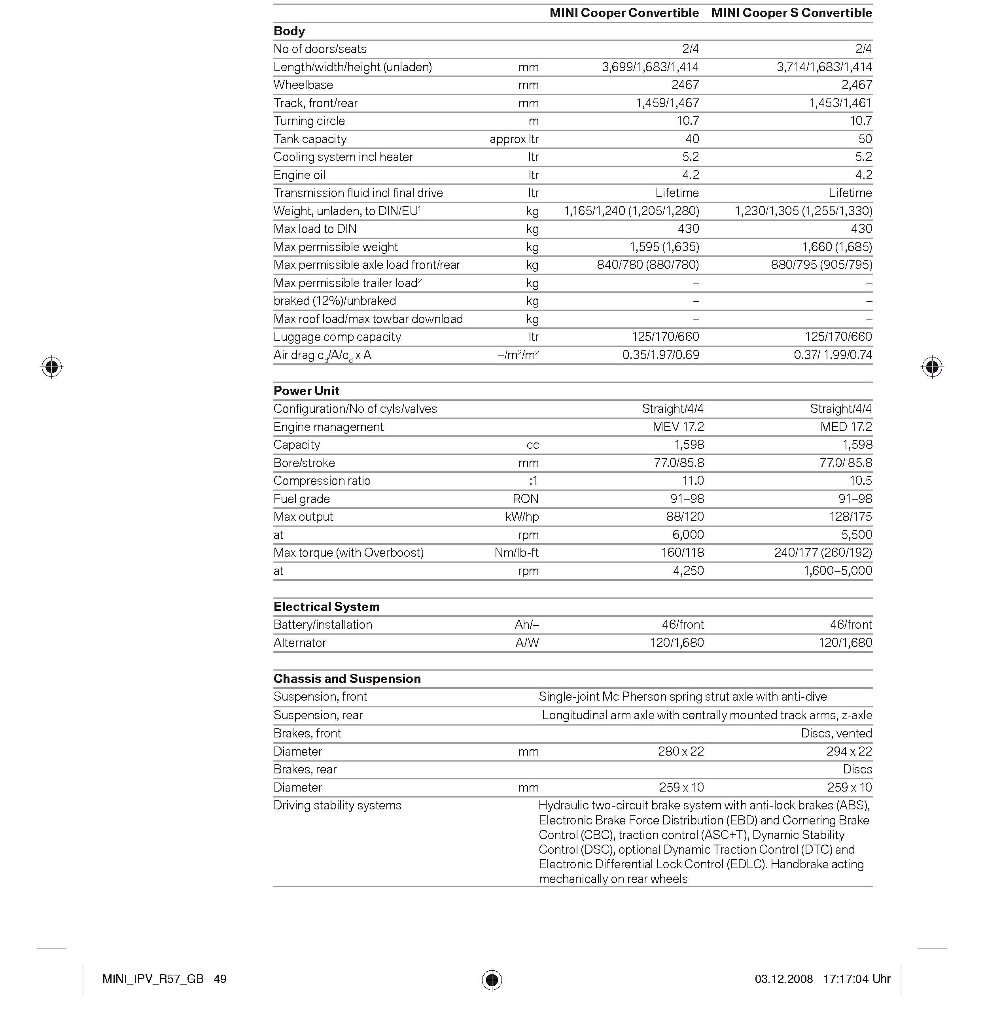

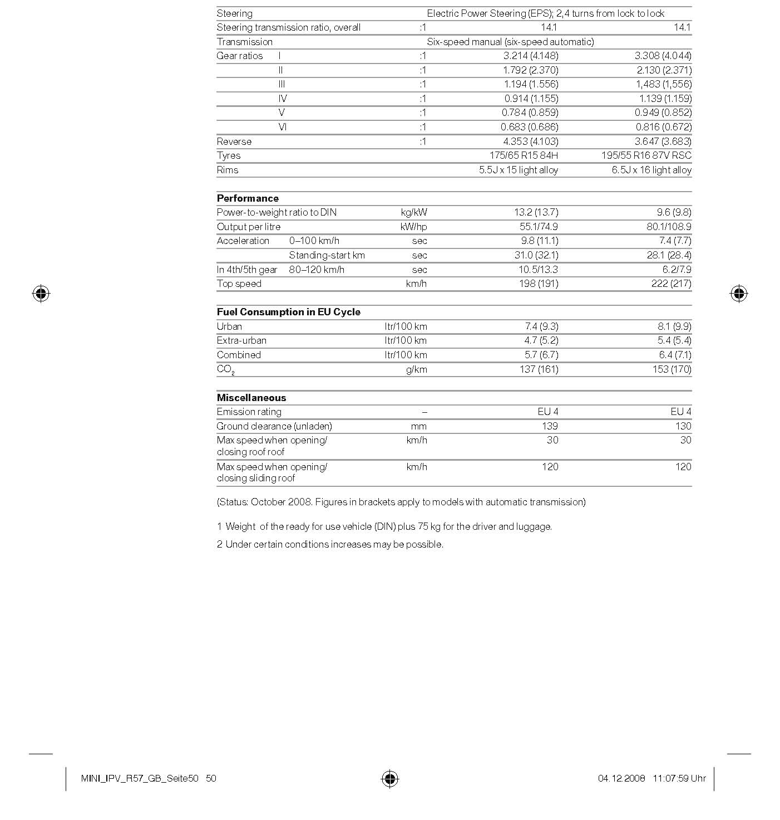
MINI Cooper Convertible.

10. Exterior and Interior Dimensions.
MINI Cooper Convertible.
MINI Cooper S Convertible.

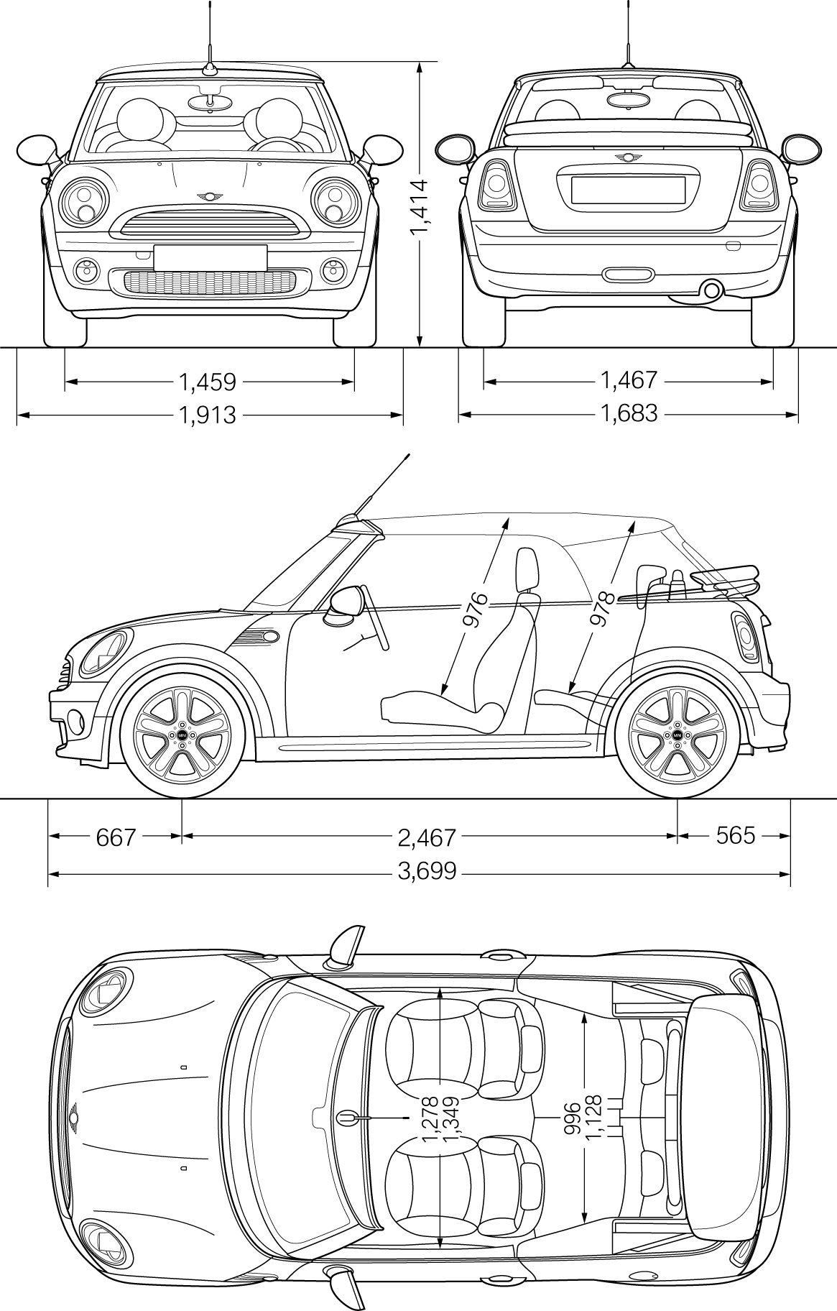

MINI Cooper S Convertible.
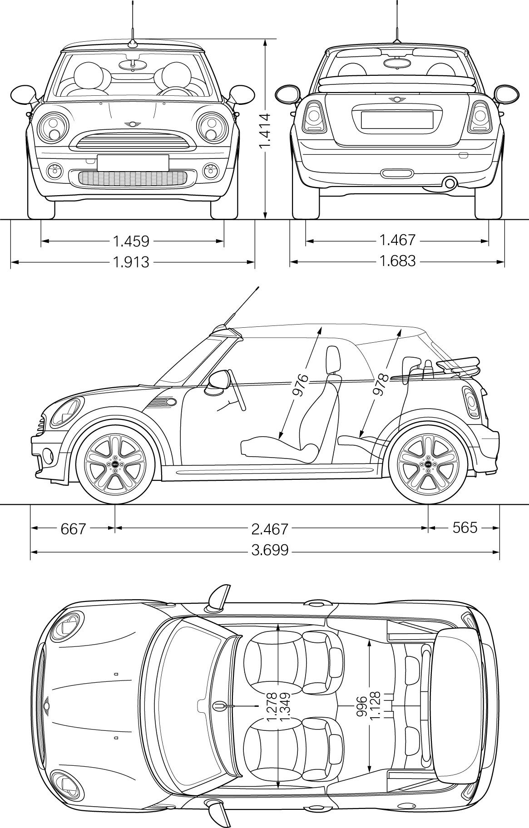

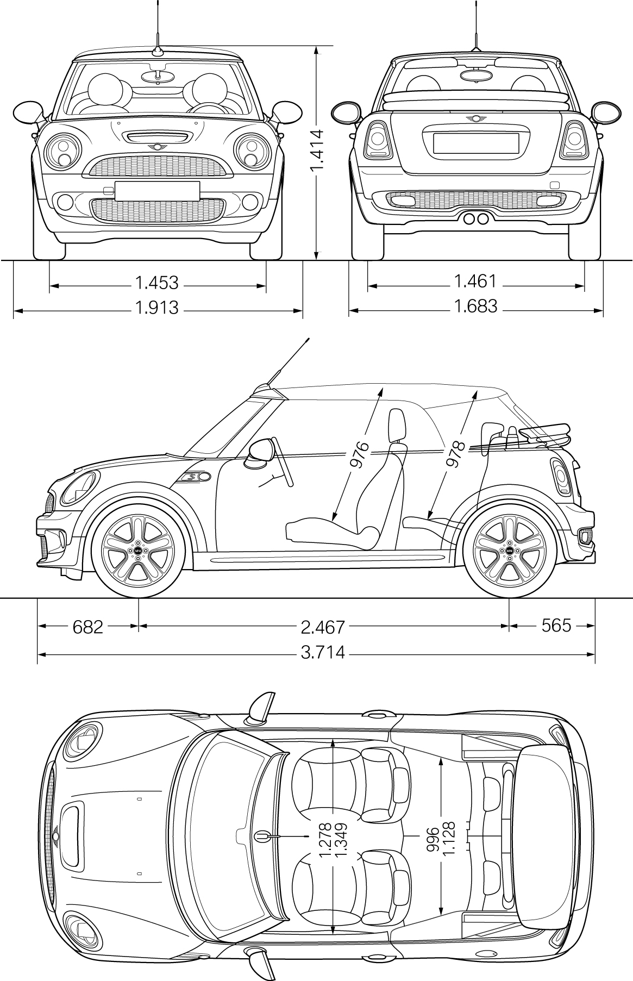MINI Cooper S Convertible.

11. Output and Torque Diagrams.

MINI Cooper Cabrio.
MINI Cooper S Cabrio.

MINI Cooper Convertible.
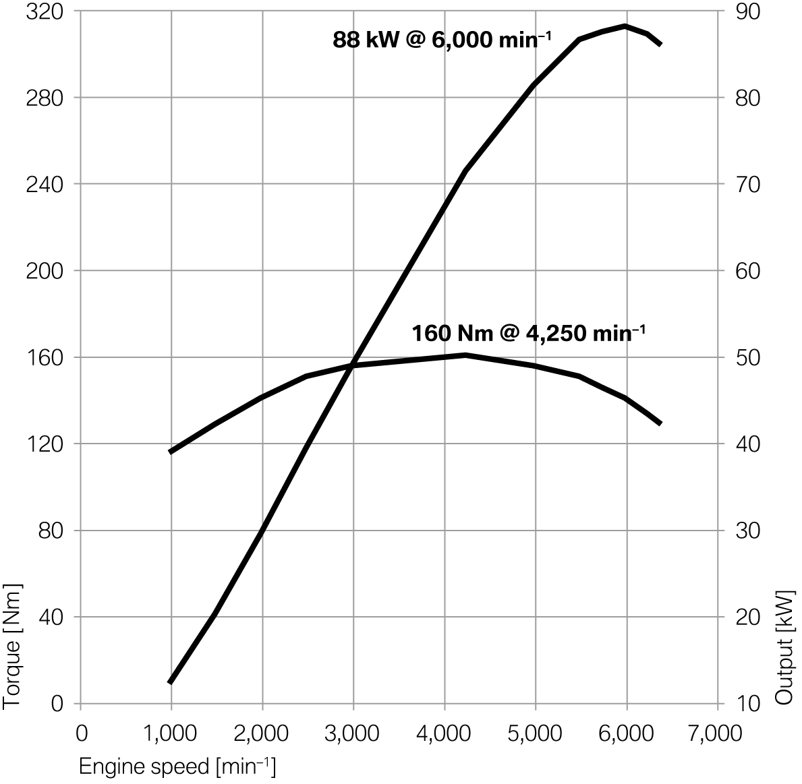

MINI Cooper S Cabrio.



