MUSE, ROLLS-ROYCE ART PROGRAMME UNVEILS WINNING ARTWORKS INSPIRED BY THE SPIRIT OF ECSTASY

5 October 2022, Goodwood, West Sussex (Embargo: 6.00pm BST)

- Muse, the Rolls-Royce Art Programme, unveils artworks created by winners of the inaugural Spirit of Ecstasy Challenge – a biennial initiative celebrating the symbol of Rolls-Royce
- Three winners, selected by an expert jury, have created textile artworks inspired by Rolls-Royce and the Spirit of Ecstasy figurine
- Works by Bi Rongrong, Ghizlane Sahli and Scarlett Yang are on show in an exhibition at Cromwell Place, London from 5-8 October 2022, before proceeding on a global tour

“The Spirit of Ecstasy continues to be our muse for the ongoing pursuit of excellence. She embodies what we as the House of Rolls-Royce stand for: strive for perfection, attention to detail and timeless beauty. It is fascinating to see our icon being transformed into these three very unique expressions, pushing technical and conceptual boundaries. I would like to thank Bi Rongrong, Ghizlane Sahli and Scarlett Yang for their extraordinary masterpieces celebrating a different dimension of our iconic figurine, manifesting the exciting future of textile design.”
Anders Warming, Director of Design, Rolls-Royce Motor Cars

Muse, the Rolls-Royce Art Programme celebrates the global debut of the artworks created by the winners of the Spirit of Ecstasy Challenge. These three unique pieces are being exhibited at Cromwell Place, London, from 5-8 October 2022, before embarking on an international tour.

The Spirit of Ecstasy Challenge is a new biennial initiative that invites emerging artists from a range of disciplines to create artworks inspired the Rolls-Royce icon – the beautiful figurine that has adorned the bonnet of every motor car created by the marque since 1911. Each edition of the Spirit of Ecstasy Challenge will focus on a different medium, challenging participants to push technical and conceptual boundaries. The inaugural 2022 edition explores the potential of textiles, inviting artists to create textile-based artwork.

The winners – Bi Rongrong, Ghizlane Sahli and Scarlett Yang – developed three unique interpretations of the Rolls-Royce symbol. As part of the creative process, the artists met Rolls-Royce’s master craftspeople to exchange experiences before bringing their ideas and innovative creations to life.

BI RONGRONG – STITCHED URBAN SKIN

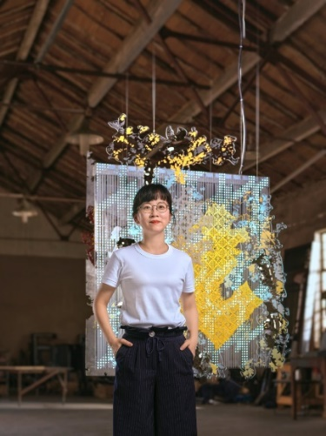  Bi Rongrong, Stitched Urban Skin, 2022. Courtesy Muse, The Rolls-Royce Art Programme. Photo by Zhang Jing_Hugo Photo  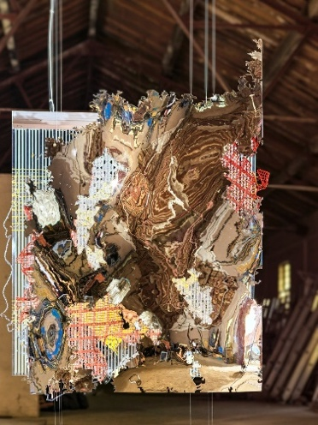  Bi Rongrong, Stitched Urban Skin, 2022. Courtesy Muse, The Rolls-Royce Art Programme. Photo by Zhang Jing_Hugo Photo | Stitched Urban Skin (2022) is inspired by the multi-layered landscape of cities and their mesmerising reflections on the glossy surface of the Spirit of Ecstasy. Old and new are woven together: the artwork consists of three suspended layers of two-dimensional sheets made from specially treated metal, an animated LED light sheet and a Perspex sheet incorporating a material created using a traditional Chinese crochet technique. The use of metal in the work is inspired by the Rolls-Royce motor car surface and pays homage to the exceptional craftsmanship at the Home of Rolls-Royce. The piece draws on Bi’s encyclopaedic archive of urban imagery, utilising both ancient craftsmanship and innovative technologies, interlacing different locations and histories.  “This piece wasn’t inspired by a singular thing, it’s a blend of patterns connected to cities and nature – the way they grow is very similar. People see only what’s on the surface – the architecture and the trees – but underneath are hidden interwinding roots”, said Bi. She continued: “The Rolls-Royce team gave me full artistic freedom, encouraging me to try new things and be truly brave. I experimented and changed the whole piece many times, which eventually made it even more captivating. This experience has presented me with new possibilities and opened up a different perspective which I will bring into my future work”.

Ghizlane Sahli – Nissa’s Rina (Woman’s Song)
Ghizlane Sahli, Nissa’s Rina (Woman’s Song), 2022. Courtesy Muse, The Rolls-Royce Art Programme. Photo by Adnane Zemmama
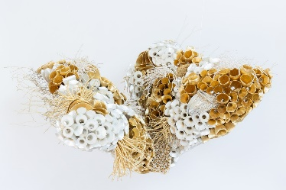  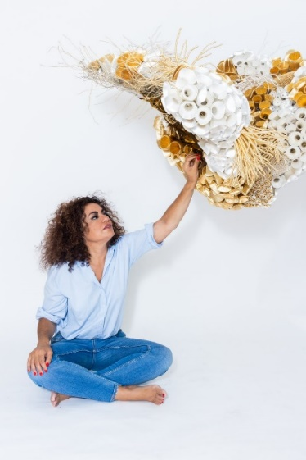  Ghizlane Sahli, Nissa’s Rina (Woman’s Song), 2022. Courtesy Muse, The Rolls-Royce Art Programme. Photo by Adnane Zemmama | Resembling two triumphant wings about to take flight, Sahli’s artwork Nissa’s Rina (Woman’s Song) (2022) is a joyous celebration of femininity and freedom. The artwork explores the beauty of metamorphose and is composed almost entirely of salvaged materials: plastic bottles, plastic tubes, caps, covered with white silk and gold threadpurchased from the artisans in Marrakech’s Medina and copper embellished with gold leaf. For Nissa’s Rina (Woman’s Song), Sahli adopts her signature technique of wrapping cut bottles in thread, the“Alveoli, and building up each element into wing-like structures evocative of the Spirit of Ecstasy.  “The Spirit of Ecstasy – that elegant, free woman who crowns the most prestigious car in the world. A symbol of power, she opens her wings to take flight, and rules the world. What a synchronicity for me! She embodies everything that I would like to express in my life today”, – said Sahli. “Nissa’s Rina (Woman’s song), aims to express the elegance, the femininity, and the freedom of the Spirit of Ecstasy”.

Scarlett Yang – Transient Materiality (2022)
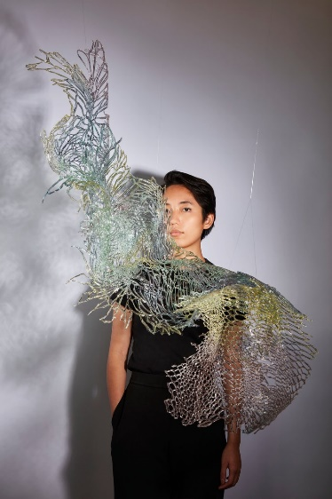  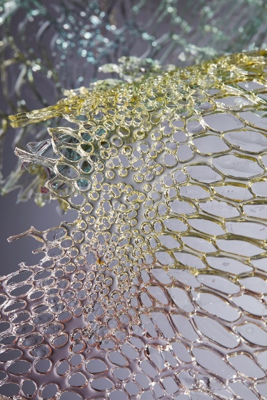  Scarlett Yang, Transient Materiality, 2022. Courtesy Muse, The Rolls-Royce Art Programme. Photo by Mark Cocksedge  Scarlett Yang, Transient Materiality, 2022. Courtesy Muse, The Rolls-Royce Art Programme. Photo by Mark Cocksedge | Scarlett Yang’s Transient Materiality (2022) is a hybrid work that consists of a physical and digital piece. The 1-metre-high sculpture is made of intertwining ribbons of synthetic biopolymer produced with liquid particles collected from the ocean and bound with algae photosynthetic organisms. The sculpture’s form, surface and colour all reflect the natural world: its unique texture was inspired the subtle intricacy of animal skin patterns and the structural resilience of translucent dragonfly wings. Made by pouring the liquid bio-polymer into a 3D-fabricated mould, while the ribbons’ green and purple hues were created through experiments with spirulina and other natural components.  Suspended in the air, the piece mesmerizes with its shimmering, iridescent qualities – an ethereal expression of elegance, reminiscent of the flying gown of the Spirit of Ecstasy. The accompanying digital element is a video documentation of the creative process as well as digital renderings of the sculpture, set to a futuristic soundscape.  “My work consists in exploring the physical properties that nature gracefully offers and enhancing them through a conscious and circular use of technology. The piece ‘Transient Materiality’ is ultimately meant to embellish the human body whilst serving a truly positive approach for the future of design”, commented Scarlett Yang.

The artists, invited to create their proposals for the Spirit of Ecstasy Challenge, were nominated by an international expert committee. Their submissions were reviewed by a renowned jury consisting of Anders Warming, Director of Design, Rolls-Royce Motor Cars; Yoon Ahn, Creative Director of AMBUSH🄬 and Director of Jewellery at Dior Men; Tim Marlow, Chief Executive and Director at the Design Museum, London; and Sumayya Vally, Founder and Principal at Counterspace Studio, Johannesburg. In April 2022 Muse announced the three winners who were chosen to bring their concept to life with support from Rolls-Royce.

The Spirit of Ecstasy Challenge is the second commissioning initiative of Muse. While the Dream Commission supports artists working with moving-image art, the Spirit of Ecstasy Challenge celebrates the endless creativity within the world of materials and craftsmanship. Every two years, the Challenge will be repeated, each time exploring the limitless possibilities of a different medium key to Rolls-Royce craftsmanship, with the Spirit of Ecstasy serving as a point of inspiration.

To stay up-to-date follow @rollsroycemuse.

-ENDS-

EDITORS’ NOTES

About Bi Rongrong
Bi Rongrong currently lives and works in Shanghai. For the Spirit of Ecstasy Challenge Bi collects images of architecture and ornaments from urban settings and, through manual or digital processing, transforms them into painting, collage, fabrics, video and site-specific installations. She has collaborated with important art institutions including, Centre for Heritage Arts & Textile in Hong Kong, Shanghai Museum of Glass, UCCA Lab, A Thousand Plateaus Art Space, and Vanguard Gallery. Public art projects include, Shenzhen-Hong Kong Bi-City Biennale of Urbanism\Architecture, Shanghai Urban Space Art Season, and Cass Sculpture Foundation (UK).

About Ghizlane Sahli
Ghizlane Sahli lives and works in Marrakech. A textile artist and designer who reuses salvaged materials in her work, Sahli draws attention to critical environmental issues while exploring the beauty of woman’s body. She studied architecture in Paris and returned to Morocco to open a workshop producing innovative textiles and design work. In less than a decade she became renowned for her award-winning tissue creations. Ghizlane embroiders, sculpts and draws. She transforms the material by covering the plastic waste she collects with natural thread (mostly silk), exulting it and giving it meaning. Sahli works with the help of local artisan women, using their ancestral techniques to create her contemporary ideas. Her work has been exhibited internationally and is part of many important collections, such as the V&A in London, the MACAAL in Marrakech, the Fondation H in Paris and and the Galila’s POC in Brussels.

About Scarlett Yang
Scarlett Yang is a cross-disciplinary innovation artist who focuses on sustainable design, biomateriality and virtual environments. Having worked in couture ateliers, bio labs and digital fabrication labs, she develops innovative approaches on the intersection of fashion, design, and technology. Scarlett Yang’s practice explores the life cycles of fashion textiles, through the research of biodegradable and meta solutions addressing the current environmental issues.. Committed to the future of technology, the artist reflects on tangibility as well as sustainable consumption by developing her creative vision across physical and digital spaces. Scarlett Yang has collaborated with renowned art institutions including the V&A Museum, Kyoto D-Lab, CentroCentro Madrid and London Design Biennale 2021.

Spirit of Ecstasy Challenge Jury
- Yoon Ahn, Creative Director of AMBUSH🄬 and Director of Jewellery at Dior Men
- Tim Marlow, Chief Executive and Director at the Design Museum, London
- Sumayya Vally, Founder and Principal at Counterspace Studio, Johannesburg
- Anders Warming, Director of Design, Rolls-Royce Motor Cars

About Muse, the Rolls-Royce Art Programme
Muse is the Rolls-Royce Art Programme, designed to foster and inspire creativity through collaboration with artists who share the marque’s passion for pushing technical and conceptual boundaries. Consisting of two ongoing biennial initiatives, Muse partners with some of the most respected and prestigious institutions in the world, such as Foundation Beyeler, Basel and Serpentine, London. Muse will provide selected artists with time and resource to produce art conceived, and to be experienced, without compromise.

Muse marks a new direction for the Rolls-Royce Art Programme, which has, since its inception in 2014, invited Rolls-Royce patrons into the world of contemporary art. To date, leading artists Sondra Perry, Refik Anadol, Tomas Saráceno, Asad Raza, Dan Holdsworth, Isaac Julien, Yang Fudong, and Ugo Rondinone have collaborated with the Art Programme.

About Rolls-Royce Motor Cars
Rolls-Royce Motor Cars is a wholly-owned subsidiary of the BMW Group and is a completely separate company from Rolls-Royce plc, the manufacturer of aircraft engines and propulsion systems. Over 2000 skilled men and women are employed at the Rolls-Royce Motor Cars’ head office and manufacturing plant at Goodwood, West Sussex, the only place in the world where the company’s super-luxury motor cars are hand-built.

FURTHER INFORMATION
You can find all our press releases and press kits, as well as a wide selection of high resolution, downloadable photographs and video footage at our media website, PressClub.

CONTACTS | Goodwood

Director of Global Communications
Emma Begley
+44 (0) 7815 371062 / Email
Head of Corporate Relations
Andrew Ball
+44 (0) 7185 244064 / Email
Head of Global Product Communications
Georgina Cox
+44 7815 370878 / Email
United Kingdom
Isabel Matthews
+44 (0) 7815 245127 / Email

CONTACTS | REGIONAL
Asia Pacific
Hal Serudin
+65 8161 2843 / Email
Central and Western Europe
Ruth Hilse
+49 (0) 89 382 60064 / Email
Central/Eastern Europe and CIS
Frank Tiemann
+49 (0) 160 9697 5807 / Email
Malika Abdullaeva
+7 916 449 86 22 / Email
Middle East and Africa
Rami Joudi
+971 56 171 7883 / Email
The Americas
Gerry Spahn
+1 201 930 8308 / Email

CONTACTS | SUTTON
Elise Hammond
+44 7889 733757 / Email

