ROLLS-ROYCE | MEDIA INFORMATION

CULLINAN INSPIRED BY FASHION: Prêt-à-porter collection by the house of rolls-royce

1 December 2022, Goodwood, West Sussex (Embargo: 13.00 GMT)
- ‘Cullinan – Inspired by Fashion’ reflects the latest couture trends and showcases infinite Bespoke possibilities
- Comprises two prêt-à-porter collections: bold Re-Belle, inspired by colour block, and Fu-Shion, bringing function and fashion together
- Starlight Tailgate – all-new Bespoke feature extending the magical celestial ambience beyond the interior of the motor car
- Matching Luggage Collection designed to complement each of the interior themes

The House of Rolls-Royce reveals‘Cullinan – Inspired by Fashion’, comprised of two prêt-à-porter collections – the bold Re-Belle and striking Fu-Shion. These exquisite ‘objects of desire’ by the Rolls-Royce Bespoke Collective take inspiration from vibrant hues and textures seen in the world of high fashion, reflecting the eclectic tastes and lifestyle of the luxury clientele. As works of art in their own right, ‘Cullinan – Inspired by Fashion’ will be unveiled to luxury connoisseurs and patrons of the brand at Art Basel in Miami this evening.
‘Cullinan – Inspired by Fashion’ brings out the multifarious character of the luxury SUV and its Black Badge alter ego. “With ‘Cullinan – Inspired by Fashion’ we drew inspiration from the world of our patrons – individuals with eclectic tastes who define trends and influence current movements in the fields of art, fashion and design”, says Celina Mettang, Bespoke Colour and Material Designer, Rolls-Royce Motor Cars. “They defy boundaries, challenge conventions and are bold in their expression of individuality. Reflective of their tastes, our ‘Cullinan – Inspired by Fashion’ models are designed as statement pieces, perfectly tailored to suit the lifestyles of our clients”.
To offer a glimpse into infinite Bespoke possibilities, for ‘Cullinan – Inspired by Fashion’ designers created eight distinctive personalities. Each collection includes two interior colourways defined by iconic accent colours: Lime Green or Peony Pink for Re-Belle and Mandarin or Forge Yellow for Fu-Shion. Each interior style can be paired with one of two carefully selected exterior looks – either eye-catching or more discrete and understated.
‘Cullinan – Inspired by Fashion’ Re-Belle is the ultimate statement piece, reflecting contemporary colour blocking trends with its vivid hues and playful combination of textures. A splash of colour in the interior with Peony Pink or Lime Green accents provides an irresistible contrast to the Arctic White or Cashmere Grey leather trim. The fascia is finished with extraordinarily detailed handwoven stainless-steel fabric, evocative of metallic apparel seen on this year’s catwalks. Delicate thread with a diameter as fine as 0.45 mm creates an intricate texture, which catches the light beautifully as the vehicle is in motion. ‘Cullinan – Inspired by Fashion’ Re-Belle is offered in Lime Green, Gunmetal, Wildberry or Arctic White exterior colours, available depending on the selected interior.
Unleashing the daring Black Badge personality, ‘Cullinan – Inspired by Fashion’ Fu-Shion reinterprets high fashion with a utilitarian edge. Reminiscent of the Spring/Summer 2023 prêt-à-porter collections, embellished with functional elements evocative of street wear, Fu-Shion showcases Cullinan’s personality – the pinnacle of luxury, effortless everywhere. For Fu-Shion, designers created two interior styles: an eye-catching combination of Military Green, Navy Blue and Mandarin or a blend of Arctic White and Cashmere Grey leather with Forge Yellow accents. Depending on the interior palette, ‘Cullinan – Inspired by Fashion’ Fu-Shion can be commissioned in one of four exterior colours: Military Green, Burnout grey, Forge Yellow or Tempest Grey.
For ‘Cullinan – Inspired by Fashion’, designers created the all-new Starlight Tailgate – a stunning feature which extends the magical, celestial ambience of the Starlight Headliner beyond the interior of the motor car. This Bespoke feature, which takes over 22 hours to manufacture, includes 192 softly illuminated stars incorporated into the perforated leather. The Starlight Tailgate is complemented by the Viewing Suite, creating a perfect setting to enjoy the enchanting beauty of a starry night, anywhere and everywhere.
A further innovation is to be found on the lower part of the fascia, which introduces a coloured Piano veneer for the first time: Cashmere Grey for Re-Belle and Navy Blue for Fu-Shion. This glossy finish acts as a unifying element, bringing yet more depth to the interior.
For travel in ultimate style, ‘Cullinan – Inspired by Fashion’ is available with matching luggage sets, designed to complement each of the four interior themes. The collection comprises of the 24hr Weekender, 48hr Weekender, Holdall, Tote Bag and Organiser Pouch, offered individually or as a five-piece set.
- ENDS -

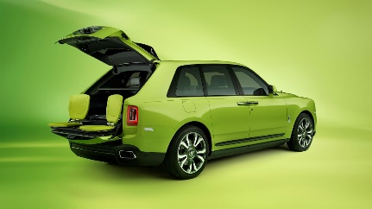 | ‘CULLINAN – INSPIRED BY FASHION’ RE-BELLE  Exterior: Lime Green or Gunmetal  Coachline: Lime Green or Scivaro Grey  Interior: Cashmere Grey, Scivaro Grey & Lime Green  Contrasts: Seat piping and stitching in Lime Green  Viewing Suite: Lime Green
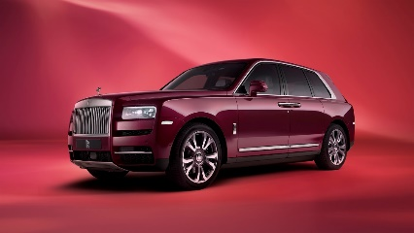 | Exterior: Wildberry or Arctic White  Coachline: Arctic White or Peony Pink  Interior: Arctic White, Navy Blue and Peony Pink  Contrasts: Seat piping and stitching in Peony Pink  Viewing Suite: Peony Pink
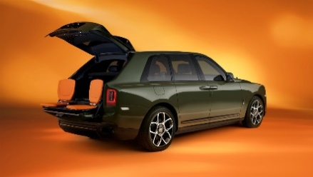 | ‘CULLINAN – INSPIRED BY FASHION’ FU-SHION  Exterior: Military Green or Burnout grey  Coachline: Mandarin  Interior: Navy Blue, Iceland Moss and Mandarin  Contrast: Seat piping and stitching in Mandarin  Viewing Suite: Mandarin
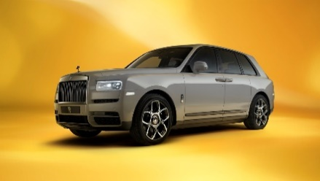 | Exterior: Forge Yellow or Tempest Grey  Coachline: Cashmere Grey or Forge Yellow  Interior: Cashmere Grey, Arctic White and Forge Yellow  Contrast: Seat piping and stitching in Forge Yellow  Viewing Suite: Forge Yellow

TECHNICAL SPECIFICATIONS

Cullinan: NEDCcorr (combined) CO2 emission: 348 g/km; Fuel consumption: 18.6 mpg / 15.2 l/100km WLTP (combined) CO2 emission: 377-368 g/km; Fuel consumption: 17.1-17.5 mpg / 16.5-16.1 l/100km.
Black Badge Cullinan: NEDCcorr (combined) CO2 emission: 343 g/km; Fuel consumption: 18.7 mpg / 15.1 l/100km WLTP (combined) CO2 emission: 377-370 g/km; Fuel consumption: 17.0-17.3 mpg / 16.6-16.3 l/100km.

EDITORS’ NOTES
Rolls-Royce Motor Cars is a wholly-owned subsidiary of the BMW Group and is a completely separate company from Rolls-Royce plc, the manufacturer of aircraft engines and propulsion systems. Over 2,000 skilled men and women are employed at the Rolls-Royce Motor Cars’ head office and manufacturing plant at Goodwood, West Sussex, the only place in the world where the company’s super-luxury motor cars are hand-built.

FURTHER INFORMATION
You can find all our press releases and press kits, as well as a wide selection of high resolution, downloadable photographs and video footage at our media website, PressClub.
You can also follow marque on social media: LinkedIn; YouTube; Twitter; Instagram; and Facebook.

CONTACTS | Goodwood

Director of Global Communications  Emma Begley  +44 (0) 1243 384060 / Email | Head of Global Product Communications  Georgina Cox  +44 (0) 7815 370878 / Email
Head of Corporate Relations  Andrew Ball  +44 (0) 7185 244064 / Email | Global Product PR manager  Katie Sherman  +44(0)7815244896 / Email
United Kingdom and Ireland
Isabel Matthews
+44 (0) 7815 245127 / Email

CONTACTS | GLOBAL

Asia Pacific  Hal Serudin  +65 8161 2843 / Email | Middle East and Africa  Rami Joudi  +971 56 171 7883 / Email
Central/Eastern Europe and CIS  Frank Tiemann  +49 (0) 160 9697 5807 / Email | The Americas  Gerry Spahn  +1 201 930 8308 / Email
Central and Western Europe
Ruth Hilse
+49 (0) 89 382 60064 / Email

