ROLLS-ROYCE | MEDIA INFORMATION
CRAFTING DREAMS INTO REALITY:
ROLLS-ROYCE REFLECTS ON A YEAR OF MAGNIFICENT BESPOKE COMMISSIONS

20 December 2023, Goodwood, West Sussex
- Rolls-Royce Motor Cars celebrates some of the most visually striking, technically challenging and creatively ambitious Bespoke commissions of 2023
- Inspirations included scenic locations, rare and beautiful materials, clients’ signature colours, celestial phenomena and more
- Bespoke commissions are a testament to the exceptional skill of the Rolls-Royce Bespoke Collective and underline the marque’s status as a true House of Luxury

A Bespoke Rolls-Royce is more than just a precious possession. For the commissioning client, it is the realisation of an ambition; a vision made solid; a dream come true.
During 2023, those wishes inspired the Rolls-Royce Bespoke Collective to push their boundaries further than ever before. The year’s commissions opened up new opportunities in the use of rare and beautiful materials, intricate craft techniques, surface finishes and other innovative technologies. There were an exceptional number of ‘firsts’ for the marque, including hand-perforated leather seats, Starlight Headliners incorporating mesmerising celestial animations and three-dimensional sculptural elements, stunning engraved artworks, numerous new paint processes and the first-ever commission to incorporate a Bespoke scent.
Commissions drew inspiration from celestial events, the mysteries of space, enchanting geographic locations, family legacies, clients’ signature colours and much more. Below are just a few spectacular examples that represent a lasting tribute to the vision, imagination and ambition of the Rolls-Royce Bespoke Collective and the remarkable clients who choose to celebrate their personal stories in Bespoke works of art.

ROSE BLOSSOM PHANTOM
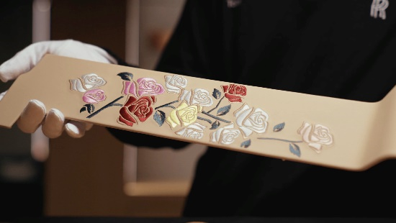  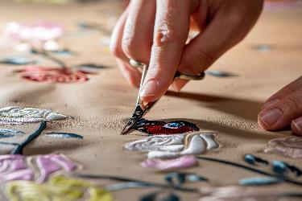 | This one-of-one Phantom Extended evokes the beauty and tranquillity of a summer garden. Embroidered artwork celebrates the marque’s very own Phantom rose that blooms in the courtyard of the Home of Rolls-Royce. This special flower is illustrated in the Gallery and on the coach doors. In addition, the flowers are depicted in the Starlight Headliner which took over 200 hours to complete. Four species of butterfly – Swallowtail, Peacock, Common Blue and Duke of Burgundy – can be seen flitting amongst the blooms.  The captivating floral theme continues in the intricate and detailed rose marquetry on the passenger panel and rear waterfall.

PHANTOM SYNTOPIA
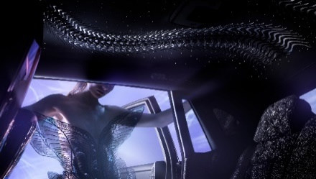  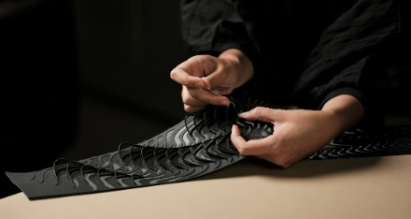  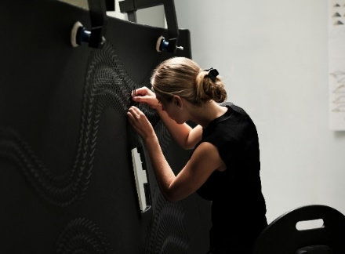 | The most technically complex Bespoke commission ever undertaken, Phantom Syntopia was created in collaboration with Dutch fashion designer and Haute Couturière Iris van Herpen. It explores the beauty of fluid motion in solid materials in its ‘Weaving Water’ theme, which extends across the Gallery artwork, picnic tables, front passenger panel, bonnet and Bespoke Starlight Headliner.  The ‘Weaving Water’ Starlight Headliner alone took almost 700 hours to produce, using a single sheet of leather overlaid on woven ‘liquid metal’ fabric to create a three-dimensional effect. It includes 162 delicate glass organza ‘petals’, applied at the Home of Rolls-Royce by members of Iris van Herpen’s team.  The rear seats are upholstered in a specially created silk-blend fabric with the Weaving Water motif. For a long-lasting, sophisticated sensory experience Bespoke Collective incorporated a scent-releasing mechanism, housed within the headrests.
BLACK BADGE GHOST ÉKLEIPSIS COLLECTION
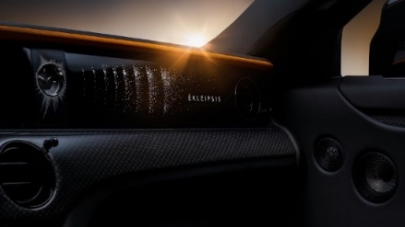  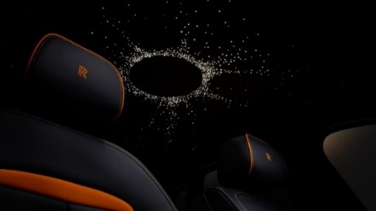  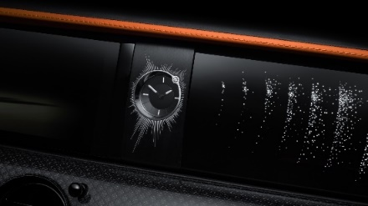 | Rolls-Royce Black Badge Ghost Ékleipsis Private Collection explores the captivating interplay of light and darkness as the Moon obscures the Sun during a total solar eclipse.  The fully Bespoke Starlight Headliner includes an animated sequence replicating the moment of totality: a circle of 940 fibre-optic ‘stars’ represents the corona around the Moon’s silhouette, surrounded by a further 192 ‘stars’. The animation remains visible for precisely seven minutes and 31 seconds – the longest possible duration of a total solar eclipse.  The illuminated fascia features 1,846 laser-etched ‘stars’ in a symbolic timeline of a total eclipse. The design culminates in a Bespoke timepiece incorporating a brilliant-cut 0.5-carat diamond set into the bezel, recalling the ‘Diamond Ring’ effect.

BLACK BADGE CULLINAN BLUE SHADOW
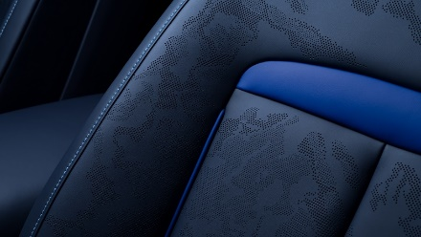  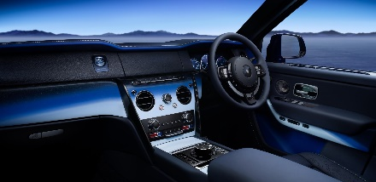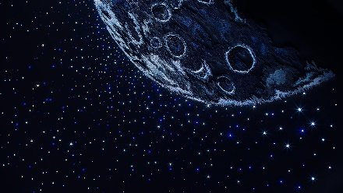 | The Black Badge Cullinan Blue Shadow Private Collection is inspired by the Kármán Line, the invisible boundary 62 miles above the Earth’s surface, where our atmosphere ends and outer space begins.  The Starlight Headliner includes an intricate embroidery depicting the Moon’s surface, made up of 250,000 individual stiches in five different thread colours. It’s surrounded by 1,183 twinkling fibre-optic ‘stars’ – 799 white and 384 blue – each placed by hand.  The leather seats feature artistic perforations for the very first time. The artwork, formed with 75,000 tiny perforations, mimics the patterns of clouds swirling over the continents and oceans as seen from space.

GHOST CHAMPAGNE ROSE
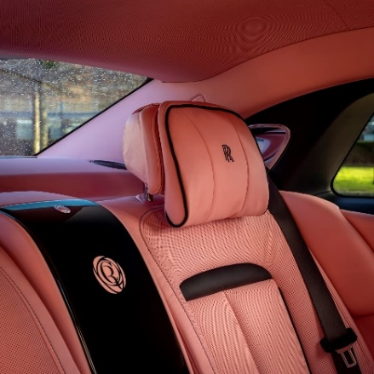 | Ghost Champagne Rose celebrates the commissioning client’s signature colour, inspired by her digital persona @ChampagneRose. Creating a single-tone colour across both exterior finish and interior trim is exceptionally complex; materials absorb and reflect light differently, and the eye perceives slight variations if exactly the same colour is applied to all surfaces. The Bespoke Collective therefore developed numerous formulations of the ‘Champagne Rose’ hue, each subtly adjusted according to each material’s specific surface characteristics – a true technical and artistic tour de force.
MANCHESTER GHOST
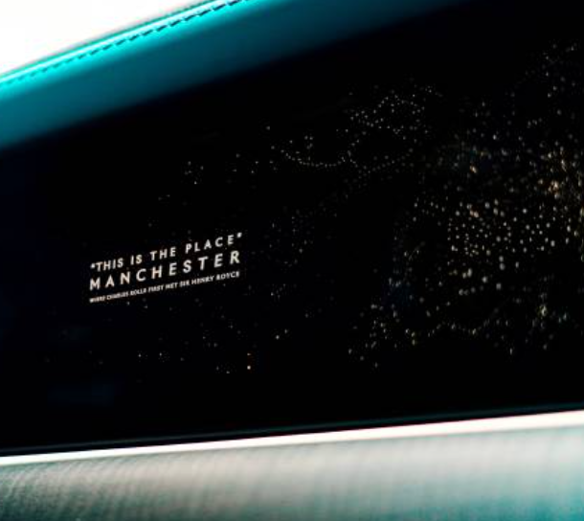 | This one-of-one Ghost celebrates Manchester’s pivotal historical connection with the marque. It was in the city’s Midland Hotel on 4 May 1904 that Charles Rolls and Henry Royce first met and agreed to build ‘the best car in the world’.  The illuminated fascia features 10,000 laser-etched dots depicting an aerial view of Manchester, with the largest dot showing the location of the Midland Hotel.
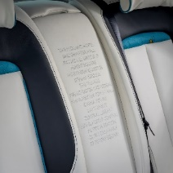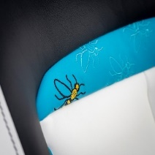 | The design also includes the Manchester Bee – the city’s emblem for over 150 years, symbolising hard work and collective endeavour. It appears as a coachline motif and delicate embroidery on the front and rear seat inserts.
GHOST AMBER ROADS
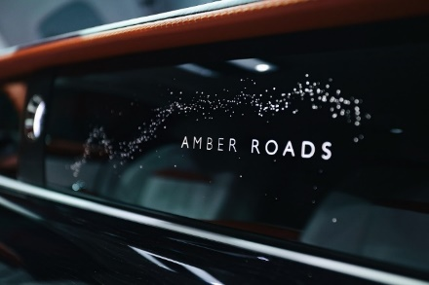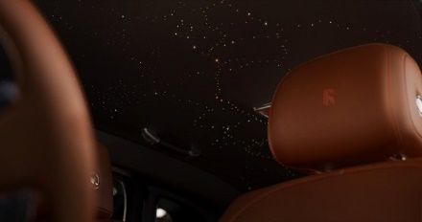 | This magnificent collection, comprising just 12 examples, is inspired by amber, known as the ‘Gold of the North’ and traded along routes known as ‘Amber Roads’ for over 3,500 years. These historic trade routes are depicted in the Bespoke Starlight Headliner and illuminated fascia panel.  The two-tone exterior finish and interior palette capture amber’s warm, lustrous character. A piece of polished amber is set into the central rotary dial to add an extra tactile dimension.

BLACK BADGE WRAITH BLACK ARROW PRIVATE COLLECTION
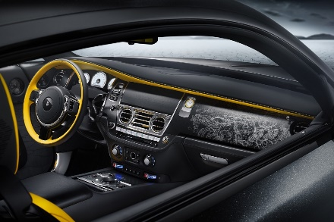  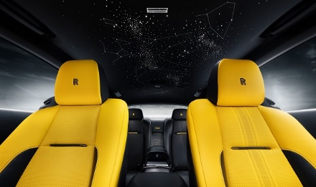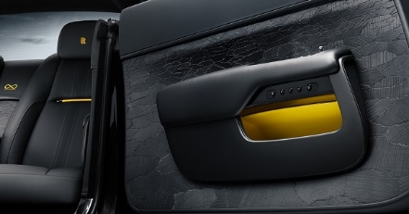 | Created to mark the end of production of Wraith, this Private Collection includes the final 12 examples of the last-ever Rolls-Royce V12 coupé.  The design celebrates the land speed record set by Captain George Eyston on 16 September 1938 on Utah’s Bonneville Salt Flats. The Bespoke Starlight Headliner’s 2,117 fibre-optic ‘stars’ depict the Milky Way and the constellations precisely as they would have appeared there that night. The complex design on coach doors, comprising over 320 lasered marquetry pieces, mimics the cracked, irregular surface of the Salt Flats.  Unique fascia artwork depicting Wraith’s V12 engine, engraved on a single sheet of black-coated aluminium to reveal the gleaming metal beneath, commemorates the legacy of this Rolls-Royce icon.
THE PEARL CULLINAN
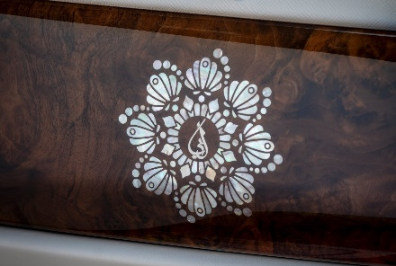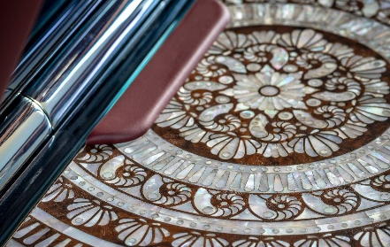 |  | Commissioned for the owner by his family to mark a significant birthday, this magnificent Cullinan reflects the client’s passion for pearls and includes some of the most elaborate use of mother-of-pearl ever seen in a Rolls-Royce motor car.  The exterior finish captures the colours of the most prized pearl in the owner’s collection. The Picnic Tables feature a spectacular circular pattern made from 1,351 separate pieces of mother-of-pearl, each individually selected and inlaid by hand. The fascia motif illustrates the Arabic symbol for ‘father’ inlaid in stainless steel. The Bespoke Starlight Headliner shows the sky as it appeared at the owner’s birthplace on the night he was born.
PHANTOM CINQUE TERRE
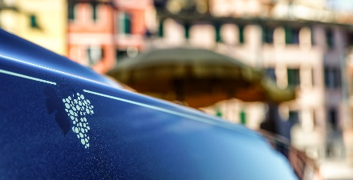  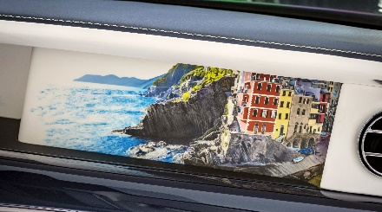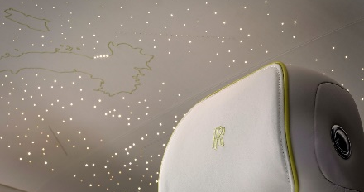 |  | This one-of-one Phantom celebrates the unique landscape and viticultural heritage of Italy’s Cinque Terre region. The Gallery artwork represents an imagined amalgamation of elements from the five Ligurian cliffside villages, sketched digitally, then airbrushed by hand.  The Bespoke Starlight Headliner features a map of Italy, embroidered in 14,338 individual stitches, with five prominent ‘stars’ marking the locations of the villages.  The rear doors are adorned with a delicate grape-branch embroidery, each comprising 9,215 stitches and using two different techniques to create lustre and texture. The grapes motif also appears as an intricate plated gold and stainless steel inlay on the rear picnic tables, as well as the coachline motif.
BLACK BADGE CULLINAN LUCID NIGHTS
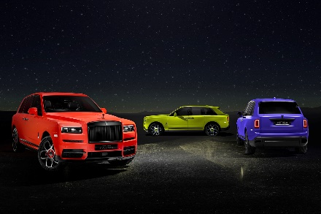 |  | These three striking commissions, created exclusively for Korea, are inspired by the scenery, atmosphere and dynamism of Seoul Metropolitan City at night. Bold exterior colourways, reminiscent of the neon-lit streets of Seoul, include the daring Lime Green, luscious Indy Red and vibrant Tucana Purple.

- ENDS -

TECHNICAL INFORMATION
- Phantom: NEDCcorr (combined): CO2 emissions: 345 g/km; Fuel consumption: 15.1 ltr/100 km / 18.7 mpg. WLTP (combined): CO2 emissions: 345-358 g/km; Fuel consumption: 15.1-15.7 ltr/100 km / 18.0-18.7 mpg.
- Phantom Extended: NEDCcorr (combined): CO2 emissions: 345 g/km; Fuel consumption: 15.1 ltr/100 km / 18.7 mpg. WLTP (combined): CO2 emissions: 348-362 g/km; Fuel consumption: 15.2-15.9 ltr/100 km / 17.7-18.6 mpg.
- Cullinan: NEDCcorr (combined): CO2 emission: 348 g/km; Fuel consumption: 15.2 ltr/100 km / 18.6 mpg. WLTP (combined): CO2 emission: 368-377 g/km; Fuel consumption: 16.1-16.5 ltr/100 km / 17.1-17.5 mpg.
- Black Badge Cullinan: NEDCcorr (combined): CO2 emission: 343 g/km; Fuel consumption: 15.1 ltr/100 km / 18.7 mpg. WLTP (combined): CO2 emission: 370-377 g/km; Fuel consumption: 16.3-16.6 ltr/100 km / 17.0-17.3 mpg.
- Ghost: NEDCcorr (combined): CO2 emission: 343 g/km; Fuel consumption: 15.0 ltr/100 km / 18.8 mpg. WLTP (combined): CO2 emission: 347-359 g/km; Fuel consumption: 15.2-15.8 ltr/100 km / 17.8-18.6 mpg.
- Black Badge Ghost: WLTP (combined): CO2 emission: 359 g/km; Fuel consumption: 15.8 ltr/100 km / 17.9 mpg.
- Black Badge Wraith: NEDCcorr (combined) CO2 emission: 367 g/km; Fuel consumption: 17.5 mpg / 16.1 l/100km. WLTP (combined) CO2 emission: 370-365 g/km; Fuel consumption: 17.2-17.4 mpg / 16.4-16.2 l/100km.
Further information: https://bit.ly/3XtQW7q

FURTHER INFORMATION
You can find all our press releases and press kits, as well as a wide selection of high resolution, downloadable photographs and video footage at our media website, PressClub.
You can also follow marque on social media: LinkedIn; YouTube; Twitter; Instagram; and Facebook.

EDITORS’ NOTES
Rolls-Royce Motor Cars is a true luxury house, creating the world’s most recognised, revered and desirable handcrafted Bespoke products for its international clientele.
The company employs more than 2,500 people at the Home of Rolls-Royce at Goodwood, West Sussex. This comprises both its global headquarters and Centre of Luxury Manufacturing Excellence – the only place in the world where Rolls-Royce motor cars are designed, engineered and meticulously built by hand. Its continuous investment in its facilities, products and people has resulted in a series of ‘record years’ for global sales, peaking in 2022 with over 6,000 motor cars sold worldwide.
Rolls-Royce Motor Cars is a wholly owned subsidiary of the BMW Group and is a completely separate, unrelated company from Rolls-Royce plc, the manufacturer of aircraft engines and propulsion systems.

CONTACTS | GOODWOOD
Director of Global Communications  Emma Begley  +44 (0) 1243 384060 / Email | Head of Global Product Communications  Georgina Cox  +44 (0) 7815 370878 / Email
Head of Corporate Relations  Andrew Ball  +44 (0) 7815 244064 / Email | Global Product PR Manager  Katie Sherman  +44 (0) 7815 244896 / Email  Global Lifestyle Communications  Malika Abdullaeva  +44 (0) 7815 244874/ Email
CONTACTS | GLOBAL
The Americas  Gerry Spahn  +1 201 930 8308 / Email | Asia Pacific  Hal Serudin  +65 8161 2843 / Email
Central/Eastern Europe and Central Asia  Frank Tiemann  +49 160 9697 5807 / Email | Central and Western Europe  Ruth Hilse  +49 89 382 60064 / Email
China  Ou Sun  +86 186 0059 0675 / Email | Japan and Korea  Yuki Imamura  +81 90 5216 1957 / Email
Middle East and Africa  Rami Joudi  +971 56 171 7883 / Email | United Kingdom and Ireland  Isabel Matthews  +44 (0) 7815 245127 / Email

