1. Inspiring elegance in motion:
The BMW 6 Series Gran Coupe.
(short version) 2

The BMW 6 Series Gran Coupe.
Table of Contents.
2. The design:
A new dimension in aesthetics. 7
3. The driving experience:
Refined sportiness. 12
4. BMW ConnectedDrive in the BMW 6 Series Gran Coupe:
A richer experience thanks to intelligent networking. 18
5. Bodywork and safety:
State-of-the-art-functionality and complete protection. 24
6. Equipment features:
Exclusive, sophisticated, unmistakable. 26
7. Production:
Optimised processes for uncompromising quality. 30
8. Technical specifications. 32
9. Performance and torque diagrams. 38
10. Exterior and interior dimensions. 41
Once again BMW is advancing into a new vehicle segment with the introduction of the BMW 6 Series Gran Coupe. Following the convertible
and the Coupe in the BMW 6 Series, this new exclusive model is the true embodiment of aesthetics, sportiness, comfort and luxury in perfect form.
The lean elegance of this vehicle, the very first four-door Coupe in the history of BMW, is truly an exceptional phenomenon. Powerful engines and the advanced chassis technology contribute to a sporty and dynamic driving experience. The BMW 6 Series Gran Coupe is also distinguished by exclusive features and equipment, roominess for rear passenger comfort and remarkable advanced functionality that is unusual even for an upscale, four-door Coupe. For example, folding rear seatbacks and an auxiliary third seat are among the unique design features that contribute to the car's versatility.
1. Inspiring elegance in motion:
The BMW 6 Series Gran Coupe.
Driving dynamics, smooth performance and efficiency are the hallmarks of
the TwinPower Turbo engines available for the BMW 6 Series Gran Coupe. Furthermore, the BMW 650i Gran Coupe will be the first model offered with a new and more efficient V8 engine that delivers an impressive 330 kW. This engine, just like the six-cylinder power units in the BMW 640i Gran Coupe and the BMW 640d Gran Coupe, is offered as standard in conjunction with an eight-speed Sport automatic transmission and proven BMW EfficientDynamics technology. Standard equipment on all models also includes the Driving Experience button with ECO PRO Mode and the Auto Start Stop function.
The distinctive character of the BMW 6 Series Gran Coupe is unmistakable in the sophisticated and luxurious interior, not to mention the wide range of standard equipment, such as Xenon headlights, automatic 2-zone air conditioning, leather upholstery and electric seat adjustment with memory function. Innovative optional equipment available includes Adaptive LED Headlights and the Bang & Olufsen High-End Surround Sound System. Furthermore, the M Sports package will also be available as an option for the BMW 6 Series Gran Coupe, or buyers may prefer the BMW Individual package designed specifically for this vehicle.
The design: Sporty elegance and exclusive flair.
The BMW 6 Series Gran Coupe represents an unusual synergy of extraordinary aesthetics, the dynamics typical of a Coupe and the functional versatility of a four-door vehicle. The BMW 6 Series Gran Coupe measures 5,007 millimetres in length and 1,894 millimetres in width, with a height of 1,392 millimetres. The car’s proportions are unmistakably BMW, from the long bonnet with its bold contours to the elegance of the extended wheelbase (2,968 millimetres) and the set-back passenger compartment. The BMW 6 Series Gran Coupe sets new standards in terms of aesthetic design for four-door vehicles as seen in its low height and the flat roofline that smoothly flows into the rear end.
At the front, chrome elements, unique to the Gran Coupe, separate the air intake from the fog lights, underlining the firm resolve expressed in the look of this car. The standard dual Xenon round headlights (for high and low beams) feature three-dimensional LED rings that are typically BMW in appearance and which create a unique and functional light architecture for the night-time driving experience. With the optional Adaptive LED Headlights, the light rings are slightly flat at the top and bottom. High and low beams are generated with the LED units that are positioned on horizontal ribs across each of the light rings, projecting their light on the reflectors facing them.
The low and graceful lines of this automobile are especially impressive when looking at the side profile. The recessed passenger compartment appears low and smoothly stretched because the window silhouette extends deep into the C pillar. The frameless door windows are also a design element indicative of a sporty Coupe. In addition, the elongated side windows optimise the incidence of light to enhance the feeling of spaciousness in the interior. The characteristic Hofmeister kink that flows into the C pillar encompasses exclusively embossed “Gran Coupe” lettering behind the glass in the lower corners of the rear windows to denote the fascinating elegance and personality of this automobile.
The visually low centre of gravity, along with the horizontal and V-shaped lines at the rear, suggests powerful and dynamic elegance. Another distinctive design feature of the BMW 6 Series Gran Coupe is the third brake light that stretches along the entire width of the rear window, thus forming the top edge.
The interior design is the embodiment of a perfect combination of elegance, luxury and dynamic, which lends to the harmonious configuration of the front and rear seating. The driver-oriented cockpit, the front passenger area enclosed by elegantly curved surfaces and the spaciousness of the set-back rear passenger compartment ensures sophisticated and luxurious comfort in all driving scenarios. The wheelbase is 113 millimetres longer than that of the BMW 6 Series Coupe and accounts for the increased legroom enjoyed by rear passengers. The interior design concept of the BMW 6 Series Gran Coupe ensures exceptional spatial variability. There is ample space to comfortably accommodate two passengers in the rear. But the 4+1 seating arrangement also provides space for a third rear passenger on short journeys. The boot has a volume of 460 litres, which can be expanded up to 1,265 litres thanks to the through-loading system and the folding rear seatbacks.
The driving experience: Harmonised dynamics and comfort.
The BMW TwinPower Turbo engines available for the BMW 6 Series Gran Coupe stand for sportiness with efficiency. The straight 6-cylinder petrol engine in the BMW 640i Gran Coupe delivers 235 kW, and the straight 6-cylinder diesel in the BMW 640d Gran Coupe has a performance rating of 230 kW. In the third quarter of 2012, a third engine will be added to the series, namely the V8 petrol engine in the BMW 650i Gran Coupe with 330 kW, also available with BMW xDrive four-wheel drive technology (the xDrive technology will not be available in SA). The new-generation BMW V8 engine features TwinPower Turbo technology using two turbochargers, plus direct High-Precision Injection and the fully variable VALVETRONIC valve control system.

The BMW 650i Gran Coupe, just like both 6-cylinder models, is equipped with an eight-speed Sport automatic transmission, the Auto Start Stop function and the Driving Experience button including ECO PRO Mode, and it accelerates from 0 to 100 km/h in just 4.6 seconds with an average
fuel consumption ranging from 8.6 to 8.9 litres per 100 kilometres. The acceleration of the BMW 640i Gran Coupe is 5.4 seconds, and it has an average fuel consumption of 7.7 to 7.9 litres per 100 kilometres. The
BMW 640d Gran Coupe can also sprint from 0 to 100 km/h in 5.4 seconds and fuel consumption ranges from 5.5 to 5.7 litres per 100 kilometres (figures according to the EU test cycle, depending on selected tyre format). The remarkable ratio of driving pleasure and fuel consumption stems from the outstanding efficiency of the engines and the automatic transmission, not to mention the benefits delivered by BMW EfficientDynamics technology. In addition to the ECO PRO Mode and the Auto Start Stop function, other model-specific technical features contribute to efficiency, e.g., brake energy regeneration, electromechanical power steering, ancillary units that operate on demand, the detachable air conditioning compressor, intelligent use of lightweight materials, active air vent control as well as suspension control systems with on-demand hydraulic technology, to name just a few.
The chassis of the BMW 6 Series Gran Coupe comprises a double-track control arm front axle and an integral rear axle along with electromechanical steering and Servotronic. Dynamic Damper Control and Adaptive Drive, including Dynamic Drive stability control, are available as optional equipment.
Standard safety features include front airbags, side airbags integrated into
the seatbacks, head airbags for front and rear seats, three-point automatic seatbelts for all seats, belt force limiters and seatbelt tensioners at the front
as well as ISOFIX child seat fasteners at the rear. Intelligent lightweight construction reduces the vehicle weight. The doors, bonnet and most of
the chassis components, including the suspension supports, are made of aluminium. The front side walls consist of thermoplastic material, while the boot lid is made of fibreglass composites.
Equipment: Exclusive features, innovative technology.
The wide range of premium standard equipment in the BMW 6 Series Gran Coupe is quite impressive: the eight-speed Sport automatic transmission, a choice of leather upholstery and trim, electric seat adjustment with memory function for the front seats, automatic air conditioning with 2-zone regulation, Xenon headlights and the BMW radio Professional with hi-fi speaker system. Additional exclusive options can be selected to give the car a personal touch. Among the highlights in the range of optional equipment are Adaptive LED Headlights and the Bang & Olufsen High-End Surround Sound System. The M Sports package is also available as an option for the BMW 6 Series Gran Coupe, or buyers may prefer the BMW Individual package designed specifically for this vehicle.
Driver assistance systems and mobile services available with
BMW ConnectedDrive include technology such as the BMW Head-Up Display with full-colour graphics, the parking assistant, Surround View, Active Cruise Control with the Stop & Go function, Lane Departure Warning System, Speed Limit Info, High-Beam Assistant and BMW Night Vision with pedestrian warning.
Assembled in Dingolfing, Germany: BMW quality at its finest.
The BMW 6 Series Gran Coupe is built at the BMW plant in Dingolfing. This is the largest manufacturing facility operated by the BMW Group worldwide. The BMW 6 Series Coupe and Convertible, as well as BMW 5 Series vehicles and luxurious BMW Series 7 sedan cars are also assembled at this site.
• First four-door Coupe in the history of BMW.
2. The design:
A new dimension in aesthetics.
• Aesthetic appeal, harmonic proportions and the characteristic design language of the BMW 6 Series.
• Luxurious interior with distinct driver orientation, spaciousness,
standard 4+1 seating.
The exterior design of the BMW 6 Series Gran Coupe reflects the characteristic design language of the BMW 6 Series as applied to create a unique four-door Coupe. The harmonic proportions, precision lines and the smooth contoured surfaces are among the elements that lend the
BMW 6 Series Gran Coupe its remarkable appeal. In terms of length (5,007 millimetres) and wheelbase (2,968 millimetres) this car is 113 millimetres longer than the BMW 6 Series Coupe. This accounts for the comfort experienced by passengers seated in the rear. The Gran Coupe is
1,894 millimetres wide, with a height of 1,392 millimetres.
The driver-oriented cockpit, the front passenger area enclosed by elegantly curved surfaces and the spaciousness of the rear passenger compartment contribute to the dynamic look and feel of the vehicle and also ensure sophisticated and luxurious interior comfort in all driving scenarios. The
BMW 6 Series Gran Coupe offers ample space for four passengers, in addition to an unusually high degree of interior versatility for a vehicle in this segment. For short journeys, the so-called 4+1 seating configuration can accommodate three passengers in the rear compartment.
Up front: A bold presence and road-hugging stance.
The large air intake vents, the trademark BMW kidney grille extending slightly forward and positioned between the characteristic dual round headlights, plus the V-shaped converging contours of the long bonnet, express a bold aura of self-confidence. The design of the kidney grille is broad and deep, with a slight angle along the upper edges that creates a shark-nose effect. Xenon headlights are standard equipment on the BMW 6 Series Gran Coupe. Adaptive LED Headlights are offered optionally as an alternative. The Adaptive LED Headlights for the low and high beams feature white LED corona rings as parking lights and daytime driving lights. These are flattened at the bottom and overlapped at the top edge by an accentuating light also featuring LED technology. This adds a new dimension to the deep and sharply concentrated look typical of BMW automobiles, almost as if the car were intensely focusing its “eyes” on the road ahead by day and by night. Both low-beam and high-beam headlight illumination is produced by both light rings, further underscoring the characteristic BMW dual-headlight front design. The light sources are LED units that are positioned on horizontal ribs across each of the light rings, projecting their light on the reflectors facing them. The three-dimensional design of the lights, which includes a transparent and illuminated extension of the light rings, impressively highlights the LED technology when viewed from the side. Even the direction indicators and brake lights feature LED technology.
Powerfully flared wheel arches emphasise the vehicle's wide track, which can be further enhanced with optional LED fog lights neatly positioned at the front corners. The lower air intake is comprised of three sections. Prominent L-shaped chrome elements, exclusive to the BMW 6 Series Gran Coupe, highlight the recessed air intake in the front apron. They take up the lines of the bonnet flowing forward toward the BMW kidney grille to further enhance the dynamic and self-confident overall expression of the front.
Side view: Lean elegance and sporty flair.
With its long, boldly contoured bonnet, the set-back passenger compartment, its elegant Coupe roof line flowing into the rear end, not to mention the extended wheelbase and short overhang, the proportions of the BMW 6 Series Gran Coupe reflect the heritage of the BMW family in an all-new manner. The four doors, combined with the extended wheelbase and more spacious passenger compartment, clearly distinguish the Gran Coupe from other models in the BMW 6 Series. Similarly, the flat, elegant and smooth roof line, which gently flows into the rear end, creates an individual and exceptional silhouette that makes the BMW 6 Series Gran Coupe easily recognisable from any perspective.
The combination of sportiness, luxury, exclusiveness and sophisticated functionality is especially evident when looking at the side profile. The set-back passenger compartment appears low and smoothly stretched because the window silhouette extends deep into the C pillar. In addition, the elongated side windows optimise the incidence of light to enhance the feeling of spaciousness in the interior. The windows themselves can be enhanced with optional exterior chrome trim. The characteristic Hofmeister kink that flows into the C pillar encompasses exclusively embossed “Gran Coupe” lettering behind the glass in the lower corners of the rear windows to denote the fascinating elegance and personality of this automobile.
Bold lines extending along the entire length of the vehicle, sweeping from the front and flowing into the artfully contoured rear quarter panels, accentuate the sharp profile and sporty personality of the BMW 6 Series Gran Coupe.
As in other BMW 6 Series models, the structure of the lines creates an appearance that is at once classic, precise and dynamic. The swage line begins at the gill element on the front wheel arch and extends through the door handles along the side of the vehicle before flowing into the rear, thus contributing to the athletic and elegant side profile of the vehicle. The area below the swage line near the rear wheels features convex contours that express the character of a powerful and robust automobile that seems to hug the road.
The curvature of the front wheel arch creates a further characterising line, which after flowing downwards between the side gill element and the door, finally continues horizontally back to the rear. The seamless and smooth profile line in the area of the doorsills enhances the muscular appearance of the car.
Rear styling: Horizontal lines and clear surface profiles.
Clearly structured surfaces and horizontal lines accentuate the powerful
grace of the rear section, which expresses the stability and sportiness of the BMW 6 Series Gran Coupe. The rear silhouette is considerably wider at the bottom and V-shaped lines guide the eye downwards in the direction of the apron and road surface. The contoured wheel arches also enhance the vehicle's wide stance. Optically the centre of gravity appears to be especially low when the car is viewed from the rear. The design of all rear elements is flat and wide. Noticeably flared wheel arches emphasise the wide track and the horizontal dimensions of the rear section. When compared with other
BMW 6 Series models, the surface and lines between the boot lid and the
rear apron have a more stretched appearance. The clearly outlined profile of the apron underlines the overall volume of the rear section and also draws attention to details such as the rear lights and the chrome exhaust ports.
The contoured shape of the split L-shaped tail lamps is typical of the
BMW 6 Series, and the lamps each have two LED light banks that create the familiar BMW night-time look. The third brake light is integrated in the roof line and stretches across the entire width of the back window.
Interior: Driver orientation, luxurious ambience.
The cockpit of the BMW 6 Series Gran Coupe has a distinctive driver orientation typical of all BMW vehicles and the interior features create a luxurious ambience for all passengers. The centre section of the instrument panel slopes slightly toward the driver. The elegantly curved centre console gives the driver convenient access to the gear selector of the automatic transmission, the Driving Experience button and the button for the parking brake.
The standard iDrive control system includes an on-board monitor with an exclusive flat-screen design. In combination with the BMW Professional navigation system, the new BMW Series 6 Gran Coupe is equipped with a 10.2-inch display, surrounded by an eye-catching chrome frame that highlights the monitor.
Long and flowing horizontal lines extending throughout the interior of the BMW 6 Series Gran Coupe serve to optically unite the front and rear seating compartments and add to the spacious feeling inside the vehicle. The characteristic design of BMW 6 Series door panels and trim, with elegant lines that stretch from front to back, even incorporate the B pillar in the seamless and harmonious look of the premium interior. The centre console extends into the rear passenger compartment and is also shaped in a manner that further enhances the roomy look and feel of the car.
Sportiness and spacious rear seating.
The interior of the BMW 6 Series Gran Coupe conveys a sensation of sportiness and tailor-made exclusiveness during the driving experience. The sweeping lines of the exterior roof profile are immediately recognisable in the contours of the interior roof liner. The rear seats are comfortable and roomy, offering passengers firm side support and good visibility in all directions. Adjustable air vents incorporated in the extended centre console also contribute to the comfort of the rear passengers. To optimise versatility for short journeys, the BMW 6 Series Gran Coupe features 4+1 seating, which means that there is even space for a third passenger in the rear compartment.
Eight metallic finishes and two non-metallic colours are available for the exterior of the new BMW 6 Series Gran Coupe. Additional exclusive paintwork can be ordered in conjunction with the BMW Individual and the M Sports packages. For the sporty and luxurious interior, a rich choice of colours and premium materials is offered to satisfy individual customer preferences. The standard Dakota leather upholstery is available in three colours, whereas the optional exclusive Nappa leather is offered in four. If desired, the instrument panel, door panels and the centre console can also be enhanced with exclusive Nappa leather. Instead of the raised felled seams in black, double-felled seams are also available in colours that contrast appropriately with the seat surfaces. There is also a choice of four interior trim lines. Exclusive ceramic applications for the gear selector, the iDrive Controller and other cockpit controls can be ordered as options.
• Straight six-cylinder petrol and diesel engines with
BMW TwinPower Turbo technology.
3. The driving experience:
Refined sportiness.
• Premiere for the new V8 engine with BMW TwinPower Turbo technology featuring VALVETRONIC; all engine variants with Auto Start Stop function and ECO PRO mode.
• Integral Active Steering, Adaptive Drive, optional intelligent
four-wheel drive system BMW xDrive.
Powerful straight six-cylinder and V8 engines with BMW TwinPower
Turbo technology of the latest generation help each model variant of the BMW 6 Series Gran Coupe develop its sporting potential. The brand-typical qualities and efficiency of the power units are characterised by outstanding response, supreme power delivery and running smoothness. The multiple-award-winning six-cylinder petrol engine with a Twin Scroll turbocharger, direct fuel injection and VALVETRONIC featured in the BMW 640i Gran Coupe delivers a maximum power output of 235 kW. The six-cylinder with variable multi-stage supercharging and Common Rail direct fuel injection of the latest generation featured in the BMW 640d Gran Coupe delivers a maximum power output of 230 kW and an average fuel consumption of 5.5 to 5.7 litres/100 km (figures according to the EU test cycle, depending on selected tyre format), an exceptional combination, not only in the luxury class. The model range is complemented by the BMW 650i Gran Coupe, the 330 kW, V8 power plant of which also features variable valve control VALVETRONIC.
All model variants come with an eight-speed Sport automatic transmission and the Driving Experience Control function as standard. Using this feature, it is possible to activate, inter alia, the ECO PRO mode to facilitate a more economical driving style. The Auto Start Stop function, which is also standard on all three model variants, provides an additional increase in efficiency.
The masterful conversion of power output into driving dynamics and outstanding comfort characteristics is the result of the BMW 6 Series Gran Coupe’s sophisticated suspension technology. Electromechanical power steering featured as standard comprises a Servotronic function. Dynamic Damper Control, Integral Active Steering and the Adaptive Drive system with Active Roll Stabilisation are available as options.
Additionally, the intelligent four-wheel drive system BMW xDrive will also become available when the BMW 650i Gran Coupe is launched in the third quarter of 2012. However, BMW xDrive will not be available in South Africa. The electronic control system linked to the DSC (Dynamic Stability Control) feature ensures ideal traction, maximum safety as well as optimal handling and power delivery in all weather and road conditions.
Better performance, greater efficiency: V8 engine with
BMW TwinPower Turbo technology including VALVETRONIC.
The top-of-the-range model 650i Gran Coupe features the new generation of the 4.4-litre V8 engine with BMW TwinPower Turbo for the very first time. Its two turbochargers located in the V-shaped space between the cylinder banks and the direct fuel injection system High-Precision Injection are now complemented by VALVETRONIC variable valve control, optimising both efficiency and engine response.
The new technology package results in maximum power output being increased to 330 kW by 5,500 rpm and a maximum torque of 650 Nm available between 2,000 and 4,500 rpm. Likewise, fuel economy and exhaust emissions are positively influenced. The BMW 650i Gran Coupe accelerates from 0 to 100 km/h in just 4.6 seconds. Average fuel consumption is between 8.6 and 8.9 litres/100 km, CO₂ levels ranging from 199 to 206 grams per kilometre (provisional figures, fuel consumption and emission levels according to the EU test cycle, depending on selected tyre format).
In conjunction with the intelligent four-wheel drive system xDrive, the power of the V8 engine can be utilised even more intensively for dynamic acceleration. Electronically controlled power distribution between the front and rear wheels also optimises, in addition to traction and vehicle stability, the agility of the BMW 650i xDrive Gran Coupe, which sprints from a standstill to 100 in a mere 4.4 seconds. Average fuel consumption is between 9.2 and 9.4 litres/100 km, with CO₂ emission levels ranging from 215 to 219 grams per kilometre (provisional figures, fuel consumption and emission levels according to the EU test cycle, depending on selected tyre format).
Straight six-cylinder with BMW TwinPower Turbo technology:
Ideal combination both for petrol and diesel power units alike.
The straight six-cylinder petrol engine in the BMW 640i Gran Coupe features BMW TwinPower Turbo technology also comprising a supercharging system, High-Precision Injection and VALVETRONIC. As opposed to the V8 engine, its turbocharger operates according to the Twin Scroll principle, by which the pulsating gas streams from three cylinders at a time are guided to the turbine wheel in separate spiral-shaped paths. In this way, a power output of 235 kW is mobilised at 5,800 to 6,000 rpm from a 3-litre displacement. The engine delivers a maximum torque of 450 Nm between 1,300 and 4,500 rpm. The BMW 640i Gran Coupe accelerates from 0 to 100 km/h in 5.4 seconds. Average fuel consumption is between 7.7 and 7.9 litres/100 km, with CO₂ emission levels of 179 to 183 grams per kilometre (figures according to the EU test cycle, depending on selected tyre format).
The BMW TwinPower Turbo technology package for the straight six-cylinder diesel power unit of the BMW 640d Gran Coupe comprises the latest generation of the two-stage, variable supercharging system and Common Rail direct fuel injection with piezo injectors. The 3-litre all-aluminium engine delivers a maximum power output of 230 kW at 4,400 rpm, already providing maximum torque of 630 Nm between 1,500 and 2,500 rpm. This is made possible by precisely coordinated interaction between a small, variable turbocharger and a large turbocharger, which both ensure optimised power delivery under all load requirements. The BMW 640d Gran Coupe accelerates from 0 to 100 km/h in 5.4 seconds. Average fuel consumption ranges from 5.5 to 5.7 litres/100 km, with CO₂ emission levels of between 146 and 149 grams per kilometre (figures according to the EU test cycle, depending on selected tyre format).
All models are equipped as standard with an eight-speed Sport automatic transmission. Sporty handling is enhanced by rapid gearshift, whilst efficiency is optimised at the same time. Moreover, shift paddles are located on the steering wheel for manual gear selection.
Sophisticated suspension technology for a perfect balance between dynamics and comfort.
The suspension technology of the BMW 6 Series Gran Coupe features a double-track control arm front axle and an integral rear axle, both of which are made predominantly of aluminium. Their construction principle offers the ideal prerequisites for sporty handling combined with a comfortable suspension setting.
Dynamic Damper Control is available as an option. The system’s electronically controlled dampers adaptively adjust to suit both the road condition and style of driving. Driving characteristics are optimised even further by means of the optionally available system Adaptive Drive, which also comprises Active Roll Stabilisation. Electronically controlled stabilisers reduce, among other things, the amount of side tilt when taking bends at higher speeds and in the event of sudden changes in direction.
Electronic power steering comes as standard with a Servotronic function for speed-dependent steering assistance. This system features an electric motor that generates the amount of speed-dependent steering assistance made available.
The BMW 6 Series Gran Coupe is the only vehicle in its class that can be optionally equipped with Integral Active Steering. In addition to regulating the amount of speed-dependent steering assistance and the steering angle of the front wheels, it also controls the steering angle of the rear wheels. The precisely coordinated wheel angles ensure a high level of agility in dynamic driving situations, comfortable and superior vehicle response when changing lanes and in bends, as well as optimised manoeuvrability in narrow bends and city traffic.
Driving Experience Control: The ideal setup at the push of a button.
The Driving Experience Control button on the centre console serves to
select the settings “COMFORT”, “SPORT” and “SPORT+“ as well as the ECO PRO mode. The “COMFORT+” mode is also available in conjunction with the options Dynamic Damper Control/Adaptive Drive. The Driving Experience Control function influences accelerator pedal progression, engine response, the characteristic curve of the power steering, the DSC settings, gearshift dynamics of the automatic transmission and, depending on how the vehicle is equipped, also the characteristic curve of the dampers and the Active Roll Stabilisation system.
The ECO PRO mode supports a fuel consumption-optimised driving style at low engine speeds. Targeted power control for electrically operated functions such as air conditioning, heated seats and exterior mirrors ensures exceptionally efficient energy management. Specific displays notify the driver, inter alia, of the additional range gained in kilometres and provide situation-related information pertaining to an efficiency-optimised driving style.
Hence, at the mere push of a button the driver activates a preconfigured and coherent overall setup, which in the BMW 640d Gran Coupe also comprises the sound response of the engine. For this purpose, the engine’s natural sound characteristics are – depending on each driving situation and the selected Driving Experience Control mode – enhanced via a sound module and conveyed into the interior of the car. The system’s digital signal processing allows for a direct exchange of information with the engine management, taking both engine speed as well as torque and vehicle speed into consideration. As a result, the driver is able to obtain a particularly accurate impression of each engine load situation and an even more intense perception of power delivery and the current driving situation.
A further button facilitates separate selection of DSC settings. Using this button, it is possible to activate the traction mode DTC (Dynamic Traction Control), which, for example, provides assistance when starting off and driving on loose sand or in deep snow. In the DSC Off mode, dynamic brake intervention becomes active, this being similar to an electronic locking function for the rear axle differential. In order to optimise traction, targeted and adequate reduction of wheel spin is induced when accelerating in narrow bends, so that drive power and pulling force are maintained via the other wheel on the same axle.
The electromechanical parking brake of the BMW 6 Series Gran Coupe is operated via a button on the centre console. If it is pressed while driving, the braking system is supplied with medium deceleration and ABS-controlled via the DSC hydraulic system. The electromechanical parking brake comprises an Auto Hold function, which enhances comfort particularly in stop-&-go traffic. When the vehicle comes to a halt, it is automatically held at a standstill – even on hills – by constant brake pressure until such time as the driver uses the accelerator pedal again. The Auto Hold function is activated and deactivated via a separate button located on the centre console.
Brake energy regeneration featured as standard ensures by means of intelligent energy management that the generation of electricity for the vehicle’s electrical system is utilised during the overrun and braking phases. Further BMW EfficientDynamics features include on-demand control of ancillary components, electromechanical steering, a detachable air conditioning compressor and reduction of air resistance by means of an active cooling air flap control.
• Unique position in the competitive environment:
networked driver assistance systems and mobility services, such as the BMW Head-Up Display, Parking Assistant, Internet and Apps.
4. BMW ConnectedDrive in the BMW 6 Series Gran Coupe:
A richer experience thanks to intelligent networking.
• Speed Limit Info, Lane Change and Lane Departure Warning.
• Combined camera and radar-based collision warning system with brake activation.
Due to the unique diversity inherent in the BMW ConnectedDrive technology, the BMW 6 Series Gran Coupe sets new, exacting standards in its segment in the field of driver assistance systems and mobility services. The intelligent network set-up between the driver, the vehicle and the outside world ensures an enhanced level of comfort, significantly increases safety and provides a new dimension of infotainment in the vehicle.
Active Cruise Control incorporating the Stop & Go function.
The BMW 6 Series Gran Coupe is fitted with a cruise control system that includes brake activation as standard equipment. The optional Active Cruise Control with Stop & Go function also includes a system which automatically monitors the distance to the vehicle ahead, assuring an effortless, comfortable passage through free-flowing traffic, both on the motorway and on country roads. In low speed, stop-and-go traffic the distance set by the driver to the vehicle ahead is automatically maintained.
A collision warning system incorporating brake activation is also a part of this functionality. It can be enabled independently of the cruise control system and is active from 15 km/h up to the maximum speed of the vehicle. The system uses radar sensors combined with a camera, positioned between the windscreen and the rear view mirror, to determine the distance to the vehicles on the road ahead. The collision warning system generates a two-stage alarm. As an initial warning, a visual signal appears on the instrument panel indicating a potentially dangerous situation. The level at which this initial warning triggers can be individually configured by the driver and is one of the settings in the iDrive menu. When an urgent warning is issued, an acoustic alarm sounds and the symbol flashes, prompting the driver to intervene. Simultaneously, a braking procedure is initiated. For a period of up to 1.2 seconds, the vehicle is slowed at a deceleration 3 m/s².
Surround View and Side View:
Camera systems provide assistance when parking and manoeuvring.
A reversing camera, integrated into the luggage compartment lid just below the BMW badge and the Surround View system, which incorporates Side View, are also available to complement the Park Distance Control system (PDC). In addition to the reversing camera and the PDC sensors, the Surround View system utilises two cameras mounted in the wing mirrors. The data thus captured is fed to a central computer and processed. This generates a comprehensive picture which is delivered to the Control Display and shows a bird's-eye view of both the vehicle and its immediate surroundings. Guided by this visual information, the driver's ability to manoeuvre with high precision in confined spaces is greatly enhanced.
The driver also has Side View, a component of the optional Surround View system, at his disposal to assist him as required. Side View utilises two cameras integrated into the front bumper to monitor traffic crossing the path of the vehicle. The images they deliver are also sent to the Control Display. They provide not only a higher level of comfort when manoeuvring, but also give the driver first sight of the traffic approaching the vehicle from both sides – a feature which is particularly useful when driving out of narrow gateways with restricted views and when leaving multi-storey car parks.
Additional safety in the dark:
The High-Beam Assistant and BMW Night Vision.
The High-Beam Assistant and BMW Night Vision with pedestrian recognition, both available as options, provide invaluable support to BMW drivers during the hours of darkness. The driver enjoys excellent visibility at all times – the system automatically activates the high-beam and dips the headlights again, as the current traffic situation changes. The second generation of the
BMW Night Vision system is fed by a thermal imaging camera integrated into the front of the vehicle, merging elegantly into the overall design. It provides a high-resolution, real-time video image to the Control Display enabling the driver to see people, animals and anything else that radiates heat even if these people, creatures and objects are located outside of the area illuminated by the headlights. An additional level of safety is provided by the pedestrian recognition feature. Using intelligent algorithms, a control processor analyses the stream of video data, looking for pedestrians and cyclists who are potentially on a collision course with the vehicle. The driver is alerted to any potential danger to persons that the system detects on the Control Display and as an option also receives a warning via the Head-Up Display.
Everything you need to know in your field of view:
The BMW Head-Up Display projects realistic icons portrayed in a complete spectrum of colours to the ideal viewing location.
The latest generation of the BMW Head-Up Displays delivers a quality of image which has been optimised yet again. Graphics are generated in a complete spectrum of colours so that extremely realistic symbols are projected onto the windscreen – where from an ergonomic point of view they are presented to the driver in the ideal location. The scope of information available on the Head-Up Display has also been broadened. In addition to the High-Guiding information supplied by the navigation system, speed limits, Check Control messages, status messages generated by the Lane Departure system and alerts issued by the BMW Night Vision system are also available, depending upon the options fitted to the vehicle.
Parking has never been easier: The BMW Parking Assistant.
The BMW Parking Assistant is a further option available for the
BMW 6 Series Gran Coupe. When searching for a potential parking space, the system provides assistance using the ultrasonic sensors which are integrated into the bezels of the turning indicator lights, mounted on the sides of the vehicle. These continuously measure the length and width of potential parking spots at the side of the road at speeds of up to 35 km/h. When this system is engaged, the parking process consists of the driver simply using the accelerator and brake pedals and keeping an eye on his surroundings. The Parking Assistant takes control of the steering wheel and reverses the vehicle into the parking spot quickly and effortlessly. Acoustic and visual information supplied by the Park Distance Control system (PDC), the reversing camera and the Surround View system aid the driver in maintaining a safe distance to other vehicles and nearby obstacles.
On a safe course at the ideal speed:
Speed Limit Info, Lane Departure Warning, Lane Change Warning.
In combination with the optional Professional navigation system, the
Speed Limit Info feature ensures that the driver is always aware of the speed limits. A camera integrated into the rear-view mirror continuously locates and registers both road signs positioned at the side of the road and the changing, programmable signs mounted on gantries spanning motorways and dual carriageways. This data is then compared with the data stored in the navigation system. The system is also able to identify and react to supplementary road signs and temporary speed limits in force around places such as construction sites. The speed limit that the system reads is displayed by means of a traffic sign icon on the instrument panel or via the optionally available Head-Up Display until a different speed limit is recognised, or the driver finds himself on a road with no speed limit. The system temporarily saves all of the data so that after taking a short break the driver still has the last speed limit and any signs showing traffic restrictions at his disposal. In addition, the BMW 6 Series Gran Coupe is fitted with a speed control system incorporating braking as standard equipment.
The camera integrated into the rear-view mirror is also used for the optional Lane Departure Warning system. It recognises and registers the road markings on at least one side of the traffic lane. A control unit calculates the position of the vehicle in relation to these road markings while also taking the vehicle's speed into account. If the vehicle drifts unintentionally out of the traffic lane, the system alerts the driver by making the steering wheel vibrate. The system can be used at speeds of at least 70 km/h and also works in curves, in narrow traffic lanes and at night, as soon as the headlights are turned on. If the driver indicates his intention to change lanes or to change direction by activating the turn indicator, the system will not issue a warning.
The optional Lane Change Warning system alerts the driver to potentially critical situations caused by vehicles approaching from behind when overtaking. The system monitors the traffic travelling in adjacent lanes by means of two radar sensors mounted on the rear of the vehicle. In this way, this area in the adjacent lanes known as the blind spot can be reliably monitored to a distance of approximately 60 metres from the rear. An illuminated yellow triangular icon, integrated into the housing of the left wing mirror, alerts the driver to the presence of a vehicle in the critical zone. This LED warning signal begins to flash if the driver sets the turn indicator, showing that he intends to pull out, or pull back in. In addition, this system also makes the rim of the steering wheel vibrate in order to warn the driver of the potential hazard.
Networked mobility services, Internet-based services and technologies for the integration of mobile devices into the vehicle (some features not available in South Africa).
The BMW ConnectedDrive information service is in effect a personal concierge service, at the driver's disposal around the clock. At the touch of a button and at no additional cost, a telephone call to the Information Service can be can be initiated via the iDrive menu in the Information Service section. The staff at the call centre are happy to research addresses, provide information on points of interest as well as to find the opening hours of cultural facilities, flight information, addresses of restaurants, to book discounted hotels via the HRS reservation portal for the driver, to provide the addresses of pharmacies with extended opening hours, ATMs and golf courses. These telephone numbers and address details are then transmitted directly from the call centre to the navigation system in the vehicle and are available to the driver at the press of a button. The information service will not be offered in South Africa at this stage.
A part of the BMW Assist service is the Enhanced Emergency Call feature which includes the automatic detection of both vehicle location and accident severity. BMW Online delivers a number of Internet-based services to the vehicle. New additions to the service include access to the Qype portal and the use of Wiki Local.
With the Apps option of BMW ConnectedDrive and the BMW Connected application, owners of an Apple iPhone can use a number of applications in the vehicle. These include the Web Radio feature and the display of messages from Facebook, Twitter and your personal calendar on the on-board monitor. With the News extension of the BMW Connected app, news from your favourite Internet sites can be selected at will and enjoyed alongside the pre-set RSS feeds. The Wiki Local feature allows Wikipedia entries which relate to the current position, the destination set on the navigation system or any postcode chosen at will, to be selected. In addition, the Wiki Local tour guide will draw the driver’s attention to the main attractions in the area. The information that has been found in this way can then be read aloud by the system in the vehicle as a voice output.
Real-Time Traffic Information: No disagreeable surprises (not available in South Africa).
Real-Time Traffic Information (RTTI) provides the driver with up-to-the-minute data on the situation on the roads. The navigation system is updated every three minutes with precise traffic alerts and re-routing recommendations. In addition to motorways and dual carriageways, RTTI also covers main roads and many inner-city roads. This option will not be offered in South Africa at this stage.
• Outstanding comfort when on the road and excellent functionality:
A third seat in the rear, through-loading facility, folding rear seatback.
5. Bodywork and safety:
State-of-the-art functionality and complete protection.
• Intelligent lightweight construction thanks to the targeted use of high-strength and ultra-high-tensile steels, aluminium and plastics.
• Adaptive LED Headlights and LED fog lights optional.
The back seat of the BMW 6 Series Gran Coupe accommodates two passengers at an extraordinary level of comfort. For short journeys, a third seat is also available. The back of the vehicle provides passengers with a generous amount of headroom, legroom and space to relax your shoulders in addition to a substantial luggage compartment which can be reconfigured and extended as required. Moreover, the bodywork of the BMW 6 Series Gran Coupe exhibits a particularly high degree of rigidity at an optimum weight.
Elegant, slim B-column trim in the footwell and a door aperture which extends well back towards the rear, allow the passengers sitting in the back of the vehicle to board and alight comfortably and easily. The luggage compartment provides a storage capacity of 460 litres and can accommodate up to three 46-inch golf bags. By folding down the rear seatback, which is split in a ratio of 40:60, the capacity of the luggage compartment can be increased to a total of 1,265 litres. Both parts of the seatback can be unlocked and folded down by means of two levers, which are located inside the luggage compartment. In addition, long pieces of luggage, such as the optional BMW ski bag, can be carried by loading them through an opening in the seatback.
An intelligent mix of materials.
The four doors, which are fitted with frameless side windows, are made of aluminium, as is the bonnet. A high proportion of this lightweight metal is also used in the manufacture of the axles and the engines. The front spring supports are made of die-cast aluminium, the front side walls are made of synthetic materials and the boot lid of composite glass fibre. The use of high-strength, multi-phase steels and hot-formed ultra-high-tensile steels endows the passenger safety cell with a maximum degree of stability at an optimised weight.
Standard safety equipment includes front airbags, side airbags integrated
into the seatbacks, head airbags for both the front and rear passengers, three-point automatic seatbelts fitted to all seats, active head restraints, belt force limiters, belt tensioners for the front, and ISOFIX child seat mountings
in the rear, concealed under a zipper in the leather upholstery. The
BMW 6 Series Gran Coupe is equipped with a country-specific active
bonnet, which ensures optimum passive protection for pedestrians.
Optimum visibility: Bi-Xenon headlights fitted as standard,
Adaptive LED Headlights and LED fog lights optional.
The standard Bi-Xenon headlights fitted to the BMW 6 Series Gran Coupe ensure excellent illumination of the road ahead. The LED units with their characteristic light rings produce a strikingly bright white light and can be operated at two levels of intensity, either as positioning lights or as daytime running lights. Adaptive Headlights are available as an option.
Adaptive LED Headlights, available optionally, provide an illuminated path that follows the curves of the road ahead. The degree to which the headlights turn depends upon the angle of the steering wheel, the yaw rate and the speed of the vehicle. The Cornering Light capability is also integrated into the headlight units. When turning a corner, an additional beam of light is switched on, to illuminate the roadway in the chosen direction. The High-Beam Assistant, which supports the driver in the optimum use of a maximum level of illumination, is also a part of the Adaptive LED Headlights. When Adaptive LED Headlights are fitted to the BMW 6 Series Gran Coupe, the turn indicators are also implemented in LED technology.
Furthermore, fog lights are available as an option, each consisting of three adjacent LED units. LED-powered banks of light shape the characteristic night design of the rear lights. The indicator lights and the brake lights are also powered by LED units.
• Exceptionally extensive range of standard equipment including leather seats, hi-fi loudspeaker system, 2-zone automatic climate control.
6. Equipment features:
Exclusive, sophisticated, unmistakable.
• Exclusive options: Active seats, Comfort Access, 4-zone climate control, electrically operated roller sunblinds, Bang & Olufsen High-End Surround Sound System.
• M Sports Package and BMW Individual features immediately available at market launch.
The exclusive experience of driving the BMW 6 Series Gran Coupe is underscored not only by a luxurious interior ambience, but also by the extensive range of standard equipment features and a varied choice of particularly high-class options. In addition to the eight-speed Sport automatic transmission, the Auto Start Stop function, Servotronic and Xenon headlights with LED light rings as daytime running lights, standard features also include the operating system iDrive with a free-standing control display integrated into the instrument panel and a leather-clad steering wheel with multi-function buttons, Cruise Control with braking function as well as electrically operated heated exterior mirrors. Further standard equipment comprises the Dakota leather trim and heated front seats, electric seat adjustment with memory function for driver and front seat passenger, 2-zone climate control with additional features, electrically adjustable steering wheel as well as the radio Professional with hi-fi loudspeakers and USB audio interface.
Choice of three different types of lightweight seat with integrated seatbelt system.
The lightweight seats developed for the new BMW 6 Series, which include an integrated seatbelt system for driver and front seat passenger, are available in three different versions. The standard type already includes electric height and longitudinal adjustment of the seat, backrest angle and headrest height with memory function. Sports and comfort seats as well as active seat ventilation can be ordered as options. As an alternative to Dakota leather trim, the version Exclusive Leather Nappa with additional features is also available. Furthermore, the comfort seats can also be had as active seats. Heated seats at the rear are also offered.
Further equipment options include Adaptive Headlights, heated steering wheel, Comfort Access, automatic dimming for exterior and interior mirrors with electric fold-in function for the exterior mirrors, the Ambient Light option, Automatic Soft Close function for the doors, 4-zone automatic climate control, electric glass sunroof as well as electrically operated roller sunblinds for the rear window and rear side windows. The optional navigation system Professional features a hard disk storage for maps and your personal music collection, an MP3-compatible CD drive, an AUX-In connection and a hi-fi audio system with nine loudspeakers. A DVD changer, a TV module and a USB audio interface complete the list of features designed to fulfil the most discerning demands on the entertainment system.
The Bang & Olufsen High-End Surround Sound System conceived exclusively for this model guarantees listening pleasure of the highest degree. As a fully active system with digital signal processing, it comprises individual amplifiers for the two subwoofers, the seven mid-range and seven high-range speakers delivering a total power output of 1,200 Watt. The Bang & Olufsen High-End Surround Sound System utilises so-called Dirac Dimensions™ technology to simulate the acoustics of a reference listening room.
Neodymium magnetic drives, the system’s mid-range units, feature exceptionally stiff Hexacone diaphragms to convert electric impulses into precisely defined sound waves. Design and colour of the high-class all-aluminium speaker covers blend in perfectly with the interior features of the BMW 6 Series Gran Coupe. The exclusive look is underscored by discreet lighting. The centre speaker of the system features Acoustic Lens Technology developed by Bang & Olufsen. As soon as the audio system is switched on, the central element with integrated mid-range driver rises from the dashboard, revealing the lens of the high-range speaker. The lens emits signals into the car’s interior at a consistent 180-degree angle, thereby ensuring remarkably harmonious sound propagation.
Immediately available at market launch:
M Sports Package and BMW Individual features.
When launched to the market, the BMW 6 Series Grand Coupe will feature
an M Sports Package developed specifically for this model. It includes an M aerodynamics package with specific car body components for the front end, side skirts and rear apron, dark chrome tailpipe trims, black brake callipers, LED fog lamps, a sports exhaust system for the BMW 650i Gran Coupe as well as 19-inch light alloys with a M double spoke design. 20-inch light alloys with an M double spoke design are also available as an alternative. Furthermore, there is a choice of the M body colours Carbon Black metallic and non-metallic Imola Red.
Inside the car, sports seats in characteristic M Alcantara/Leather trim with blue contrasting seams, an M leather-clad steering wheel with multi-function buttons and shift paddles as well as interior trim strips in Aluminium Hexagon emphasise the vehicle’s sporting character. Moreover, the M Sports Package includes doorsills boasting the M logo and an M footrest for the driver.
Thanks to the BMW Individual product range also available for the
BMW 6 Series Gran Coupe at market launch, both the interior and exterior design of the car can be customised to suit one’s very own personal style. In addition to the choice of four BMW Individual body colours, BMW Individual special colours and matt finishes can be ordered. The BMW Individual matt finish Frozen Bronze metallic is available exclusively for the BMW 6 Series Gran Coupe. There is a choice of 19 and 20-inch BMW Individual light alloys with a V-spoke design. The BMW Individual all-leather trim Merino fine grain, BMW Individual Alcantara roof lining, illuminated door sills with the BMW Individual logo, BMW Individual interior trim strips and BMW Individual wood inlays for the steering wheel all serve to create an atmosphere of exclusiveness.
Highlight of the BMW Individual product range for the interior is the all-leather trim in Opal White, which is available exclusively for the MW 6 Series Gran Coupe and is combined with the interior finish Amaro Brown. Likewise, the leather-clad instrument panel and the BMW Individual Alcantara roof lining are supplied in the matching colour Amaro Brown. Both the choice of materials and the colour combination underline the exclusive character of the
BMW Individual product range, as does the finishing quality, which is characterised by outstanding workmanship. White contrasting seams for the instrument panel, armrest and door linings are designed to match the Opal White seats and door mirrors. Likewise, the Amaro Brown seams and piping of the seats are designed to match the interior elements in the respective colour. The BMW Individual fine wood trim Ash Grain White is offered as a particularly exclusive supplementation that is perfectly suited to the colour combination.
• Joint production of the new BMW 6 Series Gran Coupe, the
BMW 5 Series, 6 Series and 7 Series at the BMW Dingolfing plant.
7. Production:
Optimised processes for uncompromising quality.
• Process and component communalities guarantee efficient production and luxury-class quality standards.
• Longstanding expertise in the production of large sedans, Coupes and convertibles.
Like the two other models in the 6 Series family, the BMW 6 Series Gran Coupe is produced jointly with the BMW 5 Series and 7 Series at the BMW Dingolfing plant. This is traditionally the factory for the large BMW Coupes and sedans within the BMW Group production network. This new luxury-class model in the premium segment is based on a newly devised vehicle architecture also used for the luxury sedans of the BMW 7 Series. This manufacturing concept incorporates the use of components across different series, resulting in highly efficient production and achieving maximum standards in terms of finishing quality.
Since 1967 the BMW plant in the Lower Bavarian town of Dingolfing
has belonged to the company’s global production network, which today encompasses more than 25 manufacturing facilities in 14 countries. 1973 saw the commencement of production of BMW automobiles at the newly erected factory 2.4 at this location, where previously more than 8 million
BMW vehicles had been built. Over 18,500 persons are currently employed
at this facility.
Integrated production for quality and efficiency at the highest level.
The BMW 6 Series Gran Coupe reaps the benefit of sharing processes and process modules with the BMW 5 Series, 6 Series and 7 Series – which, firstly, ensures the highest level of quality right from the start and, secondly, helps reduce labour time and cost by means of synergetic effects. In this way it is also possible to realise a start-up curve of just two months.
Intelligent use of synergies for all technologies.
Aluminium cast parts, pressed parts made of aluminium and steel, but also plastic components are used on the coachwork of the BMW 6 Series Gran Coupe. This construction method of incorporating different materials facilitates the highest degree of stiffness, whilst keeping weight to a minimum and also adhering to the BMW design philosophy.
For example, when assembling the front end and floor assembly of the
BMW 6 Series Gran Coupe, it is possible to utilise existing manufacturing facilities for body construction. Later, the vehicle is sent to a self-contained assembly line where differentiating bodywork components are added. When add-on parts are attached, the Gran Coupe shares the assembly line – and hence all processes – with the other two BMW 6 Series models.
In the paint shop, the BMW 6 Series Gran Coupe runs according to body colour through the existing paint shop lines along with the other models produced at Dingolfing. The new vehicle is special in that, like all other add-on parts, the wings can be assembled beforehand at the body shop thanks to the use of inline-compatible thermoplastics. Therefore, attaching these components at the paint shop becomes unnecessary.
The BMW 6 Series Coupe is assembled jointly with the BMW 7 Series, the BMW 6 Series Convertible and Coupe and some of the BMW 5 Series in the so-called “flexible assembly shop” at the Dingolfing plant. There, many already established assembly processes guarantee stable operations and high-quality standards right from the word go.
High demands on sustainability.
Like all other plants within the BMW Group production network, the Dingolfing location also attaches major importance to social, economical and ecological sustainability. Last year, the plant received the Future Prize awarded for the first time within the framework of the competition “Factory of the Year” for the creation of workplaces that are attuned to aging. The accolade honours cutting-edge manufacturing processes that take the lead in social, technical and organisational development, serving as an example for other business enterprises.
8. Technical specifications.
BMW 640i Gran Coupe,
BMW 650i Gran Coupe.
 |  | BMW 640i Gran Coupe |  |  | BMW 650i Gran Coupe
Body
Number of doors/seats |  | 4 / 5 |  |  | 4 / 5
Length/Width/Height (unladen) | mm | 5007 / 1894 / 1392 |  |  | 5007 / 1894 / 1392
Wheelbase | mm | 2968 |  |  | 2968
Track front/rear | mm | 1600 / 1665 |  |  | 1600 / 1665
Ground clearance | mm | 126 |  |  | 126
Turning circle | m | 11.95 |  |  | 11.95
Tank capacity | appr l | 70 |  |  | 70
Cooling system incl. heating | l | 10.0 |  |  | 14.4
Engine oil¹⁾ | l | 6.5 |  |  | 8.0
Weight, unladen, to DIN/EU | kg | 1750 / 1825 |  |  | 1865 / 1940
Max. load to DIN | kg | 570 |  |  | 570
Max. perm. weight, overall | kg | 2360 |  |  | 2465
Max perm axle load front/rear | kg | 1130 / 1295 |  |  | 1210 / 1315
Max perm trailer load (12%)  braked/unbraked | kg | – / – |  |  | – / –
Perm roof load/trail download | kg | 75 / – |  |  | 75 / –
Luggage capacity | l | 460 – 1265 |  |  | 460 – 1265
Air resistance | c_{X} x A | 0.29 x 2.24 |  |  | 0.29 x 2.24
Engine
Configuration/No. of cyls. /valves |  | R / 6 / 4 |  |  | V90 / 8 / 4
Engine technology |  | BMW TwinPower Turbo technology with Twin Scroll turbocharger, High-Precision direct injection and fully variable valve control (VALVETRONIC) |  | BMW TwinPower Turbo technology with two turbochargers, High-Precision direct injection and fully variable valve control (VALVETRONIC)
Capacity | cc | 2979 |  |  | 4395
Stroke/bore | mm | 89.6 / 84.0 |  |  | 88.3 / 89.0
Compression ratio | :1 | 10.2 |  |  | 10.0
Fuel grade |  | min ROZ 91 |  |  | min ROZ 91
Max output | kW/hp | 235 / 320 |  |  | 330 / 450
at | rpm | 5800 – 6000 |  |  | 5500
Max torque | Nm | 450 |  |  | 650
at | rpm | 1300 – 4500 |  |  | 2000 – 4500
Electrical system
Battery/installation | Ah/– | 90 / luggage comp |  |  | 105 / luggage comp
Alternator | A/W | 210 / 2940 |  |  | 210 / 2940
Driving dynamics and safety
Suspension, front |  | Double-track control arm with separate lower track arm level, aluminium, small steering roll radius, anti-dive
Suspension, rear |  | Integral-V multi-arm axle, aluminium, with steering function,  anti-squat and anti-dive, double acoustic separation
Brakes, front |  | Single-piston aluminium floating-calliper disc brakes, frame design
Brakes, rear |  | Single-piston aluminium floating-calliper disc brakes
Driving stability systems |  | Standard: DSC incl. ABS, ASC and DTC (Dynamic Traction  Control), CBC (Cornering Brake Control), DBC (Dynamic Brake Control), Dry Braking function, Fading Compensation, Start-Off Assistant, Dynamic Damper Control ²⁾; optional: Adaptive Drive
Safety features |  | Standard: airbags for driver and front passenger, side airbags  for driver and front passenger, head airbags for front and rear seats,  three-point inertia-reel seatbelts on all seats with belt latch  tensioner and belt force limiter integrated in the front seats,  crash-activated head restraints at the front, crash sensors, runflat tyres, Tyre Defect Indicator
Steering |  | Electric Power Steering (EPS) with Servotronic;  optional: Integral Active Steering
Overall steering transmission | :1 | 17.2 |  |  | 17.2
Tyres front/rear |  | 225/55 R17 97Y RSC  (245/45 R18 96Y RSC ²⁾) |  |  | 245/45 R18 96Y RSC
Wheels front/rear |  | 8J x17 LM (8J x 18 LM ²⁾) |  |  | 8J x 18 LM

 |  |  | BMW 640i Gran Coupe |  |  |  | BMW 650i Gran Coupe
BMW ConnectedDrive
Comfort |  |  |  |  | Optional: BMW Assist incl. Enquiry Service, remote-control  functions and V-Info+ (Traffic Info plus), Real-Time Traffic Information, BMW TeleServices, integration of mobile devices
Infotainment |  |  |  | Optional: Internet access, BMW Online incl. Park Info, National Info, Google Local Search, News, Realtime Weather, BMW Routes, Office functions, Bluetooth Audio Streaming, Online Update Music Tracks, Apps
Safety |  |  |  | Optional Adaptive Headlights with cornering lights, variable light distribution and adaptive headlight range control, High Beam Assistant,  Park Distance Control, rear-view camera, Surround View incl. Top View and Side View, BMW Night Vision with pedestrian recognition, Head-Up Display, Parking Assistant, Active Cruise Control with Stop & Go function, rear-end collision warning with braking function, Lane Change Warning, Lane Departure Warning, Speed Limit Info, Automatic/Advanced Emergency Call
Transmission
Type |  |  |  | Eight-speed automatic with Steptronic
Gear ratios I |  |  |  | 4.714 |  |  |  | 4.714
II |  | :1 |  | 3.143 |  |  |  | 3.143
III |  | :1 |  | 2.106 |  |  |  | 2.106
IV |  | :1 |  | 1.667 |  |  |  | 1.667
V |  | :1 |  | 1.285 |  |  |  | 1.285
VI |  | :1 |  | 1.000 |  |  |  | 1.000
VII |  | :1 |  | 0.839 |  |  |  | 0.839
VIII |  | :1 |  | 0.667 |  |  |  | 0.667
R |  | :1 |  | 3.295 |  |  |  | 3.317
Final drive |  | :1 |  | 3.231 |  |  |  | 2.813
Performance
Power-to-weight ratio | kg/kW |  |  | 7.4 |  |  | 5.7
Output per litre | kW/l |  |  | 78.9 |  |  | 75.1
Acceleration 0–100 km/h | s |  |  | 5.4 |  |  | 4.6
0–1000 m | s |  |  | 25.0 |  |  | 22.8
In 4th gear 80–120 km/h | s |  |  | – |  |  | –
Top speed | km/h |  |  | 250 |  |  | 250
BMW EfficientDynamics
BMW EfficientDynamics measures as standard |  |  |  | Brake Energy Regeneration with recuperation display,  Auto Start Stop function, ECO PRO mode, intelligent lightweight construction, on-demand operation of ancillary units, air flap control, Electric Power Steering (EPS), detachable a/c compressor, tyres with reduced rolling resistance
Fuel consumption EU³⁾
With standard wheels and tyres
BMW 640i: 8J x 17 wheels, 225/55 R17 tyres (SA 2K1), BMW 650i: 8J x 18 wheels, 245/45 R18 tyres (SA 2D3)
Urban | l/100 km |  |  | 10.5 |  |  | 11,9
Extra-urban | l/100 km |  |  | 6.0 |  |  | 6,6
Composite | l/100 km |  |  | 7.7 |  |  | 8.6
CO₂ | g/km |  |  | 179 |  |  | 199
with 8J x 18 wheels, 245/45 R18 tyres (SA 2D3, BMW 640i: standard in Germany)
or with winter tyres (optional extra 9WR, 931)
Urban | l/100 km |  |  | 10.6 |  |  | –
Extra-urban | l/100 km |  |  | 6.1 |  |  | –
Composite | l/100 km |  |  | 7.8 |  |  | –
CO₂ | g/km |  |  | 181 |  |  | –
With 8.5J x 19 wheels at front, 9J x 19 at the rear and 245/40 R19 tyres at front, 275/35 R19 at the rear
(optional extra 2DP, 2FB, 2ND, 2MZ, 2WE),
With 8.5J x 20 wheels at front, 9J x 20 at the rear and 245/35 R20 tyres at the front, 275/30 R20 at the rear (special option 2H9, 2NM, 2NL)
Urban | l/100 km |  |  | 10.7 |  |  | 12,4
Extra-urban | l/100 km |  |  | 6.2 |  |  | 6,9
Composite | l/100 km |  |  | 7.9 |  |  | 8.9
CO₂ | g/km |  |  | 183 |  |  | 206
Emission classification |  |  |  | EU5 |  |  | EU5
Insurance category
KH / VK / TK |  |  |  | ⁴⁾ |  |  | ⁴⁾

Technical data valid for ACEA markets/part of data relevant to homologation only apply to Germany (weight)
BMW 650i Gran Coupe: provisional figures

¹⁾ Oil change quantity
²⁾ Standard in Germany
³⁾ Fuel consumption and CO₂ emissions depend on the selected tyre format
⁴⁾ Information not yet available
BMW 640d Gran Coupe.
 |  |  |  |  | BMW 640d Gran Coupe
Body
Number of doors/seats |  |  |  |  | 4 / 5
Length/Width/Height (unladen) | mm |  |  |  | 5007 / 1894 / 1392
Wheelbase | mm |  |  |  | 2968
Track front/rear | mm |  |  |  | 1600 / 1665
Ground clearance | mm |  |  |  | 126
Turning circle | m |  |  |  | 11.95
Tank capacity | appr. l |  |  |  | 70
Cooling system incl. heating | l |  |  |  | 8.0
Engine oil¹⁾ | l |  |  |  | 7.2
Weight, unladen, to DIN/EU | kg |  |  |  | 1790 / 1865
Max. load to DIN | kg |  |  |  | 570
Max. perm. weight, overall | kg |  |  |  | 2390
Max perm axle load front/rear | kg |  |  |  | 1140 / 1305
Max perm trailer load (12%)  braked/unbraked | kg |  |  |  | – / –
Perm roof load/trail download | kg |  |  |  | 75 / –
Luggage capacity | l |  |  |  | 460 – 1265
Air resistance | c_{X} x A |  |  |  | 0.29 x 2.24
Engine
Configuration/No. of cyls./valves |  |  |  |  | R / 6 / 4
Engine technology |  |  |  | BMW TwinPower Turbo  technology with two turbochargers  (Variable Twin Turbo)  Common Rail direct injection with piezo injectors  (max. injection pressure: 2000 bar)
Capacity | cc |  |  |  | 2993
Stroke/bore | mm |  |  |  | 90.0 / 84.0
Compression ratio | :1 |  |  |  | 16.5
Fuel grade |  |  |  |  | Diesel
Max output | kW/hp |  |  |  | 230 / 313
at | rpm |  |  |  | 4400
Torque | Nm |  |  |  | 630
at | rpm |  |  |  | 1500 – 2500
Electrical system
Battery/installation | Ah/– |  |  |  | 90 / luggage comp
Alternator | A/W |  |  |  | 220 / 3080
Driving dynamics and safety
Suspension, front |  | Double-track control arm with separate lower track arm level, aluminium, small steering roll radius, anti-dive
Suspension, rear |  | Integral-V multi-arm axle, aluminium, with steering function,  anti-squat and anti-dive, double acoustic separation
Brakes, front |  | Single-piston aluminium floating-calliper, frame design
Brakes, rear |  | Single-piston aluminium floating-calliper disc brakes
Driving stability systems |  | Standard: DSC incl. ABS, ASC and DTC (Dynamic Traction  Control), CBC (Cornering Brake Control), DBC (Dynamic Brake Control), Dry Braking function, Fading Compensation, Start-Off Assistant, Dynamic Damper Control ²⁾;  optional: Adaptive Drive
Safety features |  | Standard: airbags for driver and front passenger, side airbags  for driver and front passenger, head airbags for front and rear seats,  three-point inertia-reel seatbelts on all seats with belt latch  tensioner and belt force limiter integrated in the front seats,  crash-activated head restraints at the front, crash sensors,  runflat tyres, Tyre Defect Indicator
Steering |  | Electric Power Steering (EPS) with Servotronic;  optional: Integral Active Steering
Overall steering transmission | :1 |  |  |  |  | 17.2
Tyres front/rear |  |  |  |  |  | 225/55 R17 97Y RSC  (245/45 R18 96Y RSC ²⁾)
Wheels front/rear |  |  |  |  |  | 8J x 17 LM (8J x 18 LM ²⁾)

 |  |  |  |  |  |  | BMW 640d Gran Coupe
BMW ConnectedDrive
Comfort |  |  |  |  | Extras: BMW Assist incl. Enquiry Service, remote-control  functions and V-Info+ (Traffic Info plus), Real-Time Traffic Information, BMW TeleServices, integration of mobile devices
Infotainment |  |  |  | Extras: Internet access, BMW Online incl. Park Info,  National Info, Google Local Search, News, Realtime Weather,  BMW Routes, Office functions, Bluetooth Audio Streaming,  Online Update Music Tracks, Apps
Safety |  |  |  | Extras: Adaptive Headlights with cornering lights, variable  light distribution and adaptive headlight range control, High-Beam Assistant, Park Distance Control, rear-view camera, Surround View incl. Top View and Side View, BMW Night Vision with pedestrian recognition, Head-Up Display, Active Cruise Control with Stop & Go function, rear-end collision warning with braking function, Lane Change Warning, Lane Departure Warning, Speed Limit Info,  Automatic/Advanced Emergency Call
Transmission
Type |  |  |  | Eight-speed automatic with Steptronic
Gear ratios I |  |  |  |  |  |  |  | 4.714
II |  | :1 |  |  |  |  |  | 3.143
III |  | :1 |  |  |  |  |  | 2.106
IV |  | :1 |  |  |  |  |  | 1.667
V |  | :1 |  |  |  |  |  | 1.285
VI |  | :1 |  |  |  |  |  | 1.000
VII |  | :1 |  |  |  |  |  | 0.839
VIII |  | :1 |  |  |  |  |  | 0.667
R |  | :1 |  |  |  |  |  | 3.317
Final drive |  | :1 |  |  |  |  |  | 2.813
Performance
Power-to-weight ratio | kg/kW |  |  |  |  |  | 7,8
Output per litre | kW/l |  |  |  |  |  | 76.8
Acceleration 0–100 km/h | s |  |  |  |  |  | 5,4
0–1000 m | s |  |  |  |  |  | 24.7
In 4th gear 80–120 km/h | s |  |  |  |  |  | –
Top speed | km/h |  |  |  |  |  | 250
BMW EfficientDynamics
BMW EfficientDynamics measures as standard |  |  |  | Brake Energy Regeneration with recuperation display,  Auto Start Stop function, ECO PRO Modus, intelligent lightweight construction, on-demand operation of ancillary units, air flap control, Electric Power Steering (EPS), detachable a/c compressor, tyres with reduced rolling resistance
Fuel consumption EU³⁾
With standard wheels and tyres 8J x 17 wheels, 225/55 R17 tyres (SA 2K1)
Urban | l/100 km |  |  |  |  |  | 6.8
Extra-urban | l/100 km |  |  |  |  |  | 4.8
Composite | l/100 km |  |  |  |  |  | 5.5
CO₂ | g/km |  |  |  |  |  | 146
With 8J x 18 wheels and 245/45 R18 tyres (SA 2D3, standard in Germany) or with winter tyres (SA 9WR, 931)
Urban | l/100 km |  |  |  |  |  | 6.8
Extra-urban | l/100 km |  |  |  |  |  | 4.9
Composite | l/100 km |  |  |  |  |  | 5.6
CO₂ | g/km |  |  |  |  |  | 148
With 8.5J x 19 wheels at the front, 9J x 19 at the rear and 245/40 R19 tyres at the front, 275/35 R19 at the rear
(SA 2DP, 2FB, 2ND, 2MZ, 2WE),
With 8.5J x 20 wheels at the front, 9J x 20 at the rear and 245/35 R20 tyres at the front, 275/30 R20 at the rear (SA 2H9, 2NM, 2NL)
Urban | l/100 km |  |  |  |  |  | 6.9
Extra-urban | l/100 km |  |  |  |  |  | 4.9
Composite | l/100 km |  |  |  |  |  | 5.7
CO₂ | g/km |  |  |  |  |  | 149
Emission classification |  |  |  |  |  |  | EU5
Insurance category (German)
KH / VK / TK |  |  |  |  |  |  | ⁴⁾
Technical data valid for ACEA markets/part of data relevant to homologation only apply to Germany (weights)

¹⁾ Oil change quantity
²⁾ Standard in Germany
³⁾ Fuel consumption and CO₂ emissions depend on the selected tyre format
⁴⁾ Information not yet available
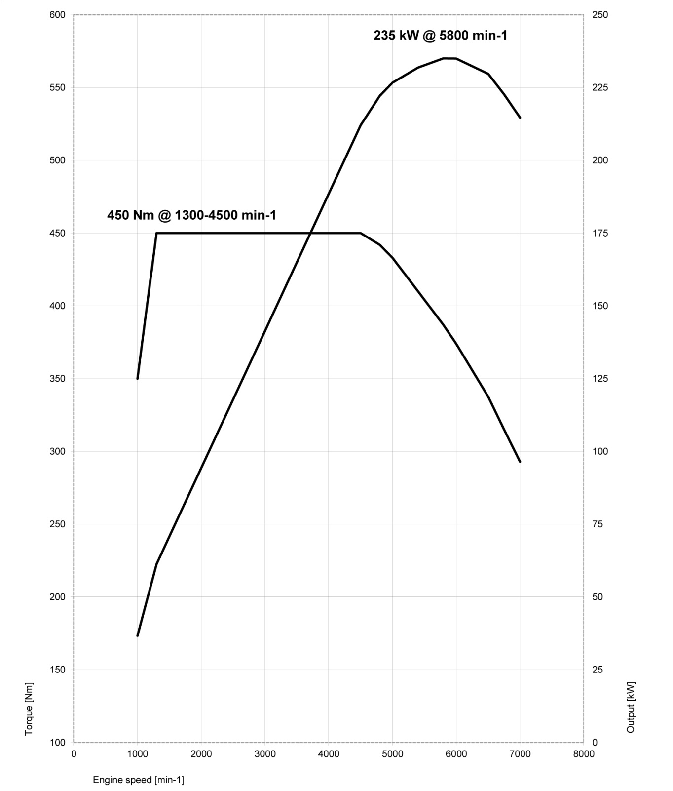
9. Performance and torque diagrams.
BMW 640i Gran Coupe.
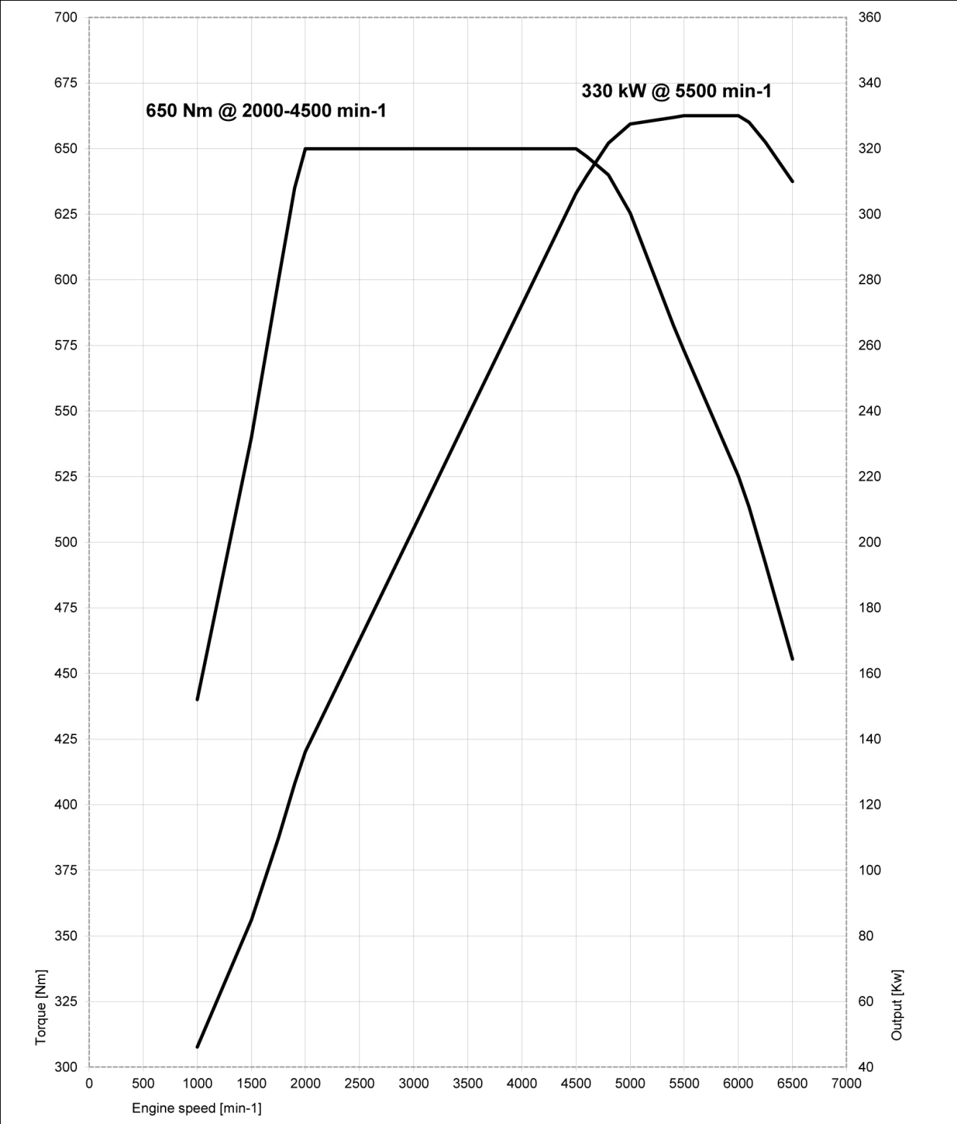
BMW 650i Gran Coupe.
BMW 650i xDrive Gran Coupe.
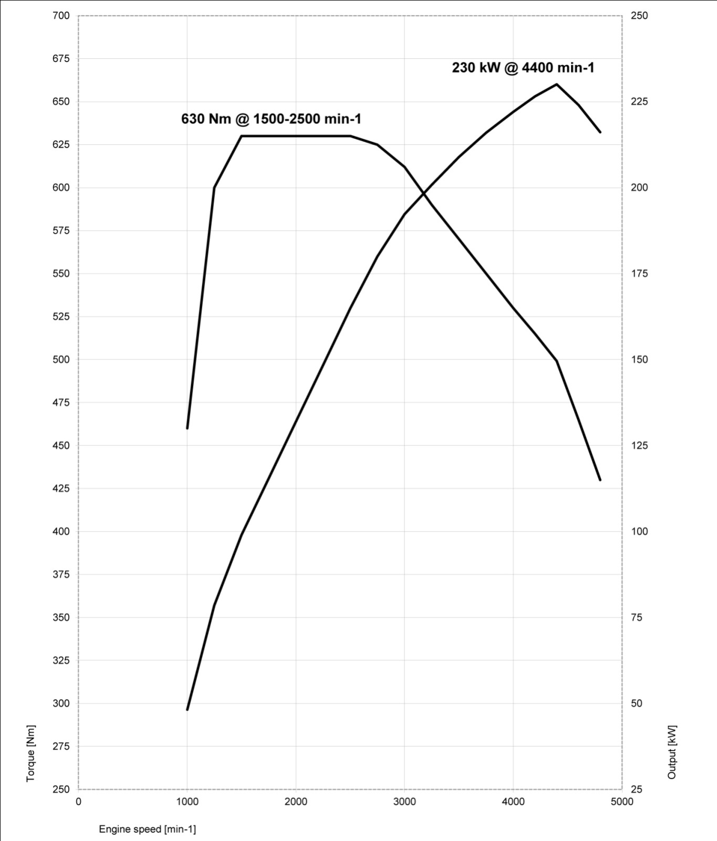
BMW 640d Gran Coupe.
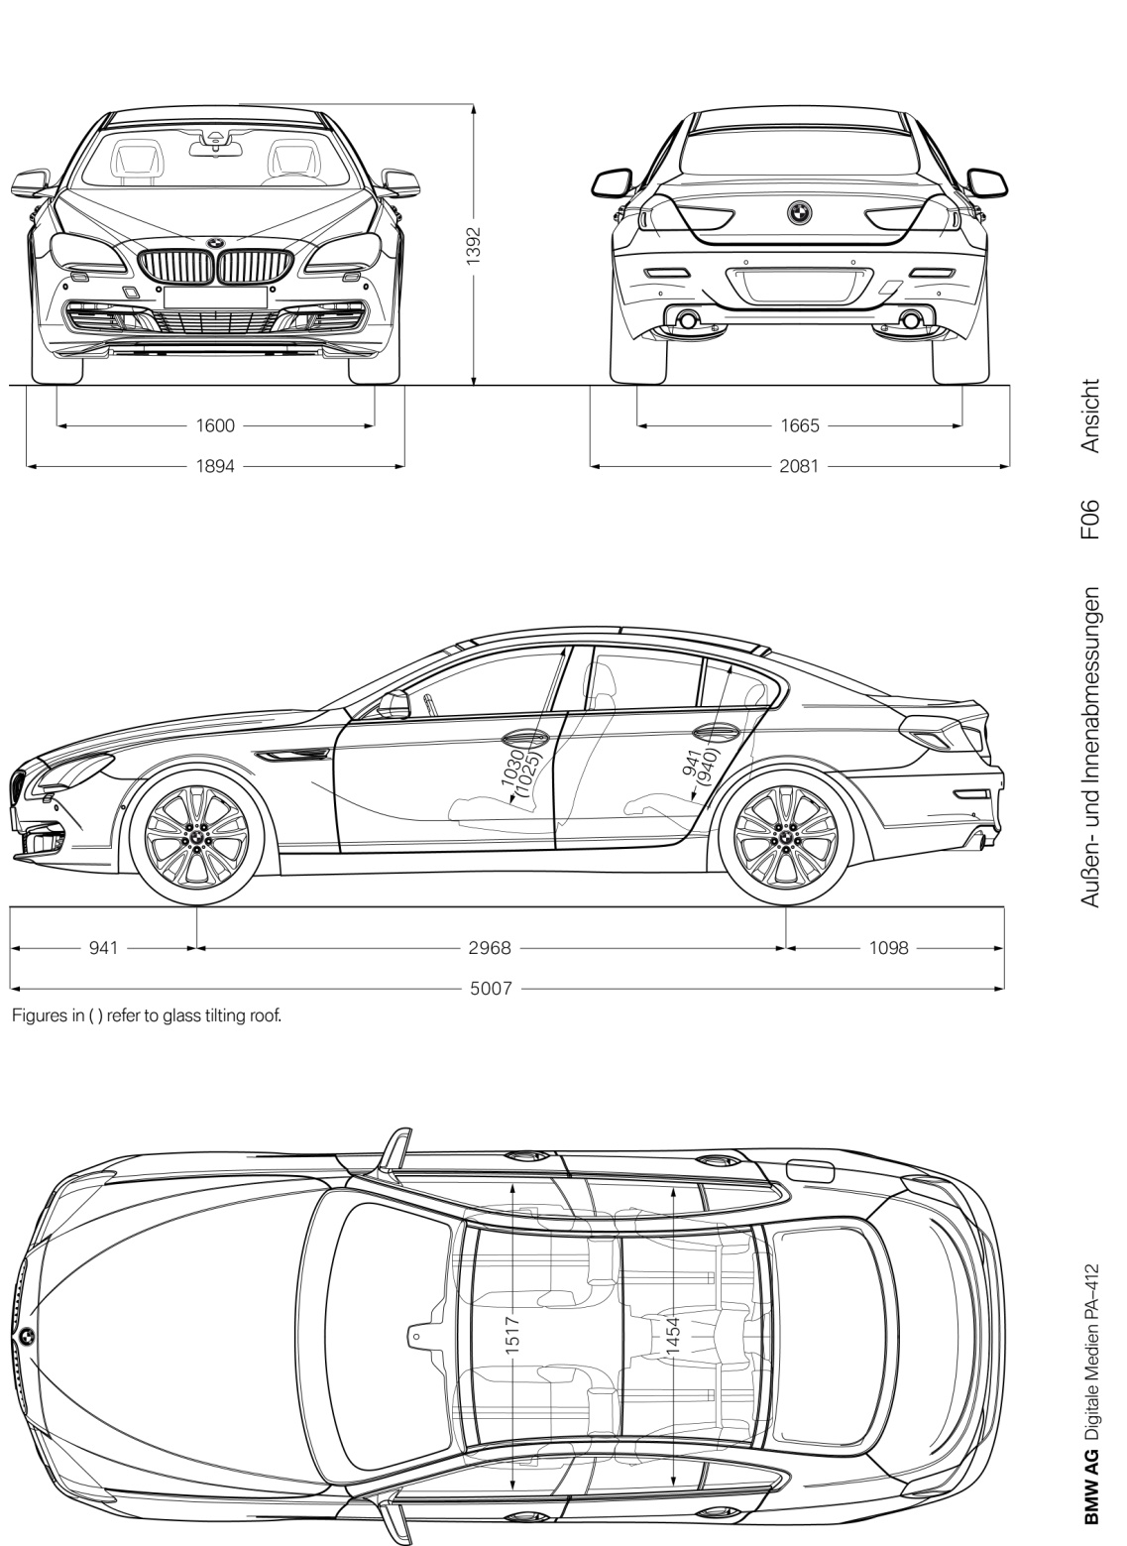
10. Exterior and interior dimensions.

