1. Moving elegance.
The BMW 6 Series Gran Coupe. 2

The BMW 6 Series Gran Coupe.
Contents.
2. At a glance. 5
3. The design:
A new dimension in aesthetics. 9
4. The driving experience:
Refined sportiness. 14
5. BMW EfficientDynamics in the BMW 6 Series Gran Coupe:
Innovations deliver sustainable driving pleasure. 19
6. BMW ConnectedDrive in the BMW 6 Series Gran Coupe:
Experience more with intelligent integration. 22
7. Body and safety:
Contemporary practicality and complete protection. 25
8. Equipment and fittings:
Exclusive, stylish, unmistakable. 27
9. Specifications. 31
10. Output and torque diagrams. 37
11. Exterior and interior dimensions. 40
The presentation of the BMW 6 Series Gran Coupe sees BMW venturing into a new vehicle segment once again. The third model in the BMW 6 Series line-up follows in the tyre tracks of the Convertible and Coupe, and is the first four-door Coupe in the history of the brand. The athletic elegance of the car’s design makes it a particularly handsome addition to the range. Powerful engines and sophisticated chassis technology combine to produce an impressively dynamic driving experience. And the BMW 6 Series Gran Coupe also makes its mark with exclusive equipment features and a level of practicality unmatched by its premium four-door Coupe rivals.
1. Moving elegance.
The BMW 6 Series Gran Coupe.
The design: athletic elegance and an exclusive aura.
The BMW 6 Series Gran Coupe integrates the stand-out looks and dynamics of a Coupe into a fresh new model with a fascinating character all of its own. The hallmark proportions of a BMW are reproduced in an unusually low-slung, sporty package given the car’s four-door construction. And they are defined by a fresh interpretation of the three-box design: a sweeping, powerfully contoured bonnet, a long wheelbase – giving the car an elegantly stretched appearance – and a set-back passenger compartment. In addition, its low height and a roof line that flows in a shallow arc into the rear allow the
BMW 6 Series Gran Coupe to set a new aesthetic benchmark for four-door cars.
The design of the interior creates a harmonious link between the front seats and the rear, and embodies the perfect combination of elegance and dynamics. The driver-focused cockpit, front passenger area bordered by elegantly sweeping surfaces and generously sized rear compartment combine joy in the car’s dynamic potential with travel comfort amid a stylish and luxurious ambience. The BMW 6 Series Gran Coupe comes with 4+1 seats, while a 113-millimetre longer wheelbase than the BMW 6 Series Coupe allows it to offer a noticeable increase in legroom for the rear passengers. Plus, a through-loading facility and folding rear seat backrests give a further boost to practicality and increase boot capacity from 460 litres to 1,265 litres.
The driving experience: a picture of dynamics and comfort.
The BMW TwinPower Turbo engines available for the BMW 6 Series Gran Coupe major in sportiness and efficiency. The six-cylinder in-line petrol engine in the BMW 640i Gran Coupe develops 235 kW, while the straight-six diesel powering the BMW 640d Gran Coupe serves up 230 kW. The icing on the cake of the model range will be provided at a later stage by the BMW 650i Gran Coupe and its 330 kW V8 powerplant. The BMW TwinPower Turbo technology of the new-generation eight-cylinder unit now also includes VALVETRONIC fully variable valve timing. All the engine variants work in tandem with an eight-speed sports automatic transmission, while measures such as the Auto Start-Stop function and ECO PRO mode – activated using the Driving Experience Control switch – help to reduce fuel consumption.
The BMW 650i Gran Coupe will also be available with BMW xDrive intelligent all-wheel drive.
The chassis technology built into the BMW 6 Series Gran Coupe includes a double-wishbone front axle, an integral rear axle, Electric Power Steering and a high-performance braking system. Plus, the Servotronic function and Dynamic Damper Control both also come as standard. Among the items on the options list are Integral Active Steering and the Adaptive Drive system.
Equipment: exclusive features, innovative technology.
As well as the eight-speed sports automatic transmission and Dynamic Damper Control, the high-quality and extensive range of standard equipment awaiting BMW 6 Series Gran Coupe customers includes electrically adjustable leather seats, 2-zone automatic climate control, xenon headlights, 18-inch light-alloy wheels, the Radio Professional with HiFi loudspeaker system, and automatically dimming exterior and rear-view mirrors. The selection of exclusive options, meanwhile, allows customers to add their own individual touch. Highlights of the optional equipment range include adaptive LED headlights and the Bang & Olufsen High-End Surround Sound System. Added to which, a bespoke M Sport package and options from BMW Individual developed exclusively for the BMW 6 Series Gran Coupe will be offered from launch.
The line-up of driver assistance systems and mobility services from
BMW ConnectedDrive includes BMW Parking Assistant, Surround View, Collision Warning with braking function (in conjunction with Active Cruise Control), Lane Change Warning, Lane Departure Warning, Speed Limit Info, the anti-dazzle High-Beam Assistant, BMW Night Vision with pedestrian recognition and the BMW Head-Up Display.
Production at BMW Plant Dingolfing: quality of the highest order.
The BMW 6 Series Gran Coupe will be produced at BMW Plant Dingolfing alongside the BMW 6 Series Coupe and Convertible, BMW 5 Series and BMW 7 Series Luxury Sedan.

• BMW demonstrates its ongoing commitment to broadening the diversity of its model range with the presentation, for the first time, of a four-door Coupe based on the BMW 6 Series; BMW 6 Series Gran Coupe sets new benchmark in the top-class premium segment in terms of aesthetics, emotionality and modernity.
2. At a glance.

• Unique combination of sporty driving pleasure, elegant design, exclusive interior ambience, travel comfort and practicality; the BMW 6 Series Gran Coupe displays an – in some areas – significant step forwards in terms of design harmony, performance, equipment, practicality and integration; high-quality interior with generous levels of space and impressive seating comfort; third rear seat (4+1-seater); length: 5,007 millimetres, wheelbase: 2,968 millimetres; split/folding rear seat backrests allow boot capacity to increase from 460 litres to 1,265 litres.

• Building on the aesthetically pleasing styling of the BMW 6 Series, the design of the BMW 6 Series Gran Coupe showcases its distinctive character; strikingly low-slung appearance.

• Front-end design points to BMW 6 Series identity, individual character embodied by model-specific electroplated bars between the air intake and foglamps; twin round headlights with three-dimensional light rings, optional adaptive LED headlights; distinctive silhouette with flowing Coupe-style roof line and elegant take on the Hofmeister kink, complete with
“Gran Coupe” lettering on the C-pillar; eye-catching rear emphasises the width of the car; LED rear lights in an L-shape – like the BMW 6 Series Coupe and BMW 6 Series Convertible; full-length third brake light above the rear window.

• Exclusively appointed interior with driver-focused cockpit; door panels flow into one another seamlessly, providing a harmonious connection all the way from the instrument panel to the rear compartment; flatscreen
Control Display; comfort-oriented rear seat backrest angle; seating position slightly higher than in the BMW 6 Series Coupe and BMW 6 Series Convertible.

• Engines with BMW TwinPower Turbo technology; BMW 640i Gran Coupe with six-cylinder in-line petrol engine (235 kW), twin-scroll turbocharging, direct injection and VALVETRONIC, and BMW 640d Gran Coupe (230 kW) with variable sequential turbocharging and common-rail direct injection available from launch; flagship BMW 650i Gran Coupe with new eight-cylinder engine (330 kW), two turbochargers, direct injection and VALVETRONIC to be added to the line-up; all model variants fitted as standard with an eight-speed sports automatic transmission and Driving Experience Control switch; BMW EfficientDynamics measures unmatched in the segment – including Auto Start-Stop function and ECO PRO mode – come as standard with all engine variants.

• State-of-the-art chassis technology including Electric Power Steering and Dynamic Damper Control as standard; Integral Active Steering and Adaptive Drive available as an option; BMW xDrive intelligent all-wheel drive available from launch of the BMW 650i Gran Coupe.

• Intelligent lightweight design mirroring that of the BMW 6 Series Coupe and BMW 6 Series Convertible: aluminium doors with frameless side windows, aluminium bonnet, chassis technology including spring supports made largely from aluminium, thermoplastic front side panels, glass fibre composite boot lid.

• High-quality and extensive standard equipment includes eight-speed sports automatic transmission, Auto Start-Stop function, Dynamic Damper Control, Servotronic, 18-inch light-alloy wheels, xenon headlights with LED daytime running light rings, cruise control with braking function, electrically operated, automatically folding and heated exterior mirrors, Dakota leather upholstery and heated front seats, electric seat adjustment with memory function for the driver and front passenger, 2-zone automatic climate control with extended features, automatically dimming exterior and rear-view mirrors, electric steering wheel adjustment, and the Radio Professional with HiFi loudspeaker system and USB audio interface.

• Unrivalled range of BMW ConnectedDrive products, including
BMW Parking Assistant, Speed Limit Info, camera-based Collision Warning with braking function (in conjunction with Active Cruise Control) and latest-generation BMW Head-Up Display; exclusive options list includes a Bang & Olufsen High-End Surround Sound System, comfort seats and sports seats, active seats, seat ventilation, Exclusive Nappa leather, ceramic applications, heated rear seats and 4-zone automatic climate control; extensive range of model-specific BMW Individual features and
M Sport package available from launch.

• Model variants:
BMW 650i Gran Coupe (BMW 650i xDrive Gran Coupe):
V8 petrol engine, BMW TwinPower Turbo technology with two turbochargers and High Precision Direct Petrol Injection, VALVETRONIC.
Displacement: 4,395 cc, output: 330 kW at 5,500 – 6 000 rpm,
max. torque: 650 Nm at 2,000 – 4,500 rpm.
Acceleration [0 – 100 km/h]: 4.6 seconds (4.5 seconds),
top speed: 250 km/h .
Average fuel consumption*: 8.6 – 8.8 (9.2 – 9.4) litres per 100 kilometres,
CO₂ emissions*: 199 – 206 g/km (215 – 219 g/km), exhaust standard: EU5.
BMW 640i Gran Coupe: Six-cylinder in-line petrol engine,
BMW TwinPower Turbo technology with twin-scroll turbocharging,
High Precision Direct Petrol Injection and VALVETRONIC.
Displacement: 2,979 cc, output: 235 kW at 5,800 – 6 000 rpm,
max. torque: 450 Nm at 1,300 – 4,500 rpm.
Acceleration [0 – 100 km/h]: 5.4 seconds,
top speed: 250 km/h.
Average fuel consumption*: 7.7 – 7.9 litres per 100 kilometres,
CO₂ emissions*: 179 – 183 g/km, exhaust standard: EU5.

BMW 640d Gran Coupe: Six-cylinder in-line diesel engine,
BMW TwinPower Turbo technology with two-stage turbocharging and common-rail direct injection.
Displacement: 2,993 cc, output: 230 kW at 4,400 rpm,
max. torque: 630 Nm at 1,500 – 2,500 rpm.
Acceleration [0 – 100 km/h]: 5.4 seconds,
top speed: 250 km/h,
Average fuel consumption*: 5.5 – 5.7 litres per 100 kilometres,
CO₂ emissions*: 146 – 149 g/km, exhaust standard: EU5.
* Figures according to EU test cycle and depending on tyre format;
BMW 650i Gran Coupe: provisional figures
• First four-door Coupe in the history of the BMW brand.
3. The design:
A new dimension in aesthetics.
• Harmonious proportions and distinctive BMW 6 Series styling
characteristics combine to aesthetically pleasing effect.
• Luxuriously appointed interior with clear driver focus, 4+1
seats and generous rear space.
BMW is driving ahead the expansion of its model range with its first venture into the world of four-door Coupes. The design of the BMW 6 Series Gran Coupe body sees the basic form of the BMW 6 Series imbued with the character profile of a four-door car. Harmonious proportions, precise lines and sleekly contoured surfaces give the BMW 6 Series Gran Coupe its unique allure. The length (5,007 millimetres) and wheelbase (2,968 millimetres) of the new model represent an increase of 113 millimetres in both cases over the BMW 6 Series Coupe. A significant part of this extra length has been used to enhance seating comfort for the rear passengers. The BMW 6 Series Gran Coupe is 1,894 millimetres wide and stands 1,392 millimetres in height.
The driver-focused cockpit, front passenger area bordered by elegantly sweeping surfaces, harmonious connection between the front seats and the rear compartment, and generous levels of space for the rear passengers bring together joy in the car’s dynamic potential and travel comfort set within a stylish and luxurious ambience.
The front end: eye-catching presence and a clear connection with the road.
The large air intakes, the slightly forward-leaning, low-set BMW kidney grille, the hallmark BMW twin round headlights and the contour lines of the bonnet – converging forwards in a V-shape – lend the front end of the BMW 6 Series Gran Coupe an expressive presence. The BMW kidney grille has a wide, sporty look, and the grille slats, angled slightly towards the top, accentuate the “shark nose” character of the front end.
The BMW 6 Series Gran Coupe can be ordered with Adaptive LED Headlights as an alternative to the standard xenon units. The LED lights feature bright white, three-dimensional LED light rings for the parking lights and daytime running lights, which are levelled off at the lower edge and overlapped at their top edge by an accent light – also featuring LEDs. The result is a new interpretation of the intent look familiar from other BMW models which is clearly visible both during the day and in darkness. Low and high beam are both generated from the two light rings, accentuating the brand’s hallmark twin round headlight look whatever the light conditions. The source of the light is LED units positioned on a horizontal LED rib in the centre of the units, which disperse their light into the reflectors in front of them. The three-dimensional design of the light units – transparent extensions for the light rings allow light to flood through them – provide an impressive showcase for the LED technology when viewed from the side. LED units also serve the direction indicators positioned under the light rings.
Powerfully flared wheel arches and the optional LED foglamps, placed well to the outside, accentuate the width of the front end. The lower air intake is split into three sections by model-specific L-shaped electroplated bars, which pick up the contours of the bonnet lines and BMW kidney grille to add extra intensity to the road-focused stance of the front end.
The side view: athletic elegance and natural sportiness.
With its long, powerfully contoured bonnet, set-back passenger compartment, long wheelbase and short overhangs, the BMW 6 Series Gran Coupe presents a fresh take on the hallmark proportions of a BMW car.
The Gran Coupe’s distinctive appearance is dominated by its four-door construction, longer wheelbase than other BMW 6 Series models and likewise longer passenger compartment. The low, elegantly stretched roof line, which flows smoothly into the rear end, is a similarly eye-catching and distinctive feature of the new model’s silhouette.
The combination of sporting credibility, luxurious exclusiveness and stylish practicality is particularly clear when viewed from the side. Longer side window surfaces than those found on the two-door BMW 6 Series models hint at the extra space available in the rear compartment and give the car a sense of both sporting verve and reassuring gravitas. Side windows extending far back into the C-pillar give the passenger compartment the low-slung, stretched look typical of Coupes. Added to which, the long strips of glass also allow light to flood the interior, further enhancing the feeling of space inside and all-round visibility for the rear passengers. High-quality Chrome Line Exterior surrounds for the side windows can be specified as an option. The hallmark BMW Hofmeister kink at the transition to the C-pillar is given an extra touch of exclusivity in the form of etched “Gran Coupe” model lettering set against a sporty lozenge structure in the rear section of the side window.
Powerfully flowing surfaces – which open out as they extend back from the front end and stretch over the full length of the body before feeding into the muscular rear end – give the BMW 6 Series Gran Coupe a naturally sporty look. As with the other BMW 6 Series models, they are given their structure by precisely drawn lines. The swage line streaming out from the gill on the front wheel arch takes in the door handle and runs the full length of the car, emphasising the athletic elegance of its side view. Around the rear wheels, the surfaces below the swage line push outwards, enhancing the impression of a powerful car with a strong, assured stance on the road. Plus, the light surfaces generated above the rear wheel arches draw further attention to the wide track and the power being channelled through the rear wheels.
Another character line, emerging from the curvature of the front wheel arch, drops down between the gill feature and the door, before levelling out and extending horizontally to the rear. The unbroken shadow surface above the side sill emphasises the car’s muscular stance from the side.
The rear-end design: horizontal lines and clean surfaces.
Clearly structured surfaces and horizontal lines add further presence to the car’s powerful rear end, which acts as a pointer to the BMW 6 Series Gran Coupe’s impressive roadholding and the sporting brief of the vehicle concept as a whole. The rear end becomes noticeably broader as it heads towards the road and the wheel arches bulge prominently into view. All of which gives the tail an extremely low visual centre of gravity. All the elements of the rear end have a broad, low-set design. The conspicuously flared wheel arches spotlight the car’s wide track and underline the horizontally structured character of the rear. The boot lid and rear apron both have flatter surfacing than their counterparts on the other BMW 6 Series models. The more clearly sculpted sill emphasises the overall volume of the rear end and brings striking details such as the rear lights and exhaust tailpipes more clearly to the fore.
The two-part, L-shaped rear lights share the contours of the car’s
BMW 6 Series siblings and each use a pair of LED light strips to generate the distinctive night-time look of a BMW car. The third brake light is integrated into the roof and stretches the full length of the rear window.
Interior: driver focus and luxurious ambience.
The interior of the BMW 6 Series Gran Coupe reveals the driver-focused cockpit design typical of the brand and a luxurious ambience for all those on board. The central section of the instrument panel is angled slightly towards the driver and the gear selector for the automatic gearbox, the Driving Experience Control switch and the activation button for the parking brake are all positioned on the surface of the centre console which opens out towards the driver.
The standard-fitted iDrive operating system comes with a flatscreen on-board monitor. If the Navigation system Professional is specified, this is upgraded to a 10.2-inch display bordered by a galvanised chrome surround.
Long horizontal lines coursing all the way through the interior of the
BMW 6 Series Gran Coupe create a visual link with the second row of seats, emphasising the size of the interior. The elegant lines of the door trim, familiar from the other BMW 6 Series models, continue into the rear compartment, incorporating the B-pillar as a design element along the way. The sweeping design of the door panels flows harmoniously from the front doors via the
B-pillars to the rear doors. The centre console also stretches through to the rear. Precise contours help to create an intriguing contrast with the interior’s soft, curvaceous surfaces, producing a vibrant and dynamic collage of forms.
The waistline surfaces of the doors form a subtly dynamic wedge shape, which extends into the luggage compartment cover. The dynamic character of the door surface design generates a feeling of depth which envelops the passengers in their seats, while the interplay of convex and concave surfaces evokes a sense of exclusive security.
Sporting verve and generous rear space.
The interior of the BMW 6 Series Gran Coupe offers a driving experience defined by sportiness and exclusiveness, and enhanced by a specially generated ambience. The line of the roof pillars reproduces the car’s arching roof form inside the car. In the rear compartment the enveloping interior typical of a Coupe and comfortable seats offering excellent lateral support combined with generous freedom of movement and good visibility both forwards and out of the car. The BMW 6 Series Gran Coupe offers 4+1 seating capacity as standard, while comfort levels in the rear are raised another notch by features including additional air vents in the centre console.
The BMW 6 Series Gran Coupe can be ordered in a choice of eight metallic exterior paint shades and two non-metallic colours. Other exclusive paint finishes are available as part of the BMW Individual range and in conjunction with the M Sport package. The colours and materials available for the interior, meanwhile, have been selected to enhance the feeling of elegant sportiness and luxury, and can be tailored to the customer’s personal style. The standard Dakota leather can be ordered in a choice of three colours, the optional Exclusive Nappa leather in four different shades. The instrument panel, door trim and centre console are also available as an option with Exclusive Nappa leather coverings. And double French seams in a contrasting colour to suit the seat covers can be ordered in preference to single seams in Black. Customers can also choose from four interior trim strip variants and optional ceramic applications for the gear selector, iDrive Controller and other controls.
• Six-cylinder in-line petrol and diesel engines with
BMW TwinPower Turbo Technology.
4. The driving experience:
Refined sportiness.
• Debut for new V8 engine with BMW TwinPower Turbo technology, including VALVETRONIC.
• Options for extra agility and comfort: Integral Active Steering, Adaptive Drive, intelligent BMW xDrive all-wheel drive.
Powerful six-cylinder in-line and V8 engines with latest-generation
BMW TwinPower Turbo technology give all model versions of the
BMW 6 Series Gran Coupe their sporty potential. All of the engines embody the hallmark BMW brand characteristics: fast-revving performance, effortless power delivery and refinement, plus efficiency. In the BMW 640i Gran Coupe, the multi-award-winning six-cylinder petrol engine with twin-scroll turbocharger, direct injection and VALVTETRONIC produces maximum power of 235 kW, while the six-cylinder BMW 640d Gran Coupe diesel model offer a combination of power and fuel efficiency which would be unusual even outside the luxury class. Maximum output is 230 kW and average fuel consumption between 5.6 and 5.7 litres per 100 km (figures acc. to EU test cycle and depending on tyre format). This is achieved by combining the six-cylinder diesel engine with latest-generation variable two-stage turbocharging and common-rail direct injection. Completing the line-up is the BMW 650i Gran Coupe, whose new V8 engine now features VALVETRONIC variable valve timing and develops maximum power of 330 kW.
An eight-speed sports automatic transmission and the Driving Experience Control function are standard on all model versions. One of the settings that can be selected with this function is ECO PRO mode, which supports a
fuel-efficient driving style. Auto Start-Stop is likewise standard on all three models and makes a further contribution to enhanced efficiency.
In all cases the engine power of the BMW 6 Series Gran Coupe is translated effortlessly into dynamic performance and outstanding refinement, thanks to top-class chassis technology. Electric Power Steering with Servotronic comes as standard, as does Dynamic Damper Control. Options include Integral Active Steering and the Adaptive Drive system, which includes anti-roll stabilisation. For the BMW 650i Gran Coupe, BMW xDrive intelligent all-wheel drive is available too.
More power, more efficiency: V8 engine with
‘BMW TwinPower Turbo technology, including VALVETRONIC.
The top-of-the-line BMW 650i Gran Coupe debuts the latest generation of the 4.4-litre V8 engine with BMW TwinPower technology. Its two turbochargers, which sit in the V between the cylinder banks, and
High Precision Direct Petrol Injection are now joined by VALVETRONIC variable valve timing, which optimises both efficiency and response.
The new technology package increases maximum power to 330 kW, which is available between 5,500 and 6,000 rpm, and maximum torque to
650 Newton metres between 2,000 and 4,500 rpm. Fuel consumption and emissions performance have been improved as well. The BMW 650i Gran Coupe accelerates from 0 to 100 km/h in 4.6 seconds. Its average fuel consumption lies between 8.6 and 8.8 litres per 100 kilometres, with CO₂ emissions of between 199 and 206 grams per kilometres (provisional figures; fuel consumption and emissions figures acc. to EU test cycle and depending on tyre format).
When the V8 is combined with the xDrive intelligent all-wheel-drive system, its power is converted into even more intense and dynamic acceleration. The electronically controlled power split between the front and rear wheels optimises not only traction and stability, whatever the weather and road surface conditions, but also the agility of the BMW 650i xDrive Gran Coupe, whose sprint time from 0 to 100 km/h is just 4.5 seconds. Average fuel consumption is between 9.2 and 9.4 litres per 100 kilometres, with CO₂ emissions of between 215 and 219 grams per kilometre (provisional figures; fuel consumption and emissions figures acc. to EU test cycle and depending on tyre format).
Six-cylinder in-line engines plus BMW TwinPower Turbo technology: the ideal combination for both petrol and diesel engines.
As embodied in the six-in-line petrol engine of the BMW 640i Gran Coupe, the BMW TwinPower Turbo technology again comprises a turbocharging system, High Precision Injection and VALVETRONIC. Unlike on the V8 engine, however, twin-scroll turbocharging is used. The exhaust gas pulses from each bank of three cylinders are fed through two separate channels to the turbine wheel. This produces maximum power of 235 kW, at 5,800 to 6,000 rpm, from a displacement of 3.0 litres. Maximum torque of
450 Newton metres is on tap between 1,300 and 4,500 rpm.
The BMW 640i Gran Coupe accelerates from 0 to 100 km/h in
5.4 seconds. Average fuel consumption is between 7.8 and 7.9 litres per
100 kilometres, with CO₂ emissions between 181 and 183 grams per kilometre (figures acc. to EU test cycle and depending on tyre format).
For the straight-six diesel engine of the BMW 640d Gran Coupe, the
BMW TwinPower Turbo technology comprises the latest-generation variable two-stage turbocharging system, and common-rail direct injection with piezo injectors. The 3.0-litre all-aluminium engine develops maximum power of 230 kW at 4,400 rpm, while peak torque of 630 Newton metres is on stream between 1,500 and 2,500 rpm. In this case the turbocharging system comprises a small variable turbocharger and a larger turbocharger, which work together in close synchronisation to boost power delivery across the entire throttle range. The BMW 640d Gran Coupe accelerates from 0 to 100 km/h in 5.4 seconds. Its average fuel consumption is just 5.6 to 5.7 litres per 100 kilometres, with CO₂ emissions of between 148 and 149 g per kilometre (figures acc. to EU test cycle and depending on tyre format).
On all model versions, the power is managed by an eight-speed sports automatic transmission. With its extremely fast gear changes this unit is built for sporty driving, comfortable shifting and optimised efficiency. It is operated using the electronic gear selector on the centre console. For manual gear changing, this transmission comes with steering wheel-mounted paddle shifts.
High-end chassis technology for a perfect balance between dynamics and comfort.
The chassis of the BMW 6 Series Gran Coupe is based on a double-wishbone front axle and an integral rear axle, both of which consist largely of aluminium. Their design offers an excellent basis for combining sporty handling characteristics with a comfortable ride.
The BMW 6 Series Gran Coupe is standard-fitted with Dynamic Damper Control, whose electronically controlled dampers adapt both to the road surface conditions and to driving style. Handling characteristics can be further enhanced with the optional Adaptive Drive system, which includes active
anti-roll stabilisation. Amongst other things, the electronically controlled
anti-roll bars reduce body roll during fast cornering or sudden manoeuvres.
The Electric Power Steering of the BMW 6 Series Gran Coupe is equipped as standard with a Servotronic speed-sensitive power assist function. Uniquely in this class, the BMW 6 Series Gran Coupe can also optionally be equipped with Integral Active Steering, which not only steers the front wheels and provides speed-sensitive power assistance but also steers the rear wheels. Precise coordination of the turning angles of the wheels provides a high level of agility in dynamic driving situations, comfortable and effortless vehicle reactions when changing lanes and on bends, and optimised manoeuvrability in tight hairpins and around town.
Driving Experience Control: the ideal set-up at the press of a button.
The Driving Experience Control switch on the centre console is used to switch between the drive settings COMFORT+, COMFORT, SPORT, SPORT+ and ECO PRO mode. The Driving Experience Control switch allows the driver to alter accelerator response characteristics, engine response, the power steering characteristics, the DSC settings, the damper characteristics and the shift characteristics of the automatic transmission. If the vehicle is equipped with Adaptive Drive, the anti-roll characteristics are modified too. Each of these predefined set-ups is configured as a synchronised overall package.
A further button can be used to separately adjust the DSC settings. This button can be used to activate the traction mode DTC (Dynamic Traction Control), which makes for easier driving and moving off on loose sand or in deep snow. The electromechanical parking brake of the BMW 6 Series Gran Coupe is operated by a button on the centre console.
Lightweight brake system and DSC stability control.
The combination of the highly efficient lightweight brake system, with its large vented brake discs, and DSC stability control provides highest standards of active safety. The DSC functionality includes DTC, Dynamic Brake Control (DBC), Cornering Brake Control (CBC), Dry Braking, Fading Compensation and Start-Off Assistant. In Germany, the standard specification also includes 18-inch alloy wheels for all model versions.
• All engines feature BMW TwinPower Turbo technology.
5. BMW EfficientDynamics
in the BMW 6 Series Gran Coupe:
Innovations deliver sustainable driving pleasure.
• Auto Start-Stop function also for eight-cylinder engine.
• ECO PRO mode: optimised efficiency at the press of a button.
All model versions of the BMW 6 Series Gran Coupe offer an exceptionally good balance between sporty performance and fuel consumption thanks to extensive use of the latest BMW EfficientDynamics technology.
All the BMW 6 Series Gran Coupe models are powered by BMW TwinPower Turbo engines. The technical details of the TwinPower Turbo package, which provides maximum efficiency and optimal power response, differ from vehicle to vehicle. This package allows both the petrol engines and the diesel engine to develop the kind of power that would normally require much larger displacement, which would mean adding to weight and fuel consumption.
BMW TwinPower Turbo technology: for each engine, the ideal solution for increased efficiency and driving enjoyment.
The BMW 650i Gran Coupe showcases the latest results of continuous engine development work at BMW: the new-generation 4.4-litre V8 engine with BMW TwinPower Turbo technology. The BMW TwinPower Turbo package for the V8 now includes two turbochargers housed in the V between the cylinder banks, High Precision Direct Petrol Injection and VALVETRONIC variable valve timing. Seamlessly variable control of intake valve lift keeps pumping losses to a minimum, so that the energy content of the fuel is utilised more efficiently. Compared with the previous engine, the new V8 features a 10 per cent power upgrade to 330 kW and a 50 Nm increase in maximum torque to 650 Newton metres. In parallel with improved power and response, VALVETRONIC also significantly reduces fuel consumption and emissions.
The 3.0-litre engine of the BMW 640i Gran Coupe comes with twin-scroll turbocharging, which means that the exhaust gases from each bank of three cylinders are fed through two separate channels in the exhaust manifold and the turbine. This engine too features High Precision Injection and VALVETRONIC.
The BMW TwinPower Turbo technology for the six-cylinder in-line diesel engine of the BMW 640d Gran Coupe boasts further improved variable two-stage turbocharging and modified common-rail direct injection, with piezo injectors that operate at a pressure of up to 2,000 bar.
Eight-speed automatic transmission and Auto Start-Stop function.
A further important contribution to increased efficiency is made by the standard-fitted eight-speed sports automatic transmission, with its innovative gearing design, low weight and high internal efficiency. The minimal torque converter slip, low friction losses (since no more than two clutches are ever open at the same time in any gear), higher gearing in the higher ratios, and transmission logic which favours lower-rpm operation all add up to significant fuel savings.
Both the six and the eight-cylinder versions of the BMW 6 Series Gran Coupe also come with an Auto Start-Stop function as standard specification, which prevents wasteful idling by automatically shutting off the engine when the vehicle is temporarily stationary in traffic.
Also, all engine versions can be operated in ECO PRO mode, which is activated using the Driving Experience Control switch. This modifies the engine management characteristics, the accelerator mapping and the shift characteristics of the automatic transmission, and supports a low-rpm driving style for optimised fuel consumption. Also in this mode, electrically powered functions such as the air conditioning, heated seats and heated exterior mirrors are programmed for optimal energy efficiency.
Also standard is Brake Energy Regeneration, whose intelligent energy management system ensures that, as far as possible, power for the vehicle electrical system is generated only during braking and overrun. Other BMW EfficientDynamics measures include on-demand operation of ancillary units, Electric Power Steering, a disengageable air-conditioning compressor and active air flap control for reduced drag. At the same time, intelligent lightweight design reduces weight and so improves fuel consumption and emissions.
• Driver assistance systems and mobility services include
Head-Up Display, Parking Assistant, Office functions, internet, Real-Time Traffic Information and Apps.
6. BMW ConnectedDrive in the
BMW 6 Series Gran Coupe:
Experience more with intelligent integration.
• Speed Limit Info, Lane Change Warning and Lane Departure Warning.
• Debut for camera/radar-based collision warning system with braking function.
Thanks to the world-leading breadth of features and services offered by
BMW ConnectedDrive, the BMW 6 Series Gran Coupe’s segment leadership also extends to driver assistance systems and mobility services. Intelligently connecting the driver, the vehicle and the outside world, BMW ConnectedDrive sets new benchmarks for convenience, safety and infotainment. As standard, the BMW 6 Series Gran Coupe is equipped with Cruise Control with braking function. The optional Cruise Control with
Stop & Go function also includes automatic distance control, which allows the driver to cruise comfortably in free-flowing traffic on motorways and main roads and which continues to maintain a pre-set following distance even when creeping along in slow-moving traffic.
A collision warning system with braking function is also onboard. This system uses radar sensors and a camera mounted behind the windscreen next to the rear-view mirror to monitor the distance from the vehicle ahead. The collision warning system features a two-stage alarm scenario. The first stage is simply a visual warning. If the driver needs to intervene very quickly, however, the system generates an acute warning, while at the same time activating automatic braking.
BMW ConnectedDrive driver assistance systems and mobility services: unique in this class.
For the BMW 6 Series Gran Coupe, as for the BMW 6 Series Coupe and the BMW 6 Series Convertible, many other driver assistance systems are available to increase comfort and safety.
For example, the Park Distance Control system (PDC) can optionally be supplemented by a rear-view camera fitted under the BMW badge in the boot lid and by the Surround View system (including Side View), while safety in the dark can be improved with the optional anti-dazzle High-Beam Assistant system and BMW Night Vision with pedestrian recognition. Also available are the BMW Parking Assistant, Lane Departure Warning and Lane Change Warning systems.
The new-generation BMW Head-Up Display now features improved display quality with full-colour graphics. This ensures that the symbols projected onto the windscreen are as realistic as possible.
Working in conjunction with the Navigation system Professional, Speed Limit Info detects speed limits and allows the driver to check what limit applies on the section of road he is currently travelling on. The BMW 6 Series Gran Coupe also has a speed limiter function.
The BMW ConnectedDrive range of mobility services, internet-based services and solutions for in-car integration of portable devices offers unrivalled choice. For example, the BMW Assist service includes Advanced Emergency Call (with automatic vehicle location and accident severity recognition), enhanced traffic information, a comprehensive telephone Enquiry Service, the interactive communication portal My Info, which includes the Google Send-to-Car function, and BMW TeleServices.
New BMW Online services, innovative Apps functions.
The BMW Online service now also offers access to the user review portal Qype, a Deutsche Post information service, the Wiki Local service and a registration number search function. Using the BMW Connected app, the BMW ConnectedDrive Apps function gives Apple iPhone owners in-car access to web-based applications. This means they can use Web radio functions and can show Facebook and Twitter posts and personal calendar entries on the iDrive monitor.
Also available is the Real-Time Traffic Information function, which transmits extremely precise traffic information and diversion recommendations to the navigation system. In the BMW 6 Series Gran Coupe, too, BMW ConnectedDrive customers can use the iDrive control system to access the internet. In 2008, BMW became the first carmaker in the world to offer
in-car internet access.
• Comfortable travel and functionality with 4+1 seats,
through-loading and folding rear backrest.
7. Body and safety:
Contemporary practicality and complete protection.
• Intelligent lightweight design based on optimal use of high-tensile and ultra-high-tensile steels, aluminium and plastics.
• Optionally available: Adaptive LED Headlights and LED foglamps.
The first four-door Coupe from the BMW brand sets new standards in this segment with regard to both the styling and the functional characteristics of its bodywork and interior. The BMW 6 Series Gran Coupe is able to seat up to five occupants: the rear compartment of the 4+1 seater offers high standards of travel comfort for two passengers, while on short journeys a third seat can also be used. The generous head, leg and shoulder room in the rear is combined with a spacious luggage compartment, whose capacity can be flexibly expanded as necessary. The weight-optimised body is also very stiff.
The slim profile of the B-pillar trim in the footwell area and the wide door opening which extends well to the rear allow easier entry and exit for rear-seat passengers. Large side windows, despite the low Coupe roofline, and a slightly higher seating position than in the BMW 6 Series Coupe make for improved visibility. The luggage compartment has a capacity of 460 litres and can accommodate up to three 46-inch golf bags. If the 40:60 split-folding backrest is folded down, the capacity can be increased to 1,265 litres. The two backrest sections can be unlocked and folded down using two levers inside the luggage compartment. A through-load system is also fitted, which among other things can be used to store the optional ski bag.
Intelligent multi-material mix.
The four doors – with frameless side windows – and the bonnet are made of aluminium. Similarly the axles and engines have a high aluminium content. The front spring supports are of cast aluminium, the front sidewalls of thermoplastic and the boot lid of glass fibre composite.
Use of higher-strength multi-phase steels and hot-stamped ultra-high-tensile steel helps give the safety passenger cell maximum rigidity while at the same time optimising weight.
The standard safety specification comprises front airbags, backrest-integrated side airbags, head airbags front and rear, three-point inertia-reel belts for all seats, front-seat active head restraints, belt force limiters and belt-pretensioners, and ISOFIX child seat attachment systems in the rear, which can be accessed by opening a zip in the leather upholstery. To improve passive pedestrian protection, in some markets the BMW 6 Series Gran Coupe comes with an active bonnet.
Optimal visibility: bi-xenon lighting standard; Adaptive LED Headlights and LED foglamps optional.
The standard-fitted bi-xenon headlamps of the BMW 6 Series Gran Coupe provide excellent road illumination. The distinctive corona rings are powered by LED units and produce a strikingly bright white light. They can be operated on two different power settings, as either side lights or daytime running lights. Optionally, Adaptive Headlights are available.
A further option is Adaptive LED Headlights. Again, this is a “road-following” lighting system. The headlights swivel in line with the steering angle, yaw rate and speed of the vehicle. A cornering light function is also included: when making a turn, an additional light beam is activated which illuminates the road in the direction the vehicle is turning. Also included in the Adaptive LED Headlight specification is High-Beam Assist, which helps drivers get the most out of high-beam mode. BMW 6 Series Gran Coupe models fitted with Adaptive LED Headlights also feature LED direction indicators.
Also available as an option are LED foglamps, each of which comprises three LED units side by side. At the rear, LED-powered light strips give the rear lights the typical BMW night-time look. The direction indicators and brake lights are LED-powered as well. To reduce the risk of rear-end collisions, the BMW 6 Series Gran Coupe is also equipped with dynamic brake lights. When the driver brakes very sharply and the ABS system intervenes, drivers behind are warned by conspicuous flashing of the brake lights likewise to brake as hard as possible.
• Unusually extensive range of standard equipment including leather seats, HiFi audio system and 2-zone automatic climate control.
8. Equipment and fittings:
Exclusive, stylish, unmistakable.
• Exclusive options: active seats, Comfort Access, 4-zone automatic climate control, electrically operated sun blinds, Bang & Olufsen High-End Surround Sound System.
• M Sport package and BMW Individual range available from launch.
The exclusive driving experience on board the BMW 6 Series Gran Coupe is underlined by both the luxurious interior ambience and the extensive array of standard equipment and wide variety of top-quality options. In addition to the eight-speed sports automatic transmission, Auto Start-Stop function, Dynamic Damper Control, Servotronic, 18-inch light-alloy wheels and xenon headlights with LED daytime running light rings, the array of standard equipment also includes the iDrive operating system with freestanding Control Display in the instrument panel, a leather steering wheel with multifunction buttons, cruise control with braking function and electrically operated, automatically folding and heated exterior mirrors. Also part of standard specification are Dakota leather trim and heated front seats, electric seat adjustment with memory function for the driver and front passenger,
2-zone automatic climate control with extended features, automatically dimming exterior and rear-view mirrors, electric steering wheel adjustment and the Radio Professional with HiFi loudspeaker system and USB audio interface.
Lightweight seats with integrated belt system in three variants.
The lightweight seats with integrated belt system developed for the driver and front passenger of the new BMW 6 Series are available in a choice of three variants. Standard specification includes electric adjustment (with memory function) for the seat height and fore/aft setting, the backrest angle and the height of the head restraints. Sports seats, comfort seats and active seat ventilation can be ordered as an option, and Exclusive Nappa leather with extended features is available as an alternative to the standard-fitted Dakota leather. Added to which, the comfort seats are also available with the “active” function. Heated rear seats can likewise be specified.
Among the other items of equipment customers can choose from are Adaptive Headlights, a heated steering wheel, Comfort Access, ambient lighting, the Soft Close Automatic function for the doors, 4-zone automatic climate control, an electrically operated glass roof and electrically operated sun blinds for the rear window and rear side windows. The optional Navigation system Professional comes with hard drive storage for maps and the driver’s music collection, while the standard-fitted Radio Professional includes an MP3-compatible CD drive, an AUX-IN socket and a HiFi audio system with nine loudspeakers. A DVD changer, TV module and USB audio interface can also be ordered to meet individual customer requirements in all things entertainment.
When it comes to delivering audio pleasure of the highest order, the bespoke Bang & Olufsen High-End Surround Sound System hits all the right notes. This is a fully active system featuring digital signal processing, which means the two bass speakers, seven mid-range speakers and seven tweeters all have individual amplifiers. Its centre speaker boasts the Acoustic Lens Technology developed by Bang & Olufsen. As soon as the audio system is activated, the central element containing the integrated mid-range speaker pops up out of the instrument panel, prompting the tweeter lens to be extended at the same time.
M Sport package and BMW Individual range available from launch.
An M Sport package developed specially for the BMW 6 Series Gran Coupe is available from the launch of the new car. Among the features included are an M aerodynamics package with bespoke body components for the front end, side skirts and rear apron, exhaust tailpipe embellishers in dark chrome, black-painted brake callipers, LED foglamps, a sports exhaust system for the
BMW 650i Gran Coupe and 19-inch light-alloy wheels in M double-spoke design. 20-inch light-alloy wheels in M double-spoke design are also available. Customers ordering the M Sport package may also opt for the M paint finishes Carbon Black metallic and Imola Red non-metallic.
The sporting theme continues inside the car in the form of special M Alcantara/leather sports seats with blue contrast stitching, an M leather steering wheel with multifunction buttons and gearshift paddles, and aluminium hexagon interior trim strips. Plus, the M Sport package adds door sill finishers sporting the M logo and an M driver’s footrest to the mix.
Also available from launch is the BMW Individual range of products, which allows customers to tailor the exterior and interior of their BMW 6 Series Gran Coupe precisely and exclusively to their personal style. The four BMW Individual paint shades are joined in the range by BMW Individual special paint finishes and a selection of matt paint finishes. For example, the BMW Individual matt finish Frozen Bronze metallic is available exclusively for the BMW 6 Series Gran Coupe. BMW Individual light-alloy wheels in V-spoke design can be specified in 19 and 20-inch format. Those looking to give the interior of their car a particularly exclusive aura, meanwhile, may like to add BMW Individual fine-grain Merino full leather trim, an Alcantara BMW Individual roof liner, BMW Individual interior strips and the BMW Individual wood inlay for the steering wheel.
One of the highlights of the BMW Individual range of interior adornments is the Opal White full-leather trim specially developed for the BMW 6 Series Gran Coupe, combined with the interior colour Amaro Brown. Here, the leather-covered instrument panel and Alcantara BMW Individual roof liner are also presented in Amaro Brown. The selection of materials and combinations of colours and a quality of manufacture underpinned by precision craftsmanship both play their part in showcasing the exclusive character of the BMW Individual range. White contrast stitching for the instrument panel, armrest and door trim are in keeping with the Opal White seats and door panels, while Amaro Brown seat stitching and piping blend with interior appointments in a corresponding colour to equally flawless effect. In addition, BMW Individual Ash Grain White fine wood trim adds a particularly high-quality touch to the interior and fits in seamlessly with the overall colour concept.
All the items in the BMW Individual range can also be ordered as individual options. And the BMW 6 Series Gran Coupe is also available with a
BMW Individual composition of products in a perfectly judged combination of colours and materials. The new BMW 6 Series Gran Coupe will go on sale in South Africa in the second quarter of 2012.
9. Specifications.
BMW 640i Gran Coupe.
BMW 650i Gran Coupe.
 |  | BMW 640i Gran Coupe |  |  | BMW 650i Gran Coupe
Body
No. of doors/seats |  | 4 / 5 |  |  | 4 / 5
Length/width/height (unladen) | mm | 5007 / 1894 / 1392 |  |  | 5007 / 1894 / 1392
Wheelbase | mm | 2968 |  |  | 2968
Track, front/rear | mm | 1600 / 1665 |  |  | 1600 / 1665
Ground clearance | mm | 126 |  |  | 126
Turning circle | m | 11,95 |  |  | 11,95
Tank capacity | approx. l | 70 |  |  | 70
Cooling system incl heating | l | 10.0 |  |  | 10.9
Engine oil¹⁾ | l | 6.5 |  |  | 8.0
Weight, unladen, to DIN/EU | kg | 1750 / 1825 |  |  | 1865 / 1940
Max load to DIN | kg | 570 |  |  | 570
Max permissible weight | kg | 2360 |  |  | 2465
Max axle load, front/rear | kg | 1130 / 1295 |  |  | 1210 / 1315
Max trailer load,  braked (12%)/unbraked | kg | – / – |  |  | – / –
Max roof load/towbar download | kg | 75 / – |  |  | 75 / –
Luggage comp capacity | l | 460 – 1265 |  |  | 460 – 1265
Air drag | c_{X} x A | 0.29 x 2.24 |  |  | 0.29 x 2.24
Engine
Configuration/No of cyls/valves |  | R / 6 / 4 |  |  | V90 / 8 / 4
Engine technology |  | BMW TwinPower Turbo technology with twin-scroll turbocharging, High Precision Direct Petrol Injection and fully variable valve control (VALVETRONIC) |  | BMW TwinPower Turbo technology with two turbochargers, High Precision Direct Petrol Injection and fully variable valve control (VALVETRONIC)
Effective capacity | cm³ | 2979 |  |  | 4395
Bore/stroke | mm | 89.6 / 84.0 |  |  | 88.3 / 89.0
Compression ratio | :1 | 10.2 |  |  | 10.0
Fuel grade |  | min RON 91 |  |  | min RON 91
Output | kW/hp | 235 / 320 |  |  | 330 / 450
at | min^{–1} | 5800 – 6000 |  |  | 5500 – 6000
Torque | Nm | 450 |  |  | 650
at | min^{–1} | 1300 – 4500 |  |  | 2000 – 4500
Electrical system
Battery/Installation | Ah/– | 90 / luggage compartment |  |  | 105 / luggage compartment
Alternator | A/W | 210 / 2940 |  |  | 210 / 2940
Driving dynamics and safety
Suspension, front |  | Double track control arm with separate lower track arm level, aluminium,  small steering roll radius, anti-dive
Suspension, rear |  | Integral-V multi-arm axle, aluminium, with anti-squat and  anti-dive, double acoustic separation
Brakes, front |  | Frame-type aluminium single-piston floating-calliper disc brakes
Diameter | mm | 348 x 30 / vented |  |  | 374 x 36 / vented
Brakes, rear |  | Aluminium single-piston floating-calliper disc brakes
Diameter | mm | 345 x 24 / vented |  |  | 345 x 24 / vented
Driving stability systems |  | Standard: DSC incl. ABS and DTC (Dynamic Traction Control), CBC (Cornering Brake Control), DBC (Dynamic Brake Control), Dry Braking function,  Fading Compensation, Start-Off Assistant, Dynamic Damper Control²⁾, optional: Adaptive Drive
Safety equipment |  | Standard: airbags for driver and front passenger, side airbags for driver and front passenger, head airbags for front and rear seats, three-point inertia-reel seatbelts on all seats with belt latch tensioner and belt force limiter integrated in the front seats, crash-activated head restraints at the front, crash sensors, runflat tyres, Tyre Defect Indicator
Steering |  | Electric Power Steering (EPS) with Servotronic function;  optional: Integral Active Steering
Steering ratio, overall | :1 | 17.2 |  |  | 17.2
Tyres, front/rear |  | 225/55 R17 97Y RSC  (245/45 R18 96Y RSC ²⁾) |  |  | 245/45 R18 96Y RSC
Rims, front/rear |  | 8J x17 light-alloy  (8J x 18 light-alloy ²⁾) |  |  | 8J x 18 light-alloy
 |  |  | BMW 640i Gran Coupe |  |  |  | BMW 650i Gran Coupe
BMW ConnectedDrive
Convenience |  |  |  |  | Optional: BMW Assist incl Enquiry Service, remote-control functions, V-Info+ (Traffic Info plus), Real-Time Traffic Information, BMW TeleServices, integration of mobile devices
Infotainment |  |  |  | Optional: internet access, BMW Online incl Park Info, National Info, Google Local Search, News, Real-Time Weather, BMW Routes, Office functions, Bluetooth Audio Streaming, Online Update Music Tracks, Apps
Safety |  |  |  | Optional: Adaptive Headlights with cornering lights, variable light distribution and adaptive headlight range control, High Beam Assistant, Park Distance Control, rear-view camera, Surround View incl Top View and Side View,  BMW Night Vision with pedestrian recognition, Head-Up Display, Parking Assistant, Active Cruise Control with Stop & Go function, Collision Warning  with braking function, Lane Change Warning, Lane Departure Warning,  Speed Limit Info incl No Passing Info display,  Automatic/Advanced Emergency Call
Transmission
Type of gearbox |  |  |  | Eight-speed automatic with Steptronic
Gear ratios I |  | :1 |  | 4.714 |  |  |  | 4.714
II |  | :1 |  | 3.143 |  |  |  | 3.143
III |  | :1 |  | 2.106 |  |  |  | 2.106
IV |  | :1 |  | 1.667 |  |  |  | 1.667
V |  | :1 |  | 1.285 |  |  |  | 1.285
VI |  | :1 |  | 1.000 |  |  |  | 1.000
VII |  | :1 |  | 0.839 |  |  |  | 0.839
VIII |  | :1 |  | 0.667 |  |  |  | 0.667
R |  | :1 |  | 3.295 |  |  |  | 3.317
Final drive |  | :1 |  | 3.231 |  |  |  | 2.813
Performance
Power-to-weight ratio  (DIN unladen weight) | kg/kW |  |  | 7.4 |  |  | 5.7
Output per litre | kW/l |  |  | 78.9 |  |  | 75.1
Acceleration 0–100 km/h | s |  |  | 5.4 |  |  | 4.6
0–1000 m | s |  |  | 25.0 |  |  | 22.5
in 4th gear 80–120 km/h | s |  |  | – |  |  | –
Top speed | km/h |  |  | 250 |  |  | 250
BMW EfficientDynamics
BMW EfficientDynamics standard features |  |  |  | Brake Energy Regeneration with recuperation display,  Auto Start-Stop function, ECO PRO mode, intelligent lightweight design,  on-demand operation of ancillary units, active air flap control (BMW 640i), Electric Power Steering (EPS), detachable a/c compressor,  tyres with reduced rolling resistance
Fuel consumption EU³⁾
with standard wheels and tyres: rims 8J x 17, tyres 225/55 R17 (SA 2K1) BMW 650i: rims 8J x 18, wheels 245/45 R18 (SA 2D3)
Urban | l/100km |  |  | 10.5 |  |  | ⁴⁾
Extra-urban | l/100km |  |  | 6.0 |  |  | ⁴⁾
Combined | l/100km |  |  | 7.7 |  |  | 8.6
CO₂ | g/km |  |  | 179 |  |  | 199
rims 8J x 18, tyres 245/45 R18 (SA 2D3, BMW 640i: standard in Germany)
or winter wheels and tyres (SA 9WR, 931)
Urban | l/100 km |  |  | 10,6 |  |  | –
Extra-urban | l/100 km |  |  | 6,1 |  |  | –
Combined | l/100 km |  |  | 7,8 |  |  | –
CO₂ | g/km |  |  | 181 |  |  | –
rims 8.5J x 19 front, 9J x 19 rear and tyres 245/40 R19 front, 275/35 R19 rear
(SA 2DP, 2FB, 2ND, 2MZ, 2WE),
rims 8.5J x 20 front, 9J x 20 rear and tyres 245/35 R20 front, 275/30 R20 rear (SA 2H9, 2NM, 2NL)
Urban | l/100km |  |  | 10.7 |  |  | ⁴⁾
Extra-urban | l/100km |  |  | 6.2 |  |  | ⁴⁾
Combined | l/100km |  |  | 7.9 |  |  | 8.8
CO₂ | g/km |  |  | 183 |  |  | 206
Emission rating |  |  |  | EU5 |  |  | EU5
Insurance group
3P / FCC / FC |  |  |  | ⁴⁾ |  |  | ⁴⁾

Specifications apply to ACEA markets; data relevant to homologation applicable in part only to Germany (weight)
BMW 650i Gran Coupe: provisional figures

¹⁾ Oil change
²⁾ Standard in Germany
³⁾ Fuel consumption and CO₂ emissions vary according to the wheel and tyre sizes selected
⁴⁾ Data not yet available

BMW 650i xDrive Gran Coupe.
 |  |  |  | BMW 650i xDrive Gran Coupe
Body
No. of doors/seats |  |  |  |  |  | 4 / 5
Length/width/height (unladen) | mm |  |  |  |  | 5007 / 1894 / 1392
Wheelbase | mm |  |  |  |  | 2968
Track, front/rear | mm |  |  |  |  | 1600 / 1665
Ground clearance | mm |  |  |  |  | 126
Turning circle | m |  |  |  |  | 11.95
Tank capacity | approx. l |  |  |  |  | 70
Cooling system incl heating | l |  |  |  |  | 10.9
Engine oil¹⁾ | l |  |  |  |  | 8.0
Weight, unladen, to DIN/EU | kg |  |  |  |  | 1940 / 2015
Max load to DIN | kg |  |  |  |  | 570
Max permissible weight | kg |  |  |  |  | 2550
Max axle load, front/rear | kg |  |  |  |  | 1260 / 1325
Max trailer load,  braked (12%)/unbraked | kg |  |  |  |  | – / –
Max roof load/towbar download | kg |  |  |  |  | 75 / –
Luggage comp capacity | l |  |  |  |  | 460 – 1265
Air drag | c_{X} x A |  |  |  |  | 0.31 x 2.24
Engine
Configuration/No of cyls/valves |  |  |  |  |  | V90 / 8 / 4
Engine technology |  |  |  |  | BMW TwinPower Turbo technology with two turbochargers, High Precision Direct Petrol Injection and fully variable valve control (VALVETRONIC)
Effective capacity | cm³ |  |  |  |  | 4395
Bore/stroke | mm |  |  |  |  | 88.3 / 89.0
Compression ratio | :1 |  |  |  |  | 10.0
Fuel grade |  |  |  |  |  | min RON 91
Output | kW/hp |  |  |  |  | 330 / 450
at | min^{–1} |  |  |  |  | 5500 – 6000
Torque | Nm |  |  |  |  | 650
at | min^{–1} |  |  |  |  | 2000 – 4500
Electrical system
Battery/Installation | Ah/– |  |  |  |  | 105 / luggage compartment
Alternator | A/W |  |  |  |  | 210 / 2940
Driving dynamics and safety
Suspension, front |  | Double track control arm with separate lower track arm level, aluminium,  small steering roll radius, anti-dive
Suspension, rear |  | Integral-V multi-arm axle, aluminium, with steering function, anti-squat  and anti-dive, double acoustic separation
Brakes, front |  | Frame-type aluminium single-piston floating-calliper disc brakes
Diameter | mm |  |  |  |  | 374 x 36 / vented
Brakes, rear |  | Aluminium single-piston floating-calliper disc brakes
Diameter | mm |  |  |  |  | 345 x 24 / vented
Driving stability systems |  | Standard: DSC incl ABS, ASC and DTC (Dynamic Traction Control), CBC (Cornering Brake Control), DBC (Dynamic Brake Control), Dry Braking function,  Fading Compensation, Start-Off Assistant, link-up with xDrive AWD system in Integrated Chassis Management (ICM), Dynamic Damper Control²⁾; optional: Adaptive Drive
Safety equipment |  | Standard: airbags for driver and front passenger, side airbags for driver and front passenger, head airbags for front and rear seats, three-point inertia-reel seatbelts on all seats with belt latch tensioner and belt force limiter integrated in the front seats, crash-activated head restraints at the front, crash sensors, runflat tyres, Tyre Defect Indicator
Steering |  | Hydraulic rack-and-pinion steering with Servotronic function
Steering ratio, overall | :1 |  |  |  |  | 18.0
Tyres, front/rear |  |  |  |  |  | 245/45 R18 96Y RSC
Rims, front/rear |  |  |  |  |  | 8J x 18 light-alloy

 |  |  |  |  |  |  | BMW 650i xDrive Gran Coupe
BMW ConnectedDrive
Convenience |  |  |  |  | Optional: BMW Assist incl Enquiry Service, remote-control functions, V-Info+  (Traffic Info plus), Real-Time Traffic Information, BMW TeleServices,  integration of mobile devices
Infotainment |  |  |  | Optional: internet access, BMW Online incl Park Info, National Info, Google Local Search, News, Real-Time Weather, BMW Routes, Office functions, Bluetooth Audio Streaming, Online Update Music Tracks, Apps
Safety |  |  |  | Optional: Adaptive Headlights with cornering lights, variable light distribution and adaptive headlight range control, High Beam Assistant, Park Distance Control, rear-view camera, Surround View incl Top View and Side View,  BMW Night Vision with pedestrian recognition, Head-Up Display, Parking Assistant, Active Cruise Control with Stop & Go function, Collision Warning  with braking function, Lane Change Warning, Lane Departure Warning,  Speed Limit Info incl No Passing Info display,  Automatic/Advanced Emergency Call
Transmission
Type of gearbox |  |  |  | Eight-speed automatic with Steptronic
Gear ratios I |  |  |  |  |  |  |  |  | 4.714
II |  |  |  |  |  |  |  |  | 3.143
III |  |  |  |  |  |  |  |  | 2.106
IV |  |  |  |  |  |  |  |  | 1.667
V |  |  |  |  |  |  |  |  | 1.285
VI |  |  |  |  |  |  |  |  | 1.000
VII |  |  |  |  |  |  |  |  | 0.839
VIII |  |  |  |  |  |  |  |  | 0.667
R |  |  |  |  |  |  |  |  | 3.317
Final drive |  |  |  |  |  |  |  |  | 2.813
Performance
Power-to-weight ratio  (DIN unladen weight.) | kg/kW |  |  |  |  |  |  | 5.9
Output per litre | kW/l |  |  |  |  |  |  | 75.1
Acceleration 0–100 km/h | s |  |  |  |  |  |  | 4.5
0–1000 m | s |  |  |  |  |  |  | 22.9
in 4th gear 80–120 km/h | s |  |  |  |  |  |  | –
Top speed | km/h |  |  |  |  |  |  | 250
BMW EfficientDynamics
BMW EfficientDynamics standard features |  |  |  | Brake Energy Regeneration with recuperation display,  Auto Start-Stop function, ECO PRO mode, intelligent lightweight design,  on-demand operation of ancillary units, flow rate-controlled  power-steering pump, detachable a/c compressor,  tyres with reduced rolling resistance
Fuel consumption³⁾
with standard wheels and tyres: rims 8J x 18, tyres 245/45 R18 (SA 2D3)
Urban | l/100km |  |  |  |  |  |  | ⁴⁾
Extra-urban | l/100km |  |  |  |  |  |  | ⁴⁾
Combined | l/100km |  |  |  |  |  |  | 9.2
CO₂ | g/km |  |  |  |  |  |  | 215
rims 8.5J x 19 front, 9J x 19 rear and tyres 245/40 R19 front, 275/35 R19 rear
(SA 2DP, 2FB, 2ND, 2MZ, 2WE),
rims 8.5J x 20 front, 9J x 20 rear and tyres 245/35 R20 front, 275/30 R20 rear (SA 2H9, 2NM, 2NL)
Urban | l/100km |  |  |  |  |  |  | ⁴⁾
Extra-urban | l/100km |  |  |  |  |  |  | ⁴⁾
Combined | l/100km |  |  |  |  |  |  | 9.4
CO₂ | g/km |  |  |  |  |  |  | 219
Emission rating |  |  |  |  |  |  |  | EU5
Insurance group
3P / FCC / FC |  |  |  |  |  |  |  | ⁴⁾
Specifications apply to ACEA markets; data relevant to homologation applicable in part only to Germany (weight)
provisional figures

¹⁾ Oil change
²⁾ Standard in Germany
³⁾ Fuel consumption and CO₂ emissions vary according to the wheel and tyre sizes selected
⁴⁾ Data not yet available

BMW 640d Gran Coupe.
 |  |  |  |  | BMW 640d Gran Coupe
Body
No. of doors/seats |  |  |  |  | 4 / 5
Length/width/height (unladen) | mm |  |  |  | 5007 / 1894 / 1392
Wheelbase | mm |  |  |  | 2968
Track, front/rear | mm |  |  |  | 1600 / 1665
Ground clearance | mm |  |  |  | 126
Turning circle | m |  |  |  | 11.95
Tank capacity | approx. l |  |  |  | 70
Cooling system incl heating | l |  |  |  | 8.0
Engine oil¹⁾ | l |  |  |  | 7.2
Weight, unladen, to DIN/EU | kg |  |  |  | 1790 / 1865
Max load to DIN | kg |  |  |  | 570
Max permissible weight | kg |  |  |  | 2390
Max axle load, front/rear | kg |  |  |  | 1140 / 1305
Max trailer load,  braked (12%)/unbraked | kg |  |  |  | – / –
Max roof load/towbar download | kg |  |  |  | 75 / –
Luggage comp capacity | l |  |  |  | 460 – 1265
Air drag | c_{X} x A |  |  |  | 0.29 x 2.24
Engine
Configuration/No of cyls/valves |  |  |  |  | R / 6 / 4
Engine technology |  |  |  | BMW TwinPower Turbo  technology with two turbochargers  (Variable Twin Turbo)  and common-rail direct injection with piezo injectors  (max pressure: 2000 bar)
Effective capacity | cm³ |  |  |  | 2993
Bore/stroke | mm |  |  |  | 90.0 / 84.0
Compression ratio | :1 |  |  |  | 16.5
Fuel grade |  |  |  |  | diesel
Output | kW/hp |  |  |  | 230 / 313
at | min^{–1} |  |  |  | 4400
Torque | Nm |  |  |  | 630
at | min^{–1} |  |  |  | 1500 – 2500
Electrical system
Battery/Installation | Ah/– |  |  |  | 90 / luggage compartment
Alternator | A/W |  |  |  | 220 / 3080
Driving dynamics and safety
Suspension, front |  | Double track control arm with separate lower track arm level, aluminium,  small steering roll radius, anti-dive
Suspension, rear |  | Integral-V multi-arm axle, aluminium, with steering function, anti-squat  and anti-dive, double acoustic separation
Brakes, front |  | Frame-type aluminium single-piston floating-calliper disc brakes
Diameter | mm |  |  |  |  | 348 x 30 / vented
Brakes, rear |  | Aluminium single-piston floating-calliper disc brakes
Diameter | mm |  |  |  |  | 345 x 24 / vented
Driving stability systems |  | Standard: DSC incl ABS, ASC and DTC (Dynamic Traction Control), CBC (Cornering Brake Control), DBC (Dynamic Brake Control), Dry Braking function,  Fading Compensation, Start-Off Assistant, Dynamic Damper Control²⁾;  optional: Adaptive Drive
Safety equipment |  | Standard: airbags for driver and front passenger, side airbags for driver and front passenger, head airbags for front and rear seats, three-point inertia-reel seatbelts on all seats with belt latch tensioner and belt force limiter integrated in the front seats, crash-activated head restraints at the front, crash sensors, runflat tyres, Tyre Defect Indicator
Steering |  | Electric Power Steering (EPS) with Servotronic function;  optional: Integral Active Steering
Steering ratio, overall | :1 |  |  |  |  | 17.2
Tyres, front/rear |  |  |  |  |  | 225/55 R17 97Y RSC  (245/45 R18 96Y RSC ²⁾)
Rims, front/rear |  |  |  |  |  | 8J x 17 LM (8J x 18 LM ²⁾)

 |  |  |  |  |  |  | BMW 640d Gran Coupe
BMW ConnectedDrive
Convenience |  |  |  |  | Optional: BMW Assist incl Enquiry Service, remote-control functions, V-Info+  (Traffic Info plus), Real-Time Traffic Information, BMW TeleServices,  integration of mobile devices
Infotainment |  |  |  | Optional: internet access, BMW Online incl Park Info, National Info, Google Local Search, News, Real-Time Weather, BMW Routes, Office functions, Bluetooth Audio Streaming, Online Update Music Tracks, Apps
Safety |  |  |  | Optional: Adaptive Headlights with cornering lights, variable light distribution and adaptive headlight range control, High Beam Assistant, Park Distance Control, rear-view camera, Surround View incl Top View and Side View,  BMW Night Vision with pedestrian recognition, Head-Up Display, Parking Assistant, Active Cruise Control with Stop & Go function, Collision Warning  with braking function, Lane Change Warning, Lane Departure Warning,  Speed Limit Info incl No Passing Info display,  Automatic/Advanced Emergency Call
Transmission
Type of gearbox |  |  |  | Eight-speed automatic with Steptronic
Gear ratios I |  |  |  |  |  |  |  | 4.714
II |  |  |  |  |  |  |  | 3.143
III |  |  |  |  |  |  |  | 2.106
IV |  |  |  |  |  |  |  | 1.667
V |  |  |  |  |  |  |  | 1.285
VI |  |  |  |  |  |  |  | 1.000
VII |  |  |  |  |  |  |  | 0.839
VIII |  |  |  |  |  |  |  | 0.667
R |  |  |  |  |  |  |  | 3.317
Final drive |  |  |  |  |  |  |  | 2.813
Performance
Power-to-weight ratio  (DIN unladen weight) | kg/kW |  |  |  |  |  | 7.8
Output per litre | kW/l |  |  |  |  |  | 76.8
Acceleration 0–100 km/h | s |  |  |  |  |  | 5.4
0–1000 m | s |  |  |  |  |  | 24.7
in 4th gear 80–120 km/h | s |  |  |  |  |  | –
Top speed | km/h |  |  |  |  |  | 250
BMW EfficientDynamics
BMW EfficientDynamics standard features |  |  |  | Brake Energy Regeneration with recuperation display,  Auto Start-Stop function, ECO PRO mode, intelligent lightweight design,  on-demand operation of ancillary units, active air flap control, Electric Power Steering (EPS), detachable a/c compressor,  tyres with reduced rolling resistance
Fuel consumption EU³⁾
with standard wheels and tyres: rims 8J x 17, tyres 225/55 R17 (SA 2K1)
Urban | l/100km |  |  |  |  |  | 6.8
Extra-urban | l/100km |  |  |  |  |  | 4.8
Combined | l/100km |  |  |  |  |  | 5.5
CO₂ | g/km |  |  |  |  |  | 146
rims 8J x 18, wheels 245/45 R18 (SA 2D3, standard in Germany) or winter wheels and tyres (SA 9WR, 931)
städtisch | l/100 km |  |  |  |  |  | 6,8
außerstädtisch | l/100 km |  |  |  |  |  | 4,9
insgesamt | l/100 km |  |  |  |  |  | 5,6
CO₂ | g/km |  |  |  |  |  | 148
rims 8.5J x 19 front, 9J x 19 rear and tyres 245/40 R19 front, 275/35 R19 rear
(SA 2DP, 2FB, 2ND, 2MZ, 2WE),
rims 8.5J x 20 front, 9J x 20 rear and tyres 245/35 R20 front, 275/30 R20 rear (SA 2H9, 2NM, 2NL)
Urban | l/100km |  |  |  |  |  | 6.9
Extra-urban | l/100km |  |  |  |  |  | 4.9
Combined | l/100km |  |  |  |  |  | 5.7
CO₂ | g/km |  |  |  |  |  | 149
Emission rating |  |  |  |  |  |  | EU5
Insurance group
3P / FCC / FC |  |  |  |  |  |  | ⁴⁾
Specifications apply to ACEA markets; data relevant to homologation applicable in part only to Germany (weight)

¹⁾ Oil change
²⁾ Standard in Germany
³⁾ Fuel consumption and CO₂ emissions vary according to the wheel and tyre sizes selected
⁴⁾ Data not yet available
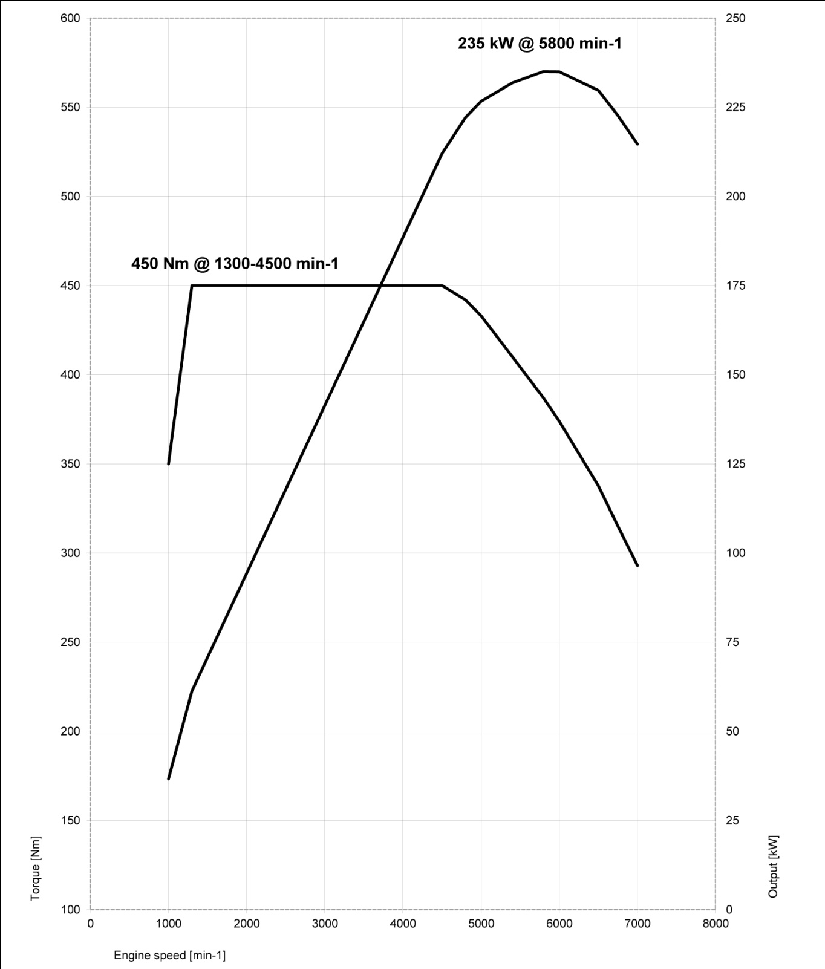
10. Power and torque diagrams.
BMW 640i Gran Coupe.
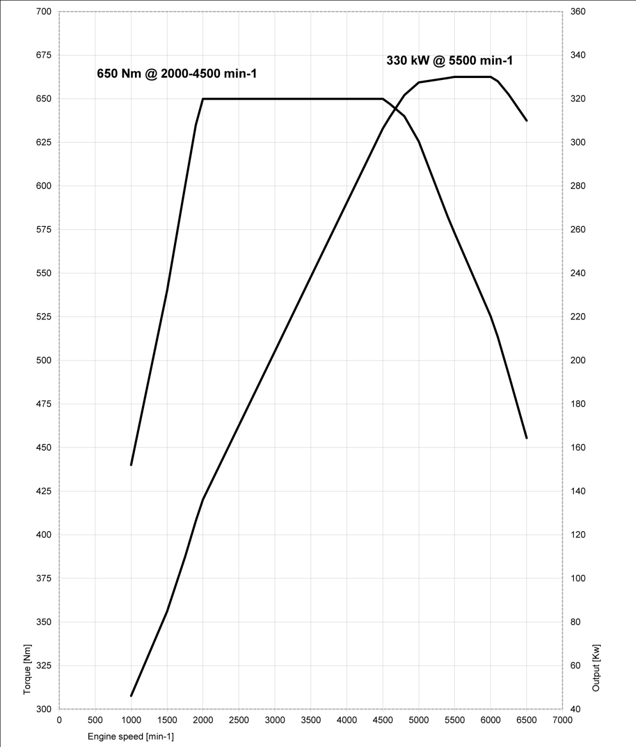
BMW 650i Gran Coupe.
BMW 650i xDrive Gran Coupe.
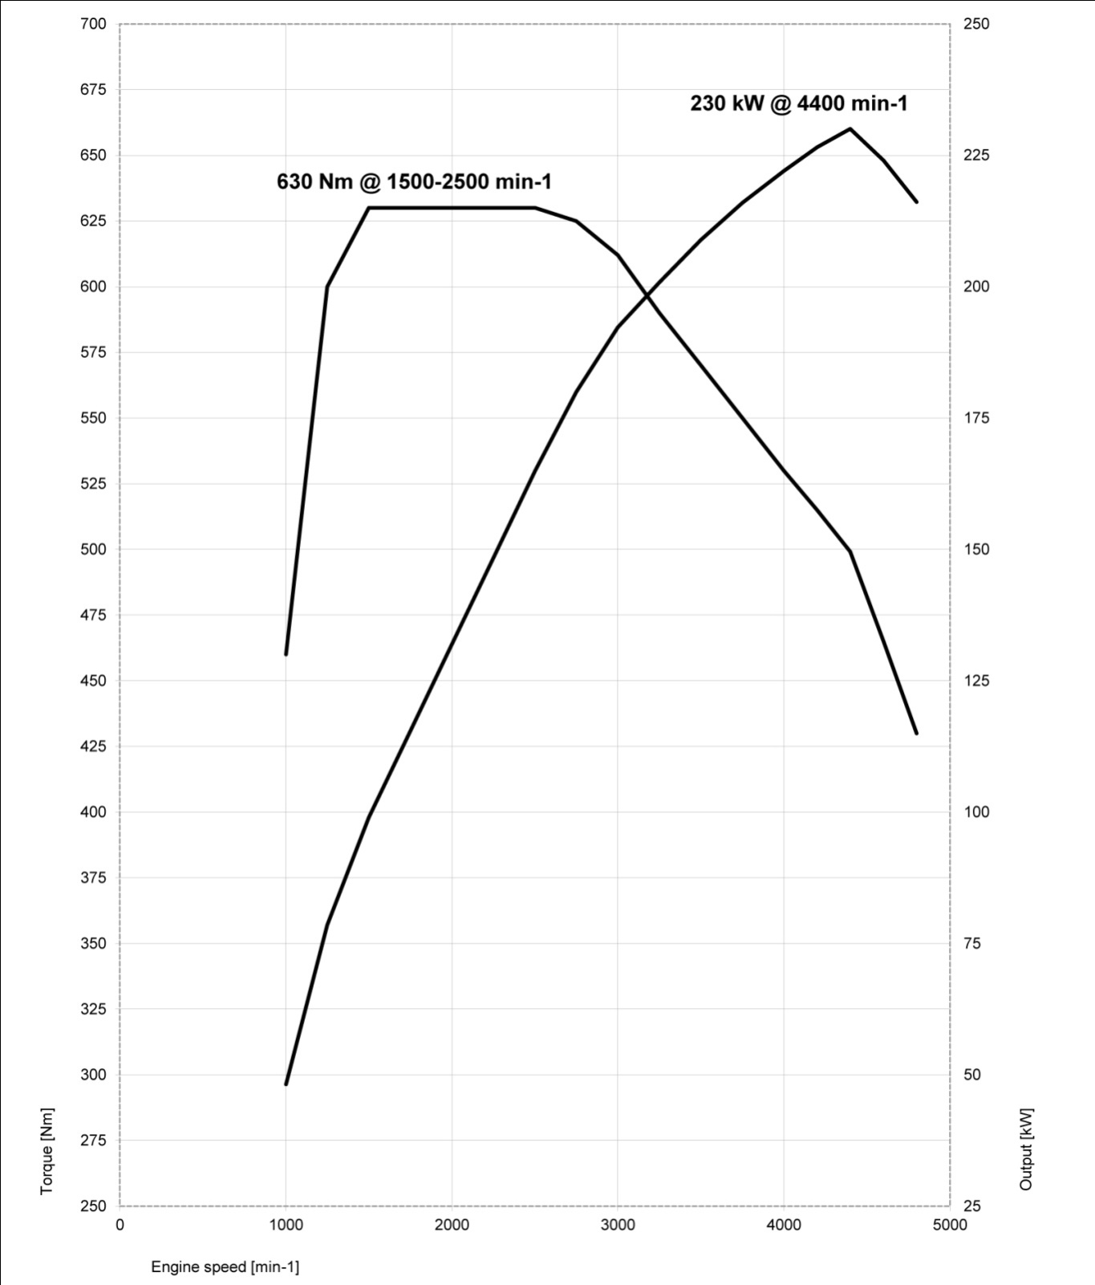
BMW 640d Gran Coupe.
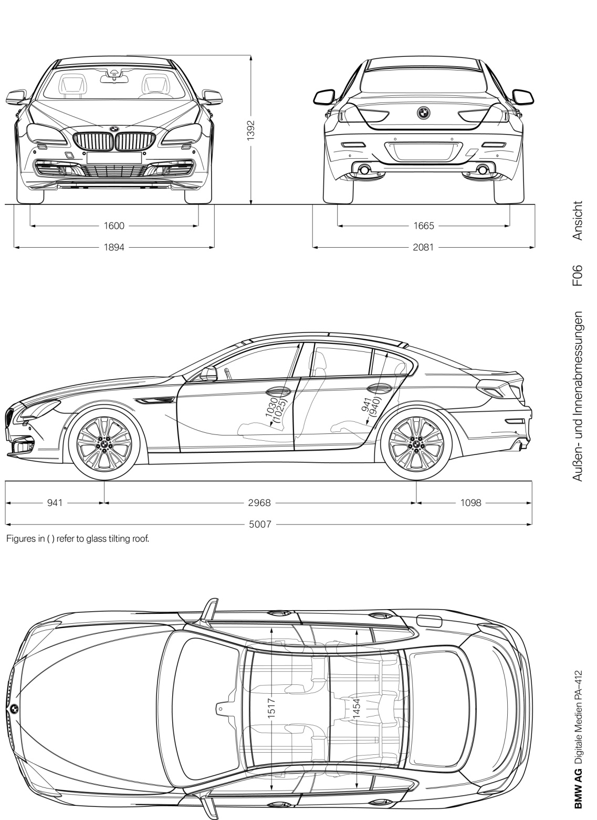
11. Exterior and interior dimensions.

