
The new BMW F 700 GS and
BMW F 800 GS.
Contents.

1. Overall concept and vehicle properties. 2

2. Drivetrain. 7

3. Chassis. 9

4. Electrical and electronic systems. 11

5. Body and design. 13

6. Equipment program. 15

7. Paint finishes. 18

8. Engine output and torque. 19

9. Technical specifications. 21

1. Overall concept and vehicle
properties

When BMW Motorrad extended the GS family with an entry-level and medium category in 2007 in the form of the F 650 GS and the F 800 GS, there was no doubt as to the message: lots of riding fun based on light, safe controllability over all surfaces, plenty of drive power and endurance on trips – even when there are only gravel tracks left to get you where you're going. A concept in two versions which many motorcycling fans responded to enthusiastically.

BMW Motorrad now continues this chapter of the GS success story with the updated versions of these two successful enduro models: the F 700 GS and
F 800 GS. As always, BMW Motorrad has faced the challenge of taking something that is already good and making it even better, consistently focusing on building on the characteristic strengths of the GS in refining the concept.

The new F 800 GS combines suitability for road use and touring with superior off-road qualities, bringing the two worlds together to an extent not previously seen in this class of motorcycle. By contrast, the new F 700 GS is geared more towards motorcyclists who do not yet need quite the same level of off-road expertise. Its strengths are a lower seating height, all-round capabilities for everyday use and more than sufficient power while also offering outstanding economy.

In accordance with the "Safety 360º" principle, BMW Motorrad provides
BMW Motorrad ABS as standard in the new F 700 GS and F 800 GS. The new F 700 GS and F 800 GS also feature other safety-related innovations within their respective classes such as the optional ASC (Automatic Stability Control) and the likewise optional ESA (Electronic Suspension Adjustment).

The well-proven parallel twin – now with increased output and torque for the new F 700 GS.

Both the F 700 GS and the F 800 GS continue to draw their power from the distinctive, liquid-cooled 4-valve 2-cylinder engine with 798 cc, electronic fuel injection, closed-loop catalytic converter and 6-speed gearbox. Its spontaneous response, impressive pulling power and low fuel consumption are what give it a particular fascination. Another unique feature in serial production motorcycle manufacture is the mass balance based on an additional connecting rod. This compensates for first and second-order inertia forces, ensuring that the 2-cylinder runs with a low level of vibration.

In the F 800 GS, the power unit still delivers 63 kW at 7,500 rpm, producing a maximum torque of 83 Nm at 5,750 rpm.

As compared to its predecessor, the new F 700 GS benefits from a boost in terms of output and torque. With 55 kW at 7,300 rpm (F 650 GS: 52 kW at 7,000 rpm), its engine now delivers 4 hp more power and with 77 Nm at 5,500 pm (F 650 GS: 75 Nm at 4,500 rpm) it also sees an increase in maximum torque. In conjunction with a somewhat shorter overall gear ratio, the bike now offers even further enhanced engine performance and riding dynamics.

F 700 GS now fitted with double disc brake. ABS now standard in both models based on the "Safety 360^{o"} principle.

The new F 700 GS and F 800 GS draw on established suspension technology. The steel frame in tubular construction integrates the engine as a load-bearing element. The rear frame in square steel tubing, the aluminium double-sided swing arm and the wheels and tyres all remain unchanged.

Like the F 800 GS, the new F 700 GS is now fitted with a double disc brake on the front wheel. What is more, the two new GS models are fitted as standard with a new generation of the BMW Motorrad two-channel ABS for the first time.

Electronic Suspension Adjustment ESA.

The Electronic Suspension Adjustment ESA is a new feature in this motorcycle segment. Available as an option ex works, it allows the rider to conveniently set the rebound stage damping of the rear spring strut at the press of a button on the handlebars, with the settings "Comfort", "Normal" or "Sport" available, thereby adapting the set-up to the needs of both route and riding style. The handwheel for setting the desired spring mount has been optimised for improved controllability.

Automatic Stability Control ASC.

BMW Motorrad ASC (Automatic Stability Control) is likewise a newly available ex works option which is also unique in the market segment of the new
F 700 GS and F 800 GS. This BMW Motorrad traction control system prevents unwanted spinning of the rear wheel while accelerating, which would result in the loss of lateral grip and thus break-out of the rear wheel. The welcome consequence - especially when the road surface offers reduced friction - is an increase in riding safety.

New switch units.

The new F 700 GS and F 800 GS each feature the latest generation of
BMW Motorrad switch units. These are more compact in design and offer improved ergonomics.

Cockpit with new dial faces and an extended range of information.

The analogue speedometer and engine speed display are arranged vertically, their new dial faces ensuring further improved legibility of road speed and engine speed in the new F 700 GS and F 800 GS. What is more, the information display already includes fuel level and coolant temperature as standard.

Smoke grey turn indicator glasses and smoke grey glass covering on the LED rear light.

The increased dynamic performance and even more harmonious appearance of the new F 700 GS and F 800 GS are reflected in the new smoke grey glasses for the turn indicators and a smoke grey glass covering on the
LED rear light.

New body features, distinctive model-specific design and new paint finishes.

In terms of shaping, too, the new BMW F 700 GS and F 800 GS have been upgraded to create a clearer design more in keeping with model character. The main revised areas are the new side trim sections, which are now more striking and dynamic in styling and reflect the differing characters of the
F 700 GS and F 800 GS even more authentically. The package of visual measures is rounded off with new paint finish concepts and inscriptions.

Lowered suspension now also available for the new F 800 GS.
In response to popular demand among existing F 800 GS customers for a reduction in seating height, BMW Motorrad now offers a lowered suspension in conjunction with a lower seat as an ex works option and as a special accessory.

Extensive expansion of the range of options and special accessories.

As part of its model revision measures, BMW Motorrad has also significantly broadened the range of options and special accessories, thereby addressing the widely differing areas of use pursued by BMW GS customers.

Overview of new technical features:
- Increased output and torque in the F 700 GS as compared to predecessor model: 55 kW at 7,300 rpm (F 650 GS: 52 kW at 7,000 rpm).
- The latest generation of BMW Motorrad two-channel ABS as standard.
- Double disc brake system at front – now also for F 700 GS.
- Automatic Stability Control ASC (ex works option).
- Electronic Suspension Adjustment ESA (ex works option).
- Rear spring mount can be adjusted via optimised handwheel.
- Newly designed body features in a more dynamic, masculine look.
- New paint finishes for the F 700 GS: Red apple metallic, Ostra grey metallic matt and Glacier silver metallic.
- New paint finishes for the F 800 GS: Kalamata metallic matt, Cordoba blue and Alpine white 3.
- New handlebar switch units and brake fluid containers, front.
- New handlebar clamp for F 700 GS.
- Cockpit with new dial faces for speedometer and engine speed display and an extended range of information.
- New windshield for F 700 GS.
- Smoke grey turn indicators and smoke grey LED rear light glass covering.
- Lowered suspension for F 800 GS (ex works option/special accessory).
- Power reduction to 35 kW (ex works option).
- Engine map adjustment for regular fuel (RON 91) (ex works option).
- Comfort seat now available as an ex works option too.
- Case carrier for Vario case now also available as an ex works option.
- New centre stand as ex works option.
- Comfort package: on-board computer, heated grips, case holder, centre stand (ex works option).
- Safety package for F 800 GS: ASC and ESA (ex works option).
- Safety package for F 700 GS: ASC, ESA, RDC (ex works option).
- LED auxiliary headlight for F 800 GS (special accessory).
- Enduro footrests, wide (special accessory).

The main differentiating technical features at a glance:

BMW F 800 GS BMW F 700 GS

63 kW 55 kW

USD telescopic fork conventional telescopic fork

Progressive damping spring strut Gas pressure spring strut

Spoke wheels Cast wheels

21-inch front wheel 19-inch front wheel

Aluminium handlebar Steel handlebar

880/850 mm seat height 820/790 mm seat height

Weight, road ready, 214 kg Weight, road ready, 209 kg

2. Drivetrain.
Like their predecessor models, the F 700 GS and F 800 GS also draw their power from the dynamic, high-torque water-cooled 2-cylinder in-line engine with 798 cc capacity, fuel injection and closed-loop catalytic converter. The parallel twin has not been changed as compared to the predecessor models. Its technical highlights remain a very compact construction with cylinders tilted just 8.3 degrees forward, two overhead camshafts with speed-resistant valve control via rocker arms and the unique mass balance by means of a system of articulated joints running over the centre of the crankshaft with specifically arranged counterbalance masses to ensure low-vibration running.
Optimised power and torque efficiency and a shorter overall gear ratio in the new F 700 GS.
The agile power delivery and revving power of the F 700 GS and F 800 GS are especially thrilling: even in the lower and medium engine speed range,
the two new GS models offer a powerful response for dynamic riding
fun - whether on or off the road.
While the output and torque of the F 800 GS remain unchanged at 63 kW at 7,500 rpm and 83 Nm at 5,750 rpm, the new F 700 GS benefits from an increase in output and torque as compared to its predecessor model. The output has been raised by 4 hp to 55 kW at 7,300 rpm (F 650 GS: 52 kW at 7,000 rpm), and the maximum torque has been increased to 77 Nm at 5,500 rpm (F 650 GS: 75 Nm at 4,500 rpm).
This increase in power now requires the use of premium fuel (RON 95) in the F 700 GS too, but both models can also run on regular fuel (RON 91) by means of an optional adaptation of the engine map. For people aged up to 25 taking their motorcycle test (in line with the EU-wide increase in the output limit relevant to those taking a motorcycle licence as of 01.01.2013), the F 700 GS and F 800 GS are also available in reduced power versions with an output of 35 kW at 7,000 rpm and a torque of 60 Nm at 5,000 rpm.

The same claw coupled six-speed gearbox has been used as in the predecessor models. In order to enhance spontaneity, liveliness and riding dynamics, the secondary ratio of the chain drive with off-road capability in the new F 700 GS is now somewhat shorter with 17 to 42 teeth
(F 650 GS: 17 to 41 teeth).

3. Chassis.
The new F 700 GS and F 800 GS continue to feature the robust and torsionally stiff steel frame in tubular construction with the engine integrated as a load-bearing element. The rear frame in square steel tubing, the steering head connection via gusset plates and the single-section chill-cast
double-sided swing arm made of aluminium also remain unchanged, reflecting the high-quality finish and slim structure of the two GS models.
Double disc brake system for the F 700 GS.
Like the F 800 GS, the new F 700 GS now also has a double disc brake with an effective diameter of 300 millimetres and dual piston floating calipers on the front wheel. The connection between the brake discs and front wheel is floating in both models.
On the rear wheels, both models feature a single disc brake with a disc diameter of 265 millimetres and single-piston floating caliper.
Both models are fitted with new brake fluid reservoirs which fit harmoniously into the overall appearance.
ABS now a standard feature in both models.
Based on the BMW Motorrad principle "Safety 360°", the latest generation of the BMW Motorrad two-channel ABS will be installed as standard for the first time. The new system is not only lighter but is also more compact in size that the previous generation. What is more, it now has inlet valves which can be infinitely adjusted for an even better response. New wheel sensors automatically monitor the distance between sensor and sensor wheel. As usual, the new standard ABS can be deactivated at the press of the button if the rider so wishes - for example for active riding over rough terrain.

Electronic Suspension Adjustment ESA as an ex works option.
On request (ex works option) and uniquely in this segment of the motorcycle market, the rider can conveniently set the rebound stage damping of the rear spring strut on the F 700 GS and F 800 GS at the press of a button on the handlebar. This Electronic Suspension Adjustment – or ESA for short – allows adjustment of the suspension settings with maximum operational convenience, even during travel. The rider selects a damping variant from among "Comfort", "Normal" and "Sport" and the electronic control system measures the appropriate damping rate based on optimum parameters stored in the data memory. Damper settings can be changed simply at the press of a button while riding, with a small, light stepper motor carrying out the commands. A symbol appears in the cockpit accordingly. The adjustment of the spring mount is made manually by means of an optimised, easily accessible hand wheel.
Automatic Stability Control ASC as an ex works option.
Another unique feature within the market segment of the new F 700 GS and F 800 GS is the availability of the BMW Motorrad rider assistance system ASC – one of the most popular ex work options for BMW motorcycles.
ASC prevents unwanted spinning of the rear wheel while accelerating, which would result in the loss of lateral grip and thus break-out of the rear wheel. By comparing the rotational speeds of the front and rear wheel obtained via the ABS sensors, the electronic system detects spin in the rear wheel and cuts back engine torque accordingly by reducing the ignition angle as well as adapting injection via the engine control system.
In this way ASC makes for more efficient power transmission and therefore increased safety. If regulatory intervention by the electronic system is not desired - on the race track for example - the rider can simply deactivate it at the press of a button, even during travel.

4. Electrical and electronic systems.
In terms of the electrical system, the new F 700 GS and F 800 GS continue to use a CAN bus system. This single-wire system (SWS) offers a wealth of benefits: it reduces the amount of wiring required, allows all control units to be networked and thus makes comprehensive diagnosis much simpler. What is more, conventional fuses are no longer required because the system automatically deactivates any component affected in the event of malfunction.
Since the introduction of CAN bus technology, electronic vehicle immobilisation has been a standard feature of BMW motorcycles. To start the engine, more is required than the appropriate key bit: the chip integrated in the BMW key also has to send the correct code to the ring aerial of the combined handlebar and ignition lock. Only then does the engine control system allow the engine to be started. This technology offers what is currently the most secure and reliable protection from theft. A battery with 14 ampere-hours and an alternator with an output of 400 watts ensure a reliable power supply.
New switch units and an extended range of information.
The latest generation of BMW Motorrad switches is now used in the new
F 700 GS and F 800 GS, too. The new switch units are much smaller and more compact thanks to MID technology (MID = Molded Interconnect Design; printed conductors rather than individual wiring) and offer a wider range of functions, a clear design and optimum usability.
Here the functions for the left and right turn indicators - previously separated - are now clustered in a single function on the left-hand side of the handlebars. The hazard warning flashers are activated via a separate, clearly visible switch integrated at the top of the left-hand handlebar panel. The functions for low beam, high beam and headlamp flasher have been combined in a switch which is located near the left index finger for convenient access.
The activation switch for the grip heating has been placed at the top for further improved usability and the functions for starter and killer switch practically combined in a rocker switch. This means that if the killer switch is activated by mistake, it prevents the starter from being triggered when the ignition is not switched on and discharging the battery. ESA and ASC are also activated by means of a combined rocker switch.
The cockpit of the new F 700 GS and F 800 GS with vertically arranged analog engine speed display and speedometer and information panel has been optimised. Newly designed dial faces now ensure even better legibility of road speed and engine speed. And the rider now gets feedback on the fuel level and coolant temperature as a standard feature – two functions which were previously only available as ex work options with the on-board computer.

5. Body and design.
As in the popular predecessor models, the F 700 GS and F 800 GS of model year 2013 also benefit from reduced width in the area of the seat and front section due to the slimline construction of the frame and engine, ensuring optimum ground reach and a narrow standing width. The low overall centre of gravity makes for outstanding off-road qualities and easy vehicle control, and the large steering angle - derived from a narrow steering head - is a bonus when riding over rough terrain. Wide handlebars suitable for enduro riding – made of cylindrical steel tubing with a new clamp in the F 700 GS and made of double-butted aluminium tubing in the F 800 GS – support the easy, agile handling of the two machines.
The wide range of adjustment provided in the hand levers for the front brake and clutch allow adaptation to individual rider preferences. The wide footrests with vibration-damping, removal rubber tops are ideal for off-road riding and lengthier tours.
The new BMW F 700 GS and F 800 GS display their kinship as authentic members of the BMW GS family more strikingly than previously with revised body features and optimised ergonomics. Their slim, wiry look gives them a feeling of lightness designed to arouse the desire to embark on motorcycle adventures. Clear lines and the selective combination of painted areas with black components give them a purist appearance with a dash of robustness typical of the enduro style.
Off-road or urban – new, authentic characters with optimised functionality in typical GS style.
The model revision has given the front sections of the new BMW F 700 GS and an even clearer shaping, perfectly in line with the character of the model. The new side trim sections are a key element here, giving both models a perceptibly more striking look.

The new body features of the F 700 GS and F 800 GS also include a reworking of the "beak" above the front mudguard – a BMW GS hallmark. This has been redesigned in both models, providing excellent functionality as a splash guard in keeping with the orientation of the F 700 GS and F 800 GS.
Different windshields are available for the two models to match the specific character of each of them. These offer optimum protection from airstream and integrate perfectly in the styling of each bike. As always, the extensive
BMW Motorrad range of special accessories offers alternatives here: a choice of tinted or more touring-oriented windshields leave nothing to be desired in terms of individual customisation.
The overall impression conveyed by the lines is much more dynamic. The flatter design of the lower edge means the new side sections give the vehicle a more elevated, mature look, especially in the new F 700 GS.
Meanwhile the differing design of the intake snorkel and the positioning of the BMW logo, model inscription and turn indicators highlight the distinct characters of the two 2-cylinder models. While the new F 800 GS displays its masculinity and off-road capability, the new F 700 GS emphasises its urban character.
New smoke grey glasses for the turn indicators and a smoke grey glass covering on the LED rear light cluster reflect the dynamic aspirations of the new F 700 GS and F 800 GS, now offering a more harmonious match with the overall look of the new BMW GS models.
Optional seat height reduction based on lowered suspension now also available in the new F 800 GS.
With a standard seat height of 880 millimetres, the BMW F 800 GS clearly reflects its off-road orientation with long spring travel. In response to frequent requests for a reduced seat height, especially among shorter riders,
BMW Motorrad now offers a lowering option in the F 800 GS in conjunction with a low seat. A reduction by 60 millimetres to just 820 millimetres now ensures accessibility and reachability for riders of smaller stature.

6. Equipment program.
Options and special accessories for a wide range of customisation opportunities.
The familiar comprehensive BMW Motorrad program of options and special accessories is available for further customisation of the new F 700 GS and F 800 GS.
Options are supplied directly ex works and are integrated in the production process. Special accessories are installed by the
BMW Motorrad partner or customers themselves. These are features which can be retrofitted, too.

Options.

- New: Automatic Stability Control ASC.
- New: Electronic Suspension Adjustment ESA.
- New: Lowered suspension for the F 800 GS (not in conjunction with ESA, centre stand or safety package).
- New: Power reduction to 35 kW (48 hp).
- New: Engine map adaptation for regular fuel (ROZ 95) for F 700 GS.
- New: Comfort seat.
- New: Case holder for Vario case.
- New: Comfort package (on-board computer, heated grips, case holder, centre stand).
- New: Safety package for F 800 GS (ASC, ESA).
- New: Safety package for F 700 GS (ASC, ESA, RDC).
- Optimized centre stand.
- Off-road tyres (F 800 GS only).
- LED turn indicators.
- Heated grips.
- Tyre pressure control RDC (F 700 GS only).
- On-board computer.
- Alarm system.
- Seat, low.

Special accessories.

Safety.
- New: Automatic Stability Control ASC.
- New: LED additional headlamp (F 800 GS only).
- Alarm system (DWA).
- Tyre pressure control RDC (F 700 GS only).
- Hand protector bar.
- Hand protector (small and large) for hand protector bar.
- Attachment spoiler for hand protector, large.
- Engine guard, plastic (F 700 GS only).
- Enduro aluminium engine guard.
- Crash bars.

Storage program.
- Luggage carrier, small.
- Luggage rack, large, for Vario topcase.
- Vario topcase, black.
- Case holder for Vario case.
- Vario case, black.
- Liners for Vario case and Vario topcase.
- Back pads for Vario topcase.
- Aluminium case (F 800 GS only).
- Functional liner for aluminium case (F 800 GS only).
- Carrying handle for aluminium case or topcase
(F 800 GS only).
- Case holder for aluminium case (F 800 GS only).
- Aluminium topcase (F 800 GS only).
- Functional liner for aluminium case (F 800 GS only).
- Back pad for aluminium topcase (F 800 GS topcase).
- Topcase holder for aluminium topcase (F 800 GS only).
- Tank rucksack, waterproof.
- Softbag 2, small.
- Enduro rear bag.

Design.
- LED turn indicators.
- Headlamp guard (for off-road use only).
- Splash guard extension, rear.

Sound.
- Akrapovič sports silencer.

Ergonomics and comfort.
- New: Windshield small, tinted (F 700 GS only).
- Windshield large, clear (F 700 GS only).
- Windshield large, tinted.
- Touring windshield (F 800 GS only).
- Wind deflection set (F 800 GS only).
- New: Enduro footrests, wide.
- Heated grips.
- Rallye seat.
- Comfort seat.
- Low seat.
- High seat (for F 700 GS only).
- Optimized centre stand.

Navigation and communication.
- BMW Motorrad Navigator IV.
- Holder for BMW Motorrad Navigator IV.
- Function pouch for BMW Motorrad Navigator IV.

Maintenance and technology.
- On-board toolkit.
- Repair kit for tubeless tyres.
- Power reduction to 35 kW.
- Automatic chain lubrication system.
- LED lamp for charging socket.
- Battery charger.

7. Paint Finishes.
The new F 700 GS and F 800 GS also reflect their more sharply drawn character in the form of new colour concepts.
Ostra grey metallic creates a deliberately modern variant of the F 700 GS with a masculine, off-road touch. Meanwhile, Red apple metallic gives the
F 700 GS a more discreet, touring-oriented appearance, while in Glacier silver metallic it has a light, dynamic feel which emphasises its sporty qualities.
The new F 800 GS acquires a particularly technical, modern and off-road look in Kalamata metallic matt, while Cordoba blue highlights the bike's sporty, dynamic qualities. In Alpine white 3, on the other hand, it appears especially light and athletic.
The new BMW F 700 GS and BMW F 800 GS will go on sale in South Africa in September 2012.

8. Engine output and torque.
BMW F 700 GS.
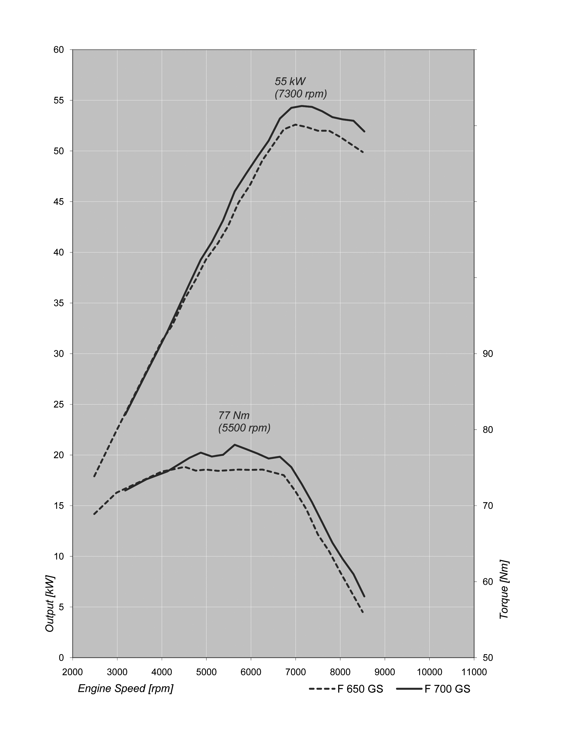

BMW F 800 GS
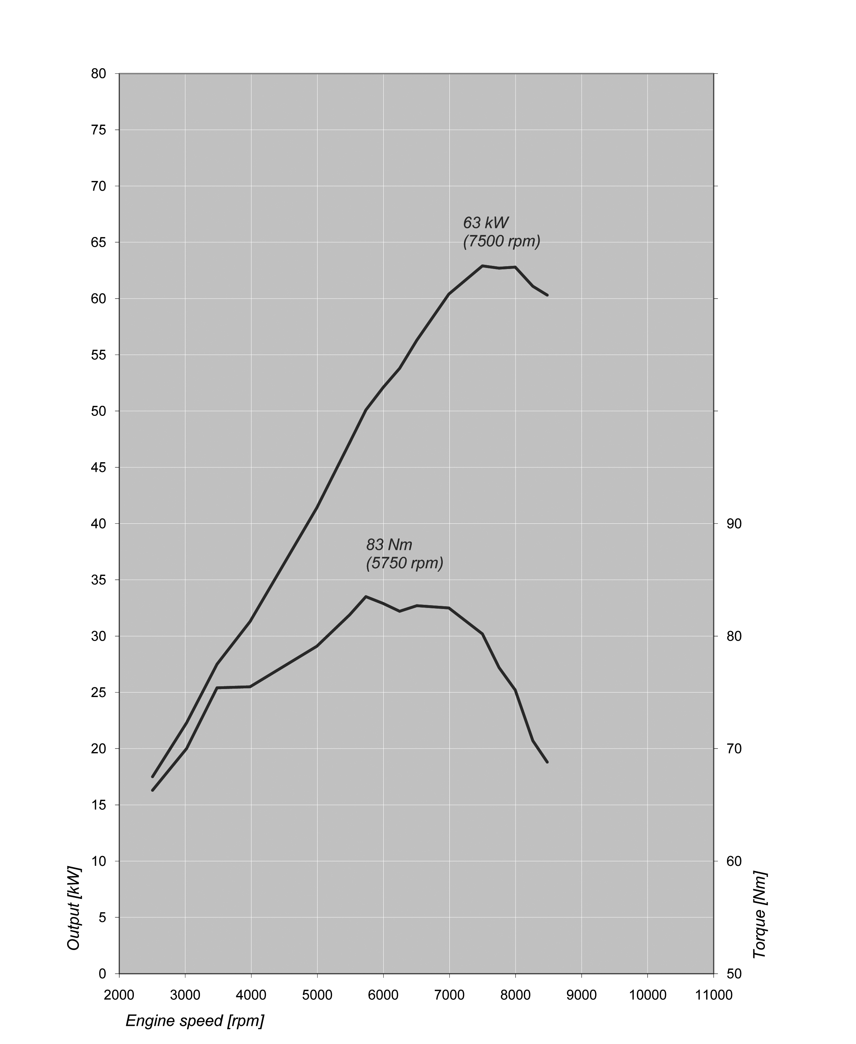

9. Technical specifications.
 |  | BMW F 800 GS | BMW F 700 GS
Engine
Capacity | cc | 798
Bore/stroke | mm | 82/75.6
Output | kW/hp | 63/85 | 55/75
at engine speed | rpm | 7,500 | 7,300
Torque | Nm | 83 | 77
at engine speed | rpm | 5,750 | 5,500
Type |  | Water cooled straight  two cylinder engine
Compression; fuel |  | 12.0 : 1 / premium unleaded (95 RON)
Valve actuation |  | DOHC (double overhead camshaft), rocker arms
Valves per cylinder |  | 4
Ø Intake/outlet | mm | 32/27.5
Ø throttle valve | mm | 46
Carburetion |  | Electronic manifold injection, engine engine management BMS-KP
Emission control |  | Fully controlled three way  catalytic converter
Electrical system
Alternator | W | 400
Battery | V/Ah | 12/14
Headlight |  | High/low-beam: 12 V/55 W, halogen
Rear light |  | LED brake/rear light
Starter | kW | 0.9
Power transmission gearbox
Clutch |  | Multidisc oil bath clutch,  mechanically actuated
Gearbox |  | Claw-shifted six-speed gearbox
Primary ratio |  | 1.943
Gear transmission ratio | I | 2.462
 | II | 1.750
 | III | 1.381
 | IV | 1.174
 | V | 1.042
 | VI | 0.960
Rear wheel drive |  | Chain
Transmission ratio |  | 2.625 | 2.471
Chassis
Frame construction type |  | Tubular stell frame,l  load-bearing power unit
Suspension, front |  | Upside-down telescopic fork, Ø 43 mm | Telescopic fork, Ø 41 mm
Suspension, rear |  | Double-strut swing arm,  aluminium cast in one piece
Spring travel, front/rear | mm | 230/215 | 180/170
Wheel castor | mm | 117 | 95
Wheelbase | mm | 1,578 | 1,562
Steering head angle | ° | 64

 |  | BMW F 800 GS | BMW F 700 GS
Brakes | front | Hydraulically actuated double disc brake, Ø 300 mm, dual piston floating caliper
 | rear | Hydraulically actuated single disc brake, Ø 265 mm,  single-piston floating caliper
ABS |  | BMW Motorrad ABS, ON/OFF (standard)
Wheels |  | Spoked wheels with aluminium rims | Aluminium cast wheels
 | front | 2.15 x 21" | 2.50 x 19"
 | rear | 4.25 x 17" | 3.5 x 17"
Tyres | front | 90/90 R21 | 110/80 R19
 | rear | 150/70 R17 | 140/80 R17
Dimensions and weights
Total length | mm | 2,320 | 2,280
Total width with/without mirrors | mm | 920/890 | 880/855
Seat height (without rider) | mm | 880 (optional equipment 850) | 820 (optional equipment 790)
DIN unladen weight, ready for road | kg | 214 | 209
Permitted total weight | kg | 444 | 436
Fuel tank capacity | l | 16
Performance figures
Fuel consumption
90 km/h | l/100 km | 3.8 | 3.9
120 km/h | l/100 km | 5.2 | 5.1
Acceleration
0–100 km/h | s | 4.1 | 4.3
Max. speed | km/h | > 200 | 192

