The all new BMW ActiveHybrid fleet in South Africa.
Contents.

1. Intelligence breeds efficiency.
The all new BMW ActiveHybrid Fleet in South Africa. 2

2. The BMW ActiveHybrid 3. 3

4. The BMW ActiveHybrid 5. 6

5. The BMW ActiveHybrid 7. 9

9. Specifications. 11

10. Output and torque diagrams. 17

11. Exterior and interior dimensions. 20

1. Intelligence breeds efficiency.
The all new BMW ActiveHybrid Fleet in South Africa.
BMW is continuing to take the development of intelligent hybrid drive systems to the next level with the offering of three ActiveHybrid models in South Africa; the BMW ActiveHybrid 3, BMW ActiveHybrid 5 and BMW ActiveHybrid 7.
The BMW ActiveHybrid 5 was the first model to be introduced locally in the second quarter of 2012 and is now joined by the BMW ActiveHybrid 3 and BMW ActiveHybrid 7.
With these models, a combustion engine and electric motor join forces to enhance both efficiency and the brand’s hallmark driving pleasure.

2. The BMW ActiveHybrid 3.
- Enhanced efficiency coupled with increased dynamics in the
BMW ActiveHybrid 3 thanks to the combination of an award-winning combustion engine and an innovative electric drive.
- BMW TwinPower Turbo technology working in tandem with an eight-speed automatic hybrid transmission and intelligent energy management.
- All-electric operation up to 75 km/h. All-electric driving range up to four kilometres.
- System output 250 kW.
In the BMW ActiveHybrid 3, a BMW TwinPower Turbo six-in-line engine is coupled with an electric motor, lithium-ion battery and an eight-speed automatic transmission which sends combined power of 250 kW to the rear wheels.
The BMW ActiveHybrid 3 offers outstanding ratio of driving performance to fuel consumption by sprinting from 0 to 100km/s in 5.3 seconds and recording a fuel consumption figure of 5.9 litres per 100 km and 139 g of CO2/km in the EU test cycle.
The 225 kW six-cylinder in-line engine with BMW TwinPower Turbo technology in the BMW ActiveHybrid 3 is the same unit renowned for its free-revving capability, pulling power and efficiency in the BMW 335i. The electric motor, meanwhile, develops 40 kW and is supplied with energy by a high-voltage lithium-ion battery integrated underneath the luggage area.
Power from the two drive systems is transferred to the rear wheels by the eight-speed automatic transmission. In addition to its full-hybrid construction, which enables purely electric and therefore local emission-free driving in urban conditions or when coasting, the BMW ActiveHybrid 3 boasts not just highly sporty performance but also a double-digit percentage improvement in fuel economy over the BMW 335i.
Superior efficiency thanks to ECO PRO mode including coasting and intelligent energy management.
In order to exploit the potential of the BMW ActiveHybrid technology, the intelligent energy management of the power electronics uses a host of innovative functions to ensure the drive system runs efficiently.

Charging of the high-performance battery primarily takes place during coasting or braking, the electric motor performing the role of a generator feeding energy into the high-voltage battery. By contrast, under acceleration the electric motor takes on a boost function. Here, it assists the petrol engine by generating an ultra-dynamic burst of power, lending the Sedan’s sporty driving experience a sharper edge.
Moreover, while coasting at speeds of up to 160 km/h in ECO PRO mode, the combustion engine can be switched off and fully decoupled. This coasting mode combines comfortable driving with optimum utilisation of the kinetic energy already generated. To avoid periods with the engine running at idle at junctions or in traffic tailbacks, the BMW ActiveHybrid 3 deploys its hybrid start-stop function. Plus, the power electronics can be intelligently linked up with the navigation system Professional. This allows for proactive analysis of the driving situation, enabling the drive components to be primed to deliver maximum efficiency (the effect may vary according to the quality of the available navigation data).

Design: sporty elegance with individual accents.
The BMW ActiveHybrid 3 sees the sporty yet elegant body design of the BMW 3 Series Sedan complemented by bespoke touches which highlight its innovative drive technology. The “ActiveHybrid 3” lettering on the C-pillars and at the rear, along with the matt chrome exhaust tailpipes, set the exterior apart from the other models in the range. Further accents come courtesy of the standard satin-finish window surrounds and the BMW Individual High-gloss Shadow features in the side graphic.
Available as an option, meanwhile, are 18-inch Streamline light-alloy wheels displaying exceptional aerodynamic efficiency.

The BMW ActiveHybrid 3 also stands out visually with door sill strips bearing “ActiveHybrid 3” lettering, an aluminium plate on the gearshift lever knob with the same ID, and a bespoke engine cover. In addition, all three Sport, Modern and Luxury lines as well as the M Sport package are available for the ActiveHybrid 3.

High-grade standard fittings, wide-ranging options.
The selection of interior colours, upholstery and interior trim elements reflects the range offered for the other BMW 3 Series Sedan variants. Added to the standard-fitted array of comfort-enhancing features is also a 2-zone climate control system with stationary air conditioning.

A wide range of driver assistance systems and BMW ConnectedDrive mobility services, as well as virtually all the other optional extras available for the conventionally powered BMW 3 Series Sedan, can also be optionally specified for the BMW ActiveHybrid 3.

Production at BMW Plant Munich.
The BMW ActiveHybrid 3 is produced at BMW Plant Munich alongside other BMW 3 Series models. The integration into the production process of BMW ActiveHybrid technology is underpinned by the efficient combination of state-of-the-art automated process engineering and the skilled craftsmanship of specially trained employees.
3. The BMW ActiveHybrid 5.
- Hybrid-related components: 40 kW synchronous electric motor, lithium-ion high-voltage battery – developed specifically for this model.

- Electric motor and eight-speed automatic transmission share the same housing.

- Hybrid model based on the BMW 5 Series Sedan, with familiar sporty and elegant body design.

- Striking design touches: lettering on the C-pillars and door sills, special kidney grille slats and exhaust tailpipes.

- High carrying capacity thanks to compact integration of
lithium-ion high-voltage battery.

The BMW ActiveHybrid 5 brings together a BMW TwinPower Turbo six-cylinder in-line engine, an electric drive system and an eight-speed automatic gearbox for the first time. The latest generation of BMW ActiveHybrid technology also adds precisely controlled – and therefore extremely effective – intelligent energy management to the mix. All of which gives the BMW ActiveHybrid 5 an exceptional balance of performance and fuel economy for the premium executive car class.
The drive system generates combined output of 250 kW, allows the car to be driven on electric power alone up to 60 km/h, accelerates the BMW ActiveHybrid 5 from 0 to 100 km/h in 5.9 seconds, cuts average fuel consumption to between 6.4 and 7.0 litres per 100 kilometres and has CO₂ emissions of just 149 – 163 g/km (figures according to EU test cycle, may vary according to the tyre format specified).
Latest-generation BMW ActiveHybrid technology: six-in-line engine, electric motor, lithium-ion battery.
The 225 kW six-cylinder in-line engine with BMW TwinPower Turbo technology in the BMW ActiveHybrid 5 is the same unit renowned for its free-revving capability, pulling power and efficiency in the BMW 535i. The electric motor, meanwhile, develops 40 kW and is supplied with energy by a high-performance lithium-ion battery integrated into the luggage area. Power from the two drive systems is transferred to the rear wheels by the eight-speed automatic gearbox. In addition to its full-hybrid construction, which enables purely electric and therefore local emission-free driving in urban conditions, the BMW ActiveHybrid 5 boasts not just highly sporty performance but also a double-digit percentage improvement in fuel economy over the BMW 535i.
Superior efficiency thanks to ECO PRO mode including coasting and intelligent energy management.
In order to fully exploit the potential of the BMW ActiveHybrid technology, the intelligent energy management of the power electronics uses a host of innovative functions to ensure the drive system runs efficiently. Charging of the high-performance battery primarily takes place during coasting or braking, the electric motor performing the role of a generator feeding energy into the high-voltage battery. By contrast, under acceleration the electric motor takes on a boost function. Here, it assists the petrol engine by generating an ultra-dynamic burst of power, lending the sedan’s sporty driving experience a sharper edge.
Moreover, while coasting at speeds of up to 160 km/h in ECO PRO mode, the combustion engine can be switched off and fully decoupled. This coasting mode combines comfortable driving with optimum utilisation of the kinetic energy already generated. To avoid periods with the engine running at idle – at junctions or in traffic tailbacks, for example – the BMW ActiveHybrid 5 is equipped with a hybrid start-stop function. Plus, the power electronics in the BMW ActiveHybrid 5 are linked up with the standard-fitted Navigation system Professional. This allows forward-looking analysis of the driving situation, enabling the drive components to be primed to deliver maximum efficiency (the effect may vary according to the quality of the available navigation data).
All the hybrid-specific components of the drive technology and energy management systems have been developed specially for use in the BMW ActiveHybrid 5. The result is an extremely well-rounded overall concept, which also provides a convincing demonstration of the BMW ActiveHybrid technology’s qualities out on the road. Needless to say, all of the new hybrid components are designed to last for the life of the vehicle.
Design: sporty elegance with individual accents.
The BMW ActiveHybrid 5 sees the sporty yet elegant body design of the BMW 5 Series Sedan complemented by bespoke touches which highlight the identity of its drive technology. The “ActiveHybrid 5” lettering on the
C-pillars, the BMW kidney grille with galvanised slats and the exhaust matt chrome tailpipes set the exterior apart from the other models in the range. Available as an option, meanwhile, are 18-inch Streamline light-alloy wheels displaying exceptional aerodynamic efficiency. The BMW ActiveHybrid 5 is the only model in the BMW 5 Series line-up to be available in the exterior paint shade Bluewater metallic, and it also stands out visually from all other
5 Series variants with door sill strips bearing “ActiveHybrid 5” lettering, an aluminium plate on the centre console with the same ID, a bespoke engine cover and the visible “ActiveHybrid Power Unit” inscription on the special casing for the high-performance battery accommodated in the luggage area.
High-grade standard fittings, wide-ranging options.
The selection of interior colours, upholstery and interior trim elements reflects the range offered for the other BMW 5 Series Sedan variants. And added to the standard-fitted array of comfort-enhancing features is not only the Navigation system Professional, but also a 4-zone climate control system with stationary air conditioning. A wide range of driver assistance systems and BMW ConnectedDrive mobility services, as well as virtually all the other optional extras available for the conventionally powered BMW 5 Series Sedan, can also be specified for the BMW ActiveHybrid 5.
Production at BMW Plant Dingolfing.
The BMW ActiveHybrid 5 is produced at BMW Plant Dingolfing – the BMW Group’s largest production plant worldwide – alongside other
BMW 5 Series models, ensuring that it benefits from the same high standards of quality and production efficiency. The integration into the production process of BMW ActiveHybrid technology is underpinned by the intelligent combination of state-of-the-art automated process engineering and the skilled craftsmanship of specially trained employees.
4. The BMW ActiveHybrid 7
- BMW TwinTurbo six-cylinder in-line petrol engine

- 40 kW synchronous electric motor, the hybrid-spec eight-speed automatic transmission, a lithium-ion high-performance battery and power electronics underpinning intelligent energy management

- System output of 260 kW and peak torque of 500 Newton metres

As BMW continues to push ahead with the development of intelligent hybrid drive systems, the second generation of the BMW ActiveHybrid 7 is celebrating its premiere this year. The updated model sets itself apart with lower fuel consumption and emissions, as well as innovative auxiliary functions. This latest evolution stage uses a BMW TwinTurbo six-cylinder in-line petrol engine displaying impressive high-revving characteristics, torque and efficiency. The cutting-edge petrol engine with BMW TwinPower Turbo technology is the 235 kW variant of the unit fitted in the new BMW 740i and replaces the eight-cylinder engine used up to now.

Other hybrid components include the 40 kW synchronous electric motor, the hybrid-spec eight-speed automatic transmission, a lithium-ion high-performance battery and power electronics underpinning intelligent energy management. The various components come together into a powerful and harmonious whole, giving the new BMW ActiveHybrid 7 exceptional dynamics and an outstanding balance between performance and fuel economy – and not only in relation to its predecessor.

With system output of 260 kW and peak torque of 500 Newton metres, the new BMW ActiveHybrid 7 accelerates from 0 to 100 km/h in just 5.7 seconds. At the same time, the Sedan posts average fuel economy of 6.8 litres per 100 kilometres and CO2 emissions of 158 g/km. That means the more powerful hybrid technology uses some 14 per cent less fuel than a BMW 740i with a conventional drive system.

A host of innovative functions are involved in enhancing the car’s dynamics and achieving the excellent efficiency of the overall system. For example, the electric motor hands the six-cylinder an extra 210 Newton metres of torque through the boost function, should the driver need to nail a quick sprint or call on some hard mid-range acceleration. In addition, Brake Energy Regeneration, the Hybrid Start Stop function, ECO PRO mode with coasting function and proactive analysis – to prepare the car’s drive system in advance for upcoming situations on the road – ensure the available energy is used as efficiently as possible (more details in the “BMW EfficientDynamics” chapter).

The new BMW ActiveHybrid 7 can also run purely on electric power. If the hybrid battery has sufficient charge and the driver goes easy on the accelerator, the car can cover a distance of up to four kilometres almost silently and without producing any tailpipe emissions. The top speed possible using electric power alone is 60 km/h.

The BMW ActiveHybrid 7 is also produced at BMW Plant Dingolfing – the BMW Group’s largest production plant worldwide. The plant also handles production of the BMW 6 Series and BMW 7 Series, including the BMW ActiveHybrid 5.

The BMW plant in Dingolfing, Lower Bavaria, has been part of the company’s global production network since 1967. Today this network comprises 25 plants in 14 countries across five continents. 1973 saw the start of BMW vehicle production at the newly constructed Plant 2.4 in Dingolfing. Approximately 18,600 people currently work at the site, more than 12,000 of them in car production at Plant 2.4.

5. Specifications.
BMW ActiveHybrid 3. BMW ActiveHybrid 5. BMW ActiveHybrid 7.

 |  |  |  |  |  |  |  |  |  | BMW ActiveHybrid 3
Body
No of doors/seats |  |  |  |  |  |  |  |  |  | 4 / 5
Length/width/height (unladen) | mm |  |  |  |  |  |  |  |  | 4624 / 1811 / 1429
Wheelbase | mm |  |  |  |  |  |  |  |  | 2810
Track, front/rear | mm |  |  |  |  |  |  |  |  | 1531 / 1572
Ground clearance | mm |  |  |  |  |  |  |  |  | 140
Turning circle | m |  |  |  |  |  |  |  |  | 11.3
Fuel tank capacity | app ltr |  |  |  |  |  |  |  |  | 57
Cooling system incl heater | ltr |  |  |  |  |  |  |  |  | 9.3
Engine oil¹⁾ | ltr |  |  |  |  |  |  |  |  | 6.5
Weight, unladen, to DIN/EU | kg |  |  |  |  |  |  |  |  | 1655 / 1730  (1520 / 1595)
Max load to DIN | kg |  |  |  |  |  |  |  |  | 530
Max permissible | kg |  |  |  |  |  |  |  |  | 2185
Max axle load, front/rear | kg |  |  |  |  |  |  |  |  | 1020 / 1230
Max trailer load (12%),  braked/unbraked | kg |  |  |  |  |  |  |  |  | --- / ---
Max roofload/max towbar downl | kg |  |  |  |  |  |  |  |  | 75 / --
Luggage comp capacity | ltr |  |  |  |  |  |  |  |  | 390
Air drag | Cd x A |  |  |  |  |  |  |  |  | 0.29 x 2.20
Power Unit
Config/No of cyls/valves |  |  |  |  |  |  |  |  |  | In-line-six / 4
Engine technology |  |  |  |  |  |  |  |  |  | BMW TwinPower Turbo technology with twin-scroll turbocharging, High Precision Direct Petrol Injection and  fully variable valve control (VALVETRONIC)
Capacity, effective | cc |  |  |  |  |  |  |  |  | 2979
Stroke / bore | mm |  |  |  |  |  |  |  |  | 89.6 / 84.0
Compression ratio | :1 |  |  |  |  |  |  |  |  | 10.2
Fuel |  |  |  |  |  |  |  |  |  | min RON 91
Max output | kW/hp |  |  |  |  |  |  |  |  | 225 / 306
at | rpm |  |  |  |  |  |  |  |  | 5800-6000
Max torque | Nm |  |  |  |  |  |  |  |  | 400
at | rpm |  |  |  |  |  |  |  |  | 1200-5000
Output electric motor | kW/hp |  |  |  |  |  |  |  |  | 40 / 55
Torque electric motor | Nm |  |  |  |  |  |  |  |  | 210
System output | kW/hp |  |  |  |  |  |  |  |  | 250/ 340
System torque | Nm |  |  |  |  |  |  |  |  | 450
Electrical System
Battery/location | Ah/– |  |  |  |  |  |  |  |  | 90 + 40 / luggage comp
High-voltage battery |  |  |  |  |  |  |  |  |  | 1350
Alternator | A/W |  |  |  |  |  |  |  |  | 200 + 170 / 2800 + 2380
Driving Dynamics and Safety
Suspension, front |  |  |  |  |  |  |  | Aluminium double-joint spring strut axle with displaced camber, small positive steering roll radius, transverse force compensation, anti-dive
Suspension, rear |  |  |  |  |  |  |  | Five-link axle in lightweight construction
Brakes, front |  |  |  |  |  |  |  | Single-piston swing-calliper disc brakes / vented
Brakes, rear |  |  |  |  |  |  |  | Single-piston fixed-calliper disc brakes / vented
Driving stability systems |  |  |  |  |  |  |  | Standard: DSC incl. ABS and DTC (Dynamic Traction Control), CBC (Cornering Brake Control), DBC (Dynamic Brake Control), Brake Drying function, Fading Compensation, Start-Off Assistant
Safety equipment |  |  |  |  |  |  |  | Standard: airbags for driver and front passenger, side airbags for driver  and front passenger, head airbags for front and rear seats, three-point  inertia-reel seatbelts on all seats with belt latch tensioner and  belt force limiter at the front, crash-activated head restraints at the front,  crash sensors, Tyre Defect Indicator
Steering |  |  |  |  |  |  |  | Electromechanical rack-and-pinion power steering (EPS)
Steering transmission, overall | :1 |  |  |  |  |  |  | 15.1
Tyres, front/rear |  |  |  |  |  |  |  |  |  | 225/50 R17 94W
Rims, front/rear |  |  |  |  |  |  |  |  |  | 7.5J x 17 light-alloy
 |  |  |  |  |  |  |  |  |  | BMW ActiveHybrid 3
BMW ConnectedDrive
Convenience |  |  |  |  |  |  | Optional: Mobile device integration
Infotainment |  |  |  |  |  | Optional: internet access, BMW Online incl. Park Info, National Info, Google Local Search, office functions, Bluetooth Audio Streaming and Online Update Music Tracks
Safety |  |  |  |  |  | Optional: Adaptive Headlights with cornering lights, variable light distribution and adaptive headlight range control, High-Beam Assistant, Park Distance Control, rear-view camera, Surround View incl. Side View and Top View, Head-Up Display, Parking Assistant, Lane Change Warning, Lane Departure Warning, Speed Limit Info.l
Transmission
Type of transmission |  |  |  | Eight-speed automatic transmission with Steptronic
Gear ratios I |  |  | :1 |  |  |  |  |  | 4.174
II |  |  | :1 |  |  |  |  |  | 3.143
III |  |  | :1 |  |  |  |  |  | 2.106
IV |  |  | :1 |  |  |  |  |  | 1.667
V |  |  | :1 |  |  |  |  |  | 1.285
VI |  |  | :1 |  |  |  |  |  | 1.000
VII |  |  | :1 |  |  |  |  |  | 0.839
VIII |  |  | :1 |  |  |  |  |  | 0.667
Reverse |  |  | :1 |  |  |  |  |  | 3.317
Final drive |  |  | :1 |  |  |  |  |  | 2.813
Performance
Power-to-weight ratio |  | kg/kW |  |  |  |  |  |  | 7.4
Output per litre |  | kW/hp |  |  |  |  |  |  | 75.5  3
Acceleration 0–100 km/h |  | sec |  |  |  |  |  |  | 5.3
Standing-start km |  | sec |  |  |  |  |  |  | 24.6
Top speed |  | km/h |  |  |  |  |  |  | 250
Top speed electrical |  | km/h |  |  |  |  |  |  | 75
Top speed coasting |  | km/h |  |  |  |  |  |  | 160
Electrical range |  | km |  |  |  |  |  |  | 3-4
BMW EfficientDynamics
BMW EfficientDynamics standard features |  |  |  |  | BMW ActiveHybrid, Brake Energy Regeneration with energy flow and efficiency display, Coasting and Green Driving Assistant, hybrid-specific auto start-stop function, ECO PRO mode, intelligent lightweight construction, air flap control, on-demand operation of ancillary units, climate compressor integrated in the high-voltage network, map-controlled oil pump, tyres with reduced rolling resistance
Fuel Consumption in
EU Cycle
Urban |  | ltr/100 km |  |  |  |  |  |  | 5.3
Extra-urban |  | ltr/100 km |  |  |  |  |  |  | 6.4
Combined |  | ltr/100 km |  |  |  |  |  |  | 5.9
CO₂ |  | g/km |  |  |  |  |  |  | 139
Emission rating |  |  |  |  |  |  |  |  | EU5

Specifications applicable to ACEA markets / homologation data applicable in part only to Germany (weight).

1) Oil change

 |  |  |  |  |  | BMW ActiveHybrid 5
Body
No. of doors/seats |  |  |  |  |  |  | 4 / 5
Length/width/height (unladen) | mm |  |  |  |  |  | 4899 / 1860 / 1464
Wheelbase | mm |  |  |  |  |  | 2968
Track, front/rear | mm |  |  |  |  |  | 1600 / 1627
Ground clearance |  |  |  |  |  |  | 141
Turning circle | m |  |  |  |  |  | 11.95
Tank capacity | approx. l |  |  |  |  |  | 67
Cooling system incl. heating | l |  |  |  |  |  | 10.3
Engine oil²⁾ | l |  |  |  |  |  | 6.5
Weight, unladen, to DIN/EU | kg |  |  |  |  |  | 1850 / 1925
Max load to DIN | kg |  |  |  |  |  | 550
Max permissible weight | kg |  |  |  |  |  | 2400
Max axle load, front/rear | kg |  |  |  |  |  | 1140 / 1350
Max trailer load,  braked (12%)/unbraked | kg |  |  |  |  |  | – / –
Max roof load/towbar download | kg |  |  |  |  |  | 100 / –
Luggage comp capacity | l |  |  |  |  |  | 375
Air drag | c_{d} x A |  |  |  |  |  | 0.28 x 2.35
Engine
Configuration/No. of cyls./valves |  |  |  |  |  |  | R / 6 / 4
Engine technology |  |  | BMW TwinPower Turbo technology  with twin-scroll turbocharging,  High Precision Direct Petrol Injection and  fully variable valve control (VALVETRONIC)
Effective capacity | cm³ |  |  |  |  |  | 2979
Bore/stroke | mm |  |  |  |  |  | 89.6 / 84.0
Compression ratio | :1 |  |  |  |  |  | 10.2
Fuel grade |  |  |  |  |  |  | min RON 91
Output | kW/hp |  |  |  |  |  | 225 / 306
at | min^{–1} |  |  |  |  |  | 5800
Torque | Nm |  |  |  |  |  | 400
at | min^{–1} |  |  |  |  |  | 1200-5000
Output electric motor | kW/hp |  |  |  |  |  | 40 / 55
Torque electric motor | Nm |  |  |  |  |  | 210
System output | kW/hp |  |  |  |  |  | 250 / 340
System torque | Nm |  |  |  |  |  | 450
Electrical system
Battery/Installation | Ah/– |  |  |  |  |  | 90 +50 / luggage comp.
High-voltage battery | Wh |  |  |  |  |  | 1350
Alternator | A/W |  |  |  |  |  | 200 + 170 / 2800 + 2400
Driving dynamics and safety
Suspension, front |  | Double track control arm with separate lower track arm level, aluminium,  small steering roll radius, anti-dive
Suspension, rear |  | Integral-V multi-arm axle, aluminium, with anti-squat and  anti-dive, double acoustic separation
Brakes, front |  | Frame-type aluminium single-piston floating-calliper disc brakes
Diameter | mm |  |  |  |  |  | 348 x 36 / vented
Brakes, rear |  | Aluminium single-piston floating-calliper disc brakes
Diameter | mm |  |  |  |  |  | 345 x 24 / vented
Driving stability systems |  | Standard: DSC incl. ABS and DTC (Dynamic Traction Control), CBC (Cornering Brake Control), DBC (Dynamic Brake Control), Dry Braking function,  Fading Compensation, Start-Off Assistant, optional: Dynamic Damping Control
Safety equipment |  | Standard: airbags for driver and front passenger, side airbags for driver and front passenger, head airbags for front and rear seats, three-point inertia-reel seatbelts on all seats with belt stopper, belt latch tensioner and belt force limiter integrated in the front seats, crash-activated head restraints at the front, crash sensors, Tyre Defect Indicator
Steering |  | Electric Power Steering (EPS) with Servotronic
Steering ratio, overall | :1 |  |  |  |  |  | 17.1
Tyres, front/rear |  |  |  |  |  |  | 225/55 R17 97W
Rims, front/rear |  |  |  |  |  |  | 8J x 17 light-alloy

Specifications apply to ACEA markets; data relevant to homologation applicable in part only to Germany (weight)

¹⁾ Height with roof fin: 1475 mm
²⁾ Oil change
³⁾ Fuel consumption and CO₂ emissions vary according to the wheel and tyre sizes selected

 |  |  |  |  |  |  |  |  | BMW ActiveHybrid 5
BMW ConnectedDrive
Comfort |  |  |  |  | Optional: integration of mobile devices
Infotainment |  |  |  | Optional: internet access, Google Local Search, Office functions, Bluetooth Audio Streaming, Online Update Music Tracks, apps
Safety |  |  |  | Optional: Adaptive Headlights with cornering lights, variable light distribution and adaptive headlight range control, High Beam Assistant, Park Distance Control, rear-view camera, Surround View incl. Top View and Side View, BMW Night Vision with pedestrian detection, Head-Up Display, Parking Assistant, Lane Change Warning, Lane Departure Warning, Speed Limit Info,  Active Protection.
Transmission
Type of gearbox |  |  |  | Eight-speed automatic with Steptronic
Gear ratios I |  | :1 |  |  |  |  |  |  | 4.714
II |  | :1 |  |  |  |  |  |  | 3.143
III |  | :1 |  |  |  |  |  |  | 2.106
IV |  | :1 |  |  |  |  |  |  | 1.667
V |  | :1 |  |  |  |  |  |  | 1.285
VI |  | :1 |  |  |  |  |  |  | 1.000
VII |  | :1 |  |  |  |  |  |  | 0.839
VIII |  | :1 |  |  |  |  |  |  | 0.667
R |  | :1 |  |  |  |  |  |  | 3.317
Final drive |  | :1 |  |  |  |  |  |  | 2.929
Performance
(System) Power/weight ratio | kg/kW |  |  |  |  |  |  |  | 8.2 (7.4)
Output per litre | kW/l |  |  |  |  |  |  |  | 75.5
Acceleration 0–100 km/h | s |  |  |  |  |  |  |  | 5.9
0–1000 m | s |  |  |  |  |  |  |  | 25.5
in 4th gear 80–120km/h | s |  |  |  |  |  |  |  | –
Top speed | km/h |  |  |  |  |  |  |  | 250
BMW EfficientDynamics
BMW EfficientDynamics standard features |  |  |  | BMW ActiveHybrid, Brake Energy Regeneration with energy flow and efficiency display, hybrid-specific Auto Start-Stop function, EPS (Electric Power Steering), ECO PRO mode, intelligent lightweight construction, air flap control,  on-demand operation of ancillary units, climate compressor integrated  in the high-voltage network, map-controlled oil pump,  tyres with reduced rolling resistance
Fuel consumption EU ³⁾
with standard tyres: rims 8J x 17, tyres 225/55 R17 (option 2K1)
Urban | l/100km |  |  |  |  |  |  |  | 5.7
Extra-urban | l/100km |  |  |  |  |  |  |  | 6.7
Combined | l/100km |  |  |  |  |  |  |  | 6.4
CO₂ | g/km |  |  |  |  |  |  |  | 149
rims 8J x 18 and tyres 245/45 R18 or winter tyres (option 2AU, 2HM, 2K2, 931)
Urban | l/100km |  |  |  |  |  |  |  | 6.1
Extra-urban | l/100km |  |  |  |  |  |  |  | 7.3
Combined | l/100km |  |  |  |  |  |  |  | 6.8
CO₂ | g/km |  |  |  |  |  |  |  | 160
rims 8J x 18 front, 9J x 18 rear and tyres 245/45 R18 front, 275/40 R18 rear (option 2AH, 2DC, 2NC),
rims 8.5J x 19 front, 9J x 19 rear and tyres 245/40 R19 front, 275/35 R19 rear (option 2K3, 2WC, 2MZ, 2ND),
rims 8.5J x 20 front, 9J x 20 rear and tyres 245/35 R20 front, 275/30 R20 rear (option 2H9)
Urban | l/100km |  |  |  |  |  |  |  | 6.2
Extra-urban | l/100km |  |  |  |  |  |  |  | 7.4
Combined | l/100km |  |  |  |  |  |  |  | 7.0
CO₂ | g/km |  |  |  |  |  |  |  | 163
Emission rating |  |  |  |  |  |  |  |  | EU5

 |  |  |  |  |  | BMW ActiveHybrid 7
Body
No of doors/seats |  |  |  |  |  | 4 / 5
Length/width/height (unladen) |  | mm |  |  |  | 5079 / 1902 / 1471
Wheelbase |  | mm |  |  |  | 3070
Track, front/rear |  | mm |  |  |  | 1611 / 1650
Ground clearance |  | mm |  |  |  | 152
Turning circle |  | m |  |  |  | 12.2
Tank capacity |  | app ltr |  |  |  | 80
Cooling system incl heater |  | ltr |  |  |  | 10.4
Engine oil¹⁾ |  | ltr |  |  |  | 6.5
Weight, unladen, to DIN/EU |  | kg |  |  |  | 1970 (2045)
Max load to DIN |  | kg |  |  |  | 590
Max permissible |  | kg |  |  |  | 2575
Max axle load, front/rear |  | kg |  |  |  | 1210 / 1450
Max trailer load (12%),  braked/unbraked |  | kg |  |  |  | ---
Max roofload/max towbar downl |  | kg |  |  |  | 100 / ---
Luggage comp capacity |  | ltr |  |  |  | 360
Air drag |  | Cd x A |  |  |  | 0.28 x 2.42
Power Unit
Config/No of cyls/valves |  |  |  |  |  | In-line six / 4
Engine technology |  |  |  |  |  | BMW TwinPower Turbo,  second-generation direct injection  (High Precision Injection)
Capacity, effective |  | cc |  |  |  | 2979
Stroke / bore |  | mm |  |  |  | 89.6 / 84.0
Compression ratio |  | :1 |  |  |  | 10.2
Fuel |  |  |  |  |  | min RON 91
Max output |  | kW/hp |  |  |  | 235 / 320
at |  | rpm |  |  |  | 5 800
Max torque |  | Nm |  |  |  | 450
at |  | rpm |  |  |  | 1300–4 500
Output electric motor |  | kW/hp |  |  |  | 40 / 55
Torque electric motor |  | Nm |  |  |  | 210
System output |  | kW/hp |  |  |  | 260 / 354
Electrical System
Battery/location |  | Ah/– |  |  |  | 90 / luggage comp
Alternator |  | A/W |  |  |  | 200 / 2800
Driving Dynamics and Safety
Suspension, front |  |  |  |  |  | Double track control arm axle with separate lower track arm level in aluminium construction, small steering roll radius, anti-dive
Suspension, rear |  |  |  |  |  | Integral-V multi-arm axle in aluminium with steering function, anti-squat and anti-dive, double acoustic separation, air suspension with automatic height adjustment
Brakes, front |  |  |  |  |  | Single-piston swing-calliper disc brakes / vented
Brakes, rear |  |  |  |  |  | Single-piston fixed-calliper disc brakes / vented
Driving stability systems |  |  |  |  |  | Standard: DSC incl ABS and DTC Dynamic Traction Control, CBC Cornering Brake Control, DBC Dynamic Brake Control, Dry Braking, Fading Compensation, Start-Off Assistant, Dynamic Damping Control, optional: Dynamic Drive anti-roll stability management
Safety equipment |  |  |  |  |  | Standard: airbags for driver and front passenger, side airbags for driver and front passenger, head airbags front and rear, active headrests at the front, three-point inertia-reel seat belts on all seats, belt latch tensioners at the front, crash sensors, Tyre Defect Indicator
Steering |  |  |  |  |  | Electronic Power Steering (EPS) with speed-related steering assistance (Servotronic) and CO₂-optimised pump
Steering transmission, overall |  | :1 |  |  |  | 17.1
Tyres, front/rear |  |  |  |  |  | 245/50 R18 100Y RSC
Rims, front/rear |  |  |  |  |  | 8J x 18 light-alloy
 |  |  |  |  |  | BMW ActiveHybrid 7
BMW ConnectedDrive
Convenience |  |  |  |  |  | Optional: Integration of mobile devices, Rear Seat Entertainment, Comfort Access with contactless opening of the tailgate
Infotainment |  |  |  |  | Optional: internet access, BMW Online including features such as Park Info, 3D City Mode, National Info, Google Local Search, Office functions, Online Update Music Tracks
Safety |  |  |  |  | Optional: Adaptive Headlights with Cornering Lights, LED High-Beam Assistant, Park Distance Control, Side View, Top View, rear-view camera, BMW Parking Assistant, BMW Night Vision with pedestrian detection + Dynamic Light Spots, Head-Up Display, Active Cruise Control premium with Stop & Go and emergency brake assist, Lane Change Warning, Lane Departure Warning, Speed Limit Info with No Passing Info, Active Protection with fatigue detection.
Transmission
Type of transmission |  |  | Eight-speed automatic transmission with Steptronic
Gear ratios I |  | :1 | 4.714
II |  | :1 | 3.143
III |  | :1 | 2.208
IV |  | :1 | 1.667
V |  | :1 | 1.285
VI |  | :1 | 1.000
VII |  | :1 | 0.839
VIII |  | :1 | 0.667
Reverse |  | :1 | 3.317
Final drive |  | :1 | 2.929
Performance
Power-to-weight ratio | kg/kW |  |  | 8.4
Output per litre | kW/hp |  |  | 78.9
Acceleration 0–100 km/h | sec |  |  | 5.7
Standing start km | sec |  |  | 25.2
Top speed | km/h |  |  | 250
BMW EfficientDynamics
BMW EfficientDynamics standard features |  |  |  | BMW ActiveHybrid, Auto Start-Stop function, ECO PRO mode, Brake Energy Regeneration, Coasting and Green Driving Assistant, Varioserve steering assistance pump, intelligent lightweight technology, air flap control, on-demand fuel pump, on-demand coolant pump, final drive with optimised thermal management, tyres with reduced rolling resistance, a/c compressor detachable, optional Dynamic Drive with on-demand pump control
Fuel Consump EU Cycle
Urban | ltr/100 km |  |  | 6.0
Extra-urban | ltr/100 km |  |  | 7.2
Combined | ltr/100 km |  |  | 6.8
CO₂ | g/km |  |  | 158
Emission rating |  |  |  | EU5

10. Output and torque
diagrams.
BMW ActiveHybrid 3. BMW ActiveHybrid 5. BMW ActiveHybrid 7.
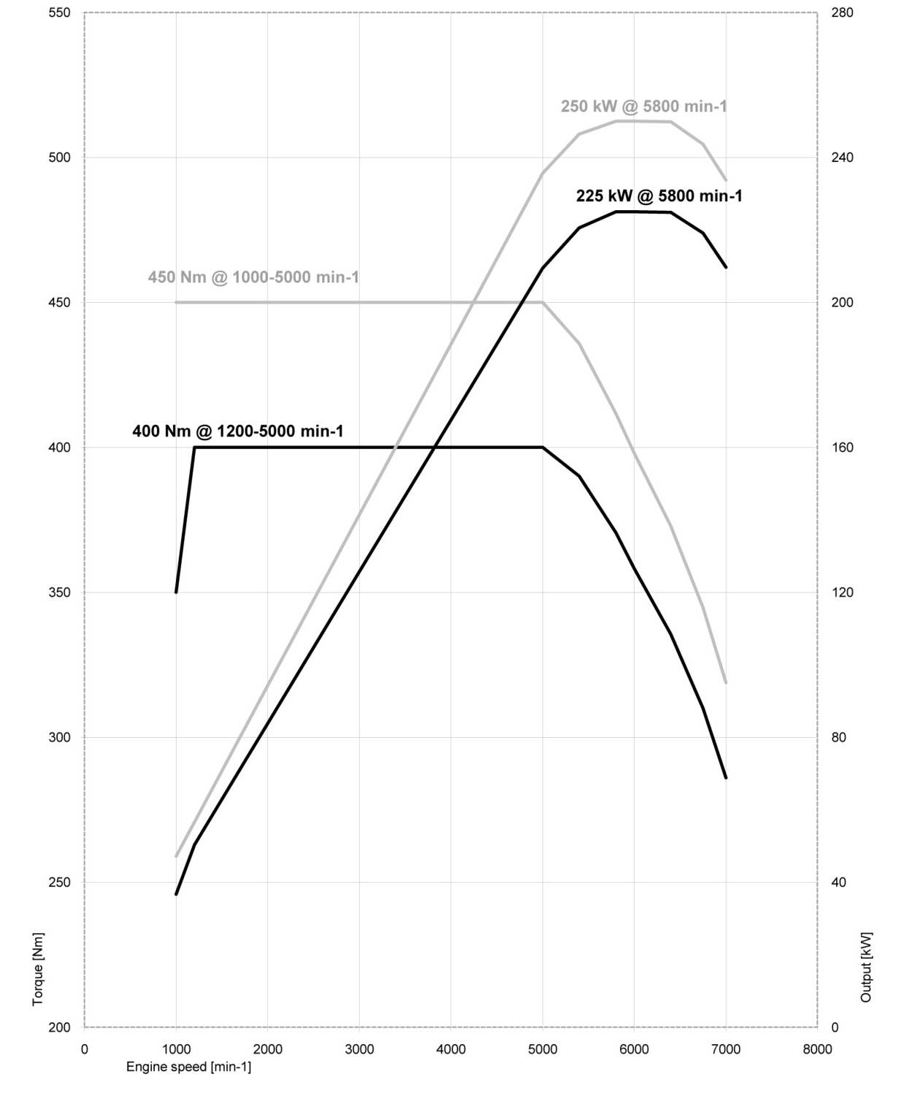
BMW ActiveHybrid 3

BMW ActiveHybrid 5

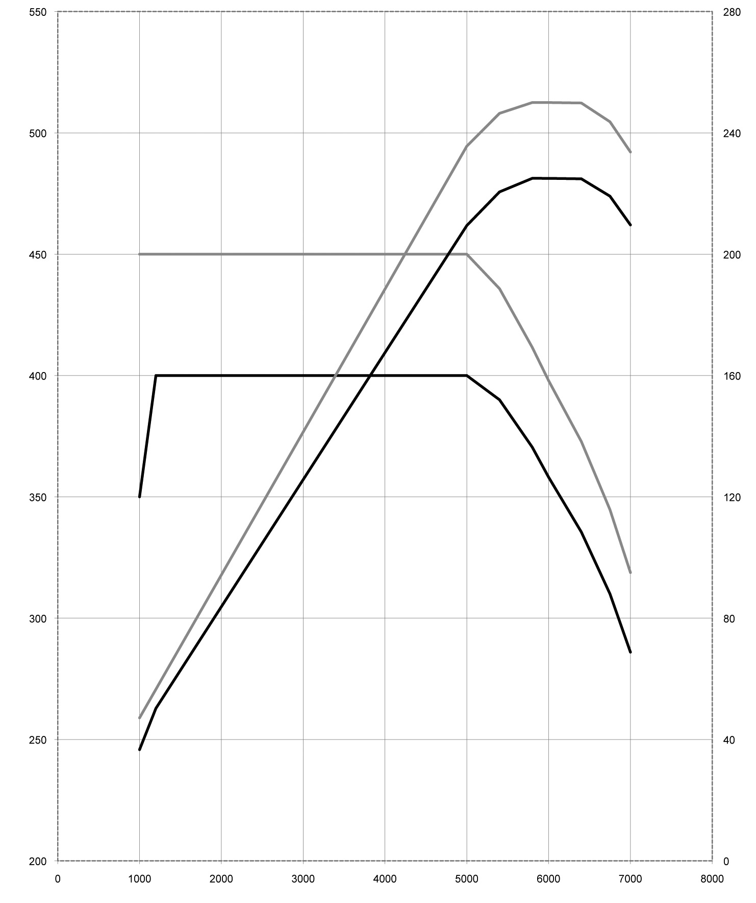
Engine Speed [min⁻¹]
Output [kW]

Torque [Nm]
400 Nm @ 1200-5000 min ⁻¹
450 Nm @ 1000-5000 min ⁻¹
250 kW @ 5800 min ⁻¹
225 kW @ 5800 min ⁻¹
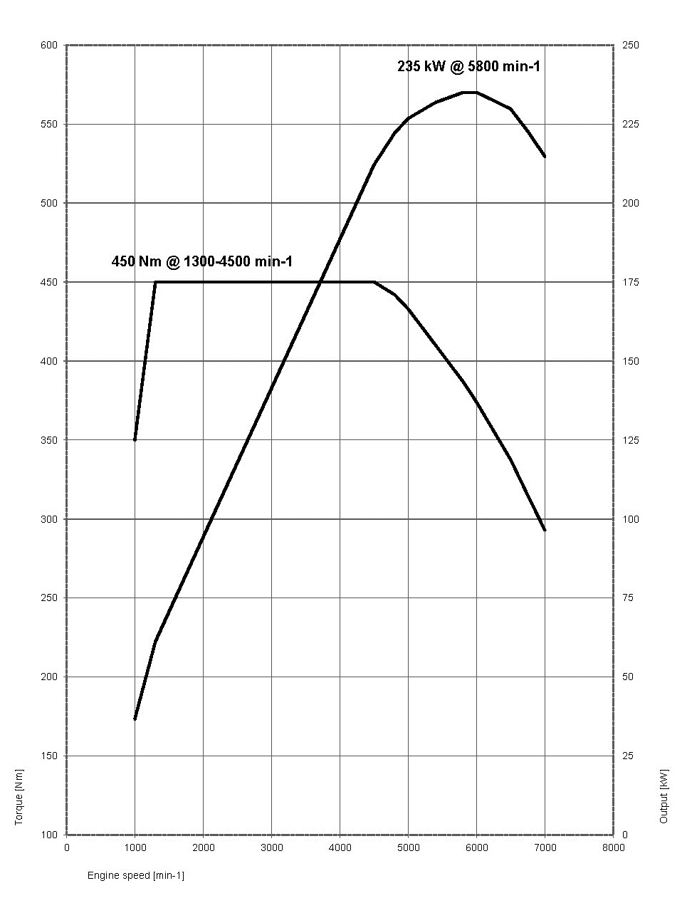
BMW ActiveHybrid 7
11. Exterior and
interior dimensions.
BMW ActiveHybrid 3. BMW ActiveHybrid 5. BMW ActiveHybrid 7.
