1. At a glance. 2

The new BMW X5.
Contents.
2. The world’s most successful Sports Activity Vehicle sets new benchmarks for driving pleasure, luxury and innovation.
The new BMW X5. 5
3. Specifications. 19
4. Output and torque diagrams. 25
5. Exterior and interior dimensions. 28

- Third generation of the BMW X5; founder of the Sports Activity Vehicle segment and global market leader in its class sets new standards in powerful design, luxurious spaciousness, cutting-edge versatility and efficient driving pleasure.
1. At a glance.
- Characteristic, evolutionary development of body design from the predecessor model; powerful, alert front-end look, with twin circular headlight units extending into the BMW kidney grille; elegantly stretched silhouette; eye-catching swage line over the athletically moulded wheel arches; horizontal lines and taut surfaces at the rear; features optimising the car’s aerodynamic properties integrated harmoniously into its overall design language, including Air Curtains, Air Breathers and Aero Blades for the rear window.
- New scope for individualisation: owners can specify new Design Pure Experience and Design Pure Excellence design worlds and M Sport package; exterior and interior features can be ordered in almost any combination.
- Increased spaciousness, clarity and luxurious ambience in the interior; raised seating position; low-set instrument panel with horizontal lines extending into the door trim and additional trim surface; enhanced interior variability thanks to 40 : 20 : 40 split/folding rear seat backrest; boot capacity: 650 – 1,870 litres; automatic tailgate operation as standard; tailgate can now also be opened and closed by remote control and from the driver’s seat; rear comfort seats and an additional third row of seats are both available as options.
- Three engine variants at launch: BMW X5 xDrive50i with a new generation of the V8 petrol engine (330 kW), BMW X5 xDrive30d with revised six-cylinder in-line diesel unit (190 kW) and the BMW X5 M50d M Performance Automobile with tri-turbo six-cylinder in-line diesel (280 kW). In December 2013 the BMW X5 xDrive40d, BMW X5 xDrive35i, BMW X5 xDrive25d and BMW X5 sDrive25d (with CO₂ emissions of just 149 g/km) will be added to the range.
- Commitment to reducing fuel consumption and emissions through weight minimisation, optimised air guidance, engine technology and the standard-fitted – and extremely efficient – eight-speed automatic gearbox with additional BMW EfficientDynamics technology; Auto Start Stop function, ECO PRO mode including coasting function and Proactive Driving Assistant also offered; all models already have the EU6 rating.
- Driving Experience Control switch fitted as standard; Comfort, Dynamic and Professional adaptive suspension packages and Adaptive M suspension can be specified to enhance the car’s sporty handling properties and ride comfort; Electric Power Steering for all model variants; Active Steering optional.
- Standard BMW xDrive all-wheel-drive system (excl. BMW X5 sDrive25d), also available with Dynamic Performance Control as part of the Dynamic and Professional adaptive suspension packages; xDrive status display makes its debut.
- More innovations in the BMW ConnectedDrive range: BMW Head-Up Display with full spectrum of colours and new display content; BMW Night Vision with human and animal detection and Dynamic Light Spot, Lane Change Warning, Speed Limit Info, new BMW Parking Assistant with longitudinal and lateral guidance*, Surround View with 360-degree display, Driving Assistant including Lane Departure Warning, plus Collision Warning and Pedestrian Warning with braking function; Driving Assistant Plus additionally with Active Cruise Control with Stop & Go function including braking to a standstill, Traffic Jam Assistant with active speed and steering angle control without driver input*; extensive range of mobility and internet-based services such as Concierge Services, Remote Services, Intelligent Emergency Call, Real Time Traffic Information, internet access, in-car use of Facebook and Twitter, dictation function with full speech recognition for emails, SMS and memos, online entertainment.
*planned availability: December 2013 (some of these BMW ConnectedDrive features will not be available in South Africa.
- Cutting-edge equipment options: freestanding, up to 10.25-inch Control Display for standard-fitted iDrive operating system; Touch Controller with touch-sensitive surface available with optional navigation system; high-quality materials; extended storage areas; Bang & Olufsen High End Surround Sound System, comfort seats in the rear and new rear-seat entertainment system with two displays all available as options.
- Engine variants:
BMW X5 xDrive50i: V8 petrol engine with BMW TwinPower Turbo technology (two turbochargers, direct injection, VALVETRONIC),
Capacity: 4,395 cc, output: 330 kW at 5,500 rpm,
max. torque: 650 Nm at 2,000 – 4,500 rpm.
Acceleration [0 – 100 km/h]: 5.0 seconds,
top speed: 250 km/h.
Average fuel consumption according to EU standard:
10.4 – 10.5 litres/100 kilometres,
CO₂ emissions according to EU standard: 242 – 244 g/km (figures depend on the tyre format specified), exhaust standard: EU6.

BMW X5 xDrive30d: Six-cylinder in-line diesel engine with
BMW TwinPower Turbo technology (turbocharger with variable inlet geometry, common rail direct injection),
Capacity: 2,993 cc, output: 190 kW at 4,000 rpm, max. torque: 560 Nm at 1,500 – 3,000 rpm.
Acceleration [0 – 100 km/h]: 6.9 seconds,
top speed: 230 km/h.
Average fuel consumption according to EU standard: 6.2 litres/100 kilometres,
CO₂ emissions according to EU standard: 162 – 164 g/km (figures depend on the tyre format specified), exhaust standard: EU6.

BMW X5 M50d: Six-cylinder in-line diesel engine with M Performance TwinPower Turbo technology (three turbochargers, high-pressure, with variable turbine geometry), common rail direct injection with piezo injectors, maximum injection pressure 2,200 bar).
Capacity: 2,993 cc, output: 280 kW at 4,000 – 4,400 rpm,
max. torque: 740 Nm at 2,000 – 3,000 rpm.
Acceleration [0 – 100 km/h]: 5.3 seconds,
top speed: 250 km/h.
Average fuel consumption according to EU standard: 6.7 litres/100 kilometres,
CO₂ emissions according to EU standard: 177 g/km, exhaust standard: EU6.
- Consistent further development of luxurious character; selection of materials, quality of workmanship, design and equipment generate exclusive ambience.

2. The world’s most successful Sports Activity Vehicle sets new benchmarks for driving pleasure, luxury and innovation:
The new BMW X5.
- Combination of driving dynamics and efficiency unrivalled in the segment.
- Uniquely harmonious blend of interior comfort and variability.

The BMW X5 – the founder of the Sports Activity Vehicle segment and globally best-selling car in its class, with more than 1.3 million units sold since the launch of the first generation – is entering a new chapter in its successful history. The third-generation X5 sees BMW once again setting the benchmark for powerful design, interior spaciousness and luxury, versatility, driving pleasure, efficiency and innovative equipment features. The new BMW X5 offers customers an assured all-round package equipped to meet the most exacting and varied demands.
Customers keen to make the configuration of the exterior and interior a little more individual can vary the car’s basic equipment with the M Sport package and Pure Experience and Pure Excellence “design worlds”. The defining features of the on-board experience of the new BMW X5 are an exclusive interior ambience with luxurious design, high-quality materials and innovative comfort-enhancing functions.
Standard BMW xDrive intelligent all-wheel drive (except on the BMW X5 sDrive25d) can be complemented by Dynamic Performance Control as part of the optional Dynamic and Professional adaptive suspension packages. The Dynamic adaptive suspension package also includes Dynamic Drive active roll stabilisation for a targeted improvement of the car’s sporty handling attributes. There is also the option of the Comfort active suspension package, which provides further enhanced ride comfort thanks to air suspension at the rear axle and Dynamic Damper Control. Adaptive M suspension, available as part of the M Sport package, also includes Dynamic Damper Control and rear-axle air suspension as well as specifically sports-oriented suspension tuning. The Professional adaptive suspension package, meanwhile, combines the features of Comfort and Dynamic. This choice allows drivers to select noticeably enhanced comfort or hallmark BMW sporting capability, as desired.
The selection of engines available from launch comprises a V8 engine producing 330 kW/450 hp for the BMW X5 xDrive50i and the 190 kW/258 hp six-cylinder in-line diesel earmarked for the BMW X5 xDrive30d. They are joined by an M Performance Automobile in the shape of the BMW X5 M50d. All models fulfil the EU6 exhaust stipulations as standard.
BMW EfficientDynamics technology allows all variants of the Sports Activity Vehicle to combine raised performance with reduced fuel consumption and CO₂ emissions. The increases in efficiency over the predecessor model have been achieved through measures including intelligent lightweight construction techniques and aerodynamic optimisations, which give the new BMW X5 xDrive30d, for example, a class-leading drag coefficient (Cd) of 0.31.
The range of BMW ConnectedDrive features is now also larger than ever, and includes innovative driver assistance systems, some of which are unique among the BMW X5’s rivals. The Sports Activity Vehicle also impresses with its outstanding practicality, headlined by its standard 40 : 20 : 40 split/folding rear seat backrest, load capacity rising from 650 to a maximum 1,870 litres and an optional third row of two additional seats.
Exterior design: an elegant blend of robust presence and dynamic flair.
Signature BMW design features combine with undeniable presence, robustness and versatility to lend BMW X models their distinctive appearance. And this design language has been given a modern and eye-catching update for the new BMW X5. The proportions of the third-generation Sports Activity Vehicle are once again defined by a short front overhang, long wheelbase, upright A-pillars and the short distance between the front axle and instrument panel. The particularly muscular design of the BMW kidney grille, set within the triangle of the twin circular headlights and front foglamps, and the bumper’s X-shaped contour lines also mark it out as a member of the BMW X model family.
The new BMW X5 has an extremely broad-set kidney grille extending all the way to the headlight units, and the hallmark BMW twin circular headlights, in turn, stretch well into the car’s side panels. Their light rings are each levelled off at the bottom and overlapped at their top edge by an LED accent light. Sweeping chrome inserts and the prominently three-dimensional design of the lights underline the car’s sophisticated character. LED front foglamps can be specified as an option, while the likewise optional Adaptive LED Headlights are identified by the horizontal light sources in the centre of the light rings. The BMW X5 xDrive50i and BMW X5 M50d are equipped with xenon headlights as standard.
The front apron, with side air intakes positioned far to its outer edges, draws further attention to the wide track and planted stance of the new BMW X5. And the car’s striking underbody protection elements provide a further nod to its robust and versatile character. Elsewhere, drag-reducing Air Curtains make their debut on a BMW X model. These vertical apertures guide the inflowing air around the wheel arches, where it creates a curtain of air over the wheels before making a controlled escape through the Air Breathers in the side panels.
The design of the BMW X5’s flanks shines a particularly clear spotlight on the car’s power and sporting ability. Precisely drawn lines rising up towards the rear end build a wedge shape exuding dynamic intent and break up the taut surfaces around the front side panels, doors and rear wheel arches. The resulting light and shadow effects bring out the athleticism and agility of the Sports Activity Vehicle.
The car’s upright front end, with its forward-thrusting BMW kidney grille, cuts an arresting figure from the side. The familiar BMW swage line, meanwhile, rises steadily from the headlight units, through the door pulls and into the rear lights. It combines with the character line extending from the upper edge of the Air Breathers and another, more obvious crease above the side skirts to stretch the figure-hugging surfaces of the car’s flanks powerfully to the rear.
The clear subdivision between the muscular body and a passenger compartment, whose large windows lend it a light and spacious feel, is clearly visible from the rear as well as from the side. Horizontal lines on the two-section tailgate and around the rear apron emphasise the width and robust stance of the new BMW X5. The thin, three-dimensional LED light strips of the two-section, L-shaped rear lights create a striking night-time look. Plus, the new BMW X5 is the brand’s first model to feature Aero Blades. These black air-channelling elements are contiguous with the roof spoiler and help it to optimise the car’s aerodynamic properties.
The exterior paintwork of the new BMW X5 can be ordered in a choice of 11 colours, among them the new metallic finish Sparkling Brown Brilliant Effect.
Interior design: high-quality materials, luxurious ambience, cutting-edge functionality.
The interior of the new BMW X5 is both elegant and generously sized. The horizontal structure of the layered surfaces underlines the broad sweep of the instrument panel and therefore also the impressive amount of space available on board. Plus, the three-dimensional design of the surfaces also generates vibrant contrasts.
The ambient lighting designs included in the lighting package lend extra emphasis to the visual unity between the instrument panel and door panels. LED units arranged in a wrap-around contour line and featuring in other areas of the interior create an alluring effect. Blue, white and orange light can be selected either individually or in nine pre-stored combinations via the iDrive system. The interior materials selected for the new BMW X5 also play a role in shaping the exclusive onboard ambience. The trim strip and accent strip extend into the front door panels and are picked up again in the rear door panels. Plus, the standard Oxide Silver dark matt (BMW X5 xDrive30d), Poplar Grain fine wood (BMW X5 xDrive50i) or Aluminium Hexagon (BMW X5 M50d) interior trim elements now sit atop a high-gloss black surface, which is bordered on its lower edge by an accent strip in Pearl Gloss Chrome.
The freestanding, up to 10.25-inch Control Display linked to the standard-fitted iDrive operating system adds further appeal. The displays for the climate control and ventilation systems – and, as an option, the instrument cluster – feature black panel technology.
The seat surfaces can be specified as an option in Dakota leather or – as part of the Pure Experience and Pure Excellence interior design lines – Exclusive Nappa leather with extended features. Customers can choose from seven upholstery colours.
Astute individualisation: Design Pure Experience and Design Pure Excellence for the exterior and interior.
Two new “design worlds” for the exterior and interior of the new BMW X5 can be ordered as an alternative to the standard specification, enabling an astutely judged level of personalisation. Each package represents a harmonious blend of design, colours and materials. The design worlds for the exterior and interior can be selected independently – i.e. customers can combine them both with one another and with standard specification, as desired. In addition, the two interior design packages are also available in combination with the M Sport package. The design worlds also encompass the new-look remote control key with operating buttons in an extremely high-quality design.
Design Pure Experience: presence and robustness
With stylistic underbody protection elements in brushed stainless steel, newly designed air intake bars in matt silver and a rear trim strip which, like the kidney grille bars, comes in matt silver, the Design Pure Experience package adds distinctive touches to the exterior and once again emphasises the SAV character of the BMW X5. This design world also includes exterior mirror bases and B-pillar and C-pillar trim in high-gloss black, as well as BMW Individual Exterior Line Aluminium satinated trim for the side windows. The exhaust tailpipe embellishers have a matt chrome finish.

The Design Pure Experience line uses a dark yet warm colour scheme to bring a classically stylish and luxurious ambience to the interior of the new BMW X5. It offers Exclusive Nappa leather trim, including extended features in Mocha/Black with contrast stitching, plus interior trim strips in textured Fineline Pure high-quality wood. The fulled leather surfaces of the instrument panel and upper-arm trim panels come in black with contrast stitching in Nut Brown. The lower section of the instrument panel is in Mocha.
Design Pure Excellence: modern and luxurious.
The Design Pure Excellence line for the exterior includes stylistic underbody protection elements and wheel arch surrounds painted in the respective body colour, black kidney grille bars with high-gloss chrome fronts, T-shaped bars for the outer air intakes and louvres for the lower aperture, plus a chrome trim strip for the rear apron and Chrome Line Exterior adornments for the side windows. The exterior mirror bases, B-pillars and C-pillars all feature high-gloss black trim.
The Design Pure Excellence package lends the interior an elegant and choice ambience through the use of Exclusive Nappa leather trim, including extended features in Ivory White with contrast stitching, fine wood interior trim elements in American Oak and a fulled leather surface for the instrument panel and door panels in Atlas Grey with contrast stitching. The lower section of the instrument panel comes in matching Ivory White.
Variable-usage interior, up to seven seats and even greater versatility.
With its luxurious ambience and enhanced ride comfort, spaciousness and seating comfort, the new BMW X5 offers noticeable advances over its predecessor. Added to which, the array of possible uses for its generously sized interior has grown once again. The newly designed seats for the driver and front passenger ensure a high level of long-distance comfort and impressive lateral hold through dynamically taken corners. Comfort seats and sports seats (standard in the BMW X5 M50d) are available as options.
Seat heating and comfort seats are both now also available for the rear compartment. The comfort seats come with bespoke upholstery, backrest adjustment through 10 degrees and 80 millimetres of fore/aft adjustment. The rear comfort seats can be specified either as an individual option or together with the optional third row of seats. The two additional seats are easy to access thanks to an Easy Entry function and a grip plate by the C-pillar. They can be lowered separately into the load compartment floor, are designed primarily for passengers measuring a maximum 1.50 metres in height and come with inertia-reel seat belts.
The folding backrest of the second-row seat bench can now be split 40 : 20 : 40, which allows load capacity to be increased in stages from 650 to as much as 1,870 litres – that’s 30 litres / 120 litres more than the predecessor model. Additional storage compartments and door pockets which can accommodate 1.5-litre bottles (front) and one-litre bottles (in the rear) also contribute to the car’s impressive functionality both in day-to-day use and on longer journeys.
The new BMW X5 also comes with a split two-section tailgate, the lower element of which can be folded down horizontally to form a single level with the load surface. Automatic tailgate operation for the upper section is a standard feature. And now, for the first time, the tailgate can be closed as well as opened using the remote control and, at the touch of a button, from the driver’s seat. An electrically pivoting trailer coupling can be ordered as an option, as can roof rails in three different design variants.
Engines: more driving enjoyment and efficiency with BMW TwinPower Turbo technology.
As the first ever Sports Activity Vehicle, the BMW X5 continues to set the trends and standards in its segment, with the accent firmly on driving enjoyment and efficiency. The new-generation V8 engine, for example, fitted in the BMW X5 xDrive50i, now develops 10 per cent – or 30 kW – more power (330 kW) than its predecessor, and combines this with a 16 per cent reduction in average fuel consumption. The improvement is down to BMW TwinPower Turbo technology, which in addition to twin turbochargers and High Precision Injection direct petrol injection now also includes VALVETRONIC variable valve timing, resulting in improved response and efficiency. Maximum torque of this 4.4-litre engine is now 650 Newton metres (+ 50 Nm), which is delivered between 2,000 and 4,500 rpm. The new BMW X5 xDrive50i completes the 0-100 km/h sprint in 5.0 seconds (– 0.5 seconds), and returns average fuel consumption of between 10.4 and 10.5 litres/100 km – that’s a 2.0 litre/100 km (approx. 4.4 mpg imp) improvement. CO₂ emissions are down 50 grams per kilometre, at 242/244 g/km (according to the EU test cycle and depending on tyre format).
The new BMW X5 xDrive30d too, with its six-cylinder in-line diesel engine, incorporates a range of detail improvements that offer an even better balance than before between performance and fuel consumption. The 3.0-litre engine, whose BMW TwinPower Turbo technology comprises VNT turbocharging and common rail direct injection, now develops maximum power of 190 kW (+ 10 kW), and maximum torque of 560 Newton metres (+ 20 Nm), which is delivered between 1,500 and 3,000 rpm. The new BMW X5 xDrive30d has a 0-100 km/h sprint time of 6.9 seconds (– 0.7 seconds). Average fuel economy in the EU test cycle has been improved by 16 per cent – or 1.2 litres per 100 kilometres – to 6.2 l/100 km, with CO₂ emissions of between 162 and 164 g/km (– 31 g/km), depending on tyre format.
The sporty temperament of the latest diesel engines finds even more potent expression in the BMW X5 M50d. This M Performance Automobile likewise gets a 3.0-litre straight-six unit, in this case featuring M Performance TwinPower Turbo technology with three-stage turbocharging. The three turbochargers work in harmony to maximise power output. Fuel is supplied via a common rail piezo injection system developing maximum pressure of 2,200 bar. This engine has a maximum output of 280 kW and develops its peak torque of 740 Newton metres between 2,000 and 3,000 rpm. The 0–100 km/h time of the BMW X5 M50d is 5.3 seconds (– 0.1 seconds), with average EU fuel consumption of 6.7 litres/100 km, an 11 per cent (0.8 l/100 km) improvement on the predecessor model. CO₂ emissions stand at 177 g/km (–22 g/km).
The BMW X5 line-up will expand further in December 2013. The BMW X5 xDrive35i (225 kW) has average fuel consumption of 8.5 litres per 100 kilometres and CO₂ emissions of 199 grams per kilometre, while the BMW X5 xDrive40d (230 kW) posts average fuel consumption of 6.4 litres per 100 kilometres and CO₂ emissions of 169 grams per kilometre. They will be joined by two models developing 160 kW– the BMW X5 xDrive25d with average fuel consumption of 5.9 litres per 100 kilometres and CO₂ emissions of 155 g/km, and the BMW X5 sDrive25d, which has average fuel consumption of 5.6 litres per 100 kilometres and CO₂ emissions of 149 grams per kilometre (provisional figures, according to the EU test cycle).
All versions of the new BMW X5 are already compliant with the EU6 emissions standard, which will apply from September 2014. On the diesel models, the lower nitrogen oxide limits are met using a close-coupled NO_{X} adsorber catalyst and an SCR catalyst with urea (AdBlue) injection.
BMW EfficientDynamics as standard: eight-speed automatic transmission and ECO PRO mode with new functions.
All engines in the new BMW X5 line-up are combined as standard with an eight-speed automatic transmission, whose high internal efficiency, precision and short shift times help to improve both efficiency and driving enjoyment. The extremely fast-shifting eight-speed sports automatic version used in the BMW X5 M50d comes with steering-wheel shift paddles, which are optionally available for the other new BMW X5 models as well. In vehicles with the eight-speed sports automatic transmission, the new “launch control” function is also available, a high-precision traction control system which allows engine power to be translated as efficiently as possible into road speed when accelerating from standstill.
In ECO PRO mode, the engine management, accelerator response and transmission characteristics are systematically tailored to support a particularly fuel-efficient, low-rpm driving style. At the same time, ECO PRO mode also programs electrically powered functions like the climate control, heated seats and heated exterior mirrors for extra-efficient energy management. In ECO PRO mode, a coasting function periodically decouples the engine from the rest of the powertrain whenever the driver eases off the accelerator at speeds between 50 and 160 km/h and does not apply the brakes at the same time. This allows the new BMW X5 to coast without engine braking, for maximised fuel efficiency. In conjunction with the optional Navigation system Professional, highly fuel-efficient ECO PRO navigation routes can be selected. When the navigation system is activated, the Proactive Driving Assistant function also tells the driver exactly when to ease off the accelerator when approaching corners or a speed-restricted section of road, in order to save fuel.
Along with the additional ECO PRO mode functions, the new BMW X5 also comes with many other BMW EfficientDynamics features. These include Brake Energy Regeneration, the Auto Start Stop function, on-demand operation of ancillary units, Electric Power Steering, low roll-resistance tyres and a variety of weight- and drag-reducing features. Along with other measures, use of ultra-high-tensile steels in the body structure, thermoplastics in the side panels, aluminium in the bonnet and magnesium in the instrument panel support make the new BMW X5 the lightest vehicle in its class. Intelligent lightweight design also means that the significantly increased standard specification compared with the previous model does not translate to increased vehicle weight. Indeed, depending on the model, the new BMW X5 actually tips the scales as much as 90 kg lighter than a comparably equipped corresponding model from the previous X5 generation.
The BMW X5 also offers best-in-class aerodynamic design. Active upper and lower front air flap control, Air Curtains, the Air Breather system, vertical aero blades at the rear window, air deflectors on the front wheel arches and a range of other detail improvements reduce the drag coefficient (Cd), depending on the model, to as low as 0.31 (BMW X5 xDrive30d).
Chassis: adjustable for customised driving enjoyment.
Sports Activity Vehicles are a vehicle segment first defined by BMW. Their combination of confident, sure-footed off-road traction and sporty but comfortable on-road driving has made them a global success. The new BMW X5 represents a further evolution of these qualities, incorporating refinements to the all-wheel-drive system and chassis technology.
Using the standard-fitted Driving Experience Control switch on the centre console, the drive settings can be matched to the requirements of the moment or to different driving situations. The COMFORT, SPORT, SPORT+ and ECO PRO modes, which can be selected at the press of a button, allow the driver to customise the accelerator response characteristics, the power steering characteristics, the characteristics of the automatic transmission and also, on vehicles fitted with the optional Comfort and Professional Adaptive Suspension packages, the characteristics of the Dynamic Damper Control. On vehicles with the optional Dynamic and Professional Adaptive Suspension packages, the characteristics of the active roll stabilisation system and the Dynamic Performance Control can also be customised.
The suspension packages available for the new BMW X5 cater to individual requirements in terms of comfortable or sporty driving styles. The Comfort Adaptive Suspension package comprises Dynamic Damper control and air suspension with automatic self-levelling rear suspension. The electronic control logic adapts the damping characteristics to changing road conditions and driving situations. Two different damping modes can be selected using the Driving Experience Control switch. The same functionality is also provided by the Adaptive M suspension, which is standard on the BMW X5 M50d and also part of the M Sport package for the other model versions. In this version, SPORT or SPORT+ modes offer extra-firm suspension and damping characteristics.
The various components of the Dynamic Adaptive Suspension package provide significantly sportier cornering dynamics. Dynamic Performance Control and the Dynamic Drive active roll stabilisation optimise directional stability and reduce body roll. Finally, the Professional Adaptive Suspension package maximises both comfort and dynamics. This option combines the components of the Comfort and Dynamic Suspension packages into an integrated system offering highest levels of driving enjoyment in all situations.
All versions of the new BMW X5 are equipped as standard with Electric Power Steering. For the BMW X5 xDrive50i and the BMW X5 xDrive30d, active steering is optionally available which, in addition to varying the power assist, also adjusts the steering input required to turn the wheels in relation to vehicle speed. This reduces the steering effort required when parking and provides precise response and feedback at high speed. The electromechanical parking brake with Auto Hold function is standard specification on the new BMW X5. The BMW X5 xDrive30d and BMW X5 xDrive50 are supplied with 18- and 19-inch alloy wheels respectively, while the BMW X5 M50d comes as standard with 19-inch “M” alloy wheels with mixed tyre sizes. Optionally, other 19- or 20-inch alloy wheels are available. Run-flat tyres are standard or optional, depending on the model. A Tyre Defect Indicator is standard on all versions of the new BMW X5.
The powerful braking system offers stable and consistent braking performance even under heavy braking, assisted by Dynamic Stability Control (DSC). Among other functions, the DSC system includes the Anti-lock Braking System (ABS), Dynamic Traction Control (DTC), Cornering Brake Control (CBC), Dynamic Brake Control (DBC) and the Automatic Differential Brake (ADB-X). Further functions include Brake Assist, the Brake Standby feature, Start-Off Assistant, Fading Compensation, the Brake Drying function, trailer stability control and Hill Descent Control (HDC).
BMW xDrive in the new BMW X5: intelligent all-wheel drive, with optional Dynamic Performance Control.
The new BMW X5 is also equipped with xDrive full-time intelligent all-wheel drive, which actively manages the drive power split between the front and rear wheels at all times. The latest version of the xDrive power divider boasts optimised efficiency and a 1.4 kg reduction in weight. xDrive’s control logic uses information about road speed, wheel speeds, steering angle and accelerator position to accurately interpret both the driver’s intentions and what the car is actually doing, and then adjusts the drive power split so as to apply as much power as possible to the road. In this way xDrive provides top-class traction and stability whatever the road and weather conditions, and also offers improved cornering dynamics, suppressing oversteer or understeer before the driver is even aware of the need.
If xDrive is combined with Dynamic Performance Control, the drive power split can be even more finely controlled. DPC, likewise electronically controlled, is integrated in the rear differential. In combination with xDrive it takes handling dynamics and directional stability to new levels. Dynamic Performance Control, which is available as part of the optional Dynamic or Professional Adaptive Suspension packages, seamlessly varies the drive power split between the rear wheels (torque vectoring), with significant benefits in terms of steering response and track-holding at all speeds. The stabilising action of Dynamic Performance Control is not affected if the driver lifts off the accelerator while cornering.
All-wheel-drive models come with a new xDrive status display in the control display boasting 3D graphics. This standard-fitted feature shows real-time information about body roll and pitch. Plus, on vehicles equipped with the optional Navigation system Professional, a compass display is also shown in the instrument cluster.
More innovations to assist the driver and underpin services: the BMW ConnectedDrive range for the new BMW X5.
A large range of BMW ConnectedDrive driver assistance systems and mobility services are available for the new BMW X5. They improve active safety, convenience and the infotainment experience and offer best-in-class standards of intelligent interaction between the driver, vehicle and external environment.
Safety: Driving Assistant and Driving Assistant Plus.
The new Driving Assistant safety package includes Lane Departure Warning, which alerts drivers to an imminent unintended lane departure, and a pedestrian and collision warning system with braking function, which detects preceding vehicles and, at speeds up to 60 km/h, also pedestrians who are on a potential collision course with the vehicle. Visual and audible warnings are given if a hazard is detected and at the same time the brake system is primed in order to reduce stopping distance. At speeds up to 60 km/h (37 mph), moderate “hazard” braking is actuated to reduce vehicle speed and alert the driver to a critical situation.
The Driving Assistant Plus package provides even more support. Here the Driving Assistant functions are combined with the Active Cruise Control system with Stop & Go function, which enhances comfort and safety in slow-moving and stop-and-go traffic. This system maintains a safe following distance at any speed up to 210 km/h. A combination of a front camera and full-range radar sensors registers preceding traffic or stationary vehicles. If the driver fails to react to a warning of an imminent frontal collision, Driving Assistant Plus automatically brakes the vehicle, if necessary to a standstill. A further Driving Assistant Plus function, the Traffic Jam Assistant, is due to be incorporated in this package from December 2013. At speeds up to 40 km/h, this function not only controls following distance but also keeps the vehicle on track. The Traffic Jam Assistant keeps the vehicle in the centre of its lane by providing active steering input.
The new BMW X5 will now be offered with the optional Active Protection system, with extended functionality. This safety package takes numerous steps in critical situations to minimise the consequences of a potential accident. It closes the side windows and the sunroof (if fitted), pulls the front seatbelts tight and adjusts the backrest of the front passenger seat to an upright position. Active Protection now also includes an Attention Assistant feature, which analyses driving behaviour and advises when it is time to take a break.
Fast and appropriate assistance in the event of a collision, with automatic vehicle location and accident severity detection, is provided by the Intelligent Emergency Call system, which is standard in many markets. The current generation of this system relays important information to the BMW Call Centre in the event of a crash, such as vehicle position (accurate within metres), chassis number, vehicle model, vehicle colour and data from the onboard sensors. The system also detects how many people are travelling in the vehicle, which airbags were activated and the intensity of the impact.
BMW ConnectedDrive technologies also enhance safety at night. In addition to Adaptive Headlights with turning lights, Adaptive LED Headlights and the dynamically controlled anti-dazzle High Beam Assistant, which automatically blocks a portion of the headlight beam, nocturnal safety can be further assisted by BMW Night Vision. This system now detects not only pedestrians but also animals, and also includes the Dynamic Light Spot. The system relays a real-time video image to the control display which shows people, sizeable animals and other heat-radiating objects even if they are outside the headlight beam, and provides a warning if there is a collision risk. The Dynamic Light Spot is generated by a special light function which “spotlights” any persons or animals detected by the system, thereby guiding the driver’s attention in the right direction in good time.
Comfort: innovative driving assistance systems and unique services.
In the new BMW X5, the BMW Head-Up Display, which projects important information in full colour onto the windscreen, now includes additional content. When required, telephone contact lists and entertainment programmes can also be projected into the driver’s direct field of view.

Also new, and due to become available for this Sports Activity Vehicle by December 2013, is the latest generation of the BMW Parking Assistant. This helps the driver look for suitable parallel parking spaces and precisely manoeuvres the vehicle into a parking space, not only by steering but also by operating the accelerator and brake pedal and selecting the appropriate gear. When the system has been activated at the press of a button, the new BMW X5 can therefore park itself automatically in a selected parking space. Ease of manoeuvring is further enhanced by the rear-view camera and the Surround View system, which now provides a 360-degree view of the vehicle and its surroundings on the control display. The Panorama View front and rear monitoring function, meanwhile, provides a better view of cross-traffic when emerging from an exit with poor visibility.
The new BMW X5, too, can now be supplied with the Speed Limit Info system, which shows any speed limits or overtaking restrictions for a particular road in the instrument cluster. The likewise optional Lane Change Warning system assesses the traffic situation on multi-lane roads in order to prevent critical situations when pulling out to overtake. When performing an intentional lane change at any speed upwards of 20 km/h, the driver is warned by a visual signal and a steering wheel vibration if another vehicle is hidden in the critical area behind or alongside the BMW X5.
The world-leading Concierge Services are a personal information service, which the BMW ConnectedDrive customer can use to make hotel reservations, search for addresses and telephone numbers or check opening times, to name just a few examples. On vehicles with the optional Navigation system Professional, the Real Time Traffic Information system is also available as an option, supplying drivers with extremely precise real-time traffic information and congestion reports.
Infotainment: perfect connectivity for office, entertainment and social media applications.
Based either on a comprehensively integrated smartphone or on a built-in SIM card, BMW ConnectedDrive offers access to a wide range of mobility services and web-based services for office, travel and infotainment applications. A hands-free system with USB port is standard specification on the new BMW X5. Also available are the Remote Functions, in-car Internet access and the Online Entertainment option, offering access to approximately 12 million tracks. The BMW ConnectedDrive Office functions allow emails, appointments, contact lists, calendar entries and notes to be shown on the control display. It also includes a dictating function that converts spoken notes into text, which can then be forwarded as an SMS or email message.
The BMW Apps option includes a web radio function and offers a customised music programme compiled by the Aupeo! service, as well as in-car Facebook and Twitter access. New apps are being added to this service all the time.
Extensive standard specification and high-end optional equipment for more driving enjoyment.
The exclusive driving experience in the new BMW X5 is reflected not only in the luxurious interior but also in the extensive standard specification and wide range of high-end optional extras. The standard equipment list now also includes a two-zone automatic climate control system, a Bluetooth hands-free system, an automatically dimming rear-view mirror and cruise control with braking function. The standard-fitted iDrive operating system can be ordered – in conjunction with the optional Navigation system Professional –with a Touch Controller, whose touch-sensitive surface allows the use of characters to program a destination into the navigation system, for example.
The Professional radio is also standard specification. Alternatively, a customised listening experience can be provided by a HiFi loudspeaker system, the Harman Kardon Surround Sound System or the Bang & Olufsen High End Surround Sound System with a 1,200-watt amplifier and 16 speakers. Digital radio (DAB) reception, a TV module and a newly developed rear-seat entertainment system with DVD drive and two tablet-style monitors are also available. Further customisation can be provided with the sports leather steering wheel, heated steering wheel, four-zone automatic climate control, automatically dimming exterior mirrors, doors with Soft Close Automatic function, Comfort Access, the panoramic glass roof, aluminium footplates in the side skirts, the storage compartments package and the ski and snowboard bag.
Production and marketing
The new BMW X5 will be built at BMW’s Spartanburg plant in the USA. This production plant in South Carolina is the competence centre for BMW X models and also produces the BMW X6 and BMW X3 – to be joined by the future BMW X4 – for supply to markets throughout the world. The market launch of the new BMW X5 in Germany is scheduled for November 2013.

3. Specifications.
BMW X5 xDrive50i.

 |  |  |  | BMW X5 xDrive50i
Body
No of doors/seats |  |  |  | 5 / 5 (7) ¹⁾
Length/width/height (unladen) | mm |  |  | 4886 / 1938 / 1762
Wheelbase | mm |  |  | 2933
Track, front/rear | mm |  |  | 1640 / 1646
Turning circle | m |  |  | 12.7
Tank capacity | app ltr |  |  | 85
Cooling system incl heater | ltr |  |  | 14.7
Engine oil²⁾ | ltr |  |  | 9.0
Weight, unladen, to DIN/EU | kg |  |  | 2175 / 2250
Max load to DIN | kg |  |  | 710
Max permissible | kg |  |  | 2885
Max axle load, front/rear | kg |  |  | 1375 / 1585
Max trailer load (12%),  braked/unbraked | kg |  |  | 2700 (3500 ³⁾) / 750
Max roofload/max towbar dwnl | kg |  |  | 100 / 140
Luggage comp capacity | ltr |  |  | 650 – 1870
Air resistance | c_{d} x A |  |  | 0.33 x 2.84
Engine
Config/No of cyls/valves |  |  |  | V / 8 / 4
Engine technology |  | BMW TwinPower Turbo technology with two turbochargers, direct injection (High Precision Injection) and fully variable valve control (VALVETRONIC)
Capacity, effective | cc |  |  | 4395
Stroke / bore | mm |  |  | 88.3 / 89.0
Compression ratio | :1 |  |  | 10.0
Fuel grade |  |  |  | min RON 91
Max output | kW/hp |  |  | 330 / 450
at | rpm |  |  | 5500
Max torque | Nm/lb-ft |  |  | 650/479
at | rpm |  |  | 2000 – 4500
Electrical System
Battery/installation | Ah/– |  |  | 105 / luggage comp
Alternator | A/W |  |  | 210 / 2940
Driving Dynamics and Safety
Suspension, front |  | Double track control arm with double joint principle,  small, negative steering roll radius, anti-dive
Suspension, rear |  | Integral-IV rear axle, spatial suspension with anti-squat and anti-dive;  optional: air suspension with automatic self-levelling
Brakes, front |  | Single-piston swing-calliper disc brakes
Diameter | mm |  |  | 385 x 36 / inner-vented
Brakes, rear |  | Single-piston swing-calliper disc brakes
Diameter | mm |  |  | 345 x 24 / inner-vented
Driving stability systems |  | Standard: DSC incl. ABS and Dynamic Traction Control (DTC), Cornering Brake Control (CB), Dynamic Brake Control (DBC), Dry Braking function,  Fading Compensation, Start-Off Assistant; DSC linked to xDrive all-wheel-drive, Automatic Differential Brake (ADB-X), Hill Descent Control (HDC);  optional in conjunction with the Comfort, Dynamic or Professional adaptive suspension packages or Adaptive M suspension: Dynamic Damper Control, active roll stabilisation, Dynamic Performance Control
Safety equipment |  | Standard: airbags for driver and front passenger, side airbags for driver  and front passenger, head airbags for front and rear seats, crash-activated head restraints at the front, three-point inertia-reel seatbelts on all seats with integrated belt latch tensioner and belt force limiter at the front, crash sensors, rollover sensors, Tyre Defect Indicator
Steering |  | Electric Power Steering (EPS) with Servotronic:  optional: Active Steering
Steering transmission, overall | :1 |  |  | 19.1
Tyres, front/rear |  |  | 255/50 R19 107 W XL RSC
Rims, front/rear |  |  |  | 9J x 19 light-alloys

 |  |  |  |  |  |  |  |  | BMW X5 xDrive50i
BMW ConnectedDrive
Convenience |  |  |  | Optional: Concierge Services, Remote Services, Real Time Traffic Information, BMW TeleServices, integration of mobile devices
Infotainment |  |  |  | Optional: internet access, BMW Online incl. Park Info, National Info, Google Services, News, Realtime Weather, BMW Routes, Office functions, Bluetooth Audio Streaming and Online Update Music Tracks, apps
Safety |  |  |  | Optional: Adaptive Headlights with turning lights, anti-dazzle High Beam Assistant, Park Distance Control, rear-view camera, Surround View, BMW Night Vision with human and animal detection and Dynamic Light Spot, Head-Up Display, Parking Assistant, Lane Change Warning, Lane Departure Warning, Collision Warning with braking function, Active Cruise Control with Stop & Go function and full braking to standstill, Speed Limit Info with No Passing Info, Active Protection with Attention Assistant, Automatic/Enhanced Emergency Call
Transmission
Type of gearbox |  |  |  |  |  |  | Eight-speed automatic transmission with Steptronic
Gear ratios I |  | :1 |  |  |  |  |  |  |  | 4.714
II |  | :1 |  |  |  |  |  |  |  | 3.143
III |  | :1 |  |  |  |  |  |  |  | 2.106
IV |  | :1 |  |  |  |  |  |  |  | 1.667
V |  | :1 |  |  |  |  |  |  |  | 1.285
VI |  | :1 |  |  |  |  |  |  |  | 1.000
VII |  | :1 |  |  |  |  |  |  |  | 0.839
VIII |  | :1 |  |  |  |  |  |  |  | 0.667
R |  | :1 |  |  |  |  |  |  |  | 3.317
Final drive |  | :1 |  |  |  |  |  |  |  | 3.154
Performance
Power-to-weight ratio (DIN) |  | kg/kW |  |  |  |  |  |  | 6.6
Output per litre |  | kW/ltr |  |  |  |  |  |  | 75.1
Acceleration 0–100 km/h |  | sec |  |  |  |  |  |  | 5.0
0–1000 m |  | sec |  |  |  |  |  |  | 23.9
Top speed |  | km/h |  |  |  |  |  |  | 250
Off-Road Specifications
Overhang angle, front/rear |  | ° |  |  |  |  |  |  | 25.0 / 20.0
Ramp angle |  | ° |  |  |  |  |  |  | 20.0
Ground clearance unladen |  | mm |  |  |  |  |  |  | 209
Fording depth (at 7 km/h) |  | mm |  |  |  |  |  |  | 500
BMW EfficientDynamics
BMW EfficientDynamics, standard features |  |  |  |  | Brake Energy Regeneration with recuperation display,  Electric Power Steering (EPS), Auto Start Stop function, ECO PRO mode with coasting function, flow rate-controlled oil pump, rpm-driven fuel pump, intelligent lightweight construction, optimised aerodynamic attributes, active air vents, detachable a/c compressor, final drive with optimised warm-up behaviour, tyres with reduced roll resistance
Fuel Consumption EU ⁴⁾
With standard wheels and tyres
Urban |  | ltr/100 km |  |  |  |  |  |  | 14.0
Extra-urban |  | ltr/100 km |  |  |  |  |  |  | 8.3
Combined |  | ltr/100 km |  |  |  |  |  |  | 10.4
CO₂ |  | g/km |  |  |  |  |  |  | 242
With 9J x 19 wheels at front, 10J x 19 at rear and 255/50 R19 tyres at front, 285/45 R19 at rear
With 10J x 20 wheels at front, 11J x 20 at rear and 275/40 R20 tyres at front, 315/35 R20 at rear
Urban |  | ltr/100 km |  |  |  |  |  |  | 14.1
Extra-urban |  | ltr/100 km |  |  |  |  |  |  | 8.3
Combined |  | ltr/100 km |  |  |  |  |  |  | 10.5
CO₂ |  | g/km |  |  |  |  |  |  | 244
Emission rating |  |  |  |  |  |  |  |  | EU6
Insurance Category (Germany)
KH / VK / TK |  |  |  |  |  |  |  |  | ⁵⁾

Specifications applicable to ACEA markets, data relevant to homologation applicable in part only to Germany (weight)
All technical data are provisional

- With optional third row of seats
- Oil change
- With optional increased towbar download (country-specific)
- Fuel consumption and CO₂ emissions depend on the selected tyre format
- Data not yet available

BMW X5 xDrive30d.

 |  |  |  | BMW X5 xDrive30d
Body
No of doors/seats |  |  |  | 5 / 5 (7) ¹⁾
Length/width/height (unladen) | mm |  |  | 4886 / 1938 / 1762
Wheelbase | mm |  |  | 2933
Track, front/rear | mm |  |  | 1644 / 1650
Turning circle | m |  |  | 12.7
Tank capacity | app ltr |  |  | 85
Cooling system incl. heater | ltr |  |  | 12.6
Engine oil²⁾ | ltr |  |  | 6.5
Weight, unladen, to DIN/EU | kg |  |  | 2070 / 2145
Max load to DIN | kg |  |  | 710
Max permissible | kg |  |  | 2780
Max axle load, front/rear | kg |  |  | 1320 / 1545
Max trailer load (12%),  braked/unbraked | kg |  |  | 2700 (3500 ³⁾) / 750
Max roofload/max towbar dwnl | kg |  |  | 100 / 140
Luggage comp capacity | ltr |  |  | 650 – 1870
Air resistance | c_{d} x A |  |  | 0.31 x 2.84
Engine
Config/No of cyls/valves |  |  |  | In-line / 6 / 4
Engine technology |  | BMW TwinPower Turbo technology: variable-geometry turbocharger, Common Rail direct injection with solenoid valve injectors (max. injection pressure: 1800 bar)
Capacity, effective | cm³ |  |  | 2993
Stroke / bore | mm |  |  | 90.0 / 84.0
Compression ratio | :1 |  |  | 16.5
Fuel grade |  |  |  | Diesel
Max output | kW/hp |  |  | 190 / 258
at | rpm |  |  | 4000
Max torque | Nm/lb-ft |  |  | 560/413
at | rpm |  |  | 1500 – 3000
Electrical System
Battery/installation | Ah/– |  |  | 105 / luggage comp
Alternator | A/W |  |  | 220 / 3080
Driving Dynamics and Safety
Suspension, front |  | Double track control arm with double joint principle,  small, negative steering roll radius, anti-dive
Suspension, rear |  | Integral-IV rear axle, spatial suspension with anti-squat and anti-dive;  optional: air suspension with automatic self-levelling
Brakes, front |  | Single-piston swing-calliper disc brakes
Diameter | mm |  |  | 332 x 30 / inner-vented
Brakes, rear |  | Single-piston swing-calliper disc brakes
Diameter | mm |  |  | 320 x 20 / inner-vented
Driving stability systems |  | Standard: DSC incl. ABS and Dynamic Traction Control (DTC), Cornering Brake Control (CB), Dynamic Brake Control (DBC), Dry Braking function,  Fading Compensation, Start-Off Assistant; DSC linked to xDrive all-wheel-drive, Automatic Differential Brake (ADB-X), Hill Descent Control (HDC);  optional in conjunction with the Comfort, Dynamic or Professional adaptive suspension packages or Adaptive M suspension: Dynamic Damper Control, active roll stabilisation, Dynamic Performance Control
Safety equipment |  | Standard: airbags for driver and front passenger, side airbags for driver  and front passenger, head airbags for front and rear seats, crash-activated head restraints at the front, three-point inertia-reel seatbelts on all seats with integrated belt latch tensioner and belt force limiter at the front, crash sensors, rollover sensors, Tyre Defect Indicator
Steering |  | Electric Power Steering (EPS) with Servotronic:  optional: Active Steering
Steering transmission, overall | :1 |  |  | 19.1
Tyres, front/rear |  |  | 255/55 R18 109 H XL
Rims, front/rear |  |  |  | 8.5J x 18 light-alloys

 |  |  |  |  |  |  |  |  | BMW X5 xDrive30d
BMW ConnectedDrive
Convenience |  |  |  | Optional: Concierge Services, Remote Services, Real Time Traffic Information, BMW TeleServices, integration of mobile devices
Infotainment |  |  |  | Optional: internet access, BMW Online incl. Park Info, National Info, Google Services, News, Realtime Weather, BMW Routes, Office functions, Bluetooth Audio Streaming and Online Update Music Tracks, apps
Safety |  |  |  | Optional: Adaptive Headlights with turning lights, anti-dazzle High Beam Assistant, Park Distance Control, rear-view camera, Surround View, BMW Night Vision with human and animal detection and Dynamic Light Spot, Head-Up Display, Parking Assistant, Lane Change Warning, Lane Departure Warning, Collision Warning with braking function, Active Cruise Control with Stop & Go function and full braking to standstill, Speed Limit Info with No Passing Info, Active Protection with Attention Assistant, Automatic/Enhanced Emergency Call
Transmission
Type of gearbox |  |  |  |  |  |  | Eight-speed automatic transmission with Steptronic
Gear ratios I |  | :1 |  |  |  |  |  |  |  | 4.714
II |  | :1 |  |  |  |  |  |  |  | 3.143
III |  | :1 |  |  |  |  |  |  |  | 2.106
IV |  | :1 |  |  |  |  |  |  |  | 1.667
V |  | :1 |  |  |  |  |  |  |  | 1.285
VI |  | :1 |  |  |  |  |  |  |  | 1.000
VII |  | :1 |  |  |  |  |  |  |  | 0.839
VIII |  | :1 |  |  |  |  |  |  |  | 0.667
R |  | :1 |  |  |  |  |  |  |  | 3.317
Final drive |  | :1 |  |  |  |  |  |  |  | 3.154
Performance
Power-to-weight ratio |  | kg/kW |  |  |  |  |  |  | 10.9
Output per litre |  | kW/ltr |  |  |  |  |  |  | 63.5
Acceleration 0–100 km/h |  | sec |  |  |  |  |  |  | 6.9
0–1000 m |  | sec |  |  |  |  |  |  | 27.5
Top speed |  | km/h |  |  |  |  |  |  | 230
Off-Road Specifications
Overhang angle, front/rear |  |  |  |  |  |  |  |  | 25.0 / 20.0
Ramp angle |  | ° |  |  |  |  |  |  | 20.0
Ground clearance unladen |  | mm |  |  |  |  |  |  | 209
Fording depth (at 7 km/h) |  | mm |  |  |  |  |  |  | 500
BMW EfficientDynamics
BMW EfficientDynamics, standard features |  |  |  |  | Brake Energy Regeneration with recuperation display,  Electric Power Steering (EPS), Auto Start Stop function, ECO PRO mode with coasting function, map-controlled oil pump, intelligent lightweight construction, optimised aerodynamic attributes, active air vents, detachable a/c compressor, final drive with optimised warm-up behaviour,  tyres with reduced roll resistance
Fuel Consumption EU ⁴⁾
With standard wheels and tyres
Urban |  | ltr/100 km |  |  |  |  |  |  | 7.0
Extra-urban |  | ltr/100 km |  |  |  |  |  |  | 5.7
Combined |  | ltr/100 km |  |  |  |  |  |  | 6.2
CO₂ |  | g/km |  |  |  |  |  |  | 162
With 9J x 19 wheels at front, 10J x 19 at rear and 255/50 R19 tyres at front, 285/45 R19 at rear
With 10J x 20 wheels at front, 11J x 20 at rear and 275/40 R20 tyres at front, 315/35 R20 at rear
Urban |  | ltr/100 km |  |  |  |  |  |  | 7.1
Extra-urban |  | ltr/100 km |  |  |  |  |  |  | 5.7
Combined |  | ltr/100 km |  |  |  |  |  |  | 6.2
CO₂ |  | g/km |  |  |  |  |  |  | 164
Emission rating |  |  |  |  |  |  |  |  | EU6
Insurance Category (Germany)
KH / VK / TK |  |  |  |  |  |  |  |  | ⁵⁾

Specifications applicable to ACEA markets, data relevant to homologation applicable in part only to Germany (weight, top speed)
All technical data are provisional

- With optional third row of seats
- Oil change
- With optional increased towbar download (country-specific)
- Fuel consumption and CO₂ emissions depend on the selected tyre format
- Data not yet available
BMW X5 M50d.

 |  |  |  | BMW X5 M50d
Body
No of doors/seats |  |  |  | 5 / 5 (7) ¹⁾
Length/width/height (unladen) | mm |  |  | 4886 / 1938 / 1762
Wheelbase | mm |  |  | 2933
Track, front/rear | mm |  |  | 1662 / 1702
Turning circle | m |  |  | 12.7
Tank capacity | app ltrl |  |  | 85
Cooling system incl. heater | ltr |  |  | 15.4
Engine oil²⁾ | ltr |  |  | 6.5
Weight, unladen, to DIN/EU | kg |  |  | 2190 / 2265
Max load to DIN | kg |  |  | 710
Max permissible | kg |  |  | 2900
Max axle load, front/rear | kg |  |  | 1370 / 1580
Max trailer load (12%),  braked/unbraked | kg |  |  | 2700 (3500 ³⁾) / 750
Max roofload/max towbar dwnl | kg |  |  | 100 / 140
Luggage comp capacity | kg |  |  | 650 – 1870
Air resistance | c_{d} x A |  |  | 0.35 x 2.84
Engine
Config/No of cyls/valves |  |  |  | In-line / 6 / 4
Engine technology |  | M Performance TwinPower Turbo technology with three turbochargers,  multi-stage variable-geometry charging, Common Rail direct injection  (max. injection pressure: 2200 bar)
Capacity, effective | cm³ |  |  | 2993
Stroke / bore | mm |  |  | 90.0 / 84.0
Compression ratio | :1 |  |  | 16.0
Fuel grade |  |  |  | Diesel
Max output | kW/hp |  |  | 280 / 381
at | rpm |  |  | 4000 – 4400
Max torque | Nm/lb-ft |  |  | 740/546
at | rpm |  |  | 2000 – 3000
Electrical System
Battery/installation | Ah/– |  |  | 105 / luggage comp
Alternator | A/W |  |  | 220 / 3080
Driving Dynamics and Safety
Suspension, front |  | Double track control arm with M-specific elastokinematics,  damping and suspension tuning, small, negative steering roll radius,  anti-dive
Suspension, rear |  | Integral-IV rear axle with M-specific elastokinematics,  damping and suspension tuning, spatial suspension with  anti-squat and anti-dive, air suspension with automatic self-levelling
Brakes, front |  | Twin-piston swing-calliper disc brakes
Diameter | mm |  |  | 385 x 36 / inner-vented
Brakes, rear |  | Single-piston swing-calliper disc brakes
Diameter | mm |  |  | 345 x 24 / inner-vented
Driving stability systems |  | Standard: DSC incl. ABS and Dynamic Traction Control (DTC), Cornering Brake Control (CB), Dynamic Brake Control (DBC), Dry Braking function,  Fading Compensation, Start-Off Assistant; DSC linked to xDrive all-wheel-drive, Automatic Differential Brake (ADB-X), Hill Descent Control (HDC);  optional in conjunction with the Comfort, Dynamic or Professional adaptive suspension packages or Adaptive M suspension: Dynamic Damper Control, active roll stabilisation, Dynamic Performance Control
Safety equipment |  | Standard: airbags for driver and front passenger, side airbags for driver  and front passenger, head airbags for front and rear seats, crash-activated head restraints at the front, three-point inertia-reel seatbelts on all seats with integrated belt latch tensioner and belt force limiter at the front, crash sensors, rollover sensors, Tyre Defect Indicator
Steering |  | Electric Power Steering (EPS) with M-specific Servotronic
Steering transmission, overall | :1 |  |  | 19.1
Tyres, front/rear |  |  | 255/50 R19 107 W RSC /  285/45 R19 111 W RSC
Rims, front/rear |  |  |  | 9J x 19 light-alloys /  10J x 19 light-alloys

 |  |  |  |  |  |  |  |  | BMW X5 M50d
BMW ConnectedDrive
Convenience |  |  |  | Optional: Concierge Services, Remote Services, Real Time Traffic Information, BMW TeleServices, integration of mobile devices
Infotainment |  |  |  | Optional: internet access, BMW Online incl. Park Info, National Info, Google Services, News, Realtime Weather, BMW Routes, Office functions, Bluetooth Audio Streaming and Online Update Music Tracks, apps
Safety |  |  |  | Optional: Adaptive Headlights with turning lights, anti-dazzle High Beam Assistant, Park Distance Control, rear-view camera, Surround View, BMW Night Vision with human and animal detection and Dynamic Light Spot, Head-Up Display, Parking Assistant, Lane Change Warning, Lane Departure Warning, Collision Warning with braking function, Active Cruise Control with Stop & Go function and full braking to standstill, Speed Limit Info with No Passing Info, Active Protection with Attention Assistant, Automatic/Enhanced Emergency Call
Transmission
Type of gearbox |  |  |  |  |  |  | Eight-speed automatic transmission with Steptronic
Gear ratios I |  | :1 |  |  |  |  |  |  |  | 4.714
II |  | :1 |  |  |  |  |  |  |  | 3.143
III |  | :1 |  |  |  |  |  |  |  | 2.106
IV |  | :1 |  |  |  |  |  |  |  | 1.667
V |  | :1 |  |  |  |  |  |  |  | 1.285
VI |  | :1 |  |  |  |  |  |  |  | 1.000
VII |  | :1 |  |  |  |  |  |  |  | 0.839
VIII |  | :1 |  |  |  |  |  |  |  | 0.667
R |  | :1 |  |  |  |  |  |  |  | 3.317
Final drive |  | :1 |  |  |  |  |  |  |  | 3.154
Performance
Power-to-weight ratio |  | kg/kW |  |  |  |  |  |  | 7.8
Output per litre |  | kW/ltr |  |  |  |  |  |  | 93.6
Acceleration 0–100 km/h |  | sec |  |  |  |  |  |  | 5.3
0–1000 m |  | sec |  |  |  |  |  |  | 24.9
Top speed |  | km/h |  |  |  |  |  |  | 250
Off-Road Specifications
Overhang angle, front/rear |  | ° |  |  |  |  |  |  | 25.0 / 20.0
Ramp angle |  | ° |  |  |  |  |  |  | 20.0
Ground clearance unladen |  | mm |  |  |  |  |  |  | 209
Fording depth (at 7 km/h) |  | mm |  |  |  |  |  |  | 500
BMW EfficientDynamics
BMW EfficientDynamics, standard features |  |  |  |  | Brake Energy Regeneration with recuperation display,  Electric Power Steering (EPS), Auto Start Stop function, ECO PRO mode with coasting function, map-controlled oil pump, intelligent lightweight construction, optimised aerodynamic attributes, active air vents, detachable a/c compressor, final drive with optimised warm-up behaviour,  tyres with reduced roll resistance
Fuel Consumption EU ⁴⁾
Urban |  | ltr/100 km |  |  |  |  |  |  | 7.6
Extra-urban |  | ltr/100 km |  |  |  |  |  |  | 6.2
Combined |  | ltr/100 km |  |  |  |  |  |  | 6.7
CO₂ |  | g/km |  |  |  |  |  |  | 177
Emission rating |  |  |  |  |  |  |  |  | EU6
Insurance Category (Germany)
KH / VK / TK |  |  |  |  |  |  |  |  | ⁴⁾

Specifications applicable to ACEA markets, data relevant to homologation applicable in part only to Germany (weight, top speed)
All technical data are provisional

- With optional third row of seats
- Oil change
- With optional increased towbar download (country-specific)
- Fuel consumption and CO₂ emissions depend on the selected tyre format
- Data not yet available

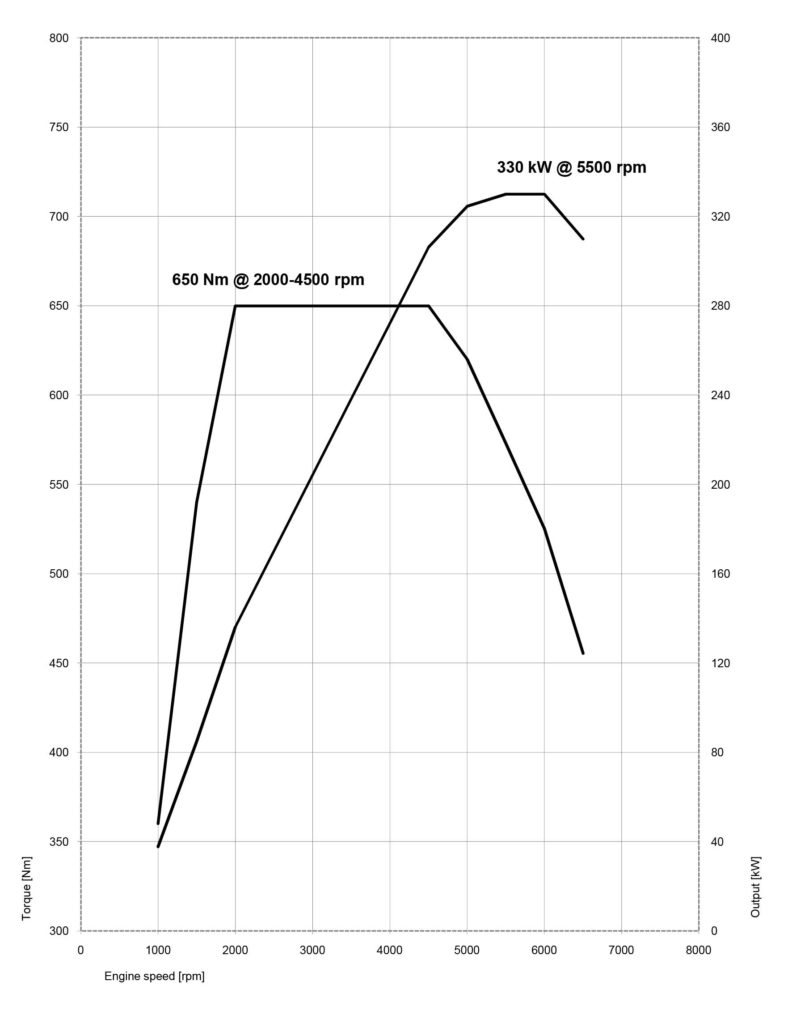

4. Output and torque diagrams.
BMW X5 xDrive50i.
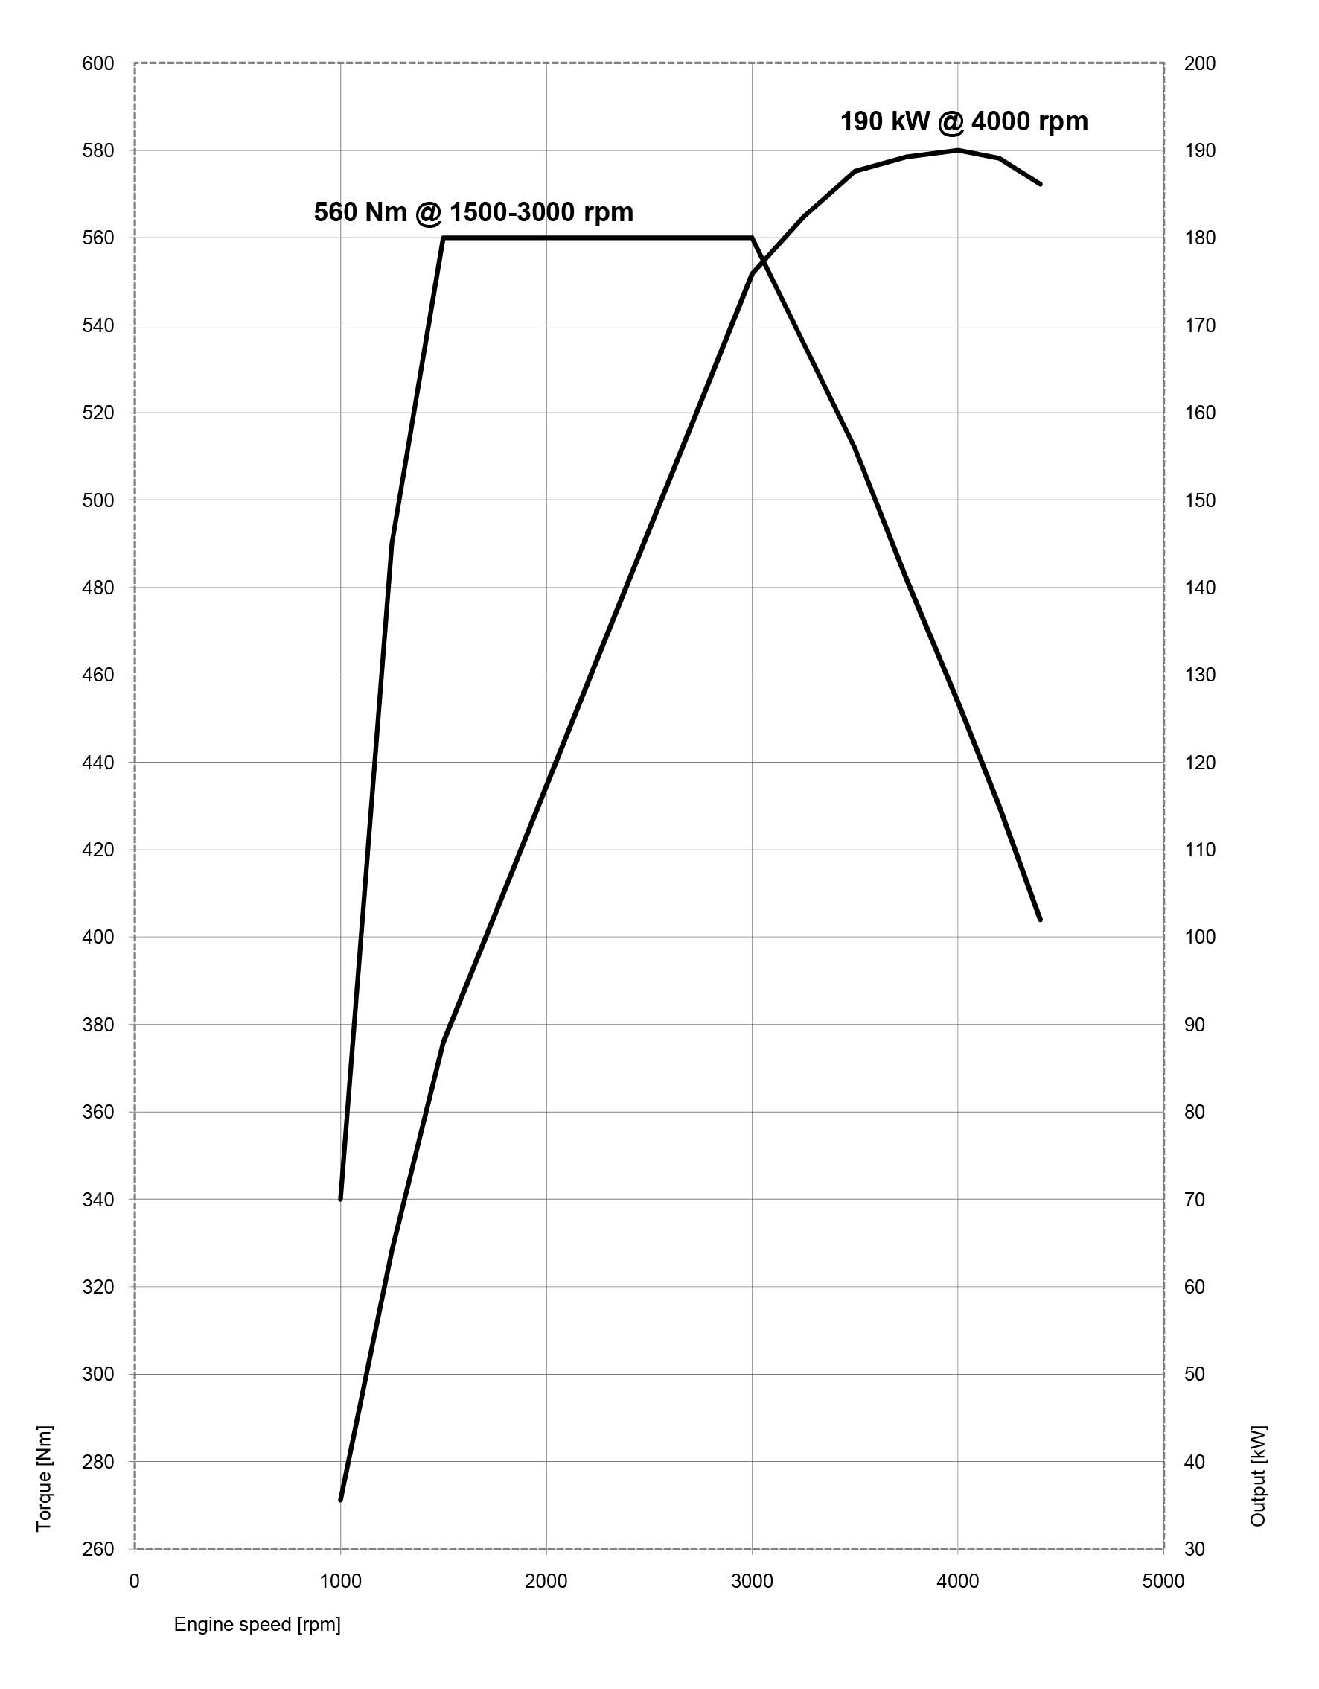
BMW X5 xDrive30d.

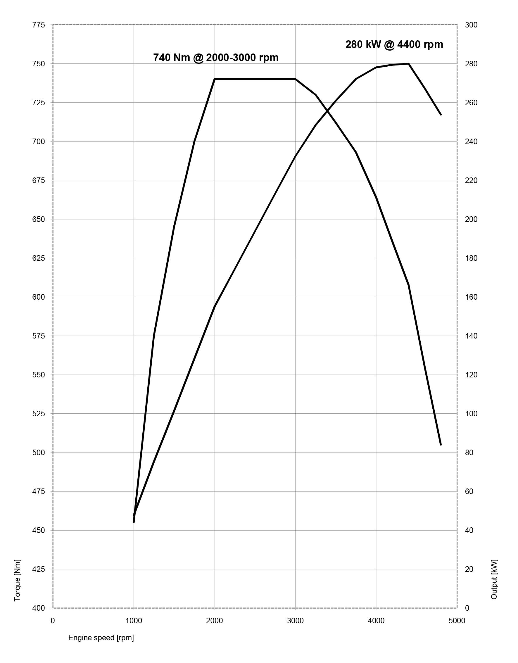
BMW X5 M50d.

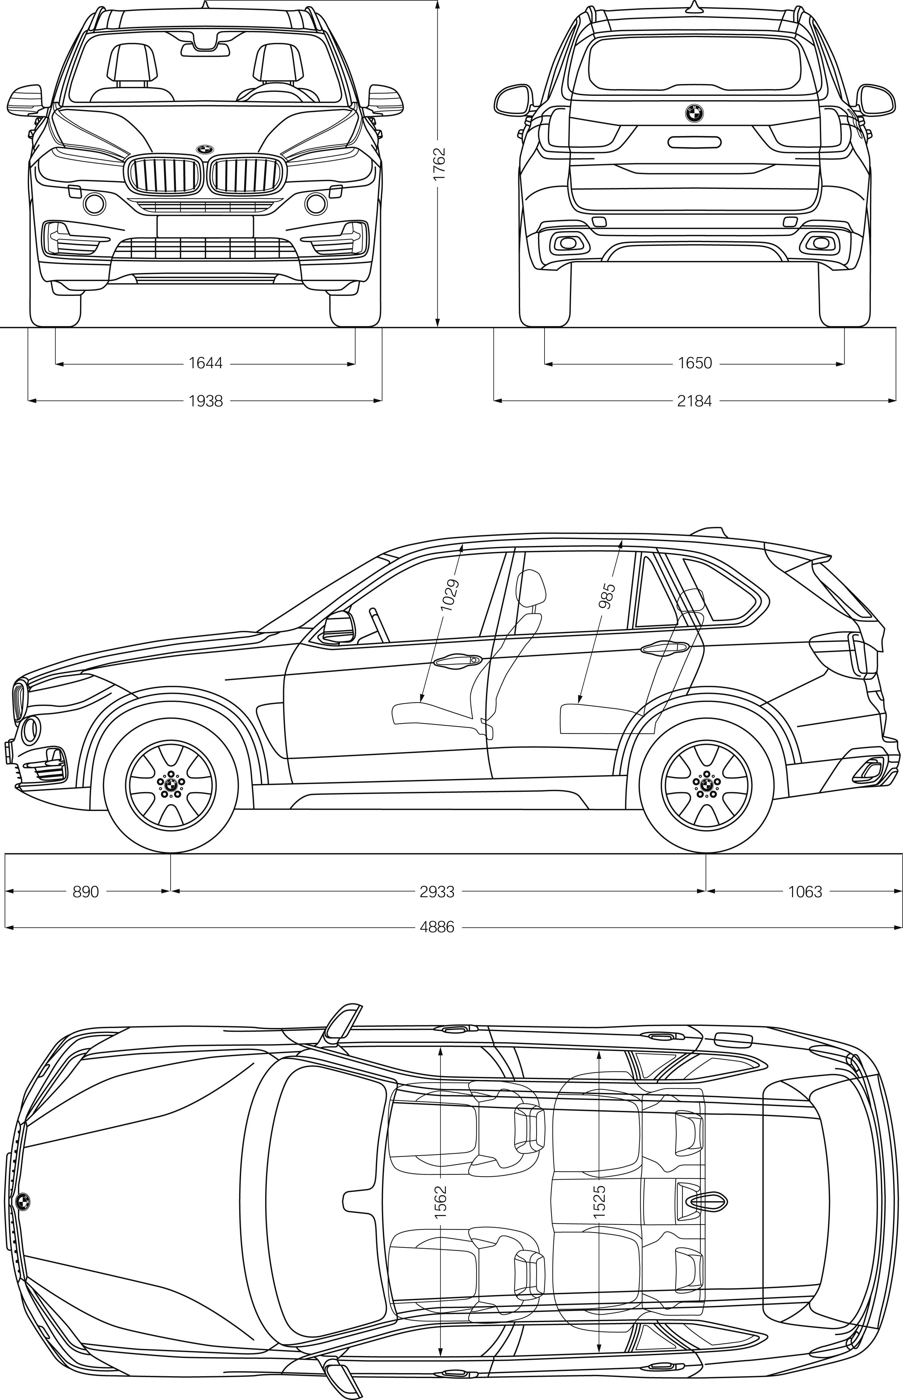
5. Exterior and interior dimensions.
The new BMW X5.

