The new BMW 3 Series Gran Turismo.
Contents.


1. The new BMW 3 Series Gran Turismo.
Highlights. 2

2. Concept:
Aesthetic appeal, space and functionality. 6

3. Design:
Innovative, emotional and practical. 7

4. Powertrain and chassis:
Driving pleasure, dynamic excellence and comfort over long and
short distances. 15

5. BMW EfficientDynamics:
More power, less fuel consumption. 22

6. BMW ConnectedDrive:
Setting the pace for safety, convenience and infotainment. 25

7. Technical specifications. 28

8. Output and torque diagrams. 32

9. Exterior and interior dimensions. 36

1. The new BMW 3 Series Gran Turismo.
(Highlights)

The new BMW 3 Series Gran Turismo adds an innovative new concept to the successful BMW 3 Series line-up. The third body variant in the current model family combines the Sedan’s dynamic, sporting genes with the practicality and versatility of the Touring, qualities which are backed up by a palpable increase in space and driving comfort. The Gran Turismo exudes aesthetic and emotional appeal, boasts a distinctive presence on the road and offers similarly pronounced driving pleasure. All of which allows the new
Gran Turismo to make a compelling case for itself as both an elegant
business carriage and a dynamic, comfortable tourer.
Typical BMW proportions, four doors with frameless windows, a coupe-style, gently downward-sloping roofline and a large, automatically opening and closing tailgate define the distinctive exterior character of the BMW 3 Series Gran Turismo. An active rear spoiler – the first of its type on a BMW – provides visual lightness
and reduces lift at touring speeds. The new BMW 3 Series Gran Turismo is
200 millimetres longer in total than the BMW 3 Series Touring, comes with a
110-millimetre longer wheelbase and stands 81 millimetres taller. However,
the clever use of proportions, surfaces and lines ensures that the
BMW 3 Series Gran Turismo is immediately recognisable as a member
of the new BMW 3 Series range.
Impressive long-distance comfort in a unique ambience.
Generous interior dimensions allow the passengers in every seat of the
BMW 3 Series Gran Turismo to sit back and enjoy an impressive feeling of space and unbeatable freedom of movement. The front and rear passengers all benefit from a seating position raised by 59 millimetres, which provides an outstanding view out and makes entry and exit significantly more comfortable. Plus, the BMW 3 Series Gran Turismo also offers extra headroom. The increase in space will be particularly noticeable in the rear compartment, where a full 70 millimetres of additional legroom over the Sedan and
Touring – giving luxury-car levels of spaciousness – is there to be enjoyed. The cocooning nature of the interior, complemented by its design forms,
colour scheme and materials, creates a lounge-style ambience which allows passengers to enjoy short trips and long journeys alike in relaxed comfort.
Intelligent load area management.
The load area also reflects the car’s increased dimensions, its 520 litres of boot capacity even outstripping that of the BMW 3 Series Touring by 25 litres. The large load aperture and high-opening tailgate make access easier. Practical standard features – such as the 40:20:40 split/folding rear
seat bench with folding head restraints and tilt-adjustable backrests
(cargo function), and the two-piece parcel shelf – underscore the impressive functionality of the BMW 3 Series Gran Turismo. The large load area can
be utilised in many different ways, allowing intelligent space management. Practical features such as lashing points, multifunction hooks and an underfloor storage compartment make it even more convenient to use, while the LED strips that illuminate the cargo area emphasise the premium quality of the 3 Series Gran Turismo.
Quintessential BMW 3 Series:
functional elegance, three equipment lines.
High-end material combinations and fit and finish of the highest quality underline the premium ambience on board the new BMW 3 Series Gran Turismo. The latest addition to the 3 Series family can be ordered in an entry-level version,
with the Sport Line, Luxury Line or Modern Line equipment packages, or with
the optional M Sport package, which will already be available from July 2013 production orders.
Three petrol engines and one diesel engine power the GT off the start line.
Customers can choose from a selection of four powerful, refined and economical engines – covering an output range from 135 kW to
225 kW – from the launch of the new BMW 3 Series Gran Turismo.
All the powerplants use BMW TwinPower Turbo technology. The range-topping six-cylinder petrol engine under the bonnet of the BMW 335i Gran Turismo is joined by the four-cylinder petrol units in the BMW 328i Gran Turismo and BMW 320i Gran Turismo. The two 2.0-litre diesel engines powering the
BMW 320d Gran Turismo round off the line-up at launch.
Power is sent to the rear wheels via a six-speed manual gearbox as
standard, although BMW also offers an eight-speed automatic as an
option for all engine variants. Both gearboxes link up with the fuel-saving
Auto Start-Stop function.
Advanced suspension technology, featuring a large number of light-alloy components, the torque steer-free Electric Power Steering, finely-balanced axle load distribution (50:50) and a torsionally stiff lightweight body ensure outstanding handling attributes and a high degree of agility and precision.
The longer wheelbase (+ 110 mm), greater wheel diameter and baseline specification of the new BMW 3 Series Gran Turismo– which includes
17-inch wheels – result in a car offering excellent directional stability and
long-distance comfort.
BMW EfficientDynamics.
In addition to its enviable practicality and sporting dynamics, the outstanding fuel economy of the new BMW 3 Series Gran Turismo also serves the cause of driving pleasure. The key here is the BMW EfficientDynamics development strategy, whose influence can be seen in virtually every area of the new model. Building on the good work of the ultra-frugal petrol and diesel
engines, the intelligent lightweight construction concept of the
BMW 3 Series Gran Turismo and its optimised aerodynamics (including
Air Curtains, Air Breathers and the active rear spoiler) do their bit to maximise efficiency and dynamics. And other measures, such as the Auto Start-Stop function, Brake Energy Regeneration, Optimum Shift Indicator and on-demand operation of ancillary components join the campaign to ensure
the powerful BMW 3 Series Gran Turismoboasts impressively low fuel consumption and emissions. The economy drive doesn’t stop there, either; the car still has the potential to cut fuel use by as much as another 20 per cent using ECO PRO mode and the new ECO PRO Route function.
BMW ConnectedDrive.
An extensive selection of driver assistance systems and mobility solutions, offered under the BMW ConnectedDrive programme, allows the new
BMW 3 Series Gran Turismo to set the benchmark in its segment in terms of safety, convenience and infotainment. One highlight of the range is the latest-generation full-colour Head-Up Display, which projects key information onto the windscreen in sharp resolution. Included alongside an array of other convenience and safety-enhancing assistance systems is highly effective interface technology that allows extensive use of external mobile phones and numerous Bluetooth office functions for internet-based services.
The Apps option and free BMW Connected application provide access to services such as social networks, web radio and iPhone calendar functions. Last but not least, information and office services, and travel and leisure planners using the Google Maps and Panoramio services, further increase levels of passenger comfort in the new BMW 3 Series Gran Turismo.

2. Concept:
Aesthetic appeal, space and functionality.
The new BMW 3 Series Gran Turismo represents a high-calibre addition to the premium reaches of the mid-size segment. This new concept performs a genuinely unique role within the successful BMW 3 Series range and provides a fresh and distinctive take on aesthetic appeal, space and functionality. The BMW 3 Series Gran Turismo fuses the dynamic sporting attributes of the
3 Series Sedan with the practicality and versatility of the 3 Series Touring,
and backs these qualities up with a palpable increase in space and long-distance comfort. The new addition to the range exudes aesthetic and emotional appeal, boasts a distinctive presence on the road and offers similarly pronounced driving pleasure.
Among the eye-catching features of the new BMW 3 Series Gran Turismo are a powerfully formed front end, an elegantly stretched silhouette with coupe-style roofline, frameless side windows and a flowing rear end with large load aperture. Here, an extended rear spoiler – the first of its type on a BMW – provides visual lightness as well as reducing lift at touring speeds. The clear increase in length over the Sedan and Touring benefits not only the car’s elegant silhouette, but also the amount of space available on board.
Ease of access, a raised seating position offering an outstanding view out to all sides and luxurious expanses of space around every passenger provide
an instant feel-good factor. The Gran Turismo offers more room in the rear compartment in particular. Indeed, passengers in the three full-size rear seats will encounter legroom normally only found in luxury-class cars.
This broad range of qualities – both functional and aesthetic – allows the
new BMW 3 Series Gran Turismo to tick all the right boxes for active and demanding drivers who use their car in a variety of ways but would also value the aesthetic appeal of a coupe. All of which allows the new Gran Turismo to make a compelling case for itself as both an elegant business carriage and a dynamic, comfortable tourer for family trips away and leisure activities.

3. Design:
Innovative, emotional and practical.
“The BMW 3 Series Gran Turismo is a car that exudes the elegance of a coupe, but at the same time offers immense practicality and extra space that can be used in a variety of ways.”
Page Beermann, exterior designer for the new BMW 3 Series Gran Turismo.
The first impression delivered by the new BMW 3 Series Gran Turismo invariably centres on the striking combination of dynamic and aesthetic appeal. Attractive proportions, four doors with frameless windows, the coupe-style, gently falling roofline and large tailgate define the distinctive character it has chiselled for itself within the BMW 3 Series ranks. Powerful lines and taut surfaces sketch out an athletic body which lends the car an actively forward-surging purpose, as well as suggesting a high degree of functionality. Indeed, the new BMW 3 Series Gran Turismo sets new standards inside as well as out. A convincing sense of roominess, a high seating position, generous levels of space and intelligent load area management seal its status as a one-off in the premium mid-size segment.
At 4,824 millimetres long, 1,489 millimetres tall, 1,828 millimetres wide and with a 2,920-millimetre wheelbase, the new BMW 3 Series Gran Turismo is notably larger all round than the Sedan and Touring variants of the
3 Series range. However, the designers’ clever use of proportions, surfaces and lines ensures that the Gran Turismo appears to cut a similarly low-slung and dynamic figure as its siblings. Its dimensions allow it to lay on impressive levels of space for passengers and their luggage, as a result of which it passes the “long-distance comfort” test with flying colours. At 520 litres, its boot capacity is up 25 litres on the BMW 3 Series Touring’s, while an extra
70 millimetres of rear legroom place it between the BMW 5 Series and
BMW 7 Series, i.e. firmly in luxury class territory.
Front view: powerful dynamics.
The eye-catching front end of the new BMW 3 Series Gran Turismo makes no secret of its BMW 3 Series family ties, but also brings its own individual flavour into the mix. The broad, powerful BMW kidney grille and modified front apron underline the car’s sporting character, while striking twin headlights with corona rings (if xenon headlights are specified) and LED accent lights form
a visual unit with the slightly forward-slanting kidneys and reinforce the sense of both width and presence. The silhouette of the headlights is larger than on the Sedan. Large air intakes below the headlights emphasise the sporting character of the car, as do the aerodynamically motivated apertures for the
Air Curtains. The bonnet, meanwhile, has smoother contours than the Sedan and Touring. The most prominent design cue remains the kidney grille,
which draws the visual focus of the front end further towards the road and gives the car a lower-slung and sportier feel. Another identifying feature of the BMW 3 Series Gran Turismoare the “blades” set into the outer air intakes of the front apron.
Side view: elegance with a coupe-style roofline.
The link between the front and rear of the BMW 3 Series Gran Turismo is particularly seamless. Hallmark BMW proportions and a coupe-style roofline sloping down towards the rear stretch the car’s silhouette, while powerfully taut surfaces and rising lines lend the flanks their inherent dynamic verve. The smooth transition of the roofline into the rear creates extra interior space while showcasing the car’s enviable functionality. The BMW 3 Series Gran Turismo is the brand’s first-ever model to sport an active rear spoiler. At lower speeds it retracts virtually out of sight, leaving barely a ripple in the coupe-style roofline. One feature that is most definitely visible from the side are the forward-surging kidney slats, which dart up into the bonnet, underlining the agile character of the Gran Turismo.
The dominant theme of the car’s flanks is the double swage line, made up of two character lines running alongside each other, which is central to the appearance of the latest BMW 3 Series. Viewed in tandem with the pronounced door sill line it strengthens the body’s dynamic wedge shape. The high-set side window graphic, which rises slightly at the Hofmeister kink, lends pleasingly aesthetic emphasis to the clear forward orientation of the exterior design. A new element of the BMW 3 Series Gran Turismo comes in the form of the Air Breathers. Located just rearwards of the front wheels, they are designed to reduce drag around the wheel arches. The Air Breathers team up with the Air Curtains to underline the sporting character of the car’s design and provide tangible evidence of the innovative aerodynamic solutions devised by BMW as part of its BMW EfficientDynamics development strategy.
Rear view: a powerful tail end with compelling functionality.
The rear of the new BMW 3 Series Gran Turismo is highlighted by horizontal surfaces and lines emphasising muscular width and unshakable roadholding. The wraparound section below the spoiler has an extremely flat appearance and visually lowers the stance of the rear. The interplay between light and shadowed surfaces generates a dynamism even when the car is stationary.
The extended rear lights, in customary BMW L-shaped design,
stretch far into the sides of the car, add further presence to the new
BMW 3 Series Gran Turismo’s powerful breadth and make the car appear lower to the road. Two integrated bars of LEDs allow a slim light design
and ensure the BMW 3 Series Gran Turismo’s distinctive appearance is maintained both day and night. The large tailgate, meanwhile, showcases the versatility and functionality of the new BMW 3 Series Gran Turismo. It allows optimum access to the load area and, thanks to its wide, generously sized aperture, makes it easier to load and unload even bulky items.
Interior: surprising spaciousness, generous freedom of movement.
“The focus of the BMW 3 Series Gran Turismo’s interior is clearly on the rear compartment – here we wanted to create a totally new, spacious yet also cocooning ambience.”
Georg Allmendinger, interior designer for the BMW 3 Series Gran Turismo.
The new BMW 3 Series Gran Turismo adds 200 millimetres to the length
of the BMW 3 Series Touring and has a 110-millimetre longer wheelbase. The new model variant also stands 81 millimetres taller. These generous dimensions create a luxurious feeling of space for the passengers and
ensure unbeatable freedom of movement in every seat. The front and rear passengers all benefit from a seating position raised by 59 millimetres, which allows an outstanding view out and makes entry and exit significantly easier. The Gran Turismo also raises headroom another notch.
Space-loving elegance with lounge-style character.
Rear passengers enjoy a particularly impressive increase in space. Indeed,
the Gran Turismo offers a full 70 millimetres of extra legroom in the rear, providing a freedom of movement normally only found in luxury-class cars. Thanks to the car’s longer wheelbase – and a reduced overlap with the rear wheel arches as a result – the full breadth of the rear seat bench can be used without restriction and three adults can be seated in comfort. This supreme feeling of space is complemented by the design forms, colour scheme and materials employed in the interior. The flowing lines of the door panels link the front and rear compartments into a single stylistic unit, while the interplay of the flat roofline and frameless windows with the cocooning character of the interior creates a spacious lounge-style ambience in the rear compartment, and thus the ideal environment for relaxed touring.
Maximum long-distance comfort.
An array of storage compartments and other practical details helps lay on a suitably sumptuous level of long-distance comfort. A pair of cupholders are integrated into the centre console, but can be swapped for an oddments tray if desired. And large door pockets front and rear can accommodate up to one-litre drinks bottles (0.75 l in the rear). The BMW 3 Series Gran Turismo can be adapted precisely to meet changing requirements. To this end, the rear seat backrests are fitted with folding head restraints and can be split 40:20:40 as standard, allowing the load area to be increased in stages from 520 up to 1,600 litres. Folding down only the central segment creates a large through-loading aperture that enables four people to bring several pairs of skis or snowboards on board with them. Folding down all the backrests, meanwhile, creates a slightly rising, almost level and flush-fitting load compartment floor.
Load area: large, practical and versatile.
The perceived value and functionality of the generously sized load area in the new BMW 3 Series Gran Turismo impress in equal measure. The gaping 1,120 x 618-millimetre (width x height) load aperture and high-opening electric tailgate make it easier to load up bulky items. Another extremely practical feature is the cargo function for the rear seat backrests. The tilt angle of the backrests can be adjusted through 15 stages and 19 degrees and even brought into a vertical position if required. This allows the space available in the load compartment to be adapted to changing requirements, a process aided by the smooth panel surfaces of the load area’s side walls. Another example of the new BMW 3 Series Gran Turismo’s practical qualities is the two-piece parcel shelf. The larger segment opens with the tailgate, facilitating access to the load area. The second segment remains on its railing, allowing smaller items to be left in place even when the tailgate is opened. When not in use the sections can be easily removed and stored away neatly under the load compartment floor. The new BMW 3 Series Gran Turismo is fitted as standard with button-controlled electric tailgate activation, but the options list also includes the Smart Opener (part of the Comfort Access option), which allows the boot lid to be opened hands-free with a movement of the foot under the rear bumper.
Four lashing points in the load compartment floor and a multifunction hook in the left-hand side panel are on hand for securing loads, while a multifunction storage tray under the load compartment floor and a deep compartment in the left-hand side panel swallow up all kinds of small items. Also located here is a 12-volt power socket to plug in a cool box or charge electrically-powered devices. The optional storage package, meanwhile, ups the comfort rating another notch when it comes to transporting both people and loads. In addition to an array of interior features, it also comprises handy extras for the load compartment. These include a remote release function for the rear seat backrests, a gas pressure spring for the load compartment floor, a sliding retaining net on the right-hand side panel, an additional strap for holding loads in place and a variable attachment system using two rails integrated into the load compartment floor.
Typical BMW 3 Series: functional elegance in the cockpit as well.
The cockpit of the new BMW 3 Series Gran Turismo fits the same template as the new 3 Series Sedan and new 3 Series Touring. In customary fashion, the driver-focused layout ensures optimum access to all driving functions. Crystal clear circular instruments with a black-panel display and a freestanding iDrive monitor in contemporary flatscreen design underline the sense of functional elegance. The iDrive Controller – within easy reach on the centre console – and the optionally fore-and-aft sliding/folding armrest between the front seats underscore the cabin’s exceptional usability and comfort. Descriptions of additional equipment features, such as the full-colour
Head-Up Display and cutting-edge convenience-enhancing and driver assistance systems, can be found in the “BMW ConnectedDrive” chapter.
Three equipment lines, each with their own individual character.
High-quality material combinations coupled with supreme levels of workmanship reinforce the premium ambience on board the new
BMW 3 Series Gran Turismo. A large number of colour and upholstery variants offer scope for a multitude of combinations. In the entry-level version, for example, three different trim colours can be combined with a choice of one cloth or two leather shades. Customers can also choose from three additional equipment lines and an M Sport package, all of which add individual touches to the car’s looks inside and out. Indeed, even the ignition key shares the colour-coding of the equipment line specified.
Sport Line: The Sport Line adds extra depth to the dynamic repertoire of the BMW 3 Series Gran Turismowith a selection of eye-catching exterior features in high-gloss black. Nine moulded black kidney grille slats in a chrome-coloured surround lend the front end a particularly sporty and alert look, and the forward-slanting angle of the BMW kidneys gains further visual impact. The black air intakes and likewise gleaming black Air Breathers, meanwhile, draw the eye to the car’s aerodynamics features. Optional 18-inch or 19-inch light-alloy wheels – depending on the model – in double-spoke design provide an additional dose of sportiness, while exterior mirrors and a “wraparound” window strip (also available in high-gloss black as an option), B-pillars in matching paint finish and a trim strip at rear apron height add further flourishes. Inside the car, the contrast between black and red accents adds a sporty and exclusive allure that is heightened by the accent strips in the doors (also part of the Luxury and Modern Line as well as the M Sport package). The standard-fitted sports seats can be specified with a choice of three upholstery variants in four different colours.
Luxury Line: Discreet high-gloss chrome touches lend the exterior of the BMW 3 Series Gran Turismoa particularly elegant and exclusive appeal.
11 intricate kidney grille slats with chrome-coloured fronts and matt black sides, two chrome blades in the front apron air intakes and chrome
Air Breathers all furnish classy touches. Within the gleaming chrome window surround the black B-pillar provides a particular highlight, and special
18 and 19-inch light-alloy wheels in a multi-spoke design accentuate the extravagance of the Luxury Line. The Gran Turismo Luxury Line can be identified from the rear by a stylish, high-gloss chrome strip above the rear apron and a chrome exhaust tailpipe embellisher. The interior also stands out with various chrome elements, such as the surround for the audio and air conditioning system. High-gloss wood strips, seats with distinctive stitching and a choice of two upholstery materials in four classically elegant colours highlight the exclusivity of the Luxury Line.
Modern Line: High-quality chrome exterior trim elements define the cool aesthetic of the Modern Line, while the BMW kidney grille with 11 slats,
the Air Breathers and the double trim strips for the air intakes continue the theme. The optional window surround in satinated aluminium draws attention to the window graphic and blends in seamlessly with the trim elements at the front and rear. 18 or 19-inch turbine-style light-alloy wheels lend a fresh angle to the exterior design of the BMW 3 Series Gran Turismo, while the light-coloured dashboard coupled with a steering wheel in dark oyster create a very special ambience in the cockpit. Leather upholstery or cloth-leather combinations in anthracite, oyster or black, and a choice of three trim surfaces with accent strips in pearl-effect chrome, ensure an appealing interplay between materials.
M Sport package: The optional M Sport package gives the new
BMW 3 Series Gran Turismo a shot of adrenaline that spreads beyond its exterior and interior design. As well as the all-new aerodynamic package, including numerous body components (front apron with large air intake, rear bumper with diffuser, side skirts), and the BMW Individual High-gloss Shadow Line trim,
the exclusive optional exterior paint shade Estoril Blue metallic ensures an unmistakably sporty appearance and unbeatable road presence– an effect underpinned by 18 or 19-inch light-alloy wheels in hallmark M design. Inside the car, features such as M door sill finishers, an M leather steering wheel and an
M driver’s footrest shape the sporty yet elegance ambience. The driver and front passenger can settle into Hexagon Anthracite cloth/Alcantara sports seats with royal blue contrast stitching offered exclusively as part of the M Sport package. Technical features of this package include lowered M Sport suspension and the optional M Sport brakes with callipers in contrasting blue paint finish
(see “Powertrain and chassis” chapter).
Exterior colours and wheels: The spectrum of colours available for the
new BMW 3 Series Gran Turismo takes its cues from the BMW 3 Series Sedan and ranges from elegant and classic to modern and expressive. Customers can choose from a total of 12 paint finishes, irrespective of the equipment line specified, including intense colour shades, an array of metallic options and a broad spread of classic tones. The Kalahari Beige metallic, Midnight Blue metallic and Sparkling Brown metallic shades are reserved exclusively for the new BMW 3 Series Gran Turismo. An impressively extensive selection of light-alloy wheels is also available.
4. Powertrain and chassis:
Driving pleasure, dynamic excellence and comfort over long and short distances.
Customers can choose from a selection of four torquey, refined and economical engines from the launch of the new BMW 3 Series Gran Turismo, all of which work with the latest BMW TwinPower Turbo technology
(see “BMW EfficientDynamics” chapter). The range-topping six-cylinder
petrol engine under the bonnet of the BMW 335i Gran Turismo is joined by the state-of-the-art four-cylinder petrol units in the BMW 328i Gran Turismo and BMW 320i Gran Turismo. The two 2.0-litre diesel engine powering the
BMW 320d Gran Turismo rounds off the line-up at launch. The power is sent to the rear wheels via a six-speed manual gearbox as standard, although BMW also offers an eight-speed automatic as an option for all engine variants. Both gearboxes link up with the fuel-saving Auto Start-Stop function.
BMW 335i Gran Turismo: six-cylinder petrol version with muscular power development, imposing torque and outstanding refinement.
Aficionados of large six-cylinder engines are in for a treat with the new
BMW 335i Gran Turismo. The 3.0-litre in-line engine will win the hearts of sporty drivers with its supreme power delivery, ravenous appetite for revs and exceptional refinement. Developing output of 225 kW at 5,800 rpm,
the six-cylinder powerplant helps the Gran Turismo to put forward a compelling dynamic case. Torque of 400 Nm is available as low down the engine speed range as 1,200 rpm and remains on tap up to 5,000 rpm. With such impressive firepower on board, the new BMW 335i Gran Turismo accelerates from 0 to 100 km/h in just 5.7 seconds on the way to an electronically limited top speed of 250 km/h. And yet, despite this eye-catching performance, the six-cylinder is also extremely economical and low-polluting. Its fuel consumption in the EU test cycle stands at 8.1 litres per 100 kilometres and CO₂ emissions come in at 188 grams per kilometre.
BMW 328i Gran Turismo: four-cylinder petrol engine sets the benchmark for dynamics and efficiency.
The power and performance, responsive acceleration, impressive torque,
high rpm ceiling and low weight of this innovative turbocharged engine
makes it the perfect fit for the dynamic overall theme of the new
BMW 3 Series Gran Turismo. At the same time, though, the four-cylinder unit is remarkably economical and low in pollutants. The advanced BMW powerplant produces a maximum 180 kW from its 1,997 cc capacity at 5,000 rpm. The petrol unit drums up peak torque of 350 Nm at just 1,250 rpm and maintains it all the way to 4,800 rpm. The new BMW 328i Gran Turismo sprints from 0 to 100 km/h in a mere 6.1 seconds and posts an electronically governed top speed of 250 km/h while recording average fuel consumption of just 6.7 litres per 100 kilometres in the EU test cycle. CO₂ emissions are also suitably restrained, at 156 grams per kilometre. The pace of technical progress is even more evident if the eight-speed automatic is fitted, with fuel consumption and emissions figures of 6.4 litres per 100 kilometres and 149 g/km.
BMW 320i Gran Turismo: entry-level petrol engine packs a punch.
The BMW 320i Gran Turismo comes with a powerplant based on the same ultra-low-friction 1,997 cc core engine as the BMW 328i, their differing output ratings achieved principally through modifications to the injection and turbocharging technology. In the new BMW 320i Gran Turismo, the four-cylinder petrol unit develops 135 kW at 5,000 rpm and serves up peak torque of 270 Nm at a meagre 1,250 rpm. Fitted with the six-speed manual gearbox, the 320i needs only 7.9 seconds to reach 100 km/h from rest, but has a very understated thirst for petrol. Impressive average fuel economy in the EU test cycle of 6.6 litres per 100 kilometres and CO₂ emissions of 153 grams per kilometre are improved still further when the eight-speed automatic gearbox is specified; then, consumption falls to 6.2 litres per 100 km with CO₂emissions dropping to 145 g/km.
BMW 320d Gran Turismo: strong-pulling diesel is also big on refinement and economy.
The new BMW 320d Gran Turismo is powered by a four-cylinder diesel engine whose enviable power output belies an extremely frugal and low-polluting nature. Maximum output of 135 kW at 4,000 rpm and torque of 380 Nm – available between 1,750 and 2,750 rpm – ensure the new BMW 320d Gran Turismo is a stand-out dynamic performer and fits the profile of a sporty GT even on diesel power. Its performance figures bear this out. The agile diesel asks a mere 8.0 seconds for the sprint from 0 to 100 km/h, and a top speed of 230 km/h is available should the need arise. Average fuel consumption in the EU test cycle of 4.9 litres per 100 kilometres and CO₂ emissions of 129 grams per kilometre already put the new BMW 320d Gran Turismo in low-pollutant territory.

Six-speed manual gearbox as standard.
Easy gear changes, precise shift travel and optimum gear spacing are the stand-out features of the six-speed manual gearboxes in the new
BMW 3 Series Gran Turismo. Their lightweight, compact construction and innovative, low-friction design allow them to make a pivotal contribution to
the driving pleasure available on board. For drivers with sporty ambitions, the interface where the power from the engine is relayed to the drivetrain is key to maximising the car’s dynamic performance.

Eight-speed automatic gearbox available as an option.
With its additional ratios, the slick eight-speed automatic gearbox is able to provide shift comfort, sports performance and efficiency of the highest order – and offer customers in the compact premium segment an option never previously available to them. The automatic fits like a glove into the dynamic overall concept of the new BMW 3 Series Gran Turismo. A raft of technical innovations and the unusually high internal efficiency of the eight-speed automatic ensure that powerful acceleration and sharp mid-range sprints can be enjoyed without any notable increase in fuel consumption. Performance-minded drivers will therefore be in for a treat, especially since they can also choose to change gear manually and so take on a significantly more active role in the driving experience. All in all, then, the potential of the new BMW 3 Series Gran Turismo can be explored in relaxed or seriously focused fashion. With its harmonious gear ratio spacing, the BMW 3 Series Gran Turismo offers refined and powerful acceleration, but can also be driven at a laid-back cruise and with an eye on fuel economy at low engine speeds.
A sports automatic variant of the new eight-speed gearbox is available as
an additional option for the new BMW 3 Series Gran Turismo, offering even sharper shift dynamics and manual gear changes using steering wheel-mounted shift paddles.
Sophisticated suspension technology: hallmark BMW 3 Series handling, impressive directional stability and increased long-distance comfort.
Driving dynamics have always been one of the stand-out qualities of the
BMW 3 Series range. Playing a key role here is carefully honed suspension technology that features a large number of light-alloy components and perfectly complements the winning formula of a longitudinally mounted engine, rear-wheel drive, torque steer-free Electric Power Steering, finely-balanced axle load distribution (50:50) and a torsionally stiff lightweight body. With the new BMW 3 Series Gran Turismo the engineers have succeeded in achieving both outstanding handling properties and a high degree of agility and precision. The overall character of the suspension has been shifted slightly towards directional stability and long-distance comfort. The key factors here are its longer 2,920-millimetre wheelbase (+ 110 mm over the
3 Series Touring) and standard specification, including 17-inch wheels
(Sedan and Touring: 16-inch). All of which points to the new BMW 3 Series Gran Turismo’s focus on enhanced long-distance comfort combined with distinctly sporting dynamics.

Double-joint tie bar front axle with spring struts and anti-roll bar.
The front axle of the new BMW 3 Series Gran Turismo is familiar from the
3 Series Sedan and 3 Series Touring. The wheel suspension combines maximum stiffness with minimum weight, while aluminium torque struts, wishbones and swivel bearings make for a significant reduction in unsprung masses. In addition, the double-joint axle has been set up to optimum effect, thanks to the absence of torque steer. Another beneficiary of this is the
BMW 3 Series Gran Turismo’s electromechanical steering system, which is low in weight and helps reduce fuel consumption.
Five-link rear axle majors on driving dynamics and comfort.
The rear axle of the new BMW 3 Series Gran Turismo makes an important contribution to the new model’s driving dynamics and ride comfort. Its space-saving five-link design features precisely calculated elastokinematics, which makes for long spring travel as well as precise wheel location in all situations. Moreover, the rear axle ensures excellent noise and vibration damping. The upshot is that the new Gran Turismo impresses with time-honoured
BMW 3 Series driving and handling characteristics and goes a noticeable extra yard in terms of directional stability and long-distance touring comfort.
Electromechanical steering enhances agility and comfort.
The new BMW 3 Series Gran Turismo is fitted with the electromechanical power steering system EPS, which only operates when steering assistance is actually required. The system’s attributes include not only high efficiency but also low weight, high steering precision with good feedback, and precise responses.
The signature BMW rear-wheel-drive layout guards against torque steer.
High-performance lightweight braking system.
The new BMW 3 Series Gran Turismo relies for its stopping power on lightweight floating-calliper brakes with large inner-vented discs, and the
front brake callipers are made from aluminium. As well as the low unsprung masses, this high-performance system also makes its mark with outstanding heat tolerance, superior wet braking performance, easy operation and excellent feel. A brake pad wear indicator and a brake drying function are standard on all models. The driver enjoys the safety net of various state-of-the-art electronic aids integrated into the Dynamic Stability Control (DSC) system. This incorporates the following functions: the Anti-lock Braking System (ABS), Automatic Stability Control (ASC), Dynamic Traction Control (DTC),
Dynamic Brake Control (DBC) and Cornering Brake Control (CBC), along
with the Start-Off Assistant and an electronic limited slip function for the rear differential, which can be activated using the “DSC Off” button.
Wheels and tyres.
Even the entry-level version of the new BMW 3 Series Gran Turismo is fitted ex-factory with high-quality light-alloy wheels and 225/55 R17 tyres. Run-flat safety tyres– which, depending on driving style and load, allow the car to be driven a further 80 kilometres or more, even with a complete loss of tyre pressure – come as standard, as does the Tyre Puncture Warning System (TPWS). This provides not only added convenience and safety benefits; dispensing with a spare tyre and jack also saves weight and
creates additional storage space in the boot.
Dynamic options: M Sport suspension, adaptive suspension,
M Sport brake and variable sports steering.
The 10-millimetre-lower M Sport suspension included as part of the
M Sport package can also be specified separately. It works with a firmer spring/damper set-up and stiffer anti-roll bars, and brings with it 18 or 19-inch M light-alloy wheels. Alternatively, customers may like to specify lowered adaptive suspension with electronically controlled dampers, which adjusts the damper mapping to the road surface and driving situation. The driver can also use the Driving Experience Control switch to vary the basic suspension tuning between more comfortable or sportier settings according to individual preference.
For performance-minded customers, BMW offers the M Sport brake. Aluminium four-piston fixed callipers at the front and two-piston fixed callipers at the rear, along with generously sized brake discs, combine extremely low weight with very short stopping distances.
Variable Sports Steering with Servotronic is available as an option, providing different steering gear ratios depending on the angle of the steering wheel. It means that less steering effort is required for parking and turning manoeuvres. Also, handling is sharpened, for example when instantaneous evasive action is required.
Driving Experience Control switch with ECO PRO mode:
extra-sporty, more relaxed or more frugal driving modes –
at the touch of a button.
The new BMW 3 Series Gran Turismo also offers drivers the ability to vary
the overall character of the vehicle to suit the driving situation or their personal preferences. As well as sportier or more comfortable drive settings, they can also opt for extra fuel efficiency. The different modes are selected via the Driving Experience Control switch with ECO PRO mode, which is standard
on all models. Using a button on the centre console, the driver can choose between ECO PRO, COMFORT, SPORT and SPORT+ modes. Each of these predefined set-ups activates different settings for the relevant powertrain and suspension components. A further button allows the driver to change the DSC settings or switch them off altogether. More information on ECO PRO mode can be found in the “BMW EfficientDynamics” chapter.
5. BMW EfficientDynamics:
More power, less fuel consumption.
Alongside its high functionality and sporty dynamics, outstanding fuel economy is another contributing factor in the driving pleasure afforded
by the new BMW 3 Series Gran Turismo. This is down to the
BMW EfficientDynamics development strategy, the results of which are incorporated in virtually every area of the new model. In addition to petrol and diesel engines with optimised fuel economy, its highly efficient transmissions, intelligent lightweight design, optimised aerodynamics and further efficiency-promoting measures ensure the new BMW 3 Series Gran Turismo is a winner not only in terms of its impressive performance, but also its enviable fuel consumption and emissions figures.
State-of-the-art petrol and diesel engines in the new
BMW 3 Series Gran Turismo forge a perfect alliance of
dynamics and efficiency.
The petrol engines available from launch stand out with their exceptional power, free-revving character and refinement combined with peerless efficiency. To this end, the engines can point to a raft of innovative technical solutions, brought together into a complete package of technology. They include BMW TwinPower Turbo technology with twin-scroll turbocharging, High Precision Direct Injection, Double-Vanos variable camshaft control and Valvetronic fully variable valve control. In addition, these low-friction engines feature a lightweight all-aluminium crankcase.
The BMW TwinPower Turbo diesel units also represent the very latest in
BMW engine technology. The current line-up of diesels features latest-generation common-rail direct injection, turbocharging and an all-aluminium construction to deliver high torque, smooth running and unsurpassed efficiency. A centrifugal pendulum in the dual-mass flywheel reduces irregular running for greater comfort at low engine speeds.
Optimised power transfer for added fuel savings: six-speed manual and eight-speed automatic.
Whether the choice is for a state-of-the-art six-speed manual gearbox or
an eight-speed automatic, both transmissions boast optimised efficiency, compact design and reduced weight. Manual models also come equipped with an Optimum Shift Indicator, which monitors the driving situation and advises the driver of the ideal moment to change gear. The eight-speed automatic with innovative gearing design offers a large overall ratio spread. Plus, the minimised torque converter slip, high internal efficiency, low friction losses and intelligent transmission management ensure substantial potential for fuel savings.
ECO PRO mode programs the automatic transmission to bring forward
upshifts and delay downshifts.
Auto Start-Stop function, Brake Energy Regeneration,
ECO PRO Route.
The new BMW 3 Series Gran Turismo comes as standard with the Auto Start-Stop function, which can also team up with the new eight-speed automatic gearbox. Another standard feature is Brake Energy Regeneration, which ensures that – as far as possible – power for the vehicle’s electrical system is generated during braking and overrun. ECO PRO mode plays a particularly effective role in helping the BMW 3 Series Gran Turismo driver to maintain an efficient and economical driving style. As well as tweaking the accelerator’s responses and engine management system, ECO PRO mode also reaps the rewards of intelligent energy and climate management. The system gives the driver tips and ideas – tailored to the driving situation at hand – on how to reduce fuel consumption even further through adjustments to his or her responses at the wheel. The ECO PRO Route function joins forces with the new Professional navigation system to monitor the driver’s personal driving style, the traffic situation and the profile of the road ahead in order to propose the most fuel-saving route. Average fuel consumption can be cut by up to
20 per cent in ECO PRO mode, with a corresponding boost to the car’s range on a tank of fuel.
On-demand operation of ancillary components saves energy.
The new BMW 3 Series Gran Turismo’s ancillary components also play a role in the car’s intelligent energy management. Examples include the on-demand coolant pump, the map-controlled oil pump and the electromechanical steering system, which only consumes electric power when steering assistance is actually required. The special air conditioning compressor works on the same principle. As soon as the driver switches the air conditioning off, the belt drive to the compressor is disconnected to minimise power drain.
Intelligent lightweight design further reduces fuel consumption and CO₂ emissions.
The use of lightweight materials makes a significant contribution to efficiency and agility, and helps to give BMW cars their impressive dynamic capability. Indeed, intelligent lightweight design can be found in every area of the development process and its reach extends to every component. As well
as the use of plastics and cutting-edge composite materials, the increased deployment of aluminium components in the engine and chassis construction has also reduced the weight of the relevant assemblies. The results are impressive. Although the new BMW 3 Series Gran Turismo has grown in terms of dimensions and space, it is barely any heavier than the 3 Series Sedan and Touring.
Aerodynamic fine-tuning in the wind tunnel.
Evidence of the new BMW 3 Series Gran Turismo’s aerodynamic fine-tuning in a state-of-the-art wind tunnel comes courtesy of a drag coefficient (Cd) of up to 0.28. The lower air resistance not only contributes to a drop in fuel consumption, it also has benefits in terms of noise reduction. The design of the car’s underside is a major factor in minimising lift forces. The new
BMW 3 Series Gran Turismo has an aerodynamically optimised underbody with extended smooth-surfaced panels at the sides, under the engine compartment shield and at the front part of the exhaust tunnel, resulting in unprecedented standards of sealing.
Air Curtains and Air Breathers.
The now familiar Air Curtains in the front apron of many BMW cars are designed to reduce turbulence – and therefore drag – around the front wheels. The aerodynamically designed wheel arches, and the air deflectors
in front of them, likewise help to whittle down fuel consumption. A totally new feature on the BMW 3 Series Gran Turismo, however, are the Air Breathers – air ducts rearwards of the front wheel arches, which reach back as far as the outlet apertures in the side of the body and double up as a new visible design element. The Air Breathers divert part of the airflow into the wheel arches, thereby reducing air resistance. They work particularly effectively in combination with the Air Curtains.
BMW premiere: active rear spoiler reduces lift.
The BMW 3 Series Gran Turismo is the brand’s first car to be fitted with an active rear spoiler, which extends automatically once the car reaches
110 km/h to ensure it retains the traditional BMW dynamic capability at higher speeds. Once extended, the spoiler reduces lift on the rear axle by more than 60 per cent, allowing the Gran Turismo to replicate the aerodynamic qualities of the BMW 3 Series Sedan. If the car’s speed slows below 70 km/h, the spoiler automatically retracts, melting back into the car’s trailing edge almost invisibly. If required, the rear spoiler can be extended and retracted manually using a button in the driver’s door control panel.
6. BMW ConnectedDrive:
Setting the pace for safety,
convenience and infotainment.
For many years now, BMW ConnectedDrive has been synonymous with innovation and forward-looking concepts in the field of automotive connectivity. The plethora of standard and optional driver assistance systems and mobility services on offer ensures that the new BMW 3 Series Gran Turismo continues the tradition of setting the pace for safety, convenience and infotainment. To make sure that the various functions available perform their task to optimum effect, BMW ConnectedDrive manages the information exchange between passengers, vehicle and the outside world in a particularly intelligent and targeted way.
High-res projection in colour: Head-Up Display.
Highlights in the new BMW 3 Series Gran Turismo include the latest-generation full-colour Head-Up Display, which projects key information onto the windscreen in sharp resolution to appear directly in the driver’s field of view. Depending on the vehicle specification, not only is the current speed displayed, but speed limits and overtaking restrictions are also flashed up for the driver’s benefit, along with navigation instructions and various warning messages.
Using sensors and camera:
Lane Change and Lane Departure Warning systems.
Among the convenience and safety-enhancing assistance systems on
offer are Lane Change Warning and Lane Departure Warning including
Collision Warning with braking function. These systems employ radar
sensors and camera monitoring to alert drivers to potential collision risks when changing lanes or if they veer out of the lane unintentionally, and also issues a warning when driving too close to the vehicle ahead.
Preventative occupant protection: Active Protection.
The Active Protection safety package with extended protection measures and the AdvancedeCall function helps passengers to mitigate the consequences of an accident, should the worst come to the worst. Active Protection is activated shortly after the journey begins, ready to pull the driver and front passenger belts tight and close the side windows and sunroof if the car enters a critical pre-crash scenario. If the system detects an impending collision and senses that a crash is unavoidable, the car will be braked automatically.
Intelligent use of advanced light technology:
anti-dazzle High-Beam Assistant and Adaptive Headlights.
Safety when driving in the dark is given a further boost by the optional
High-Beam Assistant, which automatically switches the high beam on and off as the situation requires. If the optional bi-xenon headlights are specified, the new BMW 3 Series Gran Turismo can also be ordered with Adaptive Headlights featuring cornering lights, variable headlight distribution and adaptive headlight range control for city and motorway driving. This equipment package also includes the anti-dazzle High-Beam Assistant, allowing the high beam to be left switched on even when there is oncoming traffic.
Superb overview not just when parking: Surround View, Side View, Top View and BMW Parking Assistant.
In addition to the rear view camera and Park Distance Control, customers are also able to opt for the Surround View function with Side View and Top View, which provides a bird’s-eye view of the BMW 3 Series Gran Turismo and the area around it, enabling the driver to carry out precise manoeuvres in tight spaces. If the car is moving at under 20 km/h, the Side View function can additionally be activated to allow the driver to keep an eye on cross traffic. Convenience is further enhanced by the BMW Parking Assistant system, which is able to manoeuvre the car into parking spaces parallel to the direction of travel. All the driver has to do is operate the accelerator and brake pedal while the BMW Parking Assistant takes care of the steering.
A system of many talents: Active Cruise Control with
Stop & Go function.
ACC Active Cruise Control with Stop & Go function and Speed Limit Info including No Passing Info display further adds to the functionality of the convenience and safety options. Not only does ACC Stop & Go make it possible to cruise along motorways and country roads with the greatest of ease while maintaining the desired distance to vehicles ahead, it also regulates the speed in heavy traffic, even braking to a stop if necessary before pulling away again automatically. This has the effect of making life easier for the driver in slow-moving traffic and congestion as well.
In combination with the Professional or Business navigation system,
Speed Limit Info helps to keep the driver informed of the speed limit for the current stretch of road. A camera is used to ensure that additional signs or temporary restrictions – at roadworks, for example – are taken into account. Information on speed limits or overtaking restrictions then appears in the instrument cluster or Head-Up Display. If the Professional navigation system is fitted, drivers can have the most fuel-efficient route recommended to them by selecting ECO PRO Route.
Pure infotainment: further services from BMW ConnectedDrive.
High-performance interface technology provides top-of-the-range infotainment capability that enables the driver and passengers to make extensive use of external mobile phones and music players. Users are furthermore able to access selected products from BMW Live and
BMW Online. New Bluetooth office functions allow internet-based services,
as well as calendar entries and text-based messages, to be viewed in the
Control Display of the iDrive operating system and read out via the Text to Speech function. In addition, passengers can access their personal music library on their smartphone or music player. The BMW Connected app allows in-car use of web radio and social networks such as Facebook and Twitter, while the My BMW Remote app can be used to lock and unlock the vehicle or operate the auxiliary heating remotely. Finally, information and office services, along with travel and leisure planners using the Google Maps and Panoramio services, further increase levels of individual convenience aboard the new BMW 3 Series Gran Turismo.
7. Technical specifications.
The new BMW 3 Series Gran Turismo.
320d.
BMW 320d
Gran Turismo
Body
Noofdoors/seats |  |  |  | 4 / 5
Length/width/height (unladen) | mm |  |  | 4824 / 1828 / 1508
Wheelbase | mm |  |  | 2920
Track, front/rear | mm |  |  | 1541 / 1586
Groundclearance | mm |  |  | 165
Turningcircle | m |  |  | 11,8
Fuel Tank capacity | appltr |  |  | 57
Coolingsysteminclheater | ltr |  |  | 7,0
Engine oil¹⁾ | ltr |  |  | 5,2
Weight, unladen, to DIN/EU | kg |  |  | 1565 / 1640 (1575/1650)
Max loadto DIN | kg |  |  | 570
Max permissible | kg |  |  | 2135 (2145)
Max axle load, front/rear | kg |  |  | 950 / 1245
Max trailer load (12%),  braked/unbraked | kg |  |  | 1600 / 745
Max roofload/max towbardownl | kg |  |  | 75 / 75
Luggagecompcapacity | ltr |  |  | 520 / 1600
Air drag | Cd x A |  |  | 0,28 x 2,31
Power Unit
Config/No of cyls/valves |  |  |  | In-line / 4 / 4
Engine technology |  |  | BMW TwinPower Turbo technology with variable-geometry turbocharger, Common Rail direct injection with piezo injectors (max. injection pressure: 1800 bar)
Capacity, effective | cc |  |  | 1995
Stroke / bore | mm |  |  | 90,0 / 84,0
Compression ratio | :1 |  |  | 16,5
Fuel |  |  |  | Diesel
Max output | kW/hp |  |  | 135 / 184
at | rpm |  |  | 4000
Max torque | Nm/lb-ft |  |  | 380
at | rpm |  |  | 1750 – 2750
Electrical System
Battery / installation | Ah/– |  |  | 90 / Luggagecompartment
Alternator | A/W |  |  | 175 / 2450
Driving Dynamics andSafety
Suspension, front |  | Aluminium double-joint spring strut axle with displaced camber, small positive steering roll radius, transverse force compensation, anti-dive
Suspension, rear |  | Five-link axle in lightweight construction
Brakes, front |  | Single-piston floating-calliper disc brakes / vented
Brakes, rear |  | Single-piston fixed-calliper disc brakes / vented
Drivingstabilitysystems |  | Standard: DSC incl. ABS and DTC (Dynamic Traction Control), CBC (Cornering Brake Control), DBC (Dynamic Brake Control), Dry Braking function, Fading Compensation, Start-Off Assistant
Safetyequipment |  | Standard: airbags for driver and front passenger, side airbags for driver and front passenger, head airbags for front and rear seats, three-point inertia-reel seatbelts on all seats with belt latch tensioner and belt force limiter at the front, crash-activated head restraints at the front, crash sensors, Tyre Defect Indicator
Steering |  | Electric Power Steering (EPS),  optional: Servotronic Function, Variable Sport Steering).
Steering transmission, overall | :1 |  |  | 15,3
Tyres, front/rear |  |  |  | 225/55 R17 97V
Rims, front/rear |  |  |  | 8,0J x 17 Light Alloy

BMW 320d
Gran Turismo
BMW ConnectedDrive
Comfort |  | Optional: BMW Assist incl. Enquiry Service, remote-controlfunctions and  V-Info+ (Traffic Info plus), mobile device integration
Infotainment |  | Optional: internet access, BMW Online incl. Park Info, National Info, Google Local Search, News, Office functions, Bluetooth Audio Streaming and Online Update Music Tracks, Apps
Safety |  | Optional: Adaptive Headlights with turning lights, variable light distribution and adaptive headlight range adjustment, high beam assistance, park distance control, rear view camera, Surround View incl. Side View and Top View, BMW Head-Up Display, cruise control with brake function, Parking Assistant, Lane Chance Warning, Lane Departure Warning with Collision Warning, speed limit and no passing information, Active Protection
Transmission
Type oftransmission |  | Six-speed manual (optional: eight-speed-automatic)
Gearratios I | :1 |  |  |  | 4,110 (4,171)
II | :1 |  |  |  | 2,315 (3,143)
III | :1 |  |  |  | 1,542 (2,106)
IV | :1 |  |  |  | 1,179 (1,667)
V | :1 |  |  |  | 1,000 (1,285)
VI | :1 |  |  |  | 0,846 (1,000)
VII | :1 |  |  |  | ------ (0,839)
VIII | :1 |  |  |  | ------ (0,667)
Reverse | :1 |  |  |  | 3,727 (3,295)
Final drive | :1 |  |  |  | 3,231 (3,077)
Performance
Power-to-weight ratio | kg/kW |  |  |  | 7,3 (7,3)
Output per litre | kW/l |  |  |  | 75,5
Acceleration 0–100 km/h | sec |  |  |  | 5,7 (5,4)
Standing-start km | sec |  |  |  | 24,7 (24,8)
In 4th/5th gear 80–120 km/h | sec |  |  |  | 5,8 / 6,5 (-)
Top speed | km/h |  |  |  | 250 (250)
BMW EfficientDynamics
BMW EfficientDynamicsstandardfeatures |  | Brake Energy Regeneration, electromechanical power steering, Automatic Start/Stop function, Gear Shift Indicator (Manual Transmission), ECO PRO mode, intelligent lightweight construction, on-demand operation of ancillary units, map-regulated oil pump, detachable a/c compressor (BMW 318d Manual Transmission), differential with optimized-warm-up behaviour, tyres with reduced rolling resistance
Fuel Consumption
in EU Cycle
Standard Wheels
Urban | ltr/100 km |  |  |  | 5,8 (5,9)
Extra-urban | ltr/100 km |  |  |  | 4,4 (4,4)
Combined | ltr/100 km |  |  |  | 4,9 (4,9)
CO₂ | g/km |  |  |  | 129 (129)
Emission rating |  |  |  | EU6
Specifications apply to ACEA markets/data relevant to homologation apply in part only to Germany (weight)
Figures in brackets apply to models with automatic transmission
¹⁾Oil change

The new BMW 3 Series Gran Turismo.
320i, 328i, 335i.
 |  |  | BMW 320i  Gran Turismo |  | BMW 328i  Gran Turismo |  |  |  | BMW 335i  Gran Turismo
Body
Noofdoors/seats |  |  | 4 / 5 |  | 4 / 5 |  |  |  | 4 / 5
Length/width/height (unladen) | mm |  | 4824 / 1828 / 1508 |  | 4824 / 1828 / 1508 |  |  |  | 4824 / 1828 / 1508
Wheelbase | mm |  | 2920 |  | 2920 |  |  |  | 2920
Track, front/rear | mm |  | 1541 / 1586 |  | 1541 / 1586 |  |  |  | 1541 / 1586
Groundclearance | mm |  | 165 |  | 165 |  |  |  | 165
Turningcircle | m |  | 11,8 |  | 11,8 |  |  |  | 11,8
Fuel Tank capacity | appltr |  | 60 |  | 60 |  |  |  | 60
Coolingsysteminclheater | ltr |  | 7,1 (7,7) |  | 7,2 (7,5) |  |  |  | 6,9 (7,1)
Engine oil¹⁾ | ltr |  | 5,75 |  | 5,75 |  |  |  | 6,5
Weight, unladen, to DIN/EU | kg |  | 1540 / 1615 (1560/1635) |  | 1570 / 1645 (1595/1670) |  |  |  | 1640 / 1715 (1650/1725)
Max loadto DIN | kg |  | 570 |  | 570 |  |  |  | 570
Max permissible | kg |  | 2110 (2130) |  | 2140 (2165) |  |  |  | 2210 (2220)
Max axle load, front/rear | kg |  | 935 / 1240 |  | 950 / 1260 |  |  |  | 1000 / 1265
Max trailer load (12%),  braked/unbraked | kg |  | 1400 (1500) / 695 |  | 1600 / 745 |  |  |  | 1700 / 750
Max roofload/max towbardownl | kg |  | 75 / 75 |  | 75 / 75 |  |  |  | 75 / 75
Luggagecompcapacity | ltr |  | 520 / 1600 |  | 520 / 1600 |  |  |  | 520 / 1600
Air drag | Cd x A |  | 0,29 x 2,31 |  | 0,29 x 2,31 |  |  |  | 0,30 x 2,31
Power Unit
Config/No of cyls/valves |  |  | In-line/ 4 / 4 |  | In-line / 4 / 4 |  |  |  | In-line / 6 / 4
Engine technology |  |  |  |  | BMW TwinPower Turbo technology with twin-scroll turbocharging, High Precision Direct Petrol Injection  and fully variable valve control (VALVETRONIC)
Capacity, effective | cc |  | 1997 |  | 1997 |  |  |  | 2979
Stroke / bore | mm |  | 90,1 / 84,0 |  | 90,1 / 84,0 |  |  |  | 89,6 / 84,0
Compression ratio | :1 |  | 11,0 |  | 10,0 |  |  |  | 10,2
Fuel |  |  | min. ROZ91 |  | min. ROZ 91 |  |  |  | min. ROZ 91
Max output | kW/hp |  | 135 / 184 |  | 180 / 245 |  |  |  | 225 / 306
at | rpm |  | 5000-6250 |  | 5000 |  |  |  | 5800
Max torque | Nm/lb-ft |  | 270 |  | 350 |  |  |  | 400
at | rpm |  | 1250 – 4500 |  | 1250-4800 |  |  |  | 1200-5000
Electrical System
Battery / installation | Ah/– |  | 90 / Luggagecompartment |  | 90 / Luggagecompartment |  |  |  | 90 / Luggagecompartment
Alternator | A/W |  | 170 / 2380 |  | 170 /2380 |  |  |  | 170 / 2380
Driving Dynamics andSafety
Suspension, front |  |  | Aluminium double-joint spring strut axle with displaced camber, small positive steering roll radius, transverse force compensation, anti-dive
Suspension, rear |  |  | Five-link axle in lightweight construction
Brakes, front |  |  | Single-piston floating-calliper disc brakes / vented
Brakes, rear |  |  | Single-piston fixed-calliper disc brakes / vented
Drivingstabilitysystems |  |  | Standard: DSC incl. ABS and DTC (Dynamic Traction Control), CBC (Cornering Brake Control), DBC (Dynamic Brake Control), Dry Braking function, Fading Compensation, Start-Off Assistant
Safetyequipment |  |  | Standard: airbags for driver and front passenger, side airbags for driver and front passenger, head airbags for front and rear seats, three-point inertia-reel seatbelts on all seats with belt latch tensioner and belt force limiter at the front, crash-activated head restraints at the front, crash sensors, Tyre Defect Indicator
Steering |  |  | Electric Power Steering (EPS),  optional: Servotronic Function, Variable Sport Steering).
Steeringtransmission, overall | :1 |  | 15,3 |  | 15,3 |  |  |  | 15,3
Tyres, front/rear |  |  | 225/55 R17 97V |  | 225/55 R17 97W |  |  |  | 225/55 R17 97W
Rims, front/rear |  |  | 8,0J x 17 Light Alloy |  | 8,0J x 17 Light Alloy |  |  |  | 8,0J x 17 Light Alloy
 |  |  |  | BMW 320i  Gran Turismo |  | BMW 328i  Gran Turismo | BMW 335i  Gran Turismo
BMW ConnectedDrive
Comfort |  |  |  | Optional: BMW Assist incl. Enquiry Service, remote-controlfunctionsand  V-Info+ (Traffic Info plus), mobile deviceintegration
Infotainment |  |  |  | Optional: internet access, BMW Online incl. Park Info, National Info, Google Local Search, News, Office functions, Bluetooth Audio Streaming and Online Update Music Tracks, Apps
Safety |  |  |  | Optional: Adaptive Headlights with turning lights, variable light distribution and adaptive headlight range adjustment, high beam assistance, park distance control, rear view camera, Surround View incl. Side View and Top View, BMW Head-Up Display, cruise control with brake function, Parking Assistant, Lane Chance Warning, Lane Departure Warning with Collision Warning, speed limit and no passing information, Active Protection
Transmission
Type oftransmission |  |  |  | Six-speed manual (optional: eight-speed-automatic)
Gearratios I |  | :1 |  | 4,323 (4,714) |  | 3,683 (4,174) |  | 4,110 (4,171)
II |  | :1 |  | 2,459 (3,143) |  | 2,062 (3,143) |  | 2,315 (3,143)
III |  | :1 |  | 1,659 (2,106) |  | 1,313 (2,106) |  | 1,542 (2,106)
IV |  | :1 |  | 1,230 (1,667) |  | 1,000 (1,667) |  | 1,179 (1,667)
V |  | :1 |  | 1,000 (1,285) |  | 0,809 (1,285) |  | 1,000 (1,285)
VI |  | :1 |  | 0,849 (1,000) |  | 0,677 (1,000) |  | 0,846 (1,000)
VII |  | :1 |  | – (0,839) |  | ------ (0,839) |  | ------ (0,839)
VIII |  | :1 |  | – (0,667) |  | ------ (0,667) |  | ------ (0,667)
Reverse |  | :1 |  | 3,938 (3,295) |  | 3,348 (3,295) |  | 3,727 (3,295)
Final drive |  | :1 |  | 3,231 (3,154) |  | 3,909 (3,154) |  | 3,231 (3,077)
Performance
Power-to-weight ratio |  | kg/kW |  | 11,4 (11,6) |  | 8,7 (8,9) |  | 7,3 (7,3)
Output per litre |  | kW/l |  | 67,6 |  | 90,1 |  | 75,5
Acceleration 0–100 km/h |  | sec |  | 7,9 (7,9) |  | 6,1 (6,1) |  | 5,7 (5,4)
Standing-start km |  | sec |  | 28,4 (28,7) |  | 25,9 (25,9) |  | 24,7 (24,8)
In 4th/5th gear 80–120 km/h |  | sec |  | 8,1 / 9,8 (-) |  | 6,0 / 7,7 (-) |  | 5,8 / 6,5 (-)
Top speed |  | km/h |  | 230 (229) |  | 250 (250) |  | 250 (250)
BMW EfficientDynamics
BMW EfficientDynamicsstandardfeatures |  |  |  | Brake Energy Regeneration, electromechanical power steering, Automatic Start/Stop function, Gear shift indicator (Manual Transmission) ECO PRO mode, intelligent lightweight construction, on-demand operation of ancillary units, map-regulated oil pump, detachable a/c compressor (BMW 320i Automatic Transmission), differential with optimized-warm-up behaviour, tyres with reduced rolling resistance
Fuel Consumption
in EU Cycle
Standard Wheels:
Urban |  | ltr/100 km |  | 8,7 (8,2) |  | 8,8 (8,3) |  | 11,3 (10,8)
Extra-urban |  | ltr/100 km |  | 5,3 (5,1) |  | 5,5 (5,3) |  | 6,2 (5,8)
Combined |  | ltr/100 km |  | 6,6 (6,2) |  | 6,7 (6,4) |  | 8,1 (7,7)
CO₂ |  | g/km |  | 153 (145) |  | 156 (149) |  | 188 (178)
Emission rating |  |  |  | EU6 |  | EU6 | EU5
Specifications apply to ACEA markets/data relevant to homologation apply in part only to Germany (weight)
Figures in brackets apply to models with automatic transmission
¹⁾Oil change

8. Output and torque diagrams.
The new BMW 3 Series Gran Turismo.
320d.
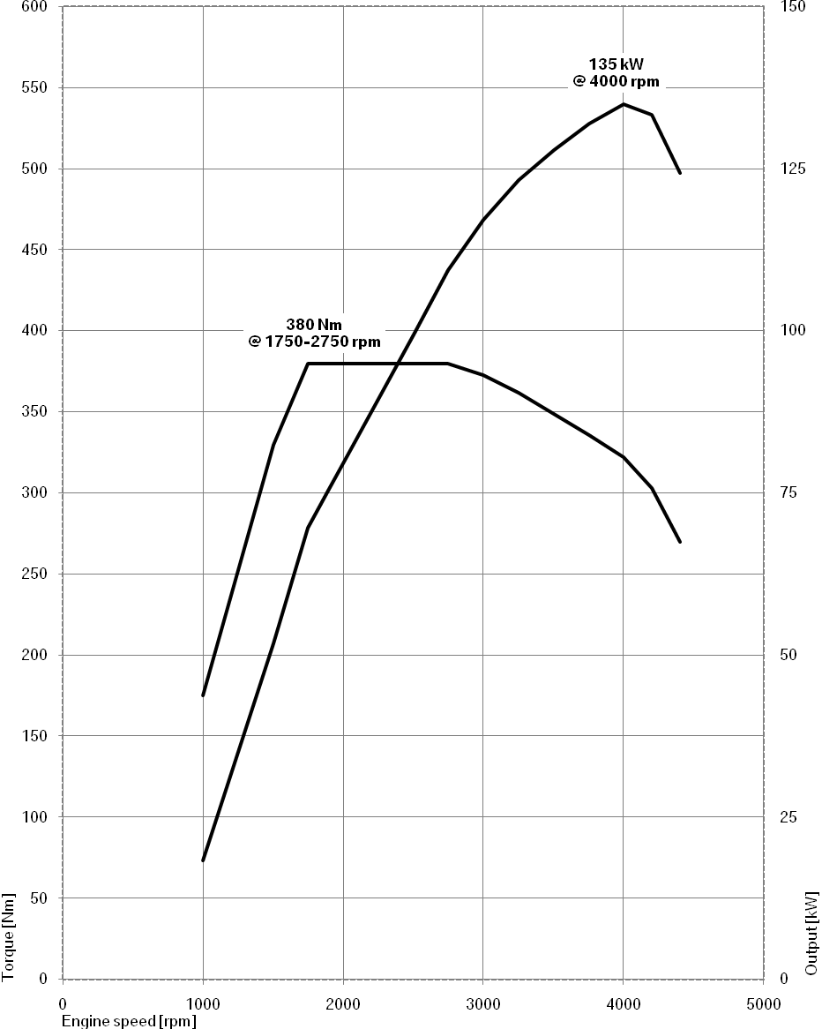
The new BMW 3 Series Gran Turismo.
320i.
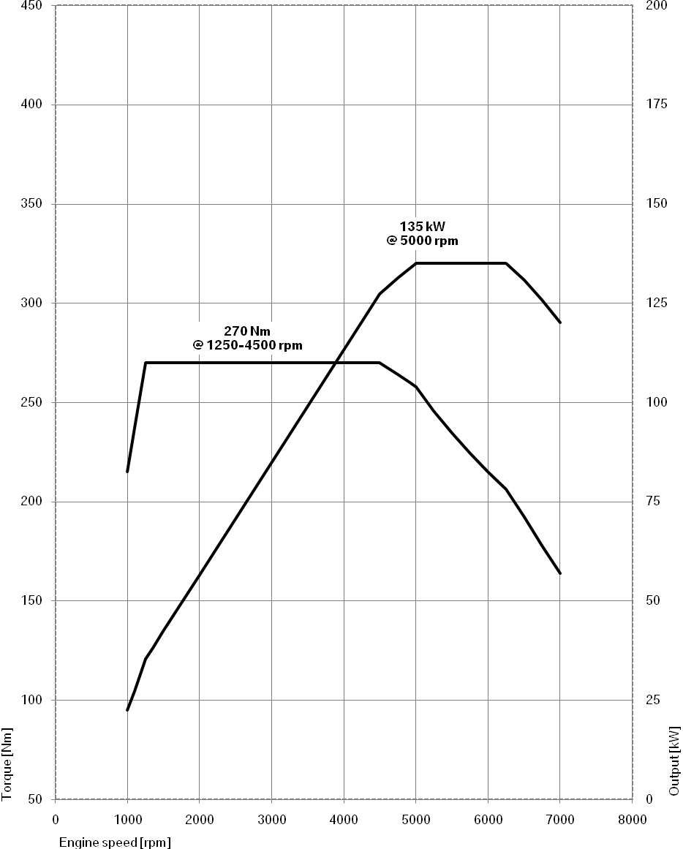
The new BMW 3 Series Gran Turismo.
328i.
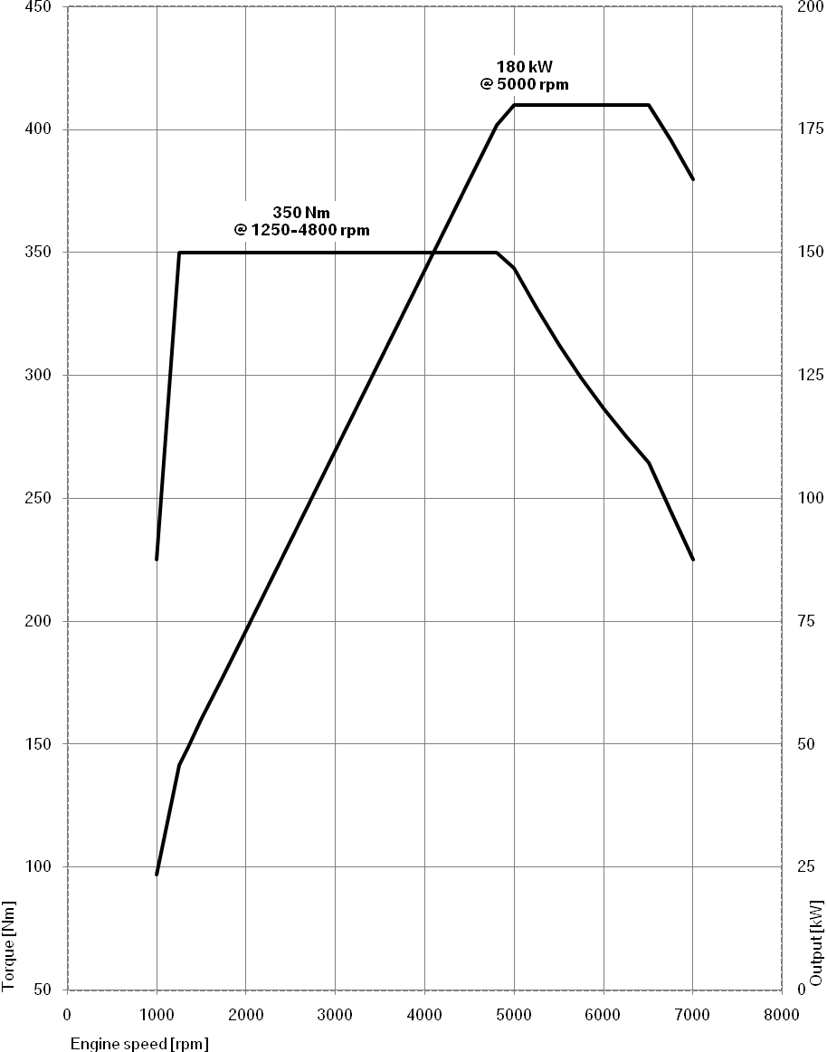
The new BMW 3 Series Gran Turismo.
335i.
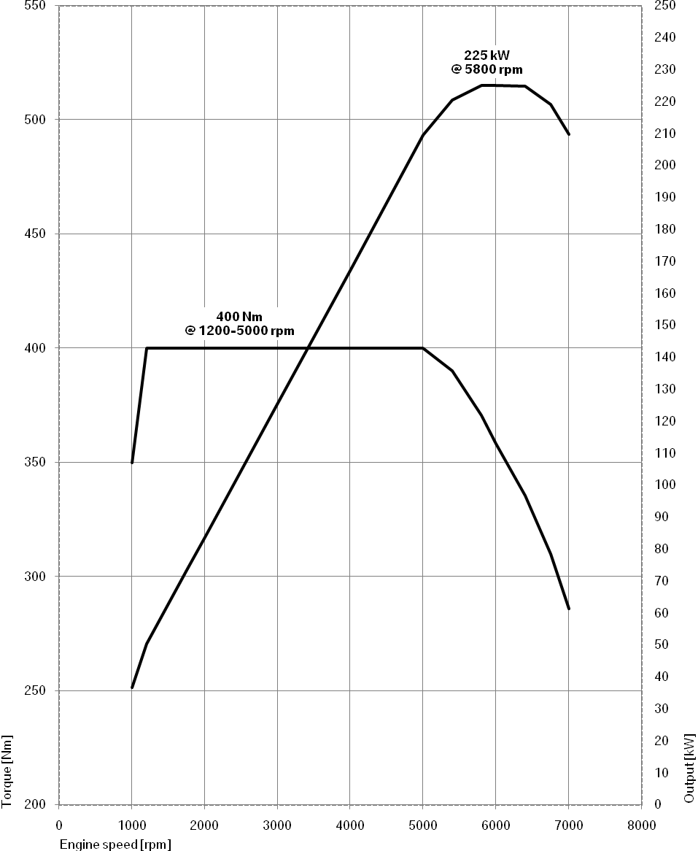
9. Exterior and interior dimensions.
