The new BMW F 800 R.
Contents.


1. The new BMW F 800 R.
(Short version). 2

2. Model characteristics and technology. 4

3. Equipment range. 7

4. Colours. 9

5. Engine output and torque. 10

6. Technical specifications. 11

1. The new BMW F 800 R.

Short version.
The new F 800 R is the latest in the line of characterful parallel twin-cylinder motorcycles from BMW Motorrad. Consistent development of its all-round qualities has ensured the dynamic roadster is ready to delight owners with its sporty performance, agile handling and even greater versatility – all wrapped up in a dynamic package.
Power is sourced, as before, from a liquid-cooled four-valve twin-cylinder engine with 798 cc displacement. With output increasing to 66 kW at 8,000 rpm (up from 64 kW at 8,000 rpm) and shorter ratios for first and second gear, the parallel twin offers even greater sprinting ability while retaining the impressive pulling power, instantaneous responses and low fuel consumption familiar from the predecessor model. Peak torque remains 86 Nm at 5,800 rpm.
The engaging riding experience on board the F 800 R is further enhanced by new suspension components and optimised ergonomics. For example, an upside-down fork now takes care of front suspension duties, while a hydraulic double-disc brake with radial brake callipers provides fade-resistant stopping power. A new seat fixed lower down (at 790 mm instead of the previous 800 mm), combined with new handlebars and rider foot pegs, creates even better ergonomics for the rider.
The design of the F 800 R – which is also pitched at novice riders – also provides a visual showcase for that extra rider engagement. With its newly designed fairings, radiator shields, front mudguard and wheels, plus a new range of colours, the sporty roadster cuts an extremely dynamic figure. The now symmetrical main headlight also gives it a distinctive “face”.
In keeping with the “Safety 360°” principle, the new F 800 R is fitted with ABS as standard. It can also be ordered with optional systems such as ASC (Automatic Stability Control) and ESA (Electronic Suspension Adjustment), ensuring it sets a new benchmark in the segment in terms of its safety performance and all-round qualities.
The new features of the BMW F 800 R:
- Higher output than its predecessor – 66 kW at 8,000 rpm (previously: 64 kW at 8,000 rpm).
- Modified ratios for first and second gear.
- New body features with an even more dynamic design.
- New colours.
- Symmetrical main headlight arrangement.
- Upside-down fork.
- Radial front brake callipers.
- Lighter wheels with dynamic design.
- Rider foot pegs.
- Seat height reduced to 790 mm (previously 800 mm).
- New tapered aluminium handlebars.
- ASC (Automatic Stability Control) – optional / special accessory.
- ESA (Electronic Suspension Adjustment) – optional.
- Output reduced to 35 kW – special accessory / optional.

2. Model characteristics and
technology.
The new F 800 R – a talented all-rounder from sports performance to touring ability.
Whether you’re out for a cruise through the city streets or a tour of the countryside, primed to explore your sportier side around twisty roads or in a track training session, the BMW F 800 R will rise to the challenge. And never more so than in this latest incarnation, which comes with a more powerful engine, revised suspension and further improvements to its all-round qualities.
Stunt-riding world champion Chris Pfeiffer has done more than most to showcase the sporting character of the compact twin-cylinder roadster over the years. The F 800 R has not only carried him to victory in a host of competitions, it has also been his bike of choice when it comes to thrilling fans with spectacular moves and tricks in his stunt shows.
Powerful parallel-twin engine with increased output to deliver even more dynamic riding pleasure.
The new F 800 R is the latest beneficiary of the dynamic propulsion produced by BMW’s torquey twin-cylinder engine. The liquid-cooled 798 cc unit uses electronic fuel injection and a closed-loop catalytic converter, linking up with a six-speed gearbox – all of which is a recipe for instantaneous responses, impressive pulling power and low fuel consumption. It also features mass balancing via an additional swivelling conrod, something none of its series-produced rivals can offer.
The engine has been retuned for the F 800 R to develop 66 kW (90 hp) (previously: 64 kW at 8,000 rpm, while peak torque of 86 Nm at 5,800 rpm is unchanged. Working in conjunction with modified ratios for first and second gear, it delivers even better performance. The bike should be fuelled – as before – with super unleaded fuel with a minimum octane rating of RON 95. A reduced-output variant producing 35 is available for riders aged up to 25 who have just passed their test.
Customers can also dip into the BMW Motorrad range of special accessories to equip their new F 800 R with an Akrapovič sport silencer. This slip-on silencer delivers a particularly sonorous twin-cylinder soundtrack. Made from titanium and stainless steel, it weighs some 1.7 kilograms less than the standard end silencer.
Revised suspension with upside-down fork and radial brake callipers.
For its suspension, the new F 800 R uses a tried and tested light-alloy perimeter frame in conjunction with a dual rear swing arm made from cast light alloy and a central spring strut. At the front wheel, the new F 800 R employs an upside-down fork with even greater torsional stiffness in place of the previous telescopic fork. Spring travel is 125 mm at both the front and rear. Comfort and user-friendliness are enhanced by a hand wheel allowing easy adjustment of the spring preload at the rear central spring strut.
Tyre dimensions remain unchanged, at 120/70 ZR 17 for the front wheel and 180/55 ZR 17 for the rear.
Enhanced directional precision and stability go hand in hand with increased braking performance at the front wheel, courtesy of a double-disc brake whose callipers are now mounted radially to the fork bases.
Latest-generation BMW Motorrad ABS fitted as standard, ASC available ex-works as an option / special accessory.
The new F 800 R comes as standard with the most advanced two-channel ABS technology from BMW Motorrad. This generation of ABS is not only lighter and more compact than the one it replaces, it also uses an additional pressure sensor in the front brake circuit, which has further optimised control precision.
Another boost for safety – in slippery road conditions, in particular – is provided by ASC (Automatic Stability Control), which can be factory-fitted as an option or special accessory. ASC can be switched off for certain purposes.
Optimised ergonomics and new design.
The new handlebars made from conical aluminium tubing allow a more relaxed riding position.
The new F 800 R has been fitted with new rider foot pegs with the aim of providing more relaxed ergonomics. They are now located 10 mm further forward and 10 mm lower, allowing them to offer a more comfortable knee angle and therefore enhanced seating comfort. Smaller riders will welcome the reduced seat height of the new F 800 R, which is now 790 mm (previously: 800 mm). Other seats which can be adjusted to suit the body size of individual riders are available as an option.
In addition to this increase in comfort, the seating position and design of the new F 800 R also shine a particularly bright spotlight on the bike’s dynamic, engaging character. The fairings, radiator shields, front mudguard and wheels have all been redesigned, as has the cockpit trim, while the now symmetrical main headlight arrangement also gives the F 800 R its very distinctive “face”.
ESA (Electronic Suspension Adjustment) available as an option.
BMW Motorrad offers the new F 800 R with ESA (Electronic Suspension Adjustment) as an ex-works option – the first time this technology has been available for a mid-size roadster. This allows the rider to adjust the compression-stage damping of the rear spring strut electrically (at the touch of a button on the handlebars) while on the move. Riders can select from three settings – comfortable, normal or sporty – depending on road conditions and individual requirements.

3. Equipment range.
Optional equipment and special accessories – perfect customisation by BMW Motorrad.
The new F 800 R with standard specification already meets the demands of a dynamic roadster with strong all-round qualities to near perfection. Beyond this BMW Motorrad has a comprehensive range of optional equipment and special accessories on offer for further optimising this roadster for the keen rider.
Riders requiring that extra dose of touring capability will be as well served as all those who embrace innovative technology. The spectrum of functional options ranges from ASC (Automatic Stability Control) to the innovative luggage system all the way to ESA (Electronic Suspension Adjustment).
Optional extras are integrated into the production process and supplied ex-works. Special accessories are added by BMW Motorrad dealers, which means the motorcycle can also be retrofitted with equipment.
Standard optional equipment.
- Safety Package with ASC, ESA and Tyre Pressure Control.
- Comfort Package with onboard computer, heated grips, pannier mountings and main stand.
- Dynamic Package with LED indicators, LED tail light, engine spoiler and pillion seat cover in body colour.
- ASC (Automatic Stability Control).
- ESA (Electronic Suspension Adjustment).
- Output reduced to 35 kW.
- New: Comfort seat 820 mm.
- Low seat 770 mm.
- Touring pannier mountings.
- LED indicators.
- Tyre Pressure Control.
- Onboard computer.
- Heated grips.
- Main stand.

4. Colours.
A range of four different colour combinations lend the new BMW F 800 R a powerful presence. Light White shines a particularly striking and sporty spotlight on the new F 800 R, while Racing Blue metallic matt / Black satin gloss stands for uncompromising dynamics. In the Racing Blue metallic matt / Light White colour combination, the F 800 R exudes a sporty, extrovert character, while Light White / Black silk gloss adds a strong technical note.
BMW F 800 R Price
R 124 800

5. Engine output and torque.
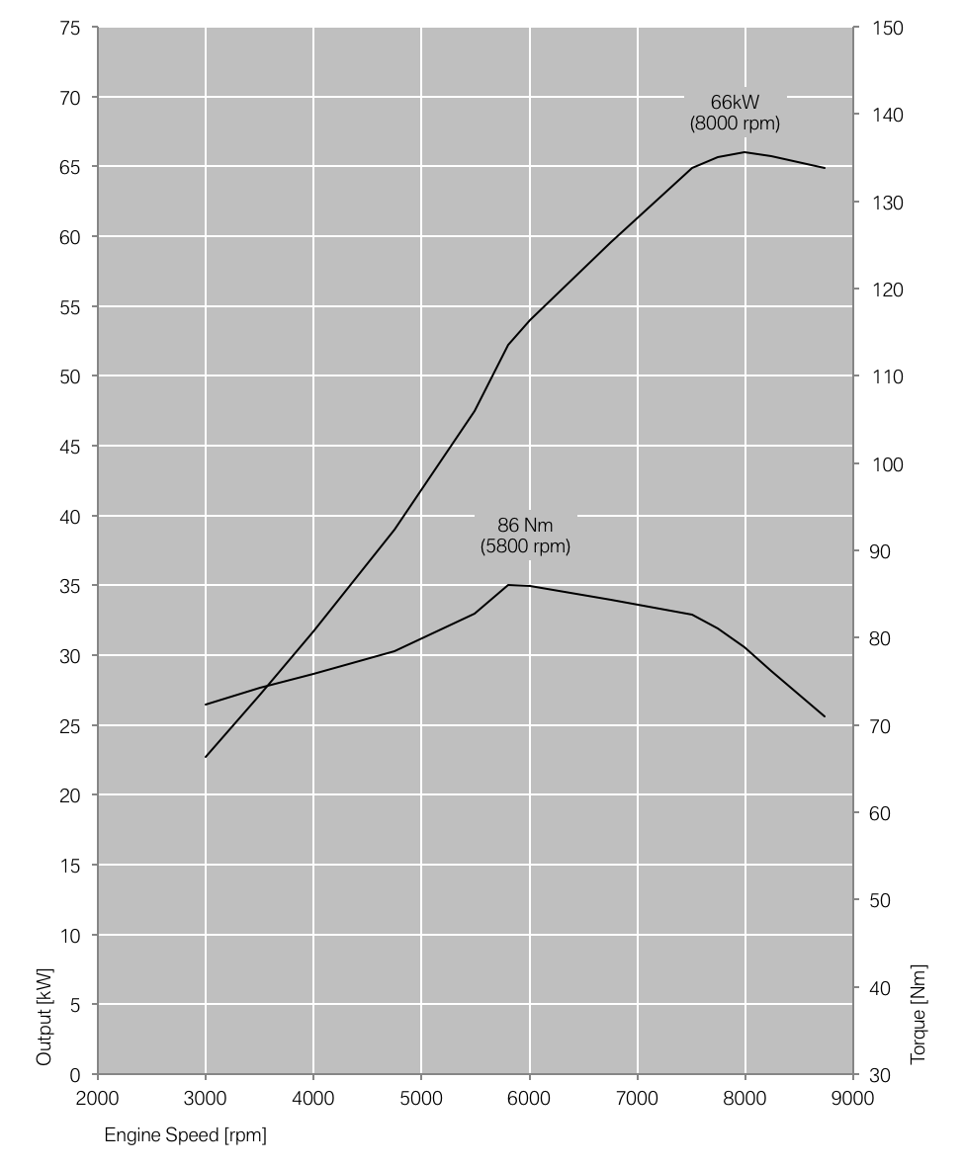

6. Technical specifications.
 |  |  |  |  | BMW F 800 R
Engine
Displacement | cm³ | 798
Bore/Stroke | mm | 82/75,6
Output | kW/hp | 66/90
at engine speed | rpm | 8,000 (reduction in output of 35 kW at 6,750 rpm possible)
Torque | Nm | 86
at engine speed | rpm | 5,800 (reduction in output: 69 Nm at 3,500 rpm)
Type |  | Water-cooled four-stroke twin-cylinde in-line engine, four valves per cyclinder, two overhead camshafts, dry sump lubrication
Compression; fuel |  | 12.0:1/super unleaded (minimum octane rating 95 RON)
Valve actuation |  | DOHC (double overhead camshaft), rocker arms
Valves per cylinder |  | 4
Ø intake/outlet | mm | 32/27.5
Ø throttle valve | mm | 46
Mixture control |  | Electronic intake pipe injection
Emission control |  | Closed-loop three-way catalytic converter, exhaust standard EU-3
Electrical system
Alternator | W | 400
Battery | V/Ah | 12/12, maintenance-free
Headlight / Rear light |  | High/low beam: 12V/55W halogen
Rear light |  | Brake light: 12V/21W, rear light: 12V/5W
Starter | kW | 0.9
Power transmission gearbox
Clutch |  | Multi-disc oil bath clutch, mechanically operated
Gearbox |  | Claw-shifted six-speed gearbox integrated in the engine body
Primary ratio |  | 1.943
Gear transmission ratio I |  | 2.462
II |  | 1.750
III |  | 1.381
IV |  | 1.227
V |  | 1.130
VI |  | 1.042
Rear wheel drive |  | chain
Transmission ratio |  | 2.35
Chassis
Frame type |  | Aluminium alloy perimeter frame, load-bearing engine
Front suspension |  | Upside-down fork
Rear suspension |  | Aluminium double-strut swing arm, central spring strut, seamless hydraulic adjustment of spring preload by hand wheel, adjustable rebound damping
Spring travel front/rear | mm | 125/125
Wheel castor | mm | 100
Wheelbase | mm | 1,526
Steering head angle | ° | 64
Brakes | front | Twin-disc brake, floating brake discs, Ø 320 mm, 4-Kolben-Radialbremssattel
 | rear | Einscheibenbremse, Ø 265 mm, Einkolben-Schwimmsattel
ABS |  | BMW Motorrad ABS
Rims |  | Aluminium-Gussräder
 | front | 3.50 x17"
 | rear | 5.50 x17"
Tyres | front | 120/70 ZR 17
 | rear | 180/55 ZR 17
Dimensions and weights
Overall length | mm | 2,145
Overall width with mirrors | mm | 860
Overall height with mirrors | mm | 1,235
Seat height | mm | 790 (optional low seat: 770, optional high seat: 820)
DIN unladen weight, road ready | kg | 202
Permitted total weight | kg | 405
 |  |  |  |  | BMW F 800 R
Tank volume | l | 15
Riding data
Fuel consumption
90 km/h | l/100 km | 3.6
120 km/h | l/100 km | 4.8
Acceleration
0-100 km/h | s | 3.9
0-1000 m | s | 23.5
Top speed | km/h | > 200

