1. Urban all-rounder delivers boundless driving pleasure.
The new BMW X1.
(Short version) 2

The new BMW X1.
Contents.

2. At a glance. 4

3. The concept:
Authentic BMW X model in a compact format. 7

4. The design:
Dynamic, authoritative and with an established premium character. 9

5. Powertrain and driving experience:
Wide range of innovations for wide-ranging sporting ability. 12

6. BMW EfficientDynamics in the new BMW X1:
Complete package ensures exceptional efficiency. 17

7. Body and equipment:
More space for variable use and exclusive comfort. 20

8. BMW ConnectedDrive in the new BMW X1:
Progress through intelligent connectivity. 22

9. Specifications. 24

10. Output and torque diagrams. 34

11. Exterior and interior dimensions. 39

The new BMW X1 – the successor to the model that blazed the trail for this class of car – treats the premium compact segment to an even more potent shot of Sports Activity Vehicle DNA. The second generation of this successful model, more than 730,000 units of which have now been sold, takes to the stage with a body design straight out of the BMW X model mould. The interior of the new BMW X1, meanwhile, offers significantly more space for passengers and luggage, a cutting-edge premium ambience and functionality grounded in solid engineering. Four-cylinder engines from the BMW Group’s latest generation of power units, an efficiency-optimised version of the BMW xDrive intelligent all-wheel-drive system and newly developed chassis technology all help to palpably enhance sporting ability and ride comfort compared to the outgoing model – with fuel consumption and emissions reduced by up to 17 per cent, model-on-model.

1. Urban all-rounder delivers boundless driving pleasure.
The new BMW X1.
(Short version)

Alongside its market-leading dynamics and efficiency, a host of innovative equipment features also help to secure the new BMW X1 its stand-out position in the segment. Among the items on the options list are full-LED headlights, Dynamic Damper Control, the BMW Head-Up Display and the Driving Assistant Plus system.
A typical BMW X model: sturdy proportions, impressive variability and established premium characteristics.
Rugged proportions, a powerful presence and dynamic lines lend the new BMW X1 a commanding appearance and highlight its status as the youngest member of the BMW X model family. The new model has grown in height compared to its predecessor (+53 millimetres), which has helped increase the spaciousness of the interior. And its significantly raised seating position (+36 millimetres at the front, +64 millimetres at the rear) optimises the driver’s view out over the road.
Knee room in the rear has increased by 37 millimetres in standard specification and by up to 66 millimetres with the optionally adjustable rear seat, while the 505-litre boot capacity is 85 litres larger than that of its predecessor. Folding down the standard-fitted 40:20:40 rear seat backrest, which can also be specified in angle-adjustable form as an option, allows load capacity to be expanded to as much as 1,550 litres. The optional folding front passenger seat backrest and a rear seat bench which can slide 13 centimetres fore and aft offer additional variability.

The interior design of the new BMW X1 combines the driver-focused cockpit design that has become a hallmark of the brand’s models with touches promoting authoritative, SAV-style driving pleasure and a contemporary premium ambience. Standard equipment includes air conditioning, an audio system with USB and AUX-in sockets, and the iDrive operating system, whose 6.5-inch display is integrated into the instrument panel in freestanding monitor form. Meanwhile, the Advantage, Sport Line, xLine and M Sport packages available as an alternative to standard specification open the door for targeted individualisation.
New generation of engines, efficiency-optimised xDrive all-wheel-drive system.
The second-generation BMW X1 (fuel consumption combined: 6.4–4.1 litres/100 km; CO₂ emissions combined: 149–109 g/km) lines up with an all-new selection of engines. Two petrol and three diesel units will be available from launch in October 2015, all of which have four cylinders and are members of the BMW Group’s new engine family. Outputs range from 110 kW to 170 kW. The engines link up with either a six-speed manual gearbox or an eight-speed Steptronic unit, both of which are new developments.
Further information on official fuel consumption figures, specific CO₂ emission values and the electric power consumption of new passenger cars is included in the following guideline: “Leitfaden über Kraftstoffverbrauch, die CO₂-Emissionen und den Stromverbrauch neuer Personenkraftwagen” (Guideline for fuel consumption, CO₂ emissions and electric power consumption of new passenger cars), which can be obtained from all dealerships, from the Deutsche Automobil Treuhand GmbH (DAT), Hellmuth-Hirth-Str. 1, 73760 Ostfildern-Scharnhausen and at http://www.dat.de/en/offers/publications/guideline-for-fuel-consumption.html. LeitfadenCO₂ (GuidelineCO₂) (PDF ‒ 2.7 MB)
The xDrive intelligent all-wheel-drive system also takes its place in the new BMW X1 in a further developed form. The weight-saving, compact and efficient system uses an electro-hydraulically controlled multi-plate clutch to distribute drive between the front and rear axle just as required for the situation at hand. Joining the fray in the BMW X1 sDrive20i and BMW X1 sDrive18d (not for South Africa), meanwhile, is a front-wheel-drive construction which has been developed to deliver the driving dynamics typical of the brand and has already proved its mettle in the BMW 2 Series Active Tourer and BMW 2 Series Gran Tourer.
Premiere in the BMW X1: Head-Up Display and Driving Assistant Plus.
The change of BMW X1 generations also brings significant advances in the field of intelligent connectivity. A new addition to the range of BMW ConnectedDrive features is a BMW Head-Up Display which, as in the larger BMW X models, projects driving-related information directly onto the windscreen. The BMW X1 can now also be specified with the Driving Assistant Plus line-up of the Active Cruise Control system with Stop & Go function, Lane Departure Warning, Traffic Jam Assistant, Collision Warning and Pedestrian Warning with City Braking function. These systems are complemented by an up-to-the-minute selection of apps allowing customers to add to the car’s comfort, navigation and infotainment functionality, as desired.
- Second generation of the globally successful BMW X representative in the premium compact segment, of which more than 730,000 units have been sold.

2. At a glance.
- Body design displays the hallmark BMW X design language; rugged proportions, powerful presence, dynamic lines.
- Newly designed interior with significantly improved space and variability, combined with the latest update of the premium ambience for which the brand is renowned.
- Latest-generation four-cylinder engines and gearboxes ensure segment-leading sporting ability and efficiency.
- BMW xDrive intelligent all-wheel-drive system in new, efficiency-optimising form; BMW X1 sDrive20i and BMW X1 sDrive18d models have front-wheel drive.
- All-new chassis technology delivers segment-leading dynamics and noticeably enhanced ride comfort; Variable Sports Steering and Dynamic Damper Control available as options. M Sport suspension is also offered as an option.
- iDrive operating system, rain-sensing wipers, Servotronic and Driving Experience Control switch as standard.
- Features such as full-LED headlights and automatic tailgate operation added to the options list.
- Precise individualisation: standard specification, Advantage, Sport Line, xLine and M Sport packages.
- Extensive additions to the BMW ConnectedDrive range: BMW Head-Up Display projecting driving-related information directly onto the windscreen, BMW Driving Assistant and BMW Driving Assistant Plus, Parking Assistant with automatic parallel and transverse parking, navigation system with map data updating via a mobile phone connection.
- Production at BMW Plant Regensburg.
- Market launch from October 2015.
- Model variants:
BMW X1 xDrive25i: Four-cylinder in-line petrol engine with BMW TwinPower Turbo technology (TwinScroll turbocharger, High Precision Injection, VALVETRONIC variable valve timing, Double-Vanos).
Capacity: 1,998cc, output: 170 kW at 5,000 – 6,000 rpm,
max. torque: 350 Nm at 1,250–4,500 rpm.
Acceleration [0–100 km/h]: 6.5 seconds,
top speed: 235 km/h.
Average fuel consumption*: 6.6–6.4 litres/100 kilometres,
CO₂ emissions*: 152–149 g/km, exhaust standard: EU6.
BMW X1 xDrive20i: Four-cylinder in-line petrol engine with BMW TwinPower Turbo technology (TwinScroll turbocharger, High Precision Direct Injection, VALVETRONIC variable valve timing, Double-Vanos).
Capacity: 1,998cc, output: 141 kW at 5,000–6,000 rpm,
max. torque: 280 Nm at 1,250–4,600 rpm.
Acceleration [0–100 km/h]: 7.4 seconds,
top speed: 223 km/h.
Average fuel consumption*: 6.4–6.3 litres/100 kilometres,
CO₂ emissions*: 149–146 g/km, exhaust standard: EU6.
BMW X1 sDrive20i: Four-cylinder in-line petrol engine with BMW TwinPower Turbo technology (TwinScroll turbocharger, High Precision Injection, VALVETRONIC variable valve timing, Double-Vanos).
Capacity: 1,998cc, output: 141 kW at 5,000–6,000 rpm,
max. torque: 280 Nm at 1,250–4,600 rpm.
Acceleration [0–100 km/h]: 7.7 seconds,
top speed: 225 km/h.
Average fuel consumption*: 6.0–5.9 litres/100 kilometres,
CO₂ emissions*: 139–136 g/km, exhaust standard: EU6.
BMW X1 xDrive25d (not for South Africa): Four-cylinder in-line diesel engine with BMW TwinPower Turbo technology (multi-stage high- and low-pressure turbocharging with variable inlet geometry, common-rail direct injection with solenoid valve injectors, max. injection pressure: 2,500 bar).
Capacity: 1,995cc, output: 170 kW at 4,400 rpm,
max. torque: 450 Nm at 1,500–3,000 rpm.
Acceleration [0–100 km/h]: 6.6 seconds,
top speed: 235 km/h.
Average fuel consumption*: 5.2–5.0 litres/100 kilometres,
CO₂ emissions*: 137–132 g/km, exhaust standard: EU6.
BMW X1 xDrive20d: Four-cylinder in-line diesel engine with BMW TwinPower Turbo technology (turbocharging with variable inlet geometry, common-rail direct injection with solenoid valve injectors, max. injection pressure: 2,000 bar).
Capacity: 1,995cc, output: 140 kW at 4,000 rpm,
max. torque: 400 Nm at 1,750–2,500 rpm.
Acceleration [0–100 km/h]: 7.6 seconds,
top speed: 219 km/h.
Average fuel consumption*: 5.1–4.9 litres/100 kilometres,
CO₂ emissions*: 133–128 g/km, exhaust standard: EU6.
BMW X1 sDrive18d (not for South Africa): Four-cylinder in-line diesel engine with BMW TwinPower Turbo technology (turbocharging with variable inlet geometry, common-rail direct injection with solenoid valve injectors, max. injection pressure: 2,000 bar).
Capacity: 1,995cc, output: 110 kW at 4,000 rpm,
max. torque: 330 Nm at 1,750–2,750 rpm.
Acceleration [0–100 km/h]: 9.2 (automatic: 9.2) seconds,
top speed: 205 km/h (205 km/h).
Average fuel consumption*: 4.3–4.1 (4.5–4.3) litres/100 kilometres,
CO₂ emissions*: 114–109 (119–114) g/km, exhaust standard: EU6.
* Figures according to EU test cycle, may vary depending on the tyre format specified.
• Second generation of the successful premium compact model; sales have exceeded 730,000 units worldwide.

3. The concept:
An authentic BMW X model
in a compact format.
• Commanding appearance, variability and driving pleasure in the style of the BMW X model family.
• Innovative connectivity and groundbreaking BMW EfficientDynamics technology unparalleled in the segment.
The first generation of the BMW X1 introduced the premium compact segment to the type of driving pleasure for which BMW X models have become renowned. More than 730,000 units of the X1 have been sold around the world, and the singular qualities upon which the car’s success is based have acquired even greater depth as part of the development of the new model generation. The status of the X1 as a member of the BMW X model family is now displayed even more clearly in both its exterior appearance and the design of the interior. The sporting prowess and efficiency of the X1 have also been enhanced, and the array of innovative equipment features earmarked to fulfil individual requirements in terms of comfort, safety and infotainment has grown. The new BMW X1 therefore has all the ingredients to remain a stand-out player in the segment founded by its predecessor and to introduce new target groups to the thrill of driving pleasure, BMW-style.
Commanding and versatile in the BMW X family mould.
Its raised seating position, increased space, stylish premium ambience and even greater interior variability underline the status of the new BMW X1 as an assured, multitalented addition to the segment. The even better view it affords the driver over the road ensures effortless driving pleasure, and there are also clear parallels with BMW Sports Activity Vehicles and Sports Activity Coupes in higher vehicle classes in terms of the style of its interior design and range of optional driver assistance systems.
The versatility typical of a BMW X model is expressed not only in the driving characteristics of the X1 on various types of terrain, but also in the way its interior can be used. The new BMW X1 offers more space for passengers and luggage and raises variability another notch. The rear seat bench comes as standard with a three-section split/folding backrest and is available as an option with the ability to slide forwards and backwards by 13 centimetres. A folding front passenger seat backrest can also be specified as an option.
The compact BMW X model – pointing the way for ultra-efficient drive system technology once again.
Armed with an all-new range of engines and gearboxes, not to mention the latest, ultra-efficient version of the xDrive all-wheel-drive system, the second generation of the BMW X1 blazes a trail once again for BMW EfficientDynamics technology. The original X1 handed a debut outing to the first four-cylinder petrol engine with BMW TwinPower Turbo technology. All the petrol and diesel units available for the new BMW X1 are taken from the BMW Group’s latest generation of power units. At market launch, petrol engines with 141 kW in the BMW X1 xDrive20i and BMW X1 sDrive20i and with 170 kW in the BMW X1 xDrive25i will be available. The BMW X1 sDrive18d sets the new efficiency benchmark in the segment with output of 110 kW and combined fuel consumption in the EU test cycle of 4.3–4.1 litres per 100 kilometres (CO₂ emissions: 114–109 g/km). The other diesel units have an output of 140 kW in the BMW X1 xDrive20d and 170 kW in the BMW X1 xDrive25d. Beyond this, the model range is scheduled to be joined from November 2015 by the BMW X1 sDrive18i and BMW X1 sDrive16d (not for South Africa) variants powered by three-cylinder engines.
• Robust proportions familiar from other BMW X models combine with distinctively dynamic lines.

4. The design:
Dynamic, authoritative and with an established premium character.
• Interior design specialises in driving pleasure headlined by a commanding presence and high-quality ambience.
• Sport Line, xLine and M Sport packages include specific design features allowing targeted individualisation.
The passing of the baton from the original BMW X1 to the second-generation model encapsulates a far-reaching maturing process clearly expressed in the design of both the exterior and the interior. Robust proportions, powerfully sculpted surfaces and design features typical of a Sports Activity Vehicle lend the new model an assured appearance and immediately identify it as a member of the BMW X model family. Its dynamic lines when viewed from the side imbue the new BMW X1 with a distinctive, fresh and youthful aura.
Another feature of the new BMW X1 that is unique in the compact segment is the design of the interior, which majors on authoritative driving pleasure. The slightly raised seating position typical of a BMW X model, a new interpretation of the hallmark driver-focused cockpit and elegant, width-accentuating surfaces are complemented by a premium ambience exuding exclusive material quality and workmanship. The Advantage, Sport Line, xLine and M Sport variants available as an alternative to standard specification include special design features for the exterior and interior. They allow X1 customers to give their car an individual character that illuminates either the agile sportiness or versatile off-road nature of the new BMW X1 with even greater intensity.
Commanding presence, robust proportions, dynamic lines.
The large, upright BMW kidney grille, three-section lower air intake and characteristic “six-eyed” look formed by the twin circular headlights and foglamps below them are the stand-out features of the new model’s front end. Flared wheel arches and lines converging in an X-shape into the kidney grille likewise contribute to the authoritative presence customary of BMW X models. Standard specification for the new BMW X1 includes LED daytime driving lights, while full-LED headlights for low and high beam – which generate a particularly white light that is close to daylight – are available as an option.
At 4,439 millimetres long, 1,821 millimetres wide and 1,598 millimetres tall, the proportions of the new BMW X1 follow the Sports Activity Vehicle blueprint in compact form. The new car has grown most notably in height compared to its predecessor (+53 millimetres), which helps to create extra space in the interior. Black borders on the lower edge of the body, the square contour of the wheel cutouts and the generous volume of the surfaces above them all underline the solid stature of the compact BMW X model. The athletic impression created by the side view is complemented by a model-specific, dynamic wedge shape formed by the roofline, eye-catching character lines and window surfaces that taper towards the rear.
The central section of the new BMW X1’s rear apron rises up significantly, mimicking a characteristic element of the front-end design. When specified with the optional full-LED units, the two-section, L-shaped rear lights produce an even band of light. Their flat outline emphasises the width of the rear end, with the vertically arranged black aeroblades, which fit flush with the roof spoiler, adding sporting accents.
Customers can choose from two non-metallic and ten metallic exterior paint finishes for their new BMW X1. The Estoril Blue metallic shade is also offered exclusively for the M Sport model.
Interior offers harmonious balance between driver focus and luxuriant elegance.
With its fine balance of a driver-focused cockpit design and elegance shaped by generously-sized surfaces, the interior of the new BMW X1 fits the classic stylistic template of a Sports Activity Vehicle. The flat surfaces of the instrument panel and centre console controls angled towards the driver help them maintain unruffled control over the car’s progress. The controls located in the lower section of the centre console are surrounded by high-quality surfaces and are marked off from the front passenger side by a newly designed bar. The instrument cluster, consisting of two circular instruments and framed by a small binnacle, also helps the driver to focus on the driving experience.
The iDrive operating system’s Control Display comes in the form of a 6.5-inch or, optionally, 8.8-inch freestanding monitor. The interior trim strip and air vents are bordered by an accent strip spanning the full width of the instrument panel. The interior strip and accent strip extend through the door panel trim, with the effect that occupants in all seats are surrounded by surfaces with a uniform material and colour structure.
Exclusive equipment lines with specific design features.
Standard specification for the new BMW X1 includes cloth seat surfaces in the colour combination Anthracite/Black and interior trim strips in Oxide Silver dark matt with accent strips in high-gloss Black. Dakota leather trim in Black or Canberra Beige can be ordered as an option, as can interior trim strips in fine-wood matt Oak Grain and Fineline Stream.
xLine: The exterior of the xLine model features a BMW kidney grille with bars that are matt aluminium at the front. The xLine’s rugged character is also accentuated by matt silver accents for the air intakes, side skirts and underbody protection. The interior trim comprises cloth/leather seats in Granite Brown/Black with black accents and interior trim strips in high-gloss Black with accent strips in Pearl Gloss Chrome.
Sport Line: Among the special exterior features of the Sport Line model are black BMW kidney grille bars, air intakes with accents in high-gloss Black and underbody protection in Black Silver with an inlay painted – like the side skirts – in body colour. The interior of the Sport Line model features black sports seats with either red or grey accents and interior trim strips in the variants high-gloss Black or aluminium with accent strips in matt Coral Red.
M Sport: The M Sport model is fitted with a model-specific M aerodynamic package and 18-inch or optionally 19-inch M light-alloy wheels that lend even further emphasis to its dynamic character. The interior of the M Sport model features sports seats in anthracite-coloured cloth/Alcantara with blue accents, and Aluminium Hexagon interior trim strips with accent strips in matt Blue. Its extremely sporty cockpit design also includes an M leather steering wheel and a BMW Individual headliner in Anthracite.
Dakota leather trim with perforation in several colours is also available as an option exclusively for the Sport Line, xLine and M Sport models. A selection of other interior trim strip variants can be specified for all models. Added to which, all equipment lines include 18-inch light-alloy wheels in their own specific design, exclusive door sill plates and an LED lighting package with vicinity and door handle lights, ambient lighting with variable use of colours and LED optical fibres in the door panel trim.
- Four-cylinder engines with BMW TwinPower Turbo technology from the BMW Group’s latest generation of power units.

5. Powertrain and driving experience:
Wide range of innovations for wide-ranging sporting ability.
- New version of BMW xDrive intelligent all-wheel drive; first BMW X model with dynamics-optimised front-wheel drive.
- Newly developed chassis technology; Dynamic Damper Control and Variable Sports Steering available as an option.
The second generation of the BMW X1 uses all-new powertrain and chassis technology to build systematically on the compact BMW X model’s stand-out position as the epitome of versatile sporting ability in its segment. Front/transverse-mounted four-cylinder engines from the BMW Group’s latest generation provide the power, which is converted into dynamic propulsion on the road and assured driving pleasure on loose terrain via either the new version of the BMW xDrive intelligent all-wheel-drive system or an advanced front-wheel-drive configuration, depending on the model variant.
Another factor in the further enhanced agility of the BMW X1 is the likewise newly developed chassis technology, which ensures not only precisely controllable handling, but also noticeably improved ride comfort. Together with the car’s low centre of gravity, virtually perfect 50 : 50 weight distribution, a wide track, short overhangs, optimised weight and the impressive rigidity of the body and chassis, this lays the foundation for a driving experience familiar to BMW drivers but without parallel in the segment.
Efficient power sources: all-new line-up of engines.
The new BMW X1 will be available from launch with an all-new range of engines comprising two petrol and two diesel units, each with 2.0-litre displacement and BMW TwinPower Turbo technology. All model variants with the exception of the BMW X1 sDrive18d feature an exhaust system with a twin-tailpipe design that draws further attention to the sporty character of the new BMW X1. Beyond this, the model range is scheduled to be extended from November 2015 by the variants BMW X1 sDrive18i with 100 kW and the BMW X1 sDrive16d with 85 kW, both driven by three-cylinder engines – only the BMW X1 sDrive18i will be available in South Africa.
The engine powering the new BMW X1 xDrive25i develops a maximum output of 170 kW and peak torque of 350 Nm, which is available between 1,250 and 4,500 rpm. Its instantaneous pulling power enables acceleration of 0 to 100 km/h in 6.5 seconds. Average fuel consumption for the BMW X1 xDrive25i, which comes as standard with the likewise newly developed eight-speed Steptronic transmission, is between 6.6 and 6.4 litres per 100 kilometres, while CO₂ emissions stand at 152– 49 grams per kilometre (in the EU test cycle, depending on the tyre format specified).
The BMW X1 xDrive20i and BMW X1 sDrive20i models are powered by a 141 kW version of the new four-cylinder petrol engine, whose peak torque of 280 Nm can also be accessed from just 1,250 rpm. This power unit likewise links up as standard with the eight-speed Steptronic transmission. The new BMW X1 xDrive20i sprints from 0 to 100 km/h in 7.4 seconds, the new BMW X1 sDrive20i in 7.7 seconds. Their average fuel consumption is 6.4–6.3 litres and 6.0–5.9 litres per 100 kilometres respectively, while CO2 emissions come in at 149–146 and 139–136 grams per kilometre (in the EU test cycle, depending on the tyre format specified).
Turbocharging and common-rail direct injection with solenoid valve injectors imbue the new diesel engines with captivating pulling power and further enhanced efficiency. Under the bonnet of the new BMW X1 xDrive25d, multi-stage turbocharging with variable turbine geometry in both the high-pressure and low-pressure chargers ensures instantaneous power delivery, which is sustained into the higher rev ranges. The unit’s injection system operates with a maximum pressure of 2,500 bar here. With maximum output of 170 kW, the new unit is the most powerful four-cylinder diesel ever fitted in a BMW and its peak torque of 450 Nm is available between 1,500 and 3,000 rpm. It accelerates the new BMW X1 xDrive25d with standard eight-speed Steptronic transmission from 0 to 100 km/h in 6.6 seconds, and posts an average fuel consumption of 5.2–5.0 litres per 100 kilometres and CO2 emissions of 137–132 grams per kilometre (in the EU test cycle, depending on the tyre format specified). This diesel engine will not be available in South Africa.
The diesel engines in the BMW X1 xDrive20d and BMW X1 sDrive18d feature turbocharging with variable turbine geometry and an injection system generating a maximum pressure of 2,000 bar. In both cases, maximum output is up 5 kW on their predecessor engines and now stands at 140 kW and 110 kW respectively. Drivers of these two models can look forward to peak torque of 400 and 330 Nm. The new BMW X1 xDrive20d, which is fitted as standard with the eight-speed Steptronic transmission, accelerates from 0 to 100 km/h in 7.6 seconds, while the new BMW X1 sDrive18d completes the same sprint in 9.2 (automatic: 9.2) seconds. This increased sportiness goes hand-in-hand with lower fuel consumption and emissions. The new BMW X1 xDrive20d, for example, posts figures of 5.1–4.9 litres per 100 kilometres and 133 –128 grams per kilometre, while the new BMW X1 sDrive18d records 4.3–4.1 (automatic: 4.5–4.3) litres per 100 kilometres) and 114 –109 (automatic: 119–114) grams per kilometre (in the EU test cycle, depending on the tyre format specified).
Also newly developed: six-speed manual gearbox and eight-speed Steptronic transmission.
The new BMW X1 sDrive18d is fitted as standard with a new six-speed manual gearbox, in which an engagement speed control function ensures optimised smoothness. A gear selection sensor matches the engine rpm to the transmission input shaft rpm, resulting in the slickest possible gear changes.
Available as an optional alternative to the manual gearbox in the BMW X1 sDrive18d is the likewise newly developed eight-speed Steptronic transmission, which is fitted as standard on all other models. The new version of the automatic stands out with its improved internal efficiency, increased smoothness and more dynamic gear changes. The BMW X1 sDrive18i and BMW X1 sDrive16d models scheduled for launch from November 2015 with feature a six-speed manual gearbox as standard and the option of a six-speed Steptronic transmission.
Flexible, quick to respond and more efficient than ever: the xDrive intelligent all-wheel-drive system in the new BMW X1.
The xDrive intelligent all-wheel-drive system is also available in updated form for the second generation of the BMW X1. The compact, low-weight and efficient all-wheel-drive system distributes the engine’s power between the front and rear axle exactly as the situation requires – at all times. Linking up with DSC (Dynamic Stability Control) allows the system to act pre-emptively to counteract any inclination on the car’s part towards oversteer or understeer. It does this by diverting power to the wheel or wheels where it can be transferred to the road to maximum effect. The BMW xDrive system therefore ensures supreme traction, optimised directional stability and enhanced cornering dynamics in all weather and road conditions. Furthermore, the combination of the DSC system and xDrive also includes Hill Descent Control, which can be activated at the touch of a button.

The xDrive system of the new BMW X1 consists of a single-speed bevel gear in the front-axle drive unit (a power take-off), and a rear-axle drive unit with an electrohydraulically controlled hang-on multi-plate clutch. The two are connected by a two-piece drive shaft. In normal driving situations, power is sent to the front wheels. When required, however, the hang-on clutch – with the help of an electrohydraulic pump – diverts up to 100 per cent of the engine’s power to the rear wheels. It does so within fractions of a second and unnoticed by the driver. The DSC system keeps the pump’s control unit constantly supplied with important data for analysing the driving situation. The data includes the car’s speed, lateral and longitudinal acceleration, steering lock, wheel speed, pitch, accelerator position and the Driving Experience Control and DSC settings. This information is used to determine – and instantly generate – the ideal power split between the front and rear wheels, seamlessly and flexibly.
A recipe for enthralling agility: sophisticated chassis technology, with Variable Sports Steering and Dynamic Damper Control also available as options.
The chassis technology of the original X1 has been totally redeveloped for the new model and now comprises single-joint strut suspension at the front and a multi-link rear axle. Aluminium swivel bearings, as well as axle carriers and control arms made from high-strength steel, reduce weight and increase the rigidity of the front axle, which in turn helps to ensure an agile turn-in response and direction-changing precision. The rear axle also employs a high proportion of high-strength steels. Tube-shaped anti-roll bars at the front and rear axle, innovative axle mounting and specially tuned elastokinematics contribute to the agility and ride comfort of the new BMW X1, as do the connection of the dampers to the body via sophisticated three-way support mounts.
The new BMW X1 is equipped as standard with Servotronic speed-sensitive steering assistance, while a new item on the options list is Variable Sports Steering. This system allows parking and turning-off manoeuvres to be completed safely and comfortably with little steering effort, and at higher speeds drivers can also look forward to the steering precision and straightline stability for which BMW is renowned. M Sport suspension is furthermore available as a special option, featuring a distinctly tauter spring and damper setting and a 10-millimetre-lower ride height.
Another option available for the first time in the BMW X1 is the Dynamic Damper Control system. The electronically controlled dampers improve the primary and secondary ride of the new BMW X models and sharpen their dynamic attributes. Two damper control settings can be activated using the Driving Experience Control switch.
The Driving Experience Control switch on the centre console allows the driver to give the car’s set-up an even sportier, more comfort-oriented or efficiency-optimised character. Calling up COMFORT, SPORT or ECO PRO mode at the touch of a button adapts the responses of the accelerator pedal and steering. The shift characteristics of the automatic transmission and the damper settings are also adjusted if the relevant equipment has been specified.
The DSC stability system includes features such as the Anti-lock Braking System (ABS), Dynamic Traction Control (DTC), Cornering Brake Control (CBC), Dynamic Brake Control (DBC), Brake Assist system, Fading Compensation, a Dry Braking function and a Start-Off Assistant. Other technology available to customers includes the trailer stabilisation function, Active Differential Brake (ADB) function and Performance Control. When DSC is deactivated, an electronic locking function for the front axle differential – known as Electronic Differential Lock Control (EDLC) – comes into play. In tight corners it brakes a spinning wheel as required and ensures power is diverted to the other wheel.
All model variants of the new BMW X1 are fitted as standard with 17-inch light-alloy wheels. Other light-alloy wheels in 17, 18 and 19-inch formats are available as an option.
- Segment-leading aerodynamics thanks to features including air flap control, Air Curtains and aeroblades.

6. BMW EfficientDynamics
in the new BMW X1:
Complete package ensures exceptional efficiency.
- New generation of engines, gearboxes and BMW xDrive with optimised efficiency.
- BMW EfficientLightweight: intelligent mix of materials and detailed weight reduction.
The enhanced functional effectiveness of all powertrain components, intelligent energy management, the rigorous application of BMW Lightweight technology and far-reaching measures designed to optimise aerodynamics all play a role in ensuring the BMW X1 generation change has brought with it significant advances in efficiency. The innovations developed under the BMW EfficientDynamics banner form an overall package that delivers greater driving pleasure combined with up to 17 per cent lower fuel consumption and emissions, depending on the model, plus lower weight yet extra rigidity for the body and chassis.
On-demand cooling, optimised lines.
Systematic improvements have also been made to the aerodynamics of the new BMW X1. Air flaps in the BMW kidney grille and the front apron’s lower intake can be actively shut off when the cooling requirement is low, reducing drag at the front of the car. The Air Curtains integrated into the outer air intakes channel the onrushing air precisely behind the front side panels, causing it to hang over the wheels like a curtain and thus reduce turbulence.
The new BMW X1 also has smooth underbody panelling, air deflectors on the front wheel arches and vertical aeroblades, which form a unit with the roof spoiler to channel the airflow around the rear of the car to best effect. With the drag coefficient (Cd) of the X1 now as low as 0.29, depending on the model variant, the new model also leads the way in its segment when it comes to aerodynamics.
Engines, gearboxes and BMW xDrive: lower weight, improved efficiency.
All the engines in the BMW Group’s new generation of power units work with the latest incarnation of BMW TwinPower Turbo technology. This contains elements such as turbochargers integrated into the exhaust manifold, plus the most recently updated generation of VALVETRONIC for the petrol engines and a common-rail direct injection system working at even higher pressure for the diesel units. The impressive functional effectiveness of the new power units is also assisted by an aluminium crankcase and cylinder heads, forged steel crankshafts with an integrated balancer shaft drive, low-weight pistons, forged connecting rods, friction-reduced cylinder coatings and map-controlled oil pumps.
With their reduced weight and enhanced internal efficiency, the new six-speed manual and eight-speed Steptronic transmission also help to optimise efficiency. The manual gearbox has a centrifugal pendulum absorber in the dual-mass flywheel, which smooths out rotational oscillations occurring at low engine speeds. This increases comfort when the driver is keeping revs low to enhance economy. Meanwhile, the reduced converter slip of the new automatic transmission cuts energy losses, and its wider gear spread keeps revs lower at higher vehicle speeds.
The version of the BMW xDrive intelligent all-wheel-drive system developed for the new BMW X1 is considerably lighter. Furthermore, the powertrain’s torque losses in normal driving situations are reduced by around 30 per cent thanks to the new hang-on multi-plate clutch. The improved functional effectiveness of the new rear differential also helps to deliver a particularly efficient all-wheel-drive experience.
Intelligent energy management, ECO PRO mode with coasting function.
The BMW EfficientDynamics technology employed in the new BMW X1 includes intelligent energy management. Brake Energy Regeneration enables extremely efficient power generation for the on-board power supply. The Electric Power Steering and on-demand fuel and coolant pumps work with maximum efficiency, while shorter glow phases reduce the amount of energy required when starting the diesel engines. The Optimum Shift Indicator and Auto Start Stop function are also part of the standard specification for the new BMW X1.
ECO PRO mode – activated via the Driving Experience Control switch – also allows drivers of new BMW X1 models with eight-speed Steptronic transmission to make use of the coasting function. At speeds between 50 and 160 km/h (31–99 mph), the powertrain is disengaged as soon as the driver takes his or her foot off the accelerator. Further efficiency gains have been achieved with items including reduced-friction wheel bearings and tyres with lower rolling resistance.
BMW EfficientLightweight: a kilo-shedding route to enhanced agility, safety and efficiency.
An intelligent mix of materials for the body structure and chassis components of the new BMW X1 allows increased agility, lower vibrations and enhanced safety to be combined with optimised vehicle weight. The targeted use of hot-stamped, high and ultra-high tensile steels enables reduced materials usage yet also significantly improved torsional rigidity and strength. Like the bonnet, the bumper supports and wheel swivel bearings – among other areas of the car – are made from aluminium.
The weight of the chassis has been reduced by the deployment of components such as tube-shaped anti-roll bars, output shafts and damper piston rods, not to mention the increased use of aluminium. Added to which, the integrated BMW EfficientLightweight concept also contains solutions for construction details, such as the production of steel with optimised material strength – in the form of tailored rolled blanks – for the front bulkhead and B-pillar support beams.
• Increases in storage capacity, storage areas and flexibility; optional sliding rear seats and folding front passenger seat backrest.

7. Body and equipment:
More space for variable use and exclusive comfort.
• High-quality standard specification including iDrive operating system, hands-free telephone facility and USB interface.
• Targeted individualisation: standard specification, Advantage, Sport Line, xLine and M Sport models.
The cutting-edge vehicle concept behind the new BMW X1 is also reflected in the significant progress made in the areas of functionality, safety and comfort. This multitalented model not only offers more space for passengers and luggage, it also impresses with additional variability when it comes to utilising its load-carrying capacity. Extensive standard specification and numerous attractive options underline the premium character of the compact BMW X model. The scope for targeted individualisation has also grown, with Advantage, Sport Line, xLine and M Sport models available as alternatives to standard specification. Their specific design features combine with high-quality equipment details which also play their part in the new BMW X1’s exclusive aura.
The raised seating position (by 36 millimetres in the front and 64 millimetres in the rear compared to the predecessor model), increased headroom, shoulder room and elbow room available to all occupants inside the new BMW X1, along with the horizontal surface design in the interior, create generous levels of space and an ambience typical of a Sports Activity Vehicle. Knee room at the rear has increased by 37 millimetres in standard specification and by up to 66 millimetres with the optionally adjustable rear seat, while boot capacity of 505 litres represents an 85-litre improvement on the first-generation X1 and can be increased further to as much as 1,550 litres by folding down the standard 40 : 20 : 40-split rear seat bench. A 60 : 40-split rear bench is optionally available with individual elements that can slide forward or back by up to 13 centimetres, allowing seating comfort and storage capacity to be adjusted even more precisely to needs. Its individual elements can slide back or forwards by 13 centimetres and the backrest angle is also adjustable. The folding process for the backrests can be initiated electrically from the boot area at the touch of a button. As an option, the front passenger seat backrest can also be folded down, further increasing variability.
Automatic tailgate operation (optional) makes using the X1’s load-carrying capacity even easier, and the Comfort Access option also includes a hands-free tailgate opening and closing function. In addition, the new BMW X1 is offered from the factory with a trailer coupling including removable ball head, as well as preparation for a rear luggage carrier rack.
The passenger compartment of the new BMW X1 has large door pockets offering space for items such as one-litre bottles, plus a selection of other storage areas. A storage compartment is integrated into the instrument panel on the driver’s side. Positioned ahead of the gearshift or selector lever in the centre console beneath a sliding cover are two full-size cupholders. An armrest for the driver and front passenger with integrated storage compartment and a storage package are also available as an option. The latter includes features such as compartments under the front seats, nets in the backrests of the driver’s and front passenger seat, a central armrest with cupholders for the rear, additional 12-volt sockets and a strap and net for securing smaller items of luggage in the boot area.
Attractive equipment variants, exclusive comfort-enhancing options.
The new BMW X1 is fitted as standard not only with the iDrive operating system with high-resolution 6.5-inch colour display, but also an audio system with six loudspeakers and an AUX-in socket and USB interface, a hands-free facility for telephones, the Driving Experience Control switch and air conditioning. Standard specification also includes front foglamps, remote-controlled central locking and keyless engine ignition, electric window controls, electrically adjustable and heated exterior mirrors, a leather steering wheel adjustable for height and reach and a rain sensor including automatic headlight control. The Advantage also offers Cruise Control with Braking function, multifunction buttons on the steering wheel, two-zone automatic climate control and Park Distance Control with rear-mounted sensors. The Sport Line, xLine and M Sport models are likewise fitted with these equipment items. But along with their specific exterior and interior design features, they also offer a sports leather steering wheel – or an M leather steering wheel and M driver’s footrest in the case of the M Sport model.
Among the items on the options list is a Panorama glass roof covering a 1,200 x 847-millimetre area. A CD player, Digital Audio Broadcasting (DAB) receiver and Harman Kardon HiFi system, complete with 12 loudspeakers and a digital amplifier with 360-watt output, provide an outstanding audio experience while on the road.
• BMW Head-Up Display projects relevant driving information onto the windscreen.

8. BMW ConnectedDrive
in the new BMW X1:
Progress through intelligent connectivity.
• Unparalleled variety of infotainment through apps; significantly larger selection of driver assistance systems.
• Intelligent Emergency Call and BMW Teleservices as standard.
The large number of additions made to the range of driver assistance systems and mobility services from BMW ConnectedDrive available for the original BMW X1 underlines the progress made in the development of the new model in the field of intelligent connectivity. The high-class and richly varied selection of options designed to optimise comfort, safety and the use of infotainment functions take their cue from those available for the BMW X models in higher segments.
Pointing the way to the future – and your destination: Navigation Plus including BMW Head-Up Display.
The Navigation option assists route guidance on the standard-fitted Control Display with direction arrows and sophisticated map graphics, including views from various angles. If a multifunction steering wheel is fitted, the destination can also be entered by voice command. Another, in many respects pioneering, option is the Navigation Plus system, which comprises a bigger, now 8.8-inch, Control Display, an instrument cluster with extended features, a split-screen function for the Control Display as well as the BMW Head-Up Display. This system allows High Guidance instructions including lane recommendations to be shown in the instrument cluster’s TFT display or projected onto the windscreen, as desired. The BMW Head-Up Display projects this and other information directly into the driver’s field of view, allowing him or her to register the information without having to divert their gaze from the road ahead. The graphics are displayed using the full spectrum of colours.
Driving Assistant Plus with Traffic Jam Assistant.
The camera-based assistance systems available for the new BMW X1 ensure greater assurance and safety in different driving situations. The Driving Assistant option includes Lane Departure Warning, Speed Limit Info with No Passing Info display, the BMW Selective Beam anti-dazzle High Beam Assistant, as well as Collision Warning and Pedestrian Warning with City Braking function. In addition to these functions, the Driving Assistant Plus line-up also features the Active Cruise Control system with Stop & Go function – which maintains both a desired speed between 30 and 140 km/h (19–87 mph) as entered by the driver and the safety distance to vehicles travelling ahead – and the Traffic Jam Assistant. At speeds up to 60 km/h (37 mph), this function takes over both proximity control and lane-keeping tasks from the driver. The Traffic Jam Assistant uses steering assistance to keep the car reliably in the middle of its lane, but the driver needs to have at least one hand on the steering wheel for the system to work.
Park Distance Control and the rear-view camera, whose images are transferred onto the Control Display, make precise and comfortable manoeuvring that much easier. The likewise optional Parking Assistant also helps the driver to find and make use of parallel parking spaces.
BMW ConnectedDrive Services and apps.
The ConnectedDrive Services option enables the use of the BMW Online internet portal via the SIM card embedded in the vehicle, as well as the integration of smartphone apps into the car. Standard features also include the Intelligent Emergency Call and BMW Teleservices. The steadily growing selection of smartphone apps comprises web radio functions as well as the use of social network services such as Twitter or services like Spotify, Life 360, GoPro among many more. The ConnectedDrive Services option is also the prerequisite for using the Concierge Service personal information service, Remote Services, the internet function, Real Time Traffic Information and the Online entertainment service from BMW ConnectedDrive, which opens up access to more than 22 million tracks across a wide range of genres.
The ConnectedDrive Store offers even more flexibility. A one-off registration allows customers to adapt the range of services available to their individual needs – there and then or at a later stage. The ConnectedDrive Store is not only available on the internet but also directly in the car. The functions purchased are made available for use just minutes later.
The new BMW X1 will go on sale in South Africa from October 2015 in the following engine variants:
- BMW X1 sDrive18i,
- BMW X1 sDrive 20i,
- BMW X1 xDrive20d,
- BMW X1 xDrive20i,
- BMW X1 xDrive 25i.
9. Specifications.
BMW X1 sDrive20i,
BMW X1 xDrive20i.
 |  | BMW X1 sDrive20i |  | BMW X1 xDrive20i
Body
No. of doors/seats |  | 5 / 5 |  | 5 / 5
Length/width/height ¹⁾ (unladen) | mm | 4439 / 1821 / 1598 |  | 4439 / 1821 / 1598
Wheelbase | mm | 2670 |  | 2670
Track, front/rear | mm | 1561 / 1562 |  | 1561 / 1562
Ground clearance | mm | 183 |  | 183
Fording depth | mm | 250 |  | 250
Turning circle | m | 11.4 |  | 11.4
Tank capacity | approx. ltr | 61 |  | 61
Engine oil ²⁾ | ltr | 5.25 |  | 5.25
Weight, unladen, to DIN/EU | kg | 1485 / 1560 |  | 1540 / 1615
Max. load to DIN | kg | 590 |  | 600
Max. permissible weight | kg | 2075 |  | 2140
Max. axle load, front/rear | kg | 1090 / 1025 |  | 1120 / 1075
Max. trailer load,  braked (12%)/unbraked | kg | 1800 / 750 |  | 2000 / 750
Max. roof load/towbar download | kg | 75 / 80 |  | 75 / 80
Luggage comp. capacity | ltr | 505 – 1550 |  | 505 – 1550
Air resistance | c_{d} x A | 0.30 x 2.46 |  | 0.30 x 2.46
Engine
Config./No. of cyls./valves |  | in-line / 4 / 4 |  | in-line / 4 / 4
Engine technology |  | BMW TwinPower Turbo technology: TwinScroll turbocharger,  High Precision Injection, VALVETRONIC fully variable valve timing,  Double-VANOS variable camshaft timing
Effective capacity | cm³ | 1998 |  | 1998
Stroke/bore | mm | 94.6 / 82.0 |  | 94.6 / 82.0
Compression ratio | :1 | 11.0 |  | 11.0
Fuel |  | min RON 91 |  | min RON 91
Output | kW/hp | 141 / 192 |  | 141 / 192
at | rpm | 5000 – 6000 |  | 5000 – 6000
Torque | Nm | 280 |  | 280
at | rpm | 1250 – 4600 |  | 1250 – 4600
Electrical System
Battery/Installation | Ah/– | 80 / luggage comp. |  | 80 / luggage comp.
Alternator | A/W | 150 / 2100 |  | 150 / 2100
Driving Dynamics and Safety
Suspension, front |  | Single-joint spring-strut axle in lightweight aluminium-steel construction
Suspension, rear |  | Multi-arm axle in lightweight steel construction with separate spring and damper configuration
Brakes, front |  | Single-piston floating-calliper disc brakes / vented
Brakes, rear |  | Single-piston floating-calliper disc brakes / vented
Driving stability systems |  | Standard: DSC incl. ABS, ASC and DTC (Dynamic Traction Control), CBC (Cornering Brake Control), DBC (Dynamic Brake Control), Dry Braking function, Fading Compensation, Start-Off Assistant, EDLC (Electrically Controlled Differential Lock Control), Performance Control; BMW X1 xDrive20i: cross-linking with xDrive all-wheel-drive system, optional: Dynamic Damper Control
Safety equipment |  | Standard: airbags for driver and front passenger, side airbags for driver and front passenger, head airbags for front and rear seats, three-point inertia-reel seatbelts on all seats with belt latch tensioner and belt force limiter at the front seats, crash sensors, Tyre Defect Indicator
Steering |  | Electric Power Steering (EPS)  with Servotronic function, optional: Variable Sport Steering
Steering ratio, overall | :1 | 15.7 |  | 15.7
Tyres, front/rear |  | 225/55 R17 97W |  | 225/55 R17 97W
Rims, front/rear |  | 7.5J x 17 light-alloy |  | 7.5J x 17 light-alloy

 |  | BMW X1 sDrive20i | BMW X1 xDrive20i
Transmission
Type of gearbox |  | 8-speed Steptronic transmission | 8-speed Steptronic transmission
Gear ratios I | :1 | 5.250 | 5.250
II | :1 | 3.029 | 3.029
III | :1 | 1.950 | 1.950
IV | :1 | 1.457 | 1.457
V | :1 | 1.221 | 1.221
VI | :1 | 1.000 | 1.000
VII | :1 | 0.809 | 0.809
VIII | :1 | 0.673 | 0.673
R | :1 | 4.015 | 4.015
Final drive | :1 | 3.200 | 3.200
Performance
Power-to-weight ratio (DIN) | kg/kW | 10.5 | 10.9
Output per litre | kW/ltr | 70.6 | 70.6
Acceleration 0–100 km/h | s | 7.7 | 7.4
in 5th gear 80–120 km/h | s | – | –
Top speed | km/h | 225 | 223
BMW EfficientDynamics
BMW EfficientDynamics standard features |  | Brake Energy Regeneration with recuperation display, Optimum Shift Indicator, ECO PRO mode with coasting function, BMW EfficientLightweight, optimised aerodynamic attributes, on-demand operation of ancillary units, map-controlled oil pump, detachable a/c compressor, final drive with optimised warm-up behaviour, efficiency- and weight-optimised all-wheel drive (BMW X1 xDrive20i), tyres with reduced roll resistance
Fuel consumption EU cycle³⁾
With standard tyres
Urban | ltr/100 km | 7.1 | 7.6
Extra-urban | ltr/100 km | 5.1 | 5.6
Combined | ltr/100 km | 5.9 | 6.3
CO2 | g/km | 136 | 146
With rims 8J x 19 and tyres 225/45 R19 as well as winter tyres
Urban | ltr/100 km | 7.2 | 7.7
Extra-urban | ltr/100 km | 5.3 | 5.7
Combined | ltr/100 km | 6.0 | 6.4
CO₂ | g/km | 139 | 149
Emission rating |  | EU6 | EU6

Specifications apply to ACEA markets; data relevant to homologation applicable in part only to Germany (weight)

¹⁾ Height with roof fin: 1612 millimetres
²⁾ Oil change
³⁾ Fuel consumption and CO₂ emissions depend on the selected tyre format

BMW X1 xDrive25i.
 |  | BMW X1 xDrive25i
Body
No. of doors/seats |  | 5 / 5
Length/width/height ¹⁾ (unladen) | mm | 4439 / 1821 / 1598
Wheelbase | mm | 2670
Track, front/rear | mm | 1561 / 1562
Ground clearance | mm | 183
Fording depth | mm | 250
Turning circle | m | 11.4
Tank capacity | approx. ltr | 61
Engine oil ²⁾ | ltr | 5.25
Weight, unladen, to DIN/EU | kg | 1540 / 1615
Max. load to DIN | kg | 600
Max. permissible weight | kg | 2140
Max. axle load, front/rear | kg | 1120 / 1075
Max. trailer load,  braked (12%)/unbraked | kg | 2000 / 750
Max. roof load/towbar download | kg | 75 / 80
Luggage comp. capacity | ltr | 505 – 1550
Air resistance | c_{d} x A | 0.31 x 2.46
Engine
Config./No. of cyls./valves |  | in-line / 4 / 4
Engine technology |  | BMW TwinPower Turbo technology: TwinScroll turbocharger,  High Precision Injection, VALVETRONIC fully variable valve timing,  Double-VANOS variable camshaft timing
Effective capacity | cm³ | 1998
Stroke/bore | mm | 94.6 / 82.0
Compression ratio | :1 | 11.0
Fuel |  | min RON 91
Output | kW/hp | 170 / 231
at | rpm | 5000 – 6000
Torque | Nm | 350
at | rpm | 1250– 4500
Electrical System
Battery/Installation | Ah/– | 80 / luggage comp.
Alternator | A/W | 150 / 2100
Driving Dynamics and Safety
Suspension, front |  | Single-joint spring-strut axle in lightweight aluminium-steel construction
Suspension, rear |  | Multi-arm axle in lightweight steel construction with separate spring and damper configuration
Brakes, front |  | Single-piston floating-calliper disc brakes / vented
Brakes, rear |  | Single-piston floating-calliper disc brakes / vented
Driving stability systems |  | Standard: DSC incl. ABS, ASC and DTC (Dynamic Traction Control), CBC (Cornering Brake Control), DBC (Dynamic Brake Control), Dry Braking function, Fading Compensation, Start-Off Assistant, EDLC (Electrically Controlled Differential Lock Control), Performance Control, cross-linking with xDrive all-wheel-drive system, optional: Dynamic Damper Control
Safety equipment |  | Standard: airbags for driver and front passenger, side airbags for driver and front passenger, head airbags for front and rear seats, three-point inertia-reel seatbelts on all seats with belt latch tensioner and belt force limiter at the front seats, crash sensors, Tyre Defect Indicator
Steering |  | Electric Power Steering (EPS)  with Servotronic function, optional: Variable Sport Steering
Steering ratio, overall | :1 | 15.7
Tyres, front/rear |  | 225/55 R17 97W
Rims, front/rear |  | 7.5J x 17 light-alloy

 |  | BMW X1 xDrive25i
Transmission
Type of gearbox |  | 8-speed Steptronic transmission
Gear ratios I | :1 | 5.250
II | :1 | 3.029
III | :1 | 1.950
IV | :1 | 1.457
V | :1 | 1.221
VI | :1 | 1.000
VII | :1 | 0.809
VIII | :1 | 0.673
R | :1 | 4.015
Final drive | :1 | 3.200
Performance
Power-to-weight ratio (DIN) | kg/kW | 9.1
Output per litre | kW/l | 85.1
Acceleration 0–100 km/h | s | 6.5
in 5th gear 80–120 km/h | s | –
Top speed | km/h | 235
BMW EfficientDynamics
BMW EfficientDynamics  standard features |  | Brake Energy Regeneration with recuperation display, EPS (Electric Power Steering), Auto Start Stop function, Optimum Shift Indicator, ECO PRO mode with coasting function, BMW EfficientLightweight, optimised aerodynamic attributes, on-demand operation of ancillary units, map-controlled oil pump, detachable a/c compressor, final drive with optimised warm-up behaviour, efficiency- and weight-optimised all-wheel drive, tyres with reduced roll resistance
Fuel consumption EU cycle³⁾
With standard tyres
Urban | ltr/100 km | 7.7
Extra-urban | ltr/100 km | 5.7
Combined | ltr/100 km | 6.4
CO2 | g/km | 149
With rims 8J x 19 and tyres 225/45 R19 as well as winter tyres
Urban | ltr/100 km | 7.8
Extra-urban | ltr/100 km | 5.8
Combined | ltr/100 km | 6.6
CO₂ | g/km | 152
Emission rating |  | EU6

Specifications apply to ACEA markets; data relevant to homologation applicable in part only to Germany (weight)

¹⁾ Height with roof fin: 1612 millimetres
²⁾ Oil change
³⁾ Fuel consumption and CO₂ emissions depend on the selected tyre format

BMW X1 sDrive18d.
 |  | BMW X1 sDrive18d
Body
No. of doors/seats |  | 5 / 5
Length/width/height ¹⁾ (unladen) | mm | 4439 / 1821 / 1598
Wheelbase | mm | 2670
Track, front/rear | mm | 1561 / 1562
Ground clearance | mm | 183
Fording depth | mm | 250
Turning circle | m | 11.4
Tank capacity | approx. ltr | 61
Engine oil ²⁾ | ltr | 5.0
Weight, unladen, to DIN/EU | kg | 1430 / 1505  (1470 / 1545)
Max. load to DIN | kg | 585 (595)
Max. permissible weight | kg | 2015 (2065)
Max. axle load, front/rear | kg | 1050 (1090) / 1020
Max. trailer load,  braked (12%)/unbraked | kg | 1800 / 750
Max. roof load/towbar download | kg | 75 / 80
Luggage comp. capacity | ltr | 505 – 1550
Air resistance | c_{d} x A | 0.29 x 2.46
Engine
Config./No. of cyls./valves |  | in-line / 4 / 4
Engine technology |  | BMW TwinPower Turbo technology: turbocharger with variable inlet geometry, common rail direct fuel injection with solenoid injectors, maximum injection pressure 2000 bar
Effective capacity | cm³ | 1995
Stroke/bore | mm | 90.0 / 84.0
Compression ratio | :1 | 16.5
Fuel |  | diesel
Output | kW/hp | 110 / 150
at | rpm | 4000
Torque | Nm | 330
at | rpm | 1750 – 2750
Electrical System
Battery/Installation | Ah/– | 80 / luggage comp.
Alternator | A/W | 150 / 2100
Driving Dynamics and Safety
Suspension, front |  | Single-joint spring-strut axle in lightweight aluminium-steel construction
Suspension, rear |  | Multi-arm axle in lightweight steel construction with separate spring and damper configuration
Brakes, front |  | Single-piston floating-calliper disc brakes / vented
Brakes, rear |  | Single-piston floating-calliper disc brakes / vented
Driving stability systems |  | Standard: DSC incl. ABS, ASC and DTC (Dynamic Traction Control), CBC (Cornering Brake Control), DBC (Dynamic Brake Control), Dry Braking function, Fading Compensation, Start-Off Assistant, EDLC (Electrically Controlled Differential Lock Control), Performance Control, optional: Dynamic Damper Control
Safety equipment |  | Standard: airbags for driver and front passenger, side airbags for driver and front passenger, head airbags for front and rear seats, three-point inertia-reel seatbelts on all seats with belt latch tensioner and belt force limiter at the front seats, crash sensors, Tyre Defect Indicator
Steering |  | Electric Power Steering (EPS)  with Servotronic function, optional: Variable Sport Steering
Steering ratio, overall | :1 | 15.7
Tyres, front/rear |  | 225/55 R17 97W
Rims, front/rear |  | 7.5J x 17 light-alloy

 |  | BMW X1 sDrive18d
Transmission
Type of gearbox |  | 6-speed manual (optional: 8-speed Steptronic transmission)
Gear ratios I | :1 | 3.923 (5.250)
II | :1 | 2.136 (3.029)
III | :1 | 1.276 (1.950)
IV | :1 | 0.921 (1.457)
V | :1 | 0.756 (1.221)
VI | :1 | 0.628 (1.000)
VII | :1 | – (0.809)
VIII | :1 | – (0.673)
R | :1 | 3.538 (4.015)
Final drive | :1 | 3.389 (2.955)
Performance
Power-to-weight ratio (DIN) | kg/kW | 13.0 (13.4)
Output per litre | kW/ltr | 55.1
Acceleration 0–100 km/h | s | 9.2 (9.2)
in 5th gear 80–120 km/h | s | 9.9 (–)
Top speed | km/h | 205 (205)
BMW EfficientDynamics
BMW EfficientDynamics  standard features |  | Brake Energy Regeneration with recuperation display, EPS (Electric Power Steering), Auto Start Stop function, Optimum Shift Indicator, ECO PRO mode with coasting function (automatic), BMW EfficientLightweight, optimised aerodynamic attributes, on-demand operation of ancillary units, map-controlled oil pump, detachable a/c compressor, final drive with optimised warm-up behaviour, tyres with reduced roll resistance
Fuel consumption EU cycle³⁾
With standard tyres
Urban | ltr/100 km | 4.9 (5.1)
Extra-urban | ltr/100 km | 3.7( 3.9)
Combined | ltr/100 km | 4.1 (4.3)
CO2 | g/km | 109 (114)
With rims 8J x 19 and tyres 225/45 R19 as well as winter tyres
Urban | ltr/100 km | 5.1 (5.3)
Extra-urban | ltr/100 km | 3.9 (4.1)
Combined | ltr/100 km | 4.3 (4.5)
CO₂ | g/km | 114 (119)
Emission rating |  | EU6

Specifications apply to ACEA markets; data relevant to homologation applicable in part only to Germany (weight)
Figures in brackets apply to automatic transmission

¹⁾ Height with roof fin: 1612 millimetres
²⁾ Oil change
³⁾ Fuel consumption and CO₂ emissions depend on the selected tyre format

BMW X1 xDrive20d.
 |  | BMW X1 xDrive20d
Body
No. of doors/seats |  | 5 / 5
Length/width/height ¹⁾ (unladen) | mm | 4439 / 1821 / 1598
Wheelbase | mm | 2670
Track, front/rear | mm | 1561 / 1562
Ground clearance | mm | 183
Fording depth | mm | 250
Turning circle | m | 11.4
Tank capacity | approx. ltr | 61
Engine oil ²⁾ | ltr | 5.0
Weight, unladen, to DIN/EU | kg | 1550 / 1625
Max. load to DIN | kg | 595
Max. permissible weight | kg | 2145
Max. axle load, front/rear | kg | 1130 / 1070
Max. trailer load,  braked (12%)/unbraked | kg | 2000 / 750
Max. roof load/towbar download | kg | 75 / 80
Luggage comp. capacity | ltr | 505 – 1550
Air resistance | c_{d} x A | 0.29 x 2.46
Engine
Config./No. of cyls./valves |  | in-line / 4 / 4
Engine technology |  | BMW TwinPower Turbo technology: turbocharger with variable inlet geometry, common rail direct fuel injection with solenoid injectors, maximum injection pressure 2000 bar
Effective capacity | cm³ | 1995
Stroke/bore | mm | 90.0 / 84.0
Compression ratio | :1 | 16.5
Fuel |  | diesel
Output | kW/hp | 140 / 190
at | rpm | 4000
Torque | Nm | 400
at | rpm | 1750 – 2500
Electrical System
Battery/Installation | Ah/– | 80 / luggage comp.
Alternator | A/W | 150 / 2100
Driving Dynamics and Safety
Suspension, front |  | Single-joint spring-strut axle in lightweight aluminium-steel construction
Suspension, rear |  | Multi-arm axle in lightweight steel construction with separate spring and damper configuration
Brakes, front |  | Single-piston floating-calliper disc brakes / vented
Brakes, rear |  | Single-piston floating-calliper disc brakes / vented
Driving stability systems |  | Standard: DSC incl. ABS, ASC and DTC (Dynamic Traction Control), CBC (Cornering Brake Control), DBC (Dynamic Brake Control), Dry Braking function, Fading Compensation, Start-Off Assistant, EDLC (Electrically Controlled Differential Lock Control), Performance Control, cross-linking with xDrive all-wheel drive system; optional: Dynamic Damper Control
Safety equipment |  | Standard: airbags for driver and front passenger, side airbags for driver and front passenger, head airbags for front and rear seats, three-point inertia-reel seatbelts on all seats with belt latch tensioner and belt force limiter at the front seats, crash sensors, Tyre Defect Indicator
Steering |  | Electric Power Steering (EPS)  with Servotronic function, optional: Variable Sport Steering
Steering ratio, overall | :1 | 15.7
Tyres, front/rear |  | 225/55 R17 97W
Rims, front/rear |  | 7.5J x 17 light-alloy

 |  | BMW X1 xDrive20d
Transmission
Type of gearbox |  | 8-speed Steptronic transmission
Gear ratios I | :1 | 5.250
II | :1 | 3.029
III | :1 | 1.950
IV | :1 | 1.457
V | :1 | 1.221
VI | :1 | 1.000
VII | :1 | 0.809
VIII | :1 | 0.673
R | :1 | 4.015
Final drive | :1 | 2.955
Performance
Power-to-weight ratio (DIN) | kg/kW | 11.1
Output per litre | kW/l | 70.2
Acceleration 0–100 km/h | s | 7.6
in 5th gear 80–120 km/h | s | –
Top speed | km/h | 219
BMW EfficientDynamics
BMW EfficientDynamics  standard features |  | Brake Energy Regeneration with recuperation display, EPS (Electric Power Steering), Auto Start Stop function, Optimum Shift Indicator, ECO PRO mode with coasting function, BMW EfficientLightweight, optimised aerodynamic attributes, on-demand operation of ancillary units, map-controlled oil pump, detachable a/c compressor, final drive with optimised warm-up behaviour, efficiency- and weight-optimised all-wheel drive, tyres with reduced roll resistance
Fuel consumption EU cycle³⁾
With standard tyres
Urban | ltr/100 km | 5.6
Extra-urban | ltr/100 km | 4.4
Combined | ltr/100 km | 4.9
CO2 | g/km | 128
With rims 8J x 19 and tyres 225/45 R19 as well as winter tyres
Urban | ltr/100 km | 5.8
Extra-urban | ltr/100 km | 4.6
Combined | ltr/100 km | 5.1
CO₂ | g/km | 133
Emission rating |  | EU6

Specifications apply to ACEA markets; data relevant to homologation applicable in part only to Germany (weight)

¹⁾ Height with roof fin: 1612 millimetres
²⁾ Oil change
³⁾ Fuel consumption and CO₂ emissions depend on the selected tyre format

BMW X1 xDrive25d.
 |  | BMW X1 xDrive25d
Body
No. of doors/seats |  | 5 / 5
Length/width/height ¹⁾ (unladen) | mm | 4439 / 1821 / 1598
Wheelbase | mm | 2670
Track, front/rear | mm | 1561 / 1562
Ground clearance | mm | 183
Fording depth | mm | 250
Turning circle | m | 11.4
Tank capacity | approx. ltr | 61
Engine oil ²⁾ | ltr | 5.0
Weight, unladen, to DIN/EU | kg | 1575 / 1650
Max. load to DIN | kg | 595
Max. permissible weight | kg | 2170
Max. axle load, front/rear | kg | 1130 / 1075
Max. trailer load,  braked (12%)/unbraked | kg | 2000 / 750
Max. roof load/towbar download | kg | 75 / 80
Luggage comp. capacity | ltr | 505 – 1550
Air resistance | c_{d} x A | 0.29 x 2.46
Engine
Config./No. of cyls./valves |  | in-line / 4 / 4
Engine technology |  | BMW TwinPower Turbo technology: multi-stage high- and low-pressure turbocharger with variable inlet geometry,  common rail direct injection with solenoid injectors, maximum injection pressure 2500 bar
Effective capacity | cm³ | 1995
Stroke/bore | mm | 90.0 / 84.0
Compression ratio | :1 | 16.5
Fuel |  | diesel
Output | kW/hp | 170 / 231
at | rpm | 4400
Torque | Nm | 450
at | rpm | 1500 – 3000
Electrical System
Battery/Installation | Ah/– | 80 / luggage comp.
Alternator | A/W | 150 / 2100
Driving Dynamics and Safety
Suspension, front |  | Single-joint spring-strut axle in lightweight aluminium-steel construction
Suspension, rear |  | Multi-arm axle in lightweight steel construction with separate spring and damper configuration
Brakes, front |  | Single-piston floating-calliper disc brakes / vented
Brakes, rear |  | Single-piston floating-calliper disc brakes / vented
Driving stability systems |  | Standard: DSC incl. ABS, ASC and DTC (Dynamic Traction Control), CBC (Cornering Brake Control), DBC (Dynamic Brake Control), Dry Braking function, Fading Compensation, Start-Off Assistant, EDLC (Electrically Controlled Differential Lock Control), Performance Control, cross-linking with xDrive all-wheel-drive system, optional: Dynamic Damper Control
Safety equipment |  | Standard: airbags for driver and front passenger, side airbags for driver and front passenger, head airbags for front and rear seats, three-point inertia-reel seatbelts on all seats with belt latch tensioner and belt force limiter at the front seats, crash sensors, Tyre Defect Indicator
Steering |  | Electric Power Steering (EPS)  with Servotronic function, optional: Variable Sport Steering
Steering ratio, overall | :1 | 15.7
Tyres, front/rear |  | 225/55 R17 97W
Rims, front/rear |  | 7.5J x 17 light-alloy

 |  | BMW X1 xDrive25d
Transmission
Type of gearbox |  | 8-speed Steptronic transmission
Gear ratios I | :1 | 5.250
II | :1 | 3.029
III | :1 | 1.950
IV | :1 | 1.457
V | :1 | 1.221
VI | :1 | 1.000
VII | :1 | 0.809
VIII | :1 | 0.673
R | :1 | 4.015
Final drive | :1 | 2.955
Performance
Power-to-weight ratio (DIN) | kg/kW | 9.3
Output per litre | kW/ltr | 85.2
Acceleration 0–100 km/h | s | 6.6
in 5th gear 80–120 km/h | s | –
Top speed | km/h | 235
BMW EfficientDynamics
BMW EfficientDynamics  standard features |  | Brake Energy Regeneration with recuperation display, EPS (Electric Power Steering), Auto Start Stop function, Optimum Shift Indicator, ECO PRO mode with coasting function, BMW EfficientLightweight, optimised aerodynamic attributes, on-demand operation of ancillary units, map-controlled oil pump, detachable a/c compressor, final drive with optimised warm-up behaviour, efficiency- and weight-optimised all-wheel drive, tyres with reduced roll resistance
Fuel consumption EU cycle³⁾
With standard tyres
Urban | ltr/100 km | 5.8
Extra-urban | ltr/100 km | 4.6
Combined | ltr/100 km | 5.0
CO2 | g/km | 132
With rims 8J x 19 and tyres 225/45 R19 as well as winter tyres
Urban | ltr/100 km | 5.9
Extra-urban | ltr/100 km | 4.8
Combined | ltr/100 km | 5.2
CO₂ | g/km | 137
Emission rating |  | EU6

Specifications apply to ACEA markets; data relevant to homologation applicable in part only to Germany (weight)

¹⁾ Height with roof fin: 1612 millimetres
²⁾ Oil change
³⁾ Fuel consumption and CO₂ emissions depend on the selected tyre format

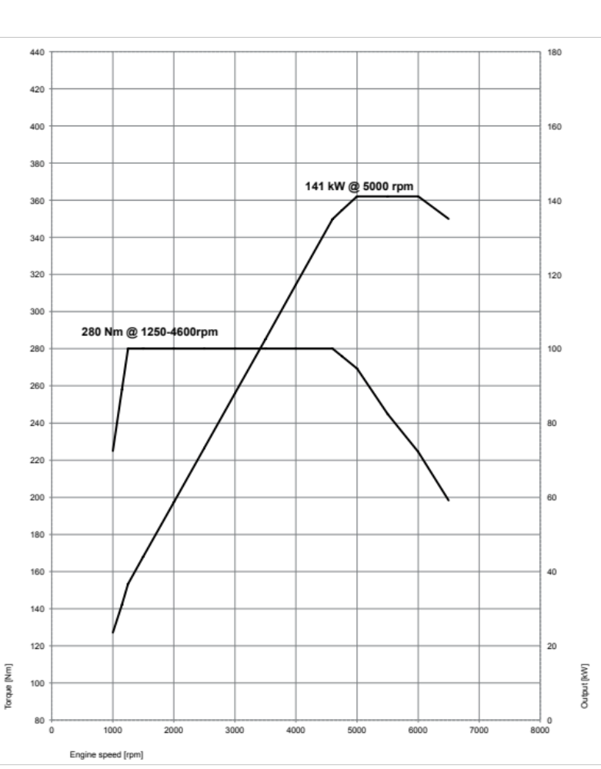

10. Output and torque
diagrams.
BMW X1 sDrive20i,
BMW X1 xDrive20i.
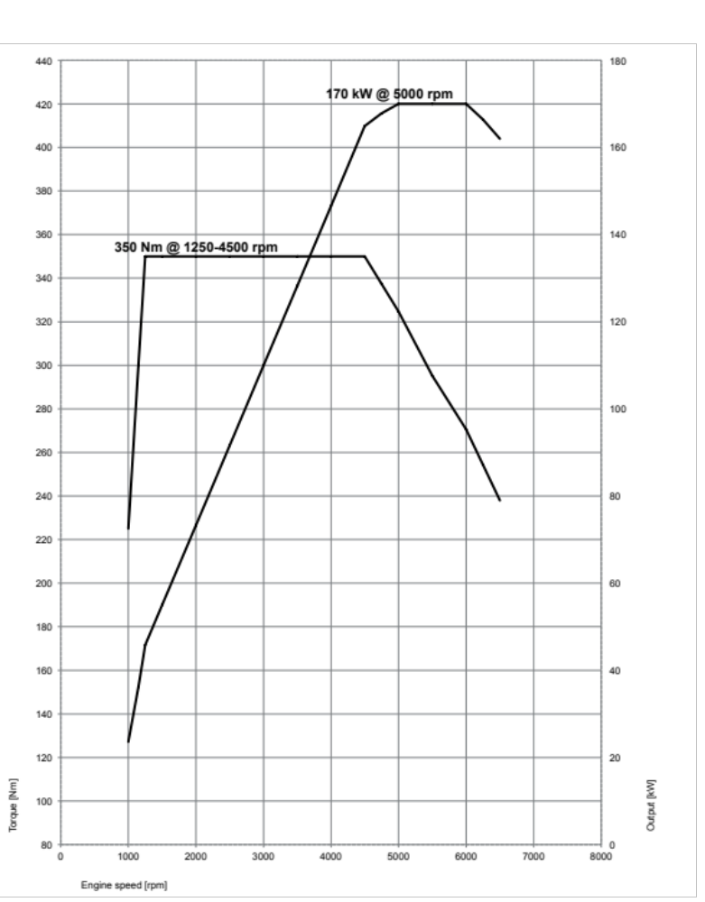

BMW X1 xDrive25i.
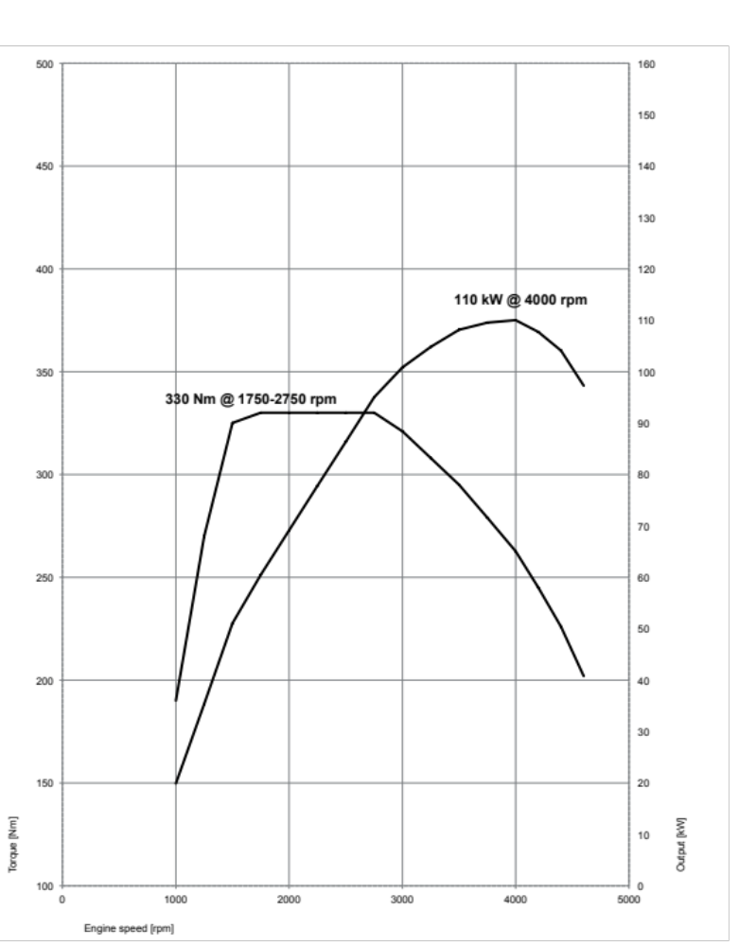

BMW X1 sDrive18d.
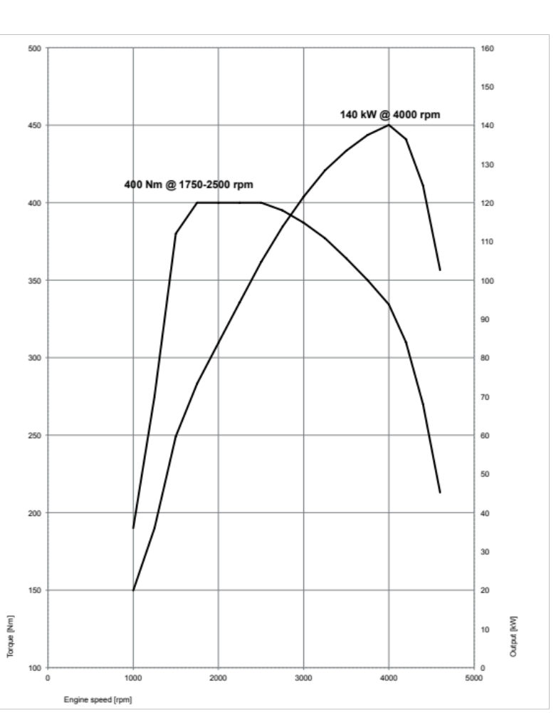

BMW X1 xDrive20d.
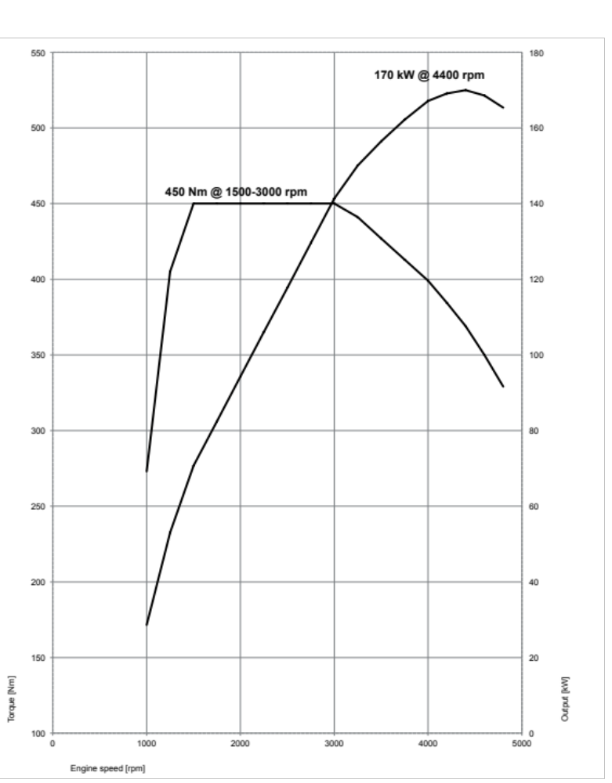

BMW X1 xDrive25d.
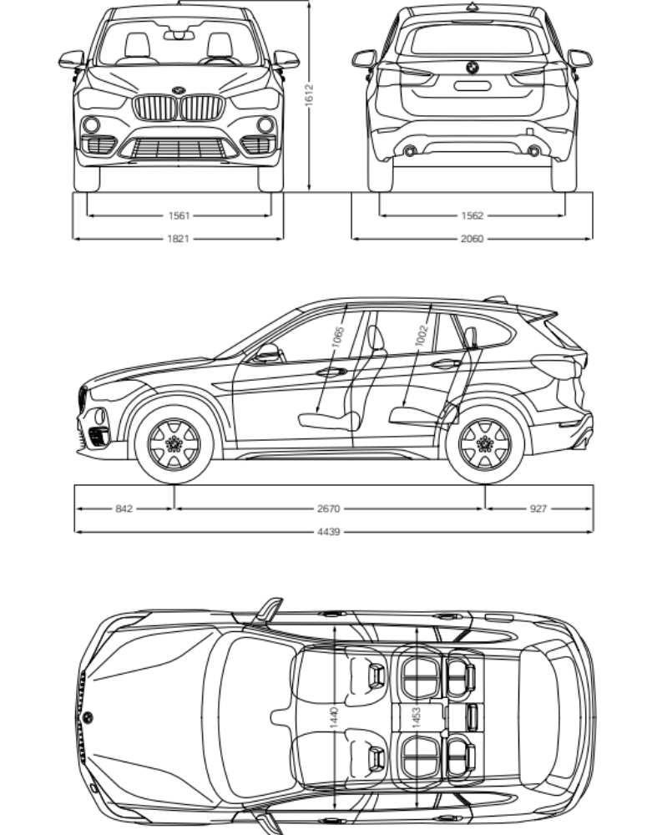

11. Exterior and interior dimensions.
The new BMW X1.

