1. At a glance. 2

The new BMW 7 Series.
Contents.

2. Driving pleasure, luxury and long-distance comfort redefined.
The new BMW 7 Series.
(Short version) 7

3. BMW’s flagship vehicle blazes a trail for innovation:
The sixth generation of the BMW 7 Series. 13

4. The design:
A precision-focused showcase of luxury and innovation. 15

5. BMW EfficientDynamics in the new BMW 7 Series:
Lightweight pioneer, benchmark for efficient driving pleasure. 19

6. Chassis technology and driving experience:
Greater dynamism, more comfort, zero compromises. 25

7. Operation, interior and travel comfort:
Groundbreaking technology for supreme well-being. 28

8. BMW ConnectedDrive in the new BMW 7 Series:
New perspectives in intelligent connectivity. 33

9. Body and safety:
Strong, comfortable, proactive. 37

10. The BMW Individual range for the new BMW 7 Series:
Maximum scope of choice for a personalised style. 39

11. Production:
Consolidated expertise ensures quality and sustainability. 41

12. Specifications. 43

13. Output and torque diagrams. 47

14. Exterior and interior dimensions. 50
- The sixth generation of the luxury BMW sedan with almost four decades of global success under its belt; the new BMW 7 Series blazes a trail for a modern form of automotive luxury that is in keeping with the times but also points the way into the future.

1. At a glance.
- The new BMW 7 Series has a clear claim to luxury segment leadership when it comes to driving dynamics, long-distance comfort, efficiency and driver assistance; exclusive options designed to optimise occupants’ personal sense of well-being inside the car.
- Two body variants with a standard and long wheelbase; authentic reinterpretation of familiar BMW design language; characteristic balance of exclusivity and dynamic flair; impressive precision in the design of details; high-quality materials and exclusive workmanship.
- The M Sport package accentuates the sporting characteristics of the 7 Series in its own distinctive style; the design Pure Excellence and BMW Individual Design Composition packages do likewise for the car’s luxurious side.
- Outstanding commitment to the application of BMW EfficientDynamics technology; unique overall package of BMW EfficientLightweight features, the latest generation of engines, an anticipatory operating strategy and segment-leading aerodynamics.
- BMW EfficientLightweight in the new BMW 7 Series: vehicle weight reduced by up to 130 kilograms compared to predecessor models.
- Carbon Core: extensive use of carbon-fibre-reinforced plastic (CFRP) in the passenger cell – as part of an intelligent material mix – based on the transfer of technology from BMW i.
- New six-cylinder in-line petrol and diesel engines from the BMW Group’s latest generation of power units; further increase in efficiency thanks to the latest BMW TwinPower Turbo technology; extensively updated V8 engine enhances dynamic ability and assurance.
- The BMW 740e has been added to the model range; plug-in hybrid model with combustion engine and BMW eDrive technology from BMW i; total system output: 240 kW, CO₂ emissions according to EU standard: 49 g/km.
- Engine power channelled through an eight-speed Steptronic gearbox with optimised internal efficiency, an increased ratio spread and a gear-change strategy assisted by navigation data.
- New-design standard-fitted Driving Experience Control switch now including ADAPTIVE mode, which adapts the car’s set-up as required to the driving style and the character of the road.
- Unique balance between sporting capability and ride comfort in the luxury sedan segment; both facets of driving pleasure significantly enhanced by the application of sophisticated chassis technology and the interplay of all chassis systems.
- 2-axle automatic self-levelling air suspension and Dynamic Damper Control as standard.
- Additional chassis control system Executive Drive Pro making its debut in the new BMW 7 Series: body roll under dynamic cornering is reduced by electromechanical anti-roll bars; irregularities detected in the road surface are taken into account in damper adjustment.
- Full-LED headlights fitted as standard; anti-dazzle BMW Laserlight with BMW Selective Beam and range doubled from 300 to 600 metres now also available as an option for a BMW model for the first time following its world premiere in the BMW i8.
- Redefinition of the luxurious onboard experience for driver and passengers in the new BMW 7 Series; generous levels of space; exclusive, modern aura; exquisite materials; precision workmanship; newly designed centre console extending into the rear as an option.
- Electrically adjustable comfort seats and the Executive Lounge provide unbeatable long-distance comfort; active seat ventilation and massage function for driver and front passenger with Vitality Programme included for rear seat passengers.
- Heat Comfort package with heated seats and steering wheel, plus heated armrests in the doors, centre console and rear centre armrest.
- Exclusive high-end music enjoyment with Bowers & Wilkins Diamond surround sound system.
- Panorama glass roof Sky Lounge with globally unique light display that can be switched between six colours.
- Ambient light including Welcome Light Carpet for the area in front of the car doors; Ambient highlight can also be ordered for the rear compartment of the new BMW 7 Series with long wheelbase; Ambient Air package (interior scent system) also available.
- Telephony with wireless charging enables inductive charging of mobile phones in the car.
- iDrive operating system gains a touch display for intuitive operation of numerous functions; display and control unit of the optional Automatic air conditioning with 4-zone control system likewise with touch-sensitive capability.
- World premiere for BMW gesture control: 3D sensor allows intuitive and easy interaction with the infotainment system using predefined hand movements.
- Innovative BMW Touch Command multifunction control unit: removable 7-inch tablet computer integrated into the centre armrest or rear console to control comfort, infotainment and communications functions.
- Remote Control Parking using the BMW Display Key.
- New BMW Head-Up Display with 75 per cent larger projection surface on the windscreen.
- Driving Assist now a complete comfort- and safety-enhancing package thanks to the additional functions Rear collision prevention, Lane Change Warning, Speed Limit Info and Rear crossing traffic warning functions.
- Driving Assist Plus now includes comfort-optimising additions: Steering and lane control assistant, Lane keeping assistant with active side collision protection, Traffic jam assistant for semi-automated driving, and Front and rear crossing traffic warning.
- New-generation Surround View system with parallel Top View display function and 3D View in the Control Display, individually selectable perspectives and Panorama Side View to check the traffic situation to the sides of the car (front and rear).
- Model variants:
BMW 750i (BMW 750Li): V8 petrol engine with BMW TwinPower Turbo technology (two TwinScroll turbochargers, direct injection, VALVETRONIC, Double-VANOS).
Capacity: 4,395cc, output: 330 kW at 5,500–6,000 rpm,
max. torque: 650 Nm at 1,800–4,500 rpm.
Acceleration [0–100 km/h]: 4.7 seconds.
top speed: 250 km/h.
Average fuel consumption*: 8.3–8.1 (8.5–8.3) litres per 100 kilometres,
CO₂ emissions*: 194–189 (197–192) g/km, exhaust standard: EU6.
BMW 740i: Six-cylinder in-line petrol engine with BMW TwinPower Turbo technology (TwinScroll turbocharger, direct injection, VALVETRONIC, Double-VANOS).
Capacity: 2,998cc, output: 240 kW at 5,500–6,500 rpm,
max. torque: 450 Nm at 1,380–5,000 rpm.
Acceleration [0–100 km/h]: 5.5 seconds.
top speed: 250 km/h.
Average fuel consumption*: 7.0–6.6 (7.0–6.6) litres per 100 kilometres,
CO₂ emissions*: 164–154 (164–154) g/km, exhaust standard: EU6.
BMW 730d: Six-cylinder in-line diesel engine with BMW TwinPower Turbo technology (turbocharging with variable inlet geometry, common-rail direct injection).
Capacity: 2,993cc, output: 195 kW at 4,000 rpm, max. torque: 620 Nm at 2,000–2,500 rpm.
Acceleration [0–100 km/h]: 6.1 seconds,
top speed: 250 km/h.
Average fuel consumption*: 4.9–4.5 (5.0–4.6) litres per 100 kilometres,
CO₂ emissions*: 129–119 (132–122) g/km, exhaust standard: EU6.
BMW 740e: Four-cylinder in-line petrol engine with BMW TwinPower Turbo technology (TwinScroll turbocharger, direct injection, VALVETRONIC, Double-VANOS).
Capacity: 1,997cc, output: 190 kW at 5,000–6,500 rpm, max. torque: 400 Nm at 1,250–4,800 rpm.
BMW eDrive technology with synchronous electric motor,
output: 70 kW/95 hp, torque: 250 Nm, lithium-ion high-voltage battery.
Total system output: 240 kW.
Acceleration [0–100 km/h]: 5.6 seconds (BMW 740Le: 5.7 seconds, BMW 740Le xDrive: 5.5 seconds),
top speed: >240 km/h,
top speed, electric: 120 km/h (electronically limited);
electric range**: 40 km.
Average fuel consumption**: 2.1 litres/100 kilometres 12.5 kWh/100 kilometres,
CO₂ emissions**: 49 g/km, exhaust standard: EU6.
* Figures according to EU test cycle, may vary depending on the tyre format specified.
** Provisional figures as calculated in the EU test cycle for plug-in hybrid vehicles, may vary depending on the tyre format specified.
All performance, fuel consumption and emissions figures are provisional.

Further information on official fuel consumption figures, specific CO₂ emission values and the electric power consumption of new passenger cars is included in the following guideline: “Leitfaden über Kraftstoffverbrauch, die CO₂-Emissionen und den Stromverbrauch neuer Personenkraftwagen” (Guideline for fuel consumption, CO₂ emissions and electric power consumption of new passenger cars), which can be obtained from all dealerships, from the Deutsche Automobil Treuhand GmbH (DAT), Hellmuth-Hirth-Str. 1, 73760 Ostfildern-Scharnhausen and at http://www.dat.de/en/offers/publications/guideline-for-fuel-consumption.html. LeitfadenCO₂ (GuidelineCO₂) (PDF ‒ 2.7 MB))

With the new BMW 7 Series, BMW has redefined what an exclusive, luxurious driving experience looks like in contemporary, pioneering form. Groundbreaking technologies in the areas of lightweight design, powertrains, chassis, operating systems, intelligent connectivity and interior ambience underline its mission to bring together unbeatable driving pleasure and long-distance comfort in a luxury sedan. The handing over of the baton from one generation to the next at the top end of BMW’s model line-up sees the brand presenting a raft of innovations unmatched by any of its rivals.

2. Driving pleasure, luxury and long-distance comfort redefined.
The new BMW 7 Series.
(Short version)

Key factors in enhancing dynamics, efficiency, comfort and safety while on the move are the use of carbon-fibre-reinforced plastic (CFRP) in the body structure, engines from the BMW Group’s new generation of power units, the plug-in hybrid system in the new BMW 740e, the Executive Drive Pro active chassis system, the Driving Experience Control switch with ADAPTIVE mode and BMW Laserlight. Maximising well-being in the rear compartment, meanwhile, are the Executive Lounge feature with massage function and Vitality Programme, the Sky Lounge Panorama glass roof, the Welcome Light Carpet, the Ambient highlight and a smartphone holder with inductive charging station. Standout innovations in operating system and driver assistance technology include the extension of the iDrive system to include a touch display and BMW gesture control, as well as Touch Command, the new BMW Head-Up Display, crossing traffic warning, the steering and lane control assistant, active side collision protection, Surround View with 3D View and the Remote Control Parking system (from March 2016 production).
Design: stylish presence, assured dynamics, exclusive elegance.
The design of the new BMW 7 Series provides an authentic showcase for the car’s character. Harmonious proportions, a strongly controlled surface design and precise lines point to the stylistic confidence, assured dynamics and exclusive elegance at work here. The optimised balance of driving pleasure and long-distance comfort finds clear expression in the unmistakable aura of the luxury sedan, which is available in both standard and long wheelbase variants.

Characteristic features of the interior include generous levels of space accentuated by its horizontal surfaces and lines, the driver-focused cockpit design, the fusion of exquisite materials and precision craftsmanship and the sophisticated functionality of the control and display elements. The M Sport package, the design Pure Excellence package and a BMW Individual Design Composition will be available for the new BMW 7 Series from launch. They underline the car’s dynamic ability, exclusive elegance and luxurious ambience to great effect, and satisfy the diverse expectations of customers around the world.

“At BMW we believe the future can be predicted most effectively if we’re helping to shape it,” explains Adrian van Hooydonk, Senior Vice President BMW Group Design. “The primary objective in the development of the new car was to create a vision of modern luxury and to exceed our customers’ expectations. In BMW’s eyes, modern luxury is rooted in the most advanced technologies and extremely fine attention to detail. This generation of the BMW 7 Series is the most luxurious, most comfortable and – all round – the best car we have ever built in this class.”
BMW EfficientLightweight: Carbon Core reduces weight by as much as 130 kilograms.
BMW EfficientLightweight helps to reduce the weight of the new BMW 7 Series models by up to 130 kilograms compared to their previous-generation counterparts. At the centre of it all is the body structure with Carbon Core, a product of the transfer of technology from the development of BMW i cars. The new BMW 7 Series is the first car in its segment in which industrially manufactured CFRP combines with steel and aluminium. The intelligent body concept uses this mixed-materials approach to increase the strength and rigidity of the passenger cell while at the same time significantly reducing vehicle weight.
New-generation straight-six engines.
The new BMW 7 Series is available with an extensively updated V8 engine and six-cylinder in-line variants from the BMW Group’s latest generation of power units. All the engines link up as standard with the likewise further developed eight-speed Steptronic transmission.
Plug-in hybrid BMW 740e features BMW eDrive technology.
The addition to the model range of the BMW 740e sees the arrival in the luxury sedan segment of BMW eDrive technology which was first introduced in BMW i cars. The plug-in hybrid model is powered by a four-cylinder petrol engine and an electric motor, which together generate total system output of 240 kW. The BMW 740e records combined fuel consumption of 2.1 litres per 100 kilometres as calculated in the EU test cycle for hybrid vehicles and a combined electric power consumption of 12.5 kWh per 100 kilometres. CO₂ emissions stand at 49 grams per kilometre (provisional). The electric drive system, supplied with energy by a high-voltage lithium-ion battery, provides a noticeable boost for the combustion engines when dynamic acceleration is required. Moreover, the BMW eDrive technology enables all-electric and therefore locally emission-free driving at speeds of up to 120 km/h and with a range of up to 40 kilometres.
Dynamics and ride comfort made to measure – and to the highest standard.
Sophisticated, precision-honed chassis technology and additional chassis control systems – fitted as standard or available as an option – enhance both the dynamics of the new BMW 7 Series and its ride quality. At the same time, the balance between these two facets of driving pleasure reaches a level without parallel in the luxury sedan segment. Standard specification includes 2-axle air suspension with automatic self-levelling and Dynamic Damper Control.

Further enhancing comfort, dynamics, poise and assurance are the latest update of the Integral Active Steering system and the Executive Drive Pro system with active roll stabilisation and data-based predictive function, which is available for the first time. Electromechanical anti-roll bars reduce body roll under dynamic cornering and the active chassis control system adapts the dampers’ responses to ruts and bumps in the road.

The latest wave of innovations offer drivers greater freedom when selecting the perfect set-up for their car; they can opt for even sportier handling or further improved ride comfort, or use the high-efficiency ECO PRO mode. ADAPTIVE mode can now also be activated via the newly designed Driving Experience Control switch. In this setting, the car set-up adapts to driving style and route characteristics.
Intuitive operation with touch display and BMW gesture control.
In the new BMW 7 Series the iDrive operating system’s monitor comes in touch display form for the first time. This means customers will also be able to operate the system in the same way as modern electronic devices. In addition to using the Controller to control the system in familiar style, its functions can also be selected and activated by touching the screen’s surface.

Another new addition to the iDrive system’s functionality is BMW gesture control, which is being introduced for the first time. Hand movements detected by a 3D sensor control infotainment functions in an extremely intuitive and user-friendly fashion. The gestures can be used for a number of functions, including controlling the volume in audio applications and accepting or rejecting incoming telephone calls. There is also the option of pairing a specific gesture with an individual choice of function. Also joining the fray is a new smartphone holder integrated into the centre console, which allows wireless, inductive charging for mobile phones for the first time in a car.
Luxury ambience with all the trimmings: Executive Lounge, Touch Command.
The BMW 7 Series models specified with the optional Executive Lounge, which redefines personal well-being in a luxury car, offer levels of comfort a class apart. This equipment package includes Automatic air conditioning with 4-zone control, Electrically adjustable comfort seats with massage function in the rear and Active seat ventilation for all seats, plus the optional Executive Lounge Seating, Executive Lounge rear console and Rear-seat entertainment Experience with BMW Touch Command. The massage function now also includes the Vitality Programme, which allows rear passengers to engage in active physical exercise for recuperation purposes. The Executive Lounge Seating option increases comfort in the rear seat behind the front passenger seat, which can slide forward by an additional 90 millimetres and has an electrically extendable footrest integrated into its backrest. The rear passenger can unwind into an extremely relaxing position thanks to a backrest which can recline impressively close to the horizontal position.

The Executive Lounge rear console houses a fold-out table, additional cupholders and the Touch Command system (750 Li only). This removable 7-inch tablet computer allows the user to control the infotainment and comfort functions available in the rear of the new BMW 7 Series and can also be used to play back external audio and video files, as a games console or to surf the internet.
Atmospheric touches: Ambient light, Sky Lounge Panorama glass roof.
The exclusive ambience inside the new BMW 7 Series is also enhanced by a precisely arranged lighting design. The Ambient light option now includes the Welcome Light Carpet, which provides eye-catching illumination of the area around the car doors. Another unique feature is the Ambient highlight for the long-wheelbase versions of the new BMW 7 Series, which bathes the rear compartment in an atmospheric light from light sources positioned vertically on the B-pillars.

Long-wheelbase versions of the new BMW 7 Series will also be available with the Sky Lounge Panorama glass roof, which is likewise one of a kind in the luxury sedan segment. When it gets dark, the light emitted from side-mounted LED modules is directed evenly onto the glass surface, where it hits an imprinted graphic. This creates an atmospheric motif mimicking a starry sky.

Another option customers can select to increase the feeling of well-being on board is the Ambient Air package, which ionises the air and generates a selection of eight aromas. Outstanding sound quality, meanwhile, is the speciality of the likewise newly developed Bowers & Wilkins Diamond surround sound system, which has been specifically tuned to the interior of the new BMW 7 Series.
World premiere in the new BMW 7 Series: Remote Control Parking.
The new BMW 7 Series is the world’s first series-produced car that owners will be able to manoeuvre in or out of forward-parking spaces or garages without anyone at the wheel. As such, the Remote Control Parking option allows drivers to access tight parking spaces with ease. The driver initiates the car’s progress forwards into or in reverse out of a space using the likewise newly developed BMW Display Key. While the car is carrying out the semi-automated manoeuvre, the driver watches out for obstacles. This function will be available in South Africa for customers who order their BMW 7 Series vehicles from March 2016 production (arrival in June 2016).
Unique in the luxury sedan segment: BMW Laserlight.
Another new feature in the luxury sedan segment is BMW Laserlight, familiar from the BMW i8. Thanks to BMW Selective Beam, this is dazzle-free and can be specified for the new BMW 7 Series as an alternative to the standard full-LED headlights. The laser headlights generate a particularly bright, pure white light as well as providing a high-beam range of 600 metres, double that of the LED headlights.
Innovative driver assistance systems from BMW ConnectedDrive enhance comfort and safety.
The Steering and lane control assistant, Lane keeping assistant with active side collision protection, Rear collision prevention and Crossing traffic warning functions have been added to the Driving Assist Plus system. Meanwhile, the Traffic jam assistant – which involves semi-automated driving – can be used on any type of road. And the Active Cruise Control with Stop & Go function now only requires drivers to press a button to incorporate speed restrictions detected by the Speed Limit Info function. The new generation of the Surround View system now also includes a 3D View and Panorama Side View option in the Control Display.
Production at BMW Plant Dingolfing: globally unparalleled lightweight design expertise.
The new BMW 7 Series will be built, like all of its predecessors, at BMW Plant Dingolfing. The Dingolfing factory combines its many years of experience in building luxury sedans with globally unmatched expertise in the field of lightweight design. BMW Plant Dingolfing serves as the aluminium competence centre within the BMW Group’s worldwide production network and has now also become the world’s first automotive manufacturing facility in which CFRP is used in body construction as part of a hybrid technique.
• BMW luxury sedans: savouring success for almost 40 years.

3. BMW’s flagship vehicle
blazes a trail for innovation:
The sixth generation
of the BMW 7 Series.
• Flagship models reflect the outstanding development expertise of BMW.
• BMW 7 Series traditionally plays a trailblazing role in innovative design and advanced technology.
The new BMW 7 Series embodies the contemporary yet also future-focused interpretation of exclusive driving pleasure in a luxury car. And it backs up this pioneering character with advanced and, in some cases, never before seen technology designed to help optimise driving dynamics and efficiency, safety, user-friendliness, long-distance comfort and personal well-being. Now, as before, the handover between generations at the top end of the BMW model range is accompanied by the introduction of numerous innovations which reflect the outstanding development expertise of the world’s most successful manufacturer of premium cars.
All variants of the luxury sedan combine enthralling dynamic ability with supreme ride comfort and exceptional efficiency. The new BMW 7 Series offers customers looking at the upper reaches of the sedan market the very finest in interior luxury and breaks new ground in intuitive operation and intelligent connectivity. Its exterior design exudes natural presence and powerful elegance, while the luxurious ambience of the interior is headlined by generous levels of space, innovative equipment features boasting design of rare quality, and carefully selected materials treated by the hand of precision craftsmanship in their every detail.
Characteristic balance of dynamics and comfort.
The harmonious balance between supreme dynamic ability and luxurious long-distance comfort, which hits another new high in the sixth-generation BMW 7 Series, has been a standout feature of the brand’s flagship models for decades now. Besides, the BMW 7 Series has always played a pioneering role when it comes to landmark design and innovative technology later found in other BMW model ranges.
Introduced in 1977 as the successor to the “Große Baureihe” (large series), the BMW 7 Series was the world’s first car to come fitted with an electronic speedometer, and also featured a Check Control display. In 1979 digital engine electronics celebrated their European premiere in the BMW 7 Series. Offered with Germany’s first post-war 12-cylinder engine, Park Distance Control and L-shaped rear lights in the second model generation, and Dynamic Stability Control (DSC) and the first built-in navigation system in its third incarnation, the BMW 7 Series has continued to make waves in the years since in terms of dynamics, safety, connectivity and design.
Innovative talent yields unique qualities.
Every model generation of the BMW 7 Series has seen important foundations laid for the unique attributes which ensure the new car’s status as an architect of innovative driving pleasure and groundbreaking luxury. From the first onboard computer with outside temperature gauge to Park Distance Control and navigation systems, the stream of innovations has continued uninterrupted. And now the latest generation of the car can be ordered with the most diverse range of BMW ConnectedDrive features yet, taking comfort, safety and the options for using infotainment functions to another new level.
Back in its fourth generation, the BMW 7 Series not only established a new, brand-shaping design language with great success, it also put in place the revolutionary iDrive operating system. In the field of ergonomically optimised, safe and user-friendly operating systems, the iDrive principle of intuitive control using a Controller and Control Display has since developed into an automotive industry standard. This competitive edge is strengthened further still in the new BMW 7 Series with a touchscreen function for the onboard monitor and unparalleled BMW gesture control technology.
The BMW 7 Series led the way once again in its fifth model generation by opening the door to BMW EfficientDynamics technology. Fuel consumption-reducing innovations such as Brake Energy Regeneration, the Auto Start Stop function and ECO PRO mode all made their way into the luxury sedan segment through the 7 Series. Moreover, the BMW ActiveHybrid 7 marked the first time an electric drive system and combustion engine had been brought together to deliver efficient driving pleasure.
The introduction of BMW eDrive technology in the new BMW 740e plug-in hybrid signalled the next stage in the electrification of the powertrain. Another element of BMW EfficientDynamics included in the latest BMW 7 Series is the Carbon Core for the passenger cell developed under the BMW EfficientLightweight banner. The use of carbon-fibre-reinforced plastic (CFRP) in the body structure is unique in volume car production worldwide, and the optimisation of weight, torsional rigidity and efficiency achievable as a result offers further evidence of the innovative and exclusive character of the BMW 7 Series.
• Commanding presence, sporting elegance, body lines and a powerfully controlled surface design.

4. The design:
A precision-focused showcase of luxury and innovation.
• Focus on the driver and atmosphere of well-being come together to harmonious effect in the interior.
• Design Pure Excellence and M Sport package allow carefully judged individualisation.
The design of the new BMW 7 Series provides an authentic showcase for a modern interpretation of luxury very much in keeping with the times. The technological progress and myriad innovations which mark out both the driving experience and long-distance comfort of the new BMW 7 Series are reflected in the high-quality appearance of the exterior and interior, every detail of which has been designed with meticulous precision. The design lends emotionally powerful, appeal-enhancing expression to the luxury sedan’s product substance, underpinned as it is by exceptional development expertise. As you’ll know the first time you set eyes on it: the new BMW 7 Series is the flagship model of the current BMW range.
The new BMW 7 Series represents a unique, emotionally rich combination of sporting refinement, exclusive elegance, advanced technology and top-class workmanship. Harmonious proportions, powerfully controlled surfaces and precise lines form a harmonious balance of hallmark BMW dynamics and status-conscious presence. Inside, the new BMW 7 Series envelops its occupants in a luxurious atmosphere of well-being. The designers placed particular importance on creating a consistent overall appearance for the interior. The cabin is framed by predominantly horizontal surfaces and lines, presented in stylistically assured colour and material compositions and generating a relaxed atmosphere in which to while away the miles.
Flagship model with forward-thrusting dynamism and a focused look.
Like its predecessor, the new BMW 7 Series is offered in two body variants. The wheelbase of the extended version of the luxury sedan is 14 centimetres longer, at 3,210 millimetres, and offers extra rear space as a result. At 5,098 millimetres in length (long-wheelbase version: 5,238 mm), 1,902 mm in width and 1,478 (1,485) in height, the new BMW 7 Series is the largest series-produced car the brand has ever built. Both body variants display familiar BMW proportions, headlined by a long bonnet, short front overhang, long wheelbase and set-back passenger compartment. And, helped by their smoothly downward-sloping roofline, they both also exude sporting elegance and a powerful sense of dynamism.
With the clear structure and upright stance of its front-end, the new BMW 7 Series radiates a feeling of assured presence. It is the brand’s first car to feature visible air flap control. The air flap is only open when there is an increased cooling air requirement, remaining closed the rest of the time. This improves aerodynamics as well as giving the front end an even more eye-catching appearance due to the visibly increased number of bars in the large BMW kidney grille. The headlight units extend up as far as the grille, while the light graphic of the familiar BMW twin circular headlights is levelled off at its upper and lower edges, giving the car a purposeful and focused look. Both in standard full-LED form and when optional BMW Laserlight is specified, the headlights have an extremely detailed design that accentuates the sophisticated technology at work. The laser headlights can be identified by a blue-coloured horizontal bar in the centre of the lights.
The bonnet is honed perfectly to fit in with the form of the kidney grille’s upper section, making the build quality of the new 7 Series immediately apparent. The lower air intake stretched wide across the front end, the chrome bars in the outer edges of the intake and the horizontal contours of the LED foglamps underline the car’s broad-set stance.
Powerfully curved surfaces, precisely drawn double swage line.
The prevalence of outward-curving surfaces when the new BMW 7 Series is viewed from the side give the car a powerful, eye-catching appearance. The door handles are incorporated with great precision into the character line, which now takes the form of a double swage line. The wrap-around window frame taking in the Hofmeister kink is a single-piece element for the first time in a series-produced model, highlighting the detail-led quality of the new BMW 7 Series. The Air Breather surround in the front side panel spawns a chrome trim strip which runs along the lower edge of the doors. This creates a high-quality accent, its horizontal form accentuating the car’s finely balanced appearance and low centre of gravity. The exterior mirrors appear to grow organically out of the window frame, a slender stalk providing the sole connection between mirrors and car body. Generating a modern and elegant effect, this design also enhances the aerodynamics of the new BMW 7 Series.
The direction of the double swage line extends into the upper contour of the body and the light strips of the rear lights. This creates a harmonious connection between the side sections of the new BMW 7 Series and the rear end. All the light sources for the tail lights feature LED technology. The two L-shaped light units are connected with one another by a chrome bar extending the full width of the rear end, while another classy detail can be found in the rear apron in the shape of exhaust tailpipes framed by chrome surrounds.
Two non-metallic and nine metallic colour shades are available for the exterior paintwork of the new BMW 7 Series. Another two variants can be ordered exclusively in conjunction with the M Sport package, with four BMW Individual paint finishes and four BMW Individual special paint finishes completing the set. Depending on the model variant, the new BMW 7 Series comes as standard with 18-inch light-alloy wheels, while the options list and Original BMW Accessories range offer a selection of other light-alloy wheels in 18- to 20-inch sizes.
The interior: precision and innovative functionality take driving pleasure and the feel-good ambience to another new level.
The balance of dynamics and comfort so central to the new BMW 7 Series’ character is also reflected in the design of the interior. Unbeatable driving pleasure behind the wheel and an unimpeachable sense of well-being in the rear seats have been created amid a modern and at the same time luxurious ambience. From the slim gearshift lever via the steering wheel and Driving Experience Control buttons to the instrument cluster and Control Display graphics, all the control and display elements share a new design that highlights their innovative functionality. Among the features playing their part here are chrome buttons on the multifunctional steering wheel and centre console, the start/stop button, the electric parking brake and the touchscreen surface for the control panel of the optional Automatic air conditioning with 4-zone control.
The controls on the centre console are – like the interior trim strip – framed by fine wood or aluminium surfaces. Both the trim strips and the instrument panel’s chrome surrounds which border them are made individually for each car; their dimensions are therefore matched to the nearest millimetre. The standard and optional equipment items designed to create a luxurious sense of well-being in the rear of the new BMW 7 Series are marked out by carefully selected materials and build quality defined by precision craftsmanship. Meanwhile, the generous levels of space on board are highlighted by a horizontal surface structure which extends through the door trim. Customers can choose from five colour variants for the standard Dakota leather upholstery, while the optional Exclusive Nappa leather is available in a selection of six colours.
Available from launch: Design Pure Excellence and the M Sport package.
Design and equipment packages available from the launch of the new BMW 7 Series underline the car’s extra sportiness and luxurious comfort to particularly striking effect. The eye-catching and exclusive appearance of the new BMW 7 Series is further enhanced by the design Pure Excellence package, which is available separately for both the exterior and the interior. The sedan’s exterior appearance is lifted another notch by an additional chrome strip above the front foglamps. This feature is joined by matt black-painted brake callipers and a chrome strip for the rear apron, which frames the exhaust tailpipe surrounds and connects them together. An Alcantara headliner, door sill plates in Fine Brushed Aluminium, precise decorative stitching in the lower section of the instrument panel, and fine wood inlays for the seat belt outlet covers, armrest and roof grab handles in the rear bring an inviting and sophisticated aura to the interior. The design Pure Excellence package for the new BMW 7 Series with long wheelbase also includes deep-pile floor mats for the rear compartment.
The M Sport package enables customers to experience the dynamic driving properties of the new BMW 7 Series in even greater depth and also ensures these attributes enjoy clear visual expression. This option includes an M aerodynamic package comprising model-specific front/rear aprons and side skirts, plus 19-inch M light-alloy wheels in twin-spoke design, matt black painted brake callipers, illuminated door sill plates bearing the M logo and accents in either light or dark chrome. M-specific details also underline the sporting character of the new BMW 7 Series in the interior. These include the BMW Individual headliner in Anthracite and the M driver’s footrest, as well as comfort seats in Dakota leather with M-specific piping, the optional Ambient light and Fineline black fine wood interior trim strips with high-gloss metal effect.
- BMW EfficientLightweight with Carbon Core body structure cuts vehicle weight by as much as 130 kilograms.

5. BMW EfficientDynamics
in the new BMW 7 Series:
Lightweight pioneer, benchmark for efficient driving pleasure.
- New straight-six engines, redeveloped V8 powerplant, BMW 740e plug-in hybrid model with BMW eDrive.
- Optimised aerodynamic properties thanks to air flap control system with adjustable kidney grille bars.
The advances achieved with the latest generation of the BMW 7 Series succeed in resolving a number of traditionally conflicting aims: the car comes with an array of new innovations but weighs less, performance is more dynamic but fuel consumption has been reduced, and while it is more luxurious than ever, emissions are lower. This groundbreaking evolution is down to BMW EfficientDynamics technology, comprising the most diverse range of measures ever to have been implemented in one of the brand’s production models. At the same time, the unrivalled expertise derived from the development of BMW i cars has also been harnessed.
The complete package for enhancing driving pleasure and efficiency in the new BMW 7 Series comprises intelligent lightweight design with carbon-fibre-reinforced plastic (CFRP) as part of the BMW EfficientLightweight concept, the first straight-six engines from the BMW Group’s new generation of drive units, together with innovative new solutions for honing energy management and aerodynamic properties. The use of BMW eDrive technology in the BMW 740e plug-in hybrid model constitutes yet another highlight.
Besides BMW EfficientLightweight and state-of-the-art powertrain technology, it is the resource-efficient material selection, new, energy-efficient production processes and further improved arrangements for environmentally friendly recycling that also help the new BMW 7 Series to obtain an exemplary life cycle assessment covering its entire product life. In order to achieve this, gaugeable sustainability targets spanning the vehicle’s entire life cycle were defined in the early strategic phase of development and actively implemented throughout the development process. The environmental impact termed the “greenhouse potential”, which is measured based on the CO₂ emissions produced by everything from the extraction of raw materials through the entire manufacturing and usage phase to recycling at the end of the vehicle’s life, is around 25 per cent lower than in the outgoing model. The results and the life cycle assessment process have been independently certified in accordance with ISO 14040/44 taking the example of a BMW 740Li.
BMW EfficientLightweight: reducing weight by up to 130 kilograms with Carbon Core.
The BMW EfficientLightweight concept means that the models in the new BMW 7 Series line-up are up to 130 kilograms lighter than their predecessors, despite boasting a significantly greater number of comfort and safety features. The key element here is the special body structure known by the name Carbon Core. Thanks to its composite construction featuring CFRP, ultra-high-tensile steels and aluminium, the intelligent body design succeeds in increasing the strength and rigidity of the passenger cell while also bringing about a substantial reduction in vehicle weight. By using a hybrid construction of CFRP with ultra-high-tensile steels for structural elements, such as those in the vicinity of the B-pillars, the design of the sheet-metal components can be adapted to save weight.
The Carbon Core body is based on technology transferred from BMW i car development. The new BMW 7 Series is the first ever vehicle in which industrially manufactured CFRP is used together with steel and aluminium. The BMW Group’s experience and expertise in using carbon fibre in the production of high-volume vehicles in a way appropriate for the material involved is unrivalled in the automotive sector, and the new model reaps the benefits of this while also assuming the role of pioneer in the creation of new possible applications for this high-tech material.
The lightweight design concept additionally entails the use of aluminium for specific sections of the body and chassis along with the systematic improvement of smaller details. Apart from the doors, the bootlid is also made from aluminium for the first time. Thanks to rigorous implementation of lightweight design measures at the wheel suspension, brakes and wheels, it was possible to reduce the unsprung masses that are so decisive for the chassis set-up by as much as 15 per cent, while taking suspension comfort to new heights. Lightweight joining technologies have furthermore been employed together with near-source thermal and acoustic shielding for the engine, which enables the overall volume and therefore the weight of the insulating material required to be reduced. The innovative insulation concept has the additional effect of further improving acoustic comfort.
As a result of this all-encompassing lightweight design approach, the vehicle’s centre of gravity is now even lower and the load is distributed 50 : 50 between the two axles for perfect balance. BMW EfficientLightweight technology thereby helps the BMW 7 Series to consolidate its lead when it comes to dynamic handling accompanied by outstanding ride and acoustic comfort.
Supreme power and intelligent all-wheel drive in the BMW 750i.
The engine line-up available at the launch of the new BMW 7 Series range is spearheaded by a V8 unit that has undergone extensive redevelopment, boasting a displacement of 4.4 litres and BMW TwinPower Turbo technology with the turbochargers located in the V-shaped space between the banks of cylinders in proven fashion. It now comes equipped with TwinScroll turbochargers featuring flow-separated, bank-specific exhaust manifolds made from thin-wall castings. Together with an increase in the compression ratio from 10.0 to 10.5 and the variability in the gas-exchange cycle brought about by the VALVETRONIC and Double-VANOS technology, this has resulted in a major improvement in engine efficiency. The optimised cooling concept with separate flows through the cylinder heads and cylinder barrels combines with a coolant pump whose map-controlled throughput can be restricted to as little as 10 per cent to warm up the engine faster and cut energy consumption. This is also the first time that the intake manifold has been partially integrated into the cylinder head in a production car, thereby allowing flow resistance to be decreased, flow volume to be increased and the exterior packaging dimensions to be reduced. As a result of all these modifications, the efficiency factor of the 330 kW eight-cylinder engine has been greatly improved, which in turn means a significant reduction in fuel consumption and emissions.
New generation, greater efficiency: straight-six petrol and diesel engines in the BMW 740i and BMW 730d.
The six-cylinder in-line engines with BMW TwinPower Turbo technology fitted in the new BMW 7 Series range stem from the BMW Group’s latest generation of engines. The 3.0-litre petrol unit under the bonnet of the BMW 740i produces an output of 240 kW, 5 kW more than the engine it replaces. The new power unit’s crankcase, cylinder head and oil sump are all made from aluminium. The TwinScroll turbocharger features an indirect system of charge air cooling that is incorporated into the intake manifold and works in unison with High Precision Direct Injection, the very latest version of VALVETRONIC and Double-VANOS variable camshaft timing. Not only has the efficiency of the new straight-six engine been increased, its response is even more spontaneous as well.
The diesel unit powering the BMW 730d is 3.0 litres in size and likewise boasts a 5 kW increase in output, in this case to 195 kW, combined with superior efficiency. Peak torque is now 620 Newton metres, which translates into formidable pulling power. The six-cylinder diesel engine also offers an unprecedented level of acoustic comfort. What’s more, fuel consumption and emissions are considerably lower as well thanks to a reduction in weight, improved thermodynamics for the turbocharging system with VNT technology and a new common-rail direct injection system whose piezo injectors now generate a maximum pressure of 2,500 bar.
Luxury sedan with BMW eDrive: the BMW 740e plug-in hybrid model (to be available in South Africa from the third quarter of 2016)..In the case of the plug-in hybrid models, it’s not just the Carbon Core for the passenger cell that is rooted in the know-how gleaned from the development of BMW i cars, but the BMW eDrive powertrain technology as well. The intelligently controlled interaction between a 2.0-litre petrol engine with BMW TwinPower Turbo technology and an electric drive unit integrated into the eight-speed Steptronic transmission endows the BMW 740e with astoundingly dynamic acceleration on the one hand and noticeably lower consumption and emissions figures in everyday driving on the other. While producing a total system output of 240 kW, the luxury sedan returns a combined fuel consumption of 2.1 litres per 100 kilometres in the guise of the BMW 740e (2.3 litres) or a combined electric power consumption of 12.5 kWh. CO₂ emissions come in at 49 grams per kilometre (provisional EU test cycle figures for plug-in hybrid vehicles, may vary depending on the tyre format specified).
The energy for the electric motor is drawn from a lithium-ion high-voltage battery housed underneath the rear seat where it is particularly well protected in the event of a crash. It can be recharged by connecting to any standard domestic power socket or a BMW i Wallbox, as well as at public charging stations. The eDrive button on the centre console lets the driver adjust the hybrid drive’s operating mode. In the AUTO eDrive basic setting, the engine’s power is boosted to notable effect by the electric drive when accelerating or during quick bursts of speed. With the MAX eDrive mode engaged, meanwhile, the BMW 740e is able to run purely on electric power, meaning zero local emissions, at speeds of up to 120 km/h and for a maximum range of 40 kilometres. The driver is also able to select the Battery Control mode, which raises or maintains the high-voltage battery’s state of charge as required. In this way, electrical power can be deliberately conserved for all-electric driving later in the journey. Whenever route guidance is active in the navigation system, the predictive power management function calculates a journey-specific strategy for electric driving through to the entered destination. The standard specification for the BMW 740e furthermore includes an auxiliary heating and ventilation system, which is powered by electricity from the high-voltage battery or from the mains supply while charging.
Eight-speed Steptronic transmission: link-up with navigation system as standard, shift paddles and Launch Control as an optional extras.
The standard-fit eight-speed Steptronic transmission serves to further boost efficiency with its wider ratio spread, reduced weight and optimised efficiency factor. A new transmission control system furthermore makes for more comfortable shifting and allows the transmission to be linked up with the optional Navigation system Professional. The navigation-data-based shift strategy means that the gear selection can be adapted to the driving situation and the route profile even when route guidance is inactive. The shift characteristics are adjusted in accordance with the selected driving mode, so that the emphasis can be placed on both driving comfort and sportiness. An eight-speed Steptronic Sport transmission with shift paddles on the steering wheel is available as an option. Besides more dynamic shifting, this also features a Launch Control function for accelerating away from standstill with maximum power and optimum traction.
Features such as Brake Energy Regeneration and the Auto Start Stop function ensure highly efficient energy management. Activating the ECO PRO mode with the Driving Experience Control switch allows use of the coasting function, which decouples the powertrain in overrun phases while travelling at speeds between 50 and 160 km/h. This mode’s range of functions – which are now individually programmable for the first time – additionally include efficiency-oriented operation of comfort functions, efficiency tips, as well as the Route-ahead Assistant, which gives recommendations for an efficient driving style based on the navigation data.
Unmistakably efficient: Air Breather and adjustable kidney grille bars.
The active air flap control system with adjustable bars in the BMW kidney grille that is being fitted for the first time aids engine cooling in line with requirements in innovative fashion. Whenever more cooling air is required, the additional bars automatically swing open. This combines with the flaps in the lower air intake to allow the supply of air for cooling the engine and brakes to be adjusted in a total of five stages as demands dictate. During the warming-up phase and when operating at low loads, the BMW kidney grille is closed completely to reduce air drag at the front of the vehicle.
Another distinctive efficiency-enhancing feature are the Air Breathers in the front side panels. This is where the air that has first been channelled around the front wheels via the Air Curtains in the front apron for more efficient aerodynamics can be carefully directed out of the wheel arches again. This has the effect of reducing the turbulence around the wheels that has a negative impact on aerodynamics. The reduction in air drag of over 15 per cent compared to the predecessor models has also been achieved thanks to the cladding covering almost the entire underbody, the new contouring of the exterior mirrors, as well as the optionally available light-alloy wheels in a streamlined design.
- 2-axle air suspension and Dynamic Damper Control as standard.

6. Chassis technology and driving experience:
Greater dynamism, more comfort,
zero compromises.
- Executive Drive Pro with active roll stabilisation and anticipatory damper control.
- Driving Experience Control switch includes ADAPTIVE mode for the first time.
Highly sophisticated, precision-honed chassis technology combines with additional standard or optional chassis control systems to give the new BMW 7 Series both sharper driving dynamics and superior ride comfort. At the same time, it succeeds in striking a balance between these two forms of driving pleasure that is quite unique in the luxury sedan segment.
The latest raft of innovations offers drivers more freedom of choice for configuring the ideal vehicle set-up, which means they can now opt for even sportier handling or yet greater ride comfort as they wish. The selection is made using the standard Driving Experience Control switch. For the first time, a new setting can be activated at a touch of this switch, which is programmed for adaptive control of the vehicle set-up as a function of the current driving style and the changing route profile. Thus equipped, the new BMW 7 Series delivers an intense driving experience that is simply in a class of its own, where all of the BMW Group’s outstanding development expertise in the field of chassis technology comes to the fore.
Air suspension and Dynamic Damper Control as standard.
With its double-joint front axle, five-link rear axle and Electric Power Steering, the new BMW 7 Series comes with all the right ingredients for precise, assured and harmonious handling characteristics. The inclusion of a 2-axle self-levelling air suspension as standard furthermore endows the luxury sedan models with notably superior ride comfort. The suspension is supplied with air by an electrically powered compressor with pressure reservoir. This means that even when the engine is switched off, the height of the vehicle body is adjusted to keep it at a constant level regardless of the load being carried. And because the air supply is controlled individually for each wheel, it is even possible to compensate for an unevenly distributed load.
The level control can additionally be operated manually, allowing the vehicle’s ride height to be raised by 20 millimetres when driving along a rough stretch of road or in multistorey car parks with particularly steep ramps, for instance. At speeds above 35 km/h, the level control automatically reverts to its standard setting. When SPORT mode is activated with the Driving Experience Control switch, on the other hand, the ride height automatically drops by 10 millimetres when travelling at high speed.
The advantages of the air suspension at the front and rear axle can be appreciated all the more thanks to the Dynamic Damper Control that likewise comes as standard. The electronically controlled dampers improve ride and suspension comfort at the same time as adding to the sedan’s dynamic handling qualities. A variety of modes can be engaged using the Driving Experience Control switch, which serve to foster either driving comfort (COMFORT, COMFORT+ modes) or sporty, agile handling (SPORT mode).
Premiere for Executive Drive Pro: chassis control system with active roll stabilisation and anticipatory damper control.
The levels of comfort, dynamism and effortlessly superior performance can be elevated further still with an equipment option that is making its debut in the new BMW 7 Series range: Executive Drive Pro. This active chassis control system, which is available for all models with the exception of the BMW 740e, works in unison with the 2-axle air suspension and the Dynamic Damper Control to achieve a remarkable standard of suspension, damping and vibration comfort. It comprises the newly refined version of the Dynamic Drive system for reducing rolling movement at the front and rear axle. For the first time, active roll stabilisation is now carried out electromechanically, allowing the body roll forces to be equalised particularly swiftly and precisely when taking bends at speed. When driving in a straight line, the adjustable anti-roll bars are set so as to allow the suspension system the greatest possible freedom of movement for increased comfort. The comfort-enhancing effect is further heightened by the standard air suspension. What’s more, the new system is also more energy efficient compared to hydraulic control.
Beyond all this, Executive Drive Pro also incorporates an anticipatory chassis control function. The advance information for regulating the combination of chassis systems is gleaned from the driving style analysis readings, the data from the navigation system and a stereo camera, and helps to considerably enhance ride comfort and driving safety.
Further refined Integral Active Steering.
A further refined version of the Integral Active Steering system is available as another optional extra for the new BMW 7 Series. By turning the rear wheels in either the opposing or the same direction when steering, depending on the specific driving situation, this system is capable of increasing both manoeuvrability in urban traffic and agility during high-paced driving, while also ensuring an especially smooth and composed response when changing lane and cornering.
Driving Experience Control switch with ADAPTIVE mode for the first time.
For the first time, an ADAPTIVE mode can also be selected in the new BMW 7 Series via the standard Driving Experience Control switch. With this setting activated, the vehicle set-up is matched to the current driving style and changing route profile in adaptive, clearly perceptible fashion. The control logic reacts to movement of the accelerator and steering wheel, and also factors in whether the gear selector is in the D or S position. Depending on the driving situation, the powertrain and chassis systems are configured for either sporty or comfortable performance. On models fitted with the Navigation system Professional, map data is also taken into account in order to select the ideal vehicle set-up for instance when switching from urban driving to the motorway, on winding roads or when approaching a road junction.
The Driving Experience Control switch located on the centre console now sports a new design. The COMFORT, SPORT, ECO PRO and ADAPTIVE modes can all be activated directly at the push of a button, while the COMFORT button additionally has the COMFORT+ mode stored on it for even greater driving comfort. Drivers have the option of programming an individual configuration for the SPORT and ECO PRO modes via the iDrive operating system. This makes it possible to combine dynamic shift characteristics and direct steering response with comfort-oriented damper tuning, for example, when SPORT mode is engaged. In ECO PRO mode, meanwhile, it is now also possible to individually program the damper control and steering characteristics for greater influence over the driving dynamics, while the extent of the efficiency-enhancing settings can also be modified.
• iDrive operating system now with touchscreen functionality and brand-new BMW gesture control.

7. Operation, interior
and travel comfort:
Groundbreaking technology for
supreme well-being.
• Executive Lounge, Touch Command, Sky Lounge panorama glass roof: relaxing luxury, inspirational flair and supreme control in the rear.
• Smartphone holder with inductive charging, Bowers & Wilkins Diamond surround sound system for the ultimate in listening pleasure.
Innovative flair and a creative spirit turn driving and travelling in a luxury sedan model from the new BMW 7 Series range into a truly inspirational experience. The arrival of the latest generation of the BMW flagship model takes interior design, functionality and passenger well-being to yet greater heights. The new BMW 7 Series once again blazes a trail for intuitive operation. The iDrive system has been consistently refined and now opens up fascinating new ways of using the vehicle, comfort and infotainment functions for driver and passengers alike. The luxurious ambience rooted in lavish spaciousness, fine materials, wonderfully precise styling and superb build quality can also be sensed from all seats. Travel comfort in the rear is taken into a new dimension by the Executive Lounge option, which redefines the meaning of personal well-being in a luxury car.
iDrive operating system with touch display and BMW gesture control.
The iDrive operating system’s monitor comes in the form of a touch display for the first time in the new BMW 7 Series in conjunction with the optional Navigation system Professional. The iDrive system’s operating concept has thereby been expanded to include the method so familiar from consumer electronics devices. Besides the customary means of operation using the Controller, direct access and favourite buttons as well as voice commands, numerous functions can alternatively be selected and activated by touching the screen’s surface. This adds a highly intuitive input method to the iDrive system’s control logic, ensuring supreme ease of operation in any situation.
The iDrive system can furthermore be optionally specified with the addition of BMW gesture control, which is being premiered in the new BMW 7 Series. By making specific hand movements in the vicinity of the centre console, where they are registered by a 3D sensor, commonly used infotainment system functions can be controlled very intuitively and conveniently. The various gestures serve, for instance, to adjust the audio volume, control the 3D view display and accept or reject incoming phone calls. There is also a further set gesture whose associated function can be individually defined from a selection of possible functions, such as navigation to the home address or deactivation of the screen.
BMW gesture control can be used as an alternative to conventional means of operation without the need for separate activation. The availability of this control method is indicated in applicable situations by a corresponding icon in the Control Display.
Multifunctional instrument display, automatic air conditioning with touch control, smartphone integration with inductive charging.
The remaining display and control elements in the new BMW 7 Series likewise stand out for their state-of-the-art, top-class design. The standard-specification instrument cluster in black panel technology comprises four classic circular dials and an 8.8-inch graphic display. There is also the option of a multifunctional instrument display with a 12.3-inch display area, which alters the graphics and colour scheme used for the cockpit gauges to match the mode selected with the Driving Experience Control switch. In COMFORT mode, the instrument cluster display features a classic four-dial arrangement, with a magnifier function to highlight the current speed and rev speed. When ECO PRO mode is activated, the rev counter turns into the EfficientDynamics gauge, which indicates how to maximise efficiency and how the journey is progressing. And with SPORT mode engaged, the entire speedometer is pared down to display just the essential information. The speed and selected gear appear as large digital readouts.
As an alternative to the two-zone automatic air conditioning that comes as standard, another variant is available with four-zone control and a separate control console in the rear. The control panels feature a touch-sensitive surface for the first time. The intensity of the ventilation, the seat climate control functions as well as the fragrance system can all be controlled by touching on-screen buttons. Opting for the Heat Comfort package makes it possible to heat up the steering wheel rim and the armrests in both the doors and the front and rear centre consoles, in addition to the front and rear seats. The Extended rear air-conditioning option for the long-wheelbase models comprises two extra, individually adjustable air vents in the roof liner.
A hands-free phone system complete with Bluetooth audio streaming and USB port is included as standard on the new BMW 7 Series. Besides the optional snap-in adapter for integrating smartphones, a universal holder with an inductive charging facility that is compatible with a range of mobile phones is also available. The Comfort telephony with wireless charging option includes a holder in the centre console with LED charge status display along with a second microphone to optimise the hands-free functionality for the front passenger.
Executive Lounge: a new dimension in travel comfort for passengers in the rear.
With the newly developed Executive Lounge appointments for the rear, the luxurious flair that pervades the interior of the BMW 7 Series can be further enhanced by an unrivalled range of options for travelling in even greater comfort and adding to one’s personal sense of well-being. Exclusively available for the long-wheelbase version of the new BMW 7 Series, the equipment package features Automatic air conditioning with 4-zone control, Electrically adjustable comfort seats and massage function in the rear, plus Active seat ventilation for all seats, along with the options Executive Lounge Seating, Executive Lounge rear console and Rear-seat entertainment Experience including BMW Touch Command.
The massage function for the comfort seats offers a choice of eight programs, each with three different levels of intensity, which are designed to relax and stimulate the muscles in regions of the body that can be individually selected. In the rear, it additionally offers a Vitality Programme that has been specially devised for the new BMW 7 Series and allows the passengers to engage in active training to revitalise the body on longer journeys. The training programme instructions are displayed on the Rear-seat entertainment system screens.
The Executive Lounge Seating provides a superlative standard of travel comfort in the rear seat behind the front passenger seat. The backrest can be reclined to an angle of up to 42.5 degrees, allowing the seat to be moved into an extremely relaxing position. To offer the passenger in the rear even greater legroom, the front passenger seat can be slid forward by an extra 90 millimetres and its backrest tilted all the way forward. For a completely unobstructed view to the front, the head restraint can be folded down as well. An electrically operated fold-out footrest can additionally be found on the back of the front passenger seat. This option will be available from July 2016 production (available at dealer floors from the last quarter of 2016). The Rear-seat entertainment system screen can also be electrically adjusted to the ideal viewing angle for the rear passenger’s current seat position. In addition to all this, the Executive Lounge rear console also features a fold-out table, two cupholders and a storage compartment, as well as the new BMW Touch Command unit.
BMW Touch Command: perfectly connected with the vehicle and the world at large.
An innovative new multifunctional control unit is being offered for the new BMW 7 Series in the form of BMW Touch Command. This removable tablet with a screen diagonal of 7 inches can be used from any seat and even outside the vehicle. It lets the occupants control comfort functions such as seat adjustment, interior lighting and air conditioning, as well as the infotainment, navigation and communication system.
BMW Touch Command is capable of far more, though, as it can also be used to play external audio and video files, as a games console or for surfing the internet. A WiFi hotspot built into the vehicle provides the necessary online connectivity. Any content retrieved from the Rear-seat entertainment menu with the aid of the tablet is shown on the Rear-seat entertainment Experience system’s two 10-inch screens.
The optional extras Automatic air conditioning with 4-zone control, Comfort seats, Active seat ventilation, Massage function, Rear-seat entertainment Experience and BMW Touch Command are also available individually for all variants in the new BMW 7 Series.
Atmospheric highlights: Ambient light, Ambient highlight, Sky Lounge Panorama glass roof (Long wheel base only).
The exclusive atmosphere inside the new BMW 7 Series can be further accentuated by a precision-crafted lighting design. The optional extra Ambient light provides harmonious indirect illumination in the vicinity of the instrument panel, the door beltlines, the map pockets on the front seat backs, and in the footwells. Courtesy lights and illuminated bars on the door sills also form part of the specification. There is a choice of six different colour variants for the lighting effects, which can be selected in the iDrive menu. Beyond this, there is also a Welcome Light Carpet that produces eye-catching lighting graphics in the entrance/exit area with the help of light sources incorporated into the side skirts.
When specified with the optional roller sunblinds for the rear side windows and rear window, the long-wheelbase versions of the new BMW 7 Series are additionally equipped with another new development known as Ambient highlight. Vertically arranged light sources in the B-pillar area illuminate the rear compartment to great effect. The intensity of the lighting can be adjusted by means of contact sensors, as well as from either the iDrive menu or BMW Touch Command.
As an alternative to the electrically operated glass roof that comes as standard in the long-wheelbase versions of the new BMW 7 Series and as an optional extra in all other models, a two-section Panorama glass roof with an opening front section is also available. There is yet another option in the form of the Sky Lounge Panorama glass roof that is quite unique in the luxury sedan segment. With this version of the roof, the light emitted by LED modules along the sides in the dark is spread evenly throughout the glass surface. Here, it strikes an imprinted graphic creating the magical effect of a starlit sky. As with the Ambient light, there is a choice of six different colour schemes for the lighting pattern. Both the moving glass section and the interior liner are electrically operated on all glass roof variants.
The optional Ambient Air package offers yet more scope for enhancing one’s personal sense of well-being. It comprises functions for ionising the air and fragrancing the vehicle interior with selected scents, both of which can be controlled from the air conditioning control console or the iDrive menu. Three levels of intensity can be set for the fragrancing, and there is a choice of eight scents in all, two of which can be applied in the vehicle at the same time.
Perfect listening pleasure: Bowers & Wilkins Diamond surround sound system.
The Bowers & Wilkins Diamond surround sound system offered as an option for the new BMW 7 Series makes it possible to experience a new dimension in listening pleasure while enjoying the in-car entertainment programme. A fully active 10-channel amplifier with an output of 1,400 watts and 16 partially illuminated speakers together produce an exceptionally precise and wonderfully rich sound in the cabin. In the process, dynamic sound equalizing with three analogue crossovers ensures uniform acoustic performance delivered to all seats.
The system also enables the sound setting to be matched to the selected entertainment genre. The five acoustic scenarios on offer include, for example, “Concert”, which reproduces the acoustics experienced in a concert hall, and the “Cinema” setting, which provides cinema-like acoustics when watching a movie on the Rear-seat entertainment system.
• New BMW Head-Up Display: 75 per cent larger projection area on windscreen.

8. BMW ConnectedDrive
in the new BMW 7 Series:
New perspectives in intelligent connectivity.
• World debut in the new BMW 7 Series: Remote Control Parking.
• Innovations for enhanced safety and semi-automated driving: Crossing traffic warning, Active side collision protection, Steering and lane control assistant.
The BMW 7 Series has always been a trendsetter in the field of intelligent connectivity. This top-of-the-line BMW model range pioneered landmark innovations such as the onboard computer with outside temperature display in 1980, Park Distance Control in 1991 and a built-in navigation system in 1994. With the most extensive range of BMW ConnectedDrive assistance systems and mobility services ever offered for a BMW, the new generation of the luxury sedan is now set to widen its lead. The latest innovations once again take comfort, safety and the infotainment experience to unbeatable levels for a passenger car. The new BMW 7 Series is offered with a wide range of all-new or optimised assistance systems, including semi-automated driving systems. Also unmatched by any other brand in the world is the number of functions that can be integrated in the car using apps, either via the built-in SIM card or a smartphone. These functions can be operated using the iDrive control system.
In conjunction with the optional Navigation system Professional, and courtesy of the embedded BMW ConnectedDrive Services SIM card, the Real Time Traffic Information function can be used. The SIM card also allows over-the-air automatic navigation map updating for a selected region. Alternatively and additionally, customers can download the entire map database from the BMW ConnectedDrive portal. In both cases, updating is free of charge for the first three years after the vehicle is first registered. Intelligent connectivity in the new BMW 7 Series also supports interactive traffic sign updating – a world-first function not offered by any other vehicle manufacturer. Images of roadside traffic signs recorded by the optional Speed Limit Info camera, along with their position data, are relayed anonymously to a BMW server, which then makes any necessary changes to keep the map database up-to-date at all times. BMW 7 Series drivers who activate this function are helping to keep the navigation database accurate, reliable and up-to-date not only for themselves but also for all BMW ConnectedDrive customers.
BMW Head-Up Display: optimised graphics, larger projection area.
By presenting information in graphical format on the windscreen, the BMW Head-Up Display acts as a highly effective aid to driver concentration. This optional system projects information about road speed, speed limits, overtaking restrictions, Check Control messages, status and warning messages from other assistance systems, turn-by-turn directions and telephone and entertainment menus directly into the driver’s field of vision, where they can be read without looking away from the road. The new-generation Head-Up Display comes with a 75 per cent larger projection area, while the displayed information and images offer further improved quality and detail. The graphics are in full colour.
A world first: Remote Control Parking; plus a further improved BMW Park Assistant.
The new BMW 7 Series is the first production car in the world that can be manoeuvred into and out of forward parking or garage spaces without the driver even having to be sitting inside the vehicle, courtesy of the optional Remote Control Parking system that takes the strain out of parking in narrow or confined spaces. The parking manoeuvre – forwards into or in reverse out of the space – is activated by the driver from outside the vehicle using the likewise new BMW Display Key and then performed semi-autonomously by the vehicle. The vehicle moves forward when entering the space, while the exit manoeuvre is performed in reverse. While parking is taking place, the driver must keep a watch for obstructions and if necessary bring the vehicle to a controlled stop. Remote Control Parking can only be activated when the vehicle is positioned centrally in front of the selected parking space. Also, the distance the vehicle is allowed to travel in driverless mode when entering and leaving the parking space is limited to 1.5 times the length of the vehicle. This will be offered to customers in South Africa from March 2016 production.
Park assist is also provided for drivers sitting inside the vehicle. The new version of the optional Park Assist makes light work of selecting and manoeuvring into parallel or forward parking spaces. It controls the entire manoeuvre into the parking space, including all the necessary steering, gear-shifting, acceleration and braking operations. Active Park Distance Control also assists the driver during manual reversing manoeuvres. By autonomously braking the vehicle at the appropriate moment, it helps prevent collisions with any obstacle to the rear of the vehicle.
Driving Assist and Driving Assist Plus: now with new functions for further improved comfort and safety.
The optional Driving Assist safety package has now been extended to include Rear collision prevention and Rear crossing traffic warning. Both these functions use data supplied by sensors at either side of the rear of the vehicle. To reduce the risk of a rear collision, a rapid-flashing warning is used to draw the attention of following traffic whenever such a risk is identified. If it is no longer possible to prevent a collision, the Active Protection system is engaged, and automatically performs functions such as pulling the seat belts tight and closing the side windows and sunroof. The second function, crossing traffic warning, assists drivers when backing out of parking spots in situations where there is a poor or impeded view of traffic. The warning takes the form of audible alerts and a visual alert in the Control Display. If the optional reversing camera is fitted, the extended view of the traffic situation behind the vehicle is shown in the Control Display. The Driving Assist package also includes the Approach control and Person Warning with light city braking function, Lane Change and Lane Departure Warning and Speed Limit Info with no-overtaking indicator.
The deluxe Driving Assist Plus package also includes not only Active Cruise Control with Stop & Go function and front crossing traffic warning, but also the Steering and lane control assistant including Traffic jam assistant and Lane keeping assistant with active side collision protection. These functions use a stereo camera and front and side radar sensors to detect lane markings, preceding vehicles or approaching side or rear traffic. At speeds up to 210 km/h they provide comfort-enhancing steering assistance to help drivers stay in lane or follow the preceding vehicle. The Steering and lane control assistant can be used independently of Active Cruise Control on all types of road. The various systems can also help to prevent collisions with approaching side or rear traffic during a lane change. The Traffic jam assistant also ensures more relaxed, stress-free driving in stop-go traffic on all types of road. This semi-automated driving function provides comfort-enhancing steering assistance whenever the driver has at least one hand on the steering wheel.
Active Cruise Control with Stop & Go function has also been extended. When this system is active, drivers can simply press a button to acknowledge speed restrictions detected by Speed Limit Info. The speed setting is then adapted to comply with the detected speed limit.
The full picture: BMW Night Vision with Dynamic Light Spot, 3D Surround View.
Night driving enjoyment and safety can be enhanced with the optional systems Adaptive LED headlights with BMW Selective Beam, for maximised high-beam usage, and BMW Night Vision. The Night Vision system, which includes pedestrian and animal protection and a marker light, relays a real-time image to the Control Display showing people, larger animals and other heat-radiating objects. The detected objects are also spotlighted by a headlight beam.
In the Control Display, the new generation of the Surround View system can now show not only a Top View mode but also a 3D View mode, as well as a Panorama View showing side traffic in the areas in front of and behind the vehicle. The 3D View mode shows the vehicle and its environment from various perspectives to aid safe manoeuvring in confined, low-visibility situations.
• Integral safety concept including pedestrian protection.

9. Body and safety:
Strong, comfortable, proactive.
• Comfort Access with hands-free tailgate opening and closing.
• BMW Laserlight with BMW Selective Beam: innovative, anti-dazzle headlight technology available for the first time in a luxury sedan.
The innovative lightweight design concept behind the new BMW 7 Series’ body structure with Carbon Core makes significant advances not just in terms of weight optimisation but also in enhancing the strength and stiffness of the passenger cell. The integral safety concept comprises not only highly resilient supporting structures but also generous deformation zones and precisely defined load paths that ensure forces generated in an impact are diverted and absorbed extremely effectively.
Reliable protection in all conceivable impact situations is also guaranteed by a comprehensive safety equipment package featuring front and side airbags, head/curtain airbags for the front and rear seats, active head restraints, three-point inertia-reel seat belts with belt force limiters and belt tensioners in the front seats, as well as ISOFIX child seat mountings in the rear. If a collision threatens, the optional Active Protection system activates the belt tensioners and, if necessary, closes the side windows and the glass roof. The seat backrests are also brought into an upright position to ensure the restraint systems work to best effect.
With the aim of optimising pedestrian protection, the new BMW 7 Series – depending on market and model specifications – features an active bonnet. In the event of a collision with a pedestrian or cyclist, a pyrotechnic trigger is actuated which automatically raises the bonnet by 60 millimetres at the back to extend the deformation zone and reduce the risk of injury when hitting particularly hard structures in the engine compartment.
Variable and convenient use of the boot.
The new BMW 7 Series also underlines its credentials as a vehicle for luxury long-distance travel with its spacious, convenient and variable-use luggage compartment. Under the standard electrically operated tailgate a broad, level load space opens up offering luggage capacity of 515 litres. The optional through-loading system provides an aperture into the cabin measuring 20 centimetres wide and 24 centimetres high.
The boot in the BMW 740e models likewise features a level surface and provides 420 litres of space, which far exceeds that of comparable plug-in hybrid models in the luxury sedan segment. Extra stowage space can be gained by lowering the cover in the rear section of the boot and opening the side storage compartments.
A further option is Comfort Access, which includes hands-free opening and closing of the boot lid. Activated by moving a foot under the rear apron, this facilitates loading and unloading bulky items. There is also the option of the Automatic Soft Close function for the doors as well as a trailer tow hitch with electrically swivelling tow ball.
Anti-dazzle laser headlights make their debut in the luxury sedan segment.
Another crucial factor for safe and comfortable driving is the advanced lighting technology of the new BMW 7 Series. The luxury sedan is equipped as standard with full-LED headlights, and LED foglamps and Adaptive headlights are optionally available.
The new BMW 7 Series is also the first car in its segment to come with the option of innovative laser headlights including BMW Selective Beam. BMW Laserlight, which had its production-model world premiere in the BMW i8, provides a high-beam range of 600 metres. Compared to the already extraordinarily powerful LED headlights featured as standard, this signifies a doubling of the range. The risk of dazzling oncoming or preceding road users is reliably excluded by the integrated BMW Selective Beam anti-dazzle High-beam assistant.
The conversion of the beams emitted by tiny laser diodes means that these innovative headlights generate a pure-white, extremely bright light. The laser diodes and reflectors are very compact in design, low in weight and low in power requirement, with energy efficiency exceeding that of the already highly efficient LED headlights by around 30 per cent.
• BMW Individual Design Composition with exclusive paint finish and interior design.

10. The BMW Individual range
for the new BMW 7 Series:
Maximum scope of choice
for a personalised style.
• Perfection as the benchmark for material selection and processing.
• Total customer focus: one-offs from the BMW Individual Manufactory.
The choice of a new BMW 7 Series car signifies the fulfilment of the highest expectations of driving pleasure, luxury and long-distance comfort in an automobile. The technology, design and equipment of the latest model generation are a reflection of the exceptional innovative prowess of the world’s most successful premium car manufacturer. Beyond this, the BMW Individual programme specially devised for the latest edition of the luxury sedan gives the driver the opportunity to combine the technological highlights with a vehicle design that is precision-tailored to his or her personal style.
All the BMW Individual features available for the exterior and exterior of the new BMW 7 Series meet the highest quality standards attainable in car manufacturing in terms of design, material selection and quality of workmanship. Expressive paintwork colours, exclusive light-alloy wheels, choice wood and leather variants and other high-quality details available as ex-factory options underline the exclusive and forward-looking character of these sedans. Additional customer requests based on personal preferences are met by the BMW Individual Manufactory.
Exclusive style in perfect harmony: BMW Individual Design Composition for the new BMW 7 Series.
The market launch of the new BMW 7 Series will be accompanied by a BMW Individual Design Composition that is made up of a perfectly harmonious combination of colours and materials. BMW Individual paintwork in the new Almandine Brown metallic variant shows off the characteristic surface sculpting and bodywork lines to particularly striking effect through its extraordinary brilliance, intriguing iridescent effects and impressive sense of depth. It is combined with the premium features of the exterior design Pure Excellence. Sporting elegance in a particularly exclusive guise is also conveyed by the 20-inch forged BMW Individual light-alloy wheels in V-spoke design that come a in Silver/Ferric Grey bi-colour look with mixed tyres.
The interior appointments of the BMW Individual Design Composition comprise BMW Individual fine-grain Merino full leather in the colour variant Tartufo, which is available for the first time. During the manufacture of this leather upholstery, carefully selected, unblemished raw materials are processed using particularly gentle techniques. As a result, the leather used for the seats, door trim panels, lower instrument panel section, centre console, armrests and door pulls retains its natural open-pore structure. The soft, fine-grain surfaces remain breathable and provide supreme comfort. Hand-woven piping and woven-look quilting on the seat surfaces lend expression to the precision workmanship and love of detail that defines the production process. To match this, the floor covering and floor mats, seat belts and BMW Individual Alcantara headliner also come in Tartufo. The harmonious and stylish ambience is capped by door sills with illuminated BMW Individual lettering, BMW Individual interior trim strips in Piano Finish Black and a BMW Individual leather steering wheel with fine-wood applications in the same finish.
In addition to these, the BMW Individual Design Composition includes selected equipment features that specifically highlight the comfortable and luxurious driving experience in the new BMW 7 Series. They include Comfort access, the Rear view camera, the BMW Head-Up Display, Surround View, the Panorama glass roof, sun blinds and Ambient highlight in the rear, as well as Comfort seats and Active seat ventilation in the front, Comfort seats in the rear, Automatic air conditioning with 4-zone control, the Heat Comfort package, the Harman Kardon surround sound system and the Rear-seat entertainment Experience.
BMW Individual single options as an expression of style and quality awareness.
Beyond all this there are numerous single options in the BMW Individual programme that reflect a quality and style awareness. Available for the new BMW 7 Series are, among other options, the BMW Individual high-gloss Shadow Line for the exterior, the BMW Individual Anthracite headliner, the BMW Individual Alcantara headliner and BMW Individual rear reading lights with gimbal-mounted light sources in the headliner. The newly developed version of the BMW Individual cool box for the rear comes in a particularly compact design. It is integrated in the rear seat backrest, where it can be conveniently opened when the centre armrest is folded down. Due to its reduced dimensions, the cool box encroaches only minimally on boot space. Indeed, the new BMW Individual cool box can be taken out of the boot with a simple hand movement, restoring full luggage capacity.
• BMW Group, Plant Dingolfing: production site for the BMW 7 Series luxury Sedans since 1977.

11. Production:
Consolidated expertise ensures quality and sustainability.
• State-of-the-art production methods enable intelligent mixed-material bodies based on Carbon Core.
• Comprehensive lightweight design and sustainability concept determine material selection and processing.
Since the production start of the first model generation in 1977, the BMW 7 Series luxury sedans have been rolling off the assembly lines of BMW Group Plant Dingolfing. The latest BMW 7 Series is likewise being built at this location which, within the BMW Group’s global production network, not only ranks as a tradition-rich manufacturing facility for BMW’s top-of-the-line models, but also plays an important role as a centre of competence for lightweight construction. For example, the aluminium bodies for Rolls-Royce models are produced in Dingolfing, as are drive and chassis components for other BMW production plants. The factory in Lower Bavaria supplies both the aluminium chassis and the high-voltage batteries – along with other electric drive components – for the BMW i models which are assembled at BMW Group Plant Leipzig.
The expertise amassed in the development of innovative production methods for weight-optimised vehicle components is now also flowing into the BMW 7 Series’ lightweight Carbon Core-based body concept as part of the BMW EfficientLightweight programme. During production of the new BMW 7 Series at the Dingolfing plant, a unique hybrid construction method is being applied that combines carbon-fibre-reinforced plastic (CFRP) with aluminium as well as ultra-high-strength steels for structural elements in the passenger cell. The latest generation of the luxury sedans also benefit from the direct application of highly advanced drive technology. The high-voltage battery for the BMW 740e plug-in hybrid model will likewise come from Dingolfing.
Unique Carbon Core body structure.
For the first time, CFRP combined with steel and aluminium is being used in the body structure of the new BMW 7 Series, with completely new production processes applied in this unique mixed-material construction. The CFRP roof frame, for example, is being built for the first time as a core-free, closed structural element, bringing both the extreme strength of the material as well as its weight advantage fully to bear. This enhances the torsional stiffness of the passenger cell and lowers the vehicle’s centre of gravity, so that both safety and driving dynamics benefit from the use of high-tech CFRP and the innovative production methods.
Another first is the combined use of ultra-high-tensile and hot-stamped steels in conjunction with CFRP for safety-related parts of the body. This likewise improves body stiffness further while at the same time reducing weight. During the paint process, the drying method and temperature management, above all, are adapted to the specific requirements of the new material mix.
All-embracing sustainability concept: CFRP production using water power, extensive use of recycled materials.
In the interests of achieving maximum possible sustainability across the vehicle’s entire life cycle, resource-saving processes are also at the core of the production of the new BMW 7 Series. Energy requirements for the manufacture of carbon fibre are 100 per cent covered by renewable resources, with hydropower providing the electricity for the carbon fibre plant in Moses Lake, USA. Innovative recycling processes are applied, moreover, so that parts of the CFRP components are made from offcuts, for instance.
Beyond this, modern methods of secondary aluminium use are available, with the recycled light alloy displaying the same attributes as the original material. Around 50 per cent of the aluminium used in cast components of the new BMW 7 Series comprises secondary material. On the thermoplastics front, some 20 per cent of the material used is recycled. The inner lining of the boot lid as well as parts of the door trim are made from the natural fibre kenaf – a first for a model bearing the BMW badge.
More than nine million premium vehicles built.
BMW Group Plant Dingolfing began building cars for the premium brand in 1973. Since that time, more than nine million vehicles have rolled off the production lines. Plant Dingolfing currently employs 17,500 staff and 800 trainees, who together turn out around 1,600 cars a day. Alongside the new BMW 7 Series, these include BMW 5 Series and BMW 6 Series models, the BMW 4 Series Gran Coupe, the BMW 3 Series Gran Turismo and the BMW M5, as well as all body styles of the BMW M6.
12. Specifications.
BMW 740i.
 |  | BMW 740i
Body
No. of doors/seats |  | 4 / 5
Length/width/height ¹⁾ (unladen) | mm | 5098 / 1902 / 1478
Wheelbase | mm | 3070
Track, front/rear | mm | 1618 / 1646
Ground clearance | mm | 135
Turning circle | m | 12.3
Tank capacity | approx. ltr | 78
Engine oil ²⁾ | ltr | 6.5
Weight, unladen. to DIN/EU | kg | 1725 / 1800
Max. load to DIN | kg | 675
Max. permissible weight | kg | 2400
Max. axle load, front/rear | kg | 1135 / 1320
Max. trailer load,  braked (12%)/unbraked | kg | 2100 / 750
Max. roof load/towbar download | kg | 100 / 100
Luggage comp. capacity | ltr | 515
Air resistance | c_{d} x A | 0.24 x 2.41
Engine
Config./No. of cyls./valves |  | In-line / 6 / 4
Engine technology |  | BMW TwinPower Turbo technology: TwinScroll turbocharger, High Precision Injection, VALVETRONIC fully variable valve control, Double-VANOS variable camshaft timing
Effective capacity | cm³ | 2998
Stroke/bore | mm | 94.6 / 82.0
Compression ratio | :1 | 11.0
Fuel |  | min RON 91
Output | kW/hp | 240 / 326
at | rpm | 5500 – 6500
Torque | Nm | 450
at | rpm | 1380 – 5000
Electrical System
Battery/Installation | Ah/– | 105 / luggage comp.
Alternator | A/W | 180 / 2520
Driving Dynamics and Safety
Suspension, front |  | Double track control arm axle with separate lower track arm level,  aluminium, small steering roll radius, anti-dive, air suspension with automatic self-levelling
Suspension, rear |  | Five-link axle, aluminium, with steering function, anti-squat and anti-dive, double acoustic separation, air suspension with automatic self-levelling
Brakes, front |  | Four-piston fixed-calliper disc brakes, vented
Brakes, rear |  | Single-piston floating-calliper disc brakes, vented
Driving stability systems |  | Standard: DSC incl ABS and Dynamic Traction Control (DTC), Cornering Brake Control (CBC), Dynamic Brake Control (DBC), Dry Braking function,  Fading Compensation, Start-Off Assistant, Dynamic Damper Control
Safety equipment |  | Standard: airbags for driver and passenger, side airbags for driver  and passenger, head airbags for 1st and 2nd seat row, three-point inertia-reel belts on all seats, integrated at the front with belt tightener and  belt force limiter, crash sensors, tyre pressure indicator
Steering |  | Electric Power Steering (EPS)  with Servotronic function, optional: Integral Active Steering
Steering ratio, overall | :1 | 16.9
Tyres, front/rear |  | 225/60 R17 99Y
Rims, front/rear |  | 7.5J x 17 light alloy

 |  | BMW 740i
Transmission
Type of gearbox |  | 8-speed Steptronic transmission
Gear ratios I | :1 | 5.000
II | :1 | 3.200
III | :1 | 2.143
IV | :1 | 1.720
V | :1 | 1.314
VI | :1 | 1.000
VII | :1 | 0.822
VIII | :1 | 0.640
R | :1 | 3.456
Final drive | :1 | 3.077
Performance
Power-to-weight ratio (DIN) | kg/kW | 7.2
Output per litre | kW/ltr | 80.1
Acceleration 0–100 km/h | s | 5.5
in 5th gear 80–120 km/h | s | –
Top speed | km/h | 250
BMW EfficientDynamics
BMW EfficientDynamics standard features |  | Brake Energy Regeneration with recuperation display, Electric Power Steering, Auto Start Stop function, Optimum Gearshift Indicator, ECO PRO mode with coasting function and Proactive Driving Assistant, BMW EfficientLightweight, optimised aerodynamic attributes, active air flap control, on-demand operation of ancillary units, map-controlled oil pump, disengageable climate compressor, differential with optimised warm-up behaviour, tyres with reduced rolling resistance
Fuel consumption EU cycle³⁾
With standard tyres
Urban | ltr/100 km | 9.1
Extra-urban | ltr/100 km | 5.2
Combined | ltr/100 km | 6.6
CO₂ | g/km | 154
With rims 8J x 18 and tyres 245/50 R18, with rims 8.5J x 19 and tyres 245/45 R19 as well as winter tyres
Urban | ltr/100 km | 9.4
Extra-urban | ltr/100 km | 5.3
Combined | ltr/100 km | 6.8
CO₂ | g/km | 159
With rims 8.5J x 19 front, 9.5J x 19 rear and tyres 245/45 R19 front, 275/40 R19 rear,
With rims 8.5J x 20 front, 10J x 20 rear and tyres 245/40 R20 front, 275/35 R20 rear.
Urban | ltr/100 km | 9.7
Extra-urban | ltr/100 km | 5.5
Combined | ltr/100 km | 7.0
CO₂ | g/km | 164
Emission rating |  | EU6

Specifications apply to ACEA markets; data relevant to homologation applicable in part only to Germany (weight)

¹⁾ Height with roof fin: 1612 millimetres
²⁾ Oil change
³⁾ Fuel consumption and CO₂ emissions depend on the selected tyre formatt

BMW 730d.
 |  | BMW 730d
Body
No. of doors/seats |  | 4 / 5
Length/width/height ¹⁾ (unladen) | mm | 5098 / 1902 / 1478
Wheelbase | mm | 3070
Track, front/rear | mm | 1618 / 1646
Ground clearance | mm | 135
Turning circle | m | 12.3
Tank capacity | approx. ltr | 78
Engine oil ²⁾ | ltr | 6.5
Weight, unladen, to DIN/EU | kg | 1755 / 1830
Max. load to DIN | kg | 695
Max. permissible weight | kg | 2450
Max. axle load, front/rear | kg | 1175 / 1340
Max. trailer load,  braked (12%)/unbraked | kg | 2100 / 750
Max. roof load/towbar download | kg | 100 / 100
Luggage comp. capacity | ltr | 515
Air resistance | c_{d} x A | 0.24 x 2.41
Engine
Config./No. of cyls./valves |  | in-line / 6 / 4
Engine technology |  | BMW TwinPower Turbo technology: turbocharger with variable inlet geometry, common-rail direct injection with piezo injectors  (max. injection pressure: 2500 bar)
Effective capacity | cm³ | 2993
Stroke/bore | mm | 90.0 / 84.0
Compression ratio | :1 | 16.5
Fuel |  | diesel
Output | kW/hp | 195 / 265
at | rpm | 4000
Torque | Nm | 620
at | rpm | 2000 – 2500
Electrical System
Battery/Installation | Ah/– | 105 / luggage comp.
Alternator | A/W | 180 / 2520
Driving Dynamics and Safety
Suspension, front |  | Double track control arm axle with separate lower track arm level,  aluminium, small steering roll radius, anti-dive, air suspension with automatic self-levelling
Suspension, rear |  | Five-link axle, aluminium, with steering function, anti-squat and anti-dive, double acoustic separation, air suspension with automatic self-levelling
Brakes, front |  | Four-piston fixed-calliper disc brakes, vented
Brakes, rear |  | Single-piston floating-calliper disc brakes, vented
Driving stability systems |  | Standard: DSC incl ABS and Dynamic Traction Control (DTC), Cornering Brake Control (CBC), Dynamic Brake Control (DBC), Dry Braking function,  Fading Compensation, Start-Off Assistant, Dynamic Damper Control
Safety equipment |  | Standard: airbags for driver and passenger, side airbags for driver  and passenger, head airbags for 1st and 2nd seat row, three-point inertia-reel belts on all seats, integrated at the front with belt tightener and  belt force limiter, crash sensors, tyre pressure indicator
Steering |  | Electric Power Steering (EPS)  with Servotronic function, optional: Integral Active Steering
Steering ratio, overall | :1 | 16.9
Tyres, front/rear |  | 225/60 R17 99Y
Rims, front/rear |  | 7.5J x 17 light alloy

 |  | BMW 730d
Transmission
Type of gearbox |  | 8-speed Steptronic transmission
Gear ratios I | :1 | 5.000
II | :1 | 3.200
III | :1 | 2.143
IV | :1 | 1.720
V | :1 | 1.313
VI | :1 | 1.000
VII | :1 | 0.823
VIII | :1 | 0.640
R | :1 | 3.478
Final drive | :1 | 2.563
Performance
Power-to-weight ratio (DIN) | kg/kW | 9.0
Output per litre | kW/ltr | 65.2
Acceleration 0–100 km/h | s | 6.1
in 5th gear 80–120 km/h | s | –
Top speed | km/h | 250
BMW EfficientDynamics
BMW EfficientDynamics standard features |  | Brake Energy Regeneration with recuperation display, Electric Power Steering, Auto Start Stop function, Optimum Gearshift Indicator, ECO PRO mode with coasting function and Proactive Driving Assistant, BMW EfficientLightweight, optimised aerodynamic attributes, active air flap control, on-demand operation of ancillary units, map-controlled oil pump, disengageable climate compressor, differential with optimised warm-up behaviour, tyres with reduced rolling resistance
Fuel consumption EU cycle³⁾
With standard tyres
Urban | ltr/100 km | 5.3
Extra-urban | ltr/100 km | 4.0
Combined | ltr/100 km | 4.5
CO₂ | g/km | 119
With rims 8J x 18 und Reifen 245/50 R18, with rims 8.5J x 19 and tyres 245/45 R19 as well as winter tyres
Urban | ltr/100 km | 5.5
Extra-urban | ltr/100 km | 4.2
Combined | ltr/100 km | 4.7
CO₂ | g/km | 124
With rims 8.5J x 19 front, 9.5J x 19 rear and tyres 245/45 R19 front, 275/40 R19 rear,
With rims 8.5J x 20 front, 10J x 20 rear and tyres 245/40 R20 front, 275/35 R20 rear.
Urban | ltr/100 km | 5.8
Extra-urban | ltr/100 km | 4.4
Combined | ltr/100 km | 4.9
CO₂ | g/km | 129
Emission rating |  | EU6

Specifications apply to ACEA markets; data relevant to homologation applicable in part only to Germany (weight)

¹⁾ Height with roof fin: 1612 millimetres
²⁾ Oil change
³⁾ Fuel consumption and CO₂ emissions depend on the selected tyre formatt

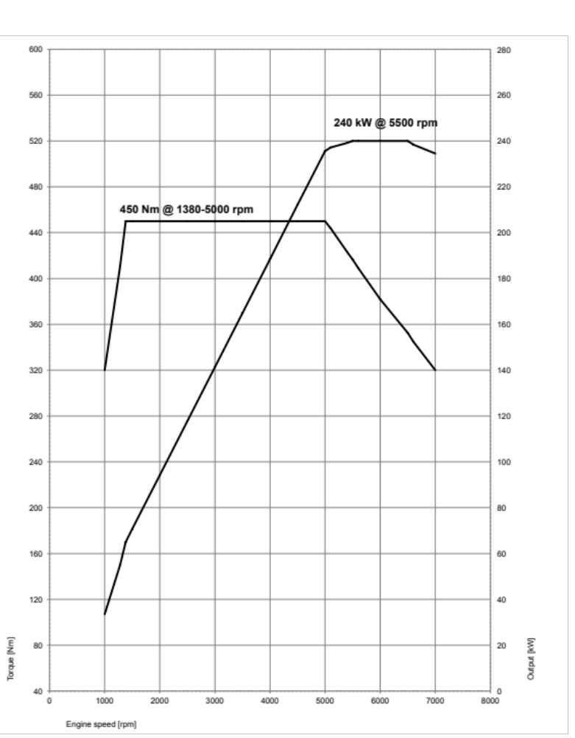

13. Output and
torque diagrams.
BMW 740i.
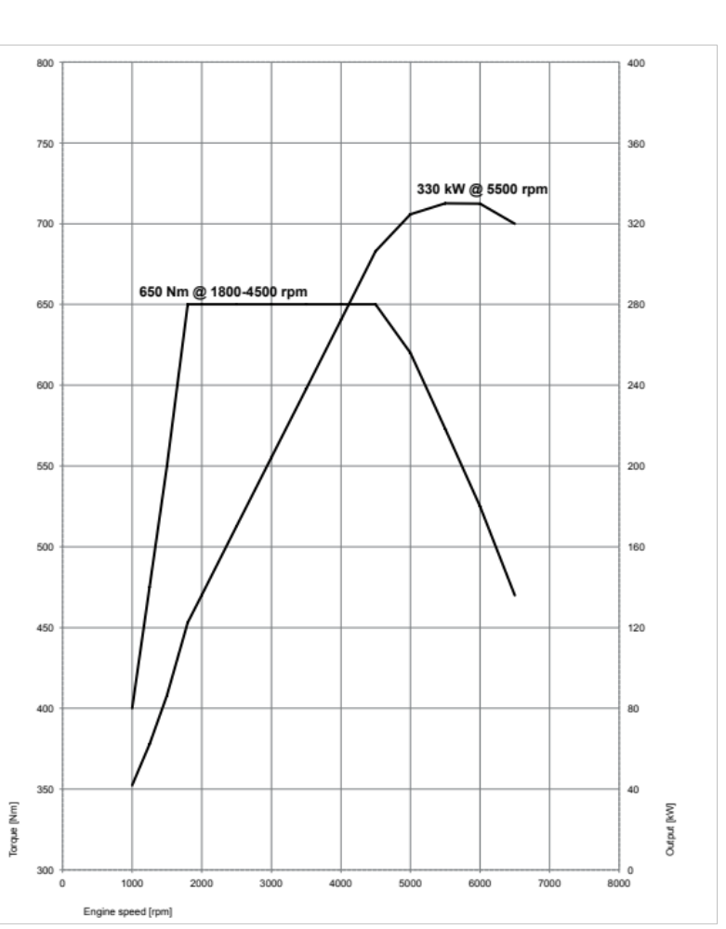

BMW 750i.
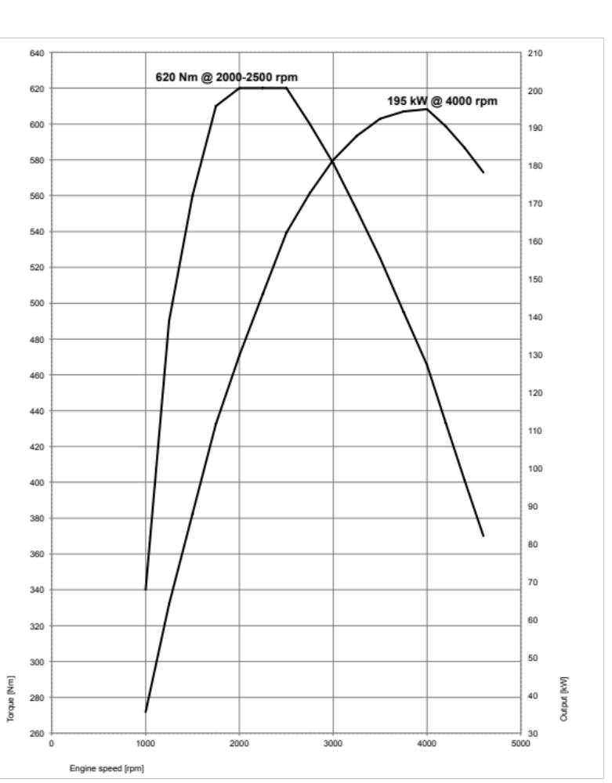

BMW 730d.
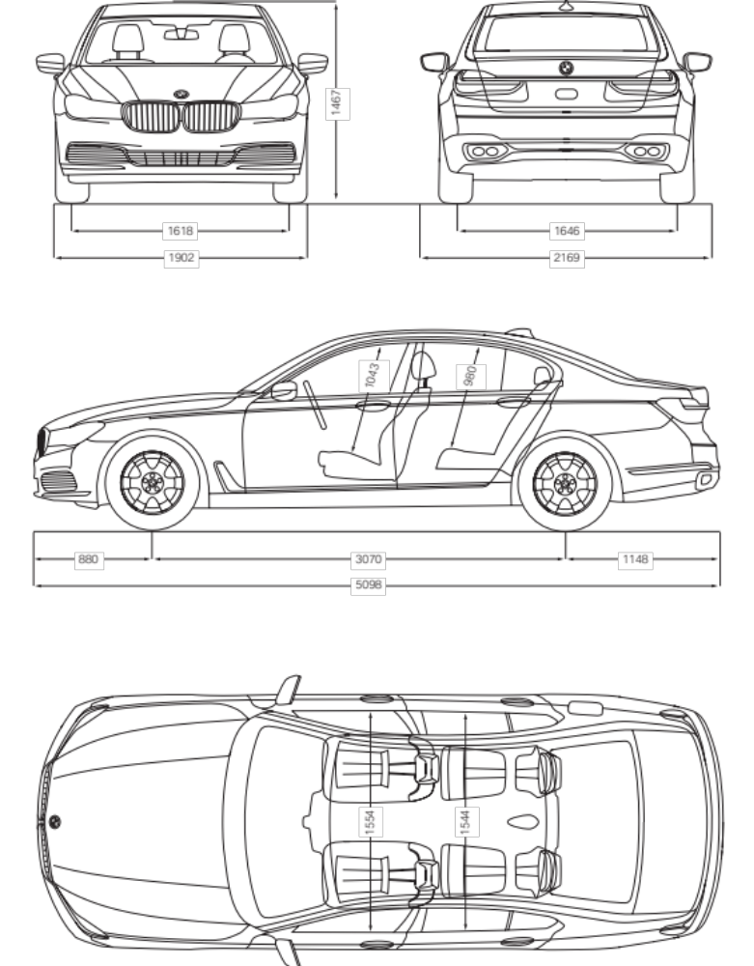

14. Exterior and interior dimensions.
The new BMW 7 Series.
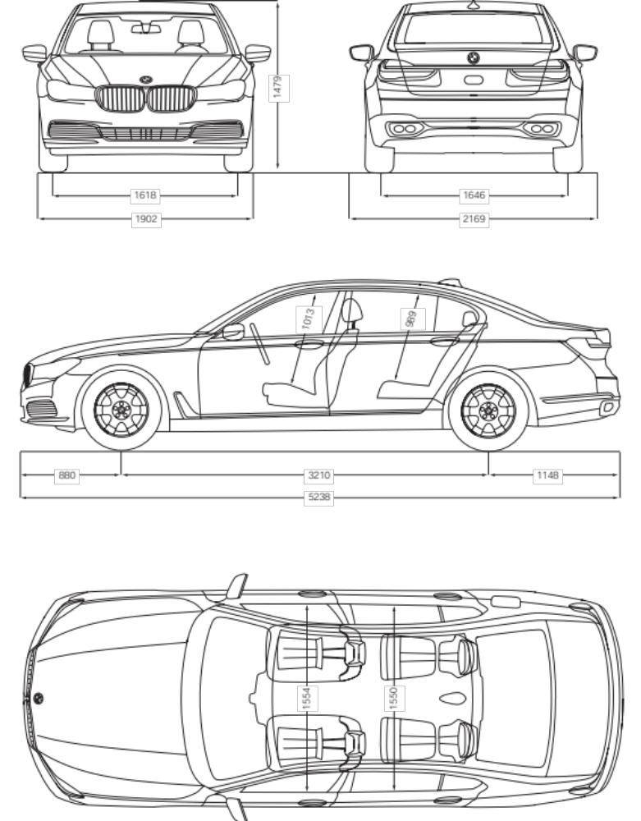

The new BMW 7 Series
long-wheelbase version.

