The new BMW 5 Series Sedan.

Highlights.
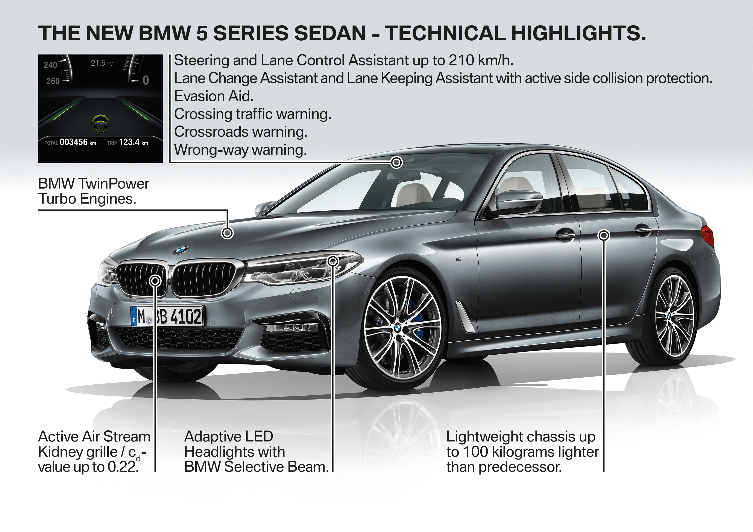
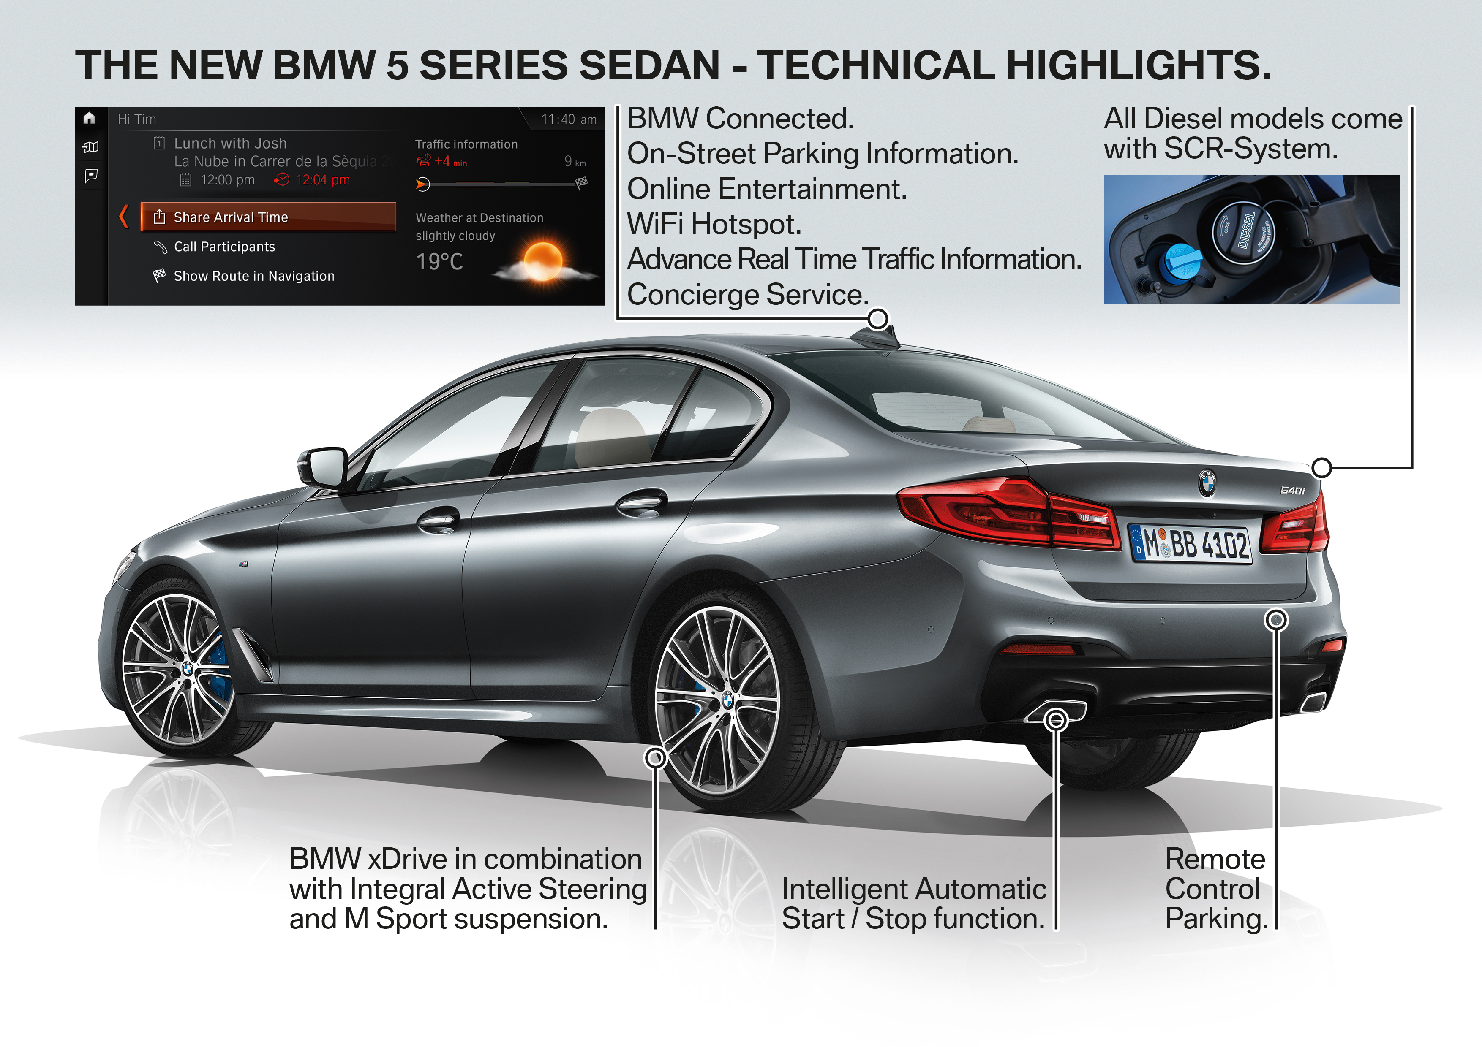
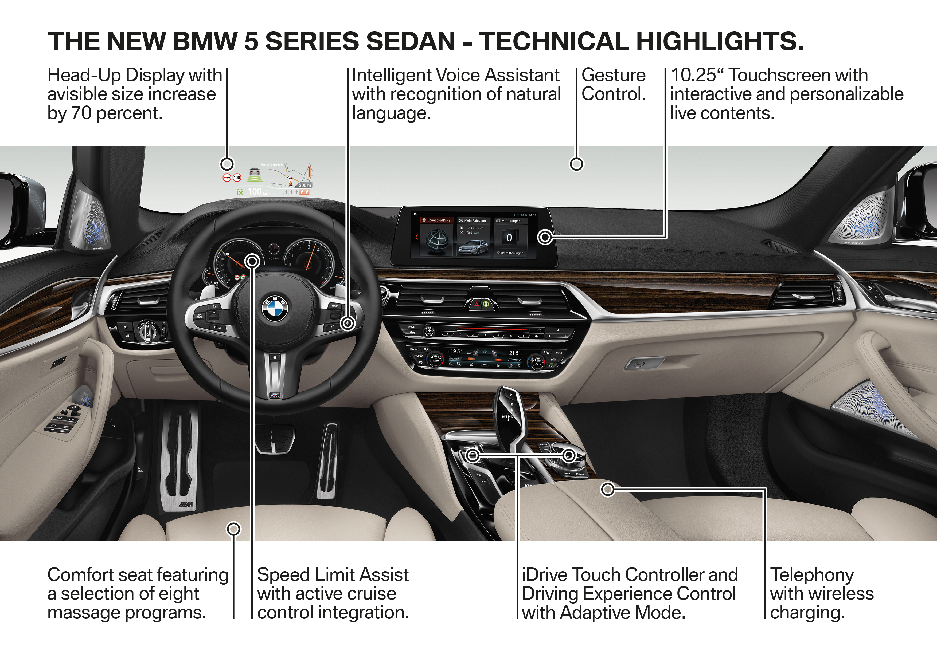
- The new BMW 5 Series model range is the seventh generation of the world’s most successful business sedan.
- Dynamically stretched silhouette, eye-catching front end. Slight increase in exterior dimensions to 4,935 millimetres in length, 1,868 millimetres in width and 1,466 millimetres in height. Generous feeling of space with greater head- and legroom in the rear and more boot space (530 litres).
- BMW EfficientLightweight lightweight construction concept lowers the vehicle weight by up to 100 kilograms over the outgoing model.
- The new 5 Series is BMW’s most aerodynamically efficient model range. A drag coefficient as low as Cd = 0.22 sets the sedan benchmark.
- Newly designed chassis with new damper technology and lightweight braking system. Driving dynamics unmatched in its class, thanks to features including BMW xDrive intelligent all-wheel drive and Integral Active Steering.
- Enhanced efficiency, with fuel consumption down by as much as 12 per cent. The BMW 520d EfficientDynamics Edition (launch: 3/2017 – not for South Africa) has combined fuel economy of 3.8 l/100 km* and CO₂ emissions of 102 g/km.
- Launch on 11 February 2017 with four engine variants (four- and six-cylinder units, petrol and diesel), rear-wheel drive or BMW xDrive intelligent all-wheel drive. An SCR system is standard on all diesels. Only rear-wheel drive models will be made available in South Africa.
- Plug-in hybrid drive system available from 3/2017. The BMW 530e iPerformance develops a system output of 185 kW, offers an electric range of 45 kilometres, and has fuel consumption of 2.0 l/100 km* and CO₂ emissions of 46 g/km.
* Fuel consumption and range figures are provisional and calculated according to the EU test cycle. Figures may vary depending on the tyre format specified.
- All models except the BMW 520d send their power as standard through an eight-speed Steptronic automatic transmission with optimised internal efficiency and a gear-change strategy assisted by navigation data.
- Exceptional display/operating concept; latest-generation iDrive system with 10.25-inch touchscreen. Vehicle systems operated using the Controller, touchscreen, voice commands or BMW gesture control. Large control “tiles” display the content of the underlying menus in constantly updated form and can be arranged as the user desires.
- Full-colour third-generation BMW Head-Up Display with 70 per cent larger, high-resolution projection surface.
- Extensive portfolio of assistance systems represents another step towards automated driving. The Steering and Lane Keeping Assistant, for example, works at up to 210 km/h. Other new assistance functions are Lane Change Assistant and Intelligent Speed Assist (incorporating speed restrictions into the cruise control system), the evasion aid, Crossing traffic warning, Priority warning and Lane Keeping Assistant with active side collision protection. Networked BMW vehicles flag up approaching dangers.
- Display Key enables functions such as remote-controlled parking to facilitate the use of very tight parking spaces.
- Benchmark connectivity with extensive BMW ConnectedDrive technology, including BMW Connected Onboard. Services such as On-Street Parking Information (OSPI) and ParkNow help users search for a parking space. Syncing of calendar, emails and contact details via Microsoft Exchange.
- LED daytime driving lights, and LED dipped/high beam headlights come as standard. Adaptive LED Headlights with variable light distribution and BMW Selective Beam anti-dazzle high beam with a range of up to 500 metres are available as an option.
- New interior acoustic concept including sound absorbers integrated into the headliner and acoustic glazing for the windscreen.
- Electric seat adjustment using touch-sensitive sensors. Optional multifunction seat with 20 air chambers offers eight massage programs.
- Optional Bowers & Wilkins Diamond surround sound system with diamond dome tweeters, brilliant sound quality and 1,400 watts of output.
- Fully wireless integration of smartphones via inductive charging, Apple CarPlay and a WiFi connection for up to 10 devices.
* Fuel consumption figures were calculated according to the EU test cycle and may vary depending on the tyre format specified. Figures for BMW xDrive in brackets.
Model variants at market launch on 11 February 2017 (March 2017 in South Africa).
BMW 530i: Four-cylinder petrol engine, eight-speed Steptronic transmission.
Capacity: 1,998cc.
Output: 185 kW at 5,200 – 6,500 rpm.
Maximum torque: 350 Nm at 1,450 – 4,800 rpm.
Acceleration (0–100 km/h): 6.2 s (6.0 s).
Fuel consumption, combined: 5.4 l/100 km (5.7 l/100 km)*.
CO₂ emissions, combined: 126 g/km (133 g/km).
BMW 540i: Six-cylinder petrol engine, eight-speed Steptronic transmission.
Capacity: 2,998cc.
Output: 250 kW/340 hp at 5,500 – 6,500 rpm.
Maximum torque: 450 Nm at 1,380 – 5,200 rpm.
Acceleration (0–100 km/h): 5.1 s (4.8 s).
Fuel consumption, combined: 6.5 l/100 km (6.7 l/100 km)*.
CO₂ emissions, combined: 150 g/km (156 g/km).
BMW 520d: Four-cylinder diesel engine, eight-speed Steptronic transmission.
Capacity: 1,995cc.
Output: 140 kW at 4,000 rpm.
Maximum torque: 400 Nm at 1,750 – 2,500 rpm.
Acceleration (0–100 km/h): 7.7 s/7.6 s (7.6 s).
Fuel consumption, combined: 4.1 l/100 km / 4.0 l/100 km (4.2 l/100 km)*.
CO₂ emissions, combined: 108 g/km / 107 g/km (112 g/km).
BMW 530d: Six-cylinder diesel engine, eight-speed Steptronic transmission.
Capacity: 2,993cc.
Output: 195 kW at 4,000 rpm.
Maximum torque: 620 Nm at 2,000 – 2,500 rpm.
Acceleration (0–100 km/h): 5.7 s (5.4 s).
Fuel consumption, combined: 4.5 l/100 km (4.7 l/100 km)*.
CO₂ emissions, combined: 118 g/km (125 g/km).
* Fuel consumption figures were calculated according to the EU test cycle and may vary depending on the tyre format specified. Figures for BMW xDrive in brackets
Model variants from March 2017.
BMW 530e iPerformance: Four-cylinder petrol engine plus BMW eDrive electric drive system (plug-in hybrid), eight-speed Steptronic transmission.
Capacity: 1,998cc.
System output: 185 kW at 4,460 – 6,500 rpm.
Maximum system torque: 420 Nm at 1,450 – 4,000 rpm.
Acceleration (0–100 km/h): 6.2 s.
Electric range: 45 km*.
Fuel consumption, combined: 2.0 l/100 km*.
CO₂ emissions, combined: 46 g/km.
BMW 520d EfficientDynamics Edition (not for South Africa): Four-cylinder diesel engine, eight-speed Steptronic transmission
Capacity: 1,995cc.
Output: 140 kW at 4,000 rpm.
Maximum torque: 400 Nm from 1,750 rpm.
Acceleration (0–100 km/h): 7.5 s.
Fuel consumption, combined: 3.9 l/100 km*.
CO₂ emissions, combined: 102 g/km.
BMW M550i xDrive (not for South Africa): Eight-cylinder petrol engine, eight-speed Steptronic transmission.
Capacity: 4,395cc.
Output: 340 kW at 5,500 rpm.
Maximum torque: 650 Nm from 1,800 rpm.
Acceleration (0–100 km/h): 4.0 s.
Fuel consumption, combined: 8.9 l/100 km.
CO₂ emissions, combined: 204 g/km.
* Fuel consumption and range figures are provisional and calculated according to the EU test cycle. Figures may vary depending on the tyre format specified.

Further information on official fuel consumption figures, specific CO₂ emission values and the electric power consumption of new passenger cars is included in the following guideline: “Leitfaden über Kraftstoffverbrauch, die CO₂-Emissionen und den Stromverbrauch neuer Personenkraftwagen” (Guideline for fuel consumption, CO₂ emissions and electric power consumption of new passenger cars), which can be obtained from all dealerships, from Deutsche Automobil Treuhand GmbH (DAT), Hellmuth-Hirth-Str. 1, 73760 Ostfildern-Scharnhausen and at http://www.dat.de/en/offers/publications/guideline-for-fuel-consumption.html. LeitfadenCO₂ (GuidelineCO₂) (PDF ‒ 2.9 MB)

