The new BMW X2.

Highlights.
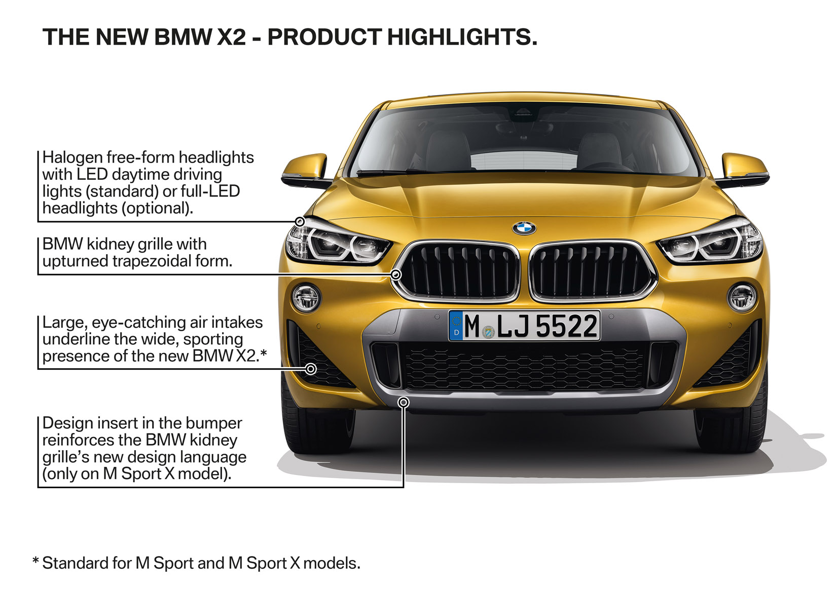
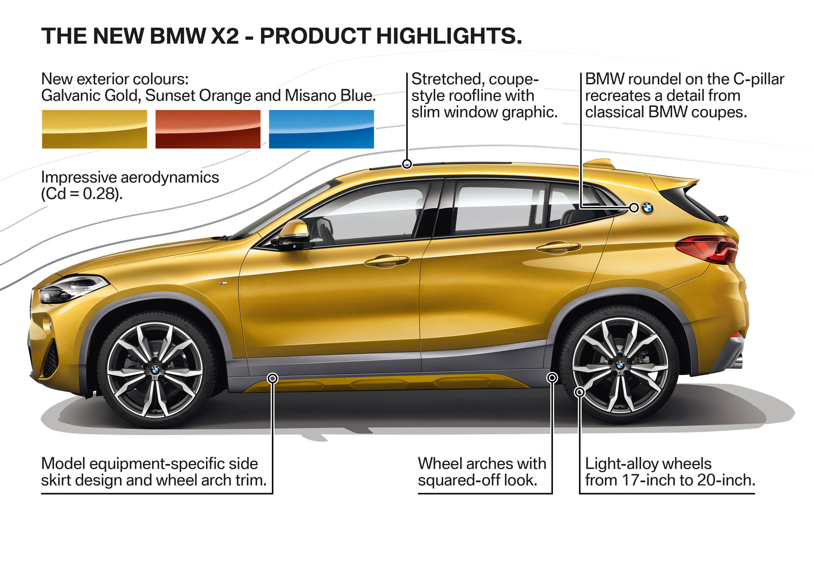
Only the M Sport and M Sport X packages offered in SA – standard 19-inch wheels.
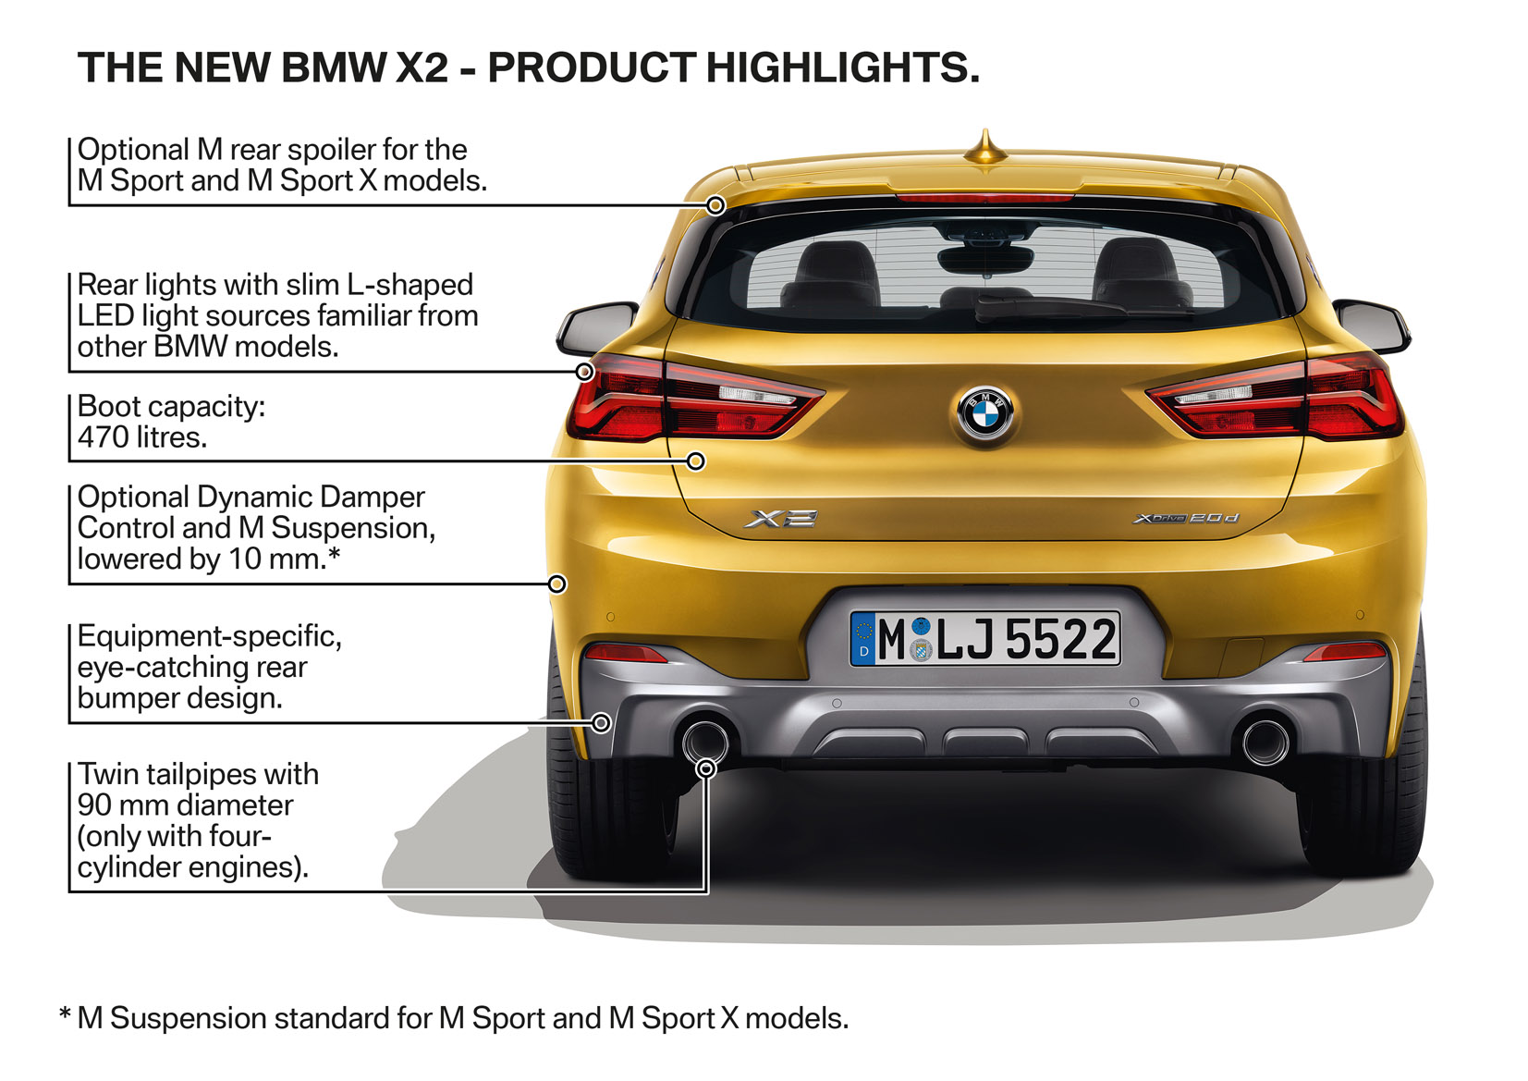

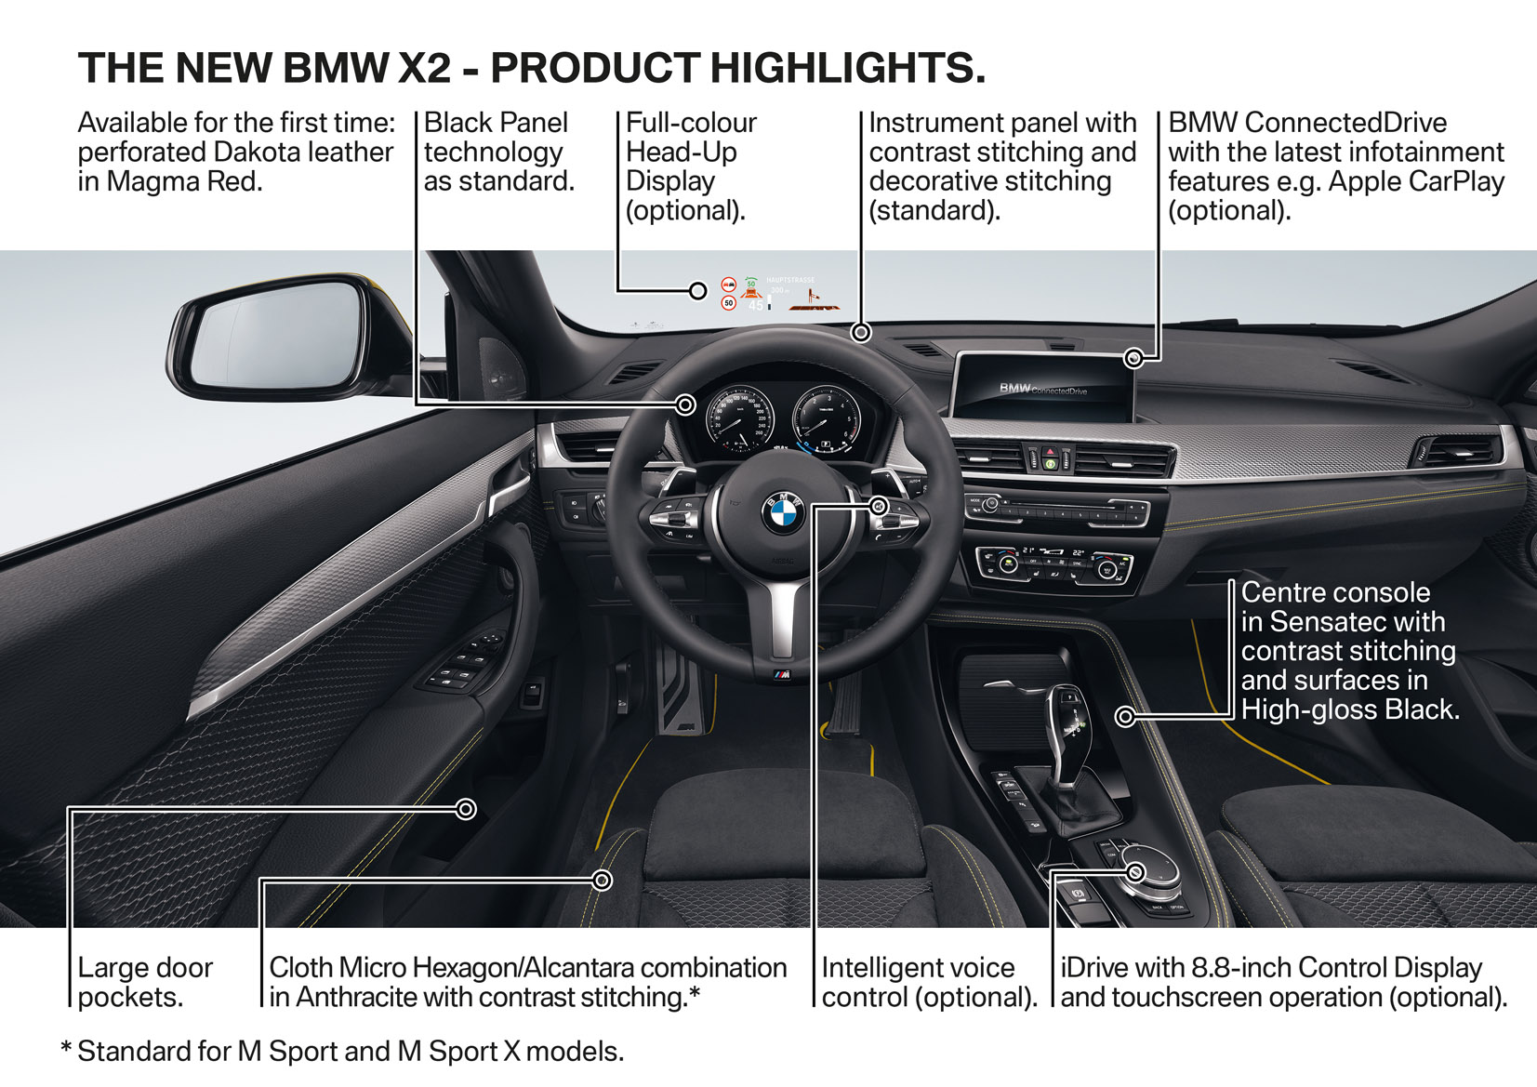
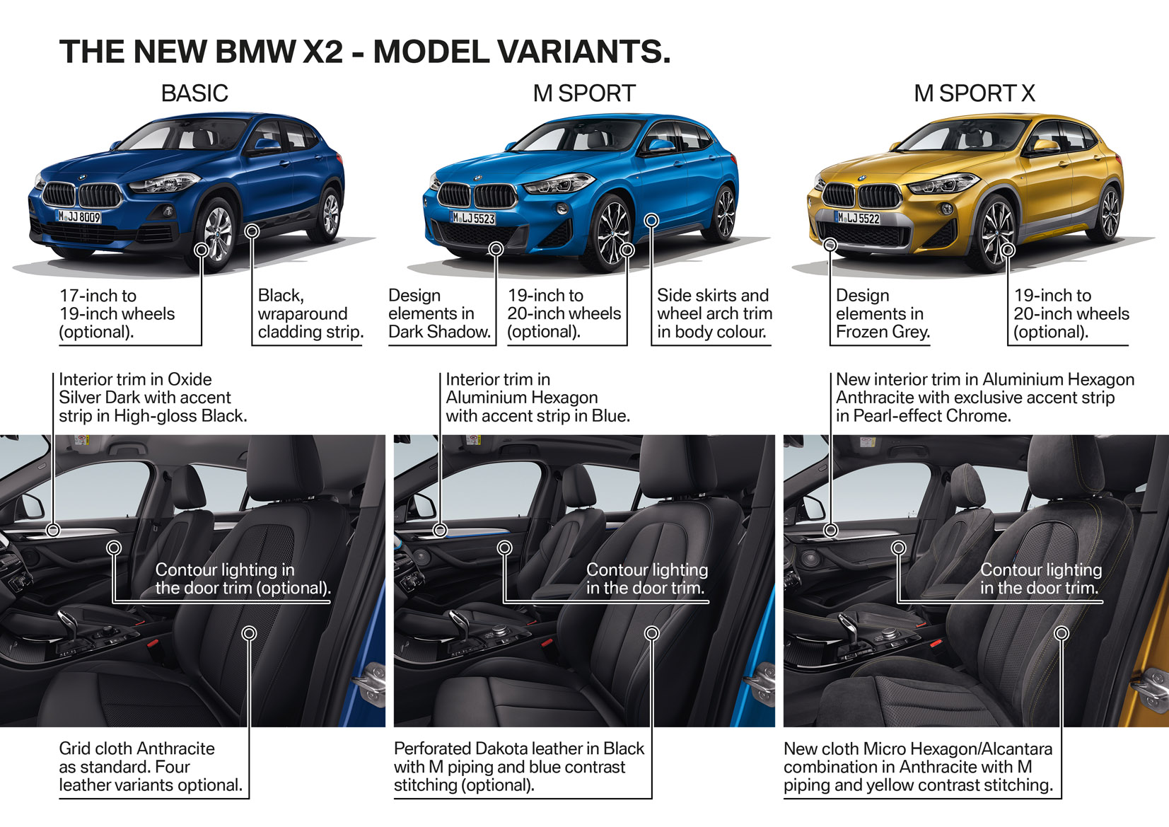
No standard / base model offered in South Africa.

The fuel consumption and CO₂ emissions figures shown were determined according to the European Regulation (EC) 715/2007 in the version applicable at the time of type approval. The figures refer to a vehicle with basic configuration in Germany and the range shown considers the different size of the selected wheels and tires. The values of the vehicles (expect xDrive20i) labelled with (**) are already based on the new WLTP regulation and are translated back into NEDC-equivalent values in order to ensure the comparison between the vehicles. With respect to these vehicles, for vehicle-related taxes or other duties based (at least inter alia) on CO₂ emissions, the CO₂ values may differ to the values stated here (depending on national legislation).

The CO₂ efficiency specifications are determined according to Directive 1999/94/EC and the Pkw-EnVKV, and based (for classification) on the fuel consumption and CO₂ values as per the NEDC cycle.

Further information on official fuel consumption figures and specific CO₂ emission values of new passenger cars is included in the following guideline: “Leitfaden über Kraftstoffverbrauch, die CO₂-Emissionen und den Stromverbrauch neuer Personenkraftwagen” (Guideline for fuel consumption, CO₂ emissions and electric power consumption of new passenger cars), which can be obtained free of charge from all dealerships and at https://www.dat.de/en/offers/publications/guideline-for-fuel-consumption.html.

