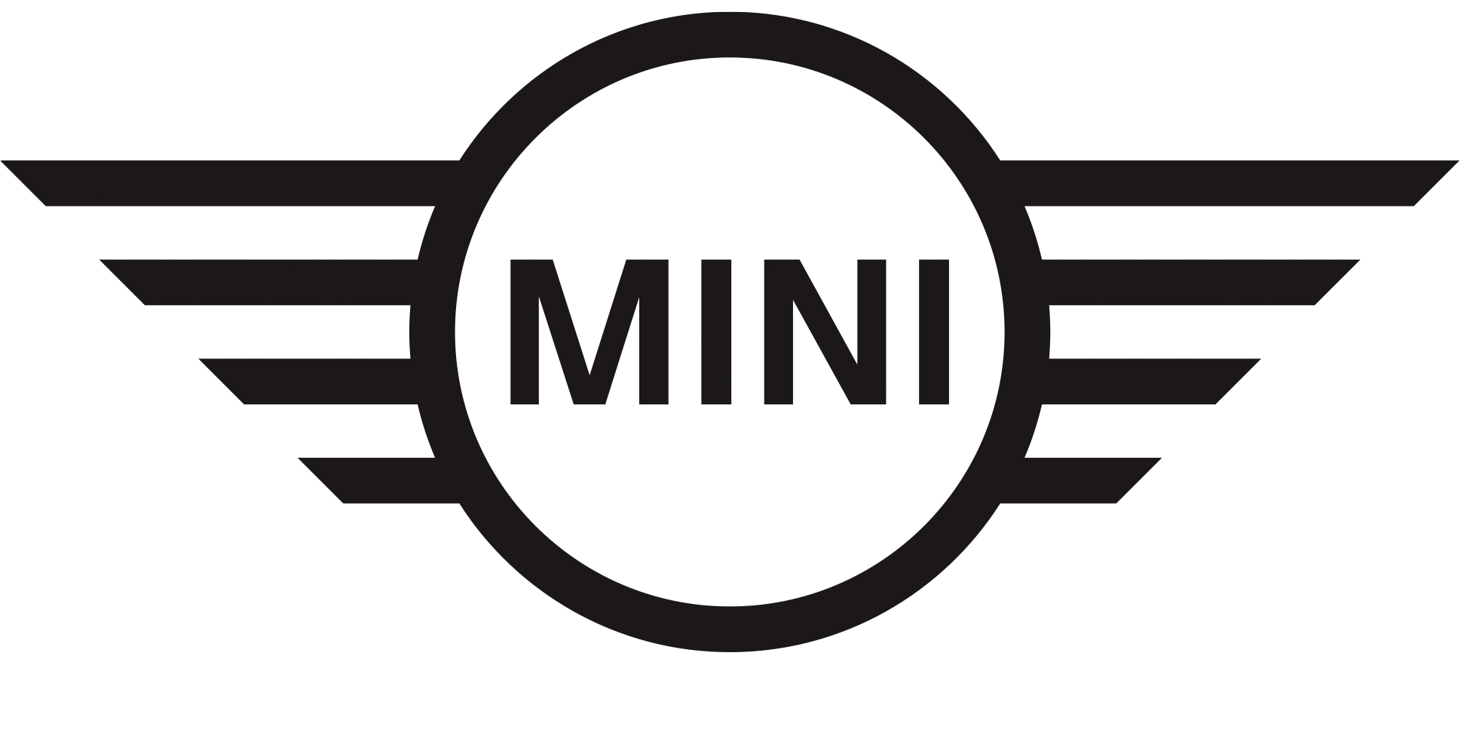
Media Release
11 October 2018

Aim high: the AUTOHOME Roof Tent for the MINI Countryman makes a special appearance in South Africa.

Midrand. A special edition AirTop two-man tent, designed to be perfectly mounted on the roof of a MINI Countryman and developed by AUTOHOME in cooperation with the MINI Design Team, is making a surprise appearance in South Africa.

The specialist in automobile roof tents, AUTOHOME, has teamed up with the British premium car brand to develop a two-man roof tent designed to be mounted perfectly onto the roof of a MINI Countryman. The roof tent comes in black or white, in keeping with the contrasting roof and mirror caps of the MINI Countryman.

Set to appeal to spontaneous travellers and adventurers, and designed in collaboration with the MINI Design Team, the roof tent looks like a conventional roof box when closed, with fibreglass housing and aerodynamic lines for minimal air resistance and noise. The tent is raised for use by means of four gas pressure springs.

The roof tent can be mounted onto the MINI roof rails, which come as standard with the MINI Countryman, without the use of tools in just a few easy moves.

Cozy indoors

Inside, there is a high-density mattress with cotton cover, two door flaps and two windows with zips, close-meshed mosquito nets at all openings and a battery-operated LED interior light, as well as luggage nets and pockets to stow personal items. A solid aluminium ladder is provided to climb up onto the top floor of the MINI Countryman.

Measuring 2.10 metres in length and 1.30 metres in width, the new MINI-inspired roof tent is the perfect solution to outdoor adventure sleeping, whether on a short weekend break or a longer travelling experience.

Launched in South Africa in March 2017, the MINI Countryman is the biggest and most versatile model to be launched in the brand’s 57-year history. With its larger external dimensions, and increases in space throughout the cabin and luggage area, it offers occupants even greater comfort and a genuinely premium ambience.

The special edition AirTop roof tent is only available to buy directly via AUTOHOME: http://shop.autohome-official.com/en/sintesi-della-gamma-maggiolina/50-autohome-roof-tent-for-mini-countryman.html. The purchase and installation of the AirTop roof tent will not be offered through MINI Aftermarket accessories or any MINI dealerships in South Africa.

For any questions on this press release, please contact BMW South Africa’s Group Communications Division as follows:

Hailey Philander
Specialist: Product Communications (MINI, BMW i and BMW Motorrad)
BMW Group South Africa (Pty) Ltd
Email: hailey.philander@bmw.co.za
Tel: 012-522-2070

The BMW Group

With its four brands BMW, MINI, Rolls-Royce and BMW Motorrad, the BMW Group is the world’s leading premium manufacturer of automobiles and motorcycles and also provides premium financial and mobility services. The BMW Group production network comprises 31 production and assembly facilities in 14 countries; the company has a global sales network in more than 140 countries.

In 2017, the BMW Group sold over 2,463,500 passenger vehicles and more than 164,000 motorcycles worldwide. The profit before tax in the financial year 2017 was approximately €10.655 billion on revenues amounting to €97.8 billion. As of 31 December 2017, the BMW Group had a workforce of 129,932 employees.

The success of the BMW Group has always been based on long-term thinking and responsible action. The company has therefore established ecological and social sustainability throughout the value chain, comprehensive product responsibility and a clear commitment to conserving resources as an integral part of its strategy.

BMW Group websites:
www.bmwgroup.com
www.mini.co.za

Social Media Pages:
Facebook: www.facebook.com/MINI.southafrica
Twitter: www.twitter.com/MINISouthAfrica
YouTube: www.youtube.com/user/MINISouthAfrica
Instagram: www.instagram.com/mini_southafrica
Google+: www.youtube.com/user/MINISouthAfrica

