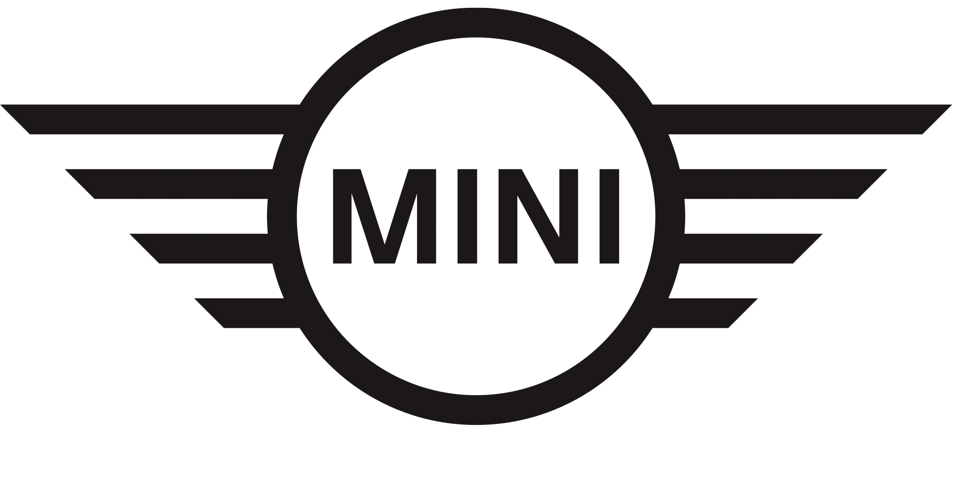
Media Release
14 February 2019

MINI Scouting Menswear competition returns to 2019 SAFW

Midrand. MINI South Africa has announced another instalment of its MINI Scouting Menswear competition in association with GQ Magazine. Now in its second year of partnering with South African Fashion Week (SAFW), the MINI Scouting Menswear Competition is aimed at empowering talented young designers in menswear and strengthen their roles in the local fashion industry.

In line with the MINI Fashion strategy that has seen the brand open itself to new ideas and areas of business, the competition will see finalists showcase their Menswear collections at SAFW’s Spring/Summer 2019 and the Autumn/Winter 2020 collections in April and October 2019, respectively.

To qualify, designers will need a fashion design qualification or show a minimum of five years’ design experience. The winner will be assisted with tools to transition from a developing creative to a sustainable business with the potential for commercial growth. In addition, this year’s winner will win a trip to menswear fashion fair Pitti Uomo 96 from 11 to 14 June 2019 in Florence, Italy, as well as media exposure in GQ South Africa.

Thilosh Moodally, Head of MINI South Africa, says: “MINI Fashion isn‘t about products, it’s about possibilities. The Urban Traveller is someone who breaks through borders and moves effortlessly between, cultures and places. MINI Fashion celebrates this individuality, knowing that when unique perspectives and passions come together, we all benefit.”

Previous MINI capsule collections across the world include MINI FIELD NOTES, MINI FLUID FASHION and MINI FASHION – BEYOND NATIVE that have effectively showcased the work of promising international designers.

For any questions on this press release, please contact BMW South Africa’s Group Communications Division as follows:

Hailey Philander
Specialist: Product Communications (MINI, BMW i and BMW Motorrad
BMW Group South Africa (Pty) Ltd
Email: hailey.philander@bmw.co.za
Tel: 012-522-2070

Or

Edward Makwana
Manager: Group Product Communications
BMW Group South Africa (Pty) Ltd
Tel: +27-12-522-2227
Email: Edward.Makwana@bmw.co.za

The BMW Group
With its four brands BMW, MINI, Rolls-Royce and BMW Motorrad, the BMW Group is the world’s leading premium manufacturer of automobiles and motorcycles and also provides premium financial and mobility services. The BMW Group production network comprises 30 production and assembly facilities in 14 countries; the company has a global sales network in more than 140 countries.

In 2018, the BMW Group sold over 2,490,000 passenger vehicles and more than 165,000 motorcycles worldwide. The profit before tax in the financial year 2017 was € 10.655 billion on revenues amounting to € 98.678 billion. As of 31 December 2017, the BMW Group had a workforce of 129,932 employees.

The success of the BMW Group has always been based on long-term thinking and responsible action. The company has therefore established ecological and social sustainability throughout the value chain, comprehensive product responsibility and a clear commitment to conserving resources as an integral part of its strategy.

BMW Group websites:
www.bmwgroup.cowww.mini.co.za
Facebook: www.facebook.com/MINI.southafrica
Twitter: www.twitter.com/MINISouthAfrica
YouTube: www.youtube.com/MINISouthAfrica
Instagram: www.instagram.com/mini_southafrica

