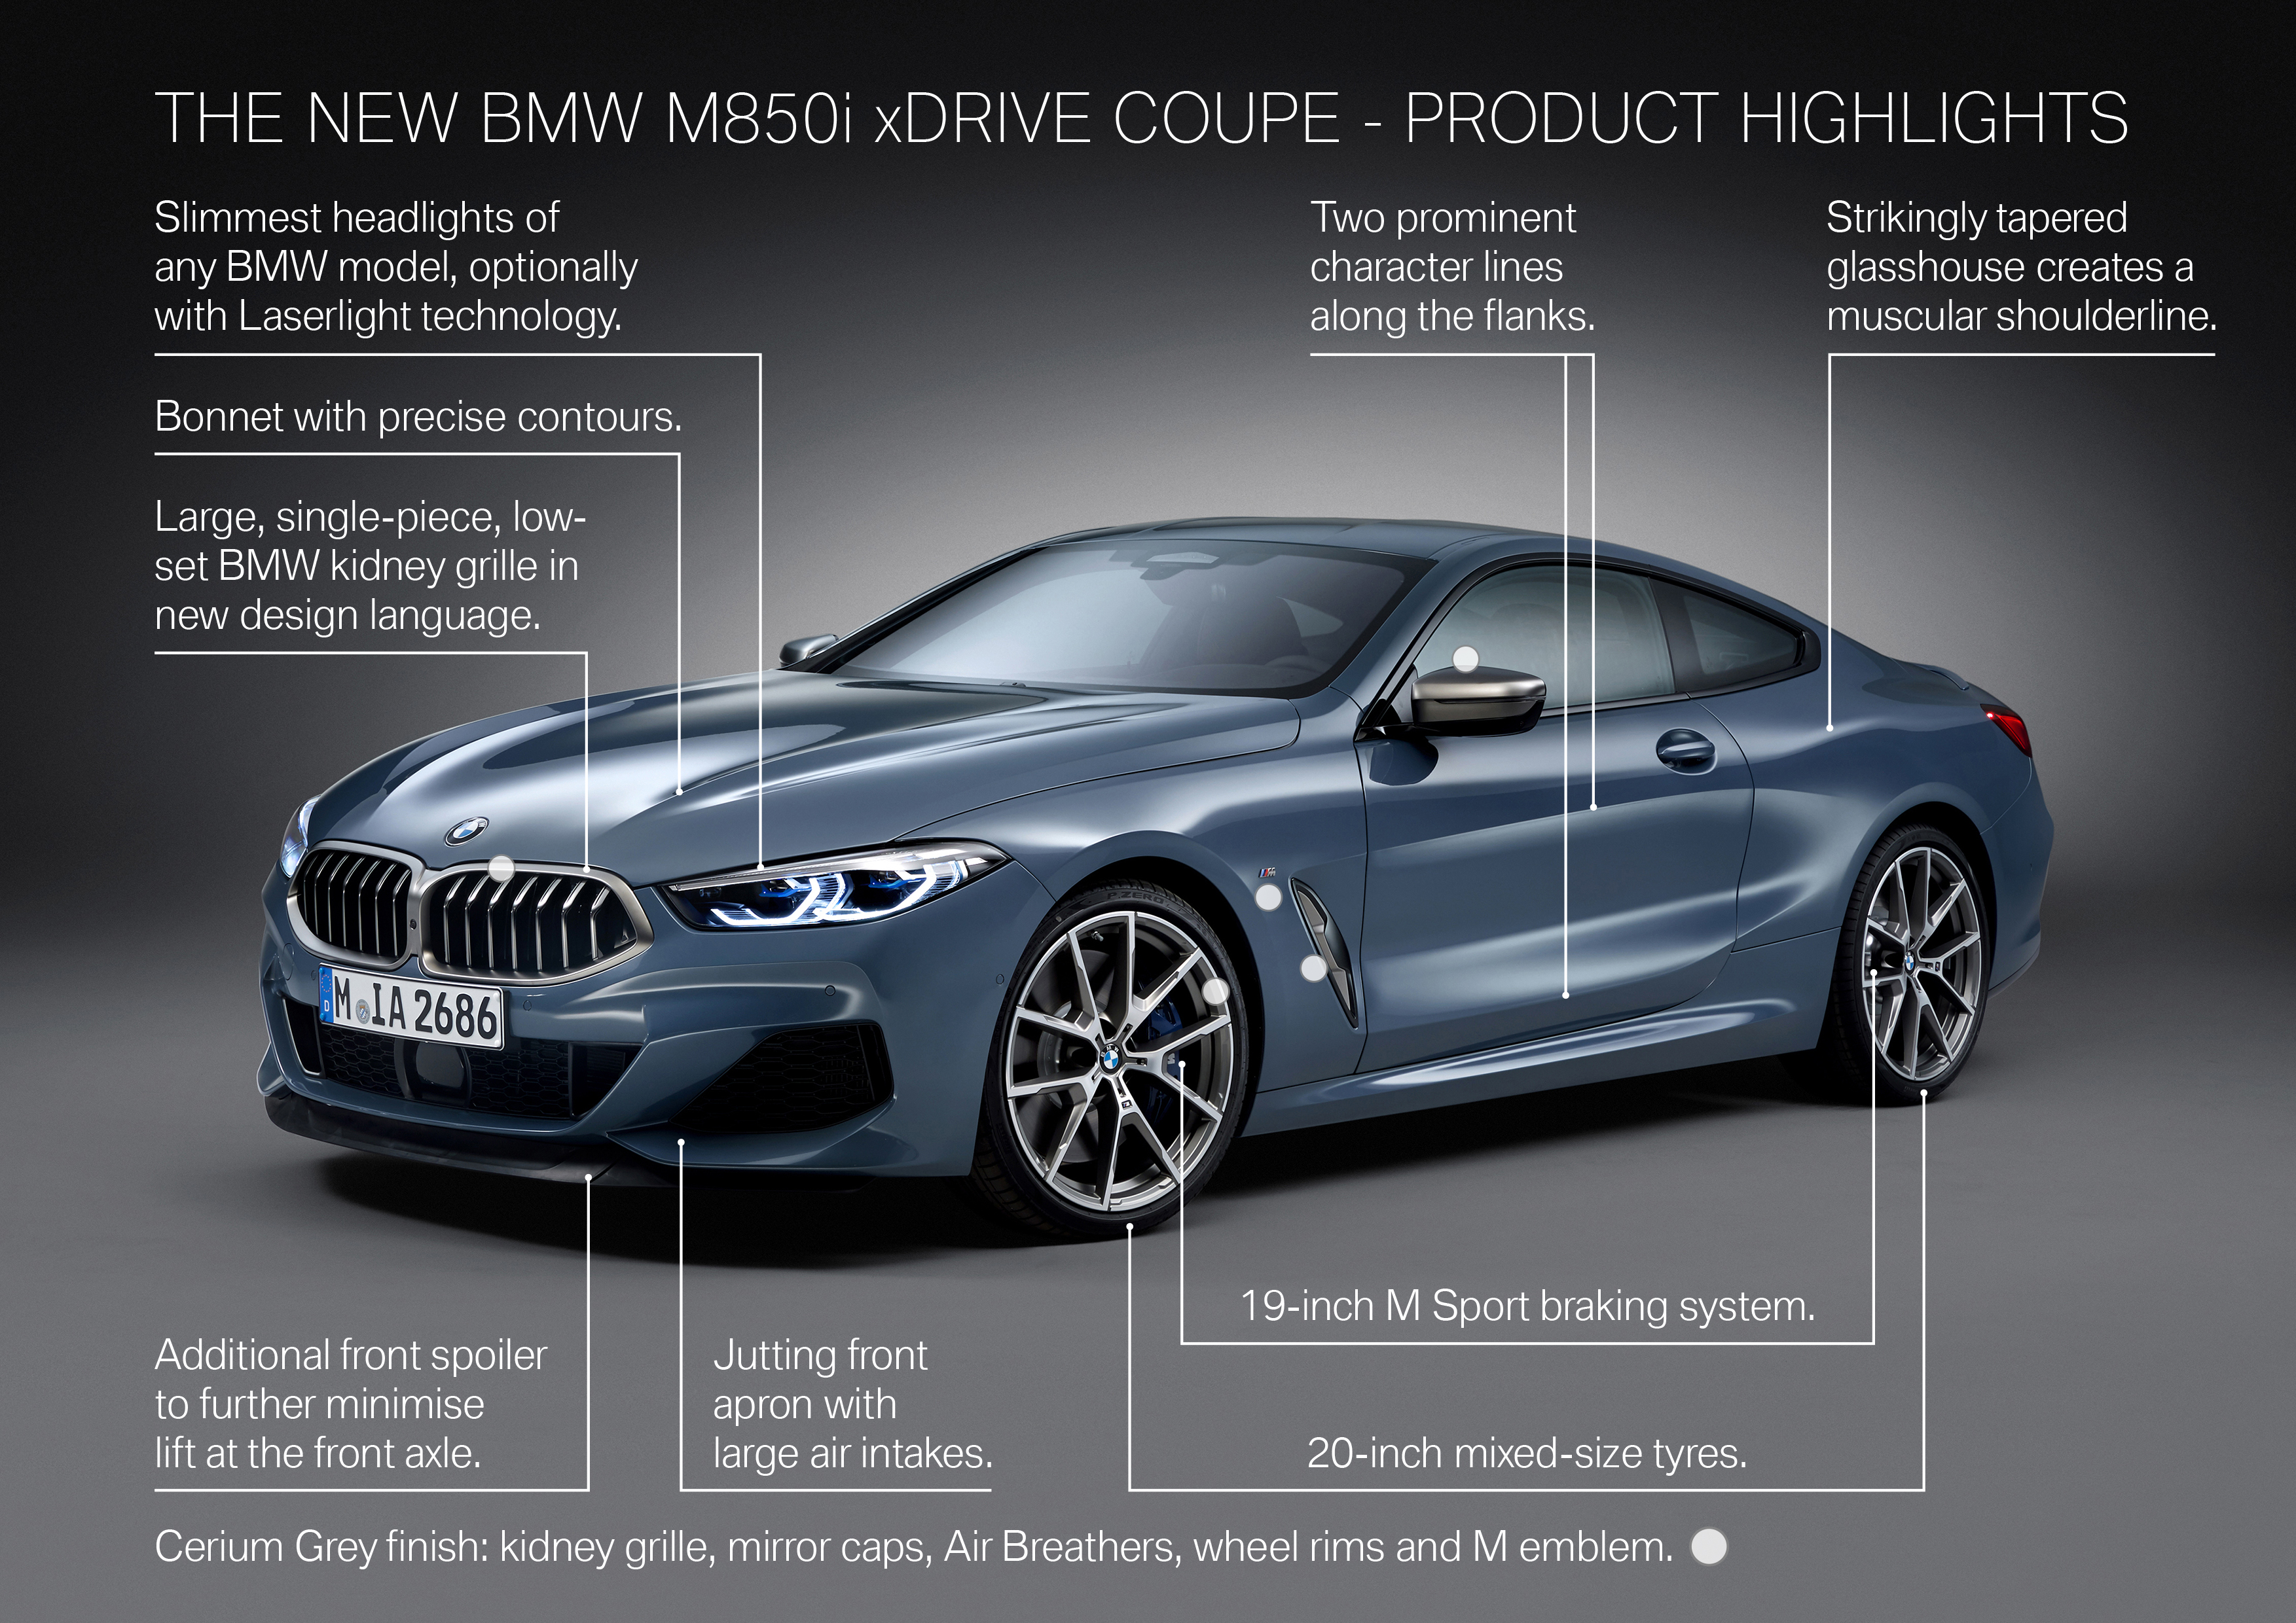

The all-new BMW 8 Series Coupe.
Highlights.
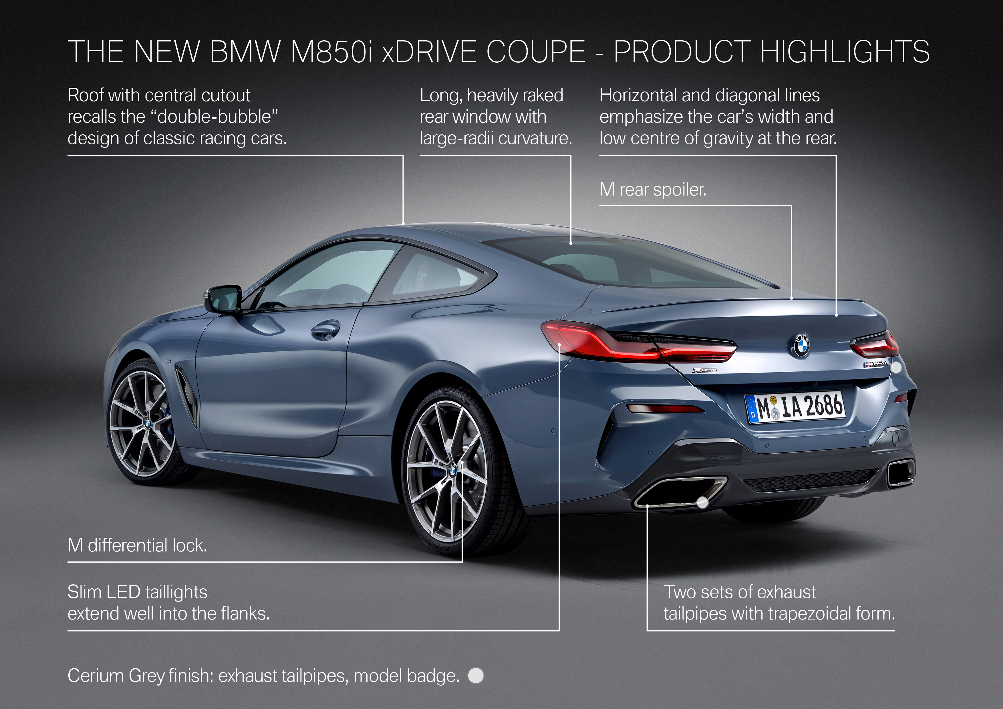
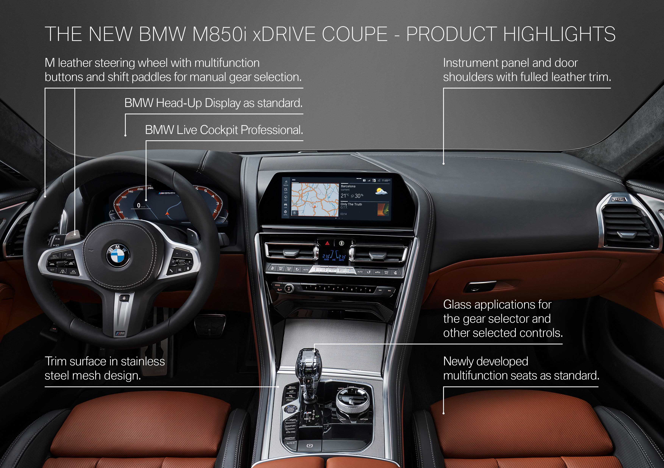
- BMW presents the redefinition of the sports car. The new BMW 8 Series Coupe combines imposing lateral and longitudinal dynamic performance with poise, assurance and luxury over long distances. The new BMW 8 Series Coupe opens a further chapter in the brand’s successful sports car history and kicks off the premium manufacturer’s model initiative in the luxury segment.
- An unrivalled combination of inspiring sportiness and contemporary luxury, assured long-distance comfort and innovative user-operation, driver assistance and connectivity technology.
- Market launch in March 2019 with one model variant: The BMW M850i xDrive Coupe M Performance model with new, 390 kW V8 engine (fuel consumption combined: 10.5 – 10.0 l/100 km; CO2 emissions combined: 240 –228 g/km)*. Power transfer in both cases is via a further developed eight-speed Steptronic transmission. Both engines comply with exhaust emission standard EU6d-TEMP.
- Body structure, drive technology and suspension focus squarely on achieving the elite dynamic performance expected of a top-class sports car. Development parallel to the BMW M8 and the BMW M8 GTE endurance racer. Low centre of gravity, well-balanced weight distribution, lightweight construction using aluminium, magnesium and carbon-fibre-reinforced plastic (CFRP), aerodynamically optimised and virtually lift-free body, powerful engines, sports exhaust system, rear axle differential lock, extremely stiff body and suspension structure. Adaptive M suspension, Integral Active Steering and mixed-size tyres come as standard. Active roll stabilisation optionally available for the BMW M850i xDrive Coupe.
- Emotionally powerful styling with new, pared-back design language, elegantly flowing lines, low-slung body, long bonnet, heavily tapered glasshouse, powerful shoulderline, distinctive “double-bubble” roof contouring, long rear window widening towards its lower edge, typical sports car proportions with an exterior length of 4,843 mm, a width of 1,902 mm, a height of 1,341 mm and a 2,822 mm wheelbase. Options include M carbon roof and M Carbon exterior package with air intake slats, exterior mirror covers, rear spoiler and rear diffuser in CFRP.
* The fuel consumption, CO₂ emissions, power consumption and operating range figures were determined according to the European Regulation (EC) 715/2007 in the version applicable. The figures refer to a vehicle with basic configuration in Germany and the range shown considers the different sizes of the selected wheels/tyres and the selected items of optional equipment.
- Slimmest headlights of any BMW model to date. LED headlights as standard, Adaptive LED Headlights and BMW Laserlight with Selective Beam and extended high beam range of up to 600 metres available as options.
- Relaxed and luxurious interior ambience, longitudinally oriented lines and surfaces direct the eye forward onto the road. Clearly structured arrangement of controls underscores the focus on the driver and the importance attached to delivering a sporty and dynamic driving experience. High-grade materials, sophisticated interior lighting, trim surfaces rising from the centre console to the instrument panel. Fulled leather trim as standard for the instrument panel and door shoulders.
- High-quality options for contemporary luxury: telephony with wireless charging, BMW Display Key, Bowers & Wilkins Diamond Surround Sound System and glass applications for specific control elements.
- Low seating position on redesigned sports seats, Vernasca leather trim as standard. Two rear seats also have a low seating position, rendering headrests unnecessary. Automatic boot lid operation also standard; luggage capacity: 420 litres. 50 : 50 spilt/folding rear seat backrest for increased stowage space.
- M Sport package with specific design and equipment features that additionally emphasise the car’s dynamic character: generously dimensioned air intakes, 19-inch M light-alloy wheels, M Sport braking system, multifunction seats, M leather steering wheel, illuminated door sills with M logo. The BMW M Performance model comes with features including 20-inch M light-alloy wheels and high-performance tyres, specific M Sport braking system, exclusive exterior elements in Cerium Grey, stainless steel mesh interior trim strips and illuminated door sills boasting the model designation. Also available at market launch are the M Technic Sport Package and model-specific BMW Individual features.
- New generation of the M Performance TwinPower Turbo V8 engine combines addictively dynamic power delivery with a characteristic eight-cylinder engine sound. 4.4-litre displacement, newly developed twin-scroll turbochargers located within the V-shaped space between the cylinder banks, optimised petrol direct injection, VALVETRONIC and Double-VANOS, maximum output up by 50 kW without weight increase, maximum torque of 750 Nm available between 1,800 und 4,600 rpm. Sports exhaust system with flap control. Exhaust gas treatment includes gasoline particulate filter.
- Driving Experience Control switch including ADAPTIVE mode. Clearly perceptible set-up differentiation between COMFORT and ECO Pro modes at one end of the spectrum and SPORT and SPORT+ modes at the other. Neatly judged management of powertrain and suspension systems enables clear focus on dynamic performance, as well as effortless handling in urban traffic and a high level of long-distance comfort.
- Standard equipment includes new BMW Operating System 7.0 display and control concept. BMW Live Cockpit Professional including fully digital instrument cluster and 10.25-inch Control Display with consistent, modern graphics. Flat, touch-oriented menu structure for fast access to settings and functions. Customisable display adapts to the situation at hand and provides the driver with the right information at the right time. Enhancement of driving experience through display of lateral acceleration data during dynamic cornering. Intuitive operation thanks to multimodal use of touchscreen display, Controller, steering wheel buttons, voice control and BMW gesture control.
- Latest version of the BMW Head-Up Display has a 16 per cent larger projection surface, optimised 3D graphics and additional display content.
- Innovative driver assistance systems enhance safety and comfort. Further progress towards automated driving, with Driving Assistant Professional including Active Cruise Control and Stop & Go function, Steering and lane control assistant, Lane Change Warning and Lane Departure Warning, side collision protection, evasion aid, distance information, Crossing traffic warning, Priority warning and Wrong-way warning.
- Parking Assistant – automated guidance for parallel and perpendicular parking. Reversing Assistant steers the vehicle when reversing over a distance of up to 80 metres on the same course as the last completed forward parking manoeuvre. Parking Assistant Plus additionally with Surround View, Top View, Panorama View and Remote 3D View.
- Complete range of services from BMW ConnectedDrive. Full connectivity between customer’s vehicle and digital devices via BMW Connected personal mobility assistant. BMW Digital Key permits access to the vehicle and engine start by smartphone. Hazard warning via link-up with other BMW vehicles. Software updates “over the air”. Integration of Microsoft Office 365 and Skype for Business.
- Model variant at launch:
BMW M850i xDrive Coupe:
V8 petrol engine, eight-speed Steptronic transmission.
Capacity: 4,395 cc, output: 390 kW/530 hp at 5,500 – 6,000 rpm,
max. torque: 750 Nm (553 lb-ft) at 1,800 – 4,600 rpm.
Acceleration [0 – 100 km/h (62 mph)]: 3.7 seconds,
top speed: 250 km/h (155 mph).
Fuel consumption combined*: 10.5 – 10.0 l/100 km [26.9 – 28.3 mpg imp],
CO₂ emissions combined*: 240 – 228 g/km, emission standard: EU6d-TEMP.
*All performance, fuel consumption and emissions figures are provisional.
The fuel consumption, CO₂ emissions and electric power consumption figures were determined according to the European Regulation (EC) 715/2007 in the version applicable. The figures refer to a vehicle with basic configuration in Germany. The range shown considers the different sizes of the selected wheels/tyres and the selected items of optional equipment, and may vary during configuration.

The values for the vehicles marked * are already based on the new WLTP test cycle and have been translated back into NEDC-equivalent values in order to ensure comparability between the vehicles. With respect to these vehicles, for vehicle-related taxes or other duties based (at least inter alia) on CO₂ emissions, the CO₂ values may differ from the values stated here (depending on national legislation).

The CO₂ efficiency specifications are determined according to Directive 1999/94/EC and the latest version of the Pkw-EnVKV, and based (for classification) on the fuel consumption and CO₂ values as per the NEDC cycle.

Further information on official fuel consumption figures and specific CO₂ emission values of new passenger cars is included in the following guideline: 'Leitfaden über den Kraftstoffverbrauch, die CO₂-Emissionen und den Stromverbrauch neuer Personenkraftwagen' (Guideline for fuel consumption, CO₂ emissions and electric power consumption of new passenger cars), which can be obtained free of charge from all dealerships and at https://www.dat.de/en/offers/publications/guideline-for-fuel-consumption.html.

