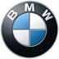Technical specifications.

The new BMW Z4.

Z4 sDrive20i.
 |  | BMW Z4 sDrive20i
Body
No of doors/seats |  | 2 / 2
Length/width/height (unladen) | mm | 4324 / 1864 / 1304
Wheelbase | mm | 2470
Track, front/rear | mm | 1609 / 1616
Ground clearance | mm | 117
Turning circle | m | 11.0
Fuel tank capacity | approx. l | 52
Engine oil 1) | l | 5.25
Weight, unladen, to DIN/EU | kg | 1405 / 1480
Max load to DIN | kg | 335
Max permissible weight | kg | 1740
Max axle load, front/rear | kg | 830 / 935
Max trailer load, braked (12%)/unbraked | kg | – / –
Max roofload/max towbar download | kg | – / –
Luggage comp capacity | l | 281
Air resistance | c_{d} x A | 0.29 x 2.07
Power Unit
Config/No of cyls/valves |  | In-line / 4 / 4
Engine technology |  | BMW TwinPower Turbo technology: TwinScroll turbocharger, High Precision Direct Injection, VALVETRONIC fully variable valve control,  Double-VANOS variable camshaft timing
Effective capacity | cc | 1998
Stroke/bore | mm | 94.6 / 82.0
Compression ratio | :1 | 10.2
Fuel |  | Min. RON 91
Max output | kW | 145
at | rpm | 4500 – 6500
Max torque | Nm | 320
at | rpm | 1450 – 4200
Electrical System
Battery/installation | Ah/– | 80 / luggage compartment
Driving Dynamics and Safety
Suspension, front |  | Double-joint spring-strut axle in lightweight aluminium-steel construction, hydraulically damped torque strut bearings
Suspension, rear |  | Five-link axle in lightweight aluminium-steel construction
Brakes, front |  | Single-piston floating-calliper disc brakes, vented
Brakes, rear |  | Single-piston floating-calliper disc brakes, vented
Driving stability systems |  | Standard: DSC incl. ABS and DTC (Dynamic Traction Control), CBC (Cornering Brake Control), DBC (Dynamic Brake Control), Dry Braking function,  Fading Compensation, Start-Off Assistant; optional: Adaptive M suspension
Safety equipment |  | Standard: airbags for driver and front passenger, side airbags for driver and front passenger with combined head airbags, three-point inertia-reel seatbelts with belt stopper, belt latch tensioner and belt force limiter, crash sensors, rollover protection system, tyre pressure indicator
Steering |  | Electric Power Steering (EPS) with Servotronic function,  variable sport steering
Steering ratio, overall | :1 | 15.1
Tyres, front/rear |  | 225/50 R17 98Y XL / 255/45 R17 98Y
Rims, front/rear |  | 7.5J x 17 light-alloy / 8.5J x 17 light-alloy

 |  | BMW Z4 sDrive20i
Transmission
Type of transmission |  | Eight-speed Steptronic transmission
Gear ratios I | :1 | 5.250
II | :1 | 3.360
III | :1 | 2.172
IV | :1 | 1.720
V | :1 | 1.316
VI | :1 | 1.000
VII | :1 | 0.822
VIII | :1 | 0.640
R | :1 | 3.712
Final drive | :1 | 3.154
Performance
Power-to-weight ratio (DIN) | kg/kW | 9.7
Output per litre | kW/l | 72.6
Acceleration 0–100 km/h | s | 6.6
Top speed | km/h | 240
BMW EfficientDynamics
BMW EfficientDynamics standard features |  | Brake Energy Regeneration with recuperation display, Electric Power Steering (EPS), Auto Start Stop function, Optimum Shift Indicator, ECO PRO mode with coasting function and Proactive Driving Assistant, BMW EfficientLightweight, optimised aerodynamic attributes, active air flap control, on-demand operation of ancillary units, map-regulated oil pump, differential with optimised warm-up behaviour, tyres with reduced rolling resistance
Fuel Consumption ECE
Urban | l/100 km | 7.4 – 7.3
Extra-urban | l/100 km | 5.4 – 5.0
Combined | l/100 km | 6.1 – 6.0
CO2 | g/km | 139 – 137
Emission rating |  | Euro 6d-TEMP
Specifications apply to ACEA markets/data relevant to homologation applies in part only to Germany (weight)

¹⁾ Oil change

The fuel consumption, CO₂ emissions and electric power consumption figures were determined according to the European Regulation (EC) 715/2007 in the version applicable. The figures refer to a vehicle with basic configuration in Germany. The range shown considers the different sizes of the selected wheels/tyres and the selected items of optional equipment, and may vary during configuration.

The values are already based on the new WLTP test cycle and are translated back into NEDC-equivalent values in order to ensure comparability between the vehicles. With respect to these vehicles, for vehicle-related taxes or other duties based (at least inter alia) on CO₂ emissions, the CO₂ values may differ from the values stated here (depending on national legislation).

Further information on official fuel consumption figures and specific CO₂ emission values of new passenger cars is included in the following guideline: 'Leitfaden über den Kraftstoffverbrauch, die CO₂-Emissionen und den Stromverbrauch neuer Personenkraftwagen' (Guide to the fuel economy, CO₂ emissions and electric power consumption of new passenger cars), which can be obtained free of charge from all dealerships, from Deutsche Automobil Treuhand GmbH (DAT), Hellmuth-Hirth-Str. 1, 73760 Ostfildern-Scharnhausen and at https://www.dat.de/co2/.

The fuel consumption, CO₂ emissions and electric power consumption figures were determined according to the European Regulation (EC) 715/2007 in the version applicable. The figures refer to a vehicle with basic configuration in Germany. The range shown considers the different sizes of the selected wheels/tyres and the selected items of optional equipment, and may vary during configuration.

The values are already based on the new WLTP test cycle and are translated back into NEDC-equivalent values in order to ensure comparability between the vehicles. With respect to these vehicles, for vehicle-related taxes or other duties based (at least inter alia) on CO₂ emissions, the CO₂ values may differ from the values stated here (depending on national legislation).

Further information on official fuel consumption figures and specific CO₂ emission values of new passenger cars is included in the following guideline: 'Leitfaden über den Kraftstoffverbrauch, die CO₂-Emissionen und den Stromverbrauch neuer Personenkraftwagen' (Guide to the fuel economy, CO₂ emissions and electric power consumption of new passenger cars), which can be obtained free of charge from all dealerships, from Deutsche Automobil Treuhand GmbH (DAT), Hellmuth-Hirth-Str. 1, 73760 Ostfildern-Scharnhausen and at https://www.dat.de/co2/.

The new BMW Z4.
Z4 M40i.
 |  | BMW Z4 M40i
Body
No of doors/seats |  | 2 / 2
Length/width/height (unladen) | mm | 4324 / 1864 / 1304
Wheelbase | mm | 2470
Track, front/rear | mm | 1594 / 1589
Ground clearance | mm | 114
Turning circle | m | 11.0
Fuel tank capacity | approx. l | 52
Engine oil 1) | l | 6.5
Weight, unladen, to DIN/EU | kg | 1535 / 1610
Max load to DIN | kg | 325
Max permissible weight | kg | 1860
Max axle load, front/rear | kg | 865 / 995
Max trailer load, braked (12%)/unbraked | kg | – / –
Max roofload/max towbar download | kg | – / –
Luggage comp capacity | l | 281
Air resistance | c_{d} x A | 0.31 x 2.07
Power Unit
Config/No of cyls/valves |  | In-line / 6 / 4
Engine technology |  | M Performance TwinPower Turbo technology: TwinScroll turbocharger, High Precision Direct Injection, VALVETRONIC fully variable valve control, Double-VANOS variable camshaft timing
Effective capacity | cc | 2998
Stroke/bore | mm | 94.6 / 82.0
Compression ratio | :1 | 11.0
Fuel |  | Min. RON 91
Max output | kW/hp | 250 / 340
at | rpm | 5000 – 6500
Max torque | Nm | 500
at | rpm | 1600 – 4500
Electrical System
Battery/installation | Ah/– | 90 / luggage compartment
Driving Dynamics and Safety
Suspension, front |  | Double-joint spring-strut axle in lightweight aluminium-steel construction, hydraulically damped torque strut bearings
Suspension, rear |  | Five-link axle in lightweight aluminium-steel construction
Brakes, front |  | Four-piston fixed-calliper disc brakes, vented
Brakes, rear |  | Single-piston floating-calliper disc brakes, vented
Driving stability systems |  | Standard: DSC incl. ABS and DTC (Dynamic Traction Control), CBC (Cornering Brake Control), DBC (Dynamic Brake Control), Dry Braking function,  Fading Compensation, Start-Off Assistant, Adaptive M suspension,  M Sport differential
Safety equipment |  | Standard: airbags for driver and front passenger, side airbags for driver and front passenger with combined head airbags, three-point inertia-reel seatbelts with belt stopper, belt latch tensioner and belt force limiter, crash sensors, rollover protection system, tyre pressure indicator
Steering |  | Electric Power Steering (EPS) with Servotronic function,  variable sport steering
Steering ratio, overall | :1 | 15.1
Tyres, front/rear |  | 255/40 ZR18 95Y / 275/40 ZR18 99Y
Rims, front/rear |  | 9J x 18 light-alloy / 10J x 18 light-alloy

 |  | BMW Z4 M40i
Transmission
Type of transmission |  | Eight-speed Steptronic transmission
Gear ratios I | :1 | 5.250
II | :1 | 3.360
III | :1 | 2.172
IV | :1 | 1.720
V | :1 | 1.316
VI | :1 | 1.000
VII | :1 | 0.822
VIII | :1 | 0.640
R | :1 | 3.712
Final drive | :1 | 3.154
Performance
Power-to-weight ratio (DIN) | kg/kW | 6.1
Output per litre | kW/l | 83.4
Acceleration 0–100 km/h | s | 4.6
Top speed | km/h | 250
BMW EfficientDynamics
BMW EfficientDynamics standard features |  | Brake Energy Regeneration with recuperation display, Electric Power Steering (EPS), Auto Start Stop function, Optimum Shift Indicator, ECO PRO mode with coasting function and Proactive Driving Assistant, BMW EfficientLightweight, optimised aerodynamic attributes, active air flap control, on-demand operation of ancillary units, map-regulated oil pump, differential with optimised warm-up behaviour
Fuel Consumption ECE
Urban | l/100 km | 9.2 – 9.2
Extra-urban | l/100 km | 6.3 – 5.9
Combined | l/100 km | 7.4 – 7.1
CO2 | g/km | 168 – 162
Emission rating |  | Euro 6d-TEMP
Specifications apply to ACEA markets/data relevant to homologation applies in part only to Germany (weight)

¹⁾ Oil change

The fuel consumption, CO₂ emissions and electric power consumption figures were determined according to the European Regulation (EC) 715/2007 in the version applicable. The figures refer to a vehicle with basic configuration in Germany. The range shown considers the different sizes of the selected wheels/tyres and the selected items of optional equipment, and may vary during configuration.

The values are already based on the new WLTP test cycle and are translated back into NEDC-equivalent values in order to ensure comparability between the vehicles. With respect to these vehicles, for vehicle-related taxes or other duties based (at least inter alia) on CO₂ emissions, the CO₂ values may differ from the values stated here (depending on national legislation).

Further information on official fuel consumption figures and specific CO₂ emission values of new passenger cars is included in the following guideline: 'Leitfaden über den Kraftstoffverbrauch, die CO₂-Emissionen und den Stromverbrauch neuer Personenkraftwagen' (Guide to the fuel economy, CO₂ emissions and electric power consumption of new passenger cars), which can be obtained free of charge from all dealerships, from Deutsche Automobil Treuhand GmbH (DAT), Hellmuth-Hirth-Str. 1, 73760 Ostfildern-Scharnhausen and at https://www.dat.de/co2/.

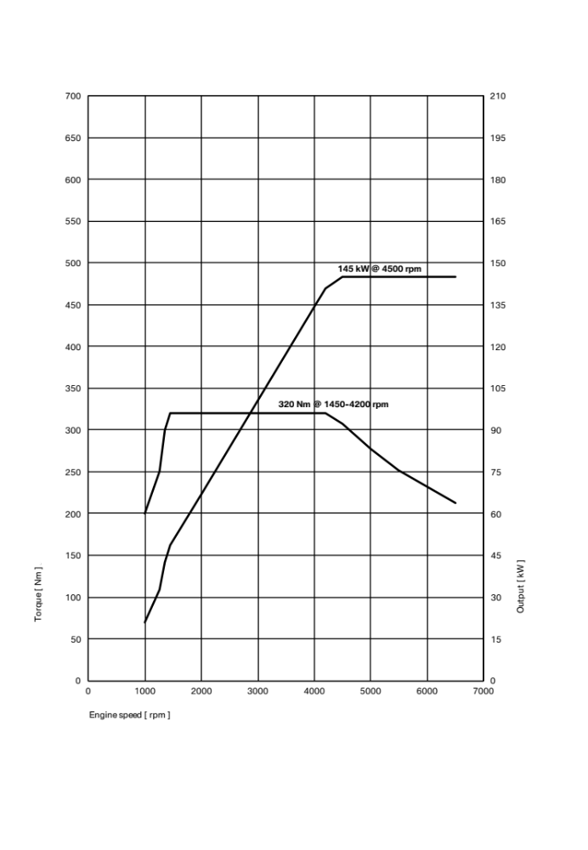

Output and torque diagrams.

The new BMW Z4.

Z4 sDrive20i.

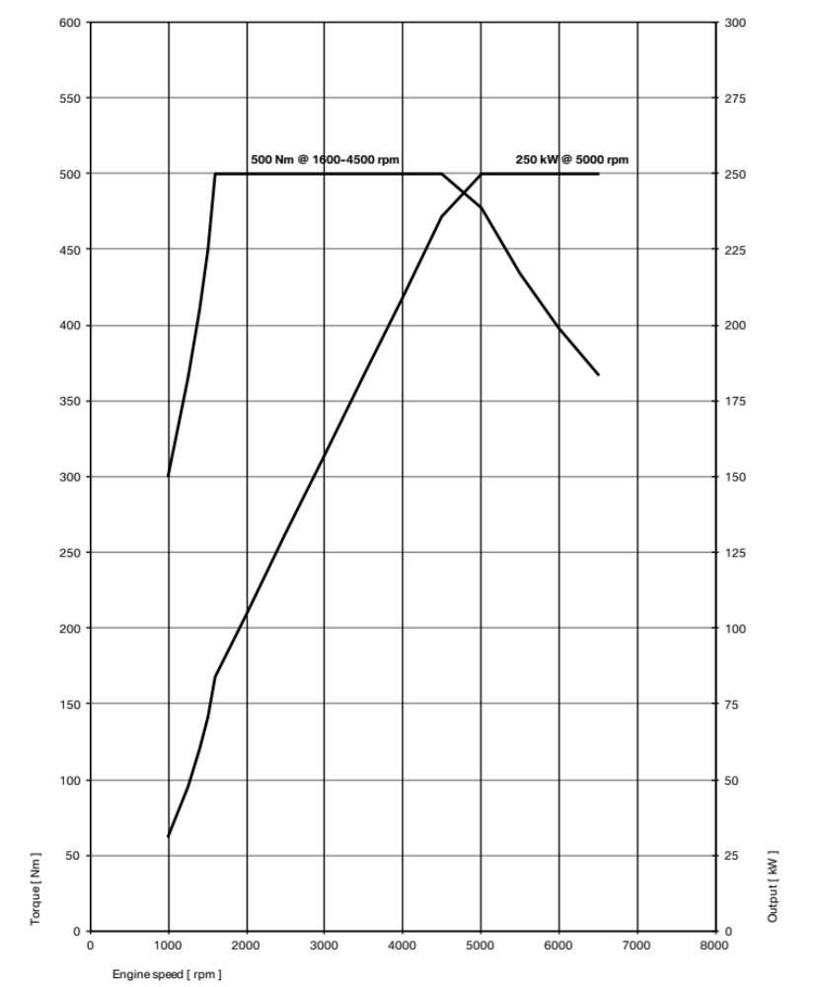

The new BMW Z4.

Z4 M40i.

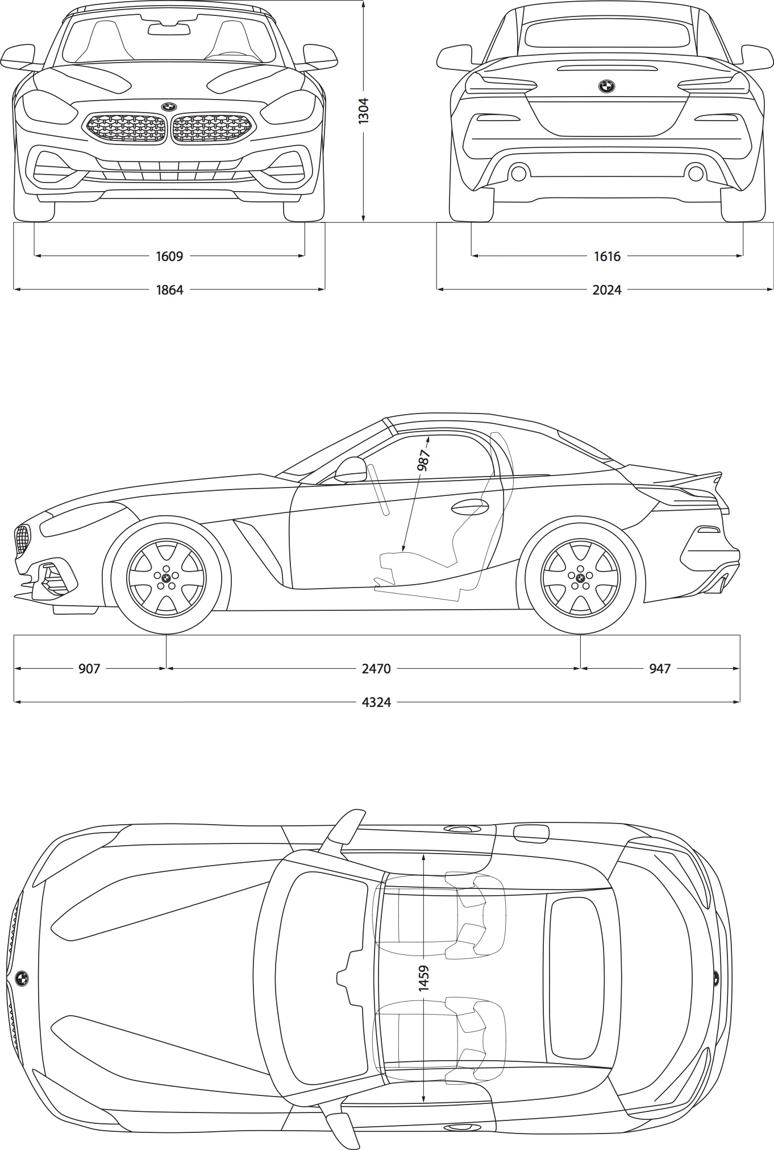

Exterior and interior dimensions.

The new BMW X5.

*dimensions in cm

