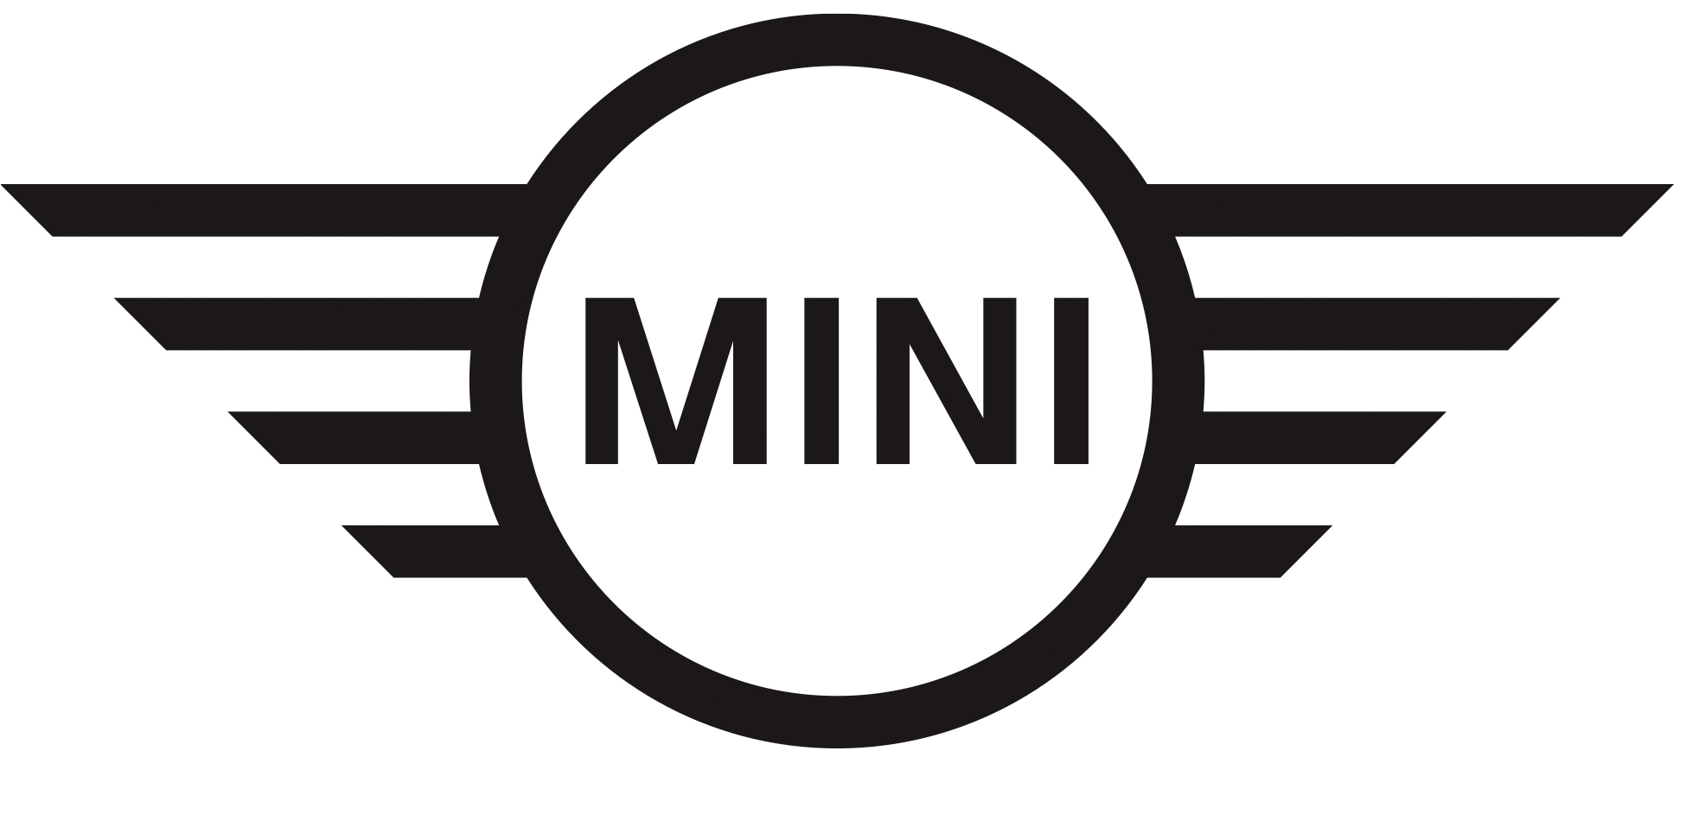
Media Release
27 august 2019

MINI gives local artists a wheel up.

Midrand. MINI South Africa has partnered with digital publishers 10and5 to host its Artist Acceleration and Exposure programme (A3E).

Following the launch of the A3E programme, the first exhibition was held at MINI Auto Bavaria in Midrand on Thursday, 22 August 2019 and will be followed by more exhibitions in the coming weeks at selected MINI dealerships.

10and5 founder and publisher Uno de Waal, and curators Banele Khoza, Makgati Molebatsi, Lezanne Viviers selected a total of 69 promising artists for the 2019 A3E programme whose artistic prowess will be cultivated. They will be provided with a platform to reach new markets and break into the art and gallery scene.

Twenty three of these artists have been selected to display their art at selected MINI showrooms across the country. The first instalment saw six artists namely; Ayla Senekal, Blessing Blaai, Bongani Ndlovu, Lebogang Mabone, Lisolomzi Pikoli, Mpho Machete and Odirile Khune showcase their art to a room full of art enthusiasts, gallery curators and art buyers.

“Iconic design is part of the MINI DNA,” says Head of MINI South Africa, Thilosh Moodally. “MINI has always been much more than just a car brand – it’s a community and a lifestyle. Since 1959, the global MINI brand has partnered with creatives to explore new and different ideas. The A3E programme allows us to embrace a range of young South African artists in the creation of their own visual identities, just as MINI has been doing for 60 years.”

Original artworks from the A3E programme can be viewed at MINI Auto Bavaria in Midrand and MINI Sandton, both in Johannesburg as well as MINI Auto Atlantic on Cape Town’s Foreshore.

For any questions on this press release, please contact BMW South Africa’s Group Communications Division as follows:

Hailey Philander
Specialist: Product Communications (MINI, BMW i and BMW Motorrad
BMW Group South Africa (Pty) Ltd
Email: hailey.philander@bmw.co.za
Tel: 012-522-2070

The BMW Group
With its four brands BMW, MINI, Rolls-Royce and BMW Motorrad, the BMW Group is the world’s leading premium manufacturer of automobiles and motorcycles and also provides premium financial and mobility services. The BMW Group production network comprises 30 production and assembly facilities in 14 countries; the company has a global sales network in more than 140 countries.

In 2018, the BMW Group sold over 2,490,000 passenger vehicles and more than 165,000 motorcycles worldwide. The profit before tax in the financial year 2018 was € 9.815 billion on revenues amounting to € 97.480 billion. As of 31 December 2018, the BMW Group had a workforce of 134,682 employees.

The success of the BMW Group has always been based on long-term thinking and responsible action. The company has therefore established ecological and social sustainability throughout the value chain, comprehensive product responsibility and a clear commitment to conserving resources as an integral part of its strategy.

BMW Group websites:
www.bmwgroup.com
www.mini.co.za

Facebook: www.facebook.com/MINI.southafrica
Twitter: www.twitter.com/MINISouthAfrica
YouTube: www.youtube.com/MINISouthAfrica
Instagram: www.instagram.com/mini_southafrica

