Media Information
16 February 2021

This press release explicitly refers to the German market. Prices in Germany were used as a basis for the calculation examples. Feel free to adapt the calculation for your market and check whether the main message "electric driving is cheaper than petrol/diesel" applies to your market!

Company
Bayerische
Motoren Werke
Aktiengesellschaft

Postal address
BMW AG
80788 Munich

Telephone
+49 89-382-60340

Internet
www.bmwgroup.com
BMW / MINI Charging makes electric driving cheaper than petrol or diesel
Standardised tariff structure introduced in 19 European countries from 1 February 2021
Access to more than 173,000 public charging points from over 500 charging infrastructure operators across Europe

Munich. The BMW Group is introducing a new and standardised tariff structure for public charging of BMW and MINI vehicles in 19 European countries, effective immediately (see table). With this move, the BMW Group is making the cost of running an electrified vehicle even more attractive for its customers and responding to the steady growth in electromobility and significant increase in sales of electrified vehicles last year (+31.8 %).

One-time registration with BMW Charging or MINI Charging provides access to public charging options, with more than 173,000 public charging points run by over 500 charging structure operators in Europe alone. Customers can choose between two basic tariffs, “Flex” or “Active”, to suit their charging preferences and individual driving and charging profile. The “IONITY Plus” package can also be added as an option to either tariff.

“Alongside range, access to a reliable charging infrastructure with competitive and transparent costs is a fundamental requirement for expanding electromobility and improving its acceptance – and that is precisely what our customers get with BMW / MINI Charging,” underlined Pieter Nota, member of the Board of Management of BMW AG responsible for Customer, Brands and Sales. “With our "Active" tariff, energy costs in Germany are still up to 25% cheaper than for comparable diesel-powered vehicles, even for customers who cannot charge at home or at their employer's premises and therefore have to rely on the public charging infrastructure. This means we can completely dispel the myth that electricity for electrified vehicles is more expensive than petrol or diesel,” Nota continued.

Easy access to networks of more than 500 charging infrastructure operators in Europe – one card + one app for all charging electricity providers

The BMW Group takes a holistic approach to electromobility: BMW Charging and MINI Charging provide a comprehensive range of charging solutions for all customer needs – from home charging solutions such as wallboxes to installation and digital services, up to and including public charging in the BMW / MINI Charging network.
With a one-time registration, a card – or, if preferred, an app – provides access to convenient charging in public areas at around 173,000 charging points (162,000 AC and 11,000 DC, incl. high-power charging (HPC) stations with a charging capacity of over 150kW) across Europe. In Germany alone, well over 33,000 charging points operated by around 300 charging electricity suppliers can be used by BMW / MINI Charging customers with just a single card / app.

The high-power charging network operated by the BMW Group joint venture IONITY is also integrated into the BMW Charging and MINI Charging network. The IONITY charging parks – with an average of four charging posts – are located along Europe’s motorways and main transport routes. A 10-minute charge at one of these stations adds up to 100 km to the fully-electric BMW iX3’s* range (NEDC), for instance. More than 400 charging stations will be installed across Europe by the end of 2021. Further expansion within cities is also planned.

BMW Charging as easy as shopping with a credit card
The steadily growing BMW / MINI Charging network offers a good solution for customers who are unable or do not wish to install adequate charging infrastructure at home and cannot charge at their workplace. It allows them to combine parking in all kinds of everyday situations (from business meetings to trips into town or to a restaurant, etc.) with charging. At the same time, it is also ideal for customers who like to drive longer distances – for example, for vacation or business trips. BMW and MINI drivers can choose between the following public charging tariffs to suit their individual driving and charging profile.

“Active” Tariff: In addition to the cost benefits, the redesigned basic tariff makes the process much simpler – especially for customers who only or primarily use public charging – since costs incurred at every charging post in the network can be reliably estimated before charging. For a basic monthly fee of 4.99 euros, customers in Germany, for example, can charge their vehicles in the BMW / MINI Charging network at the standard rate of 33 cents per kWh for AC charging and 39 cents per kWh for DC charging.

The “IONITY Plus” package is an especially attractive add-on for customers who regularly drive longer distances and charge at stations along the motorway. For a basic monthly fee of 13 euros, both BMW and MINI frequent chargers in Germany can get their driving electricity at 35 cents per kWh at IONITY high-power charging stations.

The unique aspect is that when customers take home a new electrified BMW or MINI, they receive the “Active” Tariff described above for 12 months with no basic monthly fee. This further amplifies the energy cost benefit compared to petrol and diesel drive trains. For the fully-electric BMW iX3*, BMW iX* and BMW i4 models, the “IONITY Plus” basic fee is also currently waived, since the package is already included with these vehicles.

“Flex” Tariff: Customers who use public charging on a less regular and more spontaneous basis can take advantage of the “Flex” Tariff, which, also with a single registration and no basic fee, allows vehicles to be charged as needed at any charging post in the BMW / MINI Charging network at the operator’s own rates.

Outside the borders of the driver’s home country, the respective national charging tariffs of the option selected apply. Here also, the customer can take advantage of the standardised pricing of the “Active” Tariff and “IONITY Plus” package for charging.

The BMW Group is not only committed to attractive pricing for driving electricity, but also promoting electric driving through other initiatives. Links to BMW Group PressClub can be found below:

https://www.press.bmwgroup.com/global/article/detail/T0306650EN/automatic-emission-free-city-driving:-green-light-for-bmw-edrive-zones-in-nearly-80-cities-across-europe

https://www.press.bmwgroup.com/global/article/detail/T0318758EN/drive-electric-collect-bmw-points-charge-for-free:-bmw-presents-the-worldwide-first-bonus-programme-for-plug-in-hybrid-model-drivers

https://www.press.bmwgroup.com/global/article/detail/T0318730EN/bmw-charging-and-mini-charging:-expanded-charging-options-for-gen5-market-launch

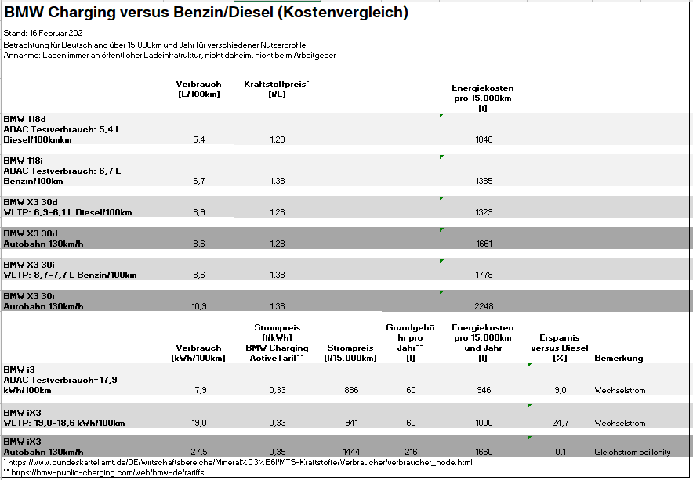

*Consumption/emission data:

BMW iX3: Fuel consumption combined: 0.0 l/100 km; power consumption combined: 17.8-17.5 (NEDC) / 19.0-18.6 (WLTP); CO2 emissions combined: 0 g/km
BMW iX: Fuel consumption combined: 0.0 l/100 km power consumption combined (NEDC) in kWh/100 km: below 21; CO2 emissions combined: 0 g/km. Data on driving performance, energy consumption and range are preliminary and based on forecasts.

If you have any questions, please contact:

Corporate Communications

Daria Nikitina, Corporate Communications
Email: daria.nikitina@bmw.de, Telephone: +49-89-382-60340

Wieland Brúch, Spokesperson Electromobility
Email: wieland.bruch@bmw.de, Telephone: +49-89-382-72652

Media website: www.press.bmwgroup.com
Email: presse@bmwgroup.com

The BMW Group

With its four brands BMW, MINI, Rolls-Royce and BMW Motorrad, the BMW Group is the world’s leading premium manufacturer of automobiles and motorcycles and also provides premium financial and mobility services. The BMW Group production network comprises 31 production and assembly facilities in 15 countries; the company has a global sales network in more than 140 countries.

In 2020, the BMW Group sold over 2.3 million passenger vehicles and more than 169,000 motorcycles worldwide. The profit before tax in the financial year 2019 was € 7.118 billion on revenues amounting to € 104.210 billion. As of 31 December 2019, the BMW Group had a workforce of 126,016 employees.

The success of the BMW Group has always been based on long-term thinking and responsible action. The company has therefore established ecological and social sustainability throughout the value chain, comprehensive product responsibility and a clear commitment to conserving resources as an integral part of its strategy.

www.bmwgroup.com
Facebook: http://www.facebook.com/BMWGroup
Twitter: http://twitter.com/BMWGroup
YouTube: http://www.youtube.com/BMWGroupView
Instagram: https://www.instagram.com/bmwgroup
LinkedIn: https://www.linkedin.com/company/bmw-group/

