Standard Equipment

BMW Z4 2.0i Roadster
Engine
- 2.0-litre four-cylinder in-line petrol engine
- Light alloy engine block and cylinder head
- VANOS and VALVETRONIC

Transmission / Suspension
- Double-joint spring-strut front axle
- Six-speed manual gearbox
- Z-link multi-link rear suspension

Safety
- Airbags – front and side airbags for driver and passenger
- Brake Force Display
- Dynamic Stability Control+ (DSC+) including:
  - Brake Drying
  - Fade Compensation
  - Brake Pre-tensioning
  - Hill-Start Assistant
  - Soft Stop
- Remote control alarm and Thatcham category 1 immobiliser
- Run-flat tyres with Tyre Puncture Warning System
- Warning triangle and first-aid kit

Exterior Equipment
- BMW 16-inch light-alloy wheels
- Electrically adjustable exterior mirrors
- Exterior parts in body colour
- Front side wheel arch reflectors
- Soft-top, lined with heated rear windscreen
- Oval exhaust tail pipe

Audio & Communication
- BMW Business radio with single CD player and MP3 CD playback capability

Interior Equipment
- Automatic air conditioning
- Courtesy lights
- Electric windows
- Free Spirit cloth / Sensatec upholstery
- Interior auto-dimming mirror
- Graphite silk interior trim
- Sports seats with manual adjustment
- Steering column, height and rake adjustment
- Three-spoke sports steering wheel

Additional Equipment for BMW Z4 2.0i SE Roadster Models
- Heated exterior mirrors and windscreen washer jets
- Front foglights
- Onboard computer
- Electrically operated soft-top, lined with heated rear windscreen

Additional Equipment for BMW Z4 2.5i SE Roadster Models
- 2.5-litre in-line six-cylinder petrol engine
- Magnesium and alloy composite engine
- Twin round exhaust tail pipes

Additional Equipment for BMW Z4 2.5si SE Roadster Models
- Chrome line interior: comprising inner door grab handles, spider of steering wheel, spider of gear knob, roll over hoops, seat belt guide loop
- Disc brakes front and rear, inner vented
- Driving Dynamics Control (Sport mode)
- Handbrake lever and gear lever knob and gaiters in leather
- Rear-view mirror, automatically dimming
- Leather steering wheel

Additional Equipment for BMW Z4 3.0si SE Roadster Models
- 3.0 litre six-cylinder in-line petrol engine
- 17-inch light-alloy wheels
- Chrome kidney grille with matt Silk Graphite vertical slats
- Headlight housing in matt chrome
- Brushed aluminium interior trim

- Oregon leather upholstery with armrest on transmission tunnel
- Electric seat adjustment with driver memory
- Rain sensing windscreen wipers and automatic headlight activation
- Headlight wash system
- Interior lights package
- Metallic paint

Additional Equipment for Sport Models (2.0i, 2.5i, 2.5si, 3.0si)
- 18-inch light-alloy M Double-spoke wheels
- Active Sports leather/sport fibre upholstery (Oregon leather on 3.0si Sport)
- Brushed aluminium interior trim
- M leather steering wheel
- M Sport seats
- M Sports suspension

Standard Equipment for BMW Z4 M Roadster Models
- 3.2-litre six-cylinder in-line petrol engine
- VANOS
- M braking system (from M3 CSL)
- Variable M differential
- M specific suspension set-up
- BMW 18-inch light alloy M double spoke wheels
- Four chrome exhaust pipes
- M Aerodynamic body styling
- Xenon headlights
- Black Carbon-structure leather interior trim
- M designation door sill finishers
- M gear lever knob, illuminated
- M instrument panel
- M rear view mirror with auto dimming
- M Sports seats with electric adjustment
- Nappa leather upholstery
- Three-spoke M multi-function sports leather steering wheel

Optional Equipment

Option name | 2.0i | 2.0i SE | 2.0i Sport | 2.5i SE | 2.5i Sport | 2.5si SE | 2.5si Sport | 3.0si SE | 3.0si Sport | M Roadster | Retail inc VAT
Automatic transmission |  |  |  | x | x |  |  |  |  |  | £1,455.00
 |  |  |  |  |  | x | x | x | x |  | £1,525.00
Only with 249 / Z4P |  |  |  |  |  |  | x |  | x
Multi-function controls for steering wheel | x | x | X | x | x | x | x | x | x | o | £110.00
Only with 255 / 710
Three-spoke leather steering wheel | x | x |  | x |  | o |  | o |  |  | £200.00
Exterior mirrors, folding | x | x | X | x | x | x | x | x | x | x | £160.00
Model designation, deletion | x | x | X | x | x | x | x | x | x | x | £0.00
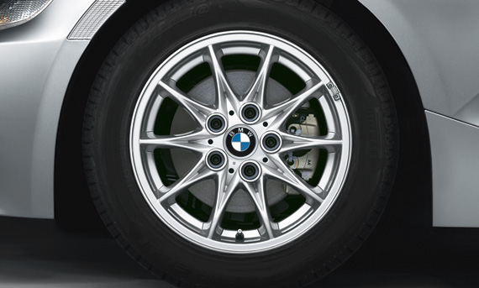 | o | o |  | o |  | o |  |  |  |  | £0.00
  16" light alloy Cross-spoke style 104
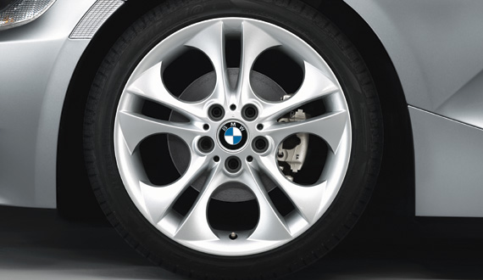 | x | x |  | x |  | x |  |  |  |  | £1,385.00
  18" light alloy Ellipsoid-spoke style 202
 |  |  |  |  |  |  |  | x |  |  | £855.00
17" light alloy Star-spoke style 200 | x | x |  | x |  | x |  | o |  |  | £640.00
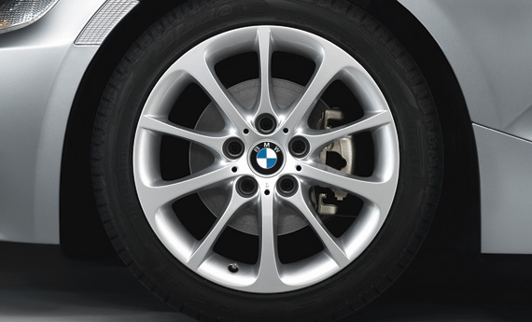

 | x | x |  | x |  | x |  |  |  |  | £710.00
  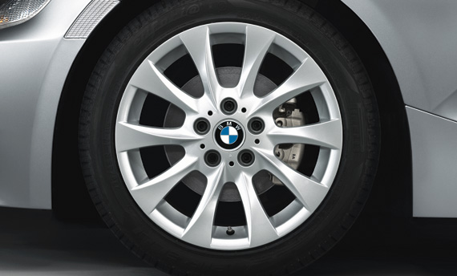
  17" light alloy Turbine-spoke style 201
 |  |  |  |  |  |  |  | x |  |  | £180.00

Option name | 2.0i | 2.0i SE | 2.0i Sport | 2.5i SE | 2.5i Sport | 2.5si SE | 2.5si Sport | 3.0si SE | 3.0si Sport | M Roadster | Retail inc VAT
 | x | x |  | x |  | x |  |  |  |  | £180.00
  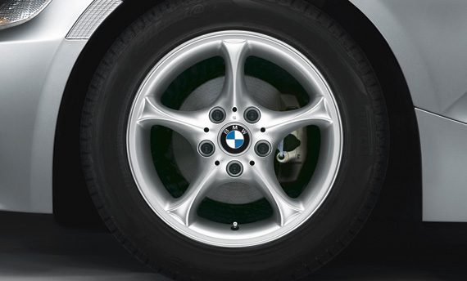
  16" light alloy Star-spoke style 102
17" light alloy Star-spoke style 105 | x | x |  | x |  | x |  |  |  |  | £995.00
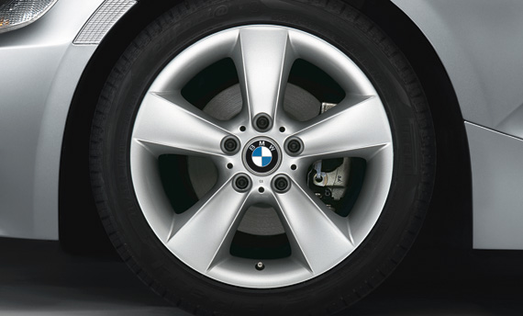 |  |  |  |  |  |  |  | x |  |  | £465.00
18" light alloy Composite Star-spoke style 108 |  |  | X |  | x |  | x |  | x |  | £275.00
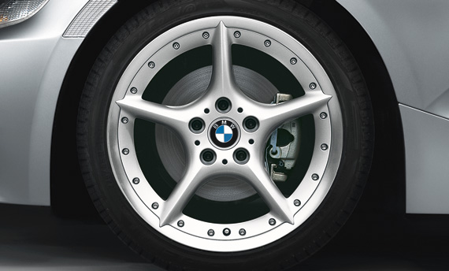

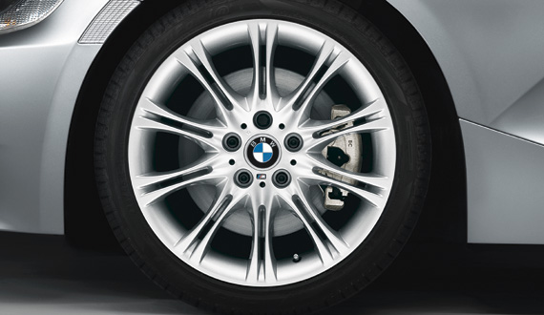 |  |  | O |  | o |  | o |  | o |  | £0.00
  18" light alloy M Double-spoke style 135 M
 |  |  |  |  |  |  |  |  |  | o | £0.00
  18" light alloy M Double-spoke style 224 M
Chrome line interior | x | x | X | x | x | o | o | o | o |  | £145.00
Graduated tinted windscreen | x | x | X | x | x | x | x | x | x | x | £50.00
Wind deflector | x | x | X | x | x | x | x | x | x | x | £165.00
Soft-top, grey | x | x | X | x | x | x | x | x | x | x | £0.00
Only with 399
Soft-top, dark beige | x | x | X | x | x | x | x | x | x | x | £0.00
Only with 399

Option name | 2.0i | 2.0i SE | 2.0i Sport | 2.5i SE | 2.5i Sport | 2.5si SE | 2.5si Sport | 3.0si SE | 3.0si Sport | M Roadster | Retail inc VAT
Soft-top - lined with heated glass rear | x | o | O | o | o | o | o | o | o | o | £710.00
windscreen, fully automatic
Rear-view and exterior mirrors, | x | x | X | x | x |  |  |  |  |  | £260.00
automatically dimming
 |  |  |  |  |  | x | x | x | x | x | £135.00
in combination with Z4P | x | x | X | x | x |  |  |  |  |  | £135.00
Rear-view mirror, automatically dimming | x | x | X | x | x | o | o | o | o | o | £150.00
Light Poplar wood trim, high-gloss | x | x | X | x | x | x | x | x | x |  | £160.00
Not with upholstery AA
Dark Poplar wood trim, high-gloss | x | x | X | x | x | x | x | x | x |  | £160.00
Not with upholstery AA
Brushed Aluminium trim | x | x | O | x | o | x | o | o | o |  | £0.00
Not with upholstery AA
Cirrus Aluminium trim | x | x | X | x | x | x | x | x | x |  | £160.00
Not with upholstery AA
Silk Graphite trim | o | o |  | o |  | o |  |  |  |  | £0.00
Only with upholstery AA
Madeira Walnut wood trim |  |  |  |  |  |  |  |  |  | x | £180.00
Individual Piano Black trim | x | x | X | x | x | x | x | x | x |  | £355.00
Not with upholstery AA
Individual Bi-colour Leather trim | x | x | X | x | x | x | x | x | x |  | £355.00
Only with upholstery NB / LP / LL
Individual Mahogany wood trim | x | x | X | x | x | x | x | x | x |  | £355.00
Not with upholstery AA
Hexagon Aluminium trim |  |  |  |  |  |  |  |  |  | x | £0.00
Black Carbon-structure leather trim |  |  |  |  |  |  |  |  |  | o | £0.00
Seat adjustment- front, electric with driver | x | x | X | x | x | x | x | o | o | o | £820.00
memory
Child seat ISOFIX attachment | x | x | X | x | x | x | x | x | x | x | £60.00
Storage package | x | x | X | x | x | x | x | x | x | x | £50.00
Seat heating | x | x | X | x | x | x | x | x | x | x | £245.00
Headlight wash | x | x | X | x | x | x | x | o | o | o | £185.00
Park Distance Control (PDC), rear | x | x | X | x | x | x | x | x | x | x | £285.00
Foglights, front | x | o | O | o | o | o | o | o | o |  | £145.00
Rain sensor with automatic headlight | x | x | X | x | x | x | x | o | o | o | £90.00
activation
Xenon headlights for low and high beam | x | x | X | x | x | x | x | x | x | o | £415.00
Only with 502 and 520

Option name | 2.0i | 2.0i SE | 2.0i Sport | 2.5i SE | 2.5i Sport | 2.5si SE | 2.5si Sport | 3.0si SE | 3.0si Sport | M Roadster | Retail inc VAT
Cruise control | x | x | X | x | x | x | x | x | x | x | £180.00
On-Board Computer (OBC) | x | o | O | o | o | o | o | o | o | o | £95.00
TV function | x | x | X | x | x | x | x | x | x | x | £710.00
Only with 609
Navigation system - Business | x |  |  |  |  |  |  |  |  |  | £1,550.00
 |  | x | X | x | x | x | x | x | x | x | £1,480.00
Includes 550
Navigation system - Professional | x |  |  |  |  |  |  |  |  |  | £2,115.00
 |  | x | X | x | x | x | x | x | x | x | £2,045.00
Includes 550
BMW Assist | x | x | X | x | x | x | x | x | x | x | £0.00
Only with 609 + 633
Voice Control | x | x | X | x | x | x | x | x | x | x | £285.00
Only with 249/Z4P + 633/644 or 609
Bluetooth telephone preparation with | x | x | X | x | x | x | x | x | x | x | £390.00
telematics
Only with 249/Z4P, 609 and 612
Bluetooth telephone preparation | x | x | X | x | x | x | x | x | x | x | £390.00
Only with 249/Z4P
MiniDisc player | x | x | X | x | x | x | x | x | x | x | £115.00
Only with 609
CD changer for six CDs | x | x | X | x | x | x | x | x | x | x | £295.00
Hi-Fi loudspeaker system | x | x | X | x | x | x | x | x | x | x | £500.00
Hi-Fi loudspeaker system - LOGIC7 | x | x | X | x | x | x | x | x | x | x | £710.00
Professional
M Sports suspension | x | x | O | x | o | x | o | x | o |  | £250.00
M Leather steering wheel |  |  | O |  | o |  | o |  | o | o | £0.00
M Sports seats | x | x | O | x | o | x | o | x | o | o | £500.00
Not with upholstery AA
Comfort Package | x | x |  | x |  |  |  |  |  |  | £655.00
 |  |  | X |  | x |  |  |  |  |  | £510.00
 |  |  |  |  |  | x | x |  |  |  | £395.00
 |  |  |  |  |  |  |  | x | x |  | £330.00
Non-metallic paintwork | o | o | O | o | o | o | o | o | o | o | £0.00
Metallic paintwork | x | x | X | x | x | x | x | o | o | o | £430.00
Individual Metallic paintwork | x | x | X | x | x | x | x |  |  |  | £1,065.00
 |  |  |  |  |  |  |  | x | x |  | £745.00

Option name | 2.0i | 2.0i SE | 2.0i Sport | 2.5i SE | 2.5i Sport | 2.5si SE | 2.5si Sport | 3.0si SE | 3.0si Sport | M Roadster | Retail inc VAT
Free Spirit cloth/Sensatec | o | o |  | o |  | o |  |  |  |  | £0.00
Active Sports leather/sport fibre | x | x | O | x | o | x | o |  |  |  | £710.00
 |  |  |  |  |  |  |  | x | x |  | £0.00
Only with 255 / 710 / Z4P
Oregon leather | x | x |  | x |  | x |  | o | o |  | £925.00
 |  |  | X |  | x |  | x |  |  |  | £215.00
Only with 255 / 710 / Z4P
New England leather | x | x |  | x |  | x |  |  |  |  | £2,095.00
 |  |  | X |  | x |  | x |  |  |  | £1,385.00
 |  |  |  |  |  |  |  | x | x |  | £1,170.00
Only with 255 / 710 / Z4P
Nappa leather |  |  |  |  |  |  |  |  |  | o | £0.00
Full Nappa leather |  |  |  |  |  |  |  |  |  | x | £1,915.00
Individual Bi-colour New England leather | x | x |  | x |  | x |  |  |  |  | £1,455.00
 |  |  | X |  | x |  | x |  |  |  | £745.00
 |  |  |  |  |  |  |  | x | x |  | £535.00
Only with 711 + 255/710/Z4P
Individual Nappa leather | x | x |  | x |  | x |  |  |  |  | £1,455.00
 |  |  | X |  | x |  | x |  |  |  | £745.00
 |  |  |  |  |  |  |  | x | x |  | £535.00
Only with 255/710/Z4P
Individual Extended Nappa leather | x | x |  | x |  | x |  |  |  |  | £3,760.00
 |  |  | X |  | x |  | x |  |  |  | £3,050.00
 |  |  |  |  |  |  |  | x | x |  | £2,840.00
Only with 255/710/Z4P

