Exterior and Interior Dimensions.

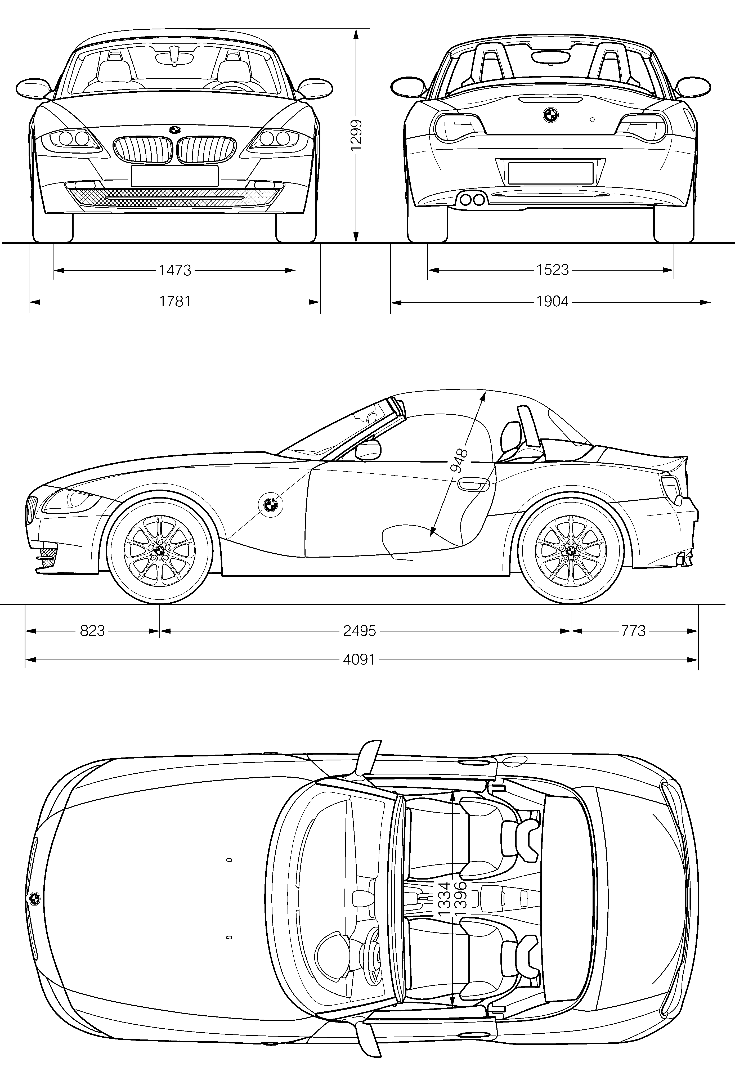
BMW Z4 Roadster.

BMW Z4 M Roadster.
