MINI Plant Oxford
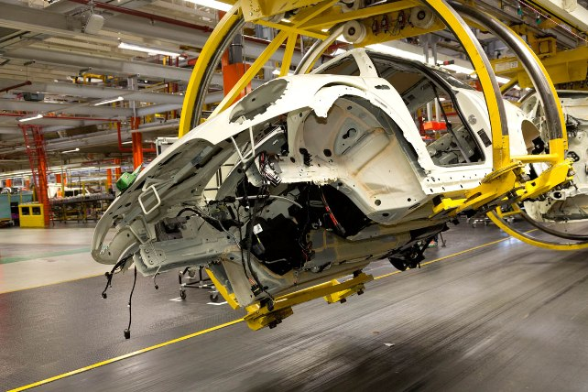
Investment | Currently a £750m investment is underway, mainly at Plant Oxford but also at Swindon and Hams Hall, for the manufacture of the new MINI  The £750m will be spent up to the end of 2015.
Associates | Around 4,000.  Plant Oxford has 95 apprentices.
Start of production for the third generation MINI | November 2013
Property area | 200 acres.
Daily production volume/capacity | Up to 900 MINIs per day.  2012 production: 207,789  More than 2.4 million MINIs have rolled off the assembly line since production began.  Nearly 1.9 million vehicles exported to 108 markets since 2001.
Average working time employee / week | 37.5 hours on average.
Technologies | Body in white, paint shop, assembly, quality and engineering centre.
Products | Five MINI models (Hatch, Convertible, Clubman, Coupé, Roadster)

Facts and figures about MINI production.
Bodyshop
- The whole Oxford bodyshop - current and new- totals 100,000m2 – or 14 football pitches.

- 1500 robots apply up to 6,000 spot welds to create one MINI bodyshell.
- There are 435 separate panels in a new MINI hatchback bodyshell.
- Accuracy of Perceptron cameras is ± 0.05mm (half the width of a human hair). There are 502 Perceptron measuring points for the car body, carried out in five stations throughout the body-in-white process.
- The approximate core temperature of a spot weld is 1500⁰C.
- Every single spot weld is applied by a robot.

Assembly
- More than 40 Automatically Guided Vehicles (AGVs) carry assembled cockpits to the production line.
- New height adjustable skillets introduced to aid assembly.
- New engine marriage station to allow greater flexibility of models coming through assembly.
- New, fully automated glazing cell with cameras mounted on robots to improve the flexibility of the station.
Quality and Engineering Centre

- The cameras in the new Geometric Optical Measurement Cell in the Quality and Engineering Centre (QEC) can record eight million megapixel images, each of these pixels representing a datum point allowing exceptional accuracy.
- The water test can simulate monsoon conditions deluging a MINI with 50 litres of water per square metre per minute.

- A new acoustic rolling road is the single biggest investment in the QEC’s facilities. It is a totally isolated chamber to test engine, gearbox and vibration sounds and can run a car up to 250km per hour.
- The acoustic chamber’s walls consist of 215 mm of concrete with an additional 450mm of fibreglass soundproofing – making them more than half a metre thick.

Paintshop
- 45 cars an hour leave the paintshop for assembly.
- Cars are baked in the paintshop ovens at 140 degrees for 30 minutes.
- Four new paint colours are being introduced for the new car.

Sustainability

- Controlling the flow of air through the paint shop with greater precision has yielded a 730 tonne saving in CO₂.

- There are 3,869 individually programmable lights in the new bodyshop facility, which will save 100 tonnes of CO2 per year.

- During 2013, the combined impact of 175 energy-saving initiatives at Plant Oxford and Plant Swindon will yield savings of almost 47.8GWh of energy savings of almost, roughly equivalent to the energy consumed by 2390 average UK homes in a year.

- The 44 AGVs used in the assembly hall are powered by electric capacitors, which have three times the life of a conventional battery

