Media information
18 May 2015
MINI PARTNERS WITH BRITISH DRIVER
HARRY HUNT FOR THE DAKAR RALLY 2016

MINI ALL4 Racing will strive for 5th consecutive title

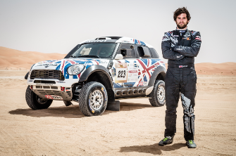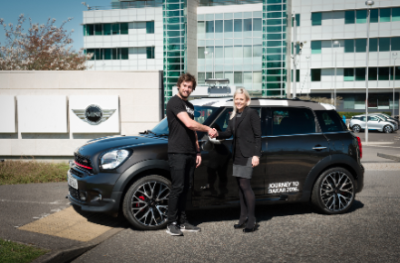

MINI UK is proud to announce British rally driver, Harry Hunt, as the new MINI brand ambassador and one of youngest contenders for the Dakar Rally 2016 title.

As part of the MINI ALL4 Racing team, London-based Hunt, 26, will drive 10,000 kilometres across deserts, mountains, sand dunes and salt flats through South America in the ultimate orienteering and endurance test.

2016 will represent the first time Hunt competes in the Dakar Rally but he has already made big strides in the world of rally driving. He was named ‘Rookie of the Year’ in his first year of world championship rallying in 2011 and more recently earned a podium place at the Abu Dhabi Dessert Challenge this year on his debut in the MINI ALL4 Racing.

MINI ALL4 Racing driver Nasser Al-Attiyah won the Dakar Rally in 2015, securing MINI its fourth consecutive title.

Commenting on the new partnership, Hunt says, “This is an incredibly exciting year for me and I am honoured to be working with MINI. I know the challenge will be tough but to have the chance to drive a championship-winning machine at my age is a dream come true. I really hope I can pay back the faith MINI has shown to me with a good result at Dakar 2016.”

Michelle Roberts, MINI UK General Manager, Brand Communications, “MINI has racing in its DNA and an impressive track record at Dakar so we are really excited to be supporting a young British driver with such a promising career. Harry is one of the hottest new racing talents – I am looking forward to seeing him in action as part of the X-Raid team behind the wheel of the MINI ALL4 Racing at Dakar 2016.”

Harry Hunt will be among the motorsport legends at the Goodwood Festival of Speed from 25th-28th June, racing up the famous Hillclimb in his MINI ALL4 Racing twice daily on Friday, Saturday and Sunday.

When Hunt is not rallying, he has an MINI JCW ALL4 Countryman to drive around London (pictured).

Follow Harry Hunt on:
Twitter @harryhuntdakar and www.instagram.com/HarryHuntDakar
For more information on MINI UK, visit www.MINI.co.uk
For more information or tickets to Goodwood Festival of Speed, visit www.goodwood.com
For more information on the Dakar Rally 2016, visit www.dakar.com

Ends
Notes to editors
Picture captions:
- MINI UK new motorsports ambassador Harry Hunt with his Dakar Car win podium place at the Abu Dhabi Desert Challenge in April 2015
- New MINI UK ambassador and rally driver Harry Hunt receives the keys for his MIN JCW Countryman from MINI UK’s General Manager Brand Communications Michelle Roberts

Harry Hunt will be on the stand and available for interviews throughout Goodwood Festival of Speed. To arrange an interview slot please contact the MINI UK press office (details below).

The BMW Group
With its three brands BMW, MINI and Rolls-Royce, the BMW Group is the world’s leading premium manufacturer of automobiles and motorcycles and also provides premium financial and mobility services. As a global company, the BMW Group operates 28 production and assembly facilities in 13 countries and has a global sales network in more than 140 countries.

In 2013, the BMW Group sold approximately 1.963 million cars and 115,215 motorcycles worldwide. The profit before tax for the financial year 2013 was € 7.91 billion on revenues amounting to approximately € 76.06 billion. As of 31 December 2013, the BMW Group had a workforce of 110,351 employees.

The success of the BMW Group has always been based on long-term thinking and responsible action. The company has therefore established ecological and social sustainability throughout the value chain, comprehensive product responsibility and a clear commitment to conserving resources as an integral part of its strategy.

www.bmwgroup.com
Facebook: http://www.facebook.com/BMWGroup
Twitter: http://twitter.com/BMWGroup
YouTube: http://www.youtube.com/BMWGroupview
Google+: http://googleplus.bmwgroup.com

MINI Press Office Contacts:
Laura Nye Iris PR, MINI Press Office
Tel: 020 7654 4726 Email: laura.nye@iris-worldwide.com

Lois Kettlewell Iris PR, MINI Press Office
Tel: 07920400582 Email: Lois.Kettlewell@iris-worldwide.com

Media website: www.press.bmwgroup.co.uk
www.mini.co.uk
www.twitter.com/miniuk
www.facebook.com/miniuk
www.youtube.com/miniuk

