For Release: | IMMEDIATE
Contact: | Thomas Plucinsky  BMW Product & Technology Communications Manager  (201) 307-3783/ thomas.plucinsky@bmwna.com  David J. Buchko  BMW Advanced Powertrain & Heritage Communications  (201) 307-3709/ dave.buchko@bmwna.com  Monty Roberts  BMW Product & Technology Communications  (201) 307-3755 / monty.roberts@bmwna.com
BMW Online Gets Updated User Experience
New menu layout will make adding new services easier
Woodcliff Lake, NJ – December 1, 2011… BMW announced that users of BMW online in the US will receive an update to the look and feel of this innovative service beginning today. Compared to the previous version of BMW Online, the new version has an updated look-and-feel. It bundles many services into an Applications menu, which may be personalized by the user. This new layout of services will allow BMW to seamlessly add new features as they become available. Customers who subscribe to the optional BMW Assist Convenience Plan and have a navigation-equipped vehicle capable of receiving the BMW Online service will immediately be updated to the newest version today, without having to make any changes to their vehicle.
Starting with selected 2009 Model Year vehicles, BMW ConnectedDrive was enhanced with the introduction of BMW Search, and since then its suite of services has grown to provide BMW customers with a convenient place to get relevant information. In March 2011, the service was renamed to BMW Online, but continued to provide the latest News headlines, Weather, Google Local Search results, Fuel Prices, Stock Indexes, and Send to Mail services.
BMW Online is just one of the many ConnectedDrive services available to BMW customers. BMW ConnectedDrive combines various elements from online applications, driver assistance, call center services and solutions for the integration of mobile devices. As a result, BMW customers are provided with an exceptional form of mobility, with more safety, more convenience, and more infotainment.
BMW Online provides access to a variety of information and services safely and conveniently:
- Stock Indexes - Want to know the Dow Jones, S&P 500 or NASDAQ indices? BMW Online provides these indices right on the customer’s control display.
- News – With BMW Online, the latest US, Business, World, Sports, Entertainment, and BMW news headlines are available to the customer.
- Weather - BMW Online provides the latest 5-day weather forecast and even provides weather advisories and warnings.
- Google Local Search –With Google Local Search, customers can search for a business listing to get important information like the address and phone number. Then, they can set the address as a destination in their navigation or call the business via their Bluetooth-connected phone.
- Fuel Prices – The latest fuel price information is just a few clicks away! With BMW Online, customers can search for fuel stations nearby and sort by price or distance.
- Send to Mail – With the Send to Mail application, customers can email their vehicle’s current location and destination to any email address.
BMW Online is available exclusively to Convenience Plan subscribers on BMW Assist with on-board Navigation system on the following models:
- 2009 and later Z4, 1, 3 and 7 Series
- 2010 and later 5 and 6 Series
- 2010 and later X5 and X6
- 2011 and later X3.
The images below show the changes to the menu:
Before December 1st, 2011
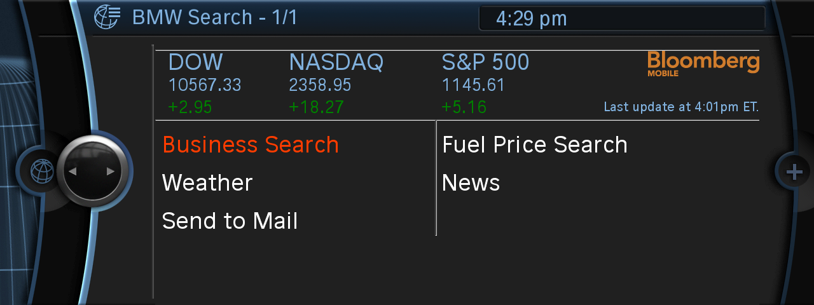

Starting December 1, 2011

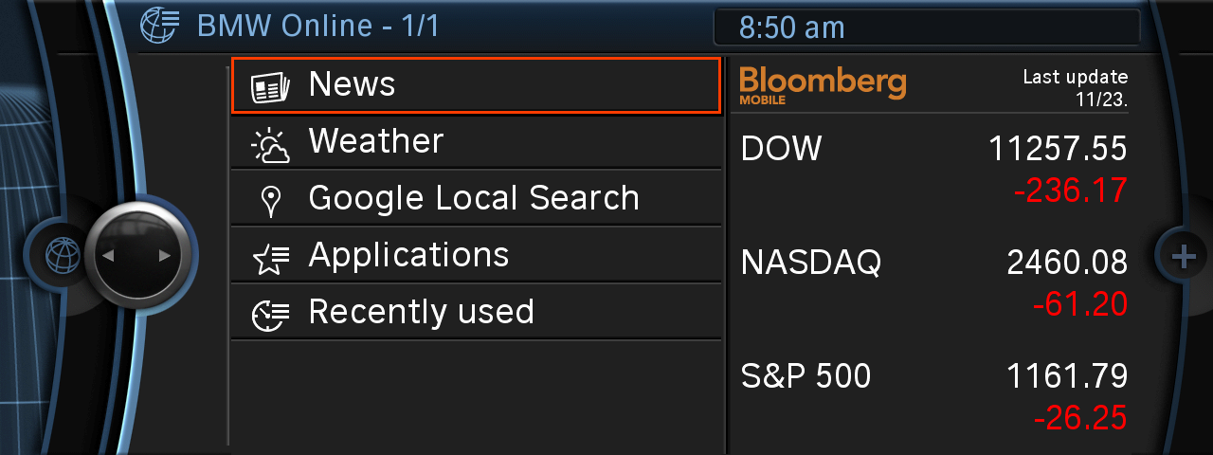

BMW Group In America
BMW of North America, LLC has been present in the United States since 1975. Rolls-Royce Motor Cars NA, LLC began distributing vehicles in 2003. The BMW Group in the United States has grown to include marketing, sales, and financial service organizations for the BMW brand of motor vehicles, including motorcycles, the MINI brand, and the Rolls-Royce brand of Motor Cars; DesignworksUSA, a strategic design consultancy in California; a technology office in Silicon Valley and various other operations throughout the country. BMW Manufacturing Co., LLC in South Carolina is part of BMW Group’s global manufacturing network and is the exclusive manufacturing plant for all X5 and X3 Sports Activity Vehicles and X6 Sports Activity Coupes. The BMW Group sales organization is represented in the U.S. through networks of 339 BMW passenger car and BMW Sports Activity Vehicle centers, 139 BMW motorcycle retailers, 110 MINI passenger car dealers, and 36 Rolls-Royce Motor Car dealers. BMW (US) Holding Corp., the BMW Group’s sales headquarters for North America, is located in Woodcliff Lake, New Jersey.
Information about BMW Group products is available to consumers via the Internet at:
www.bmwgroupna.com.
# # #

Journalist note: Information about BMW and its products in the USA is available to journalists on-line at www.bmwusanews.com.

# # #

