For Release: | IMMEDIATE
Contact: | Thomas Plucinsky  BMW Product & Technology Communications Manager  (201) 307-3783/ thomas.plucinsky@bmwna.com  David J. Buchko  BMW Advanced Powertrain & Heritage Communications  (201) 307-3709/ dave.buchko@bmwna.com  Monty Roberts  BMW Product & Technology Communications  (201) 307-3755 / monty.roberts@bmwna.com
BMW Online Adds Yelp to Suite of Services
New application lets customers find businesses and get reviews
Woodcliff Lake, NJ – December 21, 2011… BMW today announced that users of BMW Online in the US can now access Yelp in their vehicles. With Yelp on-board, customers can search for everything from the best local restaurants and boutiques to parking garages and banks. They are able to see ratings for those businesses while hearing reviews read out to them via the vehicle’s text-to-speech feature. With the recent update to BMW Online’s layout, BMW can seamlessly add new features (known as “applications”) as they become available. Yelp is the first such application and there will be more to follow.
Customers who subscribe to the optional BMW Assist Convenience Plan and have a navigation-equipped vehicle capable of receiving the BMW Online service will be able to add the service today, without having to make any changes to their vehicle. Yelp reviews can be accessed through the new Applications screen that is now part of BMW Online with the update which took place earlier this month.
BMW Online is just one of the many ConnectedDrive services available to BMW customers. BMW ConnectedDrive combines various elements from online applications, driver assistance, call center services and solutions for the integration of mobile devices. As a result, BMW customers are provided with an exceptional form of mobility, with more safety, more convenience, and more infotainment.

The BMW Online Yelp application has several exciting features
- Category Search – Search by category for nearby restaurants, cafes, shopping, nightlife, and more.
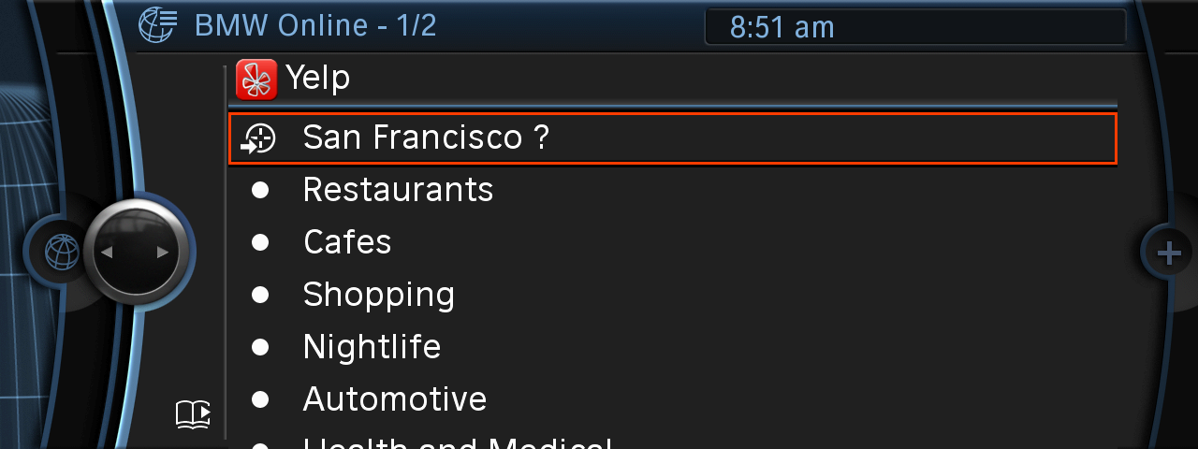

- Results Overview - Results are sorted by distance and star ratings, and also list category information and number of reviews.
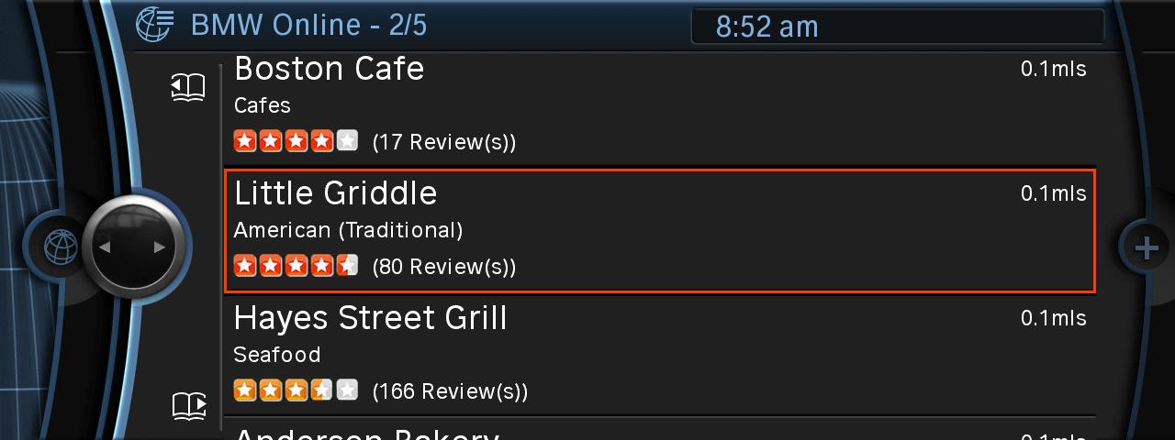

- Details – Selecting a particular place gives more details about it. Customers can see the rating, address, distance, phone number, and information about reviews. Additionally, they can e-mail details of the business to themselves or any other e-mail address.
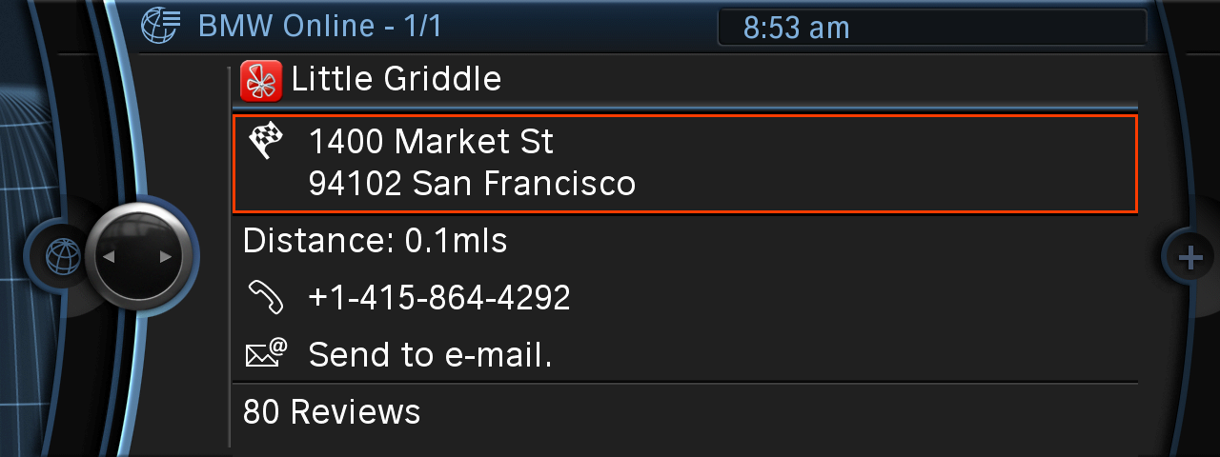

- Reviews – The 3 latest reviews are available for the business. The customer can select one of those reviews and have it read back automatically.
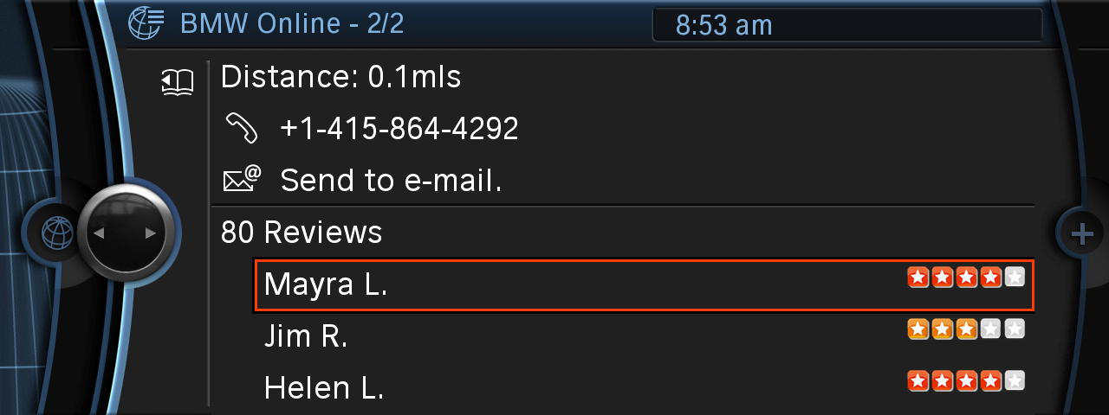

BMW Online is available exclusively to Convenience Plan subscribers on BMW Assist with on-board Navigation system on the following models:
- 2009 and later Z4, 1, 3 and 7 Series
- 2010 and later 5 and 6 Series
- 2010 and later X5 and X6
- 2011 and later X3.

BMW Group In America
BMW of North America, LLC has been present in the United States since 1975. Rolls-Royce Motor Cars NA, LLC began distributing vehicles in 2003. The BMW Group in the United States has grown to include marketing, sales, and financial service organizations for the BMW brand of motor vehicles, including motorcycles, the MINI brand, and the Rolls-Royce brand of Motor Cars; DesignworksUSA, a strategic design consultancy in California; a technology office in Silicon Valley and various other operations throughout the country. BMW Manufacturing Co., LLC in South Carolina is part of BMW Group’s global manufacturing network and is the exclusive manufacturing plant for all X5 and X3 Sports Activity Vehicles and X6 Sports Activity Coupes. The BMW Group sales organization is represented in the U.S. through networks of 339 BMW passenger car and BMW Sports Activity Vehicle centers, 139 BMW motorcycle retailers, 110 MINI passenger car dealers, and 36 Rolls-Royce Motor Car dealers. BMW (US) Holding Corp., the BMW Group’s sales headquarters for North America, is located in Woodcliff Lake, New Jersey.
Information about BMW Group products is available to consumers via the Internet at:
www.bmwgroupna.com.
# # #

Journalist note: Information about BMW and its products in the USA is available to journalists on-line at www.bmwusanews.com.

# # #

