For Release: | IMMEDIATE
Contact: | Thomas Plucinsky  BMW Product & Technology Communications Manager  (201) 307-3783/ thomas.plucinsky@bmwna.com  David J. Buchko  BMW Advanced Powertrain & Heritage Communications  (201) 307-3709/ dave.buchko@bmwna.com  Monty Roberts  BMW Product & Technology Communications  (201) 307-3755 / monty.roberts@bmwna.com
My BMW Remote Mobile App Now Available
New mobile app lets customers access remote services for their vehicles
Woodcliff Lake, NJ – February 15, 2012… BMW announced that the My BMW Remote app is available for Apple iOS devices beginning today. This app allows many BMW customers to access remote features for their vehicle by using their mobile device and the power of BMW Assist. These features include remotely locking and unlocking of doors, getting the location of their parked vehicle, and sending Google Local Search results to their vehicle. Additionally, some customers will even be able to send a command to sound the horn or flash the headlights of their BMW.
Customers who have an active BMW Assist Safety Plan, a compatible vehicle, and an Apple device running iOS 4.0 or later will be able to download the app to their device starting today via the Apple iTunes store. No changes are required to their BMW. My BMW Remote operates on the customer’s mobile device, sending remote commands to their BMW.
My BMW Remote includes the following functions in detail:

- Vehicle Position – If the vehicle’s ignition is off, and it is located within 0.6 miles (1km) of the mobile device, the current vehicle location can be displayed on a map in the mobile device:
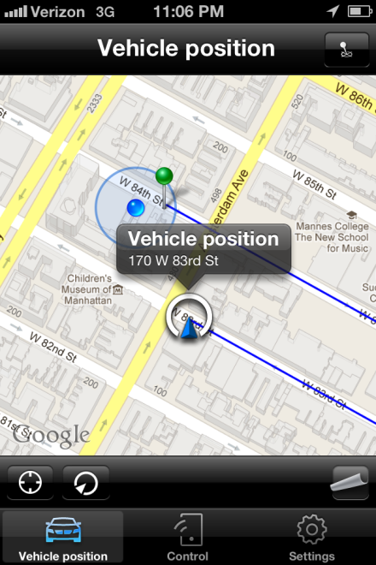

- Google Local Search - Search for local businesses, restaurants, and more on the mobile device and send the details to the vehicle:

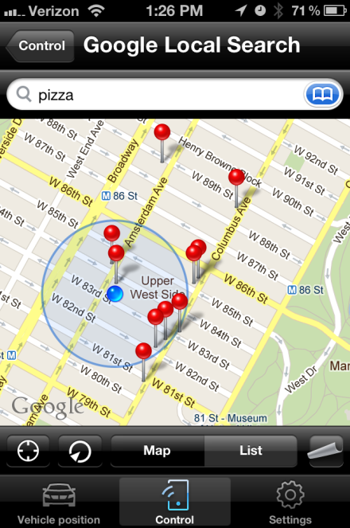

- Remote Locking & Unlocking – Customers can remotely lock or unlock their vehicles, providing peace of mind if they are unsure whether they locked the vehicle in the parking lot or if they have accidently locked keys in the vehicle :

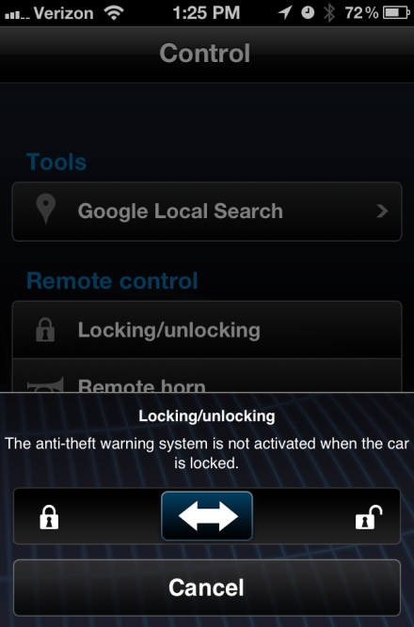

- Remote Horn - send a remote command to sound the horn of your BMW to help locate the vehicle:

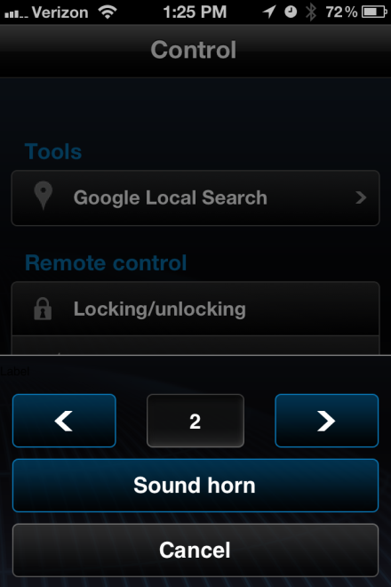

Remote Headlights – remote control of configurable exterior light functions to help locate the vehicle:

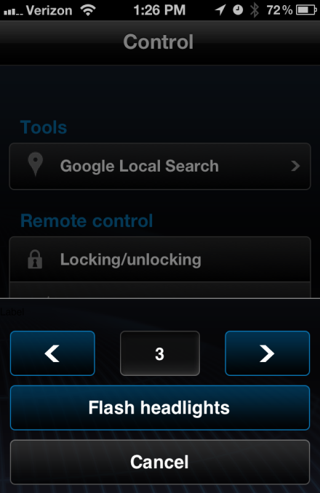

The remote features available to the customer will depend on which BMW model they have.
The following vehicles will have Remote Door Lock & Unlock, Google Local Search, and Vehicle Position available:
- 1 Series, 3 Series, 5 Series, or 6 Series produced March 2008 or later
- X5 SAV or X6 SAC produced April 2008 or later
- Z4 Roadster from Model Year 2009 or later

The following vehicles will have Remote Horn and Remote Flash Headlights available, in addition to Remote Door Lock & Unlock, Google Local Search, and Vehicle Position:
- X3 SAV from Model Year 2011 or later
- 3 Series Sedan from Model Year 2012 or later
- 5 Series Gran Turismo from Model Year 2010 or later
- 5 Series Sedan from Model Year 2011 or later
- 6 Series from Model Year 2012 or later
- 7 Series from Model Year 2009 or later

My BMW Remote is just one of the many ConnectedDrive services available to BMW customers. BMW ConnectedDrive combines various elements from online applications, driver assistance systems, call center services and solutions for the integration of mobile devices. As a result, BMW customers are provided with an exceptional form of mobility, with more safety, more convenience, and more infotainment.

BMW Group In America
BMW of North America, LLC has been present in the United States since 1975. Rolls-Royce Motor Cars NA, LLC began distributing vehicles in 2003. The BMW Group in the United States has grown to include marketing, sales, and financial service organizations for the BMW brand of motor vehicles, including motorcycles, the MINI brand, and the Rolls-Royce brand of Motor Cars; DesignworksUSA, a strategic design consultancy in California; a technology office in Silicon Valley and various other operations throughout the country. BMW Manufacturing Co., LLC in South Carolina is part of BMW Group’s global manufacturing network and is the exclusive manufacturing plant for all X5 and X3 Sports Activity Vehicles and X6 Sports Activity Coupes. The BMW Group sales organization is represented in the U.S. through networks of 339 BMW passenger car and BMW Sports Activity Vehicle centers, 139 BMW motorcycle retailers, 110 MINI passenger car dealers, and 36 Rolls-Royce Motor Car dealers. BMW (US) Holding Corp., the BMW Group’s sales headquarters for North America, is located in Woodcliff Lake, New Jersey.
Information about BMW Group products is available to consumers via the Internet at:
www.bmwgroupna.com.
# # #

Journalist note: Information about BMW and its products in the USA is available to journalists on-line at www.bmwusanews.com.

# # #

