For Release: | July 2, 2012
Contact: | Roy Oliemuller  BMW Motorrad USA Communications Manager  Tel. 201-307-4082 /roy.oliemuller@bmwna.com

The New BMW F 700 GS and F 800 GS
Off-road or urban – new, authentic character with improved functionality in typical GS style

Woodcliff Lake, NJ – July 2, 2012…When BMW Motorrad extended the GS family with an entry-level and medium category in 2007 in the form of the F 650 GS and the F 800 GS, there was no doubt as to the message: lots of riding fun based on light, safe controllability over all surfaces, plenty of drive power and endurance on trips - even when there are only gravel tracks left to get you where you're going. A concept in
two versions which many motorcycling fans responded to enthusiastically.

BMW Motorrad now continues this chapter of the GS success story with the updated versions of these two successful enduro models: the F 700 GS and F 800 GS. As always, BMW Motorrad has faced the challenge of taking something that is already good and making it even better, consistently focusing on building on the characteristic strengths of the GS in refining the concept.

The new F 800 GS combines suitability for road use and touring with superior off-road qualities, bringing the two worlds together to an extent not previously seen in this class of motorcycle. By contrast, the new F 700 GS is geared more towards motorcyclists who do not yet need quite the same level of off- road expertise. Its strengths are a lower seating height, all-round capabilities for everyday use and more than sufficient power while also offering outstanding economy.

In accordance with the "Safety 360°" principle, BMW Motorrad provides BMW Motorrad ABS as standard in the new F 700 GS and F 800 GS. The new F 700 GS and F 800 GS also feature other safety-related innovations within their respective classes, such as the optional ASC (Automatic Stability Control) and optional ESA (Electronic Suspension Adjustment).
The well-proven parallel twin - now with increased output and torque for the new F 700 GS. Both the F 700 GS and the F 800 GS continue to draw their power from the
distinctive, liquid-cooled 4-valve 2-cylinder engine with 798 cc, electronic fuel injection, closed-loop catalytic converter and 6-speed gearbox. Its spontaneous response, impressive acceleration and low fuel consumption are what give it a particular fascination. Another unique feature in production motorcycle manufacture is the mass balance based on an additional connecting rod. This compensates for first and second-order inertia forces, ensuring that the 2-cylinder runs with a low level of vibration. In the F 800 GS, the power unit still delivers 63 kW (85 hp) at 7,500 rpm, producing a maximum torque of 83 Nm at 5,750 rpm.

As compared to its predecessor, the new F 700 GS benefits from a boost in terms of output and torque. With 55 kW (75 hp) at 7,300 rpm (F 650 GS: 52 kW [71 hp] at 7,000 rpm), its engine now delivers 4 hp more power and with 77 Nm at 5,500 pm (F 650 GS: 75 Nm at 4,500 rpm) it also sees an increase in maximum torque. In conjunction with a somewhat shorter overall gear ratio, the bike now offers even further enhanced engine performance and riding dynamics.

F 700 GS now fitted with double disc brake. ABS now standard in both models based on the "Safety 360°" principle.*

The new F 700 GS and F 800 GS draw on established suspension technology. The steel frame in tubular construction integrates the engine as a load-bearing element. The rear frame in square steel tubing, the aluminum double-sided swing arm and the wheels and tires all remain unchanged.

Like the F 800 GS, the new F 700 GS is now fitted with a double disc brake on the front wheel. What is more, the two new GS models are fitted as standard with a new generation of the BMW Motorrad two-channel ABS for the first time.
*ABS standard for all models in the U.S. since Model Year 2012

Electronic Suspension Adjustment ESA.

The Electronic Suspension Adjustment ESA is a new feature in this motorcycle segment. Available as an option, it allows the rider to conveniently set the rebound stage damping of the rear spring strut at the press of a button on the handlebars, with the settings "Comfort", "Normal" or "Sport" available, thereby adapting the set-up to the needs of both route and riding style. The knob for setting the desired spring mount allows increased adjustment.

Automatic Stability Control ASC.

BMW Motorrad ASC (Automatic Stability Control) is also available as an option which is unique in the market segment of the new F 700 GS and F 800 GS. This BMW Motorrad traction control system prevents unwanted spinning of the rear wheel while accelerating, which would result in the loss of lateral grip and thus loss of traction of the rear wheel. The result - especially when the road surface offers reduced friction - is an increase in riding safety.

New switch units.

The new F 700 GS and F 800 GS each feature the latest generation of BMW Motorrad switchs. These are more compact in design and offer improved ergonomics.

Cockpit with new dial faces and an extended range of information. The analog speedometer and engine speed display are arranged vertically, their new dial faces ensuring improved legibility of road speed and engine speed in the new F 700 GS and F 800 GS. The information display includes fuel level and coolant temperature as standard.

Smoke grey turn indicator glasses and smoke grey lenses on the LED rear light. The increased dynamic performance and even more harmonious appearance of the new F 700 GS and F 800 GS are reflected in the new smoke grey lenses for the turn indicators and a smoke grey lens on the LED rear light.

New body features, distinctive model-specific design and new paint finishes. In terms of styling, the new BMW F 700 GS and F 800 GS have been upgraded to create a simple design more in keeping with model character. The main revised areas are the new side trim panels, which are now more striking and dynamic in styling and reflect the differing characters of the F 700 GS and F 800 GS. The design package includes new paint finish concepts.

Lowered suspension now also available for the new F 800 GS.

In response to popular demand among existing F 800 GS customers for a lower seat height, BMW Motorrad now offers a lowered suspension in conjunction with a lower seat as an option and as a dealer accessory.

Extensive expansion of the range of options and special accessories.

As part of its model revision measures, BMW Motorrad has also significantly broadened the range of options and special accessories, thereby addressing the widely differing areas of use pursued by BMW GS customers.

Overview of new technical features:

• Increased output and torque in the F 700 GS as compared to predecessor model:
55 kW (75 hp) at 7,300 rpm (F 650 GS: 52 kW [71 hp] at 7,000 rpm).
• The latest generation of BMW Motorrad two-channel ABS as standard.*
• Double disc brake system at front - now also for F 700 GS.
• Automatic Stability Control ASC (option).
• Electronic Suspension Adjustment ESA (option).
• Rear spring mount can be adjusted via optimized handwheel.
• Newly designed body features in a more dynamic appearance.
• New paint finishes for the F 700 GS:
Red apple metallic, Ostra grey metallic matt and Glacier silver metallic.
• New paint finishes for the F 800 GS:
Kalamata metallic matt, Cordoba blue and Alpine white 3.
• New handlebar switches and brake fluid reservoirs, front.
• New handlebar clamp for F 700 GS.
• Cockpit with new dial faces for speedometer and engine speed display and an
extended range of information.
• New windshield for F 700 GS.
• Smoke grey turn indicators and smoke grey LED rear light lens.
• Lowered suspension for F 800 GS ( option).
• Comfort seat now available as an option.
• Case carrier for Vario case (option).
• New center stand (option).
• Comfort package: on-board computer, heated grips, case holder, center stand
(option).
• Safety package for F 800 GS: ASC and ESA (option).
• Safety package for F 700 GS: ASC, ESA, TPM (option).
• LED auxiliary headlight for F 800 GS (accessory).
• Enduro footrests, wide (accessory).

*ABS standard for all models in the U.S. since model year 2012

The main differentiating technical features at a glance:

BMW F 800 GS BMW F 700 GS

63 kW/85 hp 55 kW/75 hp
USD telescopic fork Conventional telescopic fork
Progressive damping spring strut Gas pressure spring strut
Spoke wheels Cast wheels
21-inch front wheel 19-inch front wheel
Aluminum handlebar Steel handlebar
880/850 mm seat height 820/790 mm seat height
Weight, road ready, 214 kg Weight, road ready, 209 kg

Like their predecessor models, the F 700 GS and F 800 GS also draw their power from the dynamic, high-torque water-cooled 2-cylinder in-line engine with 798 cc capacity, fuel injection and closed-loop catalytic converter. The parallel twin has not been changed as compared to the predecessor models. Its technical highlights remain a very compact construction with cylinders tilted just 8.3 degrees forward, two overhead camshafts with speed-resistant valve control via rocker arms and the unique mass balance by means of a system of articulated joints running over the center of the crankshaft with specifically arranged counterbalance masses to ensure low-vibration running.

Optimized power and torque efficiency and a shorter overall gear ratio in the new F 700 GS.

The agile power delivery and revving power of the F 700 GS and F 800 GS are especially thrilling: even in the lower and medium engine speed range, the two new GS models offer a powerful response for dynamic riding fun - whether on or off the road.
While the output and torque of the F 800 GS remain unchanged at 63 kW (85 hp) at 7,500 rpm and 83 Nm at 5,750 rpm, the new F 700 GS benefits from an increase in output and torque as compared to its predecessor model. The output has been raised by 4 hp to 55 kW (75 hp) at 7,300 rpm (F 650 GS: 52 kW [71 hp] at 7,000 rpm), and the maximum torque has been increased to 77 Nm at 5,500 rpm (F 650 GS: 75 Nm at 4,500 rpm). This increase in power now requires the use of premium fuel (RON 95) in the F 700 GS too.

The same six-speed gearbox has been used as in the predecessor models. In order to enhance riding dynamics, the secondary ratio of the chain drive with off-road capability in the new F 700 GS is now somewhat shorter with 17 to 42 teeth (F 650 GS: 17 to 41 teeth).

The new F 700 GS and F 800 GS continue to feature the robust and torsionally stiff steel frame in tubular construction with the engine integrated as a load-bearing element. The rear frame in square steel tubing, the steering head connection via gusset plates and the single-section chill-cast double-sided swing arm made of aluminum also remain unchanged, reflecting the high-quality finish and slim structure of the two GS models.

Double disc brake system for the F 700 GS.

Like the F 800 GS, the new F 700 GS now also has a double disc brake with an effective diameter of 300 millimeters and dual piston floating calipers on the front wheel. The connection between the brake discs and front wheel is floating in both models. On the rear wheels, both models feature a single disc brake with a disc diameter of 265 millimeters and single-piston floating caliper. Both models are equipped with new brake fluid reservoirs improving the overall appearance.

ABS now a standard feature in both models.*

Based on the BMW Motorrad principle "Safety 360°", the latest generation of the BMW Motorrad two-channel ABS will be installed as standard for the first time. The new system is not only lighter but is also more compact in size that the previous generation. What is more, it now has inlet valves which can be infinitely adjusted for an even better response. New wheel sensors automatically monitor the distance between sensor and sensor wheel. As usual, the new standard ABS can be deactivated at the press of the button if the rider so wishes - for example for active riding over rough terrain.

*ABS standard for all models in the U.S. since Model Year 2012

Electronic Suspension Adjustment ESA as an option.

On request (option) and unique in this segment of the motorcycle market, the rider can conveniently set the rebound stage damping of the rear spring strut on the F 700 GS and F 800 GS at the press of a button on the handlebar. This Electronic Suspension Adjustment - or ESA for short - allows adjustment of the suspension settings with maximum operational convenience, even during travel. The rider selects a damping variant from among "Comfort", "Normal" and "Sport" and the electronic control system measures the appropriate damping rate based on optimum parameters stored in the data memory. Damper settings can be changed simply at the press of a button while riding, with a small, light stepper motor carrying out the commands. A symbol appears in the cockpit accordingly. The adjustment of the spring mount is made manually by means of an easily accessible knob.

Automatic Stability Control ASC as an option.

Another unique feature within the market segment of the new F 700 GS and F 800 GS is the availability of the BMW Motorrad rider assistance system ASC - one of the most popular options for BMW motorcycles.

ASC prevents unwanted spinning of the rear wheel while accelerating, which would result in the loss of lateral grip and reduced traction of the rear wheel. By comparing the rotational speeds of the front and rear wheel obtained via the ABS sensors, the electronic system detects spin in the rear wheel and cuts back engine torque accordingly by reducing the ignition angle as well as adapting injection via the engine control system.

In this way ASC makes for more efficient power transmission and therefore increased safety. If traction control is not desired - on the race track for example - the rider can simply deactivate it at the press of a button, even during travel.

In terms of the electrical system, the new F 700 GS and F 800 GS continue to use a CAN bus system. This single-wire system (SWS) offers a wealth of benefits: it reduces the amount of wiring required, allows all control units to be networked and thus makes comprehensive diagnosis much simpler. What is more, conventional fuses are no longer required because the system automatically deactivates any component affected in the event of malfunction.

Since the introduction of CAN bus technology, electronic vehicle immobilization has been a standard feature of BMW motorcycles. To start the engine, more is required than the appropriate key bit: the chip integrated in the BMW key also has to send the correct code to the ring antennae of the combined handlebar and ignition lock. Only then does the engine control system allow the engine to be started. This technology offers what is currently the most secure and reliable protection from theft. A battery with 14 ampere- hours and an alternator with an output of 400 watts ensure a reliable power supply.

New switchs and an extended range of information.

The latest generation of BMW Motorrad switches is now used in the new F 700 GS and F 800 GS, too. The new switches are much smaller and more compact thanks to MID technology (MID = Molded Interconnect Design; printed conductors rather than individual wiring) and offer a wider range of functions and improved operation.

Here the functions for the left and right turn indicators - previously separated - are now combined in a single function on the left-hand side of the handlebars. The hazard warning flashers are activated via a separate, clearly visible switch integrated at the top of the left-hand handlebar panel. The functions for low beam, high beam and headlamp flasher have been combined in a switch which is located near the left index finger for convenient access.

The activation switch for the heated grips has been placed at the top for easier access and the functions for starter and kill switch combined in a rocker switch. This means that if the kill switch is activated by mistake, it prevents the starter from being triggered when the ignition is not switched on and discharging the battery. ESA and ASC are also activated by means of a combined rocker switch.

The cockpit of the new F 700 GS and F 800 GS with vertically arranged analog engine speed display and speedometer and information panel has been improved. Newly designed dial faces now ensure even better legibility of road speed and engine speed. And the rider now gets feedback on the fuel level and coolant temperature as a standard feature - two functions which were previously only available as options with the on-board computer.

As in the popular predecessor models, the F 700 GS and F 800 GS of model year 2013 also benefit from reduced width in the area of the seat and front section due to the slimline construction of the frame and engine, ensuring improved seat height and narrow standing width. The low overall center of gravity makes for outstanding off-road qualities and easy vehicle control, and the large steering angle - derived from a narrow steering head - is a bonus when riding over rough terrain. Wide handlebars suitable for enduro riding – made of cylindrical steel tubing with a new clamp in the F 700 GS and made of double-butted aluminum tubing in the F 800 GS - support the easy, agile handling of the two machines.

The wide range of adjustment provided in the hand levers for the front brake and clutch allow adaptation to individual rider preferences. The wide footrests with vibration-damping, removal rubber tops are ideal for off-road riding and lengthier tours.

The new BMW F 700 GS and F 800 GS display their kinship as authentic members of the BMW GS family more strikingly than previous models with revised body features and optimized ergonomics. Their slim look gives them a feeling of lightness. Clear lines and the selective combination of painted areas with black components give them a purist appearance with a dash of robustness typical of the enduro style.

Off-road or urban – new, authentic character with improved functionality in typical GS style.

The model revision provides the front sections of the new BMW F 700 GS with an even clearer design, in line with the character of the model. The new side trim sections are a key element here, giving both models a perceptibly more striking look.
The new body features of the F 700 GS and F 800 GS also include a reworking of the "beak" above the front mudguard - a BMW GS hallmark. This has been redesigned in both models, providing excellent functionality as a splash guard in keeping with the orientation of the F 700 GS and F 800 GS.

Different windshields are available for the two models to match the specific character of each of them. These offer optimum protection from airstream and integrate perfectly in the styling of each bike. As always, the extensive BMW Motorrad range of special accessories offers alternatives here: a choice of tinted or more touring-oriented windshields for individual customization.

The overall impression conveyed by the lines is much more dynamic. The flatter design of the lower edge means the new side sections give the vehicle a more elevated appearance, especially in the new F 700 GS.

Meanwhile the differing design of the engine air intake and the positioning of the BMW logo, model inscription and turn indicators highlight the distinct characters of the two 2-cylinder models. While the new F 800 GS displays its off-road capability, the new F 700 GS emphasizes its urban character.

New smoke grey lenses for the turn indicators and a smoke grey lens on the LED rear light cluster reflect the dynamic design of the new F 700 GS and F 800 GS, now making the appearance more closely match the new BMW GS model line.

Optional seat height reduction based on lowered suspension now also available in the new F 800 GS.

With a standard seat height of 880 millimeters, the BMW F 800 GS clearly reflects its off-road orientation with long spring travel. In response to frequent requests for a reduced seat height, BMW Motorrad now offers a lowering option in the F 800 GS in conjunction with a low seat. A reduction by 60 millimeters to just 820 millimeters now ensures accessibility and reachability for all riders.

Options and special accessories for a wide range of customization opportunities.

The familiar comprehensive BMW Motorrad program of options and special accessories is available for further customization of the new F 700 GS and F 800 GS.

Options are supplied from the factory and are integrated in the production process. Special accessories are installed by Authorized BMW Motorrad dealers and are features which may be retrofitted, too.

Options.

• New: Automatic Stability Control ASC.
• New: Electronic Suspension Adjustment ESA.
• New: Lowered suspension for the F 800 GS (not available with ESA, center stand
or safety package).
• New: Comfort seat.
• New: Case holder for Vario case.
• New: Comfort package (on-board computer, heated grips, case holder, center
stand).
• New: Safety package for F 800 GS (ASC, ESA).
• New: Safety package for F 700 GS (ASC, ESA, TPM).
• Optimized center stand.
• Off-road tires (F 800 GS only).
• Heated grips.
• Tire pressure control TPM (F 700 GS only).
• On-board computer.
• Anti-Theft Alarm system.
• Low Seat.

Special accessories.

Safety.

• New: Automatic Stability Control ASC.
• New: LED additional headlamp (F 800 GS only).
• Antitheft alarm system.
• Tire pressure control TPM (F 700 GS only).
• Hand protector bar.
• Hand protector (small and large) for hand protector bar.
• Attachment spoiler for hand protector, large.
• Engine guard, plastic (F 700 GS only).
• Enduro aluminum engine guard.
• Crash bars.

Storage program.

• Luggage carrier, small.
• Luggage rack, large, for Vario topcase.
• Vario topcase, black.
• Case holder for Vario case.
• Vario case, black.
• Liners for Vario case and Vario topcase.
• Back pads for Vario topcase.
• Aluminum case (F 800 GS only).
• Functional liner for aluminum case (F 800 GS only).
• Carrying handle for aluminum case or topcase

(F 800 GS only).

• Case holder for aluminum case (F 800 GS only).
• Aluminum topcase (F 800 GS only).
• Functional liner for aluminum case (F 800 GS only).
• Back pad for aluminum topcase (F 800 GS topcase).
• Topcase holder for aluminum topcase (F 800 GS only).
• Tankbag, waterproof.
• Softbag 2, small.
• Enduro rear bag.

Design.

• LED turn indicators (accessory).
• Headlamp guard (for off-road use only).
• Splash guard extension, rear.

Sound.

• Akrapovič sports exhaust silencer.

Ergonomics and comfort.

• New: Windshield small, tinted (F 700 GS only).
• Windshield large, clear (F 700 GS only).
• Windshield large, tinted.
• Touring windshield (F 800 GS only).
• Wind deflection set (F 800 GS only).
• New: Enduro footrests, wide.
• Heated grips.
• Rallye seat.
• Comfort seat.
• Low seat.
• High seat (for F 700 GS only).
• Optimized center stand.

Navigation and communication.

• BMW Motorrad Navigator IV.
• Holder for BMW Motorrad Navigator IV.
• Function pouch for BMW Motorrad Navigator IV.

Maintenance and technology.

• On-board toolkit.
• Repair kit for tubeless tires.
• Automatic chain lubrication system.
• LED lamp for charging socket.
• Battery charger.

The new F 700 GS and F 800 GS also reflect their more sharply drawn character in the form of new color concepts.

Ostra grey metallic creates a deliberately modern variant of the F 700 GS with an off-road touch. Meanwhile, Red apple metallic gives the F 700 GS a more discreet, touring-oriented appearance, while in Glacier silver metallic it has a light, dynamic feel which emphasizes its sporty qualities.

The new F 800 GS acquires a particularly technical, modern and off-road look in Kalamata metallic matt, while Cordoba blue highlights the bike's sporty, dynamic qualities. In Alpine white 3, on the other hand, it appears especially light and athletic.

Engine Output and Torque – F 700 GS
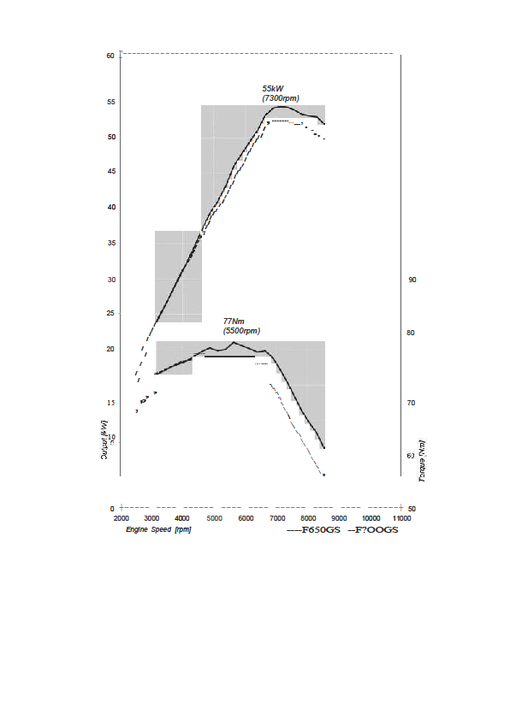
Technical Specifications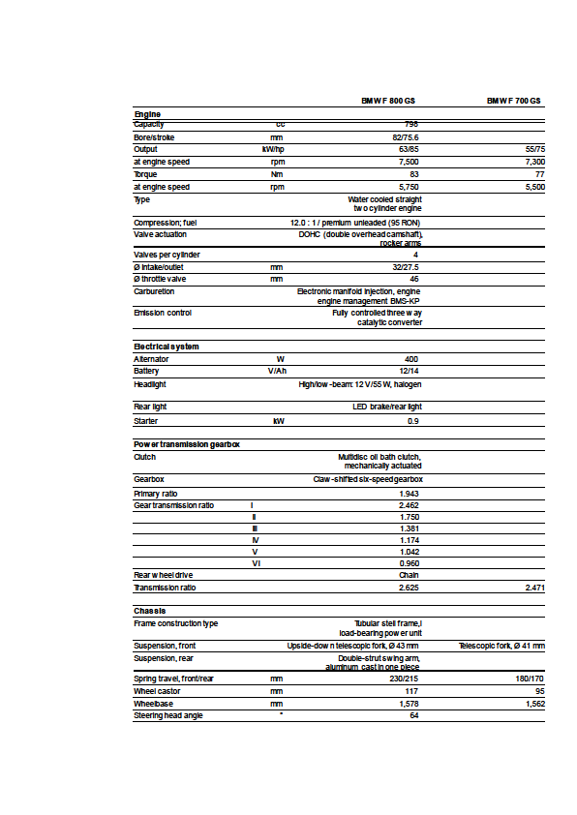
BMW Group In America
BMW of North America, LLC has been present in the United States since 1975. Rolls-Royce Motor Cars NA, LLC began distributing vehicles in 2003. The BMW Group in the United States has grown to include marketing, sales, and financial service organizations for the BMW brand of motor vehicles, including motorcycles, the MINI brand, and the Rolls-Royce brand of Motor Cars; DesignworksUSA, a strategic design consultancy in California; a technology office in Silicon Valley and various other operations throughout the country. BMW Manufacturing Co., LLC in South Carolina is part of BMW Group’s global manufacturing network and is the exclusive manufacturing plant for all X5 and X3 Sports Activity Vehicles and X6 Sports Activity Coupes. The BMW Group sales organization is represented in the U.S. through networks of 338 BMW passenger car BMW Sports Activity Vehicle centers, 139 BMW motorcycle retailers, 113 MINI passenger car dealers, and 32 Rolls-Royce Motor Car dealers. BMW (US) Holding Corp., the BMW Group’s sales headquarters for North America, is located in Woodcliff Lake, New Jersey.

# # #

Journalist note: Information about the BMW Group and its products is available to journalists on-line at the BMW Group PressClub at the following address: www.press.bmwna.com. Additional information, images and video may be found at www.bmwusanews.com. Broadcast quality video footage is available via The NewsMarket at www.thenewsmarket.com.

# # #

