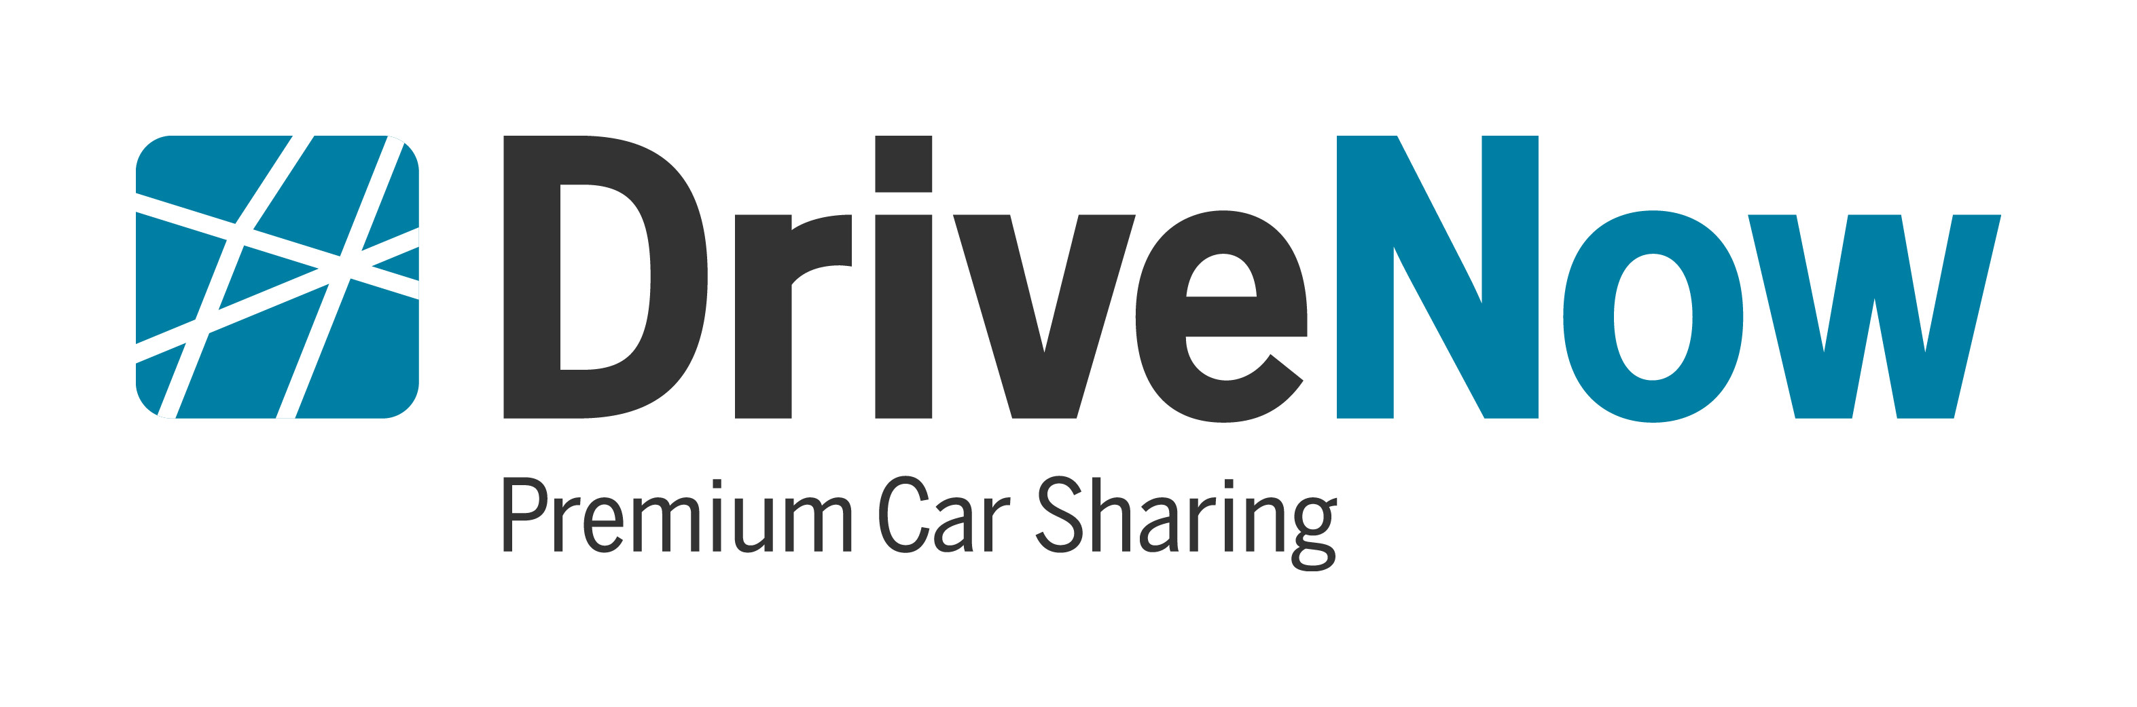

QUICK FACTS

- DriveNow is the convenient, flexible and premium car sharing program from BMW, launched in the U.S. in San Francisco.

- The San Francisco fleet is initially comprised of 70 BMW ActiveE electric vehicles with zero emission driving, the first all-electric BMW.

- There are currently eight DriveNow Stations in San Francisco conveniently located close to BART, MUNI and bike-sharing stations where customers can pick up and drop off cars. Two additional DriveNow stations, one each in Palo Alto and at the San Francisco International Airport; will be added soon.

- Customers can register for DriveNow membership using smartphone app, online at www.drive-now.com/usa or in person at a DriveNow Station.

- The DriveNow ID functions as both a car key and a membership card for the ChargePoint Network, the largest network of individually-owned electric vehicle charging stations.

- Customers can pick up DriveNow vehicles at any DriveNow station and return them to any DriveNow station.

- Available DriveNow vehicles along with their charging status are displayed on an interactive map on DriveNow’s website and the DriveNow app. Just press the “Book Now” button to reserve.

- Vehicles can be charged at ChargePoint charging stations or any other public charging station.

- The one-time activation fee is $39

- Rates start at $12 for the first 30 minutes, with a daily maximum of $90

- There are no time limits – drivers may keep the car for as long, or as little, as they like.

- Richard Steinberg is the CEO of DriveNow. He was previously Manager, Electric Vehicle Operations and Strategy for BMW of North America.

# # #

