For Release: | May 2, 2013
Contact: | Roy Oliemuller  BMW Motorrad USA Communications Manager  Tel. 201-307-4082 /roy.oliemuller@bmwna.com

BMW Motorrad USA Introduces The 2014 F 800 GS Adventure

Authentic GS Adventure Experience in a Mid-Size Motorcycle

Woodcliff Lake, NJ – May 2, 2013... Building upon a track record of success in the large-capacity and mid-size enduro segments, BMW Motorrad proudly offers the new F 800 GS Adventure. Based on the dynamic, off-road-oriented F 800 GS, the Adventure model offers an optimal combination of agility, touring practicality and off-road capability. Following the tradition of the popular boxer-engined GS Adventure models, it provides off-road-oriented touring aficionados, world travellers and endure fans with an authentic GS Adventure experience in the mid-size segment.

The F 800 GS Adventure is powered by the liquid-cooled 798 cc four-valve twin-cylinder engine featured on the F 800 GS, with electronic fuel injection, closed-loop catalytic converter and six-speed transmission. Delivering maximum power of 63 kW (85 hp) at 7,500 rpm, and with maximum torque of 83 Nm (61 lb/ft) at 5,750 rpm, this engine impresses with quick and lively response, powerful torque and low fuel consumption.

Engineered and equipped for world travel.
Like the F 800 GS, the Adventure model features a robust, torsionally resistant tubular steel frame, while the rear subframe is reinforced to accommodate the larger, 24-liter tank (6.3 gallons) (8 liters (2.1 gallons) more than the F 800 GS model), which increases the bike’s range. Like the F 800 GS, the Adventure model is equipped with ABS as standard, while further safety and performance-enhancing systems – Automatic Stability Control (ASC) and Electronic Suspension Adjustment (ESA) – are available as factory equipped options, and in the case of ASC, also as a dealer installed special accessory. These features position the BMW F 800 GS Adventure, along with the F 800 GS, as the safest mid-size touring enduro on the market.

The new F 800 GS Adventure is also available with Enduro mode as part of a package featuring ASC as a factory option.. At the push of a button, the rider can increase the slip threshold of the ABS and ASC systems when heading off-road, for an even more dynamic riding experience with improved acceleration and braking on loose terrain.

The F 800 GS Adventure boasts new, masculine bodywork that underscores its globetrotting abilities, while a new, very comfortable bench seat, a larger windscreen for improved protection against the elements and hand protectors also support this image. Other new standard features on the F 800 GS Adventure include wide enduro footrests, an adjustable, reinforced foot brake lever, an engine protection bar and a pannier rack which also functions as a tank protection bar.

Highlights of the new BMW F 800 GS Adventure compared to the F 800 GS:
- Based on the same versatile overall concept as the F 800 GS, with powerful twin-cylinder engine and agile suspension, but with enhanced off-road and globetrotting abilities.
- Robust and masculine GS Adventure bodywork styling.
- Balanced proportions, despite large rear tank.
- Larger, 24-liter (6.3 gallons) fuel tank (+ 8 liters/ + 2.1 gallons).
- Extended range (by approx.100 miles).
- Enduro mode as a new optional extra, in combination with ASC.
- Reinforced rear subframe.
- More comfortable bench seat.
- Large windscreen.
- Wide enduro footrests.
- Adjustable, reinforced foot brake lever.
- Engine protection bar.
- Pannier rack also serves as a tank protection bar.
- Wide range of dealer installed special accessories and factory options.

Key technical differences at a glance:

BMW F 800 GS Adventure BMW F 800 GS
Tank volume: 6.3 gallons 4.2 gallons
Standard seat height: 35.0 in 34.6 in
Low seat height: 33.9 in 33.5 in
Low Suspension option: no yes, 32.3 in
DIN unladen weight: 505 lbs 472 lbs
Max load: 496 lbs 507 lbs
Dimensions
L / W / H: 90.7/36.4/57.1 in 90.6/36.2/53.0 in
Fuel consumption
55 mph 55mpg 62 mpg

Model Characteristics and Design

BMW GS Adventure is a byword for the finest in two-wheeled exploration.
For many years, the Adventure versions of the large BMW GS boxer bikes have been discovering far corners of our planet and pressing on where others have turned back. With the arrival of the F 800 GS Adventure, BMW Motorrad offers this same concept for the mid-size enduro segment for the first time – and just like the boxer-engined GS Adventure models, the newcomer is also built for increased off-road riding and operation under the harshest conditions.

High-torque, smooth running parallel-twin engine.
Just like the F 800 GS, the new F 800 GS Adventure uses the extremely compact two-cylinder engine inclined forward at an angle of 8.3 degrees with a displacement of 798 cc and four valves per combustion chamber. Equipped with electronic fuel injection, closed-loop catalytic converter and a six-speed gearbox, the engine excels with its quick throttle response, acceleration and low fuel consumption. Its system of balancing masses using a swivelling connecting rod that compensates for first and second-order inertia forces is the only one of its kind to be installed on a standard production bike. Valve actuation is by means of double overhead camshafts and speed-resistant rocker arms. Output of the liquid-cooled engine is unchanged at 63 kW (85 hp) at 7,500 rpm, with a peak torque of 83 Nm (61 lb-ft) at 5,750 rpm.

Robust chassis with reinforced rear frame and ABS as standard.
The chassis of the new F 800 GS Adventure is based on the proven concept used on the F 800 GS, featuring a robust, torsionally stiff steel frame in tubular construction with the engine integrated as a load-bearing element. The steering head connection via gusset plates and the one-piece double-strut swing arm made of diecast aluminum is unchanged. The only difference is that the rear frame in square steel tubing has been strengthened to allow for both the 8-liter/2.1 gallon increase in fuel tank capacity and the more rigorous demands on the bike’s off-road abilities. ABS already comes equipped as standard on the new F 800 GS Adventure, as it does on all BMW production motorcycles.

The new, extra-light and compact two-channel Bosch 9M BMW system featured on the F 800 GS is also included. It comes equipped with inlet valves that can be infinitely adjusted for even better response as well as wheel sensors that automatically monitor the distance between sensor and sensor wheel. ABS can be deactivated at the press of a button if the rider so wishes – ideal for riding in off-road terrain.

Electronic Suspension Adjustment (ESA) as a factory equipped option.

The list of factory equipped options includes a unique feature for the mid-size enduro segment in
the form of Electronic Suspension Adjustment (ESA). This allows the rider to conveniently adjust
the rebound damping of the rear spring strut in the same way as on the F 800 GS with a simple
push of a button on the left handlebar panel, even while on the move. Depending on the damping
mode selected – “Comfort”, “Normal” or “Sport” – the electronic control unit determines and sets
the appropriate damping rate. This is done by means of a small, light stepper motor on the shock
absorber, while a corresponding symbol appears in the instrument cluster display. The spring
preload, on the other hand, is adjusted manually using an easily accessible hand wheel.

Automatic Stability Control (ASC) with new Enduro mode available as a factory equipped option.
A unique feature of BMW’s mid-size enduro segment is the Automatic Stability Control (ASC) system on the F 800 GS. This anti-slip control function regulates the amount of engine drive torque transmitted as a function of the friction coefficient between the road surface and the rear tire. This has the effect of preventing the rear wheel from spinning, thereby enhancing traction and handling safety. Riders can disengage the system by pressing a button, even on the move.
The new F 800 GS Adventure is the world’s-first mid-size bike to offer an Enduro riding mode as an option with ASC. When changing from roads to rougher terrain, a handlebar control enables the rider to simply switch to Enduro mode and thereby activate an ASC and ABS setting that has been specially tuned for off-road riding. In this mode, the ASC and ABS control logic is modified to delay intervention. The slip threshold is increased, resulting in improved acceleration and stopping power on loose surfaces at the same time as making the riding experience even more dynamic and active. The Enduro mode can only be ordered in conjunction with the optional ASC in the Enduro package, although ASC is available also on its own.

New styling and extended equipment features.

The new F 800 GS Adventure underscores its credentials as an enduro bike eminently suited to world travel as well as a safe and dependable means of exploring even the remotest regions of the planet with a host of specialized equipment features.

The introduction of the new F 800 GS Adventure clearly signals what its name promises. It takes its cue from the large boxer GS Adventure models by adopting the same authentic, and robust look. The characteristic GS styling continues to stand out clearly from all angles.

When it comes to ergonomics and comfort, the new F 800 GS Adventure further demonstrates its globetrotting capabilities with a seat that is more comfortable and slightly higher than the F 800 GS, making longer day rides even easier to cover. A lower seat can be selected as an accessory. Meanwhile, an enlarged windscreen provides even better protection from the elements, while sturdy hand protectors and adjustable brake and clutch levers are also standard..
Suitability for off-road use is further enhanced by widened enduro footrests with vibration-damping rubber tops that can be removed for riding off-road. The adjustable rest for the foot brake lever allows for optimum operation of the rear-wheel brake when the rider is in a standing position off road.

The severe operating conditions often encountered in rough terrain prompted the reinforcement of the foot brake lever and the inclusion of an engine protection bar plus the pannier racks that double as protection bars for the enlarged fuel tank. Its capacity of 24 liters/6.3 gallons means that it holds 8 liters/2.1 gallons more than the F 800 GS, increasing the bike’s range by around 100 miles.

Equipment Range

Optional equipment and accessories for a wide range of personalization.
BMW Motorrad offers its customary extensive range of optional equipment and accessories for further personalization of the new F 800 GS Adventure.

Options are factory equipped while accessories are retrofit items that can be added by BMW Motorrad dealers or customers themselves.

Optional equipment.
- Automatic Stability Control (ASC).
- Electronic Suspension Adjustment (ESA).
- Low seat.
- Center stand.
- Comfort package: onboard computer, heated grips, center stand.
- new: Enduro package: ASC, Enduro mode.
- new: Off-road tires.
- new: LED Fog Lights. .
- Anti-theft alarm system.
- Active Package: LED Fog Lights, ESA

Special accessories.
- Safety.
- Automatic Stability Control (ASC).
- new: LED Fog Lights.
- Anti-theft alarm system.
- Add-on spoiler (small and large) for hand protectors.
- Add-on windscreen spoiler, large.

- Storage options.
- new: Tinted windscreen.
- Case Holder, large, for aluminum topcase.
- Aluminum case.
- Inner bags for aluminum case.
- Aluminum topcase.
- Waterproof tank bag.
- Softbag Sport, small.
- Softbag Sport, large.
- Enduro rear bag.

- .Sound.
- Akrapovic sports silencer.

- Ergonomics and comfort.
- Wind deflector set.
- Heated handlebar grips.
- Low seat.
- Splash guard extension, rear.

- Navigation and communication.
- new: BMW Motorrad Navigator Adventure.
- Holder for navigation system, cable and accessory set.
- Function pouch for Navigator.

- Maintenance and technology.
- Service tool kit.
- Center stand.

Colors

The new F 800 GS Adventure also signals its adventurous nature through two new colors.
In Sandrover matt, the F 800 GS Adventure stakes its claim to adventure riding. Racing red, on the other hand, lends the F 800 GS Adventure a particularly light and sporty look while accentuating its dynamic qualities.

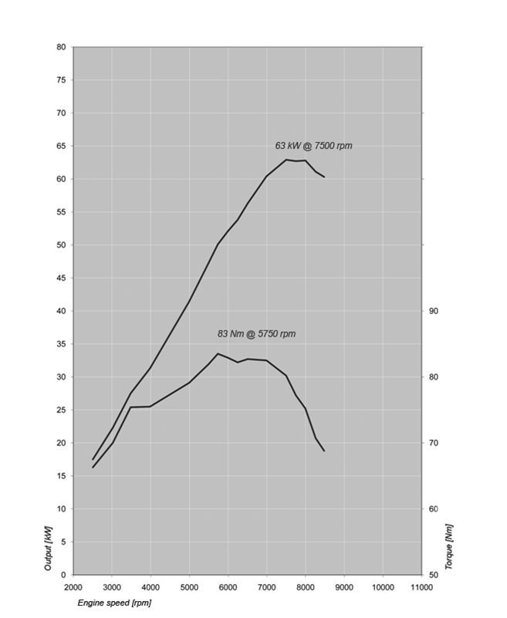
Engine Output and Torque

Technical Specifications

Engine
Type | Water-cooled 4-stroke in-line two-cylinder engine, four valves per cylinder, two overhead camshafts, dry sump lubrication
Bore x stroke | 82 mm x 75.6 mm
Capacity | 798 cc
Rated output | 63 kW (85 hp) at 7,500 rpm
Max. torque | 61 lb/ft at 5,750 rpm
Compression ratio | 12.0 : 1
Mixture control / engine management | Electronic fuel injection, digital engine management (BMS-K+)
Emission control | Closed-loop 3-way catalytic converter / emission standard EU-3
Performance / fuel consumption
Maximum speed | 120 mph
Fuel consumption per 100 km at constant 90 km/h | 55 mpg, at a constant 55 mph
Fuel consumption per 100 km at constant 120 km/h
Fuel type | Premium Unleaded
Electrical system
Alternator | three-phase alternator 400 W (rated power)
Battery | 12 V / 14 Ah, maintenance-free
Power transmission
Clutch | Multiple-disc clutch in oil bath, mechanically operated
Gearbox | Constant mesh 6-speed gearbox integrated into crankcase
Drive | Endless O-ring chain with shock damping in rear wheel hub
Chassis / brakes
Frame | Tubular steel trellis frame, load-bearing engine
Front wheel location / suspension | Upside-down telescopic fork, Ø 43 mm
Rear wheel location / suspension | Cast aluminium dual swing arm, WAD strut (travel related damping), spring pre-load hydraulically adjustable, rebound damping adjustable
Suspension travel front / rear | 9.1 inches / 8.5 inches (230 mm / 215 mm)
Wheelbase | 62.1 inches (1,578 mm)
Castor | 4.6 inches (117 mm)
Steering head angle | 64°
Wheels | Wire spoke wheels
Rim, front | 2.15 x 21"
Rim, rear | 4.25 x 17"
Tyres, front | 90/90 - 21 54V
Tyres, rear | 150/70 - 17 69V
Brake, front | Dual floating discs, Ø 300 mm, two-piston floating calipers, ABS
Brake, rear | Single disc, diameter 265 mm, single-piston floating caliper, ABS
ABS | STANDARD
Dimensions / weights
Length | 90.7 inches (2,305 mm)
Width (incl. mirrors) | 36.4 inches (925 mm)
Height (excl. mirrors) | 57.1 inches (1,450 mm)
Seat height, unladen weight | 35.0 inches Standard; low seat 33.9 inches (available as accessories and/or factory options, see an authorized BMW Motorrad dealer)
Inner leg curve, unladen weight | 77.2 inches Standard; optional inner leg curve (inseam) 75.6 inches (seats available as accessories and/or factory options, see an authorized BMW Motorrad dealer)
Unladen weight, road ready, fully fuelled ¹⁾ | 505 lbs (229 kg)
Dry weight
Permitted total weight | 1,001 lbs (454 kg)
Payload (with standard equipment) | 496 lbs (225 kg)
Usable tank volume | 6.3 gallons (24.0 liters)
Reserve | Approx. 1 gallon (4.0 liters)

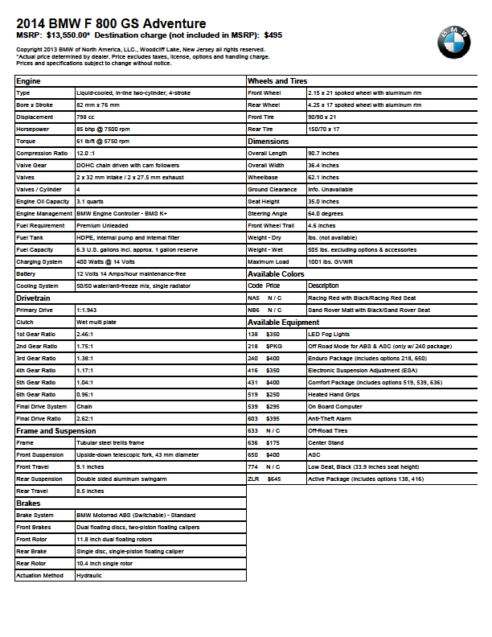

BMW Group In America

BMW of North America, LLC has been present in the United States since 1975. Rolls-Royce Motor Cars NA, LLC began distributing vehicles in 2003. The BMW Group in the United States has grown to include marketing, sales, and financial service organizations for the BMW brand of motor vehicles, including motorcycles, the MINI brand, and the Rolls-Royce brand of Motor Cars; DesignworksUSA, a strategic design consultancy in California; a technology office in Silicon Valley and various other operations throughout the country. BMW Manufacturing Co., LLC in South Carolina is part of BMW Group’s global manufacturing network and is the exclusive manufacturing plant for all X5 and X3 Sports Activity Vehicles and X6 Sports Activity Coupes. The BMW Group sales organization is represented in the U.S. through networks of 338 BMW passenger car and BMW Sports Activity Vehicle centers, 139 BMW motorcycle retailers, 117 MINI passenger car dealers, and 34 Rolls-Royce Motor Car dealers. BMW (US) Holding Corp., the BMW Group’s sales headquarters for North America, is located in Woodcliff Lake, New Jersey.

Information about BMW Group products is available to consumers via the Internet at:
www.bmwgroupna.com
# # #

Journalist note: Information about BMW Group and its products in the USA is available to journalists on-line at www.bmwgroupusanews.com and www.press.bmwna.com.

# # #

