For Release: | October 7, 2013
Contact: | Roy Oliemuller  BMW Motorrad USA Communications Manager  Tel. 201-307-4082 /roy.oliemuller@bmwna.com
The New BMW R 1200 GS Adventure
Next-Generation Icon Of Large-Capacity Travel Enduros
Woodcliff Lake, NJ – October 7, 2013…The arrival of the new BMW R 1200 GS Adventure heralds the beginning of a new chapter in the success story of BMW Motorrad’s large, boxer-engine GS models that dates back more than 30 years. Since its debut in 2005, the big GS Adventure has been firmly established as the definitive machine for long-distance travel. It transports two-wheeled explorers to the farthest-flung corners of the world and allows them to keep pressing on when others have long since turned back.

The BMW R 1200 GS Adventure as the quintessential travel companion for expeditions and long-distance exploration.

The new R 1200 GS Adventure continues in this same tradition. Building on the dynamic performance characteristics and superb off-road and touring capabilities of the R 1200 GS, the latest BMW large capacity enduro provides the new, ultimate solution for globetrotters, travel enduro aficionados and touring riders with a passion for off-road action.

The new R 1200 GS Adventure is powered by the same spirited air/liquid-cooled boxer engine featured on the R 1200 GS, with a displacement of 1,170 cc and an output of 92 kW (125 hp) at 7,750 rpm. The stand-out feature of the power unit – introduced last year after being newly developed for the R 1200 GS – is the new precision cooling system which uses water instead of oil as a cooling agent. Also new is the engine’s through-flow (intake/exhaust), which is now vertical for even more efficient power output, as well as the six-speed gearbox that is integrated into the engine housing along with the wet clutch. For the first time on a BMW production motorcycle, the maintenance-free cardan-shaft drive is now positioned on the left-hand side. To enhance rideability, especially on off-road terrain, the drive’s flywheel mass has been increased by 2.1 lbs. and an extra vibration damper has been incorporated into the powertrain.

Designed, engineered and equipped for supreme globetrotting capabilities.

The big BMW GS Adventure is an icon among large-capacity travel enduros and has been a top choice for world travelers on long-distance tours, even to the remotest regions of the planet. No matter whether it is negotiating tarmac roads, gravel tracks or rough terrain, the large-capacity GS Adventure gets its riders safely to their destination. This both compelled and inspired BMW Motorrad to make the new R 1200 GS Adventure even better in every way.

Like the R 1200 GS, the Adventure is also built around a robust and torsionally resistant tubular steel spaceframe. However, it has a larger 7.9 gallon fuel tank (2.6 gallons more than on the R 1200 GS) to allow for an increased range, while the fuel tank itself is now made from lightweight aluminum. The R 1200 GS Adventure already comes equipped as standard with ABS, Automatic Stability Control (ASC), as well as the two riding modes “Rain” and “Road”, which enable the riding characteristics to be adapted to most road conditions. This considerably enhances its range of use while also providing a significant safety boost on slippery surfaces. Three additional riding modes can be added by ordering the optional Ride Modes Pro feature, which is accompanied by the Enduro settings for ABS and ASC for off-road riding. The three extra riding modes – Dynamic, Enduro and Enduro Pro (which can be activated with a coding plug) – make it possible to adjust the settings of both ASC and ABS and, if fitted, the semi-active suspension Dynamic ESA (Electronic Suspension Adjustment) to suit the specific requirements of off-road operation.

Besides new bodywork styling with an even stronger character, the globetrotting abilities and greater off-road expertise of the new R 1200 GS Adventure are clearly brought to the forefront by a new chassis set-up with an additional 0.8 inches of spring travel, increased ground clearance and a trailing arm with modified geometry for even better handling. A larger windshield with convenient hand-wheel adjustment, additional air flaps as well as hand guards greatly increase wind and weather protection. Wide enduro footrests, adjustable, reinforced foot-operated levers and completely restyled bodywork add the finishing touches to the look of the new R 1200 GS Adventure.

Highlights of the new BMW R 1200 GS Adventure:

• Based on the same versatile overall concept as the R 1200 GS, with spirited twin-
cylinder boxer engine and agile chassis, but with enhanced off-road prowess and
globetrotting abilities.
• Increased flywheel mass in the engine and additional vibration damper for even
smoother running and superior rideability.
• Spring travel 0.8 inches longer at front and rear compared to R 1200 GS.
• 0.4 inches more ground clearance than predecessor.
• Modified geometry of trailing arm for even sharper handling.
• Completely restyled bodywork in distinctly robust and masculine GS Adventure design.
• 7.9 gallon fuel tank with similar range to predecessor.
• ABS, ASC and two riding modes as standard.
• Three further riding modes available as factory option.
• Semi-active suspension Dynamic ESA (Electronic Suspension Adjustment) available as
factory option.
• More comfortable height and tilt-adjustable rider seat.
• Large, adjustable windshield and air flaps.
• Wide enduro footrests.
• Adjustable, reinforced foot-operated levers.
• Robust engine and tank protection bar.
• Wide range of accessories and factory options.

Key technical differences at a glance:
BMW R 1200 GS Adventure BMW R 1200 GS
Tank capacity: 7.9 gallons 5.3 gallons
Spring travel
front / rear: 8.3 / 8.7 inches (210 / 220 mm) 7.5 / 7.9 inches (190 / 200 mm)
Seat height: 35.0 / 35.8 inches (890 / 910 mm) 33.5 / 34.3 inches (850 / 870 mm)
Weight with tank
90% full: 573 lbs. 525 lbs.
Max. load: 485 lbs. 467 lbs.
Dimensions
L / W: 88.8 / 38.6 inches 86.9 / 37.5 inches
Fuel consumption
at 55/75 mph: 54.7 / 39.9 mpg 57.4 / 42.8 mpg
Technology and design.

The BMW R 1200 GS Adventure – an expert explorer and long-distance traveler.

For years, the Adventure versions of the large-displacement BMW GS boxer have been synonymous with travelling to distant lands, whether on tarmac roads, gravel tracks or unsurfaced trails. With the latest R 1200 GS Adventure bike, BMW Motorrad is taking this model line to the next level by offering the big GS in a version specially built for long-distance travel, increased off-road riding and harsh operating conditions.

Powerful boxer engine with increased flywheel mass for even smoother engine running and supreme off-road capabilities.

Like the R 1200 GS, the new R 1200 GS Adventure also features the newly developed twin-cylinder boxer engine with an output of 92 kW (125 hp) at 7,750 rpm and a peak torque of 125 Nm (92 lb-ft) at 6,500 rpm. The new power unit has a displacement of 1,170 cc, as did the engine on the previous model. It still relies on air/liquid cooling, but with water instead of oil as the cooling agent – the water’s higher heat absorption capacity ensures more efficient heat dissipation. With this system of precision cooling, as it is known, only the parts of the engine that are particularly exposed to thermal stress are cooled by the coolant. The engine continues to be air-cooled too, thereby preserving the characteristic appearance of the boxer unit and its ability to handle tough operating conditions.

The through-flow (intake/exhaust) is vertical for optimum cylinder charging and the engine housing incorporates the 6-speed gearbox as well as an oil-bath clutch with anti-hopping function. The secondary drive runs via the maintenance-free cardan shaft that is now positioned on the left-hand side.

The flywheel mass of the boxer engine’s crankshaft was increased by 2.1 lbs. on the new R 1200 GS Adventure. This results in even smoother engine running and is of particular benefit when riding off-road at low speeds and low revs, such as when negotiating tight trails. The running characteristics are further enhanced by an additional vibration damper between the gearbox output and the cardan shaft.

Thanks to the E-gas ride-by-wire system, the rider’s inputs are relayed by a sensor on the throttle twist grip directly to the engine management, which adjusts the opening angle of the throttle valve accordingly. This produces a significant improvement in the new power unit’s controllability and response, while the introduction of the standard riding modes further enables the rider to adapt the engine’s character to the situation at hand.

ASC and two riding modes as standard. Three additional riding modes available with optional Ride Modes Pro.

For optimum adaptation to the rider’s individual needs and the intended use, the new R 1200 GS Adventure comes equipped as standard with two riding modes along with Automatic Stability Control (ASC). The ride characteristics can be adapted to most road conditions with the help of the two standard riding modes, “Rain” and “Road”. Together with the ABS system, also standard, ASC substantially increases the range of use of the new R 1200 GS Adventure, while also providing a significant safety boost on slippery surfaces.

Three additional riding modes can be added by ordering the optional Ride Modes Pro feature, which is accompanied by the Enduro ABS and Enduro ASC for off-road riding. The three riding modes – Dynamic, Enduro and Enduro Pro (which can be activated with a coding plug) – make it possible to adjust the settings of both ASC and ABS and, if fitted, the semi-active suspension Dynamic ESA (Electronic Suspension Adjustment) to suit the specific requirements of off-road operation.

When riding on wet surfaces or in difficult grip conditions, the standard-fit “Rain” mode provides particularly gentle engine control and response characteristics to assist the rider. ABS operation is programmed for on-road use and the Automatic Stability Control (ASC) is triggered sooner than in “Road” mode. If the Dynamic ESA option is selected, damping of the front and rear spring struts is softer to suit requirements.

In “Road” mode, engine response is spontaneous and the control systems are set to ensure optimum performance on all roads. ABS is configured for on-road use and ASC provides optimum traction. If Dynamic ESA is fitted, the front and rear damping is controlled in the standard setting.

The new BMW R 1200 GS Adventure can really show off its sporty prowess out on the open road in Dynamic mode. The engine is tuned for direct throttle response, while restrained intervention by the ASC system enables the skilled rider to drift out slightly. ABS is once again configured for on-road use. If the optional Dynamic ESA is fitted, a firm damping set-up allows the motorcycle’s full potential to be unleashed.

The Enduro mode is ideal for experiencing the R 1200 GS Adventure on off-road terrain. The engine responds gently in this mode and corrective control by the ASC is more restrained, allowing the experienced rider to execute deliberate and controllable rear wheel slides. Operation of the ABS is optimized for loose surfaces and road tires, while Dynamic ESA shifts to a soft setting to suit the operating requirements.

More ambitious enduro riders can engage the Enduro Pro mode to tap into the full off-road potential of the new R 1200 GS Adventure. This riding mode – with its spontaneous engine response – is designed for use with knobby tires. Plus, when the footbrake lever is operated, the ABS function is deactivated at the rear and the optional Dynamic ESA switches to a firmer setting.

BMW Motorrad Dynamic ESA semi-active suspension: a factory option for optimum riding dynamics in any situation.

The semi-active suspension BMW Motorrad Dynamic ESA (Electronic Suspension Adjustment) is designed to maximize ride safety and performance. Spring travel sensors at the front and rear monitor the vertical movements of the respective wheel suspension and collect additional data, allowing the damping to be automatically adapted to riding conditions and maneuvers. Dynamic ESA is integrated into the riding mode control concept.

Robust chassis with tubular steel bridge frame and longer spring travel for superior off-road capabilities.

The chassis of the new R 1200 GS Adventure is based on the all-new, continuous tubular steel bridge frame with a bolt-on rear frame featured on the R 1200 GS. The telelever at the front and the paralever at the rear have been re-engineered, resulting in a significant increase in torsional stiffness and ride precision compared to the predecessor model. The chassis’s geometry has been further refined to optimize handling. The R 1200 GS Adventure comes with an extra 0.8 inches of spring travel at the front (8.3 inches) and rear (8.7 inches) and 0.4 inches more ground clearance than its predecessor to make it even more suited for off-road riding. The new Adventure model is equipped with a steering damper as standard and also features a longitudinal control arm with specially adjusted geometry to further improve its handling characteristics. The center and side stands have been adapted to allow longer spring travel.

LED main headlight as factory option for even greater safety during daytime and night-time riding.

Like the R 1200 GS, the new R 1200 GS Adventure is equipped as standard with a halogen main headlight with optimized light output. For even greater illumination of the road ahead and safety, both day and night, an LED main headlight with daytime running light (low beam) is available as a factory option, featuring state-of-the-art LED technology, an ingenious cooling concept and a decondensation function.

Completely restyled bodywork including 7.9 gallon aluminum tank for ideal globetrotting abilities.

The new R 1200 GS Adventure’s bodywork and authentic design underscores its technical features and leadership as the ultimate enduro bike for world travel.

The fundamental architecture of the R 1200 GS has been retained for the Adventure version, with the characteristic flyline running in customary fashion from the GS beak over the fuel tank and seat to the functionally styled rear. Thanks to an even more distinctive composition of body and frame components, the new R 1200 GS Adventure uncompromisingly fulfills the high style standards expected of a globetrotter along with maximum robustness for optimum protection from wind and weather.

Compared to its predecessor, the new R 1200 GS Adventure now has a unique sense of lightness about it. This is mainly due to the open design of the tubular spaceframe which, together with the newly developed raised rear, makes it possible to see virtually right through the machine. The feeling of lightness expressed by the rear end gives added impact to the agile and dynamic character of the new Adventure model.

The vertical air flow through the new boxer engine produces a vertical flow of lines as well, starting from the cooling air intake in grained matt black and continuing via the kneepads on the redesigned, 7.9 gallon aluminum tank (R 1200 GS: 5.3 gallon tank) to the engine, conveying a sense of aerodynamic lightness. At the front, additional crash bars form a protective frame around the front section of the new R 1200 GS Adventure. Together with the standard hand protectors and the protective grills for the two restyled air intake ducts on the left and right, they give visual confirmation of the bike’s outstanding robustness and off-road prowess. Its increased everyday practicality is also reflected in more minor details, such as the storage compartment in front of the fuel filler cap for small items like change or road toll cards.

The undeniably high-class visual appeal of the new R 1200 GS Adventure is also rooted in its skillful blend of varying surfaces. Besides the select paintwork finishes and grains, numerous naturally anodized components such as the upper fork bridge and axle clamp blocks underline the high technical prowess of this globetrotting enduro bike.

New GS beak, optimized windshield, plus air flaps for even better wind and weather protection.

The GS beak with its more angular contours as well as a visually separate beak extension continues to radiate a sense of utmost resilience and supremacy. The extension has the additional effect of further improving spray protection. The tapered windshield – likewise purpose-developed for the Adventure – works in unison with two air flaps at the sides to improve the bike’s aerodynamic qualities. The windshield allows convenient, single-handed adjustment by means of a hand wheel and directs the airflow past the rider with little turbulence on fast legs of the journey, helping to reduce strain on the upper body at high speeds. The additional flaps, meanwhile, help to reduce draught effects in the kidney area.

Flawless ergonomics – for off-road riding, as well.

Despite its large fuel tank, the R 1200 GS Adventure has a slim waist in the knee grip area, which does more than just add to the bike’s visual sense of lightness. Apart from offering wide thigh support, the seat has been made narrower at the front, giving the rider far more freedom of movement than on the predecessor model. It is adjustable for tilt and offers seat heights of 35 inches and 35.8 inches as standard.

Wider enduro footrests than on the R 1200 GS, together with adjustable foot-operated levers for the footbrake and gearshift, allow for the occasional change in requirements on the new Adventure, particularly when riding off road. It can be adapted to suit individual riding styles and habits as well as varying types of footwear.

Colors.

The new R 1200 GS Adventure clearly signals its adventurous, globetrotting nature with a choice of new color schemes.

In Olive matt, the R 1200 GS Adventure emphasizes its long-distance touring qualities and exudes a particularly robust and strong character.

The BMW Motorrad brand color Alpine white lends the R 1200 GS Adventure a light look and underlines its off-road expertise.

Racing blue metallic matt offers a sporty appearance and accentuates its dynamic on-road performance abilities.

Equipment range.

Optional equipment and special accessories.

BMW Motorrad offers an extensive range of optional equipment and special accessories for further customization of the new R 1200 GS Adventure.

Optional extras are integrated into the production process and supplied as factory options. Special accessories are retrofit items that can be added by BMW Motorrad dealers or customers themselves.

Optional equipment.

• Ride Modes Pro (three additional riding modes – Dynamic, Enduro and Enduro Pro –
plus the Enduro ABS and Enduro ASC add-ons for off-road riding).
• Semi-active suspension Dynamic ESA (Electronic Suspension Adjustment).
• Navigation system preparation.
• Onboard computer Pro.
• Cruise control.
• Full-LED headlight.
• LED auxiliary lights.
• TPM (tire pressure monitor).
• Heated grips.
• Chrome-plated exhaust system.
• Anti-theft alarm system.
• Off-road tires

Special accessories.

Safety.

• LED auxiliary lights.
• Anti-theft alarm system.

Storage Options.

• Aluminum cases.
• Inner bags for aluminum cases.
• Aluminum topcase.
• Inner bag for aluminum topcase.
• Water-resistant tank bag.
• Softbag 2, small.
• Softbag 2, large.

Sound.

• HP sport silencer by Akrapović.

Ergonomics and comfort.

• Rally seat with luggage plate (seat height 35.2 inches).
• Tinted windshield.
Navigation and communication.

• BMW Motorrad Navigator V.
• Holder, cable and attachment kit.

Maintenance and technology.

• Onboard toolkit service kit.

BMW Group In America

BMW of North America, LLC has been present in the United States since 1975. Rolls-Royce Motor Cars NA, LLC began distributing vehicles in 2003. The BMW Group in the United States has grown to include marketing, sales, and financial service organizations for the BMW brand of motor vehicles, including motorcycles, the MINI brand, and the Rolls-Royce brand of Motor Cars; DesignworksUSA, a strategic design consultancy in California; a technology office in Silicon Valley and various other operations throughout the country. BMW Manufacturing Co., LLC in South Carolina is part of BMW Group’s global manufacturing network and is the exclusive manufacturing plant for all X5 and X3 Sports Activity Vehicles and X6 Sports Activity Coupes. The BMW Group sales organization is represented in the U.S. through networks of 338 BMW passenger car and BMW Sports Activity Vehicle centers, 139 BMW motorcycle retailers, 119 MINI passenger car dealers, and 34 Rolls-Royce Motor Car dealers. BMW (US) Holding Corp., the BMW Group’s sales headquarters for North America, is located in Woodcliff Lake, New Jersey.

Information about BMW Group products is available to consumers via the Internet at:
www.bmwgroupna.com
# # #

Journalist note: Information about BMW Group and its products in the USA is available
to journalists on-line at www.bmwgroupusanews.com and www.press.bmwna.com.

Engine output and torque.

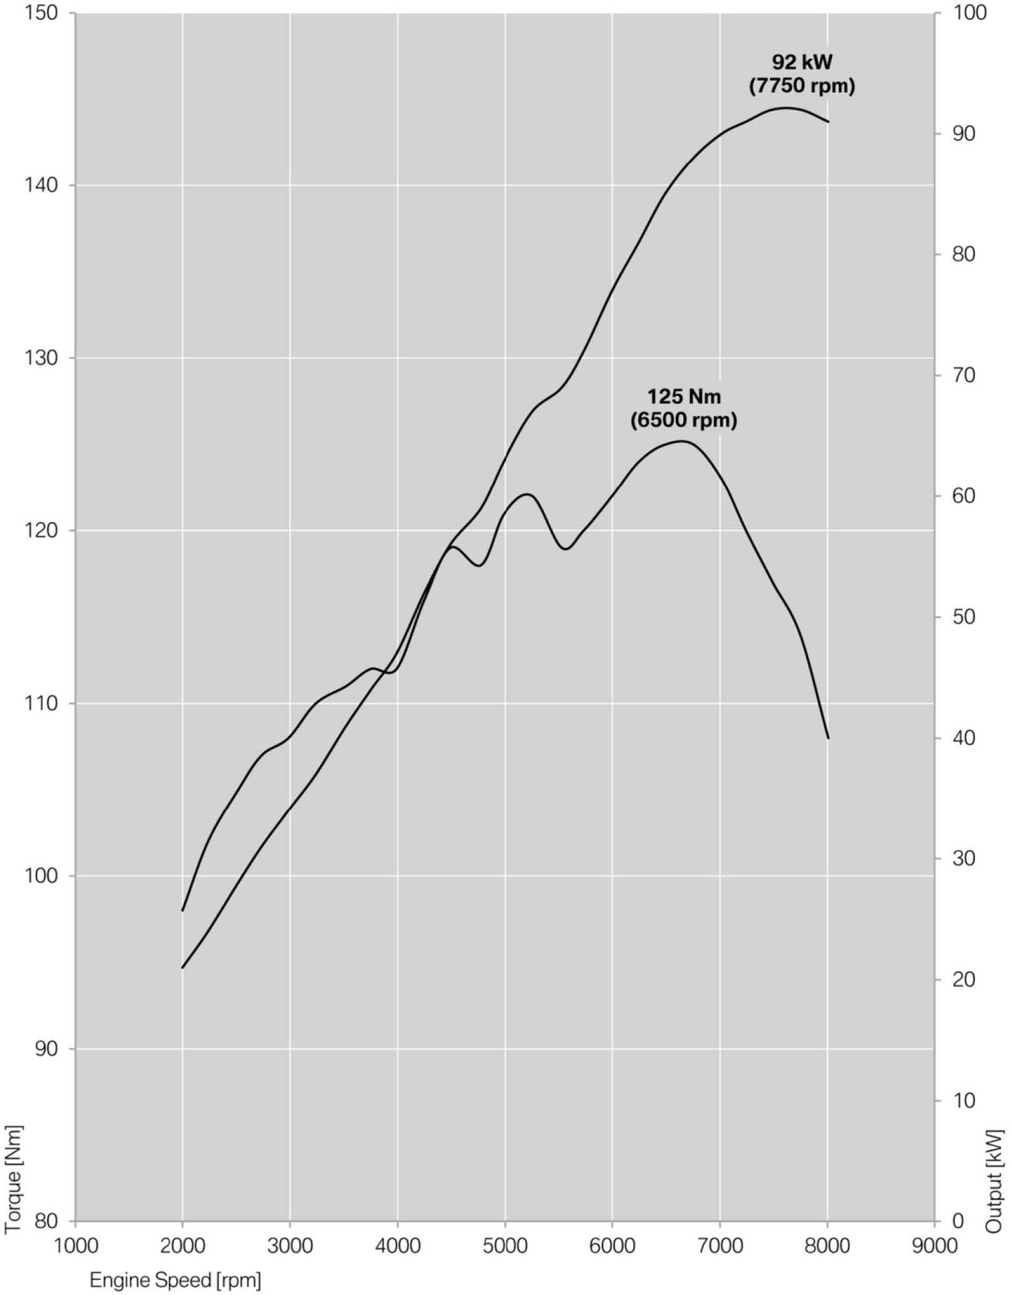

Technical specifications.

 |  |  | BMW R 1200 GS Adventure
Engine

Displacement | cc |  | 1170
Bore/stroke | mm |  | 101/73
Output | kW/hp |  | 92/125
at | rpm |  | 7750
Torque | lb-ft |  | 92
at | rpm |  | 6500
Type |  |  | air/water-cooled twin-cylinder boxer engine
No. of cylinders |  |  | 2
Compression/fuel |  |  | 12.5:1, premium unleaded (95 RON)
Valve actuation |  |  | DOHC
Valves per cylinder |  |  | 4
Ø Intake/outlet | mm |  | 40/34
Ø Throttle valve | mm |  | 52
Carburetion |  |  | BMS-X
Emission control |  |  | closed-loop 3-way catalytic converter
Electrical system
Alternator | W |  | 510
Battery | V/Ah |  | 12/12 maintenance-free
Headlight | W |  | H7/LED (option)
Starter | kW |  | 0.9
Power transmission - gearbox
Clutch |  |  | anti-hopping wet clutch
Gearbox |  |  | constant mesh 6-speed gearbox
Primary ratio |  |  | 1.65
Transmission ratios  I |  |  | 2.438
II |  |  | 1.714
III |  |  | 1.296
IV |  |  | 1.059
V |  |  | 0.943
VI |  |  | 0.848
Rear wheel drive |  |  | cardan shaft
Transmission ratio |  |  | 2.91
Chassis
Frame construction type |  |  | tubular steel bridge frame, engine self-supporting
Suspension, front |  |  | BMW Telelever
Suspension, rear |  |  | BMW EVO Paralever
Spring travel, front/rear | In (mm) |  | 8.3 / 8.7 inches (210 / 220 mm)
Wheel castor | In (mm) |  | 3.6 inches (92.7 mm)
Wheelbase | In (mm) |  | 59.4 inches (1510 mm)
Steering head angle | ° |  | 65.5
Brakes | front |  | hydraulically actuated twin-disc brake, Ø 305 mm
 | rear |  | single-disc brake Ø 276 mm
ABS |  |  |  | BMW Motorrad Integral ABS (standard, part  integral, disengageable)
Wheels |  | cross-spoke wheels
 | front | 3.0 x 19"
 | rear | 4.5 x 17"
Tires | front | 120/70 R19
 | rear | 170/60 R17
Dimensions and weights

Total length | Inches (mm ) | 88.8 inches (2255 mm)
Total width with mirrors | Inches (mm) | 38.6 inches (980 mm)
Seat height | Inches (mm) | 35.0 / 35.8 inches (890/910 mm)
DIN unladen weight, road ready | lbs (kg) | 573 lbs (260 kg)
Permitted total weight | lbs (kg) | 1,058 lbs (480 kg)
Fuel tank capacity | gal (l) | 7.9 gal (30 l)
Performance figures
Fuel consumption
55 mph | mpg | 54.7 mpg
75 mph | mpg | 39.9 mpg
Acceleration
0‒100 km/h (62 mph) | s | 3.75
Maximum speed | mph | >125

