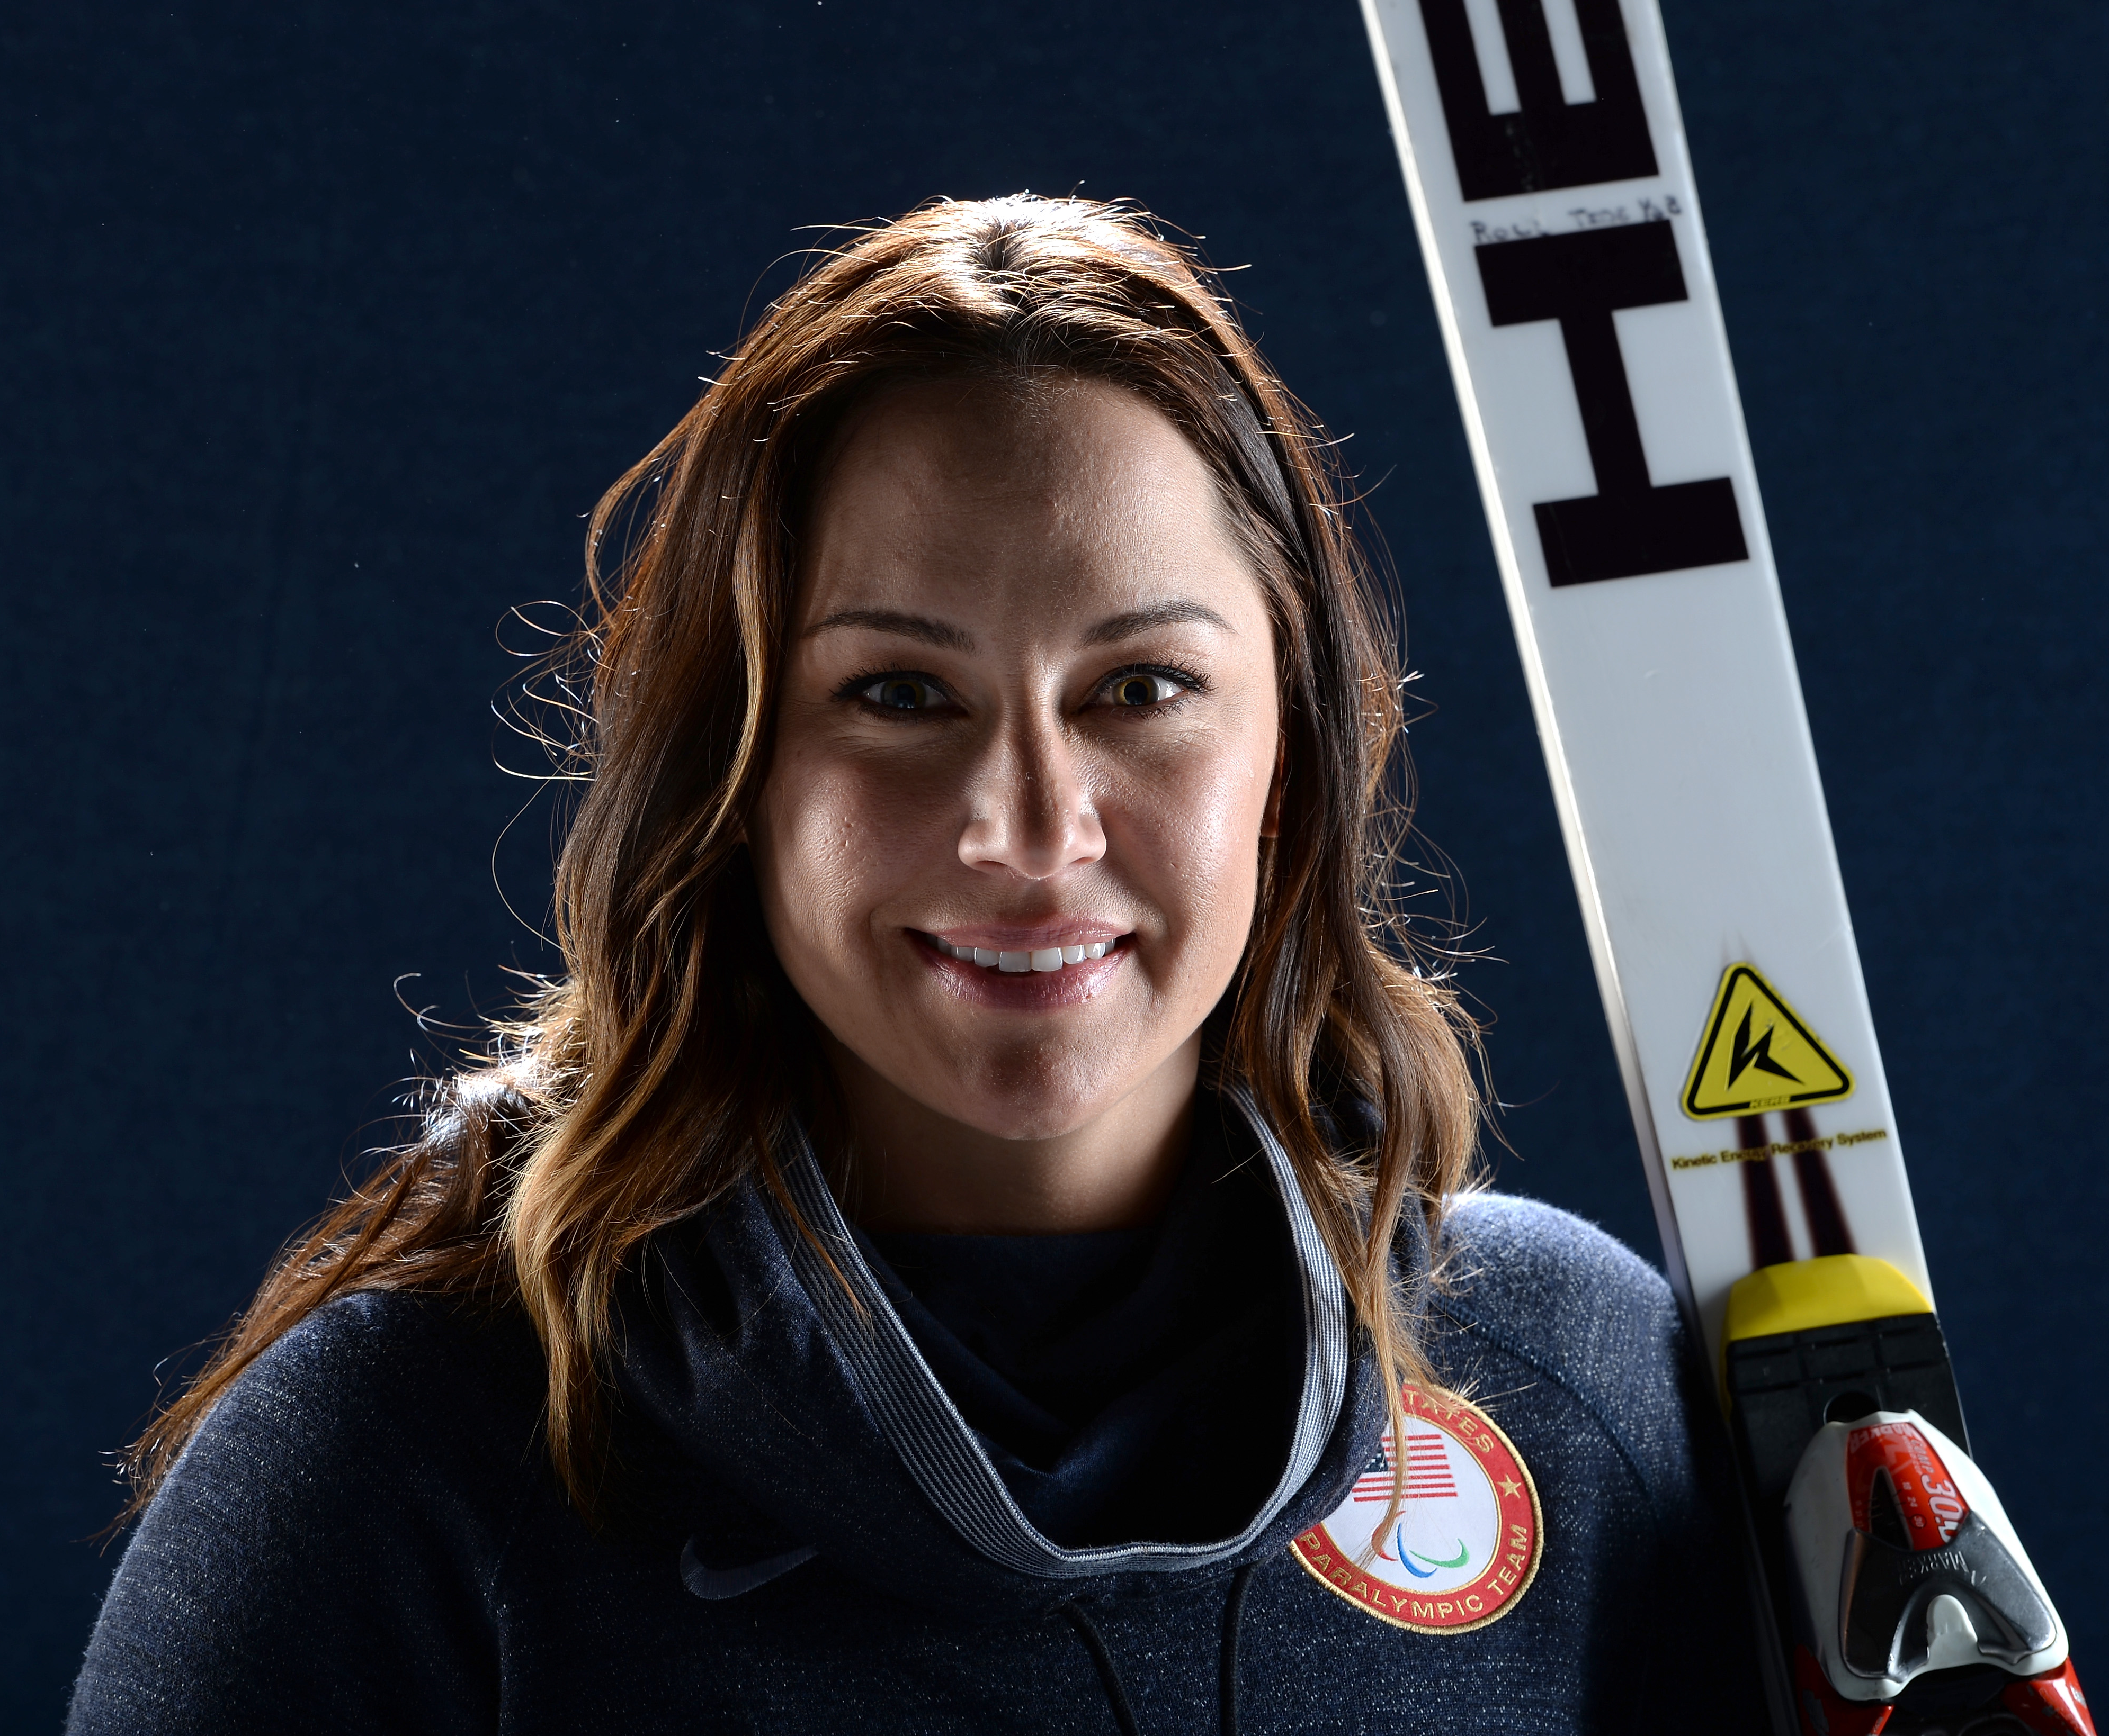
Alana Nichols

When she was younger, Northern New Mexico native Alana Nichols would spend all her winters snowboarding in the nearby Colorado slopes. However, it all changed in 2000 when a snowboarding injury left her paralyzed from the waist down. Despite her injury, Alana was determined to stay active. After picking up wheelchair basketball in 2002, she continued to play the sport at the University of Arizona.

After college, Alana made her Paralympic Games debut at the Beijing 2008 Paralympic Games, where she won a gold medal as a member of the U.S. Women's Wheelchair Basketball Team. She also earned her master’s degree in Kinesiology from the University of Alabama in 2008. Afterwards, Alana moved to Colorado to train in her dream sport, alpine skiing. Alana went on to win two gold medals, one silver medal and one bronze medal at the Vancouver 2010 Paralympic Winter Games.

With those remarkable victories, she became part of history as the first American woman to win gold medals in both the Paralympic and Paralympic Winter Games. Four years later, Alana hopes to continue her Paralympic successes in Sochi.

