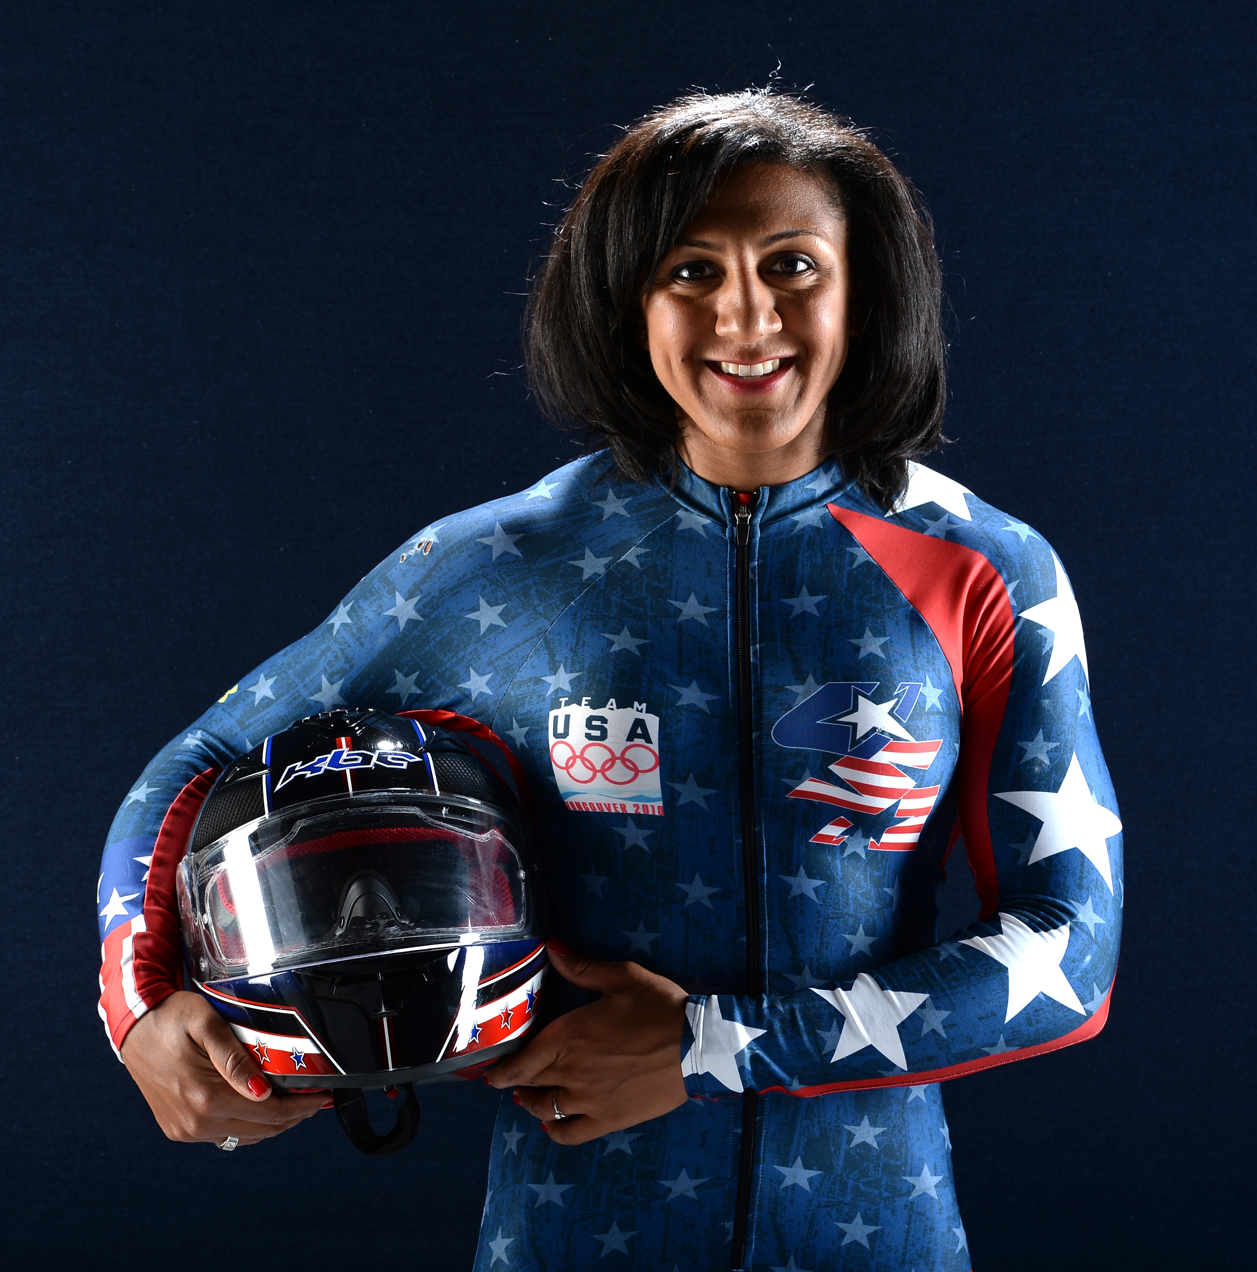
Elana Meyers

Georgia native Elana Meyers knew she wanted to be an Olympian after attending the Atlanta 1996 Olympic Games. Years later, she attended George Washington University where she was both a shortstop and pitcher for their Division 1 softball team. After being named to the ECAC Division 1 Softball All–StarTeam, it seemed like her Olympic dreams could actually come true. But unfortunately, the sport of softball was dropped from the Olympic Games roster. Not wanting to give up on her dream, Elana took up bobsledding.

She made the U.S. Bobsled Team in her rookie season and went on to win a bronze medal at the Vancouver 2010 Olympic Winter Games. Since then, she's won multiple World Championship medals and been named the USBSF Female Athlete of the Year for two consecutive years. Ultimately, Elana hopes to add the one medal that is missing from her collection–Olympic gold.

