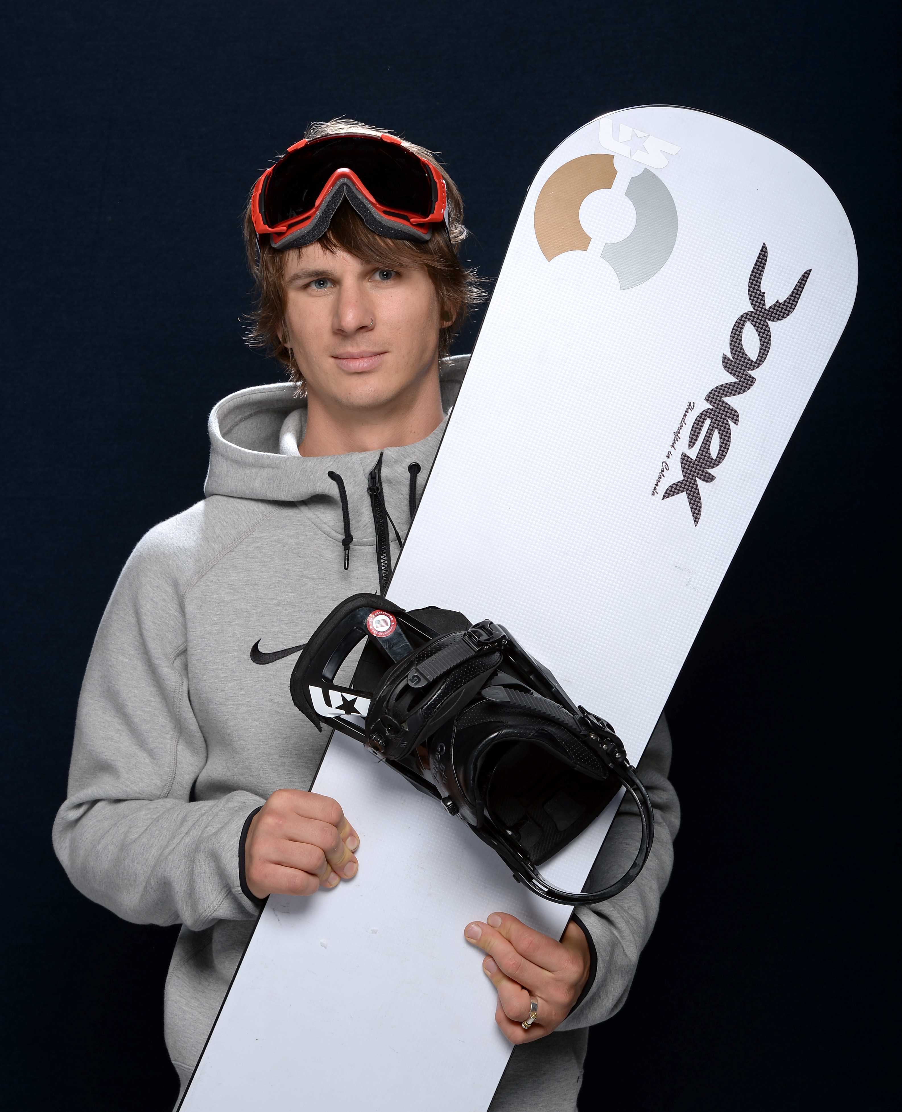
Evan Strong

Snowboarder Evan Strong grew up on the shores of Maui. Originally a surfer, he took up skateboarding at the age of 13 and quickly started working towards his dreams of going pro. By the age of 17, Evan was all ready to climb the pro ranks. However, his dreams were sidelined when a drunk driver tragically struck him while he was on his motorcycle. Doctors amputated his left leg three days later. Even though his recovery was difficult, he refused to give up the sports he loved.

After becoming very involved with the Challenged Athletes Foundation, Evan decided to move to Lake Tahoe to pursue his interest in snowboarding. Since starting the sport, he's won eight World Cups, as well as Gold and Bronze medals in the X-Games and even earned the title of World Champion. Now, he has two goals he wants to achieve: winning the able-bodied U.S. Snowboarding National Championship, and representing Team USA in Sochi.

