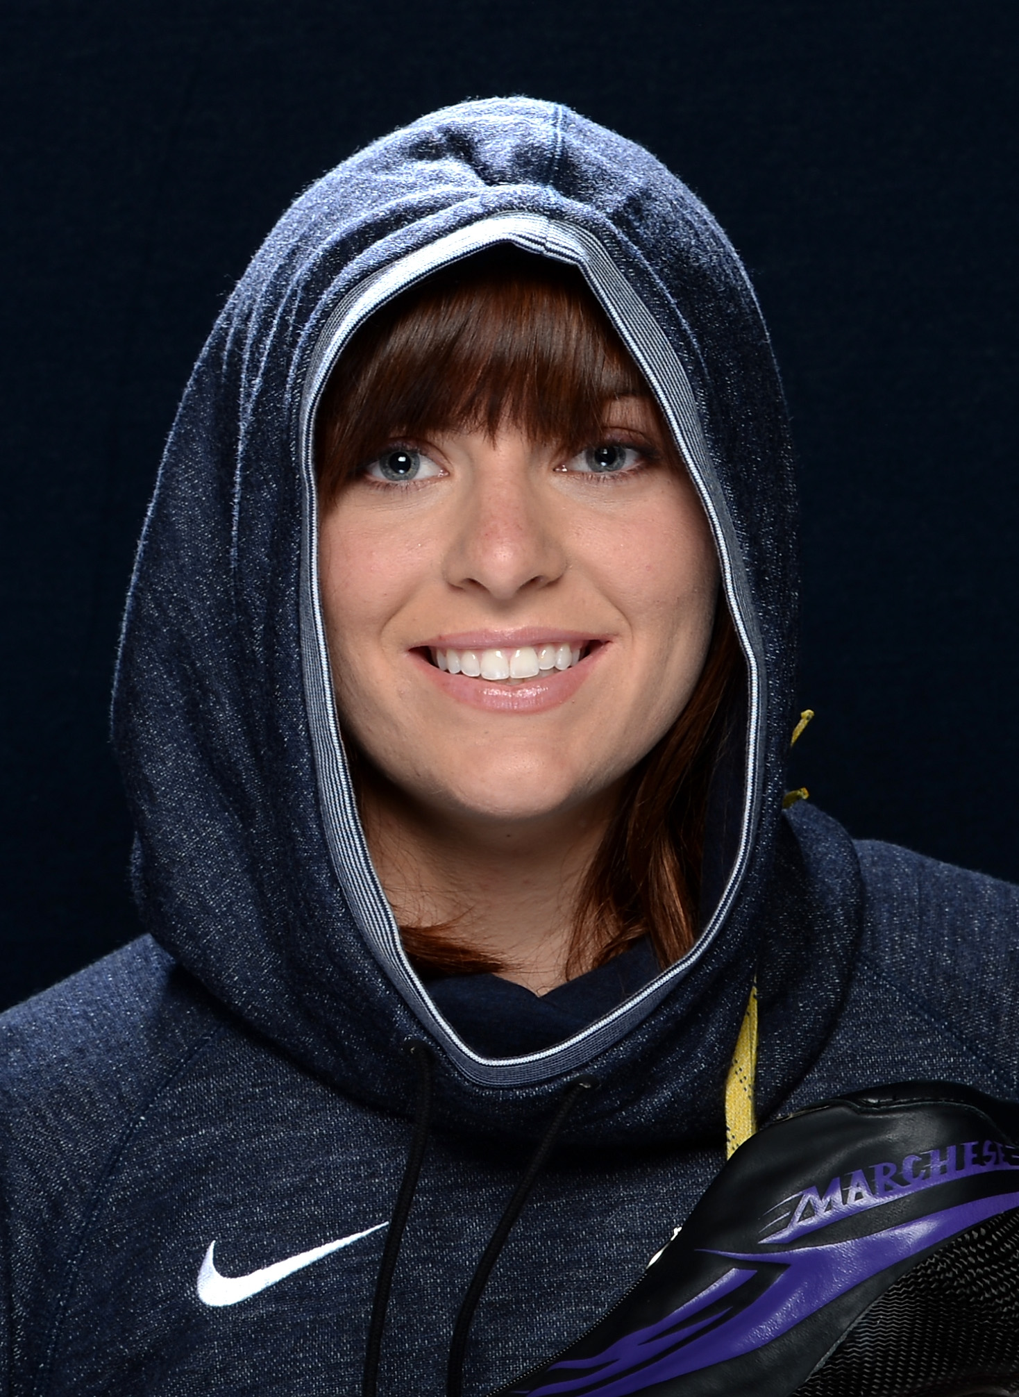
Heather Richardson

Speedskating is in Heather Richardson's blood. As the daughter of two competitive roller skaters, she started competitive inline skating at the age of nine. During her inline skating years, she racked up 11 World Championship medals. However, Heather had higher aspirations of competing in the Olympic Games.

In 2007, she followed the footsteps of other inline skaters turned ice skaters and took to the ice. Four short months later, she made the US Speedskating Team. After competing at the Vancouver 2010 Olympic Winter Games, she's gone on to win 10 World Cup medals, three World Championship medals and most recently, ended the 2013 season by capturing the World Sprint Champion time with a new world record. As one of only four athletes in history who can claim that they are a World Champion on both roller and ice skates, Heather hopes to finally add an Olympic medal to an already impressive collection.

