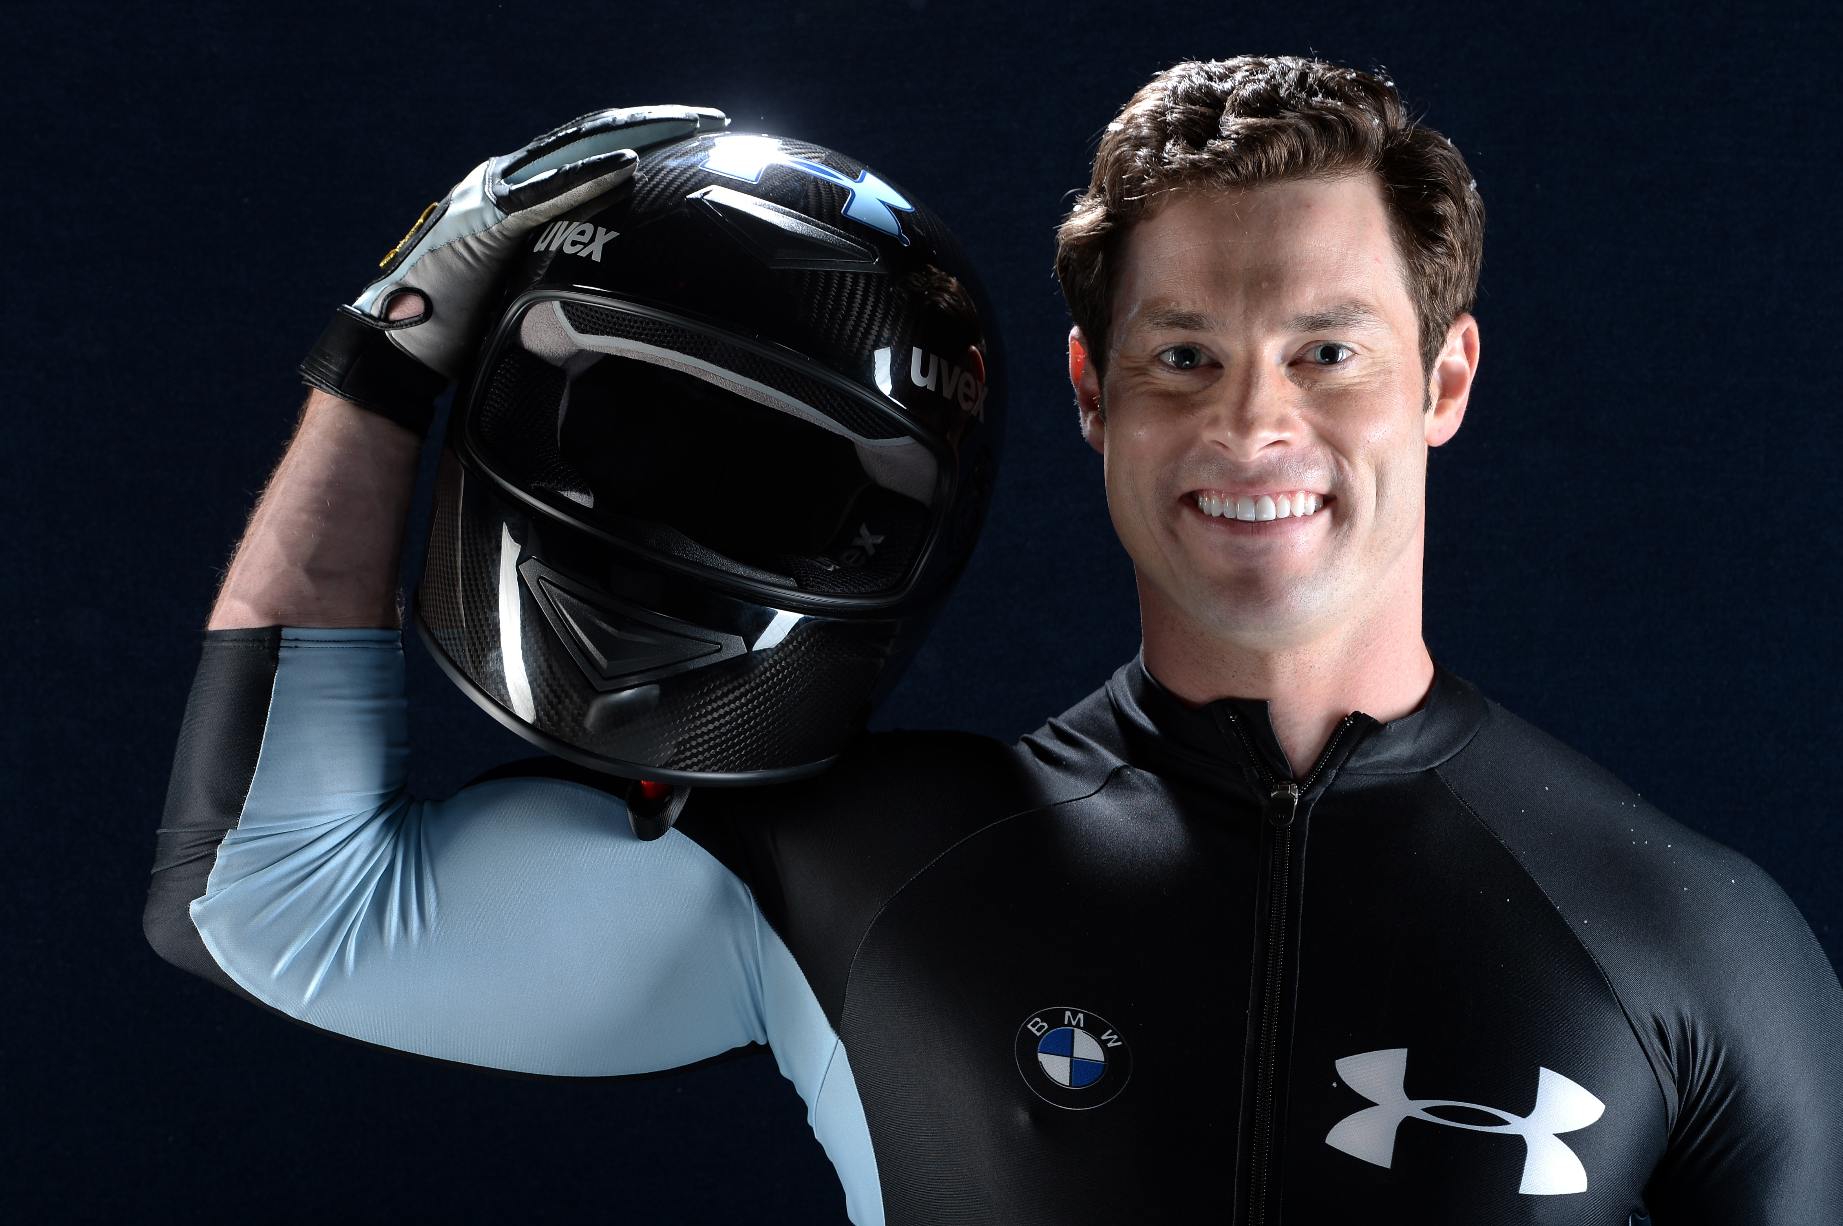
Steve Langton

As an accomplished track and field athlete, Steve Langton always loved watching the bobsled events during the Olympic Winter Games. After years of observing, Steve decided to apply for a spot at a U.S. Bobsled and Skeleton Federation recruitment camp even though he had never actually competed in the sport. He was accepted and shortly thereafter earned himself a spot on the U.S. national team for the 2007 World Cup circuit and made his Olympic Winter Games debut at the Vancouver 2010 Olympic Winter Games.

Steve has medaled in multiple World Championship and World Cup competitions, including two World Championship titles in both two-man and four-man events in 2012.

