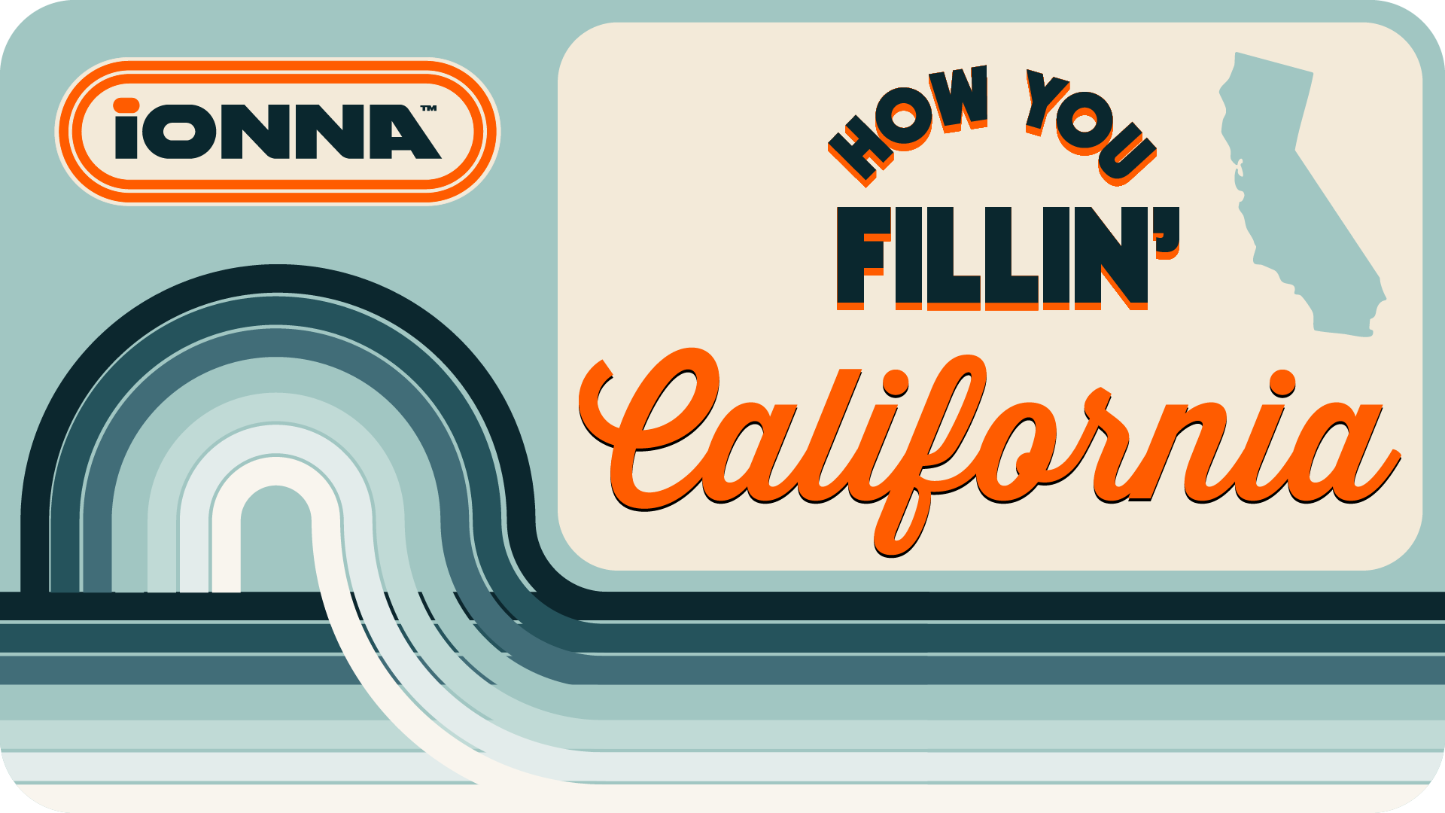

IONNA Surges ahead in California with a planned investment of $250M, New Rechargery Stations, and Expanded Integration
- IONNA announces over $250 million planned investment in California EV infrastructure
- Over 1,100 bays live or under construction, nationwide
- IONNA Plug G Charge now available with seven manufacturers
- Official IONNA Merchandise, available now
DURHAM, NC — [November 20, 2025] — IONNA, the joint venture and nationwide electric vehicle (EV) charging network, is celebrating a swell in the California wave, first announced last May. Concluding a week-long kickoff tour of Rechargery stations across major metropolitan cities in California, IONNA is announcing a planned investment of more than
$250 million in infrastructure across the Golden State over the next three years.
This week alone, IONNA marked a significant milestone with kickoff ceremonies in San Francisco, Sacramento, San Diego, San Jose, and Westminster — representing only a fraction of the over 1,000 bays now contracted across California. These locations bring IONNA’s total network to just over 4,000 bays contracted across the US and highlights a shift in the company’s focus from building to flipping on the switch for over 1,100 bays currently in construction or beyond in the US.
"This week’s expansion into California is a snapshot of the national momentum IONNA has built in under a year’s time,” said Seth Cutler, Chief Executive Officer of IONNA. “‘IONNA

Speed’ isn’t just about how quickly we grow, but also how we deliver, and the IONNA team consistently operates with a driver-first mentality to elevate the charging experience. Every new Rechargery reflects our commitment to providing the coverage, quality, and reliability our drivers deserve.”

"Recharging the California Test Drive”
Coverage is important, but quality is king when creating reliable, public EV charging experiences. Beginning with the Westminster Rechargery Beacon, IONNA’s first flagship location, the organization is rolling up their sleeves to ensure that California Rechargery stations open with a bang and that customers feel supported. With the launch of a California ‘EV Education Program’ IONNA aims to not only educate new EV drivers about the benefits of electric mobility but also allow them a glimpse into the world they are building with the network of ‘Rechargeries’. Following each opening, IONNA ambassadors will partner with local dealerships and EV Groups to host an event on site. Where better for the ‘EV Curious’ to explore options and demystify charging as they transition to zero- emission transportation.
IONNA Plug G Charge continues to grow
IONNA continues to push the envelope in their efforts to reduce friction in the customer experience, no matter the make or model. With five of the eight founding automakers already integrated with Plug C Charge (BMW, General Motors, Hyundai, Kia and Mercedes) and three more planned by end of 2026 (Honda, Stellantis, Toyota), we now welcome Rivian and Ford vehicles into the fold. Each Rechargery station allows for seamless, automatic charging as a fully integrated partner with Rivian and full-fledged member of Ford’s BlueOval™ Charge Network.
Living the Brand
No holiday season would be complete without the perfect gift, and your annual shopping spree just got easier. IONNA is teasing the launch of its official merch store, with a onetime offering swag drop, available at shop.ionna.com. We are eager to bring to life the brand that our drivers have come to love, with local flavor, retro style and a hint of nostalgia that pulls you in. With this end of year special, we are one step closer to our official merchandise store that celebrates the people, places, and EVs that make up our network and yours.

About IONNA

IONNA is a rising joint venture founded by eight of the world’s biggest automakers, BMW, General Motors, Honda, Hyundai, Mercedes-Benz, Kia, Stellantis and Toyota. Purpose-built to lead, innovate, create, and drive forward a redefinition of charging as an end-to-end integrated customer experience. Delivering this mission by developing and deploying a trailblazing nationwide network of stations with cutting-edge technology, retail integration, amenities, and unparalleled customer service. Enabling urban and long-distance EV mobility for all with over 30,000 ultra-fast-and-reliable charging points by 2030. IONNA will provide the coverage drivers need, the reliability they deserve, and the amenities they crave.

